EXERCISE NO:5

DATE:12/10/2020

AIM:

Write a Python function to print missing characters to make string pangram.

PROGRAM:

x=input()

x=x.replace(" ","")

alpha_flag=[0]*26

for char in x:

asci=ord(char)-97

alpha_flag[asci]=1

asci=0

for i in range(0,len(alpha_flag)):

if(alpha_flag[i]==0):

asci=i+97

print(chr(asci),end="")

LINK:

<http://103.53.53.18/mod/vpl/forms/edit.php?id=235&userid=1748>

OUTPUT:

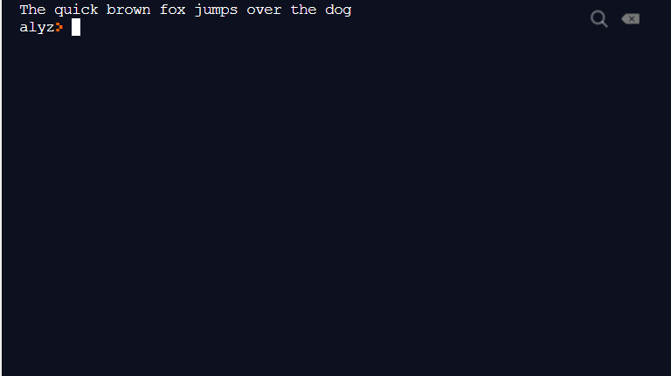

RESULT:

The output is obtained successfully.