1. 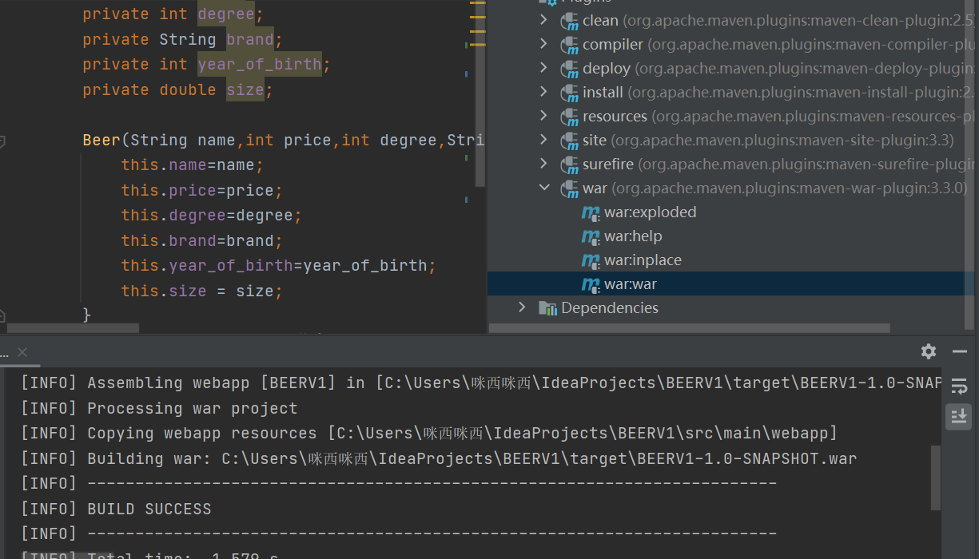first pack the project as war

2.find war by path

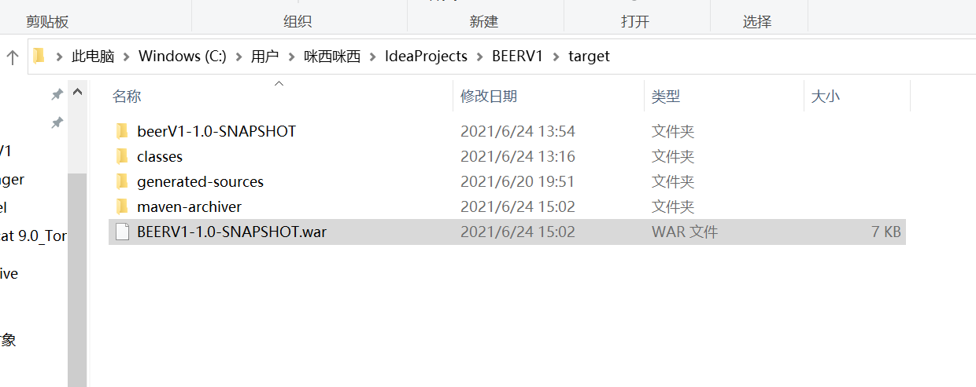

1. paste war into tomcat webapps.

