
SIMATS ENGINEERING
DEPARTMENT OF COMPUTER SCIENCE AND ENGINEERING
DSA04 – FUNDAMENTALS OF DATA SCIENCE
ASSIGNMENT 2 – CO2
Student Performance Data Preparation and Visualization Using Python
Course Outcome CO2: Apply data pre-processing and visualization techniques using Python libraries for effective data handling.
Name | Vigneshwaran B
Register Number | 192324022
Department | AI & Data Science
Course Code | DSA04
Assignment | Assignment 2 – CO2
Total Marks | 50
Mode | Individual
Bloom's Level: BL4 – Analyse

Contents
Section | Title | Marks
1 | Introduction and Objective | –
2 | Sample Dataset, Tools and Project Structure | –
Task 1 | Inspecting and Reading the Dataset | 4
Task 2 | Data Selection and Filtering | 4
Task 3 | Identifying and Handling Missing Data | 5
Task 4 | Sorting, Grouping and Ranking | 5
Task 5 | Data Manipulation Using Pandas and NumPy | 5
Task 6 | Data Preprocessing Workflow | 4
Task 7 | Data Visualization Using Matplotlib | 6
Task 8 | Choosing Suitable Python Libraries | 4
Task 9 | Interpreting Visualized Data for Academic Support | 6
Task 10 | Integrated Preprocessing and Visualization Case Study | 7
3 | Assumptions, Missing-Value Treatment and Changes Made to the Data | –
4 | Conclusion | –
 | Total | 50

1. Introduction and Objective
An engineering college wants to analyse student academic performance using data combined from its student information system, attendance records, internal assessment results and learning management system (LMS). Data merged from several sources is rarely ready for analysis: it contains missing values, duplicate records, inconsistent formats and values that cannot be interpreted directly.
As a member of the college Data Science team, the objective of this assignment is to prepare the raw student dataset for analysis and present meaningful visualizations using Python. Pandas and NumPy are used for reading, selecting, cleaning and manipulating the data; SciPy and Scikit-learn support statistical checks and preprocessing utilities; and Matplotlib is used to create the charts and flowcharts. Every task below gives the aim, the Python code, the actual output produced by that code, an explanation and an analysis.

2. Sample Dataset, Tools and Project Structure

2.1 Dataset Declaration
Synthetic dataset notice: The dataset used in this assignment is a synthetic sample dataset created only for this assignment. All student names, IDs and values are invented. It does not contain any real student personal information.
The raw file student_performance_raw.csv contains 20 rows for 18 distinct students from four departments. Data-quality problems were deliberately introduced so that each preprocessing technique can be demonstrated. The same file is used consistently in all ten tasks.
Table 2.1: Data dictionary
Column | Meaning | Valid range / format
Student_ID | Unique student identifier | S101 – S118
Student_Name | Student name (synthetic) | Text
Department | Academic department | CSE, ECE, MECH, AI&DS
Attendance_Pct | Attendance percentage for the semester | 0 – 100 (%)
Internal_Marks | Internal assessment marks | 0 – 100
Assignment_Score | Total assignment score | 0 – 50
Online_Activity_Hrs | Average LMS learning activity per week | Hours (exported as text)

Table 2.2: Raw synthetic dataset (student_performance_raw.csv, 20 rows)
# | Student_  ID | Student_Name | Department | Attendance_  Pct | Internal_  Marks | Assignment_  Score | Online_Activity  _Hrs
0 | S101 | Arjun Mehta | CSE | 92 | 88 | 46 | 6.5
1 | S102 | Divya Ramesh | cse | 68 | 42 | 30 | 2 hrs
2 | S103 | Karthik Raja | ECE | 81 | 74 | 40 | 5
3 | S104 | Priya Nair | Computer Science | (blank) | 79 | 42 | 4.5
4 | S105 | Rahul Verma | MECH | 59 | 35 | 22 | 1.5
5 | S106 | Sneha Iyer | 'ECE ' (space) | 88 | (blank) | 44 | 5.5 hrs
6 | S107 | Vikram Singh | Mechanical | 76 | 61 | (blank) | 3
7 | S108 | Ananya Das | AIDS | 95 | 112 | 48 | 7
8 | S109 | Mohammed Faiz | AI&DS | 72 | 48 | 28 | 2.5
9 | S103 | Karthik Raja | ECE | 81 | 74 | 40 | 5
10 | S110 | Lakshmi Prasad | ECE | (blank) | 66 | 35 | 4 hrs
11 | S111 | Rohan Gupta | CSE | 84 | 71 | 38 | 5
12 | S112 | Meera Krishnan | mech | 64 | 30 | 20 | 1
13 | S113 | Aditya Rao | AI & DS | 90 | 85 | (blank) | 6
14 | S114 | Kavya Menon | ECE | 79 | -4 | 36 | 3.5
15 | S115 | Siddharth Jain | CSE | 70 | (blank) | 25 | 2
16 | S116 | Nithya Suresh | MECH | (blank) | 58 | 33 | 3 hrs
17 | S117 | Harish Kumar | AIDS | 86 | 97 | 47 | 8
18 | S118 | Pooja Shetty | ECE | 55 | 18 | 15 | 0.5
19 | S111 | Rohan Gupta | CSE | 84 | 71 | 38 | 5

Table 2.3: Data-quality issues intentionally introduced
Issue | Where it occurs | Handled in
Missing values (7 cells) | Attendance: S104, S110, S116; Internal marks: S106, S115; Assignment: S107, S113 | Task 3, 6, 10
Duplicate records (2) | S103 and S111 each appear twice (rows 9 and 19) | Task 6, 10
Inconsistent department names | 11 labels for 4 departments: cse, Computer Science, 'ECE ', Mechanical, mech, AIDS, AI & DS … | Task 5, 6, 10
Incorrect data type | Online_Activity_Hrs mixes numbers and text such as '2 hrs', so it is read as text | Task 5, 6, 10
Invalid marks | Internal marks 112 (S108) and -4 (S114) lie outside 0–100 | Task 6, 10
Unusually high / low but valid marks | 97 (S117) and 18 (S118) | Task 6, 10

2.2 Creating the Dataset
Python Code – task00_create_dataset.py
# NOTE: All names and values are SYNTHETIC (invented for this assignment).
# No real student personal information is used.
import numpy as np
import pandas as pd

columns = ["Student_ID", "Student_Name", "Department", "Attendance_Pct",
"Internal_Marks", "Assignment_Score", "Online_Activity_Hrs"]

# Internal_Marks out of 100, Assignment_Score out of 50,
# Online_Activity_Hrs = average LMS hours per week (stored as text, as exported)
records = [
("S101", "Arjun Mehta", "CSE", 92, 88, 46, "6.5"),
("S102", "Divya Ramesh", "cse", 68, 42, 30, "2 hrs"),
("S103", "Karthik Raja", "ECE", 81, 74, 40, "5"),
("S104", "Priya Nair", "Computer Science", np.nan, 79, 42, "4.5"),
("S105", "Rahul Verma", "MECH", 59, 35, 22, "1.5"),
("S106", "Sneha Iyer", "ECE ", 88, np.nan, 44, "5.5 hrs"),
("S107", "Vikram Singh", "Mechanical", 76, 61, np.nan, "3"),
("S108", "Ananya Das", "AIDS", 95, 112, 48, "7"),
("S109", "Mohammed Faiz", "AI&DS", 72, 48, 28, "2.5"),
("S103", "Karthik Raja", "ECE", 81, 74, 40, "5"),
("S110", "Lakshmi Prasad", "ECE", np.nan, 66, 35, "4 hrs"),
("S111", "Rohan Gupta", "CSE", 84, 71, 38, "5"),
("S112", "Meera Krishnan", "mech", 64, 30, 20, "1"),
("S113", "Aditya Rao", "AI & DS", 90, 85, np.nan, "6"),
("S114", "Kavya Menon", "ECE", 79, -4, 36, "3.5"),
("S115", "Siddharth Jain", "CSE", 70, np.nan, 25, "2"),
("S116", "Nithya Suresh", "MECH", np.nan, 58, 33, "3 hrs"),
("S117", "Harish Kumar", "AIDS", 86, 97, 47, "8"),
("S118", "Pooja Shetty", "ECE", 55, 18, 15, "0.5"),
("S111", "Rohan Gupta", "CSE", 84, 71, 38, "5"),
]

raw = pd.DataFrame(records, columns=columns)
raw.to_csv("data/student_performance_raw.csv", index=False)
print("Raw dataset saved: data/student_performance_raw.csv")
print("Shape:", raw.shape)
Output:
Raw dataset saved: data/student_performance_raw.csv
Shape: (20, 7)

Missing values are written as np.nan, which Pandas stores as an empty field in the CSV and reads back as NaN. Online activity is deliberately stored as text (for example "2 hrs") to imitate a typical LMS export.

2.3 Tools and Environment
Tool | Version used | Purpose
Python | 3.13 | Programming language
Pandas | 3.0.5 | Reading, selecting, cleaning, grouping, ranking
NumPy | 2.5.3 | Array-based numerical operations
SciPy | 1.18.1 | Statistical test (Pearson correlation with p-value)
Scikit-learn | 1.9.1 | Imputation and scaling utilities
Matplotlib | 3.11.2 | Charts and flowcharts
Note: the outputs in this report were produced with Pandas 3.x, which shows text columns as str. Older Pandas 2.x versions show the same columns as object; every other result is identical.

2.4 Project Files and Data Flow
The submitted ZIP contains one script per task. Tasks 1–3 work directly on the raw file. The preprocessing workflow in Task 6 produces student_clean.csv, which is used by Tasks 4, 5, 8 and 9; Task 5 adds derived columns and saves student_prepared.csv, which is used by Tasks 7 and 9. Task 10 is a self-contained case study that starts again from the raw file. The script run_all.py executes everything in the correct order (python code/run_all.py).
File | Description
data/student_performance_raw.csv | Raw synthetic dataset (20 rows, with quality issues)
data/student_clean.csv | Output of the Task 6 workflow (18 rows, no missing/invalid values)
data/student_prepared.csv | Clean data + derived columns from Task 5
data/student_case_study_final.csv | Final dataset from the Task 10 case study
code/task00 … task10_*.py | Python source code for each task
code/flowcharts.py | Draws the labelled flowcharts for Tasks 6 and 10
charts/*.png | All charts and flowcharts embedded in this report

TASK 1 – Inspecting and Reading the Dataset (4 Marks)

Aim
To load the student performance CSV file into a Pandas DataFrame and examine its structure – records, dimensions, column names, data types and column categories – before any preprocessing, and to identify data-quality concerns.

1(a) Reading the CSV File and Displaying the First Five Records
Python Code – (a) Read the CSV file into a DataFrame
import pandas as pd

pd.set_option("display.width", 112) # wider console output
pd.set_option("display.max_columns", None) # show every column

df = pd.read_csv("data/student_performance_raw.csv")
print("Dataset loaded successfully.")
print("\nFirst five records:")
print(df.head())
Output:
Dataset loaded successfully.

First five records:
Student_ID Student_Name Department Attendance_Pct Internal_Marks Assignment_Score \
0 S101 Arjun Mehta CSE 92.0 88.0 46.0
1 S102 Divya Ramesh cse 68.0 42.0 30.0
2 S103 Karthik Raja ECE 81.0 74.0 40.0
3 S104 Priya Nair Computer Science NaN 79.0 42.0
4 S105 Rahul Verma MECH 59.0 35.0 22.0

Online_Activity_Hrs
0 6.5
1 2 hrs
2 5
3 4.5
4 1.5

Explanation: import pandas as pd loads the Pandas library. pd.read_csv() reads the comma-separated file and uses the first line as column names. The two set_option calls only widen the console display so that all columns are visible. df.head() returns the first five rows. Already in the first five rows we can see a missing attendance value (NaN for S104), a lower-case department name (cse), a different spelling (Computer Science) and an online activity value written with a unit (2 hrs).

1(b) Displaying the Last Five Records
Python Code – (b) Last five records
print("Last five records:")
print(df.tail())
Output:
Last five records:
Student_ID Student_Name Department Attendance_Pct Internal_Marks Assignment_Score Online_Activity_Hrs
15 S115 Siddharth Jain CSE 70.0 NaN 25.0 2
16 S116 Nithya Suresh MECH NaN 58.0 33.0 3 hrs
17 S117 Harish Kumar AIDS 86.0 97.0 47.0 8
18 S118 Pooja Shetty ECE 55.0 18.0 15.0 0.5
19 S111 Rohan Gupta CSE 84.0 71.0 38.0 5

Explanation: df.tail() returns the last five rows. Row 19 is S111 (Rohan Gupta), which already appeared at row 11 – an early sign of duplicate records. Row 16 (S116) has missing attendance and row 15 (S115) has missing internal marks.

1(c) Dataset Dimensions, Column Names and Data Types
Python Code – (c) Dimensions, column names and data types
print("Dataset dimensions (rows, columns):", df.shape)
print("\nColumn names:")
print(", ".join(df.columns))
print("\nData types:")
print(df.dtypes)
Output:
Dataset dimensions (rows, columns): (20, 7)

Column names:
Student_ID, Student_Name, Department, Attendance_Pct, Internal_Marks, Assignment_Score, Online_Activity_Hrs

Data types:
Student_ID str
Student_Name str
Department str
Attendance_Pct float64
Internal_Marks float64
Assignment_Score float64
Online_Activity_Hrs str
dtype: object

Explanation: df.shape returns a tuple (rows, columns): the file has 20 rows and 7 columns. df.columns lists the column names and df.dtypes gives the data type of each column. The three score columns are float64; they are floats rather than integers because Pandas needs a floating-point type to store NaN. Online_Activity_Hrs is stored as text (str) even though it represents hours, because some entries contain the word "hrs".

1(d) Identifying Numerical and Categorical Columns
Python Code – (d) Identify numerical and categorical columns
numerical_cols = df.select_dtypes(include="number").columns.tolist()
categorical_cols = df.select_dtypes(exclude="number").columns.tolist()
print("Numerical columns :", numerical_cols)
print("Categorical columns:", categorical_cols)

print("\nUnique values in Department:")
print(df["Department"].unique().tolist())
Output:
Numerical columns : ['Attendance_Pct', 'Internal_Marks', 'Assignment_Score']
Categorical columns: ['Student_ID', 'Student_Name', 'Department', 'Online_Activity_Hrs']

Unique values in Department:
['CSE', 'cse', 'ECE', 'Computer Science', 'MECH', 'ECE ', 'Mechanical', 'AIDS', 'AI&DS', 'mech', 'AI & DS']

Explanation: select_dtypes(include="number") keeps only numeric columns and select_dtypes(exclude="number") keeps the rest. Three columns are numerical (Attendance_Pct, Internal_Marks, Assignment_Score) and four are categorical/text. Online_Activity_Hrs is wrongly classified as categorical, so it cannot be averaged or plotted until it is converted. unique() shows 11 different department labels, although the college has only four departments.

1(e) Quick Data-Quality Checks
Python Code – (e) Quick data-quality checks for the analysis
print("Missing values per column:")
print(df.isnull().sum())
print("\nNumber of exact duplicate rows:", df.duplicated().sum())
print("\nSummary statistics of numerical columns:")
print(df.describe().round(2))
print("\nSample Online_Activity_Hrs values:", df["Online_Activity_Hrs"].unique()[:6].tolist())
Output:
Missing values per column:
Student_ID 0
Student_Name 0
Department 0
Attendance_Pct 3
Internal_Marks 2
Assignment_Score 2
Online_Activity_Hrs 0
dtype: int64

Number of exact duplicate rows: 2

Summary statistics of numerical columns:
Attendance_Pct Internal_Marks Assignment_Score
count 17.00 18.00 18.00
mean 77.88 61.39 34.83
std 11.66 29.04 9.72
min 55.00 -4.00 15.00
25% 70.00 43.50 28.50
50% 81.00 68.50 37.00
75% 86.00 77.75 41.50
max 95.00 112.00 48.00

Sample Online_Activity_Hrs values: ['6.5', '2 hrs', '5', '4.5', '1.5', '5.5 hrs']

Explanation: isnull().sum() counts missing values per column (7 in total), duplicated().sum() counts rows that are exact copies of an earlier row (2), and describe() gives count, mean, standard deviation, minimum, quartiles and maximum. The minimum internal mark of -4 and maximum of 112 are impossible on a 0–100 scale.

Analysis – What the Initial Inspection Reveals
The dataset is small (20 × 7) and contains one identifier column, one name column, one categorical attribute (Department) and four measures of academic behaviour and performance. The inspection shows that the data cannot be analysed directly. Two important data-quality concerns are:
- Inconsistent categorical values: the Department column holds 11 labels (e.g. CSE, cse, Computer Science) for only four departments. Any department-wise grouping would wrongly create 11 groups and split the averages.
- Incomplete and incorrect values: 7 cells are missing (15% of attendance values), 2 records are duplicated, internal marks contain impossible values (112 and -4), and online activity is stored as text. These problems would distort averages, counts and charts.
These findings define the preprocessing plan used in later tasks: handle missing values (Task 3), standardise text and convert types (Task 5), and remove duplicates and invalid values (Task 6).

TASK 2 – Data Selection and Filtering (4 Marks)

Aim
To select the columns relevant to academic performance and filter records by attendance and internal marks in order to locate students who may require academic support.

2(a) Selecting Student Name, Department, Attendance and Internal Marks
Python Code – (a) Select student name, department, attendance and internal marks
import pandas as pd

pd.set_option("display.width", 112)
pd.set_option("display.max_columns", None)

df = pd.read_csv("data/student_performance_raw.csv")

selected_cols = ["Student_Name", "Department", "Attendance_Pct", "Internal_Marks"]
selected = df[selected_cols] # column selection using a list of names
print("Selected columns (first 8 rows):")
print(selected.head(8))
Output:
Selected columns (first 8 rows):
Student_Name Department Attendance_Pct Internal_Marks
0 Arjun Mehta CSE 92.0 88.0
1 Divya Ramesh cse 68.0 42.0
2 Karthik Raja ECE 81.0 74.0
3 Priya Nair Computer Science NaN 79.0
4 Rahul Verma MECH 59.0 35.0
5 Sneha Iyer ECE 88.0 NaN
6 Vikram Singh Mechanical 76.0 61.0
7 Ananya Das AIDS 95.0 112.0

Explanation: Passing a list of column names inside square brackets (df[selected_cols]) returns a new DataFrame containing only those four columns. Identifier and assignment columns are not needed for this specific question, so the view is easier to read.

2(b) Filtering Students with Attendance Below 75%
Python Code – (b) Filter students whose attendance is below 75%
low_attendance = df.loc[df["Attendance_Pct"] < 75, selected_cols]
print("Students with attendance below 75%:")
print(low_attendance)
print("\nCount:", len(low_attendance))

# Rows with missing attendance are NOT returned by the condition (NaN < 75 is False)
print("\nRecords with missing attendance (cannot be classified yet):")
print(df.loc[df["Attendance_Pct"].isna(), ["Student_ID", "Student_Name"]])
Output:
Students with attendance below 75%:
Student_Name Department Attendance_Pct Internal_Marks
1 Divya Ramesh cse 68.0 42.0
4 Rahul Verma MECH 59.0 35.0
8 Mohammed Faiz AI&DS 72.0 48.0
12 Meera Krishnan mech 64.0 30.0
15 Siddharth Jain CSE 70.0 NaN
18 Pooja Shetty ECE 55.0 18.0

Count: 6

Records with missing attendance (cannot be classified yet):
Student_ID Student_Name
3 S104 Priya Nair
10 S110 Lakshmi Prasad
16 S116 Nithya Suresh

Explanation: df["Attendance_Pct"] < 75 creates a Boolean mask (True/False for each row). df.loc[mask, columns] keeps the rows where the mask is True and the listed columns. Six students have attendance below the 75% requirement. The three students with missing attendance are not returned because a comparison with NaN is always False – they cannot be classified until the missing values are handled in Task 3.

2(c) Filtering Students with Internal Marks Above a Threshold
Python Code – (c) Filter students with internal marks above a chosen threshold
MARKS_THRESHOLD = 75 # chosen threshold: internal marks > 75 out of 100
high_marks = df.loc[df["Internal_Marks"] > MARKS_THRESHOLD, selected_cols]
print(f"Students with internal marks above {MARKS_THRESHOLD}:")
print(high_marks)
Output:
Students with internal marks above 75:
Student_Name Department Attendance_Pct Internal_Marks
0 Arjun Mehta CSE 92.0 88.0
3 Priya Nair Computer Science NaN 79.0
7 Ananya Das AIDS 95.0 112.0
13 Aditya Rao AI & DS 90.0 85.0
17 Harish Kumar AIDS 86.0 97.0

Explanation: The chosen threshold is 75 out of 100, i.e. distinction-level performance. Five records satisfy the condition. One of them, Ananya Das with 112, is not a real high score but an invalid entry; filtering on raw data therefore needs validation first (done in Task 6).

2(d) Combined Filter for Academic Support
Python Code – (d) Combined filter: students who may need academic support
support = df.query("Attendance_Pct < 75 and Internal_Marks < 50")[selected_cols]
print("Students with attendance < 75% AND internal marks < 50:")
print(support)
Output:
Students with attendance < 75% AND internal marks < 50:
Student_Name Department Attendance_Pct Internal_Marks
1 Divya Ramesh cse 68.0 42.0
4 Rahul Verma MECH 59.0 35.0
8 Mohammed Faiz AI&DS 72.0 48.0
12 Meera Krishnan mech 64.0 30.0
18 Pooja Shetty ECE 55.0 18.0

Explanation: df.query() accepts the condition as a readable string; and combines both rules. Five students have both attendance below 75% and internal marks below 50.

Analysis – Using Selection and Filtering to Identify Students Needing Support
Selecting only the relevant columns lets faculty focus on the two indicators that matter most for early warning: attendance and internal marks. The attendance filter produces a list of six students who are at risk of attendance shortage, and the combined filter narrows this to five students (Divya Ramesh, Rahul Verma, Mohammed Faiz, Meera Krishnan and Pooja Shetty) whose low attendance is already reflected in low marks – these are the highest-priority candidates for mentoring or remedial classes. The high-marks filter identifies students who could act as peer tutors. The exercise also shows the limits of filtering raw data: three students with missing attendance and one with missing marks (Siddharth Jain) fall outside both lists, and an invalid mark (112) appears as a top score. Reliable support decisions therefore require the missing-value and validation steps that follow.

TASK 3 – Identifying and Handling Missing Data (5 Marks)

Aim
To detect missing values in attendance, internal marks and assignment scores, demonstrate more than one method of handling them, justify the method chosen for each column, and compare the dataset before and after treatment.

3(a) Identifying Missing Values
Python Code – (a) Identify missing values and report the count for each column
import pandas as pd

pd.set_option("display.width", 112)
pd.set_option("display.max_columns", None)

df = pd.read_csv("data/student_performance_raw.csv")

missing_summary = pd.DataFrame({
"Missing_Count": df.isnull().sum(),
"Missing_%": (df.isnull().mean() * 100).round(2),
})
print("Missing-value summary:")
print(missing_summary)
print("\nTotal missing cells:", int(df.isnull().sum().sum()))

print("\nRecords that contain at least one missing value:")
print(df[df.isnull().any(axis=1)])
Output:
Missing-value summary:
Missing_Count Missing_%
Student_ID 0 0.0
Student_Name 0 0.0
Department 0 0.0
Attendance_Pct 3 15.0
Internal_Marks 2 10.0
Assignment_Score 2 10.0
Online_Activity_Hrs 0 0.0

Total missing cells: 7

Records that contain at least one missing value:
Student_ID Student_Name Department Attendance_Pct Internal_Marks Assignment_Score \
3 S104 Priya Nair Computer Science NaN 79.0 42.0
5 S106 Sneha Iyer ECE 88.0 NaN 44.0
6 S107 Vikram Singh Mechanical 76.0 61.0 NaN
10 S110 Lakshmi Prasad ECE NaN 66.0 35.0
13 S113 Aditya Rao AI & DS 90.0 85.0 NaN
15 S115 Siddharth Jain CSE 70.0 NaN 25.0
16 S116 Nithya Suresh MECH NaN 58.0 33.0

Online_Activity_Hrs
3 4.5
5 5.5 hrs
6 3
10 4 hrs
13 6
15 2
16 3 hrs

Explanation: df.isnull() returns True for every missing cell; .sum() counts them per column and .mean()*100 converts the count to a percentage. isnull().any(axis=1) selects rows that have at least one missing value. There are 7 missing cells in 7 different rows: Attendance_Pct 3 (15%), Internal_Marks 2 (10%) and Assignment_Score 2 (10%). Each incomplete record is missing only one value.

3(b) Method 1 – Deletion
Python Code – (b) Method 1 - Deletion (listwise deletion with dropna)
df_deleted = df.dropna()
print("Rows before deletion:", len(df))
print("Rows after deletion :", len(df_deleted))
print("Rows lost :", len(df) - len(df_deleted),
f"({(len(df) - len(df_deleted)) / len(df) * 100:.1f}% of the data)")
Output:
Rows before deletion: 20
Rows after deletion : 13
Rows lost : 7 (35.0% of the data)

Explanation: dropna() removes every row that contains at least one NaN (listwise deletion). It is simple, but here it removes 7 of 20 rows (35%). Because each removed row is missing only one value, six useful values are thrown away for each missing one. Deletion would also remove Siddharth Jain, a low-attendance student who should be monitored.

3(c) Method 2 – Replacement Using Median and Mean
Python Code – (c) Method 2 - Replacement using median / mean
df_imputed = df.copy()

att_median = df_imputed["Attendance_Pct"].median() # robust to skew
marks_median = df_imputed["Internal_Marks"].median() # robust to extreme marks (112, -4)
assign_mean = round(df_imputed["Assignment_Score"].mean(), 1) # no extreme values

df_imputed["Attendance_Pct"] = df_imputed["Attendance_Pct"].fillna(att_median)
df_imputed["Internal_Marks"] = df_imputed["Internal_Marks"].fillna(marks_median)
df_imputed["Assignment_Score"] = df_imputed["Assignment_Score"].fillna(assign_mean)

print("Values used for replacement:")
print(f" Attendance_Pct -> median = {att_median}")
print(f" Internal_Marks -> median = {marks_median}")
print(f" Assignment_Score -> mean = {assign_mean}")
print("\nMissing values after imputation:")
print(df_imputed.isnull().sum())
Output:
Values used for replacement:
Attendance_Pct -> median = 81.0
Internal_Marks -> median = 68.5
Assignment_Score -> mean = 34.8

Missing values after imputation:
Student_ID 0
Student_Name 0
Department 0
Attendance_Pct 0
Internal_Marks 0
Assignment_Score 0
Online_Activity_Hrs 0
dtype: int64

Explanation: median() and mean() calculate the replacement value from the available data and fillna() replaces the NaN values in that column only. After imputation no missing values remain and all 20 rows are kept.

3(d) Method 3 – Mode Replacement (for categorical data)
Python Code – (d) Method 3 (for reference) - Mode replacement for a categorical column
dept_mode = df["Department"].mode()[0]
print("Mode of Department (would be used if a department were missing):", dept_mode)
Output:
Mode of Department (would be used if a department were missing): ECE

Explanation: mode() returns the most frequent value. It is the appropriate method for a categorical column such as Department. No department value is missing in this dataset, so it is shown only for completeness.

Justification of the Method Selected for Each Column
Table 3.1: Missing-value treatment strategy
Column | Missing | Method selected | Justification
Attendance_Pct | 3 (15%) | Median | Attendance is bounded (0–100) and skewed by a few low values (55–64%). The median represents a typical student and is not pulled down by these values.
Internal_Marks | 2 (10%) | Median | The column contains extreme/invalid values (112 and -4) that distort the mean. The median is robust to such values.
Assignment_Score | 2 (10%) | Mean | Values lie in a narrow valid range (15–48) with no extreme entries, so the mean is a fair estimate and keeps the column average unchanged.
Department | 0 | Mode (if required) | Most frequent category is the only sensible replacement for text data.
All columns | 7 cells | Deletion rejected | Would lose 35% of the records, including students who need support.

3(e) Comparing the Dataset Before and After Treatment
Python Code – (e) Compare the dataset before and after treatment
treated_rows = df.isnull().any(axis=1)
show = ["Student_ID", "Attendance_Pct", "Internal_Marks", "Assignment_Score"]
print("Treated records - BEFORE:")
print(df.loc[treated_rows, show])
print("\nTreated records - AFTER (imputation):")
print(df_imputed.loc[treated_rows, show])

cols = ["Attendance_Pct", "Internal_Marks", "Assignment_Score"]
counts = pd.DataFrame({"Before": df[cols].count(),
"After_Deletion": df_deleted[cols].count(),
"After_Imputation": df_imputed[cols].count()})
stats = pd.DataFrame({"Mean_Before": df[cols].mean(),
"Mean_Deleted": df_deleted[cols].mean(),
"Mean_Imputed": df_imputed[cols].mean(),
"Std_Before": df[cols].std(),
"Std_Imputed": df_imputed[cols].std()}).round(2)
print("\nNumber of usable values per column:")
print(counts)
print("\nMean and standard deviation before and after treatment:")
print(stats)
Output:
Treated records - BEFORE:
Student_ID Attendance_Pct Internal_Marks Assignment_Score
3 S104 NaN 79.0 42.0
5 S106 88.0 NaN 44.0
6 S107 76.0 61.0 NaN
10 S110 NaN 66.0 35.0
13 S113 90.0 85.0 NaN
15 S115 70.0 NaN 25.0
16 S116 NaN 58.0 33.0

Treated records - AFTER (imputation):
Student_ID Attendance_Pct Internal_Marks Assignment_Score
3 S104 81.0 79.0 42.0
5 S106 88.0 68.5 44.0
6 S107 76.0 61.0 34.8
10 S110 81.0 66.0 35.0
13 S113 90.0 85.0 34.8
15 S115 70.0 68.5 25.0
16 S116 81.0 58.0 33.0

Number of usable values per column:
Before After_Deletion After_Imputation
Attendance_Pct 17 13 20
Internal_Marks 18 13 20
Assignment_Score 18 13 20

Mean and standard deviation before and after treatment:
Mean_Before Mean_Deleted Mean_Imputed Std_Before Std_Imputed
Attendance_Pct 77.88 76.92 78.35 11.66 10.76
Internal_Marks 61.39 58.15 62.10 29.04 27.56
Assignment_Score 34.83 34.46 34.83 9.72 9.19

Explanation: The first two outputs show the seven treated records before and after imputation – only the missing cells changed. The comparison tables show that imputation restores 20 usable values in every column while deletion leaves only 13.

Analysis – Effect of the Chosen Methods on Data Quality
- Completeness: imputation raises completeness from 85–90% to 100% without losing any student, whereas deletion reduces the sample by 35%.
- Bias: deletion shifts the means noticeably (attendance 77.88 → 76.92, internal marks 61.39 → 58.15) because the removed rows are not random. Imputation changes the means only slightly (77.88 → 78.35 and 61.39 → 62.10), and mean imputation leaves the assignment mean unchanged (34.83).
- Variability: imputation slightly reduces the standard deviation (attendance 11.66 → 10.76, marks 29.04 → 27.56) because the filled values sit at the centre of the distribution. With only 2–3 imputed values per column this effect is small and acceptable.
- Limitation: an imputed value is an estimate, not the real value. Imputed records are therefore interpreted with care in later tasks (see the tied ranks in Task 4).
Note: this task demonstrates the methods on the raw file. In the final workflow (Task 6) the same median/mean strategy is applied after duplicates are removed and invalid marks are set to missing, so the final fill values are slightly different (attendance 79.0, internal marks 63.5, assignment 34.3).

TASK 4 – Sorting, Grouping and Ranking (5 Marks)

Aim
To organise the prepared student dataset by sorting, grouping by department and ranking students, in order to compare performance across students and departments.
Input: student_clean.csv – the output of the preprocessing workflow in Task 6 (18 unique students, standardised departments, no missing or invalid values).

4(a) Sorting by Internal Marks in Descending Order
Python Code – (a) Load the prepared (clean) dataset and sort in descending order
import pandas as pd

pd.set_option("display.width", 112)
pd.set_option("display.max_columns", None)

# student_clean.csv is produced by the preprocessing workflow (task06_preprocessing.py)
df = pd.read_csv("data/student_clean.csv")
cols = ["Student_ID", "Student_Name", "Department", "Attendance_Pct", "Internal_Marks"]

by_marks = df.sort_values("Internal_Marks", ascending=False)[cols]
print("Students sorted by internal marks (highest first):")
print(by_marks.to_string(index=False))
Output:
Students sorted by internal marks (highest first):
Student_ID Student_Name Department Attendance_Pct Internal_Marks
S117 Harish Kumar AI&DS 86.0 97.0
S101 Arjun Mehta CSE 92.0 88.0
S113 Aditya Rao AI&DS 90.0 85.0
S104 Priya Nair CSE 79.0 79.0
S103 Karthik Raja ECE 81.0 74.0
S111 Rohan Gupta CSE 84.0 71.0
S110 Lakshmi Prasad ECE 79.0 66.0
S115 Siddharth Jain CSE 70.0 63.5
S108 Ananya Das AI&DS 95.0 63.5
S106 Sneha Iyer ECE 88.0 63.5
S114 Kavya Menon ECE 79.0 63.5
S107 Vikram Singh MECH 76.0 61.0
S116 Nithya Suresh MECH 79.0 58.0
S109 Mohammed Faiz AI&DS 72.0 48.0
S102 Divya Ramesh CSE 68.0 42.0
S105 Rahul Verma MECH 59.0 35.0
S112 Meera Krishnan MECH 64.0 30.0
S118 Pooja Shetty ECE 55.0 18.0

Explanation: sort_values("Internal_Marks", ascending=False) orders the rows from the highest to the lowest internal mark. to_string(index=False) prints the table without the row index. Harish Kumar (97) is at the top and Pooja Shetty (18) at the bottom.

4(b) Sorting by Attendance (with a Tie-Breaker)
Python Code – (b) Sort by attendance, using internal marks to break ties
by_att = df.sort_values(["Attendance_Pct", "Internal_Marks"], ascending=[False, False])[cols]
print("Top 5 students by attendance:")
print(by_att.head().to_string(index=False))
Output:
Top 5 students by attendance:
Student_ID Student_Name Department Attendance_Pct Internal_Marks
S108 Ananya Das AI&DS 95.0 63.5
S101 Arjun Mehta CSE 92.0 88.0
S113 Aditya Rao AI&DS 90.0 85.0
S106 Sneha Iyer ECE 88.0 63.5
S117 Harish Kumar AI&DS 86.0 97.0

Explanation: Passing two columns and two ascending values sorts first by attendance and then by internal marks for students with equal attendance. The student with the highest attendance (Ananya Das, 95%) does not have the highest marks, which shows that attendance alone does not decide performance.

4(c) Grouping by Department
Python Code – (c) Group by department - average attendance and internal marks
dept_summary = (df.groupby("Department")
.agg(Students=("Student_ID", "count"),
Avg_Attendance=("Attendance_Pct", "mean"),
Avg_Internal=("Internal_Marks", "mean"),
Min_Internal=("Internal_Marks", "min"),
Max_Internal=("Internal_Marks", "max"))
.round(2)
.sort_values("Avg_Internal", ascending=False))
print("Department-wise summary:")
print(dept_summary)
Output:
Department-wise summary:
Students Avg_Attendance Avg_Internal Min_Internal Max_Internal
Department
AI&DS 4 85.75 73.38 48.0 97.0
CSE 5 78.60 68.70 42.0 88.0
ECE 5 76.40 57.00 18.0 74.0
MECH 4 69.50 46.00 30.0 61.0

Explanation: groupby("Department") splits the data into one group per department and agg() calculates several summaries at once using named aggregation (new_name=(column, function)). The result is sorted by average internal marks.

4(d) Ranking Students on Internal Marks
Python Code – (d) Rank students on internal marks (overall and within department)
df["Overall_Rank"] = df["Internal_Marks"].rank(ascending=False, method="min").astype(int)
df["Dept_Rank"] = (df.groupby("Department")["Internal_Marks"]
.rank(ascending=False, method="min").astype(int))

ranked = df.sort_values("Overall_Rank")[["Overall_Rank", "Student_Name", "Department",
"Internal_Marks", "Dept_Rank"]]
print("Ranking of students by internal marks:")
print(ranked.to_string(index=False))
Output:
Ranking of students by internal marks:
Overall_Rank Student_Name Department Internal_Marks Dept_Rank
1 Harish Kumar AI&DS 97.0 1
2 Arjun Mehta CSE 88.0 1
3 Aditya Rao AI&DS 85.0 2
4 Priya Nair CSE 79.0 2
5 Karthik Raja ECE 74.0 1
6 Rohan Gupta CSE 71.0 3
7 Lakshmi Prasad ECE 66.0 2
8 Ananya Das AI&DS 63.5 3
8 Siddharth Jain CSE 63.5 4
8 Kavya Menon ECE 63.5 3
8 Sneha Iyer ECE 63.5 3
12 Vikram Singh MECH 61.0 1
13 Nithya Suresh MECH 58.0 2
14 Mohammed Faiz AI&DS 48.0 4
15 Divya Ramesh CSE 42.0 5
16 Rahul Verma MECH 35.0 3
17 Meera Krishnan MECH 30.0 4
18 Pooja Shetty ECE 18.0 5

Explanation: rank(ascending=False, method="min") gives rank 1 to the highest mark. With method="min", students with equal marks share the best rank of the group and the next rank is skipped (four students share rank 8, so the next student is rank 12). Applying rank() after groupby("Department") produces a rank within each department.

Analysis – Department-wise Results and Rankings
- AI&DS has the highest average attendance (85.75%) and internal marks (73.38), followed by CSE (78.60%, 68.70). ECE (76.40%, 57.00) and MECH (69.50%, 46.00) are below the overall average of 61.44.
- The departments appear in the same order for attendance and for marks, which suggests that departments with better attendance also perform better.
- MECH is the only department whose average attendance is below the 75% requirement, and its maximum internal mark (61) is lower than the average of AI&DS. It needs department-level attention.
- ECE has the widest spread (18 to 74): its average is lowered mainly by one student (Pooja Shetty, 18). A department average can therefore hide individual students at risk, so rankings are needed along with averages.
- The bottom five of the overall ranking (ranks 14–18) are exactly the five students identified for support in Task 2. The four-way tie at 63.5 is caused by median imputation (S106, S108, S114, S115); ranks of imputed students are less reliable and should be confirmed once the real marks are available.

TASK 5 – Data Manipulation Using Pandas and NumPy (5 Marks)

Aim
To convert inconsistent values and data types into a usable format and to create derived variables using Pandas and NumPy for further academic analysis.

5(a) Converting Data Types and Inconsistent Values
Python Code – (a) Convert inconsistent values and data types (raw data)
import numpy as np
import pandas as pd

pd.set_option("display.width", 112)
pd.set_option("display.max_columns", None)

raw = pd.read_csv("data/student_performance_raw.csv")
print("Before conversion:")
print(raw[["Student_ID", "Department", "Online_Activity_Hrs"]].head(6).to_string(index=False))
print("\ndtypes before:", raw[["Department", "Online_Activity_Hrs"]].dtypes.astype(str).to_dict())

converted = raw.copy()

# 1. Text -> number: '2 hrs' -> 2.0, '5.5 hrs' -> 5.5, '6.5' -> 6.5
converted["Online_Activity_Hrs"] = (converted["Online_Activity_Hrs"]
.str.replace("hrs", "", regex=False)
.str.strip()
.astype(float))

# 2. Inconsistent labels -> one standard label, stored as a category
dept_map = {"CSE": "CSE", "COMPUTER SCIENCE": "CSE", "ECE": "ECE",
"MECH": "MECH", "MECHANICAL": "MECH",
"AIDS": "AI&DS", "AI&DS": "AI&DS", "AI & DS": "AI&DS"}
converted["Department"] = (converted["Department"].str.strip().str.upper()
.map(dept_map).astype("category"))

print("\nAfter conversion:")
print(converted[["Student_ID", "Department", "Online_Activity_Hrs"]].head(6).to_string(index=False))
print("\ndtypes after :", converted[["Department", "Online_Activity_Hrs"]].dtypes.astype(str).to_dict())
print("Department categories:", list(converted["Department"].cat.categories))
print("Mean online activity (now computable):",
round(converted["Online_Activity_Hrs"].mean(), 2), "hrs/week")
Output:
Before conversion:
Student_ID Department Online_Activity_Hrs
S101 CSE 6.5
S102 cse 2 hrs
S103 ECE 5
S104 Computer Science 4.5
S105 MECH 1.5
S106 ECE 5.5 hrs

dtypes before: {'Department': 'str', 'Online_Activity_Hrs': 'str'}

After conversion:
Student_ID Department Online_Activity_Hrs
S101 CSE 6.5
S102 CSE 2.0
S103 ECE 5.0
S104 CSE 4.5
S105 MECH 1.5
S106 ECE 5.5

dtypes after : {'Department': 'category', 'Online_Activity_Hrs': 'float64'}
Department categories: ['AI&DS', 'CSE', 'ECE', 'MECH']
Mean online activity (now computable): 4.03 hrs/week

Explanation: Online activity: .str.replace("hrs", "") removes the unit, .str.strip() removes the spaces left behind and .astype(float) converts the text to numbers, so "2 hrs" becomes 2.0. Department: .str.strip() removes the trailing space in "ECE ", .str.upper() makes cse and CSE identical, and .map(dept_map) converts every spelling to one of four standard labels. astype("category") stores the column as a categorical type, which uses less memory and accepts only the four valid categories. After conversion, statistics such as the mean online activity can be calculated.

5(b) Pandas – Creating Derived Columns
Python Code – (b) Pandas - derived measures on the clean dataset
df = pd.read_csv("data/student_clean.csv")

# Total_Assessment = Internal_Marks (out of 100) + Assignment_Score (out of 50) -> out of 150
df["Total_Assessment"] = df["Internal_Marks"] + df["Assignment_Score"]
# Percentage = Total_Assessment / 150 x 100
df["Percentage"] = (df["Total_Assessment"] / 150 * 100).round(2)

print(df[["Student_ID", "Internal_Marks", "Assignment_Score",
"Total_Assessment", "Percentage"]].head(8).to_string(index=False))
Output:
Student_ID Internal_Marks Assignment_Score Total_Assessment Percentage
S101 88.0 46.0 134.0 89.33
S102 42.0 30.0 72.0 48.00
S103 74.0 40.0 114.0 76.00
S104 79.0 42.0 121.0 80.67
S105 35.0 22.0 57.0 38.00
S106 63.5 44.0 107.5 71.67
S107 61.0 34.3 95.3 63.53
S108 63.5 48.0 111.5 74.33

Calculation used:
- Total_Assessment = Internal_Marks + Assignment_Score (maximum 100 + 50 = 150)
- Percentage = Total_Assessment / 150 × 100 (rounded to 2 decimals)
Explanation: Pandas performs the arithmetic on whole columns at once (vectorised operations), so no loop is needed. Example: S101 → 88 + 46 = 134 → 134/150 × 100 = 89.33%.

5(c) NumPy – Numerical Operations
Python Code – (c) NumPy - numerical operations
marks = df["Internal_Marks"].to_numpy()

# 1. z-score standardisation: z = (x - mean) / std
df["Marks_ZScore"] = np.round((marks - np.mean(marks)) / np.std(marks), 2)

# 2. Performance band using np.select
conditions = [df["Percentage"] >= 75, df["Percentage"] >= 50]
df["Performance_Band"] = np.select(conditions, ["High", "Medium"], default="Low")

# 3. At-risk flag using np.where (low attendance AND low internal marks)
df["At_Risk"] = np.where((df["Attendance_Pct"] < 75) & (df["Internal_Marks"] < 50), "Yes", "No")

# 4. Correlation coefficient between attendance and internal marks
r = np.corrcoef(df["Attendance_Pct"], df["Internal_Marks"])[0, 1]

print(f"Mean internal marks = {np.mean(marks):.2f}, Std = {np.std(marks):.2f}")
print(f"Correlation (attendance vs internal marks) = {r:.3f}")
print()
print(df[["Student_ID", "Attendance_Pct", "Internal_Marks", "Percentage",
"Marks_ZScore", "Performance_Band", "At_Risk"]].to_string(index=False))
Output:
Mean internal marks = 61.44, Std = 20.09
Correlation (attendance vs internal marks) = 0.842

Student_ID Attendance_Pct Internal_Marks Percentage Marks_ZScore Performance_Band At_Risk
S101 92.0 88.0 89.33 1.32 High No
S102 68.0 42.0 48.00 -0.97 Low Yes
S103 81.0 74.0 76.00 0.62 High No
S104 79.0 79.0 80.67 0.87 High No
S105 59.0 35.0 38.00 -1.32 Low Yes
S106 88.0 63.5 71.67 0.10 Medium No
S107 76.0 61.0 63.53 -0.02 Medium No
S108 95.0 63.5 74.33 0.10 Medium No
S109 72.0 48.0 50.67 -0.67 Medium Yes
S110 79.0 66.0 67.33 0.23 Medium No
S111 84.0 71.0 72.67 0.48 Medium No
S112 64.0 30.0 33.33 -1.57 Low Yes
S113 90.0 85.0 79.53 1.17 High No
S114 79.0 63.5 66.33 0.10 Medium No
S115 70.0 63.5 59.00 0.10 Medium No
S116 79.0 58.0 60.67 -0.17 Medium No
S117 86.0 97.0 96.00 1.77 High No
S118 55.0 18.0 22.00 -2.16 Low Yes

Explanation: to_numpy() converts the column into a NumPy array. (1) z-score: (x − np.mean(x)) / np.std(x) expresses each mark as the number of standard deviations from the mean (61.44, SD 20.09). Pooja Shetty's z-score of -2.16 shows that her mark is more than two standard deviations below the class average. (2) np.select assigns a performance band: High (≥ 75%), Medium (50–75%) or Low (< 50%). (3) np.where creates an At_Risk flag when attendance < 75% and internal marks < 50. (4) np.corrcoef returns a correlation of 0.842 between attendance and internal marks.

5(d) Saving the Prepared Dataset
Python Code – (d) Save the prepared dataset for visualisation
df.to_csv("data/student_prepared.csv", index=False)
print("Saved: data/student_prepared.csv | shape:", df.shape)
print(df["Performance_Band"].value_counts())
Output:
Saved: data/student_prepared.csv | shape: (18, 12)
Performance_Band
Medium 9
High 5
Low 4
Name: count, dtype: int64

Analysis – Why the Derived Columns and Transformations Are Useful
- Percentage combines two assessments with different maximum marks into one comparable 0–100 measure of overall performance.
- z-score shows how unusual a student is compared to the class, independent of the marking scale – useful for spotting students far below the average.
- Performance_Band turns numbers into simple categories (5 High, 9 Medium, 4 Low) that are easy to count, tabulate and communicate to faculty.
- At_Risk encodes the support rule once, so every later table and chart uses the same definition (5 students flagged).
- Type conversion is a precondition for any analysis: text hours cannot be averaged or plotted, and inconsistent department labels would split groups. After conversion, the online activity variable can be used in Task 9 and Task 10.

TASK 6 – Data Preprocessing Workflow (4 Marks)

Aim
To develop and implement an ordered preprocessing workflow that converts the raw student dataset into a clean dataset suitable for visualization, and to explain how each step improves data quality.

Step 1 – Detecting and Handling Duplicate Records
Python Code – Step 1 - Read the raw data and detect duplicate records
import numpy as np
import pandas as pd

pd.set_option("display.width", 112)
pd.set_option("display.max_columns", None)

raw = pd.read_csv("data/student_performance_raw.csv")
df = raw.copy()
print("Raw shape:", df.shape)

print("\nExact duplicate rows:", df.duplicated().sum())
print("Repeated Student_IDs :", df.duplicated(subset="Student_ID").sum())
print("\nAll copies of the duplicated records:")
print(df[df.duplicated(keep=False)].sort_values("Student_ID"))

df = df.drop_duplicates(keep="first").reset_index(drop=True)
assert df["Student_ID"].is_unique # each student now appears once
print("\nShape after removing duplicates:", df.shape)
Output:
Raw shape: (20, 7)

Exact duplicate rows: 2
Repeated Student_IDs : 2

All copies of the duplicated records:
Student_ID Student_Name Department Attendance_Pct Internal_Marks Assignment_Score Online_Activity_Hrs
2 S103 Karthik Raja ECE 81.0 74.0 40.0 5
9 S103 Karthik Raja ECE 81.0 74.0 40.0 5
11 S111 Rohan Gupta CSE 84.0 71.0 38.0 5
19 S111 Rohan Gupta CSE 84.0 71.0 38.0 5

Shape after removing duplicates: (18, 7)

Explanation: duplicated() marks a row True if it is identical to an earlier row; keep=False marks all copies so both versions can be inspected. duplicated(subset="Student_ID") checks for repeated IDs even when other values differ. Both checks find 2 duplicates (S103 and S111), and the copies are identical in every column, so they are double entries. drop_duplicates(keep="first") keeps the first copy, leaving 18 unique students. The assert statement confirms that every Student_ID is now unique.

Step 2 – Correcting Inconsistent Entries
Python Code – Step 2 - Standardise inconsistent department names
print("Department values before cleaning:")
print(df["Department"].unique().tolist())

dept_map = {
"CSE": "CSE", "COMPUTER SCIENCE": "CSE",
"ECE": "ECE",
"MECH": "MECH", "MECHANICAL": "MECH",
"AIDS": "AI&DS", "AI&DS": "AI&DS", "AI & DS": "AI&DS",
}
df["Department"] = df["Department"].str.strip().str.upper().map(dept_map)
assert df["Department"].notna().all() # every value was matched

print("Department values after cleaning:")
print(sorted(df["Department"].unique()))
print("\nStudents per department:")
print(df["Department"].value_counts())
Output:
Department values before cleaning:
['CSE', 'cse', 'ECE', 'Computer Science', 'MECH', 'ECE ', 'Mechanical', 'AIDS', 'AI&DS', 'mech', 'AI & DS']
Department values after cleaning:
['AI&DS', 'CSE', 'ECE', 'MECH']

Students per department:
Department
CSE 5
ECE 5
MECH 4
AI&DS 4
Name: count, dtype: int64

Explanation: Inconsistent entries are checked with unique(), which reveals case differences, extra spaces and alternative names. They are corrected in three operations: strip spaces → convert to upper case → map to a standard label. The assert statement guarantees that no label was left unmapped (an unmapped label would become NaN). The result is four departments with 5, 5, 4 and 4 students.

Step 3 – Correcting Incorrect Data Types
Python Code – Step 3 - Correct data types
print("Online_Activity_Hrs before:", df["Online_Activity_Hrs"].tolist()[:6],
"| dtype:", df["Online_Activity_Hrs"].dtype)

# keep only the numeric part of entries such as '2 hrs' or '5.5 hrs'
df["Online_Activity_Hrs"] = (df["Online_Activity_Hrs"].astype(str)
.str.extract(r"(\d+\.?\d*)")[0].astype(float))

num_cols = ["Attendance_Pct", "Internal_Marks", "Assignment_Score", "Online_Activity_Hrs"]
df[num_cols] = df[num_cols].apply(pd.to_numeric, errors="coerce")
df["Department"] = df["Department"].astype("category")

print("Online_Activity_Hrs after :", df["Online_Activity_Hrs"].tolist()[:6],
"| dtype:", df["Online_Activity_Hrs"].dtype)
print("\nData types after conversion:")
print(df.dtypes)
Output:
Online_Activity_Hrs before: ['6.5', '2 hrs', '5', '4.5', '1.5', '5.5 hrs'] | dtype: str
Online_Activity_Hrs after : [6.5, 2.0, 5.0, 4.5, 1.5, 5.5] | dtype: float64

Data types after conversion:
Student_ID str
Student_Name str
Department category
Attendance_Pct float64
Internal_Marks float64
Assignment_Score float64
Online_Activity_Hrs float64
dtype: object

Explanation: Incorrect types are checked with dtypes. str.extract(r"(\d+\.?\d*)") uses a regular expression to keep only the numeric part (digits with an optional decimal point) of values such as 5.5 hrs. pd.to_numeric(errors="coerce") converts all score columns to numbers and would turn any non-numeric text into NaN instead of stopping the program.

Step 4 – Validating Values and Treating Invalid Entries
Python Code – Step 4 - Validate ranges and treat invalid values
valid_range = {
"Attendance_Pct": (0, 100),
"Internal_Marks": (0, 100),
"Assignment_Score": (0, 50),
"Online_Activity_Hrs": (0, 40),
}
for col, (low, high) in valid_range.items():
invalid = df[col].notna() & ~df[col].between(low, high)
if invalid.any():
print(f"Invalid values in {col} (allowed {low}-{high}):")
print(df.loc[invalid, ["Student_ID", "Student_Name", col]].to_string(index=False))
df.loc[invalid, col] = np.nan # impossible value -> treated as missing
print("\nMissing values after invalid entries were set to NaN:")
print(df[num_cols].isnull().sum())
Output:
Invalid values in Internal_Marks (allowed 0-100):
Student_ID Student_Name Internal_Marks
S108 Ananya Das 112.0
S114 Kavya Menon -4.0

Missing values after invalid entries were set to NaN:
Attendance_Pct 3
Internal_Marks 4
Assignment_Score 2
Online_Activity_Hrs 0
dtype: int64

Explanation: Invalid values are checked against a valid range for each column using between(low, high). Two internal marks are impossible: 112 (S108) and -4 (S114). Because the true values are unknown, they are treated as missing (np.nan) rather than guessed; internal marks now have 4 missing values.

Step 5 – Handling Missing Values
Python Code – Step 5 - Handle missing values
fill_values = {
"Attendance_Pct": float(df["Attendance_Pct"].median()),
"Internal_Marks": float(df["Internal_Marks"].median()),
"Assignment_Score": round(float(df["Assignment_Score"].mean()), 1),
}
print("Fill values:", fill_values)
df = df.fillna(value=fill_values)
print("Remaining missing values:", int(df.isnull().sum().sum()))
Output:
Fill values: {'Attendance_Pct': 79.0, 'Internal_Marks': 63.5, 'Assignment_Score': 34.3}
Remaining missing values: 0

Explanation: Using the strategy justified in Task 3, attendance and internal marks are filled with the median and assignment score with the mean. These values are calculated on the de-duplicated, validated data, which is why they differ slightly from Task 3.

Step 6 – Checking Unusual (but Valid) Marks
Python Code – Step 6 - Flag unusually high or low (but valid) marks using the IQR rule
q1, q3 = df["Internal_Marks"].quantile([0.25, 0.75])
iqr = q3 - q1
low_fence, high_fence = q1 - 1.5 * iqr, q3 + 1.5 * iqr
print(f"Q1 = {q1}, Q3 = {q3}, IQR = {iqr}, fences = ({low_fence}, {high_fence})")
outliers = ~df["Internal_Marks"].between(low_fence, high_fence)
print("Students outside the IQR fences:", int(outliers.sum()))
print("\nLowest and highest internal marks (kept - they are valid):")
print(df.nsmallest(2, "Internal_Marks")[["Student_ID", "Internal_Marks"]].to_string(index=False))
print(df.nlargest(2, "Internal_Marks")[["Student_ID", "Internal_Marks"]].to_string(index=False))
Output:
Q1 = 50.5, Q3 = 73.25, IQR = 22.75, fences = (16.375, 107.375)
Students outside the IQR fences: 0

Lowest and highest internal marks (kept - they are valid):
Student_ID Internal_Marks
S118 18.0
S112 30.0
Student_ID Internal_Marks
S117 97.0
S101 88.0

Explanation: The interquartile range (IQR) rule marks a value as an outlier if it lies below Q1 − 1.5×IQR or above Q3 + 1.5×IQR. The fences are 16.4 and 107.4, so after the impossible values were removed, no mark is an outlier. The lowest (18) and highest (97) marks are unusual but genuine performances, so they are kept – removing them would hide the student who most needs support and the top performer.

Step 7 – Final Check and Saving the Clean Dataset
Python Code – Step 7 - Final check and save the clean dataset
print("Clean dataset shape:", df.shape)
print(df.to_string(index=False))
df.to_csv("data/student_clean.csv", index=False)
print("\nSaved: data/student_clean.csv")
Output:
Clean dataset shape: (18, 7)
Student_ID Student_Name Department Attendance_Pct Internal_Marks Assignment_Score Online_Activity_Hrs
S101 Arjun Mehta CSE 92.0 88.0 46.0 6.5
S102 Divya Ramesh CSE 68.0 42.0 30.0 2.0
S103 Karthik Raja ECE 81.0 74.0 40.0 5.0
S104 Priya Nair CSE 79.0 79.0 42.0 4.5
S105 Rahul Verma MECH 59.0 35.0 22.0 1.5
S106 Sneha Iyer ECE 88.0 63.5 44.0 5.5
S107 Vikram Singh MECH 76.0 61.0 34.3 3.0
S108 Ananya Das AI&DS 95.0 63.5 48.0 7.0
S109 Mohammed Faiz AI&DS 72.0 48.0 28.0 2.5
S110 Lakshmi Prasad ECE 79.0 66.0 35.0 4.0
S111 Rohan Gupta CSE 84.0 71.0 38.0 5.0
S112 Meera Krishnan MECH 64.0 30.0 20.0 1.0
S113 Aditya Rao AI&DS 90.0 85.0 34.3 6.0
S114 Kavya Menon ECE 79.0 63.5 36.0 3.5
S115 Siddharth Jain CSE 70.0 63.5 25.0 2.0
S116 Nithya Suresh MECH 79.0 58.0 33.0 3.0
S117 Harish Kumar AI&DS 86.0 97.0 47.0 8.0
S118 Pooja Shetty ECE 55.0 18.0 15.0 0.5

Saved: data/student_clean.csv

Labelled Preprocessing Flowchart
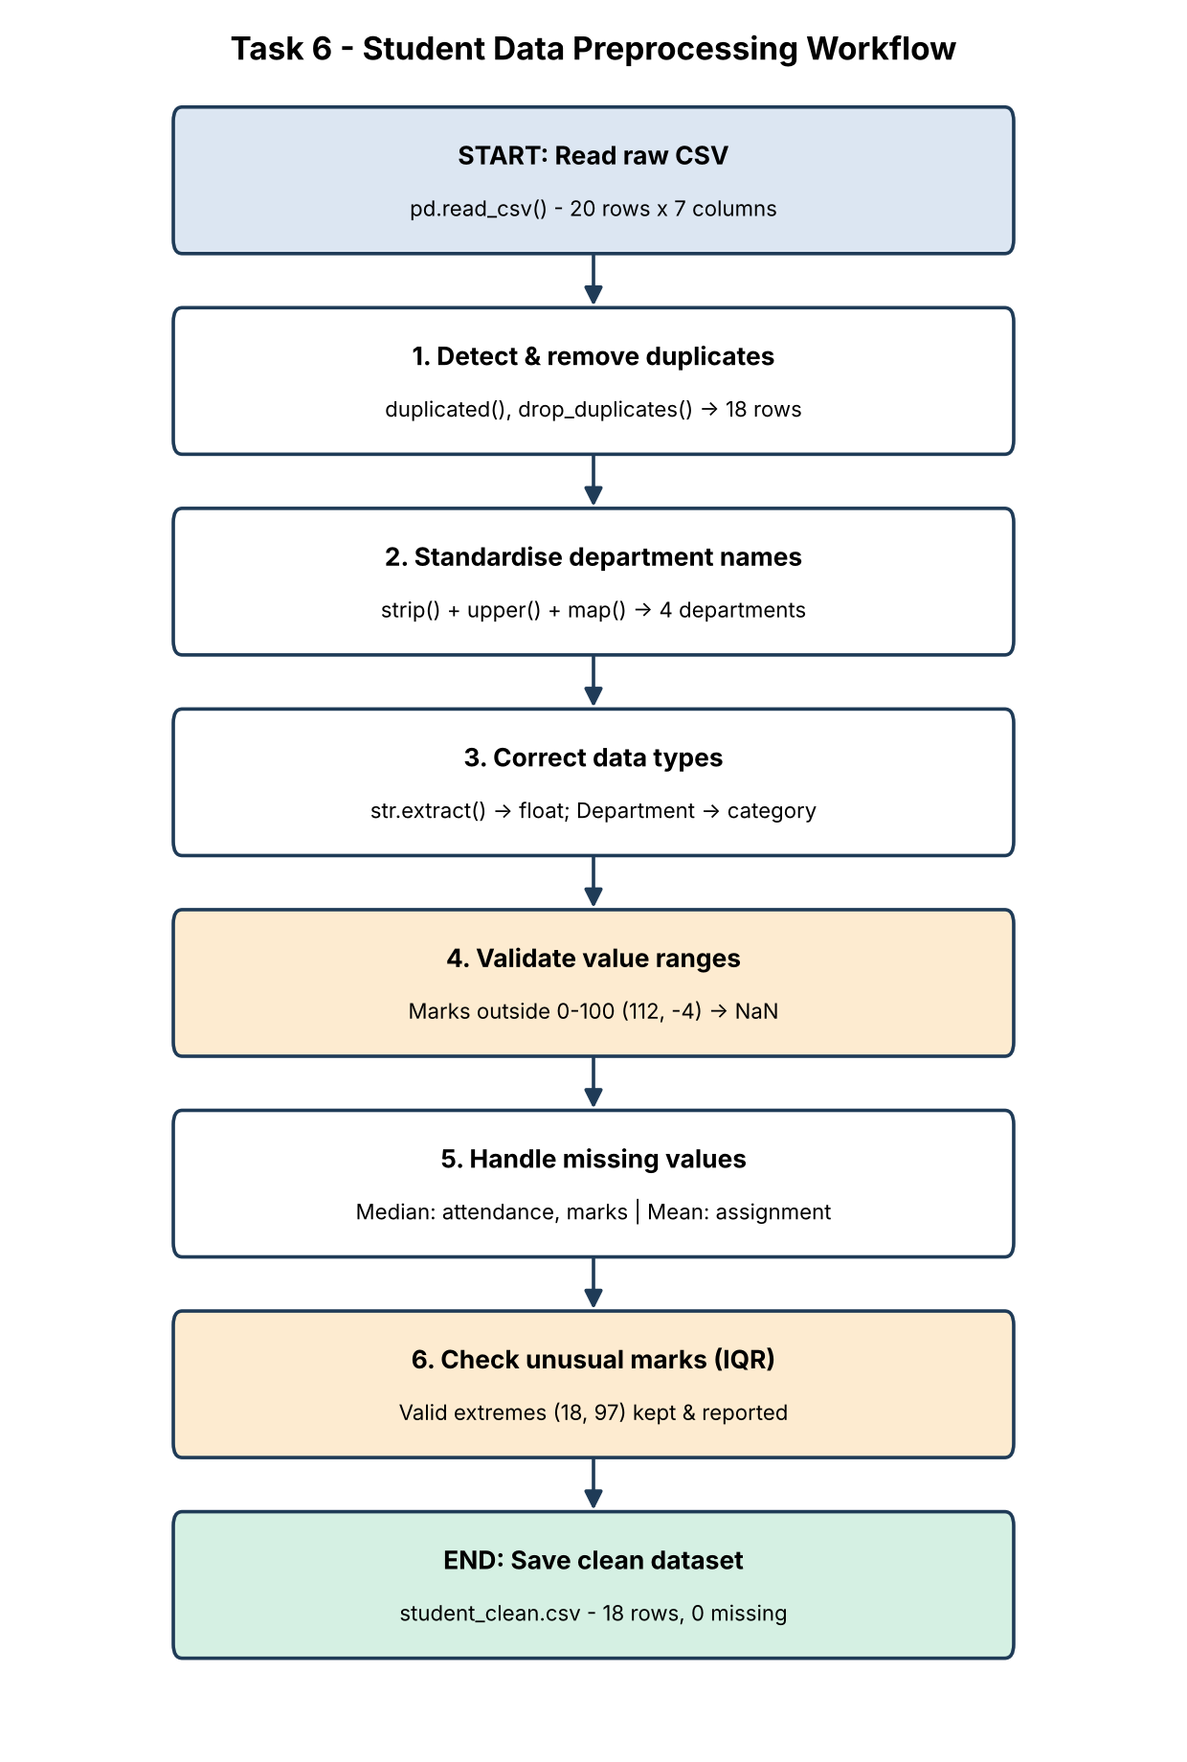
Figure 6.1: Ordered preprocessing workflow for the student dataset

Analysis – How the Workflow Improves Reliability
Table 6.1: Data quality before and after the workflow
Quality measure | Raw data | Clean data
Rows / unique students | 20 / 18 | 18 / 18
Department labels | 11 | 4
Numeric analysis columns | 3 | 4 (online hours converted)
Invalid internal marks | 2 (112, -4) | 0
Missing values | 7 | 0

The order of the steps matters. Duplicates are removed first so that S103 and S111 are not counted twice in averages and medians. Text is standardised and types are converted before validation so that every value can be compared numerically. Invalid values are converted to missing before imputation, otherwise 112 and -4 would remain in the data and affect the median. Only then are missing values filled. As a result, department averages are calculated on four correct groups, each student contributes exactly once, and charts are not distorted by impossible values – the subsequent analysis is reproducible and trustworthy.

TASK 7 – Data Visualization Using Matplotlib (6 Marks)

Aim
To create a bar chart, a histogram and a scatter plot with proper titles, axis labels and legends, and to analyse the distribution and patterns in student performance.
Input: student_prepared.csv (clean data with derived columns from Task 5). matplotlib.use("Agg") renders the figures directly to PNG files; plt.savefig() saves each chart and plt.close() releases the memory.

7(a) Bar Chart – Average Internal Marks by Department
Python Code – (a) Bar chart - average internal marks by department
import matplotlib
matplotlib.use("Agg") # render charts to image files
import matplotlib.pyplot as plt
import numpy as np
import pandas as pd

df = pd.read_csv("data/student_prepared.csv")
DEPT_COLORS = {"AI&DS": "#2E5A88", "CSE": "#E07B39", "ECE": "#3A9D7A", "MECH": "#8E6BB8"}

avg_marks = df.groupby("Department")["Internal_Marks"].mean().sort_values(ascending=False)
overall = df["Internal_Marks"].mean()
print("Average internal marks by department:")
print(avg_marks.round(2))

fig, ax = plt.subplots(figsize=(7, 4.2))
bars = ax.bar(avg_marks.index, avg_marks.values,
color=[DEPT_COLORS[d] for d in avg_marks.index], width=0.6, label="Department average")
ax.bar_label(bars, fmt="%.1f", padding=3, fontsize=10)
ax.axhline(overall, color="black", linestyle="--", linewidth=1,
label=f"Overall average ({overall:.1f})")
ax.set_title("Average Internal Marks by Department", fontsize=13, fontweight="bold")
ax.set_xlabel("Department")
ax.set_ylabel("Average internal marks (out of 100)")
ax.set_ylim(0, 100)
ax.legend(loc="upper right")
ax.grid(axis="y", alpha=0.3)
plt.tight_layout()
plt.savefig("charts/task7_bar_avg_marks.png", dpi=200)
plt.close()
Output:
Average internal marks by department:
Department
AI&DS 73.38
CSE 68.70
ECE 57.00
MECH 46.00
Name: Internal_Marks, dtype: float64

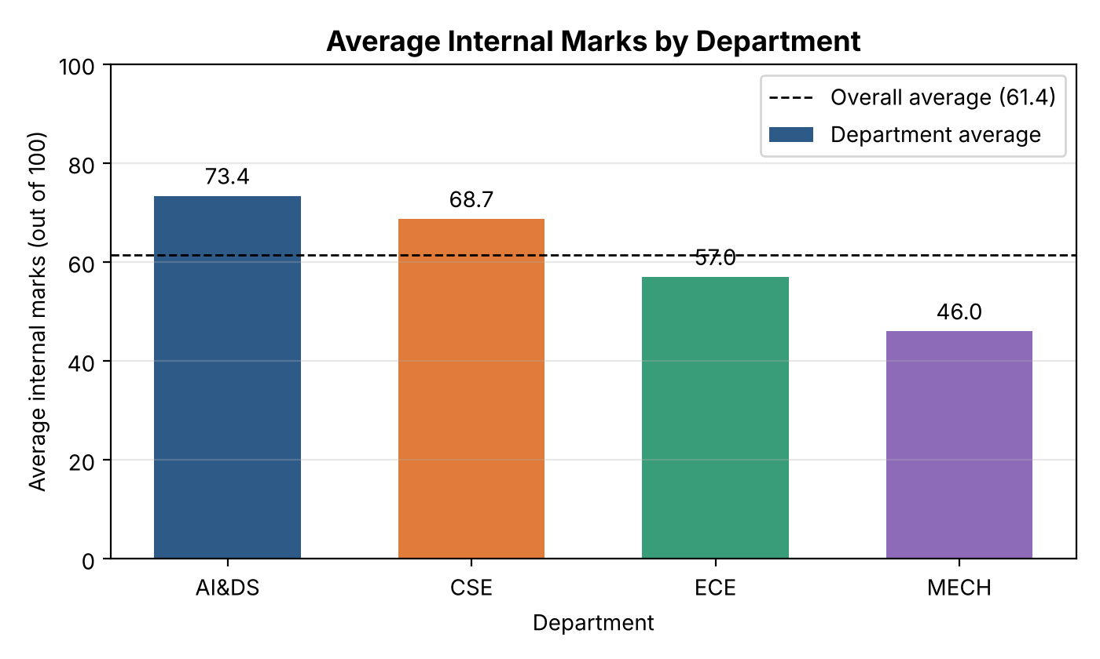
Figure 7.1: Average internal marks by department
Interpretation: AI&DS (73.4) and CSE (68.7) are above the overall average of 61.4 (dashed line), while ECE (57.0) and MECH (46.0) are below it. The gap between the highest and lowest department is 27.4 marks. bar_label() prints the exact value on each bar so the chart can be read without estimating.

7(b) Histogram – Distribution of Attendance Percentage
Python Code – (b) Histogram - distribution of attendance percentage
fig, ax = plt.subplots(figsize=(7, 4.2))
bins = np.arange(50, 101, 5) # 50-55, 55-60, ... , 95-100
counts, edges, _ = ax.hist(df["Attendance_Pct"], bins=bins, color="#2E5A88",
edgecolor="white", label="Number of students")
ax.axvline(75, color="#C0392B", linestyle="--", linewidth=1.5, label="75% attendance requirement")
ax.axvline(df["Attendance_Pct"].mean(), color="black", linestyle=":", linewidth=1.5,
label=f"Mean ({df['Attendance_Pct'].mean():.1f}%)")
ax.set_title("Distribution of Attendance Percentage", fontsize=13, fontweight="bold")
ax.set_xlabel("Attendance (%)")
ax.set_ylabel("Number of students")
ax.set_xticks(bins)
ax.legend(loc="upper left")
ax.grid(axis="y", alpha=0.3)
plt.tight_layout()
plt.savefig("charts/task7_hist_attendance.png", dpi=200)
plt.close()

print("Students per attendance band:")
for lo, c in zip(edges[:-1], counts):
if c:
print(f" {lo:.0f}-{lo + 5:.0f}% : {int(c)}")
print("Students below 75% attendance:", int((df["Attendance_Pct"] < 75).sum()))
Output:
Students per attendance band:
55-60% : 2
60-65% : 1
65-70% : 1
70-75% : 2
75-80% : 5
80-85% : 2
85-90% : 2
90-95% : 2
95-100% : 1
Students below 75% attendance: 6

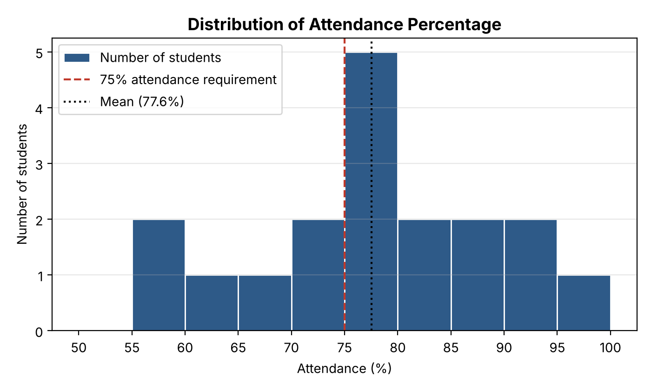
Figure 7.2: Distribution of attendance percentage (5% bins)
Interpretation: The most common band is 75–80% (5 students). The mean attendance is 77.6%, only slightly above the 75% requirement. The distribution has a tail on the left: 6 of 18 students (33%) are below 75%, two of them between 55% and 60%. The red line makes it easy to see how many students fall short of the requirement.

7(c) Scatter Plot – Attendance vs Internal Marks
Python Code – (c) Scatter plot - attendance vs internal marks
fig, ax = plt.subplots(figsize=(7, 4.6))
for dept, group in df.groupby("Department"):
ax.scatter(group["Attendance_Pct"], group["Internal_Marks"], s=60,
color=DEPT_COLORS[dept], edgecolor="black", linewidth=0.5, label=dept)

slope, intercept = np.polyfit(df["Attendance_Pct"], df["Internal_Marks"], 1) # line of best fit
x_line = np.linspace(df["Attendance_Pct"].min(), df["Attendance_Pct"].max(), 50)
ax.plot(x_line, slope * x_line + intercept, color="grey", linestyle="--", label="Trend line")

r = df["Attendance_Pct"].corr(df["Internal_Marks"])
ax.set_title(f"Attendance vs Internal Marks (r = {r:.2f})", fontsize=13, fontweight="bold")
ax.set_xlabel("Attendance (%)")
ax.set_ylabel("Internal marks (out of 100)")
ax.legend(title="Department", loc="upper left")
ax.grid(alpha=0.3)
plt.tight_layout()
plt.savefig("charts/task7_scatter_att_marks.png", dpi=200)
plt.close()

print(f"Pearson correlation r = {r:.3f}")
print(f"Trend line: Internal_Marks = {slope:.2f} x Attendance_Pct + ({intercept:.2f})")
Output:
Pearson correlation r = 0.842
Trend line: Internal_Marks = 1.56 x Attendance_Pct + (-59.22)

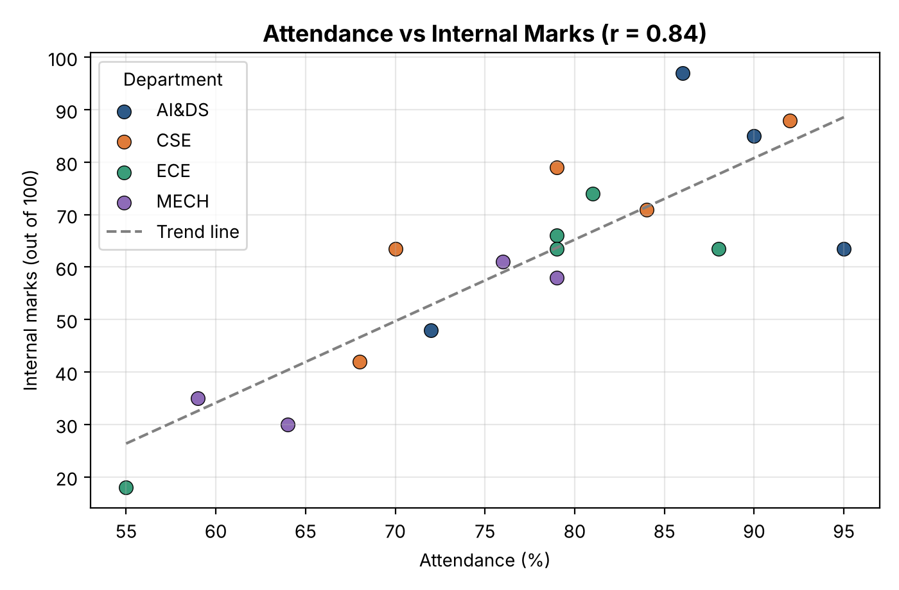
Figure 7.3: Relationship between attendance and internal marks
Interpretation: The points rise from bottom-left to top-right, showing a strong positive relationship (r = 0.842). The trend line (from np.polyfit) suggests that each additional 1% of attendance is associated with about 1.56 more marks. MECH points (purple) are concentrated in the lower-left area, while AI&DS and CSE points are mostly upper-right. A few points lie in a horizontal row at 63.5 (for example 95% attendance with 63.5 marks); these are students whose marks were imputed with the median, so they lie away from the trend – a visible effect of imputation that analysts should be aware of.

Analysis – Patterns Observed in the Plots
Together, the three plots show that (1) performance differs clearly between departments, (2) one-third of students do not meet the attendance requirement, and (3) attendance and internal marks move together. The bar chart answers "which department?", the histogram answers "how many students?" and the scatter plot answers "is there a relationship?". Titles, axis labels with units, legends and reference lines (overall mean, 75% rule, trend line) make each chart self-explanatory.

TASK 8 – Choosing Suitable Python Libraries (4 Marks)

Aim
To explain the roles of Pandas, NumPy, SciPy, Scikit-learn and Matplotlib in the student data project and to map each data-handling activity to a suitable library and function.

8(a) Roles of the Libraries in the Context of the Student Dataset
- Pandas – provides the DataFrame, a table with named columns. It is used to read the CSV, inspect it (info, describe), select and filter records, handle missing values and duplicates, standardise text, group by department and rank students.
- NumPy – provides fast arrays and mathematical functions. Pandas is built on NumPy. It is used for z-scores, conditional columns (np.where, np.select), correlation (np.corrcoef) and the trend line (np.polyfit).
- SciPy – provides scientific and statistical functions. scipy.stats.pearsonr confirms whether the attendance–marks relationship is statistically significant by returning a p-value.
- Scikit-learn – a machine-learning library whose preprocessing tools (SimpleImputer, MinMaxScaler, StandardScaler) prepare data in a repeatable way for future models, e.g. predicting at-risk students.
- Matplotlib – the plotting library used for bar charts, histograms, scatter plots, box plots and the flowcharts in this report.

8(b) Comparison Table of the Five Libraries
Table 8.1: Comparison of Python libraries for data science
Library | Main purpose | Core structure | Key functions | Role in this assignment
Pandas | Tabular data handling | DataFrame, Series | read_csv, head, loc, query, isnull, fillna, dropna, drop_duplicates, groupby, sort_values, rank | Tasks 1–6, 9, 10: reading, selecting, cleaning, grouping, ranking
NumPy | Numerical computing | ndarray | mean, std, where, select, corrcoef, polyfit, nan | Tasks 5, 7, 9, 10: z-score, flags, bands, trend line
SciPy | Statistics and scientific methods | Functions on arrays | stats.pearsonr, stats.zscore, stats.ttest_ind | Tasks 8, 9: significance of correlations
Scikit-learn | Machine learning and preprocessing | Estimators / transformers | SimpleImputer, MinMaxScaler, StandardScaler, train_test_split | Task 8: repeatable imputation and scaling
Matplotlib | Visualization | Figure, Axes | bar, hist, scatter, boxplot, legend, savefig | Tasks 6, 7, 9, 10: charts and flowcharts

8(c) Mapping Data-Handling Activities to Libraries
Table 8.2: Activity – library – function mapping
Activity | Suitable library | Relevant function / capability | Example in this project
Reading data | Pandas | pd.read_csv() | Load student_performance_raw.csv
Inspecting data | Pandas | head(), tail(), shape, dtypes, describe() | Task 1 inspection
Selecting columns | Pandas | df[[cols]], df.loc[] | Name, department, attendance, marks
Filtering records | Pandas | Boolean masks, query() | Attendance < 75%, marks > 75
Cleaning – missing values | Pandas / Scikit-learn | isnull(), fillna(), dropna() / SimpleImputer | Median/mean imputation
Cleaning – duplicates and text | Pandas | duplicated(), drop_duplicates(), str.strip/upper, map() | Remove S103/S111 copies; 4 departments
Type conversion | Pandas | astype(), pd.to_numeric(), str.extract() | '2 hrs' → 2.0
Numerical operations | NumPy | np.mean, np.std, np.where, np.select | z-score, At_Risk flag, bands
Statistical testing | SciPy | stats.pearsonr() | r = 0.842, p < 0.001
Scaling for modelling | Scikit-learn | MinMaxScaler, StandardScaler | Marks scaled to 0–1
Sorting, grouping, ranking | Pandas | sort_values(), groupby().agg(), rank() | Department summary, ranks
Visualization | Matplotlib | bar(), hist(), scatter(), boxplot() | Figures 7.1–10.3

8(d) Demonstration – One Activity per Library
Python Code – task08_libraries.py
import matplotlib
matplotlib.use("Agg")
import matplotlib.pyplot as plt
import numpy as np
import pandas as pd
from scipy import stats
from sklearn.impute import SimpleImputer
from sklearn.preprocessing import MinMaxScaler

# Pandas - reading, selecting, cleaning
raw = pd.read_csv("data/student_performance_raw.csv")
print("Pandas : read_csv ->", raw.shape, "| drop_duplicates ->", raw.drop_duplicates().shape)

df = pd.read_csv("data/student_clean.csv")

# NumPy - fast numerical operations on arrays
att = df["Attendance_Pct"].to_numpy()
print("NumPy : mean attendance =", np.round(np.mean(att), 2),
"| students >= 75% =", int(np.sum(att >= 75)))

# SciPy - statistical testing
r, p = stats.pearsonr(df["Attendance_Pct"], df["Internal_Marks"])
print(f"SciPy : pearsonr(attendance, marks) -> r = {r:.3f}, p-value = {p:.5f}")

# Scikit-learn - imputation and scaling for modelling
imputer = SimpleImputer(strategy="median")
filled = imputer.fit_transform(raw[["Attendance_Pct"]])
scaled = MinMaxScaler().fit_transform(df[["Internal_Marks"]])
print("Scikit-learn: SimpleImputer(median) filled", int(raw["Attendance_Pct"].isna().sum()),
"values | MinMaxScaler range =", (round(float(scaled.min()), 2), round(float(scaled.max()), 2)))

# Matplotlib - visualisation
fig, ax = plt.subplots(figsize=(4, 3))
ax.boxplot(df["Internal_Marks"])
ax.set_title("Internal Marks")
plt.savefig("charts/task8_matplotlib_demo.png", dpi=120)
plt.close()
print("Matplotlib : box plot saved -> charts/task8_matplotlib_demo.png")
Output:
Pandas : read_csv -> (20, 7) | drop_duplicates -> (18, 7)
NumPy : mean attendance = 77.56 | students >= 75% = 12
SciPy : pearsonr(attendance, marks) -> r = 0.842, p-value = 0.00001
Scikit-learn: SimpleImputer(median) filled 3 values | MinMaxScaler range = (0.0, 1.0)
Matplotlib : box plot saved -> charts/task8_matplotlib_demo.png

Explanation: The program performs one representative operation with each library on the same student data. Pandas reads the file and removes duplicates (20 → 18 rows); NumPy counts students with attendance ≥ 75% (12); SciPy returns r = 0.842 with a p-value of 0.00001, meaning the relationship is very unlikely to be due to chance; Scikit-learn's SimpleImputer fills the 3 missing attendance values and MinMaxScaler rescales marks to 0–1; Matplotlib saves a box plot.

Analysis – Why Selecting Suitable Libraries Improves Efficiency
Each library is optimised for one job. Pandas performs filtering, grouping and cleaning on whole columns with one line of code instead of manual loops, and NumPy executes numerical operations in compiled code, which is much faster than plain Python lists. SciPy provides tested statistical procedures, so the team does not have to implement formulas such as the p-value by hand, and Scikit-learn makes preprocessing steps reusable when new student data arrives each semester. Matplotlib works directly with Pandas and NumPy data. Because the libraries share the same NumPy foundation, data passes between them without conversion. Choosing the right tool for each stage therefore reduces code length, errors and processing time, and makes the workflow easy for other team members to understand and repeat.

TASK 9 – Interpreting Visualized Data for Academic Support (6 Marks)

Aim
To use the preprocessed data and visualizations to identify performance patterns, communicate them to faculty members and recommend data-informed academic support actions.
Input: student_prepared.csv – clean data with Percentage, Performance_Band and At_Risk columns from Task 5.

Pattern 1 – Low Attendance Is Associated with Low Internal Marks
Python Code – Pattern 1 - Low attendance is linked with low internal marks
import matplotlib
matplotlib.use("Agg")
import matplotlib.pyplot as plt
import numpy as np
import pandas as pd
from scipy import stats

pd.set_option("display.width", 112)
pd.set_option("display.max_columns", None)

df = pd.read_csv("data/student_prepared.csv")
df["Attendance_Group"] = np.where(df["Attendance_Pct"] < 75, "Below 75%", "75% and above")

group_summary = (df.groupby("Attendance_Group")
.agg(Students=("Student_ID", "count"),
Avg_Attendance=("Attendance_Pct", "mean"),
Avg_Internal=("Internal_Marks", "mean"),
Avg_Percentage=("Percentage", "mean"))
.round(2))
print("Performance by attendance group:")
print(group_summary)

r, p = stats.pearsonr(df["Attendance_Pct"], df["Internal_Marks"])
print(f"\nPearson r = {r:.3f} (p-value = {p:.5f})")

at_risk = df[df["At_Risk"] == "Yes"].sort_values("Internal_Marks")
print("\nStudents flagged At-Risk (attendance < 75% and internal marks < 50):")
print(at_risk[["Student_ID", "Student_Name", "Department", "Attendance_Pct",
"Internal_Marks", "Online_Activity_Hrs", "Performance_Band"]].to_string(index=False))

# Quadrant scatter plot for faculty
fig, ax = plt.subplots(figsize=(7.2, 4.8))
colors = np.where(df["At_Risk"] == "Yes", "#C0392B", "#2E5A88")
ax.scatter(df["Attendance_Pct"], df["Internal_Marks"], c=colors, s=70,
edgecolor="black", linewidth=0.5)
ax.axvline(75, color="grey", linestyle="--", linewidth=1)
ax.axhline(50, color="grey", linestyle="--", linewidth=1)
ax.axvspan(50, 75, ymin=0, ymax=0.5, color="#C0392B", alpha=0.08)
for _, row in at_risk.iterrows():
ax.annotate(row["Student_ID"], (row["Attendance_Pct"], row["Internal_Marks"]),
textcoords="offset points", xytext=(6, -3), fontsize=9)
ax.text(51, 3, "Support zone:\nattendance < 75% and marks < 50", fontsize=9, color="#C0392B")
ax.scatter([], [], c="#C0392B", s=70, edgecolor="black", label="At-risk student")
ax.scatter([], [], c="#2E5A88", s=70, edgecolor="black", label="Other student")
ax.set_xlim(50, 100)
ax.set_ylim(0, 100)
ax.set_title("Identifying Students Who Need Academic Support", fontsize=13, fontweight="bold")
ax.set_xlabel("Attendance (%)")
ax.set_ylabel("Internal marks (out of 100)")
ax.legend(loc="upper left")
ax.grid(alpha=0.3)
plt.tight_layout()
plt.savefig("charts/task9_support_quadrant.png", dpi=200)
plt.close()
Output:
Performance by attendance group:
Students Avg_Attendance Avg_Internal Avg_Percentage
Attendance_Group
75% and above 12 84.00 72.46 74.84
Below 75% 6 64.67 39.42 41.83

Pearson r = 0.842 (p-value = 0.00001)

Students flagged At-Risk (attendance < 75% and internal marks < 50):
Student_ID Student_Name Department Attendance_Pct Internal_Marks Online_Activity_Hrs Performance_Band
S118 Pooja Shetty ECE 55.0 18.0 0.5 Low
S112 Meera Krishnan MECH 64.0 30.0 1.0 Low
S105 Rahul Verma MECH 59.0 35.0 1.5 Low
S102 Divya Ramesh CSE 68.0 42.0 2.0 Low
S109 Mohammed Faiz AI&DS 72.0 48.0 2.5 Medium

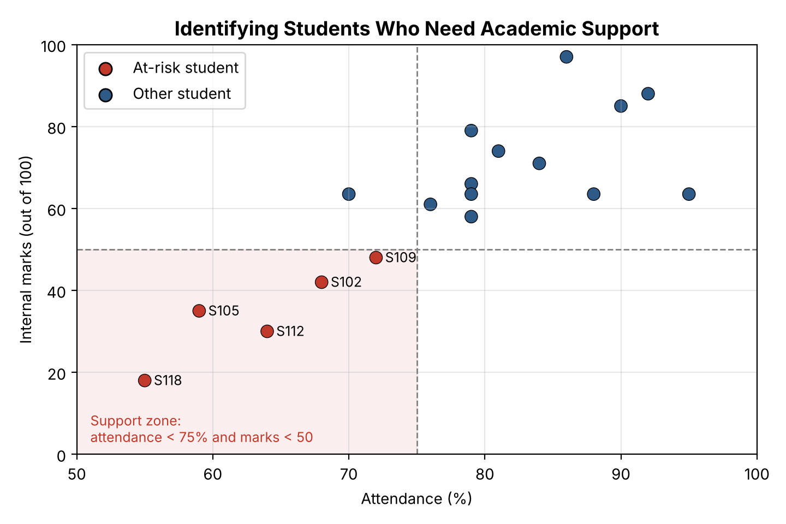
Figure 9.1: Support quadrant – students with attendance < 75% and internal marks < 50
Evidence: The 12 students with attendance of 75% or more average 72.46 internal marks, while the 6 students below 75% average only 39.42 – a difference of 33 marks. The overall percentage drops from 74.84% to 41.83%. The Pearson correlation is r = 0.842 with p = 0.00001, so the relationship is strong and statistically significant. Five students (S118, S112, S105, S102, S109) fall in the support zone; all five also have online activity of 2.5 hours per week or less.

Pattern 2 – Clear Differences Between Department Averages
Python Code – Pattern 2 - Differences in department averages
dept = (df.groupby("Department")
.agg(Avg_Attendance=("Attendance_Pct", "mean"),
Avg_Internal=("Internal_Marks", "mean"),
Avg_Assignment_Pct=("Assignment_Score", lambda s: s.mean() / 50 * 100),
At_Risk_Count=("At_Risk", lambda s: (s == "Yes").sum()))
.round(2)
.sort_values("Avg_Internal", ascending=False))
print("Department comparison (assignment converted to %):")
print(dept)

fig, ax = plt.subplots(figsize=(7.2, 4.4))
x = np.arange(len(dept))
w = 0.26
metrics = [("Avg_Attendance", "Attendance %", "#2E5A88"),
("Avg_Internal", "Internal marks", "#E07B39"),
("Avg_Assignment_Pct", "Assignment %", "#3A9D7A")]
for i, (col, label, color) in enumerate(metrics):
b = ax.bar(x + (i - 1) * w, dept[col], w, label=label, color=color)
ax.bar_label(b, fmt="%.0f", fontsize=8, padding=2)
ax.set_xticks(x, dept.index)
ax.set_ylim(0, 105)
ax.set_title("Department-wise Comparison of Academic Indicators", fontsize=13, fontweight="bold")
ax.set_xlabel("Department")
ax.set_ylabel("Average score (%)")
ax.legend(loc="upper right", ncol=3, fontsize=9)
ax.grid(axis="y", alpha=0.3)
plt.tight_layout()
plt.savefig("charts/task9_department_comparison.png", dpi=200)
plt.close()
Output:
Department comparison (assignment converted to %):
Avg_Attendance Avg_Internal Avg_Assignment_Pct At_Risk_Count
Department
AI&DS 85.75 73.38 78.65 1
CSE 78.60 68.70 72.40 1
ECE 76.40 57.00 68.00 1
MECH 69.50 46.00 54.65 2

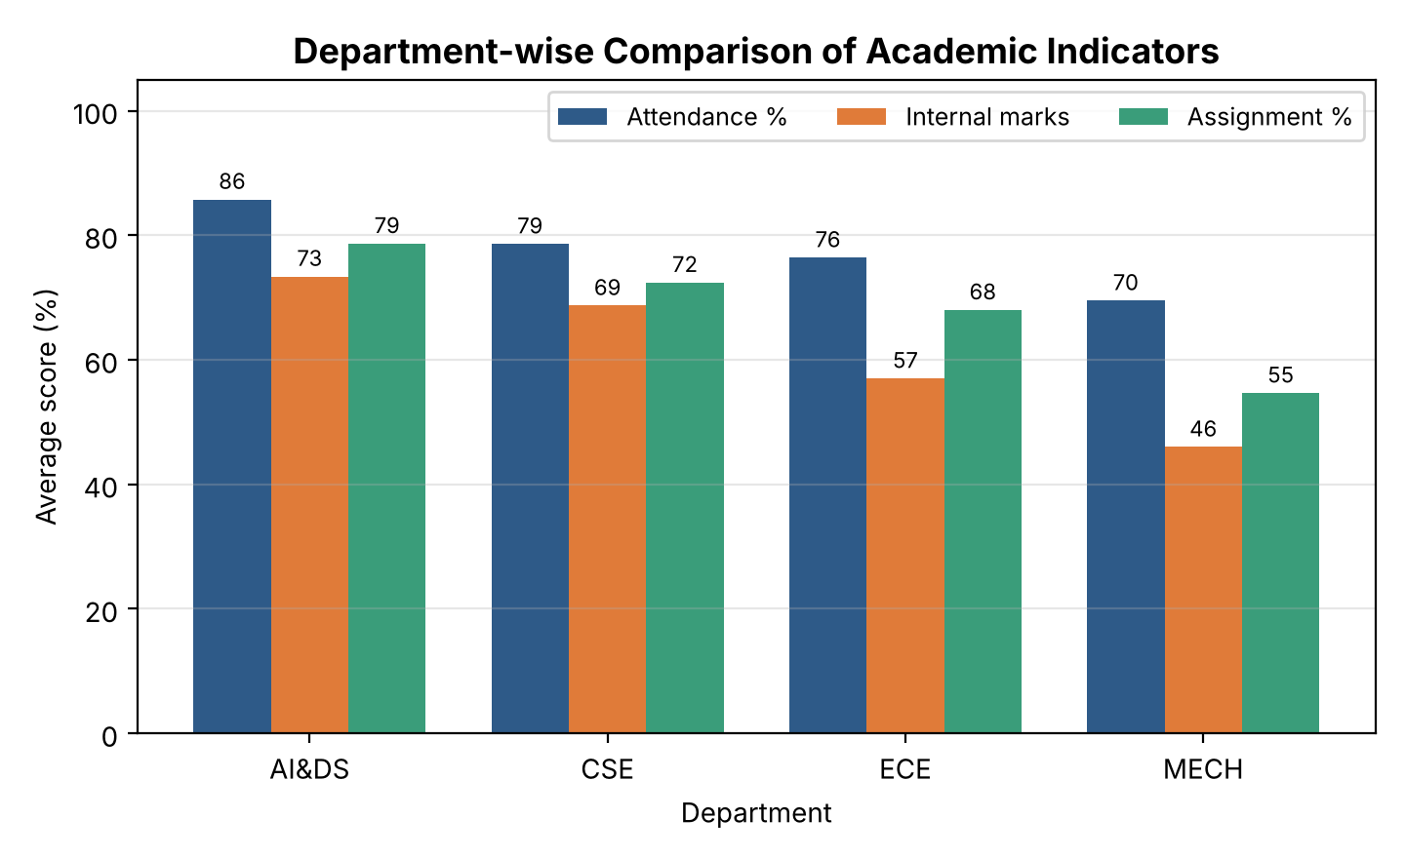
Figure 9.2: Department-wise comparison of attendance, internal marks and assignment scores
Evidence: All three indicators follow the same order: AI&DS > CSE > ECE > MECH. MECH is lowest in every indicator (attendance 69.5%, internal marks 46.0, assignments 54.65%) and has 2 of the 5 at-risk students although it has only 4 students. Assignment scores are higher than internal marks in every department, so students perform better in continuous coursework than in internal tests.

Pattern 3 – Low Online Learning Activity Accompanies Low Performance
Python Code – Pattern 3 - Online learning activity and overall performance
df["Engagement"] = np.where(df["Online_Activity_Hrs"] < 3,
"Low (< 3 hrs/week)", "Regular (>= 3 hrs/week)")
engagement = (df.groupby("Engagement")
.agg(Students=("Student_ID", "count"),
Avg_Online_Hrs=("Online_Activity_Hrs", "mean"),
Avg_Percentage=("Percentage", "mean"))
.round(2))
print("Overall percentage by online learning engagement:")
print(engagement)
r2, p2 = stats.pearsonr(df["Online_Activity_Hrs"], df["Percentage"])
print(f"\nPearson r (online hours vs percentage) = {r2:.3f} (p-value = {p2:.5f})")
Output:
Overall percentage by online learning engagement:
Students Avg_Online_Hrs Avg_Percentage
Engagement
Low (< 3 hrs/week) 6 1.58 41.83
Regular (>= 3 hrs/week) 12 5.08 74.84

Pearson r (online hours vs percentage) = 0.925 (p-value = 0.00000)

Evidence: Students who use the LMS for less than 3 hours a week average 41.83%, compared with 74.84% for regular users; the correlation between online hours and percentage is r = 0.925. This is shown visually in Figure 10.3 (Task 10).

How the Visualizations Help Communicate the Findings to Faculty
- The support quadrant (Figure 9.1) turns a numeric rule into a picture: faculty immediately see which students lie in the shaded zone and can read their IDs, without studying tables of numbers. The dashed lines show the policy thresholds (75% attendance, 50 marks) in a way everyone understands.
- The grouped bar chart (Figure 9.2) lets heads of department compare three indicators across departments at a glance; the consistent colours and value labels make the lower MECH bars obvious.
- Using IDs instead of names on the chart protects student privacy when the figure is shared in meetings.
Caution: the dataset is small and synthetic, and correlation does not prove causation – low attendance and low marks may both result from another factor (e.g. health or personal problems). The findings identify who to talk to, not the reason, so they should be followed by a conversation with the student.

Recommended Data-Informed Academic Support Actions
Table 9.1: Recommendations based on the observed patterns
# | Recommendation | Evidence | Target | How success is measured
1 | Early-warning mentoring: assign a faculty mentor, hold weekly check-ins and remedial classes for students in the support zone; send an alert when attendance falls below 75%. | Pattern 1: below-75% group averages 39.42 marks vs 72.46; r = 0.842 | S102, S105, S109, S112, S118 | Attendance ≥ 75% and internal marks ≥ 50 in the next assessment
2 | Department-level intervention for MECH: extra tutorial hours, peer-study groups led by high scorers from other departments, and a review of internal test difficulty and teaching approach. | Pattern 2: MECH lowest in all three indicators; 2 of 4 students at risk | MECH department | MECH average rises towards the college average (61.4)
3 | LMS engagement drive (supporting action): set a minimum of 3 hours/week of online activity, share LMS progress dashboards and contact students with low usage. | Pattern 3: < 3 hrs/week group averages 41.83% vs 74.84%; r = 0.925 | 6 low-engagement students | Weekly LMS hours and change in overall percentage

These actions are data-informed because each one is linked to a measured pattern, targets a specific group identified by the data and has a measurable success criterion that can be tracked by re-running the same Python workflow at the next assessment.

TASK 10 – Integrated Preprocessing and Visualization Case Study (7 Marks)

Aim
To prepare a dataset containing student ID, department, attendance, internal marks, assignment score and online learning activity – with missing attendance values, duplicate records, inconsistent department names and unusually high or low marks – using one connected Python workflow, and to present meaningful findings for academic decision-making.

10(a) Outline of the Workflow
- Read the raw CSV with Pandas.
- Inspect the shape, missing values, duplicates, category labels, value ranges and data types.
- Select only the columns needed for analysis (Student_Name is dropped to keep the analysis anonymous).
- Clean: remove duplicates → standardise department names → convert text hours to numbers → mark invalid marks as missing → impute missing values.
- Derive the overall percentage and the at-risk flag.
- Summarise with grouping, sorting and ranking.
- Visualise with Matplotlib and interpret the results for decision-making.
- Save the final analysis-ready dataset.

10(b) Assumptions
- Rows that are identical in every column are double entries of the same student, so one copy is kept.
- cse, Computer Science → CSE; ECE → ECE; Mechanical, mech → MECH; AIDS, AI & DS → AI&DS. All variants refer to these four departments.
- Internal marks outside 0–100 (112, -4) are data-entry errors; the true value is unknown, so they are treated as missing.
- Marks that are unusual but valid (18 and 97) are real performances and are kept.
- Missing attendance and marks are replaced by the median, missing assignment scores by the mean (see Task 3).
- Online activity values such as 2 hrs and 2 mean the same number of hours per week.
- A student is "at risk" if attendance < 75% and internal marks < 50; overall percentage = (internal + assignment) / 150 × 100.

10(c) Implementation – Read, Inspect and Select
Python Code – Step 1 - Read and inspect the raw dataset
import matplotlib
matplotlib.use("Agg")
import matplotlib.pyplot as plt
import numpy as np
import pandas as pd

pd.set_option("display.width", 112)
pd.set_option("display.max_columns", None)

raw = pd.read_csv("data/student_performance_raw.csv")
print("Shape:", raw.shape)
print("\nMissing values:", raw.isnull().sum()[raw.isnull().sum() > 0].to_dict())
print("Duplicate rows:", raw.duplicated().sum())
print("Distinct department labels:", raw["Department"].nunique())
print(sorted(raw["Department"].unique()))
print("Internal_Marks range:", raw["Internal_Marks"].min(), "to", raw["Internal_Marks"].max())
print("Online_Activity_Hrs dtype:", raw["Online_Activity_Hrs"].dtype)
Output:
Shape: (20, 7)

Missing values: {'Attendance_Pct': 3, 'Internal_Marks': 2, 'Assignment_Score': 2}
Duplicate rows: 2
Distinct department labels: 11
['AI & DS', 'AI&DS', 'AIDS', 'CSE', 'Computer Science', 'ECE', 'ECE ', 'MECH', 'Mechanical', 'cse', 'mech']
Internal_Marks range: -4.0 to 112.0
Online_Activity_Hrs dtype: str

Explanation: The inspection confirms all four problems described in the case: 3 missing attendance values (plus 2 missing marks and 2 missing assignment scores), 2 duplicate rows, 11 department labels and internal marks from -4 to 112. Online activity is stored as text.
Python Code – Step 2 - Select the columns needed for analysis
# Student_Name is not needed for analysis -> dropped to keep the analysis anonymous
analysis_cols = ["Student_ID", "Department", "Attendance_Pct", "Internal_Marks",
"Assignment_Score", "Online_Activity_Hrs"]
df = raw[analysis_cols].copy()
print("Selected columns:", ", ".join(df.columns))
Output:
Selected columns: Student_ID, Department, Attendance_Pct, Internal_Marks, Assignment_Score, Online_Activity_Hrs

Explanation: Selecting a list of columns creates a copy with the six analysis variables named in the case study. Dropping the name column means that the remaining analysis and charts identify students only by ID.

10(d) Implementation – Handling Duplicates, Inconsistent Entries and Missing Values
Python Code – Step 3 - Clean: duplicates, inconsistent entries, types, invalid values, missing values
log = {}

# 3a. Duplicates (assumption: identical rows are double entries of the same student)
log["duplicates_removed"] = int(df.duplicated().sum())
df = df.drop_duplicates().reset_index(drop=True)

# 3b. Inconsistent department names (assumption: all variants refer to 4 departments)
dept_map = {"CSE": "CSE", "COMPUTER SCIENCE": "CSE", "ECE": "ECE", "MECH": "MECH",
"MECHANICAL": "MECH", "AIDS": "AI&DS", "AI&DS": "AI&DS", "AI & DS": "AI&DS"}
df["Department"] = df["Department"].str.strip().str.upper().map(dept_map).astype("category")

# 3c. Text hours -> numeric
df["Online_Activity_Hrs"] = df["Online_Activity_Hrs"].str.extract(r"(\d+\.?\d*)")[0].astype(float)

# 3d. Invalid marks (assumption: marks outside 0-100 are data-entry errors)
invalid = ~df["Internal_Marks"].between(0, 100) & df["Internal_Marks"].notna()
log["invalid_marks_set_to_NaN"] = df.loc[invalid, "Student_ID"].tolist()
df.loc[invalid, "Internal_Marks"] = np.nan

# 3e. Missing values (median for attendance/marks, mean for assignment score)
log["missing_before_imputation"] = df.isnull().sum()[df.isnull().sum() > 0].to_dict()
df["Attendance_Pct"] = df["Attendance_Pct"].fillna(df["Attendance_Pct"].median())
df["Internal_Marks"] = df["Internal_Marks"].fillna(df["Internal_Marks"].median())
df["Assignment_Score"] = df["Assignment_Score"].fillna(round(df["Assignment_Score"].mean(), 1))

for k, v in log.items():
print(f"{k:28}: {v}")
print("Clean shape:", df.shape, "| missing values left:", int(df.isnull().sum().sum()))
Output:
duplicates_removed : 2
invalid_marks_set_to_NaN : ['S108', 'S114']
missing_before_imputation : {'Attendance_Pct': 3, 'Internal_Marks': 4, 'Assignment_Score': 2}
Clean shape: (18, 6) | missing values left: 0

Explanation: The log dictionary records every change, giving an audit trail of the cleaning: 2 duplicates removed, S108 and S114 invalid marks converted to missing (so internal marks have 4 missing values before imputation), and all missing values filled. The final clean table has 18 students and 0 missing values.
Python Code – Step 4 - Derived measures
df["Percentage"] = ((df["Internal_Marks"] + df["Assignment_Score"]) / 150 * 100).round(2)
df["At_Risk"] = np.where((df["Attendance_Pct"] < 75) & (df["Internal_Marks"] < 50), "Yes", "No")
print(df.head().to_string(index=False))
Output:
Student_ID Department Attendance_Pct Internal_Marks Assignment_Score Online_Activity_Hrs Percentage At_Risk
S101 CSE 92.0 88.0 46.0 6.5 89.33 No
S102 CSE 68.0 42.0 30.0 2.0 48.00 Yes
S103 ECE 81.0 74.0 40.0 5.0 76.00 No
S104 CSE 79.0 79.0 42.0 4.5 80.67 No
S105 MECH 59.0 35.0 22.0 1.5 38.00 Yes

Explanation: Percentage combines both assessments on a 0–100 scale and np.where creates the At_Risk flag used in the summaries and charts.

10(e) Sorting, Grouping and Ranking Summary
Python Code – Step 5 - Grouping, sorting and ranking summaries
summary = (df.groupby("Department", observed=True)
.agg(Students=("Student_ID", "count"),
Avg_Attendance=("Attendance_Pct", "mean"),
Avg_Internal=("Internal_Marks", "mean"),
Avg_Percentage=("Percentage", "mean"),
At_Risk=("At_Risk", lambda s: (s == "Yes").sum()))
.round(2)
.sort_values("Avg_Percentage", ascending=False))
print("Department summary (sorted by average percentage):")
print(summary)

df["Rank"] = df["Percentage"].rank(ascending=False, method="min").astype(int)
print("\nTop 5 students by overall percentage:")
top5 = df.nsmallest(5, "Rank")[["Rank", "Student_ID", "Department", "Percentage"]]
print(top5.to_string(index=False))
print("\nBottom 5 students by overall percentage:")
print(df.nlargest(5, "Rank")[["Rank", "Student_ID", "Department", "Attendance_Pct",
"Percentage", "At_Risk"]].to_string(index=False))
Output:
Department summary (sorted by average percentage):
Students Avg_Attendance Avg_Internal Avg_Percentage At_Risk
Department
AI&DS 4 85.75 73.38 75.13 1
CSE 5 78.60 68.70 69.93 1
ECE 5 76.40 57.00 60.67 1
MECH 4 69.50 46.00 48.88 2

Top 5 students by overall percentage:
Rank Student_ID Department Percentage
1 S117 AI&DS 96.00
2 S101 CSE 89.33
3 S104 CSE 80.67
4 S113 AI&DS 79.53
5 S103 ECE 76.00

Bottom 5 students by overall percentage:
Rank Student_ID Department Attendance_Pct Percentage At_Risk
18 S118 ECE 55.0 22.00 Yes
17 S112 MECH 64.0 33.33 Yes
16 S105 MECH 59.0 38.00 Yes
15 S102 CSE 68.0 48.00 Yes
14 S109 AI&DS 72.0 50.67 Yes

Explanation: Grouping by department with agg() gives the department summary sorted by average percentage, and rank(method="min") ranks all students on overall percentage. AI&DS leads (75.13%) and MECH is lowest (48.88%), the only department with an average below 50%. The bottom five students are exactly the five at-risk students, which confirms that the at-risk rule captures the weakest performers.

10(f) Visualizations and Interpretation
Python Code – Visualization 1: department labels before and after cleaning
before = raw["Department"].value_counts()
after = df["Department"].value_counts().reindex(["CSE", "ECE", "MECH", "AI&DS"])

fig, axes = plt.subplots(1, 2, figsize=(9, 3.8), gridspec_kw={"width_ratios": [1.6, 1]})
axes[0].barh([repr(s) for s in before.index[::-1]], before.values[::-1], color="#B0B7C3")
axes[0].set_title("Before cleaning: 11 labels", fontweight="bold")
axes[0].set_xlabel("Number of rows")
b = axes[1].bar(after.index, after.values, color=["#E07B39", "#3A9D7A", "#8E6BB8", "#2E5A88"])
axes[1].bar_label(b, padding=2)
axes[1].set_title("After cleaning: 4 departments", fontweight="bold")
axes[1].set_ylabel("Number of students")
axes[1].set_ylim(0, 6.5)
fig.suptitle("Effect of Standardising Department Names", fontsize=13, fontweight="bold")
plt.tight_layout()
plt.savefig("charts/task10_dept_before_after.png", dpi=200)
plt.close()

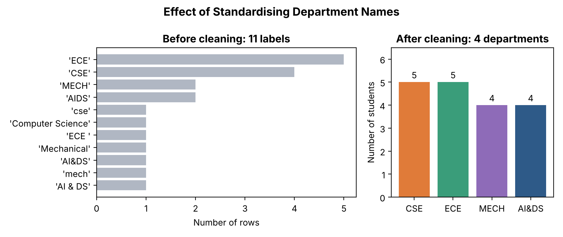
Figure 10.1: Department labels before cleaning (11) and after cleaning (4)
Interpretation: The left panel shows the problem – the same department is spread across several labels (for example 'CSE', 'cse' and 'Computer Science'); a grouping on this column would produce 11 small, misleading groups. After cleaning, the right panel shows the true department sizes (CSE 5, ECE 5, MECH 4, AI&DS 4). This chart documents the effect of preprocessing for anyone reviewing the analysis.
Python Code – Visualization 2: box plot of overall percentage by department
order = summary.index.tolist()
data = [df.loc[df["Department"] == d, "Percentage"] for d in order]
fig, ax = plt.subplots(figsize=(7, 4.3))
bp = ax.boxplot(data, tick_labels=order, patch_artist=True, widths=0.5)
for patch, color in zip(bp["boxes"], ["#2E5A88", "#E07B39", "#3A9D7A", "#8E6BB8"]):
patch.set_facecolor(color)
patch.set_alpha(0.75)
for i, d in enumerate(data, start=1):
ax.scatter(np.full(len(d), i), d, color="black", s=14, zorder=3)
ax.axhline(50, color="#C0392B", linestyle="--", linewidth=1, label="50% (minimum expected)")
ax.set_title("Spread of Overall Percentage by Department", fontsize=13, fontweight="bold")
ax.set_xlabel("Department")
ax.set_ylabel("Overall percentage (%)")
ax.legend(loc="lower left")
ax.grid(axis="y", alpha=0.3)
plt.tight_layout()
plt.savefig("charts/task10_boxplot_percentage.png", dpi=200)
plt.close()

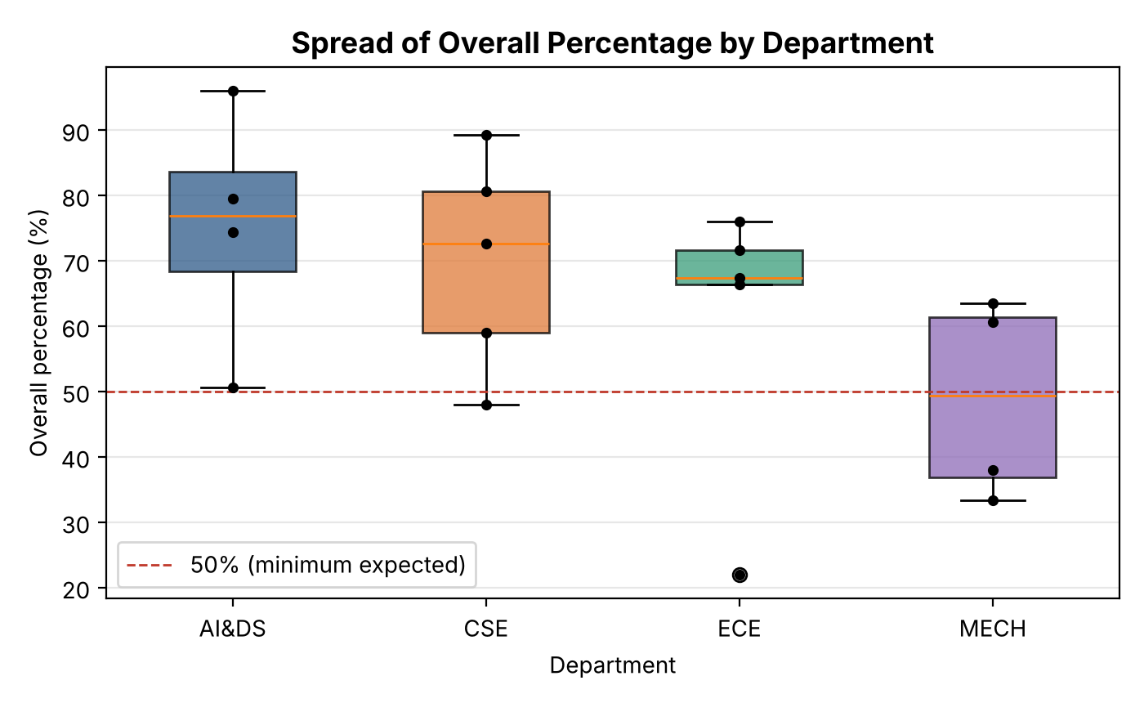
Figure 10.2: Spread of overall percentage by department
Interpretation: The box plot shows both the level and the spread of each department. AI&DS and CSE have most students above 50%. MECH has the lowest median and half of its students are below the 50% line. ECE has a narrow box (most students around 66–76%) but one clear low outlier at 22% (S118) – an individual student who needs support even though the department average looks acceptable. Each black dot is one student.
Python Code – Visualization 3: online activity vs overall percentage
fig, ax = plt.subplots(figsize=(7, 4.3))
for flag, color, label in [("No", "#2E5A88", "Not at risk"), ("Yes", "#C0392B", "At risk")]:
part = df[df["At_Risk"] == flag]
ax.scatter(part["Online_Activity_Hrs"], part["Percentage"], s=65, color=color,
edgecolor="black", linewidth=0.5, label=label)
r = df["Online_Activity_Hrs"].corr(df["Percentage"])
ax.set_title(f"Online Learning Activity vs Overall Percentage (r = {r:.2f})",
fontsize=12, fontweight="bold")
ax.set_xlabel("Online learning activity (hours per week)")
ax.set_ylabel("Overall percentage (%)")
ax.legend(loc="upper left")
ax.grid(alpha=0.3)
plt.tight_layout()
plt.savefig("charts/task10_online_vs_percentage.png", dpi=200)
plt.close()
print(f"Correlation between online hours and percentage: r = {r:.3f}")
Output:
Correlation between online hours and percentage: r = 0.925

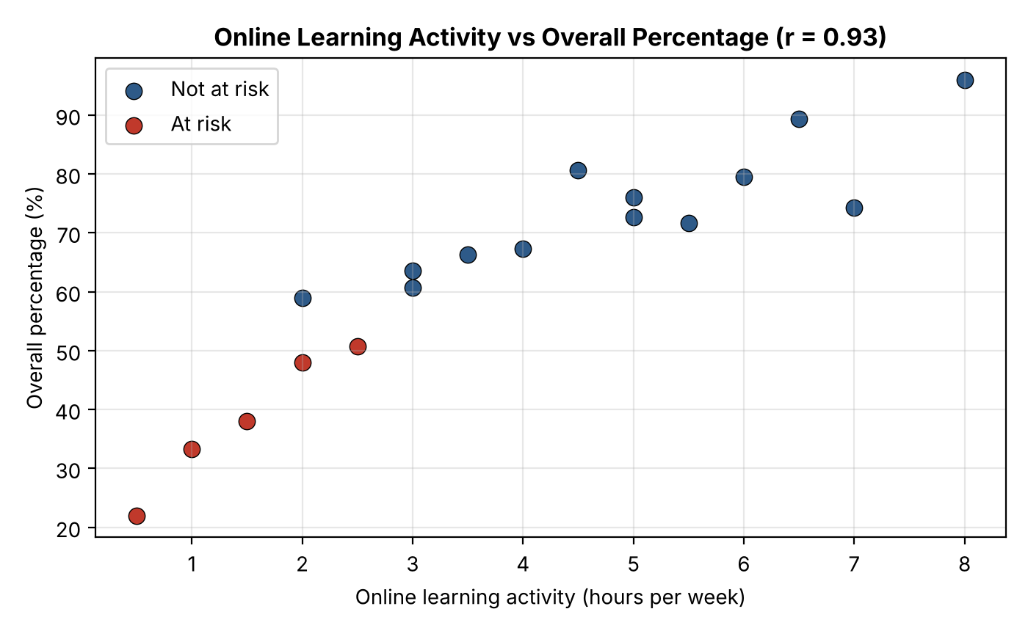
Figure 10.3: Online learning activity vs overall percentage
Interpretation: There is a very strong positive relationship (r = 0.93) between weekly LMS activity and overall percentage. All five at-risk students (red) use the LMS for 2.5 hours or less per week and lie in the lower-left corner. Online activity is therefore a useful additional early-warning indicator that is available every week, long before internal test results.
Python Code – Saving the final dataset
df.to_csv("data/student_case_study_final.csv", index=False)
print("Saved: data/student_case_study_final.csv | shape:", df.shape)
Output:
Saved: data/student_case_study_final.csv | shape: (18, 9)

10(g) Complete Workflow – Labelled Flowchart
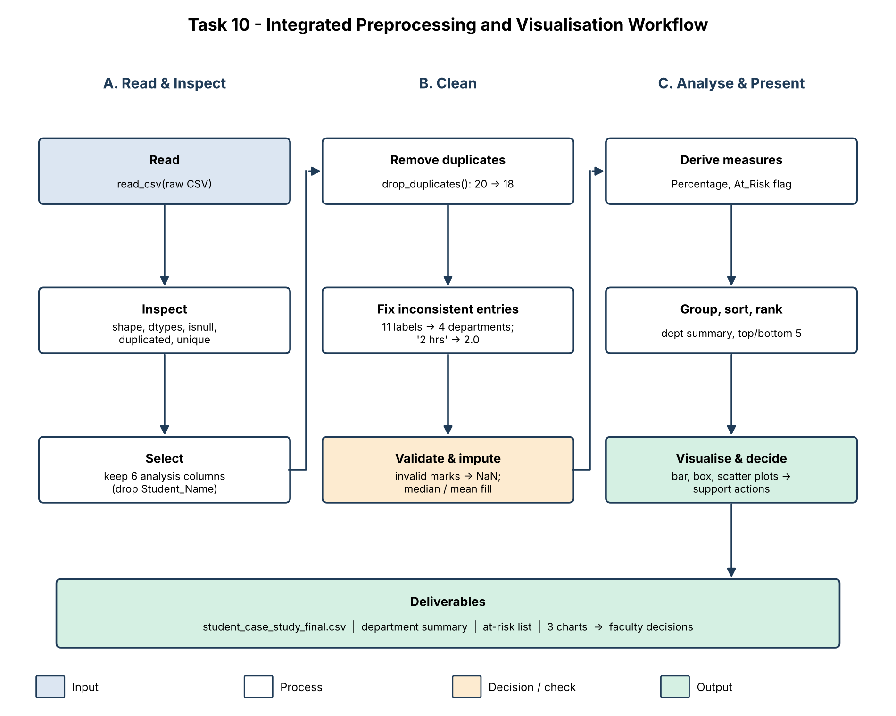
Figure 10.4: Integrated preprocessing and visualization workflow for the case study

Justification – How the Prepared Data and Visualizations Support Academic Decision-Making
- Trustworthy numbers: without cleaning, the department grouping would have 11 groups, S103 and S111 would be counted twice and an impossible mark of 112 would raise the AI&DS average. The cleaned data ensures each decision is based on correct counts and averages.
- Targeted support: the ranking and at-risk flag produce a short, specific list of five students (S102, S105, S109, S112, S118) for mentoring, rather than a general instruction to "improve results".
- Department planning: the summary table and box plot show that MECH needs a department-level plan, while ECE needs individual support for one student – two different decisions that a single average would hide.
- Early intervention: attendance and online activity are both strongly related to performance and are available weekly, so the college can act before the end-semester examination.
- Repeatability: the workflow is one script with documented assumptions; it can be re-run on next semester's data to check whether the support actions worked.

3. Assumptions, Missing-Value Treatment and Changes Made to the Data
Table 3.2: Summary of all changes made to the original data
Change | Records affected | Method | Reason / assumption
Duplicate rows removed | S103, S111 (second copies) | drop_duplicates(keep='first') | Identical rows are double entries
Department names standardised | 8 of 18 records | strip() + upper() + map() | All variants refer to CSE, ECE, MECH, AI&DS
Online activity converted to numbers | All records | str.extract() → float | '2 hrs' and '2' mean 2 hours per week
Invalid internal marks set to missing | S108 (112), S114 (-4) | between(0, 100) check | Values outside 0–100 are entry errors
Missing attendance filled | S104, S110, S116 | Median = 79.0 | Robust to low values
Missing internal marks filled | S106, S115, S108, S114 | Median = 63.5 | Robust to extreme values
Missing assignment scores filled | S107, S113 | Mean = 34.3 | No extreme values in this column
Unusual valid marks kept | S118 (18), S117 (97) | IQR check – within fences | Genuine performances
New columns added | All records | Percentage, z-score, band, At_Risk | Support analysis and communication
Student_Name dropped (Task 10) | All records | Column selection | Anonymous analysis

The raw file itself is never modified: every script reads student_performance_raw.csv and writes its results to new files, so the original data remains available for checking.

4. Conclusion
This assignment converted a raw, combined student dataset into a reliable, analysis-ready dataset and used it to produce meaningful visual findings. The initial inspection revealed missing values, duplicate records, inconsistent department labels, text-formatted numbers and impossible marks. These were handled through an ordered workflow: duplicates were removed, labels standardised, data types corrected, invalid marks treated as missing, and missing values imputed using the median or mean after comparing this approach with deletion, which would have lost 35% of the records.
Sorting, grouping and ranking showed clear differences between departments (AI&DS highest, MECH lowest), and the visualizations revealed a strong link between attendance and internal marks (r = 0.84) and between online learning activity and overall performance (r = 0.93). Five students were consistently identified as needing support across the filtering, ranking and visual analyses. Based on this evidence, early-warning mentoring for at-risk students and a department-level intervention for MECH, supported by an LMS engagement target, were recommended.
The assignment demonstrates how Pandas, NumPy, SciPy, Scikit-learn and Matplotlib each contribute to a different stage of the data science process, and how careful preprocessing directly determines whether the conclusions drawn for academic decision-making can be trusted.

