**Decimal To Hexadecimal**

**EXP.NO:28**

**PROGRAM:**

**#include<stdio.h>**

**int main()**

**{**

**long**

**int decimalNumber,remainder,quotient;**

**int i=1,j,temp;**

**char hexadecimalNumber[100];**

**printf("Enter any decimal number: ");**

**scanf("%ld",&decimalNumber);**

**quotient = decimalNumber;**

**while(quotient!=0)**

**{**

**temp= quotient % 16;**

**if(temp < 10)**

**temp =temp + 48;**

**else**

**temp = temp + 55;**

**hexadecimalNumber[i++]=temp;**

**quotient= quotient / 16;**

**}**

**printf("Equivalent hexadecimal value of decimal number %d: ",decimalNumber);**

**for(j = i -1 ;j> 0;j--)**

**printf("%c",hexadecimalNumber[j]);**

**return 0;**

**}**

**INPUT:**

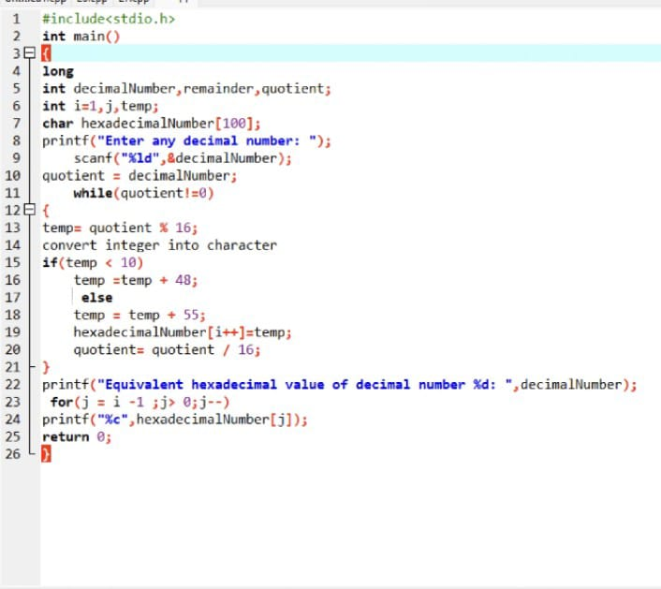

**OUTPUT:**

