Marwadi University
Faculty of Computer Applications

BCA 4E Python CSE Exam

Enrollment No. : 92400527319
Name : Vicky Kumar
Class : BCA 4-E
Date : 03-04-2026

Answer – 1

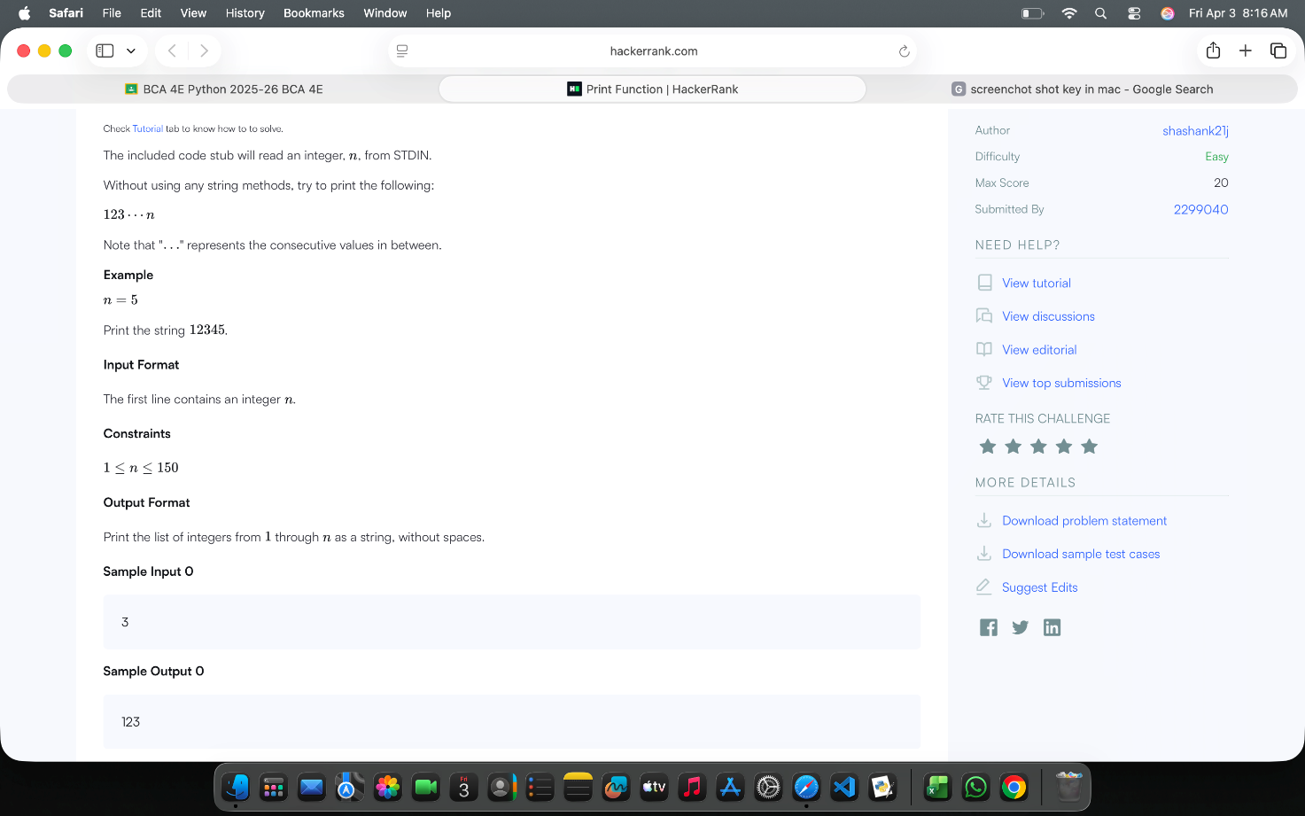

Answer – 2
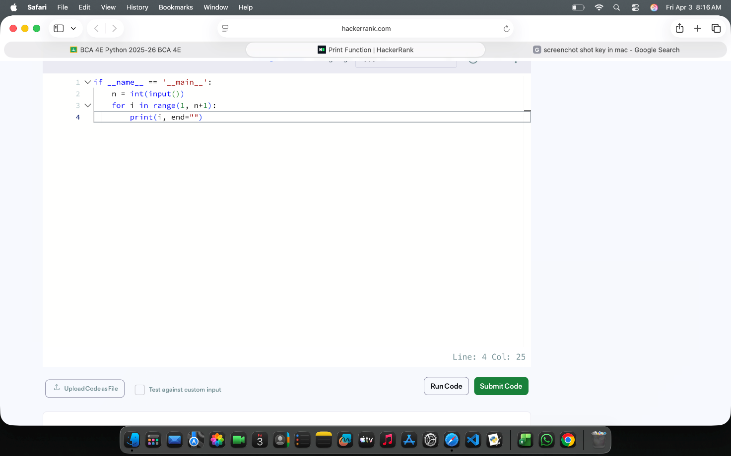
Answer – 3
