NAME : Vicky Kumar
CLASS: BCA 4E
ROLL NO. : 92400527319
------------------------------------------------------------------------------------------------------------------
9. Pelendrom number

public class Solution {
public bool IsPalindrome(int x) {

if(x < 0)
return false;

int temp = x;
int rev = 0;

while(temp != 0){
rev = (rev * 10) + temp % 10;
temp /= 10;
}

if (x == rev)
return true;
else
return false;
}
}
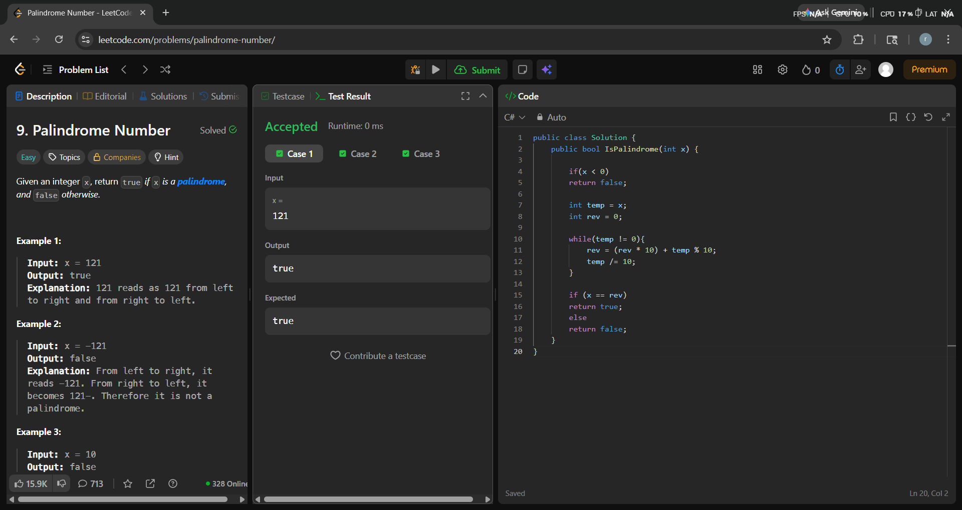

2840. Check if Strings Can be Made Equal With Operations II

public class Solution {
public bool CheckStrings(string s1, string s2) {

int[] even = new int[26];
int[] odd = new int[26];

for (int i = 0, j = 1; i < s1.Length || j < s1.Length; i += 2, j += 2) {

if (i < s1.Length) {
even[s1[i] - 'a']++;
even[s2[i] - 'a']--;
}

if (j < s1.Length) {
odd[s1[j] - 'a']++;
odd[s2[j] - 'a']--;
}
}

for (int k = 0; k < 26; k++) {
if (even[k] != 0 || odd[k] != 0) {
return false;
}
}

return true;
}
}

