This is a complete end-to-end DevOps portfolio project. You can put it on your resume as: "DevOps CI/CD Pipeline for DevOps-Themed Website using GitHub + Jenkins + Docker + Selenium + AWS EC2 + Grafana"
Here is the exact step-by-step roadmap (beginner-friendly, no confusion).
Phase 1: Create the DevOps-Themed Website (Node.js):
Phase 2: Push to GitHub (Source of Truth)
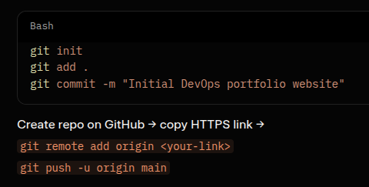
Phase 3: Dockerize the App (Build Phase)
Create Dockerfile in root
Build & test
Phase 4: Jenkins + Full CI/CD Pipeline
Option A (Easiest for beginner): Run Jenkins in Docker on your laptop first.

Phase 5: Selenium UI Testing (Simple example)
Create test/selenium-test.js:
JavaScript

Phase 6: AWS EC2 Deployment (Free Tier)
- Create AWS free account → Launch t2.micro (Ubuntu) → download .pem key.
- SSH into it, install Docker:
- Bash
- sudo apt update && sudo apt install docker.io -ysudo usermod -aG docker $USER
Add your SSH key to Jenkins credentials.
tall docker.io -ysudo usermod -aG docker $USER
- Add your SSH key to Jenkins credentials.

Phase 7: Buy Domain (under ₹600 easily)
Current offers (Feb 2026):
- Hostinger: .in → ₹1 first year, .com → ₹199
- GoDaddy: .in or .com from ₹90–₹499 first year
- BigRock: .in from ₹1–₹599
Go to Hostinger.in or godaddy.com/in → search devopsbyd.in or mydevopsjourney.in → buy in 2 minutes. Point A record to your EC2 public IP.

Phase 8: Live Monitoring with Grafana + Prometheus (Real-time Dashboard)
On same EC2:Import ready DevOps dashboard in Grafana (CPU, RAM, Docker containers, app response time — all live!).
Example pipeline + monitoring architecture (exactly like your project):
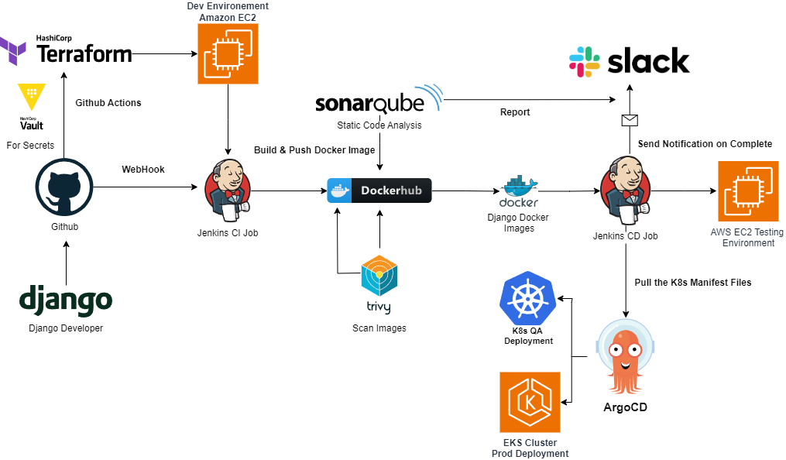
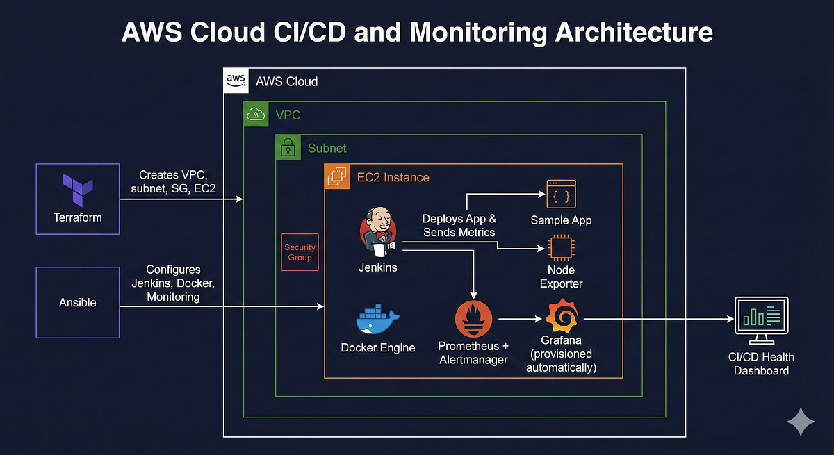

Recommended Design Style (2026 Trend)
- Dark Mode (black/very dark gray background) + Blue & Cyan accents (DevOps colors)
- Clean cards, smooth scrolling, subtle animations
- Responsive (looks perfect on mobile too)
- Live Dashboard is the hero — people will remember it forever
Here are real professional examples (exactly what your site can look like):
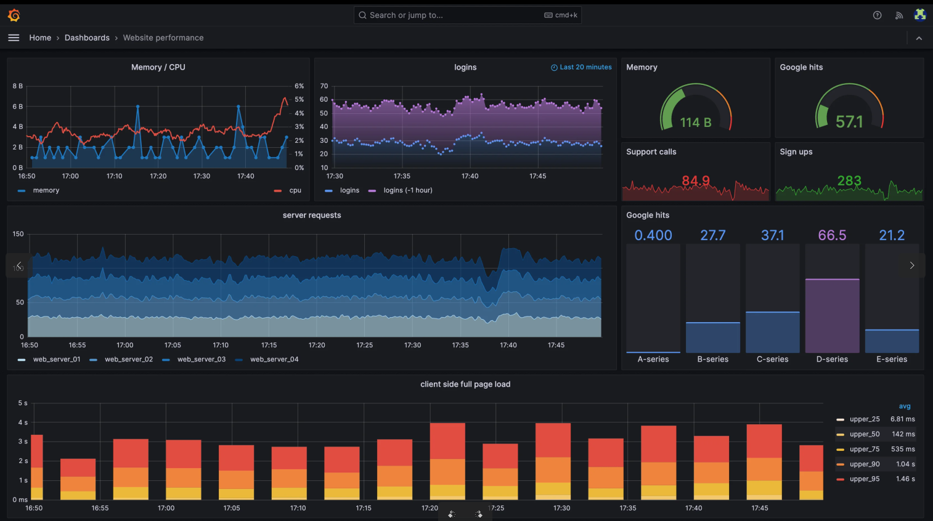

User Journey (What Visitor Sees)
- Opens yourdomain.com → Sees big hero: "DevOps Live Demo" + your name + "Built with GitHub → Jenkins → Docker → AWS → Grafana"
- Immediately below: 4 small live cards (CPU 42%, RAM 58%, Uptime 99.9%, Last Deployment 2 min ago)
- Scroll → Beautiful DevOps lifecycle diagram (Code → Build → Test → Deploy → Monitor)
- Sections: What is DevOps? | Tools I Used | My Pipeline | Full Live Dashboard (big Grafana)
- Footer: "This entire site runs on real CI/CD + monitoring"
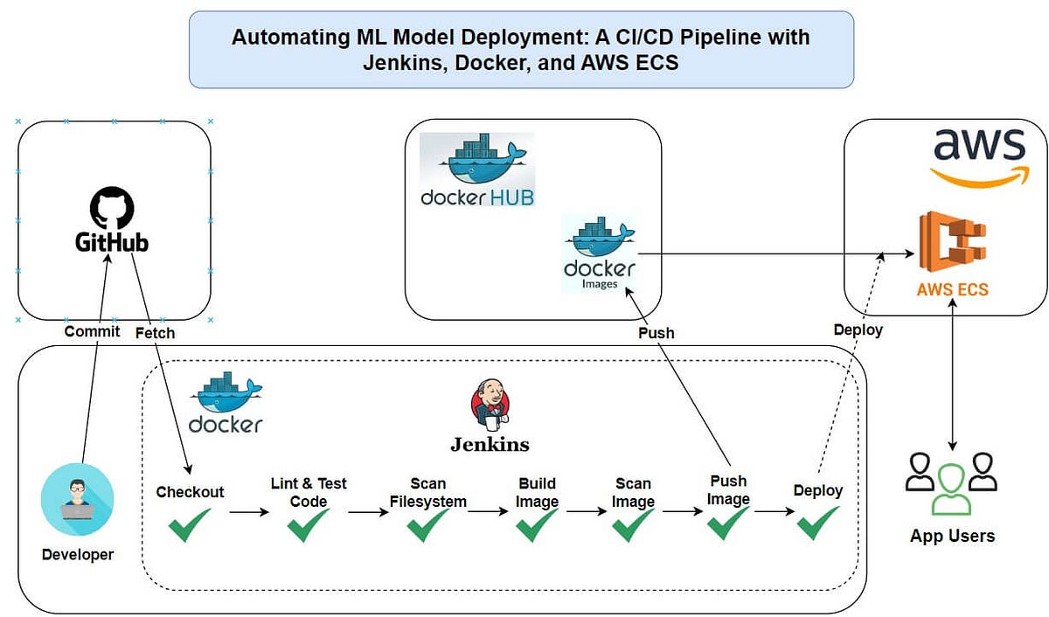

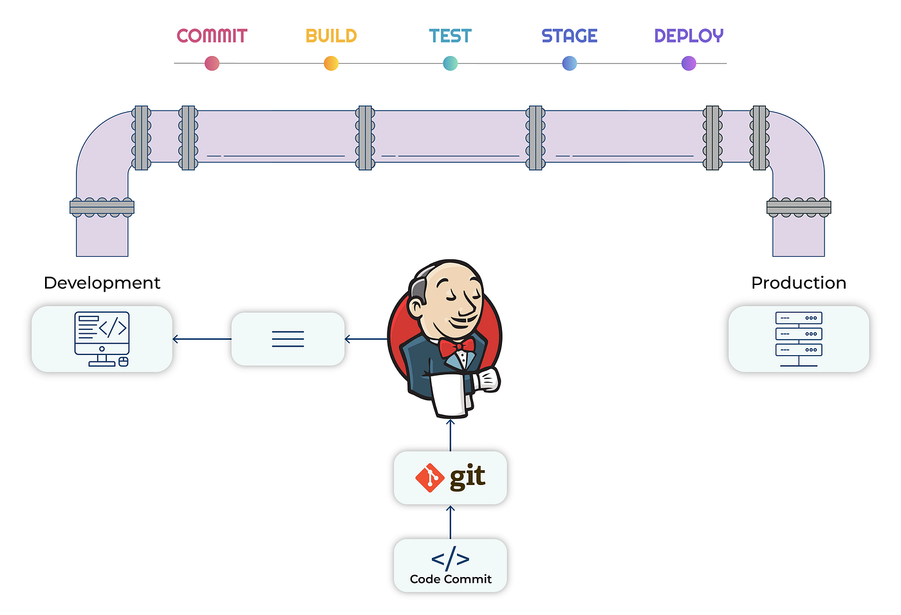

This is the standard structure used by real DevOps engineers and companies.

