**PRACTICAL 7**

**7a) BeanClass HelloWorld**

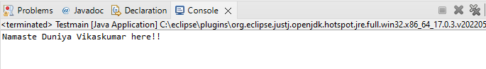

7b) Dependency Injection using Setter method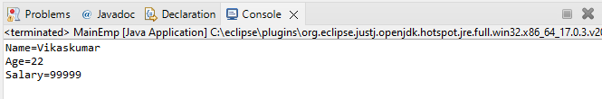

7b1) Dependency Injection Setter method using BeanFactory

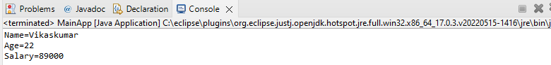

7c) Dependency Injection using Constructor

