
SCHOOL OF COMPUTER SCIENCE ENGINEERING AND INFORMATION SYSTEMS
UBCA202P - Database Management System Lab
Assessment - 1

Register No.: | 23BCA0075
Student Name: | VIGNESH KUMAR B

DDL
Create the following tables:
Employee (SSN, First_Name, Last_Name, Email, Gender, Address, Salary, DOB, Designation)
Department (DNumber, Name, Location)

Q. | Problem Statement(s):  - Create the tables given by identifying appropriate primary keys for the tables  - Set the following constraints at the time of table creation:  - Gender of the employee can be male or female  - The Salary of the employee must be greater than 15000  - The DOB field must not be empty  - Ensure that two employees are not having the same email  - The default designation of the employee is “Developer”.
Command:

SQL> create table employee(SSN number(10) constraint emp_ssn_pk primary key,
2 First_name varchar(10),
3 Last_name varchar(10),
4 Email varchar(10) constraint emp_ema_un unique,
5 Gender varchar(3) constraint emp_gen_ck check((Gender='M') or (Gender='F')),
6 Address varchar(10),
7 Salary number(8,2) constraint emp_sal_ck check(Salary>15000),
8 D0B date constraint emp_dob_nn not null,
9 Designation varchar(10) default 'Developer'
10 );

Table created.

SQL> create table department(Dnumber varchar(10),
2 Name varchar(10),
3 Location varchar(10)
4 );

Table created.

Execution:

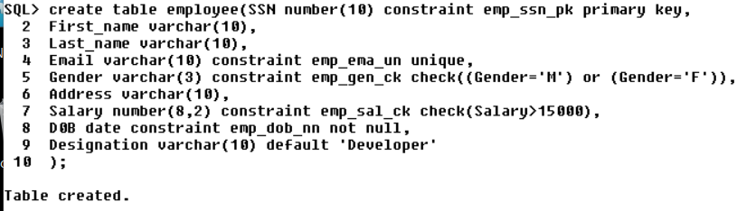

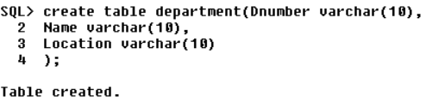

Q. | Problem Statement(s):  - Create a table Test with your own fields.
Command:

SQL> create table cricket(country varchar(10) primary key,
2 captain varchar(10) unique);

Table created.

Execution:

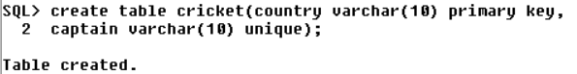

Q. | Problem Statement(s):  - Delete the Test table created
Command:

SQL> drop table cricket;

Table dropped.

Execution:

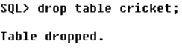

Q. | Problem Statement(s):  - Alter the table as given below:  a. Add a field dept_number in the employee table
Command:

SQL> alter table employee add Dnumber varchar(10);

Table altered.

Execution:

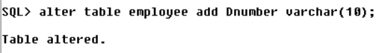

Q. | Problem Statement(s):  b. Add a field managerSSN in Department table
Command:

SQL> alter table department add(ManagerSSN number(10));

Table altered.

Execution:

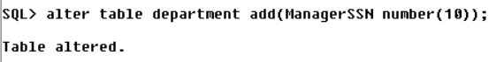

Q. | Problem Statement(s):  c. Increase the size of Address field
Command:

SQL> alter table employee modify(Address varchar(12));

Table altered.

Execution:

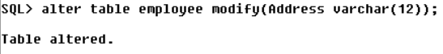

Q. | Problem Statement(s):  d. Drop the Last_Name field in employee table
Command:

SQL> alter table employee drop column Last_Name;

Table altered.

Execution:

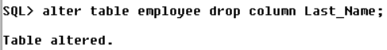

Q. | Problem Statement(s):  - Rename First_Name as Name in the employee table
Command:

SQL> alter table employee rename column First_name to Name;

Table altered.

Execution:

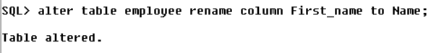

Q. | Problem Statement(s):  - Add a constraint such that dept_number in employee table contains values already in department table
Command:

SQL> alter table employee add constraint emp_dnum_fk foreign key(Dnumber) references department(Dnum
ber);

Table altered.

Execution:

Q. | Problem Statement(s):  - Add a constraint such that managerSSN in department table contains values already in employee table
Command:

SQL> alter table department add constraint dep_ssn_fk foreign key(ManagerSSN) references employee(SS
N);

Table altered.

Execution:

Q. | Problem Statement(s):  - Remove the constraint from salary in employee table
Command:

SQL> alter table employee drop constraint emp_sal_ck;

Table altered.

Execution:

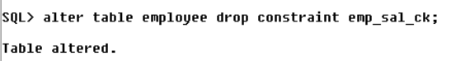

Q. | Problem Statement(s):  - Add the constraint such that Salary of the employee is greater than 20000.
Command:

SQL> alter table employee add constraint emp_sal_ck check(salary>20000);

Table altered.

Execution:

DML

Employee (SSN, Name, Email, Gender, Address, Salary, DOB, Designation, Dept_number)
Department (DNumber, Name, Location, ManagerSSN)

Q. | Problem Statement(s):  - Insert atleast 5 rows in each table and test the constraints added
Command:

Employee:

SQL> insert into employee values(&SSN,'&Name','&Email','&Gender','&Address',&Salary,'&DOB','&Design
ation','&Dnumber');
Enter value for ssn: 101
Enter value for name: vicky
Enter value for email: ab@xyz.com
Enter value for gender: M
Enter value for address: vellore
Enter value for salary: 29000.00
Enter value for dob: 26-jan-2000
Enter value for designation: Manager
Enter value for dnumber: d100
old 1: insert into employee values(&SSN,'&Name','&Email','&Gender','&Address',&Salary,'&DOB','&De
new 1: insert into employee values(101,'vicky','ab@xyz.com','M','vellore',29000.00,'26-jan-2000',

1 row created.

SQL> /
Enter value for ssn: 102
Enter value for name: dinesh
Enter value for email: bc@xyz.com
Enter value for gender: M
Enter value for address: vellore
Enter value for salary: 35000.00
Enter value for dob: 1-apr-2002
Enter value for designation: T Leader
Enter value for dnumber: d101
old 1: insert into employee values(&SSN,'&Name','&Email','&Gender','&Address',&Salary,'&DOB','&De
new 1: insert into employee values(102,'dinesh','bc@xyz.com','M','vellore',35000.00,'1-apr-2002',

1 row created.

SQL> /
Enter value for ssn: 103
Enter value for name: sakthi
Enter value for email: cd@xyz.com
Enter value for gender: M
Enter value for address: Gudiyatham
Enter value for salary: 60000.00
Enter value for dob: 24-may-1999
Enter value for designation: Programmer
Enter value for dnumber: d102
old 1: insert into employee values(&SSN,'&Name','&Email','&Gender','&Address',&Salary,'&DOB','&De
new 1: insert into employee values(103,'sakthi','cd@xyz.com','M','Gudiyatham',60000.00,'24-may-19

1 row created.

SQL> /
Enter value for ssn: 104
Enter value for name: karthi
Enter value for email: de@xyz.com
Enter value for gender: M
Enter value for address: Katpadi
Enter value for salary: 70000.00
Enter value for dob: 16-apr-1987
Enter value for designation: Programmer
Enter value for dnumber: d103
old 1: insert into employee values(&SSN,'&Name','&Email','&Gender','&Address',&Salary,'&DOB','&De
new 1: insert into employee values(104,'karthi','de@xyz.com','M','Katpadi',70000.00,'16-apr-1987'

1 row created.

SQL> /
Enter value for ssn: 105
Enter value for name: karthi
Enter value for email: ef@xyz.com
Enter value for gender: M
Enter value for address: ooty
Enter value for salary: 21000.00
Enter value for dob: 25-feb-2000
Enter value for designation:
Enter value for dnumber: d104
old 1: insert into employee values(&SSN,'&Name','&Email','&Gender','&Address',&Salary,'&DOB','&De
new 1: insert into employee values(105,'karthi','ef@xyz.com','M','ooty',21000.00,'25-feb-2000',''

1 row created.

SQL> /
Enter value for ssn: 106
Enter value for name: priya
Enter value for email: gh@xyz.com
Enter value for gender: F
Enter value for address: chennai
Enter value for salary: 80000.00
Enter value for dob: 10-dec-1999
Enter value for designation: editing
Enter value for dnumber: d105
old 1: insert into employee values(&SSN,'&Name','&Email','&Gender','&Address',&Salary,'&DOB','&De
new 1: insert into employee values(106,'priya','gh@xyz.com','F','chennai',80000.00,'10-dec-1999',

1 row created.

SQL> /
Enter value for ssn: 107
Enter value for name: deepika
Enter value for email: hi@xyz.com
Enter value for gender: F
Enter value for address: Mumbai
Enter value for salary: 100000.00
Enter value for dob: 9-aug-1997
Enter value for designation: Marketing
Enter value for dnumber: d106
old 1: insert into employee values(&SSN,'&Name','&Email','&Gender','&Address',&Salary,'&DOB','&De
new 1: insert into employee values(107,'deepika','hi@xyz.com','F','Mumbai',100000.00,'9-aug-1997'

1 row created.

Department:

SQL> insert into department values('&Dnumber','&Name','&Location',&ManagerSSN);
Enter value for dnumber: d100
Enter value for name: admin
Enter value for location: chennai
Enter value for managerssn: 101
old 1: insert into department values('&Dnumber','&Name','&Location',&ManagerSSN)
new 1: insert into department values('d100','admin','chennai',101)

1 row created.

SQL> /
Enter value for dnumber: d101
Enter value for name: HR
Enter value for location: mumbai
Enter value for managerssn: 102
old 1: insert into department values('&Dnumber','&Name','&Location',&ManagerSSN)
new 1: insert into department values('d101','HR','mumbai',102)

1 row created.

SQL> /
Enter value for dnumber: d102
Enter value for name: design
Enter value for location: kolkata
Enter value for managerssn: 103
old 1: insert into department values('&Dnumber','&Name','&Location',&ManagerSSN)
new 1: insert into department values('d102','design','kolkata',103)

1 row created.

SQL> /
Enter value for dnumber: d103
Enter value for name: design
Enter value for location: kolkata
Enter value for managerssn: 104
old 1: insert into department values('&Dnumber','&Name','&Location',&ManagerSSN)
new 1: insert into department values('d103','design','kolkata',104)

1 row created.

SQL> /
Enter value for dnumber: d104
Enter value for name: program
Enter value for location: delhi
Enter value for managerssn: 105
old 1: insert into department values('&Dnumber','&Name','&Location',&ManagerSSN)
new 1: insert into department values('d104','program','delhi',105)

1 row created.

SQL> /
Enter value for dnumber: d105
Enter value for name: editing
Enter value for location: pune
Enter value for managerssn: 106
old 1: insert into department values('&Dnumber','&Name','&Location',&ManagerSSN)
new 1: insert into department values('d105','editing','pune',106)

1 row created.

SQL> /
Enter value for dnumber: d106
Enter value for name: marketing
Enter value for location: bangalore
Enter value for managerssn: 107
old 1: insert into department values('&Dnumber','&Name','&Location',&ManagerSSN)
new 1: insert into department values('d106','marketing','bangalore',107)

1 row created.

Execution:

Employee:

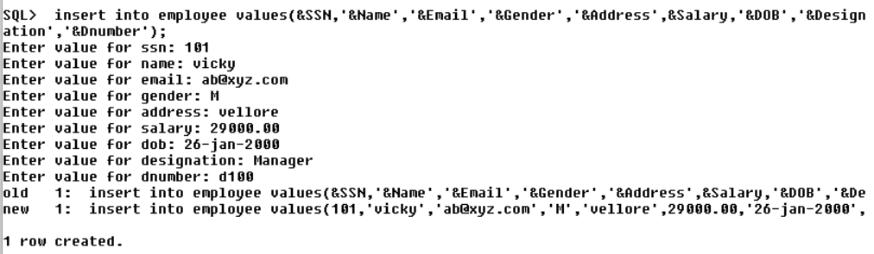

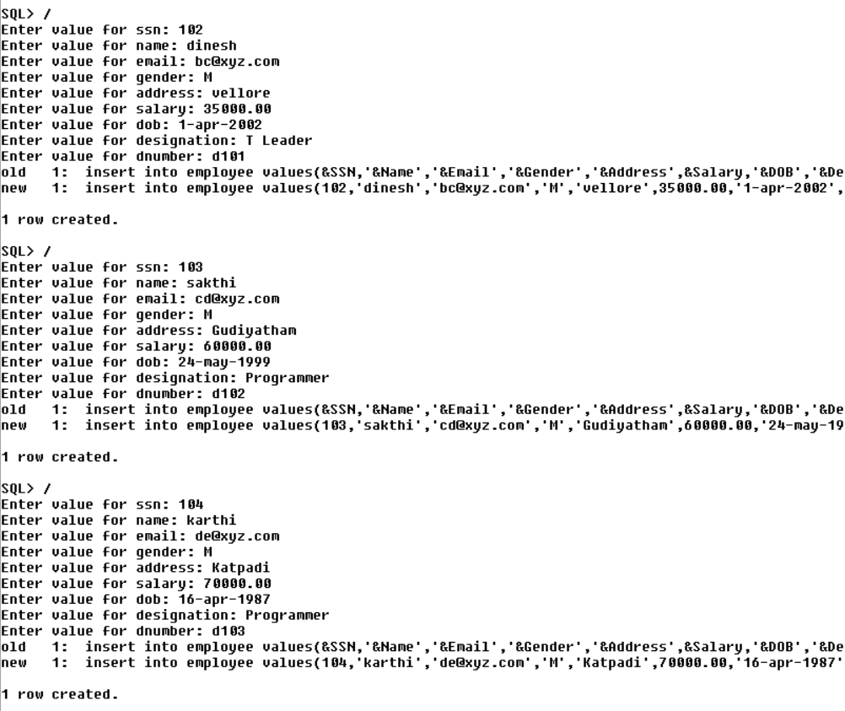
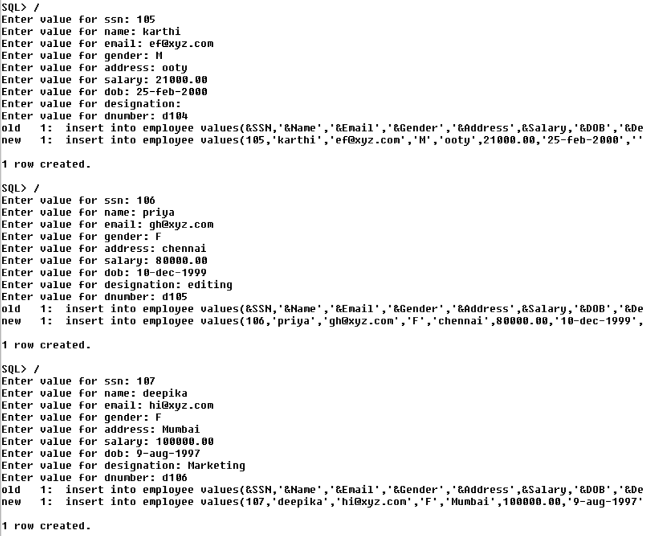

Department:

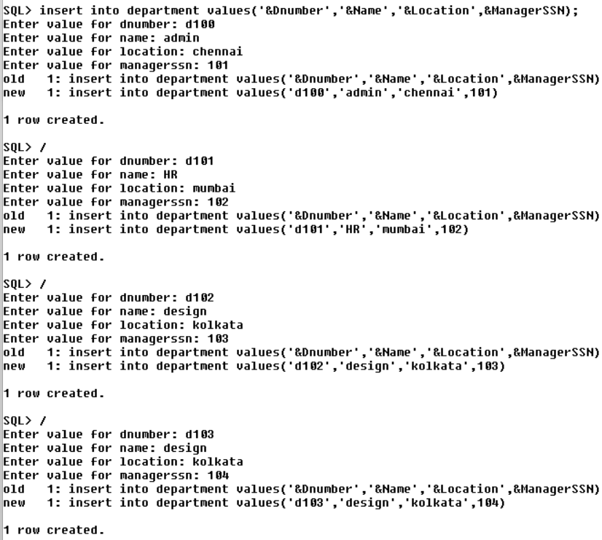

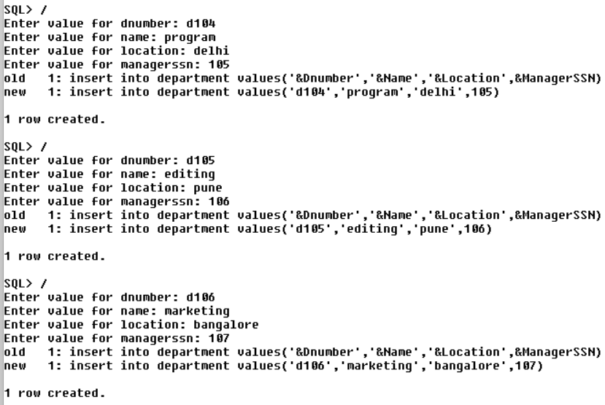

Q. | Problem Statement(s):  - Insert only dnumber, name and managerSSN in department table
Command:

SQL> insert into department(Dnumber,Name,ManagerSSN) values('d107','sales',108);

1 row created.

SQL> insert into department(Dnumber,Name,ManagerSSN) values('d108','logistics',109);

1 row created.

Execution:

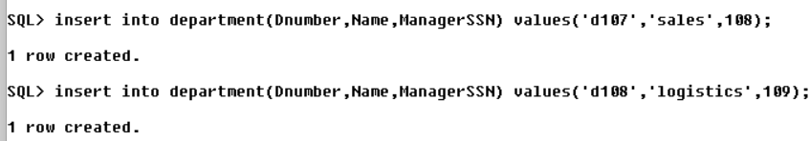

Q. | Problem Statement(s):  - Display all the values in Employee and Department table
Command:

Employee:

SQL> select * from employee;

SSN NAME EMAIL GEN ADDRESS SALARY D0B
---------- ---------- ---------- --- ------------ ---------- ---------
DESIGNATIO DNUMBER
---------- ----------
101 vicky ab@xyz.com M vellore 29000 26-JAN-00
Manager d100

102 dinesh bc@xyz.com M vellore 35000 01-APR-02
T Leader d101

103 sakthi cd@xyz.com M Gudiyatham 60000 24-MAY-99
Programmer d102

SSN NAME EMAIL GEN ADDRESS SALARY D0B
---------- ---------- ---------- --- ------------ ---------- ---------
DESIGNATIO DNUMBER
---------- ----------
104 karthi de@xyz.com M Katpadi 70000 16-APR-87
Programmer d103

105 karthi ef@xyz.com M ooty 21000 25-FEB-00
Developer d104

106 priya gh@xyz.com F chennai 80000 10-DEC-99
editing d105

SSN NAME EMAIL GEN ADDRESS SALARY D0B
---------- ---------- ---------- --- ------------ ---------- ---------
DESIGNATIO DNUMBER
---------- ----------
107 deepika hi@xyz.com F Mumbai 100000 09-AUG-97
Marketing d106

108
Developer d107

109
Developer d108

9 rows selected.

Department:

SQL> select * from department;

DNUMBER NAME LOCATION MANAGERSSN
---------- ---------- ---------- ----------
d100 admin chennai 101
d101 HR mumbai 102
d102 design kolkata 103
d103 design kolkata 104
d104 program delhi 105
d105 editing pune 106
d106 marketing bangalore 107
d107 sales 108
d108 logistics 109

9 rows selected.

Execution:

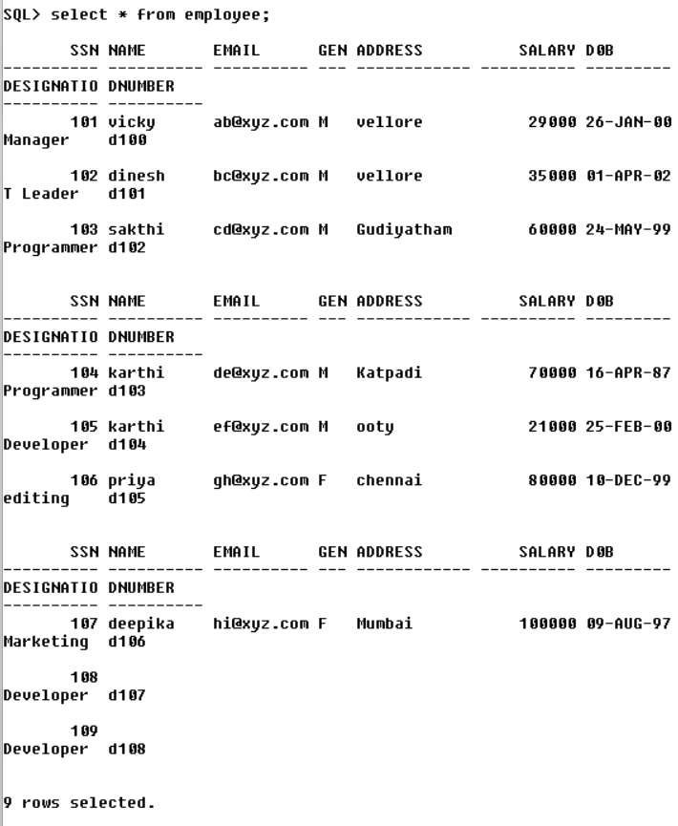

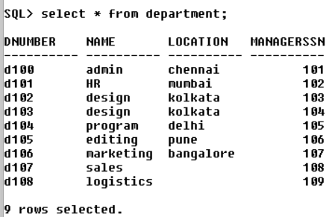

Q. | Problem Statement(s):  - Display only dnumber and location from the department table
Command:

SQL> select Dnumber,Location from department;

DNUMBER LOCATION
---------- ----------
d100 chennai
d101 mumbai
d102 kolkata
d103 kolkata
d104 delhi
d105 pune
d106 bangalore
d107
d108

9 rows selected.

Execution:

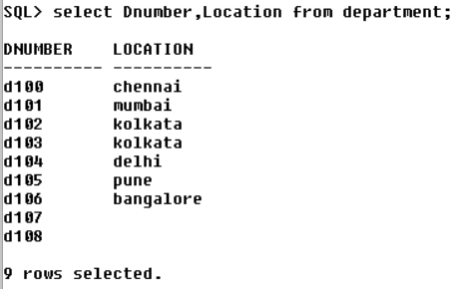

Q. | Problem Statement(s):  - Display only unique names of the employee from the employee table
Command:

SQL> select distinct Name from employee;

NAME
----------

deepika
dinesh
karthi
priya
vicky
sakthi

7 rows selected.

Execution:

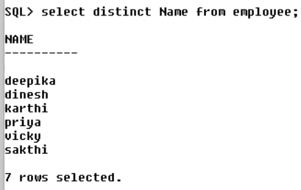

Q. | Problem Statement(s):  - Display the details of the employee whose salary is between 30000 and 50000
Command:

SQL> select * from employee where salary between 30000 and 50000;

SSN NAME EMAIL GEN ADDRESS SALARY D0B
---------- ---------- ---------- --- ------------ ---------- ---------
DESIGNATIO DNUMBER
---------- ----------
102 dinesh bc@xyz.com M vellore 35000 01-APR-02
T Leader d101

Execution:

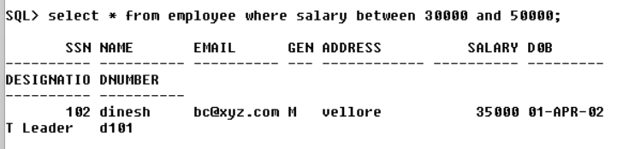

Q. | Problem Statement(s):  - Display the details of the department whose location is not available
Command:

SQL> select * from department where Location is null;

DNUMBER NAME LOCATION MANAGERSSN
---------- ---------- ---------- ----------
d107 sales 108
d108 logistics 109

Execution:

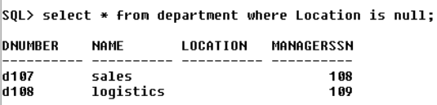

Q. | Problem Statement(s):  - Increase the salary of all the employees by 10%
Command:

SQL> update employee set salary=salary+salary*(10/100);

7 rows updated.

Execution:

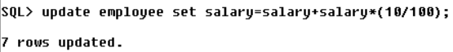

Q. | Problem Statement(s):  - Increase the salary of the employee by Rs.5000 whose designation is TeamLeader
Command:

SQL> update employee set salary=salary+5000 where Designation='T Leader';

1 row updated.

Execution:

Q. | Problem Statement(s):  - Remove details of the department having no location
Command:

SQL> delete from department where Location is null;

2 rows deleted.

Execution:

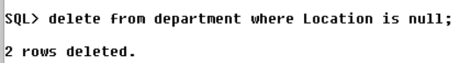

Aggregate Functions:

Q. | Problem Statement(s):  - Display the details of the employee getting minimum salary.
Command:

SQL> select * from employee where salary=(select min(salary) from employee);

SSN NAME EMAIL GEN ADDRESS SALARY D0B
---------- ---------- ---------- --- ------------ ---------- ---------
DESIGNATIO DNUMBER
---------- ----------
105 karthi ef@xyz.com M ooty 23100 25-FEB-00
d104

Execution:

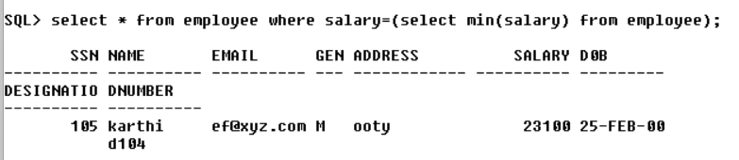

Q. | Problem Statement(s):  - Display the details of the employee getting maximum salary
Command:

select * from employee where salary=(select min(salary) from employee);

Execution:

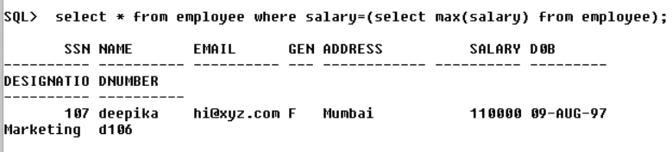

Q. | Problem Statement(s):  - Display the number of employees from Vellore.
Command:

SQL> select count(*) No_of_employees from employee where Address='vellore';

NO_OF_EMPLOYEES
---------------
2
Execution:

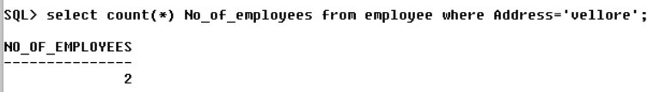

Q. | Problem Statement(s):  - Display the average salary of the employee in department with department number 'd100'
Command:

SQL> select avg(salary) from employee where Dnumber='d100';

AVG(SALARY)
-----------
31900

Execution:

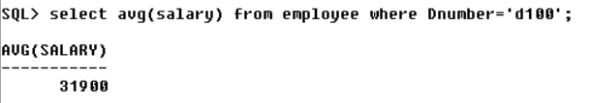

Q. | Problem Statement(s):  - Count the number of unique department names and display it
Command:

SQL> select count(distinct Name) No_of_departments from department;

NO_OF_DEPARTMENTS
-----------------
6

Execution:

