**Case Study: Git and GitHub Workflow Exercise**

**1. Project Initialization:**

git init

git add .

git commit -m "First commit"

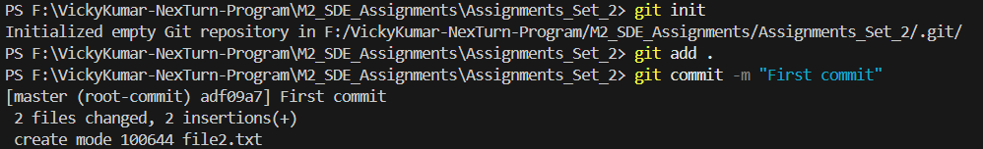

git remote add origin https://github.com/Vickykumar1001/git_exercise.git

git branch -M master

git push -u origin master

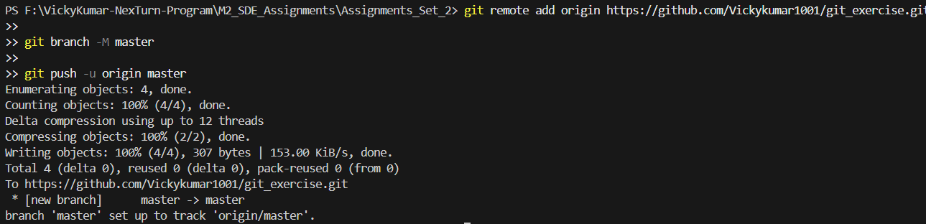

**2. Feature Addition:** Adding readme file

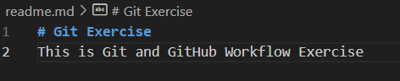

**3. Branch Management:** creating new branch

git checkout -b feature/update-readme

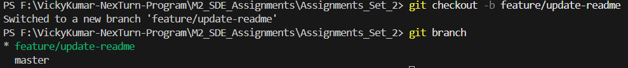

Pushing the branch to the remote repository

git add .\readme.md  
 git commit -m "Added readme.md file"

git push -u origin feature/update-readme

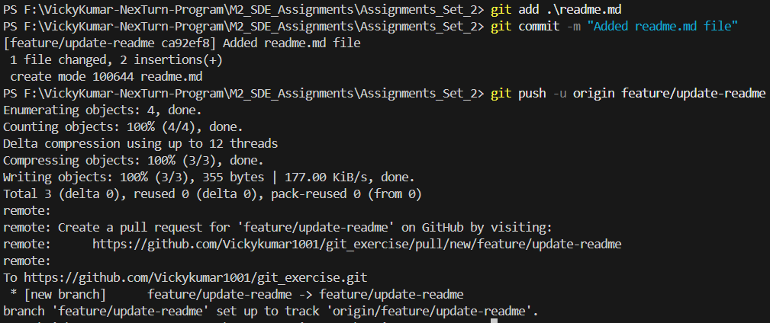

**4. Merge Branch to master:**

Switching to master branch

git checkout master



Merging feature branch to master

git merge feature/update-readme

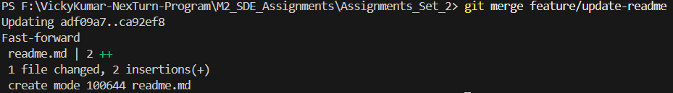Pushing the merged changes

git push –u origin master

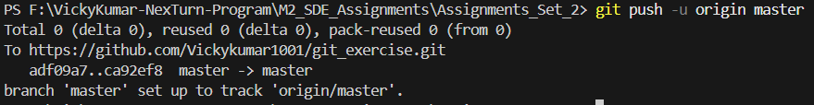

**5. Branch Cleanup:**

Deleting feature branch locally  
 git branch -d feature/update-readme



Deleting feature branch remotely

git push origin --delete feature/update-readme

