WIDE-SCALE SAMPLING WITH HARD-ARGMIN SELECTION AND CBF PROJECTION FOR SAFE QUADROTOR NAVIGATION IN NARROW PASSAGES
Abstract
A common implementation of sampling-based NMPC for quadrotor obstacle avoidance draws candidate commands from a narrow Gaussian around a PD nominal. In tight passages, this nominal can point toward the conservative composite-barrier boundary rather than through the actual geometric gap. Adding more samples close to that nominal does not address this failure mode — it is a candidate-generation problem, not a solver problem. TSH-NMPC widens the sampling distribution (σ = 5 N around the PD nominal at K = 10), selects the lowest-cost rollout by hard argmin, and projects the result through a DT-CBF quadratic program before execution. On the narrow-passage benchmark, the wide-scale sampler reached 97–99% success, while the narrow-scale PD-Gaussian baseline reached 64–70%. Under +50% mass mismatch the baseline failed in all 40 trials; the wide-scale variants retained 77.5%–82.5% success. Compared with CasADi+IPOPT, TSH-NMPC achieved the same success rate at roughly 6 ms per call with a fixed O(K · S) rollout budget, although CasADi retained lower terminal error. A learned-proposal ablation reduced success from 97.7% to 88.7%, suggesting that coverage mattered more than prediction accuracy in this setting.
Key Words: Nonlinear model predictive control; sampling-based MPC; control barrier functions; quadrotor obstacle avoidance.
1. Introduction
When flying a quadrotor and needing to avoid obstacles, the controller has to handle non-convex collision rules fast, on a small chip inside the drone. Sampling-based NMPC is quite good for this because it just rolls out different candidate controls through a model, and you do not need convexity or differentiability of the cost. The per-step work is bounded (K rollouts of S steps each) and easy to run in parallel. Two common versions that people use are MPPI ^{[1, 2]} and CEM ^{[3]}.
The usual single-source setup draws all K first-step candidates from one Gaussian around a nominal control. When the nominal points at an obstacle boundary — as often happens in narrow passages, where the conservative composite barrier treats a geometrically feasible gap as unsafe — every candidate picks up the same directional bias. Making K larger inside a narrow sampling scale does not fix this: more samples near a bad nominal stay near that nominal. On our narrow-passage benchmark, single-source PD-Gaussian rollout NMPC reached only 73.8% success at K = 20 (Section 5.2). The pattern suggests that what matters is not just how many candidates you draw, but where you draw them from.
The useful change was not just to draw from a wider Gaussian. Wider sampling can produce controls that point through the geometric gap, but it also produces unsafe commands that need filtering. Hard selection matters because the useful escape candidates are sparse inside the pool, and soft aggregation can wash them out. Safety projection matters because some of the wider samples land outside the safe set. In the experiments below, the three changes played separable empirical roles (Fig. 1). (P1) Wider sampling (σ = 5 N per axis) raised the odds of drawing an escape candidate. (P2) Hard argmin kept sparse escape candidates. (P3) DT-CBF projection filtered the unsafe subset of the wider pool. Taking away any one changed a different piece of the failure mode.
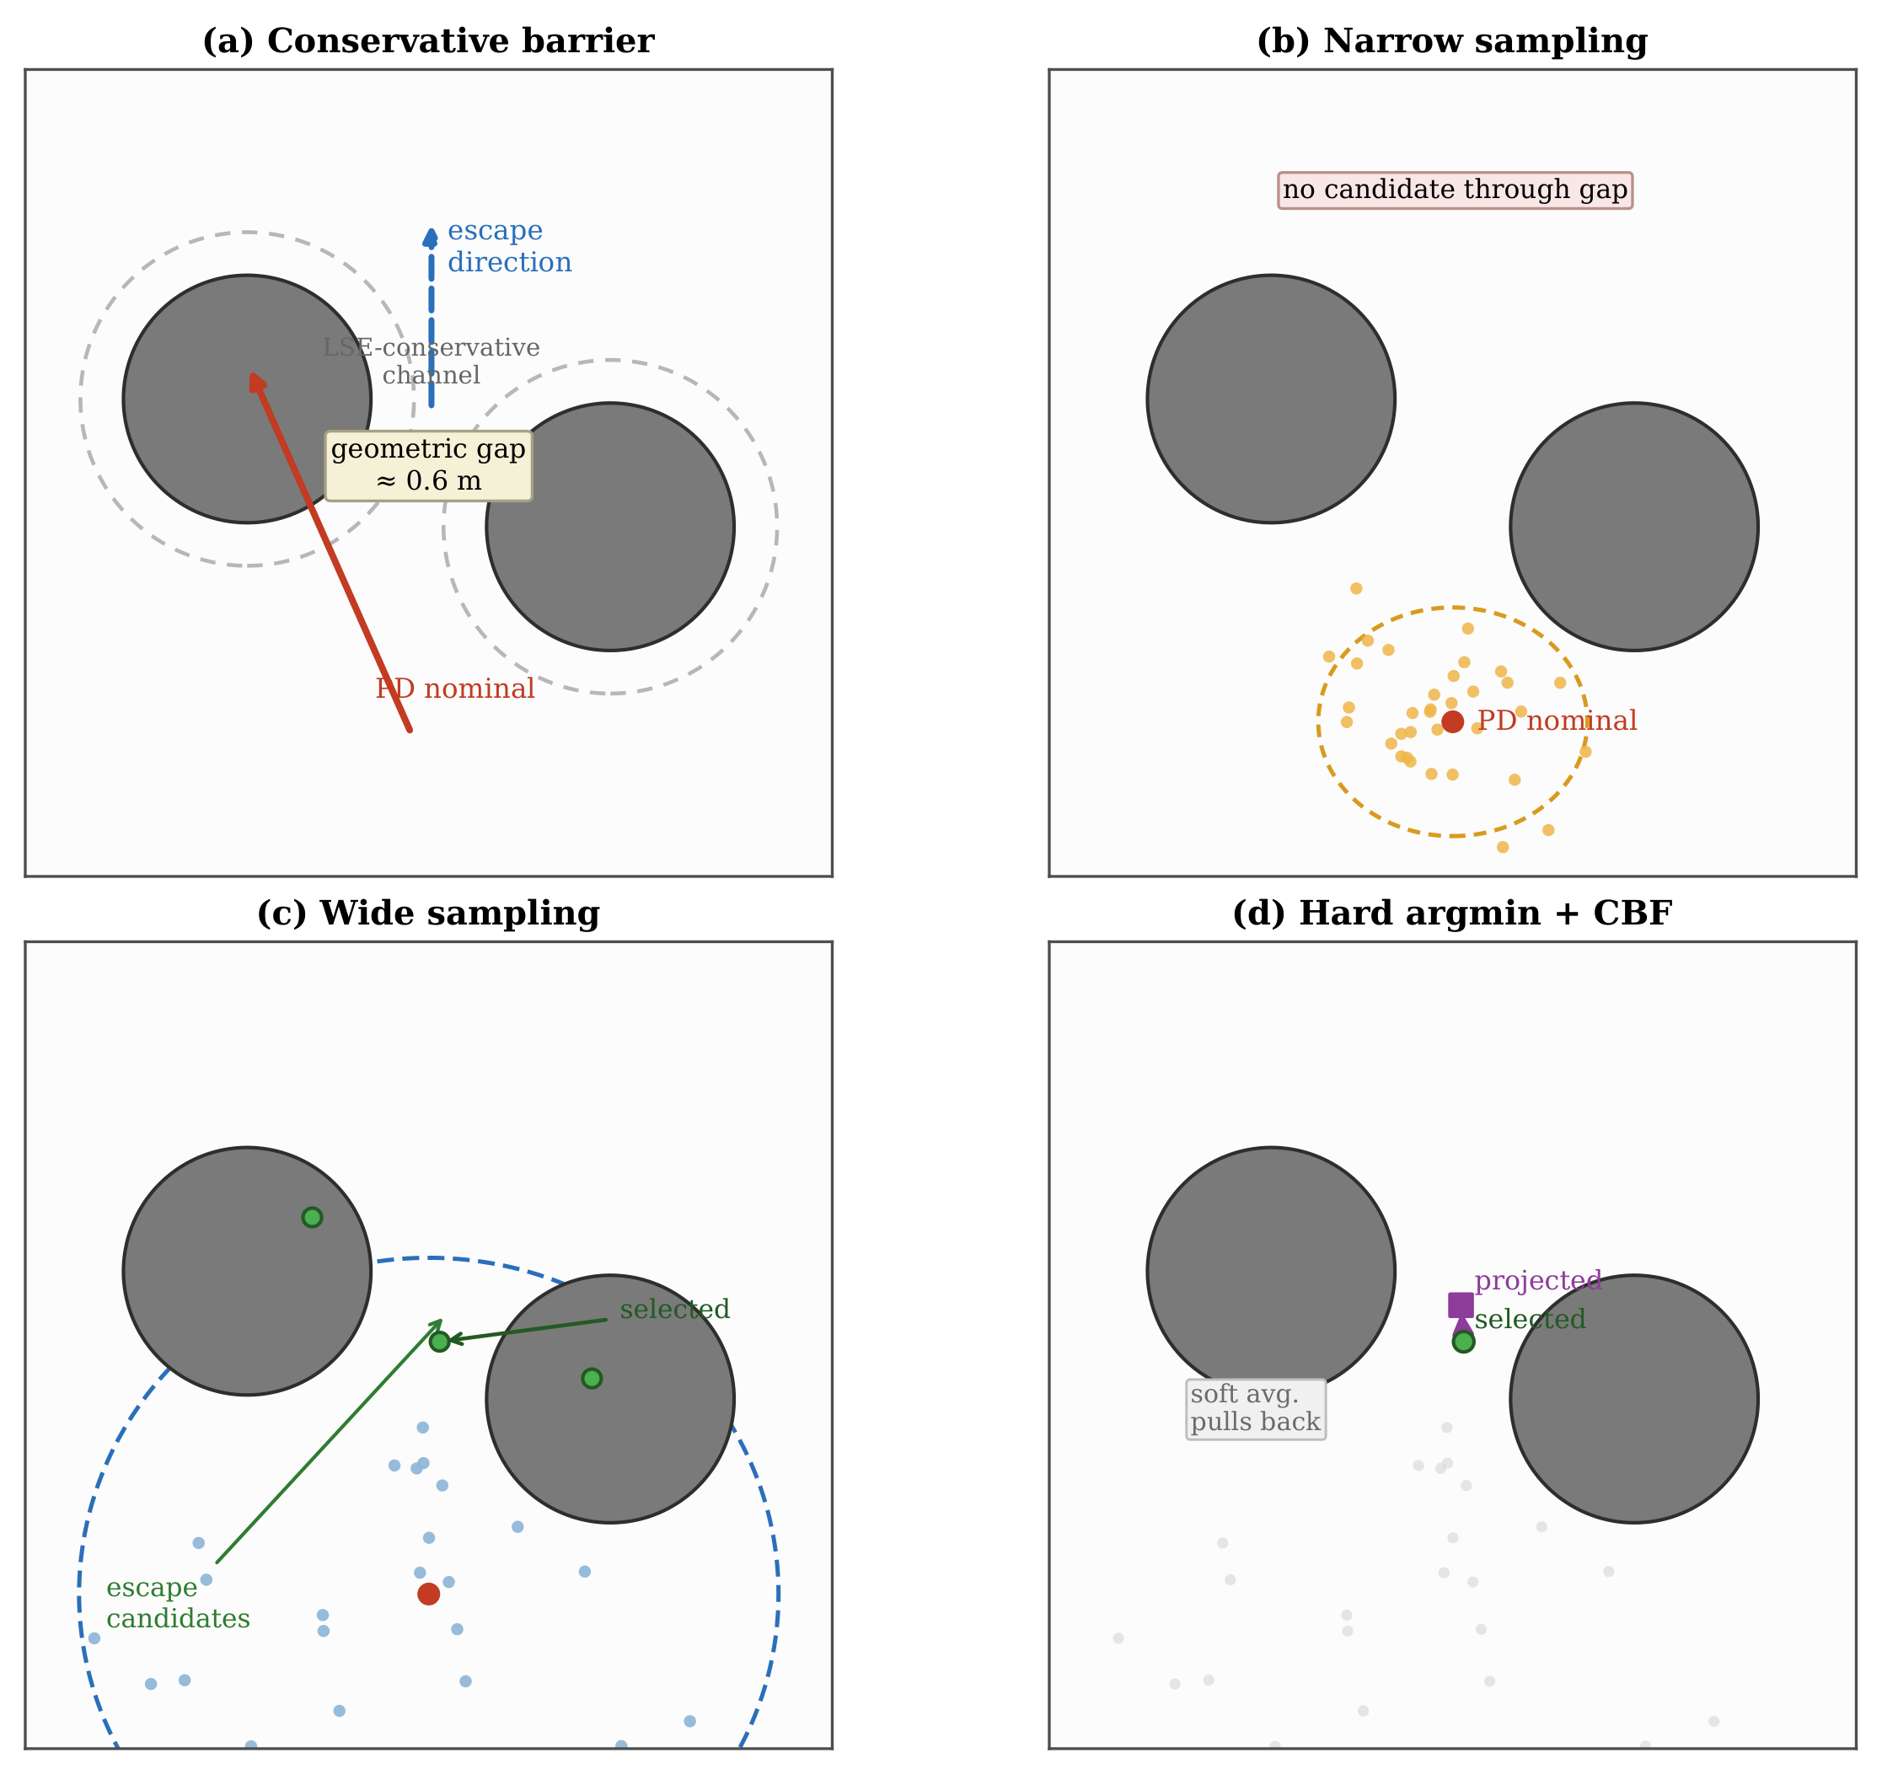
Figure 1. Candidate-generation failure and the three roles of TSH-NMPC. Narrow PD-centred sampling can miss the escape direction, while wide sampling creates sparse escape candidates. Hard argmin preserves the selected escape, and DT-CBF projection filters it before execution.
1.1 Contributions
1. Mechanistic diagnosis and controller design. Single-source PD-Gaussian sampling fails in narrow passages because the candidate pool inherits the directional bias of the nominal. TSH-NMPC couples wide sampling, hard-argmin selection, and DT-CBF projection to address escape generation, candidate preservation, and collision safety, respectively.
2. Empirical decomposition. The ablations show that narrowing the sampling scale caps success, soft selection degrades terminal tracking, and removing the CBF projection causes collisions. These effects support the view that the three design choices act on different parts of the narrow-passage failure mode.
3. Controlled comparisons. A learned-prior ablation shows that candidate-space coverage can dominate single-candidate prediction accuracy in this benchmark. Compared with CasADi+IPOPT, TSH-NMPC provides solver-free, fixed-budget computation rather than higher terminal accuracy.
1.2 Related Work
Sampling NMPC. MPPI ^{[1, 2]} uses importance-weighted averaging of K Gaussian-perturbed trajectories. This works well when many candidates provide graded improvement, but can dilute sparse escape directions in tight passages ^{[4, 5]}. CEM ^{[3, 6]} iteratively refits the proposal to the top-β quantile, at the cost of additional rollout evaluations. TSH-NMPC uses a fixed wide scale and hard selection without refitting or averaging.
CBFs, learned proposals, and scenario optimisation. Continuous-time CBFs ^{[7]} enforce forward-invariance; discrete-time variants ^{[8]} extend this to sampled-data execution. This paper uses DT-CCBF as a safety filter for wide exploration, not as a new CBF. Prior works replace the Gaussian proposal by a learned distribution ^{[9, 10, 11, 12]}, but few compare against an isotropic random source at matched budget (Section 5.3). Scenario optimisation ^{[13, 14]} bounds violation probability under a convexity assumption. TSH-NMPC satisfies only the weaker monotone property (Proposition 2) and makes no violation-probability claim.
2. Problem Formulation and Background
2.1 Quadrotor Abstract Translational Dynamics
The outer-loop translational guidance operates on a 6D state $x_{t}=[p_{t}^{⊤},v_{t}^{⊤}]^{⊤}∈ℝ^{6}$. The virtual control $u_{t}∈ℝ^{3}$ is the gravity-precompensated net force command; the inner-loop attitude controller is assumed fast enough ($T_{att}≪Δt$) that flatness-mapped tracking does not affect the translational closed loop. Discrete-time dynamics:
$$x_{t+1}=A_{d}x_{t}+B_{d}u_{t},A_{d}=\left(\begin{matrix}I_{3} & ΔtI_{3} \\ 0 & I_{3}\end{matrix}\right),B_{d}=\frac{Δt}{m}\left(\begin{matrix}0 \\ I_{3}\end{matrix}\right)$$ (1)
with body drag omitted in the nominal model (added in simulation, Section 5.1). Input saturation: $u_{t}∈[u_{min},u_{max}]^{3}$, $u_{max}=15N$.
2.2 Discrete-Time Composite CBF (DT-CCBF)
Let $𝒞_{i}=\left\{x∈ℝ^{6}:h_{i}(x)≥0\right\}$ be the obstacle-free set for obstacle i, with $h_{i}(x)={\left|p−p_{i}\right|}^{2}−r_{i}^{2}$. The unsafe set $∪_{i}{\overset{―}{𝒞}}_{i}$ is non-convex. We replace the per-obstacle minimum by the LSE composite:
$$h(x)=−\frac{1}{κ}log\sum_{i=1}^{M}{exp\left(−κh_{i}(x)\right),κ=5}$$ (2)
with $h(x)≤\min_{i}h_{i}(x)$ and $h(x)→\min_{i}h_{i}(x)$ as κ → ∞.
Remark (LSE conservatism). For M = 5 and κ = 5, the LSE composite introduces a conservative barrier-value offset of $κ^{−1}logM≈0.32$ m${}^{2}$. Because $h_{i}$ is quadratic in distance, this offset should not be interpreted as a constant radial inflation; locally it corresponds to an equivalent radial shift $Δr≈\sqrt{r^{2}+κ^{−1}logM}−r$, which reduces the apparent passage width. On narrow, the geometric gap is ≈0.6 m, so the LSE-conservative channel is substantially narrower. The DT-CBF condition ^{[8, 7]}:
$$h(x_{t+1})≥(1−α_{d})h(x_{t})−γ_{d}$$ (3)
with $(α_{d},γ_{d})=(0.8,0.2)$. Linearising about (1) yields $A(x_{t})^{⊤}u≤b(x_{t})$. The safety filter:
$$u_{safe}={argmin}_{u∈[u_{min},u_{max}]^{3}}\frac{1}{2}{\left|u−u_{nom}\right|}^{2}\text{s.t.}A(x_{t})^{⊤}u≤b(x_{t})$$ (4)
projects $u_{nom}$ onto the safe set. When infeasible, a box-constrained fallback with $δ_{buffer}=0.15m$ is used.
2.3 Sampling NMPC
Given $x_{t}$, $x_{sp}$, and budget K, a sampling NMPC controller builds K first-step candidates ${\left\{u^{(k)}\right\}}_{k=1}^{K}$, scores each by simulation-based cost $J^{(k)}$, and executes the lowest-cost candidate after CBF projection. The formulation is single-source when all K candidates share one Gaussian:
$$u^{(k)}\sim 𝒩(μ_{t},σ^{2}I_{3}),k=1,…,K$$ (5)
centred at a single nominal $μ_{t}$. MPPI ^{[1]} replaces hard argmin by importance-weighted averaging; CEM ^{[3]} iteratively refits a single-source Gaussian to the top-β quantile. Two-source (Section 3) combines two Gaussians of different covariances at the same nominal.
3. Method: Wide-Scale Sampling with Hard-Argmin Selection and CBF Projection
This section presents TSH-NMPC: K candidates from a wide-scale PD-centred Gaussian, scored by short rollout, hard-argmin selected, and CBF-projected. No learned predictor, importance weighting, or iterative refit is used (a learned-prior ablation appears in Section 5.3).
3.1 Wide-Scale PD-Centred Candidate Generation
At each step t, the controller draws K first-step controls from a wide-scale PD-centred Gaussian.
Default: single-source-wide ($R_{0,σ=5}$). With $u_{pd}(x_{t},x_{sp})=m(K_{p}(p_{sp}−p_{t})+K_{d}(v_{sp}−v_{t}))$, $(K_{p},K_{d})=(4,3)$:
$$u^{(k)}\sim 𝒩(u_{pd},σ_{r}^{2}I_{3}),k=1,…,K$$ (6)
where $σ_{r}=5.0N$ is a fixed scalar (operating plateau [5, 8], Section 5.2). At $σ_{r}≈u_{max}/3$, the distribution escapes PD basins while remaining narrow enough for rollout selection.
A two-source variant ($R_{1,σ=5}$) splits the budget evenly between $σ_{pd}=2$ and $σ_{r}=5$ and is empirically equivalent to the single-source-wide form (p = 0.51, Section 5.2.1). All candidates are clamped:
$$u^{(k)}←clip(u^{(k)},u_{min},u_{max}),k=1,…,K$$ (7)
3.2 Rollout-Based First-Step Cost Evaluation
Each candidate is scored by a short closed-loop rollout: $u^{(k)}$ at s=0, PD baseline at $s=1,…,S−1$:
$${\overset{\sim }{u}}_{s}^{(k)}=\left\{\begin{matrix}u^{(k)}, & s=0, \\ u_{pd}({\overset{\sim }{x}}_{s}^{(k)},x_{sp}), & 1≤s≤S−1,\end{matrix}\right.$$ (8)
with ${\overset{\sim }{x}}_{s+1}^{(k)}=f({\overset{\sim }{x}}_{s}^{(k)},{\overset{\sim }{u}}_{s}^{(k)})$ (Section 2), S = 20 (0.4 s). The cost is quadratic with obstacle penalty:
$$J^{(k)}=\sum_{s=1}^{S}{\left({\left|{\overset{\sim }{x}}_{s}^{(k)}−x_{sp}\right|}_{Q}^{2}+R{\left|{\overset{\sim }{u}}_{s}^{(k)}\right|}^{2}+ρ\sum_{i}{[δ−d_{i}({\overset{\sim }{x}}_{s}^{(k)})]_{+}^{2}}\right)}$$ (9)
$Q=diag(15,15,15,1,1,1)$, R = 0.02, ρ = 2000, δ = 0.3 m, $d_{i}(x)=\left|p−p_{i}\right|−r_{i}$. Hard-argmin:
$$k^{⋆}={argmin}_{1≤k≤K}J^{(k)},u_{nom}=u^{(k^{⋆})}$$ (10)
Rollout evaluation replaces Q-head pre-screening and MPPI averaging; Proposition 2 gives the monotone K-cost relation.
3.3 DT-CCBF Safety Projection
$u_{nom}$ from (10) is projected onto the safe set via the QP (4), solved in closed form via active-set on $ℝ^{3}$. The resulting $u_{safe}$ is executed.
3.4 Algorithm
The closed-loop step is: compute the PD nominal, sample K wide candidates, clamp to actuator bounds, roll out each candidate for S steps under the PD baseline, select the lowest-cost first input (hard argmin), and project it through the DT-CBF QP. Unless stated otherwise, all experiments use K = 10, $σ_{r}=5N$, S = 20, κ = 5, with $σ_{pd}=2N$ used only in the legacy two-source variant.
4. Theoretical Properties
We record two properties. The theory is minimal: TSH-NMPC is a sampling scheme atop an off-the-shelf DT-CCBF. We claim no stability or convergence beyond what either component provides.
4.1 Forward-Invariance of the Safe Set
Since $h_{i}$ depends on position and the input enters through acceleration, the input has relative degree 2 w.r.t. $h_{i}$. Expanding $h(x_{t+1})$ yields $A(x_{t})^{⊤}u≤b(x_{t})$, with A, b depending on the barrier gradient, velocity, and $(α_{d},γ_{d})$ (^{[8]}, ^{[7]}). The LSE composite has $h(x)≤\min_{i}h_{i}(x)$, gap $≤κ^{−1}logM≈0.32m$; h(x) ≥ 0 implies all per-obstacle barriers are non-negative.
Proposition 1 (Conditional DT-CBF invariance and empirical collision avoidance). Let $\overset{\sim }{h}(x):=h(x)+γ_{d}/α_{d}$, $\overset{\sim }{C}:=\left\{x:\overset{\sim }{h}(x)≥0\right\}$. Conditional on QP (4) feasibility at every step, $\overset{\sim }{C}$ is forward invariant: $x_{t}∈\overset{\sim }{C}⇒x_{t+1}∈\overset{\sim }{C}$. The trajectory remains in $\left\{x:h(x)≥−γ_{d}/α_{d}\right\}$ (margin = 0.25 m).
If the QP has no feasible solution, a box-constrained fallback applies full effort in the barrier-gradient direction. The proposition does not apply during fallback, but $δ_{buffer}=0.15m$ absorbs the one-step excursion (≈0.06 m at v ≤ 3 m/s). Empirically, zero collisions are observed across all CBF-enabled trials (Section 5.4).
4.2 Monotone Expected Min-Cost in K
Proposition 2 (Monotone expected cost). Let $u^{(1)},…,u^{(K)}$ be drawn independently from the sampling distribution, then clamped to $[u_{min},u_{max}]^{3}$. Define $J_{K}^{⋆}:=\min_{1≤k≤K}J(u^{(k)})$ where J(·) is the rollout cost (9). Then $𝔼[J_{K+1}^{⋆}]≤𝔼[J_{K}^{⋆}]$ for every K ≥ 1.
This is the non-convex analogue of the monotone-cost property in scenario optimisation ^{[13, 14]}: more candidates cannot worsen the expected selected cost. It establishes non-pathology only — no rate, no convergence to the continuous-space optimum.
5. Experiments
We evaluate TSH-NMPC against a single-source PD-rollout baseline on three task families, sweep $σ_{r}$, test under perturbed parameters, ablate learned vs. random priors, and report latency. All reported numerical values are generated from logged experiment files; figures and tables are not manually edited.
5.1 Setup
Tasks. Three families (see Supplementary Fig. S1): narrow (five-sphere tight passage), two_gate (homotopy choice), u_shape. Dynamics: m = 1.5 kg, $Δt=0.02s$, $u_{max}=15N$, $N_{steps}=150$ (3 s), $(α_{d},γ_{d})=(0.8,0.2)$, κ = 5. Obstacle positions perturbed $δ_{p}\sim 𝒰(−0.03,+0.03)^{3}m$ per trial. Three quadrotor configurations: nominal (1.5, 0.1), +50% mass (2.25, 0.1), +50% drag (1.5, 0.15); controllers not re-tuned.
Methods and metrics. $R_{1,σ_{r}}$: TSH-NMPC with random Source B at scale $σ_{r}$; pd: single-source $𝒩(u_{pd},σ_{pd}^{2}I)$; $A_{3}$: learned-prior Source B (Section 5.3). Main result sweeps $K∈\left\{5,10,20\right\}$; elsewhere K = 10. Success: TErr ≤ 0.3 m and collision-free. TErr: $\left|p_{T}−p_{sp}\right|$, IAE: $\sum_{t}{\left|p_{t}−p_{sp}\right|Δt}$.
Statistics. Each cell uses $N_{MC}$ paired trials. McNemar exact two-sided p on discordant counts; bootstrap 95% CIs on $ΔTErr$ and $ΔIAE$ with failures imputed (TErr = 10 m, IAE = 20). Significance: p < 0.05 and CI excluding zero. Holm–Bonferroni ^{[15]} at m = 13 confirms 7/13 tests at family-corrected level (m = 28 consistent). Additional fallback, wind, dynamic-obstacle, and latency results are provided in Supplementary Secs. S1–S5.
5.2 Main Results, Scale Sweep, and Robustness
Fig. 2 summarises the main NARROW results. At K = 10, success rose from 66.3% to 98.8%, and TErr dropped from 0.380 m to 0.039 m. TSH-NMPC at K = 5 already exceeded PD at K = 20, indicating a qualitative candidate-distribution effect rather than a pure sample-count effect. Full confidence intervals and McNemar counts are in Supplementary Table S4.
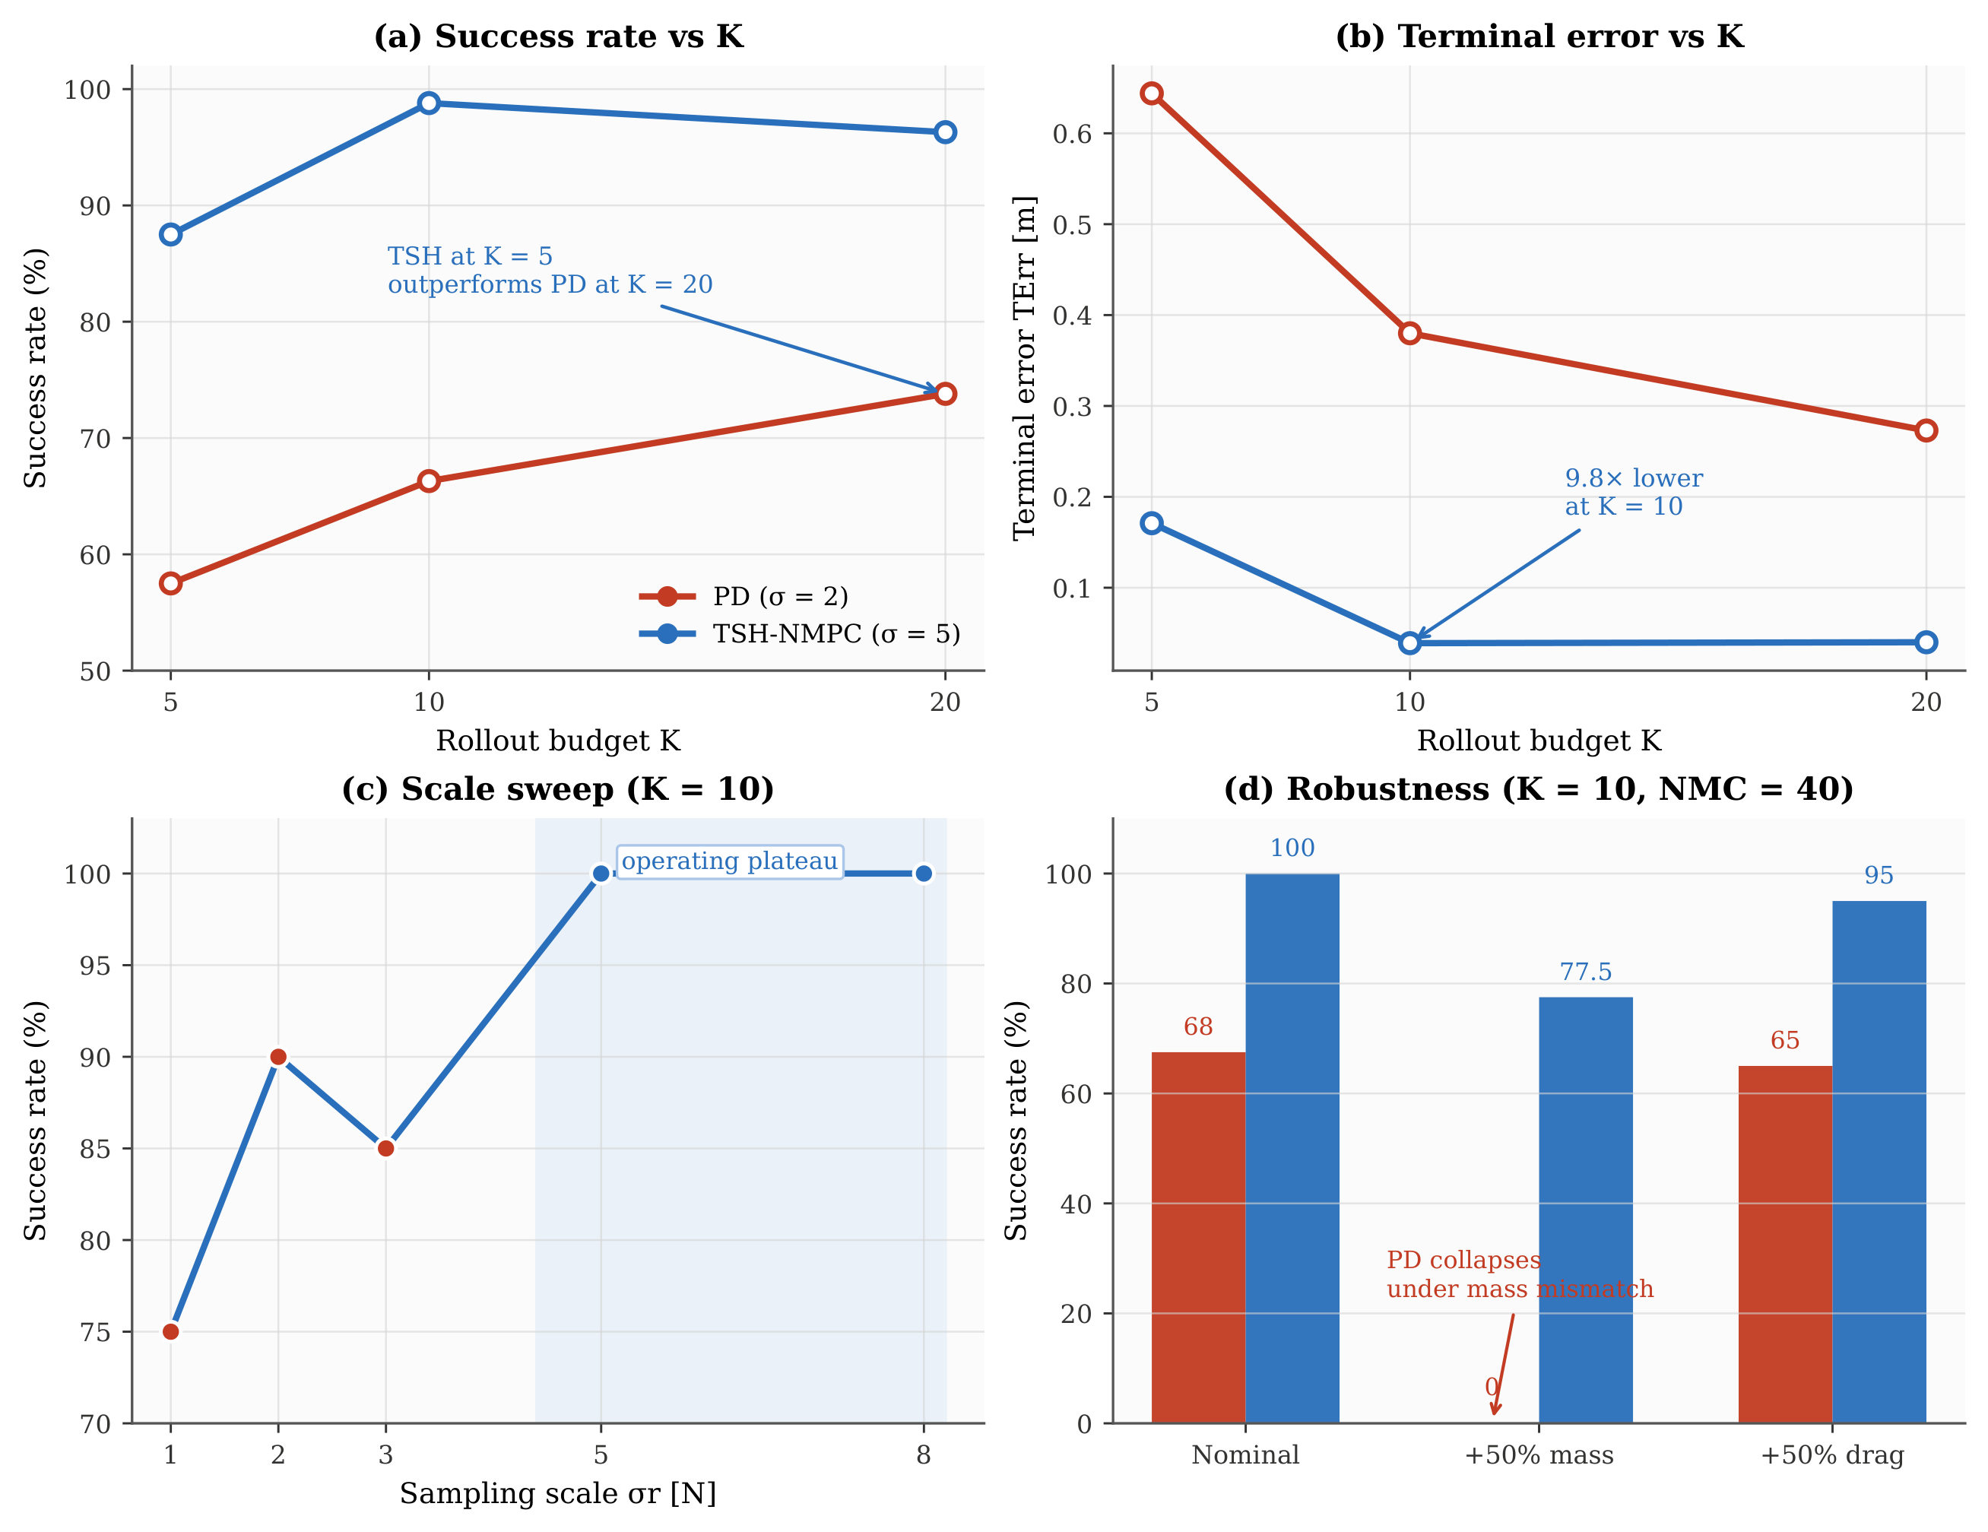
Figure 2. Main quantitative evidence on narrow. (a,b) Success rate and terminal error versus K: TSH-NMPC outperforms PD across budgets. (c) $σ_{r}$ sweep (K=10): success saturates at $σ_{r}≥5$ N, defining the operating plateau (shaded). (d) Robustness under +50% mass and +50% drag: TSH-NMPC retains success while PD collapses under mass mismatch.
On two_gate and u_shape (K = 10, $N_{MC}=40$), PD achieves 100% success; $R_{1,σ=5}$ matches 40/40 and strictly improves TErr and IAE (Supplementary Table S1).
The $σ_{r}$ sweep in Fig. 2(c) shows that $σ_{r}≤1N$ is too tight, $σ_{r}=2$–3 N improves but does not saturate success, and $σ_{r}≥5N$ forms the operating plateau (full table with CIs in Supplementary Table S6).
Under +50% mass, PD collapsed to 0/40 while TSH-NMPC retained 31/40 success at K = 10; across three seeds this rose to 99/120 vs. 0/120. Under +50% drag, success improved from 26/40 to 38/40 (full tables in Supplementary Tables S2–S3).
5.2.1 PI-PD, Single-Source-Wide Ablation, and MPPI/CEM Baselines
Additional ablations ruled out simpler alternatives. PI-PD also failed under +50% mass. $R_{0,σ=5}$ was statistically equivalent to $R_{1,σ=5}$ (p = 0.508). MPPI and CEM required wider sampling or larger budgets to match success, and accepted worse terminal tracking. Full PI-PD, MPPI, CEM, and iCEM sweeps are in Supplementary Tables S7–S8.
5.3 Diversity-over-Accuracy Ablation: Learned Prior as Source B
Can Source B be improved by a learned predictor? $A_{3}$ keeps Source A unchanged ($K_{A}=K/2$ PD-centred Gaussian) but draws $K_{B}=K/2$ from a 27,935-parameter TRM trained on 50,000 closed-loop PD+CBF trajectories; otherwise identical to TSH-NMPC.
Headline ($N_{MC}=300$). The well-powered comparison ($Δ_{min}≈0.06$) is decisive: $R_{1,σ=5}$ (293/300, 97.7%) and $R_{0,σ=5}$ (296/300, 98.7%) dominate $A_{3}$ (266/300, 88.7%; McNemar $p=7.4×{10}^{−6}$). In this benchmark, random wide sampling outperformed the learned source, indicating that candidate diversity was more important than single-step prediction accuracy. A second TRM with better one-step accuracy performed worse, consistent with diversity collapse (Supplementary Table S9).
5.4 Comparison against CasADi+IPOPT NLP-based NMPC
We evaluate multiple-shooting NMPC with CasADi+IPOPT ^{[16, 17]} (identical Q,R, soft obstacle penalty; details are provided in Supplementary Sec. S4). CasADi-H20 achieved 80/80 success on nominal narrow with TErr = 0.003 m and 5.3 ms mean latency. TSH-NMPC achieved the same success rate at K ≥ 20 (TErr = 0.032 m at K=20, 0.015 m at K=50) but did not match CasADi’s terminal accuracy. Under +50% mass, TSH-NMPC at K = 150 reached 40/40 versus CasADi’s 37/40. The key distinction is fixed rollout computation instead of data-dependent NLP iterations. Per-call controller cost is 5.7 ms at K = 10, close to CasADi’s 5.3 ms; full per-step latency including simulator bookkeeping is 10.7 ± 2.1 ms. P99, deadline overruns, and McNemar details are in Supplementary Tables S10–S11. TSH-NMPC should therefore be interpreted as a fixed-budget solver-free alternative, not as a higher-accuracy replacement for NLP-based NMPC.
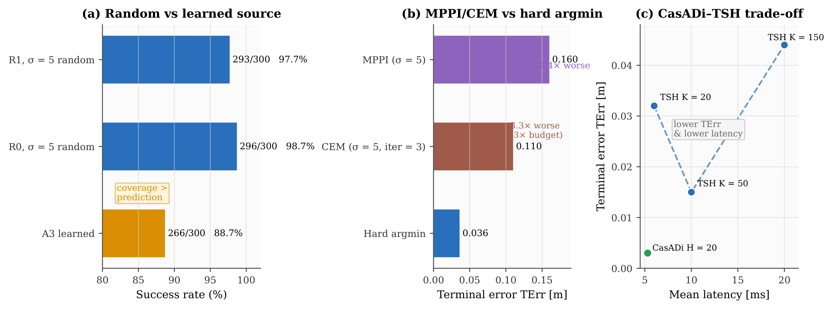
Figure 3. Controlled comparisons. (a) Random wide vs. learned source ($N_{MC}=300$): coverage dominates prediction accuracy. (b) MPPI/CEM vs. hard-argmin: soft weighting and refitting degrade terminal tracking. (c) CasADi vs. TSH latency–error trade-off: lower TErr and latency for CasADi; fixed-budget computation for TSH.
6. Discussion
6.1 Mechanism and Relation to Alternatives
What the ablation shows is that the three pieces have separate jobs. Wider sampling (σ ≥ 5) is what makes escape candidates possible. Hard-argmin keeps those rare escape candidates from getting washed out by soft averaging (4.4× lower TErr than MPPI at matched σ). The CBF projection stops collisions that wider exploration would otherwise cause. The three pieces only work together in this narrow-passage regime: if the sampling is narrow you cannot escape, soft aggregation dilutes escape candidates, and without the safety filter wide exploration is unsafe.
At matched σ = 5, hard-argmin gave lower terminal error than MPPI (4.4× worse TErr) and CEM (3.3× worse TErr at 3× the rollout budget). Against CasADi+IPOPT, the method trades terminal accuracy for a fixed-budget computation.
6.2 Limitations and Future Work
A few limits narrow how far the results carry: (i) simulation only; hardware would need to deal with attitude lag and non-isotropic disturbances; (ii) single 6D quadrotor model; (iii) author-constructed benchmarks; (iv) $σ_{r}$ is a fixed scalar, not yet adaptive; (v) the diversity-over-accuracy finding is tied to roughly isotropic escape geometries; (vi) Proposition 2 gives monotone expected cost only, with no violation-probability bound. Stress tests with Dryden wind and dynamic obstacles are reported in the supplementary material; the remaining gap is hardware validation including attitude lag, actuator limits, sensing noise, and PX4 SITL deployment.
7. Conclusion
This paper looked at a specific way that PD-centred sampling NMPC can break down in narrow-passage quadrotor flight. When the PD nominal points toward a conservative barrier boundary, narrow sampling may give no control that actually goes through the gap. TSH-NMPC fixes this by putting together three things: wide PD-centred sampling, hard-argmin rollout selection, and DT-CBF projection. The experiments show these three pieces each deal with a different piece of the failure: one generates escape candidates, one keeps the rare useful ones, and one filters out collisions. In the end, the controller is best thought of as a solver-free, fixed-budget option for this benchmark setting. It gets to the same success rate as NLP-based NMPC on the tasks tested, but it does not match the terminal accuracy. The results are still only from simulation and use a fixed sampling scale; hardware tests and adaptive scale selection still need to be done.
8. References
[1] G. Williams, N. Wagener, B. Goldfain, P. Drews, J. M. Rehg, B. Boots, and E. A. Theodorou, “Information theoretic MPC for model-based reinforcement learning,” in Proc. IEEE Int. Conf. Robot. Autom. (ICRA), 2017, pp. 1714–1721.
[2] G. Williams, P. Drews, B. Goldfain, J. M. Rehg, and E. A. Theodorou, “Information-theoretic model predictive control: Theory and applications to autonomous driving,” IEEE Trans. Robot., vol. 34, no. 6, pp. 1603–1622, Dec. 2018.
[3] Z. I. Botev, D. P. Kroese, R. Y. Rubinstein, and P. L’Ecuyer, “The Cross-Entropy Method for Optimization,” in Handbook of Statistics, vol. 31, ch. 3, 2013.
[4] S. Sun, A. Romero, P. Fojt, G. Cioffi, and D. Scaramuzza, “A comparative study of nonlinear MPC and differential-flatness-based control for quadrotor agile flight,” IEEE Trans. Robot., vol. 38, no. 6, pp. 3357–3373, Dec. 2022.
[5] M. S. Gandhi, B. Vlahov, J. Gibson, G. Williams, and E. A. Theodorou, “Robust model predictive path integral control: Analysis and performance guarantees,” IEEE Robot. Automat. Lett., vol. 6, no. 2, pp. 1423–1430, Apr. 2021.
[6] R. Y. Rubinstein and D. P. Kroese, The Cross-Entropy Method: A Unified Approach to Combinatorial Optimization, Monte-Carlo Simulation, and Machine Learning. Springer, 2004.
[7] A. D. Ames, X. Xu, J. W. Grizzle, and P. Tabuada, “Control barrier function based quadratic programs for safety critical systems,” IEEE Trans. Autom. Control, vol. 62, no. 8, pp. 3861–3876, Aug. 2017.
[8] L. Wang, A. D. Ames, and M. Egerstedt, “Safety barrier certificates for collisions-free multirobot systems,” IEEE Trans. Robot., vol. 33, no. 3, pp. 661–674, Jun. 2017.
[9] Y. Pan, C.-A. Cheng, K. Saigol, K. Lee, X. Yan, E. Theodorou, and B. Boots, “Agile autonomous driving using end-to-end deep imitation learning,” RSS, 2017.
[10] G. Kahn, A. Villaflor, B. Ding, P. Abbeel, and S. Levine, “Self-supervised deep RL with generalized computation graphs for robot navigation,” ICRA, 2018.
[11] M. Okada, L. Martinez, and T. Taniguchi, “Variational inference MPC for multi-modal control proposals,” IEEE Robot. Automat. Lett., vol. 5, no. 4, pp. 5580–5587, 2020.
[12] M. Janner et al., “Planning with diffusion for flexible behavior synthesis,” ICML, 2022.
[13] M. C. Campi and S. Garatti, “The exact feasibility of randomized solutions of uncertain convex programs,” SIAM J. Optim., vol. 19, no. 3, pp. 1211–1230, 2008.
[14] M. C. Campi and S. Garatti, “Wait-and-judge scenario optimisation,” Mathematical Programming, vol. 167, no. 2, pp. 307–346, 2018.
[15] S. Holm, “A simple sequentially rejective multiple test procedure,” Scand. J. Stat., vol. 6, no. 2, pp. 65–70, 1979.
[16] J. A. E. Andersson, J. Gillis, G. Horn, J. B. Rawlings, and M. Diehl, “CasADi: A software framework for nonlinear optimisation and optimal control,” Mathematical Programming Computation, vol. 11, no. 1, pp. 1–36, 2019.
[17] A. Wächter and L. T. Biegler, “On the implementation of an interior-point filter line-search algorithm for large-scale nonlinear programming,” Mathematical Programming, vol. 106, no. 1, pp. 25–57, 2006.

