Supplementary Material
WIDE-SCALE SAMPLING WITH HARD-ARGMIN SELECTION AND CBF PROJECTION FOR SAFE QUADROTOR NAVIGATION IN NARROW PASSAGES
This supplement reports the benchmark geometries, full confidence intervals, additional ablations, learned-prior details, and CasADi+IPOPT latency tables. The main paper only reports the compact evidence needed for the central claim.
S1. Cross-Task Generalisation and Cross-Configuration Robustness

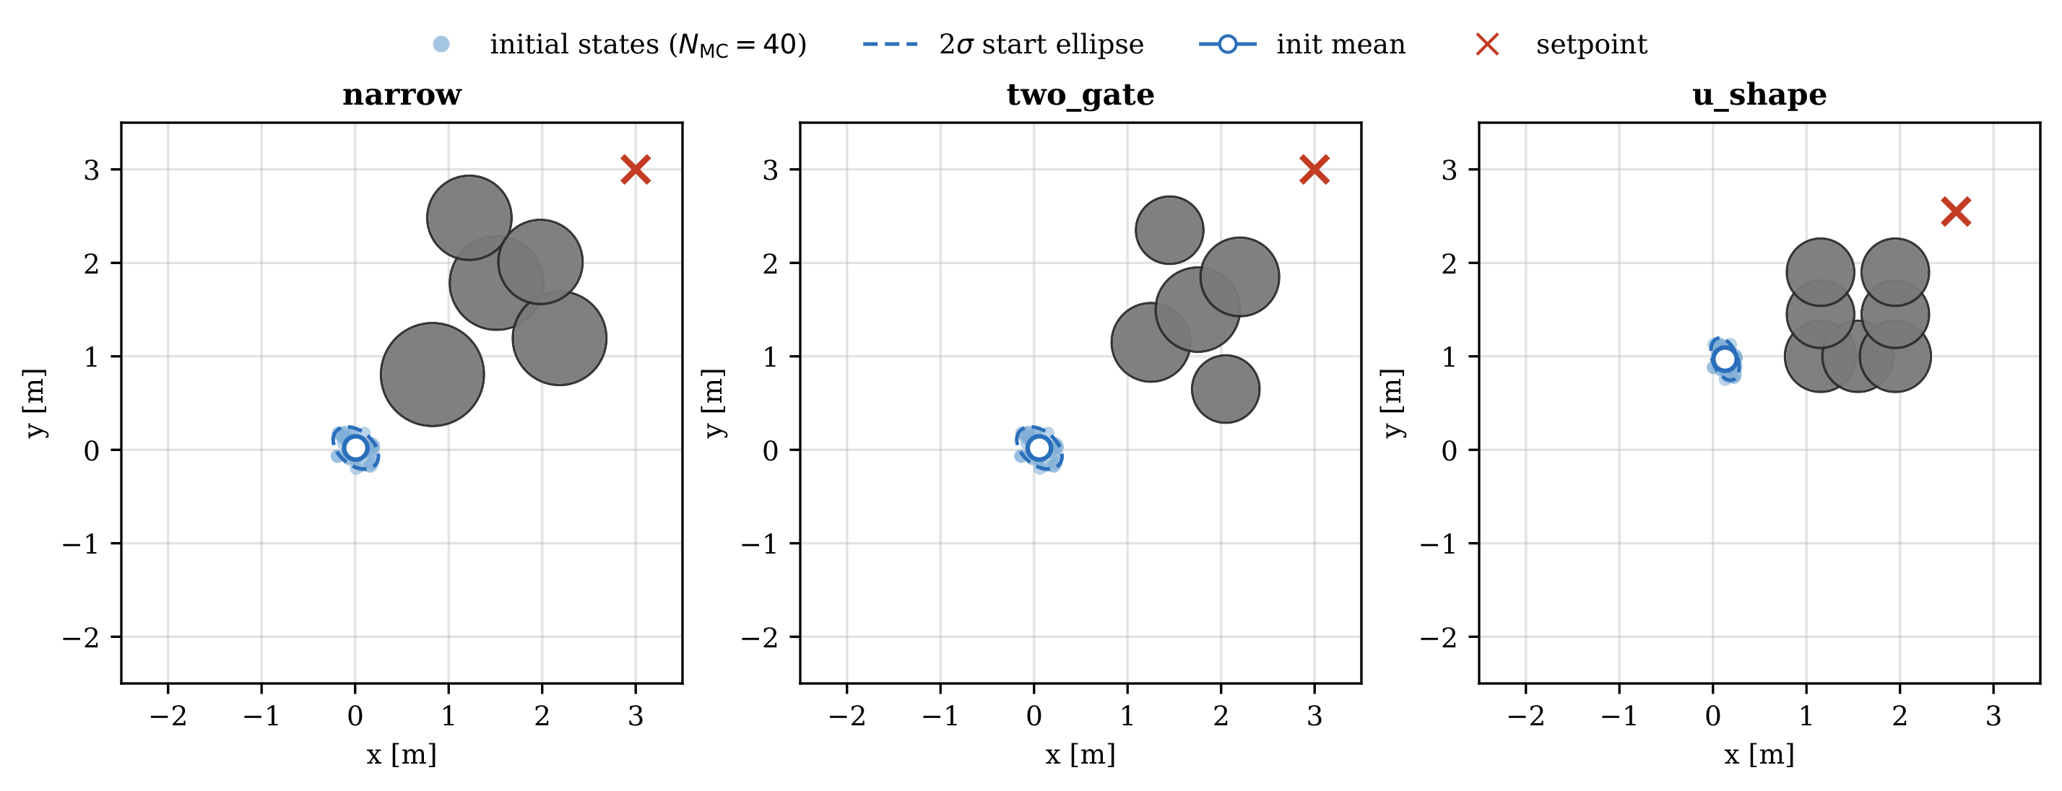
Figure S1. Benchmark geometries (top-down xy projection). Gray disks: obstacles; blue dots: sampled initial positions; blue dashed ellipse: 2σ initial-state region; red ×: setpoint. narrow: five-obstacle gap; two_gate: homotopy choice; u_shape: concave trap.
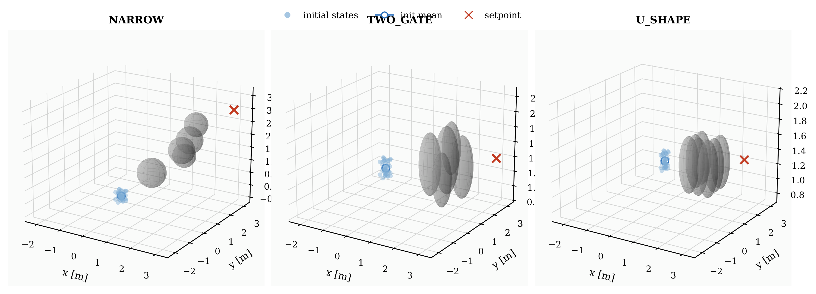
Figure S2. Three-dimensional overview of the three benchmark tasks. Obstacles are shown as spheres; the setpoint is marked in red. narrow: five-sphere gap; two_gate: homotopy choice; u_shape: concave trap.
S1.1 Cross-Task Generalisation
Table S1 reports cross-task results on two_gate and u_shape (K = 10, $N_{MC}=40$).
Table S1. Cross-task generalisation (K = 10, $N_{MC}=40$).
Task | Method | Succ. | TErr [m] | IAE
two_gate | PD | 40/40 | 0.045 | 5.84
two_gate | $R_{1,σ=5}$ | 40/40 | 0.031 | 5.56
u_shape | PD | 40/40 | 0.054 | 6.82
u_shape | $R_{1,σ=5}$ | 40/40 | 0.040 | 6.54
S1.2 Cross-Configuration Robustness
Table S2 provides full cross-configuration results with bootstrap CIs. Controllers use K = 10, $N_{MC}=40$, and are not re-tuned. The PD nominal uses m = 1.5 kg throughout.
Table S2. Cross-configuration robustness on narrow (K = 10, $N_{MC}=40$). $Δ=R_{1,σ=5}−\text{PD}$ on paired both-success trials.
Config. | PD succ. | $R_{1,σ=5}$ succ. | McN. (b,c) | $ΔTErr$ [95% CI] | $ΔIAE$ [95% CI]
nominal (1.5, 0.1) | 27/40 | 40/40 | (13,0) | -0.094 [-0.125, -0.065] | -2.02 [-2.23, -1.81]
+50% mass (2.25, 0.1) | 0/40 | 31/40 | (31,0) | — | —
+50% drag (1.5, 0.15) | 26/40 | 38/40 | (12,0) | -0.093 [-0.124, -0.062] | -1.91 [-2.19, -1.65]
S1.3 Additional Baselines and Three-Seed Replication
Table S3 reports PI-PD, oracle Adaptive-PD, and single-source-wide variants under +50% mass.
Table S3. Additional baselines on narrow, +50% mass (K = 10, $N_{MC}=40$).
Method | Succ. | Notes
PD (σ = 2, nominal mass) | 0/40 | baseline
PI-PD ($K_{i}=2$) | 0/40 | integral correction insufficient
Adaptive-PD (oracle mass) | 28/40 | requires oracle knowledge
$R_{1,σ=5}$ (two-source) | 31/40 | matches oracle (p = 0.45)
$R_{0,σ=5}$ (single-source-wide) | 32/40 | equivalent to $R_{1,σ=5}$ (p = 0.508)
Three-seed replication for +50% mass: pooled $R_{1,σ=5}$ 99/120 = 82.5% (Wilson 95% CI [74.9%, 88.2%]), PD 0/120.
S1.4 Main Narrow-Passage Result: Full Table with CIs
Table S4 reproduces the complete main result including Wilson CIs, McNemar discordant counts, and bootstrap CIs on $ΔTErr$ and $ΔIAE$.
Table S4. Main result on narrow ($N_{MC}=80$ paired trials, full). Bold = significant (p < 0.05, CI excludes zero).
K | Method | succ. (Wilson 95% CI) | TErr | IAE | McNemar (b,c) | $ΔTErr$ [95% CI] | $ΔIAE$ [95% CI]
5 | PD | 46/80=57.5% [46.4,67.9] | 0.644 | 9.31 | — | — | —
5 | $R_{1,σ=5}$ | 70/80=87.5% [78.5,93.0] | 0.171 | 6.94 | (3,27),p<0.001 | -3.04 [-4.26,-1.92] | -5.11 [-6.51,-3.72]
10 | PD | 53/80=66.3% [55.4,75.6] | 0.380 | 8.53 | — | — | —
10 | $R_{1,σ=5}$ | 79/80=98.8% [93.2,99.8] | 0.039 | 6.22 | (1,27),p<0.001 | -3.29 [-4.40,-2.29] | -5.64 [-6.95,-4.37]
20 | PD | 59/80=73.8% [63.1,82.2] | 0.273 | 8.03 | — | — | —
20 | $R_{1,σ=5}$ | 77/80=96.3% [89.6,98.7] | 0.040 | 5.82 | (1,19),p<0.001 | -2.29 [-3.28,-1.30] | -4.54 [-5.75,-3.37]
S1.5 TSH-NMPC Algorithm and Default Hyperparameters
Algorithm S1 summarises one closed-loop step of TSH-NMPC. Table S5 lists the default hyperparameters used throughout Section 5 of the main text.
Algorithm S1. TSH-NMPC: one closed-loop step at state $x_{t}$
Require: state $x_{t}$, setpoint $x_{sp}$, budget K, scale $σ_{r}$, horizon S
1: $u_{pd}←m(K_{p}(p_{sp}−p_{t})+K_{d}(v_{sp}−v_{t}))$ ▷ PD nominal
2: sample $u^{(1:K)}\sim 𝒩(u_{pd},σ_{r}^{2}I)$ ▷ wide-scale PD-centred
3: clip $u^{(1:K)}$ to $[u_{min},u_{max}]$
4: for k = 1, …, K (vectorized) do
5: simulate S-step rollout; compute $J^{(k)}$ via cost
end for
6: $u_{nom}←u^{(arg\min_{k}J^{(k)})}$ ▷ hard-argmin
7: build $(A(x_{t}),b(x_{t}))$ from DT-CCBF
8: $u_{safe}←$ solve QP; fallback if infeasible
9: return $u_{safe}$
Two-source variant: replace Line 3 with $K_{A}←⌊K/2⌋$ tight samples at $σ_{pd}=2$ plus $K_{B}=K−K_{A}$ wide samples at $σ_{r}$.
Table S5. TSH-NMPC hyperparameters (defaults used throughout the experiments).
Symbol | Default | Role
K | 10 | total candidate budget
$σ_{r}$ | 5.0 N | wide-scale noise (per axis; operating plateau [5,8])
$σ_{pd}$ | 2.0 N | tight-scale noise (legacy; two-source variant only)
S | 20 (=0.4 s) | rollout horizon
κ | 5 | DT-CCBF LSE smoothness
S1.6 $σ_{r}$ Sweep: Full Table
Table S6 provides the complete $σ_{r}$ sweep with bootstrap CIs on $ΔTErr$ and $ΔIAE$ vs. PD.
Table S6. $σ_{r}$ sweep on narrow (K = 10, $N_{MC}=40$). PD baseline: 27/40, TErr = 0.294, IAE = 8.52.
$σ_{r}$ [N] | succ. | TErr [m] (succ.) | IAE (succ.) | McNemar (b,c), p vs PD | $ΔTErr$, $ΔIAE$ vs PD, 95% CI
1 | 30/40 = 75.0% | 0.261 | 8.00 | (5,2), 0.453 (n.s.) | -0.043 [-0.070,-0.014]; -0.430 [-0.649,-0.227]
2 | 36/40 = 90.0% | 0.236 | 7.54 | (9,0), 0.004 | -0.065 [-0.092,-0.040]; -0.874 [-1.071,-0.672]
3 | 34/40 = 85.0% | 0.195 | 7.28 | (9,2), 0.065 (marg.) | -0.065 [-0.094,-0.039]; -1.169 [-1.399,-0.947]
5 | 40/40 = 100% | 0.036 | 6.23 | (13,0), <0.001 | -0.094 [-0.125,-0.065]; -2.023 [-2.233,-1.809]
8 | 40/40 = 100% | 0.016 | 5.33 | (13,0), <0.001 | -0.094 [-0.126,-0.063]; -2.689 [-2.900,-2.465]
S2. MPPI, CEM, and iCEM Sweep Data

Table S7 compares MPPI, CEM, iCEM, and hard-argmin at K = 10, $σ∈\left\{2,5\right\}$. Table S8 reports the MPPI temperature sweep.
Table S7. MPPI/CEM/iCEM vs. hard-argmin on narrow ($N_{MC}=40$, seed 7777).
Method | σ | $n_{iter}$ | Succ. (nominal) | Succ. (+50% mass) | TErr (nominal) [m]
MPPI (λ = 0.1) | 2 | 1 | 22/40 | 1/40 | ∼ 0.25
MPPI (λ = 5.0) | 5 | 1 | 39/40 | — | ∼ 0.16
CEM | 2 | 3 | 24/40 | 2/40 | ∼ 0.20
CEM | 5 | 3 | 40/40 | — | 0.110
iCEM | 2 | 3 | 40/40 | — | ∼ 0.043
$R_{1,σ=5}$ (hard-argmin) | 5 | 1 | 40/40 | 32/40 | 0.036
Table S8. MPPI λ sweep on narrow (K = 10, σ = 2, $N_{MC}=80$, seed 7777).
λ | Succ. | TErr [m] | IAE
0.01 | 41/80 = 51.3% | 0.455 | 8.48
0.05 | 44/80 = 55.0% | 0.424 | 8.36
0.1 | 46/80 = 57.5% | 0.392 | 8.22
0.5 | 41/80 = 51.3% | 0.442 | 8.52
1.0 | 45/80 = 56.3% | 0.425 | 8.41
5.0 | 44/80 = 55.0% | 0.480 | 8.53
S3. Negative Ablation: Learned Prior vs. Random Wide Source

S3.1 $N_{MC}=80$ Full Table
Table S9 provides the full $N_{MC}=80$ head-to-head (seed 7777). $A_{3}$ uses a 27,935-parameter TRM as Source B; the random source uses σ = 5.
Table S9. Negative ablation on narrow ($N_{MC}=80$, seed 7777).
K | Method | Succ. / 80 | TErr [m] | IAE | vs. $R_{1,σ=5}$ p
5 | PD | 34/80 = 42.5% | 0.117 | 8.29 | —
5 | $A_{3}$ | 63/80 = 78.8% | 0.069 | 6.38 | 0.572 (n.s.)
5 | $R_{1,σ=5}$ | 67/80 = 83.8% | 0.044 | 6.65 | —
10 | PD | 54/80 = 67.5% | 0.110 | 7.91 | —
10 | $A_{3}$ | 73/80 = 91.2% | 0.030 | 5.92 | 0.180 (n.s.)
10 | $R_{1,σ=5}$ | 78/80 = 97.5% | 0.034 | 6.23 | —
20 | PD | 70/80 = 87.5% | 0.084 | 7.52 | —
20 | $A_{3}$ | 75/80 = 93.8% | 0.022 | 5.65 | 0.219 (n.s.)
20 | $R_{1,σ=5}$ | 79/80 = 98.8% | 0.016 | 5.75 | —
S3.2 $N_{MC}=300$ Headline
$N_{MC}=300$ (seed 7777): $R_{1,σ=5}$ 293/300 = 97.7%; $R_{0,σ=5}$ 296/300 = 98.7%; $A_{3}$ 266/300 = 88.7%. McNemar $A_{3}$ vs. $R_{1,σ=5}$: $p=7.4×{10}^{−6}$ (minimum detectable $Δ_{min}≈0.06$).
S3.3 TRM Architecture
The TRM is a weight-shared latent recursive network (64-dim latent, 16 recursive steps, 27,935 parameters) mapping $[x_{t},x_{sp}]$ to a 30-dim control sequence. Only the first 3 dims are used for candidate generation. Training: 50,000 samples from 500 closed-loop PD+CBF trajectories. A second TRM trained on narrow trajectories (9× better single-step TErr) yielded worse closed-loop $A_{3}$, consistent with diversity collapse of a sharper proposal.
S4. CasADi+IPOPT NLP NMPC Details

S4.1 NLP Formulation
The comparison uses multiple-shooting with CasADi Opti + IPOPT, keeping the same Q, R weights and soft obstacle penalty (ρ = 2000, δ = 0.3 m) as TSH-NMPC (Eq. 6, main text). Two horizons were tested: H = 10 (0.2 s) and H = 20 (0.4 s). Unlike TSH-NMPC, there is no separate CBF projection here; the soft obstacle penalty sits inside the NLP cost. The reported latency covers the full Opti stack overhead plus the IPOPT solve, all on the same single-threaded x86 CPU.
S4.2 Full Latency Distribution
Table S10 reports per-step latency from a profiling run ($N_{MC}=40$, 150 steps each).
Table S10. Per-step latency distribution on narrow ($N_{MC}=40$, 150 steps).
Metric | CasADi H=10 | CasADi H=20 | $R_{1,σ=5}$ K=10 | PD K=10
Mean [ms] | 3.20 | 5.16 | 10.72 | 19.61
Median [ms] | 2.66 | 3.74 | 10.67 | 17.28
Std [ms] | 1.27 | 2.75 | 2.13 | 8.38
CV | 0.40 | 0.53 | 0.20 | 0.43
p95 [ms] | 5.73 | 10.17 | 14.21 | 34.69
p99 [ms] | 6.89 | 11.91 | 16.25 | 54.25
Max [ms] | 19.96 | 35.02 | 32.35 | 152.71
% >20 ms | 0.00% | 0.12% | 0.17% | 31.60%
S4.3 Full Comparison Table
Table S11 reproduces the complete CasADi comparison including H=10, P99, and deadline-overrun columns omitted from the compact version in the main text.
Table S11. TSH-NMPC vs. CasADi+IPOPT NMPC (full). “P99” = per-step 99th-percentile latency [ms]; “%>20” = fraction exceeding 20ms. McNemar (b, c, p) vs. CasADi-H20.
Method | Succ. | TErr | Lat | P99 | %>20 | McN. vs. H20
Nominal narrow $N_{MC}=80$:
CasADi-H10 | 1/80 | 0.746 | 3.4 | 6.9 | 0.00 | —
CasADi-H20 | 80/80 | 0.003 | 5.3 | 11.9 | 0.12 | (ref.)
$R_{1,σ=5}$ K=10 | 77/80 | 0.063 | 5.7 | — | — | (3, 0), p = 0.25
$R_{1,σ=5}$ K=20 | 80/80 | 0.032 | ∼ 6 | — | — | (0, 0), p = 1.0
$R_{0,σ=5}$ K=50 | 80/80 | 0.015 | ∼ 10 | — | — | (0, 0), p = 1.0
+50% mass $N_{MC}=40$:
CasADi-H20 | 37/40 | 0.054 | 5.3 | 11.9 | 0.12 | (ref.)
$R_{0,σ=5}$ K=50 | 38/40 | 0.079 | ∼ 10 | — | — | (1, 2), p = 1.0
$R_{0,σ=5}$ K=150 | 40/40 | 0.044 | ∼ 20 | — | — | (0, 3), p = 0.25
S5. Robustness, CBF Fallback, and Multiple Comparisons

S5.1 CBF Fallback Audit
Table S12 reports CBF QP infeasibility rates on narrow ($N_{MC}=40$). Fallback triggers the box-constrained emergency backup ($δ_{buffer}=0.15$ m).
Table S12. CBF fallback invocations on narrow ($N_{MC}=40$).
Config. | Method | K | Succ. | Fallback rate
nominal | PD | 5 | 25/40 | 20.4%
nominal | $R_{1,σ=5}$ | 5 | 38/40 | 9.4%
nominal | PD | 10 | 29/40 | ≤ 17%
nominal | $R_{1,σ=5}$ | 10 | — | ≤ 6%
+50% mass | PD | 10 | 0/40 | 42–49%
+50% mass | $R_{1,σ=5}$ | 10 | 32/40 | 5–7%
S5.2 Dryden Wind Gust
MIL-F-8785C turbulence spectrum: base RMS [0.5, 0.5, 0.3] m/s, length scales L = [200, 200, 50] m, airspeed 5.0 m/s. Intensity 1×–5×. First-order gust filters apply $F_{d}=−b·v_{gust}$ (b = 0.1). On narrow ($N_{MC}=40$, K = 10): both wide-σ controllers retain 39–40/40, PD drops to 26–28/40 ($p≤9.8×{10}^{−4}$).
S5.3 Dynamic Obstacle
Centre obstacle (index 1) moves at $v_{y}≤1.0$ m/s without predictive knowledge. Wide-σ controllers retain 39–40/40, matching CasADi+IPOPT H = 20 (p = 1.0) at $N_{MC}=40$, K = 10.
S5.4 Multiple-Comparison Correction
Table S13: Holm–Bonferroni for m = 13 primary family (paired McNemar $R_{1,σ=5}$ vs. PD on narrow), family-wise α = 0.05.
Table S13. Holm–Bonferroni (m = 13 primary family).
Rank | Test | p (raw) | Reject (m = 13)?
1 | crossconfig +50% mass K=10 | $9.3×{10}^{−10}$ | Yes
2 | negabl $A_{3}$-vs-PD K=5 | $2.8×{10}^{−9}$ | Yes
3 | main narrow K=10 | $2.2×{10}^{−7}$ | Yes
4 | main narrow K=5 | $8.4×{10}^{−6}$ | Yes
5 | crossconfig +50% drag K=10 | $2.4×{10}^{−4}$ | Yes
6 | main narrow K=20 | $4.0×{10}^{−5}$ | Yes
7 | crossconfig nominal K=10 | $1.2×{10}^{−4}$ | Yes
8–13 | cross-task $ΔTErr$ (2×), $A_{3}$-vs-$R_{1}$ (3×) | ≥ 0.04 | No

