Commissioning-Calibrated GP-HOCBF Safety Filtering for Ultra-Supercritical Boiler-Turbine Control under Model Mismatch

Abstract
Ultra-supercritical power-unit control must enforce pressure, separator-enthalpy, and power limits despite residual errors caused by changing coal quality, heat absorption, and process dynamics. These errors can make a command that is acceptable to the nominal coordinated controller unsafe for the measured plant. This paper proposes RoCBF-SF, a commissioning-calibrated Gaussian-process high-order control barrier function (GP-HOCBF) safety filter placed between an existing coordinated controller and the actuators. It corrects the nominal drift with three GP residual models, propagates posterior uncertainty through the HOCBF chain, and projects each proposed command through a one-step quadratic program. In a fifth-order benchmark aligned with the certificate assumption $Δg=0$, the no-GP HOCBF produces 10,756 violations in 15,000 mismatch samples; GP mean correction reduces this count to 36. The calibrated setting $ϵ_{κ}=0.02$ gives 0/17,500 observed violations in the primary sweep, while an independent 50,000-sample holdout test reports a 0.132% violation rate and 0.144% QP-rejection rate. The full-margin endpoint $ϵ_{κ}=1$ can over-tighten the actuator-limited QP. Plant evidence from a 660 MW ultra-supercritical unit includes 1950 load-matched historian windows and confirmed controller exports. In a representative matched pair, pressure-error standard deviation decreases from 0.375 to 0.156 MPa. Three high-load exports contain 4320 records over 480.7–629.7 MW: direct pressure, enthalpy, and power margins remain positive; two windows use the full QP throughout, and one records 43 guarded reduced-QP recoveries. The maximum total task time is 28.665 ms against a 1000 ms deadline. The results support a deployable safety-filter workflow with explicit calibration, coverage, feasibility, and fallback boundaries.

Keywords: Ultra-supercritical boiler-turbine control; model mismatch; safety filter; high-order control barrier function; Gaussian process residual learning; robustness-margin calibration
1 Introduction
1.1 Industrial Measurement and Control Context
During load following and deep peak shaving, ultra-supercritical power units operate close to equipment protection limits. Their boiler-turbine coordinated control systems must keep pressure, separator enthalpy, and power within bounds while coordinating fuel, feedwater, and turbine-valve actuation. For this plant class, constraint handling is a coordinated control problem, not only a nominal tracking problem.
The controller design model is imperfect in service. Coal quality varies across shipments, heat absorption changes as heat-transfer surfaces foul, valve and fuel-delivery characteristics drift, and unmodeled coupling becomes more visible during load following. These effects create persistent mismatch between the controller model and the true process response. A controller that appears feasible under the nominal model, whether PID, LQR, MPC, or a learned policy, can still drive constrained variables toward a pressure, enthalpy, or power violation.
Recent applied-control studies similarly report disturbance response and computational update burden alongside tracking accuracy when plant response departs from the nominal design^{1,2}. We adopt the same discipline for boiler-turbine model mismatch by treating safety-margin selection as a commissioning task for a downstream safety-filter overlay.
1.2 Safety-Filter View
We study a downstream safety filter, not a replacement for the plant controller. The filter receives current plant measurements and the upstream controller’s proposed command, checks that command against process safety constraints, and returns the nearest admissible command. This placement suits industrial control practice because it separates tracking from protection: the existing controller handles load following and economic operation, while the safety layer enforces the final operating constraints.
We implement the projection as a low-latency quadratic program (QP) whose rows are derived from control barrier functions (CBFs)³. Boiler-turbine constraints do not all respond to actuation at the same order, so high-order CBFs (HOCBFs)⁴ are needed to preserve the correct constraint dynamics. A uniform first-order CBF baseline would ignore these relative-degree differences, for example by treating the pressure constraint as if the input appeared in its first derivative. That baseline is structurally mismatched for this setting, independent of the separate plant-model mismatch studied below.
1.3 Technical Gap: Uncertainty Propagation in High-Relative-Degree Constraints
Gaussian processes (GPs) provide a natural way to learn model residuals from commissioning or operation data while quantifying posterior uncertainty^{5,6}. Existing GP-CBF methods usually apply the uncertainty bound to first-order barrier constraints^{7–9}, while recent GP-HOCBF work extends learning-based safety to high-order constraints through chance-constraint or convex reformulations^{10,11}. These studies establish useful theory, but they do not by themselves resolve the commissioning problem faced by actuator-limited boiler-turbine loops.
For boiler-turbine control, the difficulty is structural. Pressure, separator enthalpy, and power constraints have different relative degrees, and residual uncertainty propagates through the HOCBF recursion rather than appearing only at the final constraint row. Applying the full theoretical margin can over-tighten the online QP, reduce actuator authority, or trigger fallback behavior. Applying no margin can also be unsafe when the perturbation is state-dependent and amplifies along the trajectory. The unresolved question is therefore not only how to construct a GP-HOCBF margin, but how much of that margin should be applied in real time for the residual structure observed during commissioning.
RoCBF-SF addresses this question by combining GP residual mean correction, compositional uncertainty propagation through the HOCBF $ψ$-chain, QP projection, and a robustness factor calibrated from commissioning residuals. The scientific contribution is the safety-filter overlay and its calibration procedure under measured model mismatch, rather than a new upstream controller.
1.4 Contributions
We introduce RoCBF-SF, a commissioning-calibrated GP-HOCBF safety filter for ultra-supercritical boiler-turbine control. The paper makes four contributions to industrial measurement, constrained control, and real-time deployment:
- Downstream safety-filter architecture for boiler-turbine process control. RoCBF-SF preserves the upstream controller while enforcing pressure, separator-enthalpy, and power constraints with their correct relative degrees.
- Compositional uncertainty propagation through the HOCBF chain. The method propagates GP posterior residual uncertainty through each HOCBF $ψ$-level and embeds the resulting state-dependent margin in a real-time QP projection.
- Commissioning-calibrated robustness factor. The scalar factor $ϵ_{κ}$ interpolates between mean-corrected operation and the full worst-case margin, with diagnostics for selecting this factor under additive and state-dependent mismatch.
- Simulation and production-data validation. The approach is validated on a fifth-order nonlinear boiler-turbine benchmark and bounded production historian records and controller-log exports from a 660 MW ultra-supercritical unit, including violation, intervention, feasibility, latency, and post-retrofit execution diagnostics.
The validation is organized around this applied process-control logic. Controlled simulations first isolate the model-mismatch mechanism and show when GP mean correction and $ϵ_{κ}$ calibration are needed. Plant historian records then compare pre- and post-retrofit response under matched load movement, and controller-log exports verify the online execution path across repeated post-retrofit windows. Together, these evidence sources connect the formal safety-filter mechanism to plant measurements while keeping the upstream controller outside the proposed method.
2 Related Work
2.1 Boiler–Turbine Coordinated Control Under Model Mismatch
Boiler–turbine units are multivariable, nonlinear, delayed, and strongly coupled process-control systems. The Astrom–Bell benchmark made this class of dynamics a standard control problem¹². Later coordinated control studies addressed boiler–turbine load following, pressure regulation, and actuator coordination through fuzzy reasoning, internal-model or linear-control structures, supercritical-unit coordinated control, and constrained predictive control^{13–15}. These studies establish the boiler–turbine loop as a constrained coordinated control problem rather than a single-input tracking problem.
More recent boiler–turbine work has pushed this line toward constrained predictive control, hierarchical optimization, and operational flexibility. Constrained predictive schemes address thermal limits during power-plant coordinate control¹⁵, and recent boiler–turbine MPC formulations emphasize feasibility, input limits, and load-response capability¹⁶. Coal-fired flexibility studies further show why load-following operation is exposed to coal-quality variation, heat-absorption drift, and actuator coordination limits¹⁷. The remaining gap for the present paper is architectural: most prior boiler–turbine controllers replace or redesign the coordinated controller itself, whereas an industrial retrofit often needs a downstream safety layer that can be inserted after the existing controller and verified through plant measurements.
2.2 Constrained Process Control: MPC, Robust MPC, and Safety Filters
MPC remains the dominant constrained-control methodology in process industries^{18,19}, and offset-free MPC addresses steady-state model mismatch²⁰. Robust and stochastic MPC extend this framework by tightening constraints against bounded or probabilistic uncertainty^{21,22}, and cautious MPC incorporates GP uncertainty into the prediction horizon²³. These approaches provide a natural benchmark for boiler–turbine constraint handling, but their online optimization, horizon modelling, and controller-replacement assumptions differ from a low-latency retrofit filter.
A safety filter takes a different architectural position. Rather than re-solving the full tracking problem, it modifies a proposed command only when that command threatens the constraint set. This role also matches applied control reporting, where pressure regulation is judged through delay and disturbance response¹ and update burden is reported with tracking performance². RoCBF-SF uses this one-step filtering role to keep the upstream boiler–turbine controller outside the proposed method.
2.3 CBF/HOCBF Under Uncertainty and Feasibility Limits
Control barrier functions enforce forward invariance through QP-based control projection^{3,24}. HOCBFs extend this idea to high-relative-degree constraints⁴, which is necessary when different process outputs respond to actuation at different orders. Robust and adaptive CBF formulations add disturbance or parameter margins^{25–27}, but actuator bounds and multiple barrier rows can still make the online CBF-QP infeasible. Feasibility-aware CBF work therefore optimizes barrier decay rates or modifies the safety program to maintain pointwise feasibility under input constraints²⁸.
The sampled-data implementation adds another boundary. Discrete CBFs translate barrier conditions to discrete-time systems²⁹, sampled-data CBFs address the gap between continuous-time design and discrete-time implementation³⁰, and recent stochastic discrete-time CBF work studies robustness under uncertainty³¹. These results motivate explicit reporting of sample time, zero-order hold, feasibility relaxation, fallback logic, and inter-sample checks. The present work uses a continuous-time GP-HOCBF certificate as the conservative endpoint and treats the sampled implementation as an engineering boundary that must be verified by offline benchmark tests and controller logs exported from the unit.
2.4 GP Residual Learning and Commissioning-Calibrated Margins
GPs provide nonparametric residual learning with uncertainty quantification^{5,6}. Uniform GP error bounds support safe-control certificates under data-limited residual models³², and Bayesian measurement studies similarly use posterior uncertainty to quantify calibration limits from limited data³³. GP-CBF methods combine this residual-learning logic with safety filters. Cheng et al.⁷ use GPs to support safe reinforcement learning, Fisac et al.⁸ develop a learning-based safety framework for uncertain systems, and Castañeda et al.⁹ analyze pointwise feasibility for GP-based CBF-CLF optimization under model uncertainty.
For high-order constraints, the comparison is narrower. Aali and Liu¹⁰ integrate GPs with HOCBFs by converting chance constraints into a second-order cone safety filter and analyzing feasibility. Zhang et al.¹¹ develop a real-time sparse-GP HOCBF filter for high-order robotic systems. These methods show that GP uncertainty can support HOCBF safety filters, but they do not target boiler–turbine DCS deployment, mixed pressure/enthalpy/power relative degrees, or commissioning diagnostics based on plant historian and controller-log records. Existing robust CBF and GP-CBF formulations also tend to interpret the uncertainty margin as a certificate-driven tightening term. In actuator-limited process-control loops, however, feasibility, fallback activation, and retained control authority are themselves safety-relevant. This leaves a commissioning question: how should residual-data coverage and replay diagnostics determine the usable fraction of the GP-HOCBF margin?
3 Commissioning-Calibrated GP-HOCBF Safety-Filter Architecture
3.1 Safety-Filter Workflow and Implementation Settings
Online operation has three steps: evaluate the GP residual model, build HOCBF rows with the correct relative degrees, and solve one QP to project the proposed deviation command. Offline commissioning supplies the residual data, GP coverage checks, and scalar margin factor $ϵ_{κ}$. The theorem formalizes the conservative endpoint. Section 4 then evaluates how much of that margin should be applied under each mismatch regime.
Figure 1 summarizes the overlay architecture. The upstream controller produces a deviation command $v_{prop}$ around the LQR-stabilized equilibrium controller, and the safety filter returns the nearest admissible command $v^{*}$. The total actuator command is
$$u_{k}=u_{0}+K(x_{0}−x_{k})+v_{k}^{*},$$ | (1)
where $u=[u_{B},D_{fw},u_{t}]^{⊤}$ denotes coal feed, feedwater flow, and turbine-valve opening. The HOCBF and QP are formulated in the deviation-input space. With $ξ=x−x_{0}$ and $A_{K}=A−BK$, the stabilized deviation model used to build the HOCBF rows is
$$\dot{ξ}=A_{K}ξ+Bv+Δf_{ξ}(ξ).$$ | (2)
Table 1 lists the measurement, constraint, GP, QP, fallback, and runtime settings used in the benchmark and plant implementation.
Table 1. Measurement/control variables and implementation settings used by the RoCBF-SF safety filter in the fifth-order CCS benchmark and plant implementation.
Item | Setting | Role in the filter
Benchmark state | State vector $x=[r_{B},p_{m},h_{m},N_{e},τ_{f}]^{⊤}$ | Five-state nominal predictor used to construct the benchmark dynamics and HOCBF rows.
GP input/output | $x_{k}^{GP}=[p_{m,k},h_{m,k},N_{e,k}]^{⊤}$ and three residual rates | Measured constrained outputs used by both benchmark and plant GPs; all five states and three proposed controls remain inputs to the nominal one-step predictor.
Manipulated inputs | Input vector $u=[u_{B},D_{fw},u_{t}]^{⊤}$ | Coal feed, feedwater flow, and turbine valve opening; QP optimizes the deviation command $v$.
Pressure limit | Range 13–24 MPa; relative degree $m=2$ | High-order pressure CBF with two $ψ$-levels.
Enthalpy limit | Range 2670–2830 kJ/kg; relative degree $m=1$ | Active heat-absorption safety constraint.
Power tracking band | Band $N_{ref}±50$ MW; relative degree $m=1$ | Load-following and turbine-output safety constraint around the active dispatch target.
Sampling and hold | Controller period $T_{s}=1$ s; zero-order hold | Online QP solved once per controller cycle; plant-validation exports use 5 s record spacing.
GP calibration | Three 500-point Matérn-5 of 2 residual GPs with frozen input/output standardization | Learns pressure, enthalpy, and power residual-rate means and posterior uncertainties; 200 time-isolated points are retained for validation.
QP implementation | qpax, row scaling, box/rate constraints, ${10}^{−6}$ feasibility tolerance | Projects $v_{prop}$ to the nearest admissible $v^{*}$ and rejects non-converged or infeasible candidates.
Recovery and bypass | One guarded pressure_low reduced-QP retry; otherwise live DCS command | The guarded retry is outside the full-row certificate; actuator rows are never removed.
Runtime deadline | Controller period and deployed task deadline both 1000 ms | Field exports report QP and total-task timing against the deployed deadline.
Plant controller platform | AMD EPYC Embedded 4565P; 64 GB (2×32 GB) DDR5-5600 ECC; openEuler 24.03 LTS | Deployed controller compute platform; data exchange with the DCS uses Modbus TCP.
Plant software stack | Python 3.11; qpax 0.1.3; SciPy 1.17.1; Kubernetes | qpax provides the online QP solve; Kubernetes manages the deployed workload.
Online filtering algorithm. At each sampling instant, RoCBF-SF performs the following operations:
- Read $x_{k}$ and the proposed deviation action $v_{prop,k}$.
- Evaluate $μ_{GP}(x_{k})$ and $σ_{GP}(x_{k})$.
- Build mean-corrected HOCBF constraints with the correct relative degree.
- Propagate GP uncertainty through the $ψ$-chain to compute $σ_{total}(x_{k})$.
- Solve the real-time QP
$$v_{k}^{*}={arg min}_{v}∥v−v_{prop,k}∥_{2}^{2} s.t. A(x_{k})v≤b(x_{k})−ϵ_{κ}σ_{total}(x_{k}), v∈V,$$ | (3)
- where $V$ is the deviation-input box induced by actuator limits. Row scaling is applied before the numerical solve and does not change the feasible set.
- Apply $u_{k}=u_{0}+K(x_{0}−x_{k})+v_{k}^{*}$ and log intervention, feasibility, and margin diagnostics.
Notation summary. The benchmark state is $x=[r_{B},p_{m},h_{m},N_{e},τ_{f}]^{⊤}$, and $ξ=x−x_{0}$ is the deviation state. The physical actuator command is $u$, while $v$ is the deviation input optimized by the safety filter. The upstream controller proposes $v_{prop,k}$, the QP returns $v_{k}^{*}$, and Eq. (1) maps $v_{k}^{*}$ back to the physical actuator command. The HOCBF rows are written as $A(x)v≤b(x)$ in deviation-input form. The term $σ_{total}(x)$ is the compositional GP-HOCBF margin, and $ϵ_{κ}$ is the commissioning factor multiplying that margin.
Both the benchmark and plant implementations use the measured-output vector
$$x_{k}^{GP}=[p_{m,k},h_{m,k},N_{e,k}]^{⊤}.$$ | (4)
Three independent GPs model the corresponding one-step nominal-model residual rates. The benchmark target is $(x_{k+1,J_{GP}}−{\hat{x}}_{k+1|k,J_{GP}}^{nom})/T_{s}$, where $J_{GP}=\{p_{m},h_{m},N_{e}\}$. The full nominal predictor uses all five states and all three control deviations; fuel, feedwater, and turbine-valve commands are therefore represented in the nominal prediction but are not direct kernel inputs.
Operating-point interpretation. RoCBF-SF denotes the complete safety-filter design in Fig. 1: correct-relative-degree HOCBF rows, GP residual mean correction, compositional uncertainty propagation, QP projection, and tunable $ϵ_{κ}$. The upstream controller may be classical or learned; the experiments evaluate the downstream filter contribution rather than the upstream controller. Experimental rows labelled GP-HOCBF and RoCBF-SF are fixed operating points or ablations. Thus, $ϵ_{κ}=0$ tests mean correction alone, $ϵ_{κ}=1$ tests the full worst-case margin, and Section 4.3 selects and evaluates the calibrated benchmark operating point.
3.2 Mismatch Model and HOCBF Constraints
Consider a control-affine system with model mismatch:
$$\dot{x}=\underset{\text{nominal}}{\underset{⏟}{f_{0}(x)+g_{0}(x)u}}+\underset{\text{residual}}{\underset{⏟}{Δf(x)}}, x∈R^{n}, u∈U⊂R^{m}$$ | (5)
where $Δf$ represents unmodeled dynamics, parameter drift, and external disturbances. The formal certificate assumes a known input matrix ($Δg=0$), so the GP learns drift residuals rather than uniform actuator-gain uncertainty.
The six scalar safety barriers used in the benchmark are
$$\begin{aligned}h_{p,L}(x)&=p_{m}−13, h_{p,U}(x)=24−p_{m}, \\ h_{h,L}(x)&=h_{m}−2670, h_{h,U}(x)=2830−h_{m}, \\ h_{N,L}(x)&=N_{e}−(N_{ref}−50), h_{N,U}(x)=N_{ref}+50−N_{e}.\end{aligned}$$ | (6)
Pressure barriers use relative degree two, while separator-enthalpy and power barriers use relative degree one.
For a constraint $h(x)≥0$ with relative degree $m$, the HOCBF $ψ$-chain is:
$$ψ_{0}=h(x), ψ_{i}={\dot{ψ}}_{i−1}+α_{i}(ψ_{i−1}), i=1,…,m$$ | (7)
With linear $α_{i}(r)=k_{i}r$, substituting Eq. (1) into the stabilized model gives exact-model rows in deviation-input form, $A_{0}(x)v≤b_{0}(x)$. This preserves the bookkeeping between pressure ($m=2$) and enthalpy/power ($m=1$) constraints while keeping the QP decision variable equal to $v$.
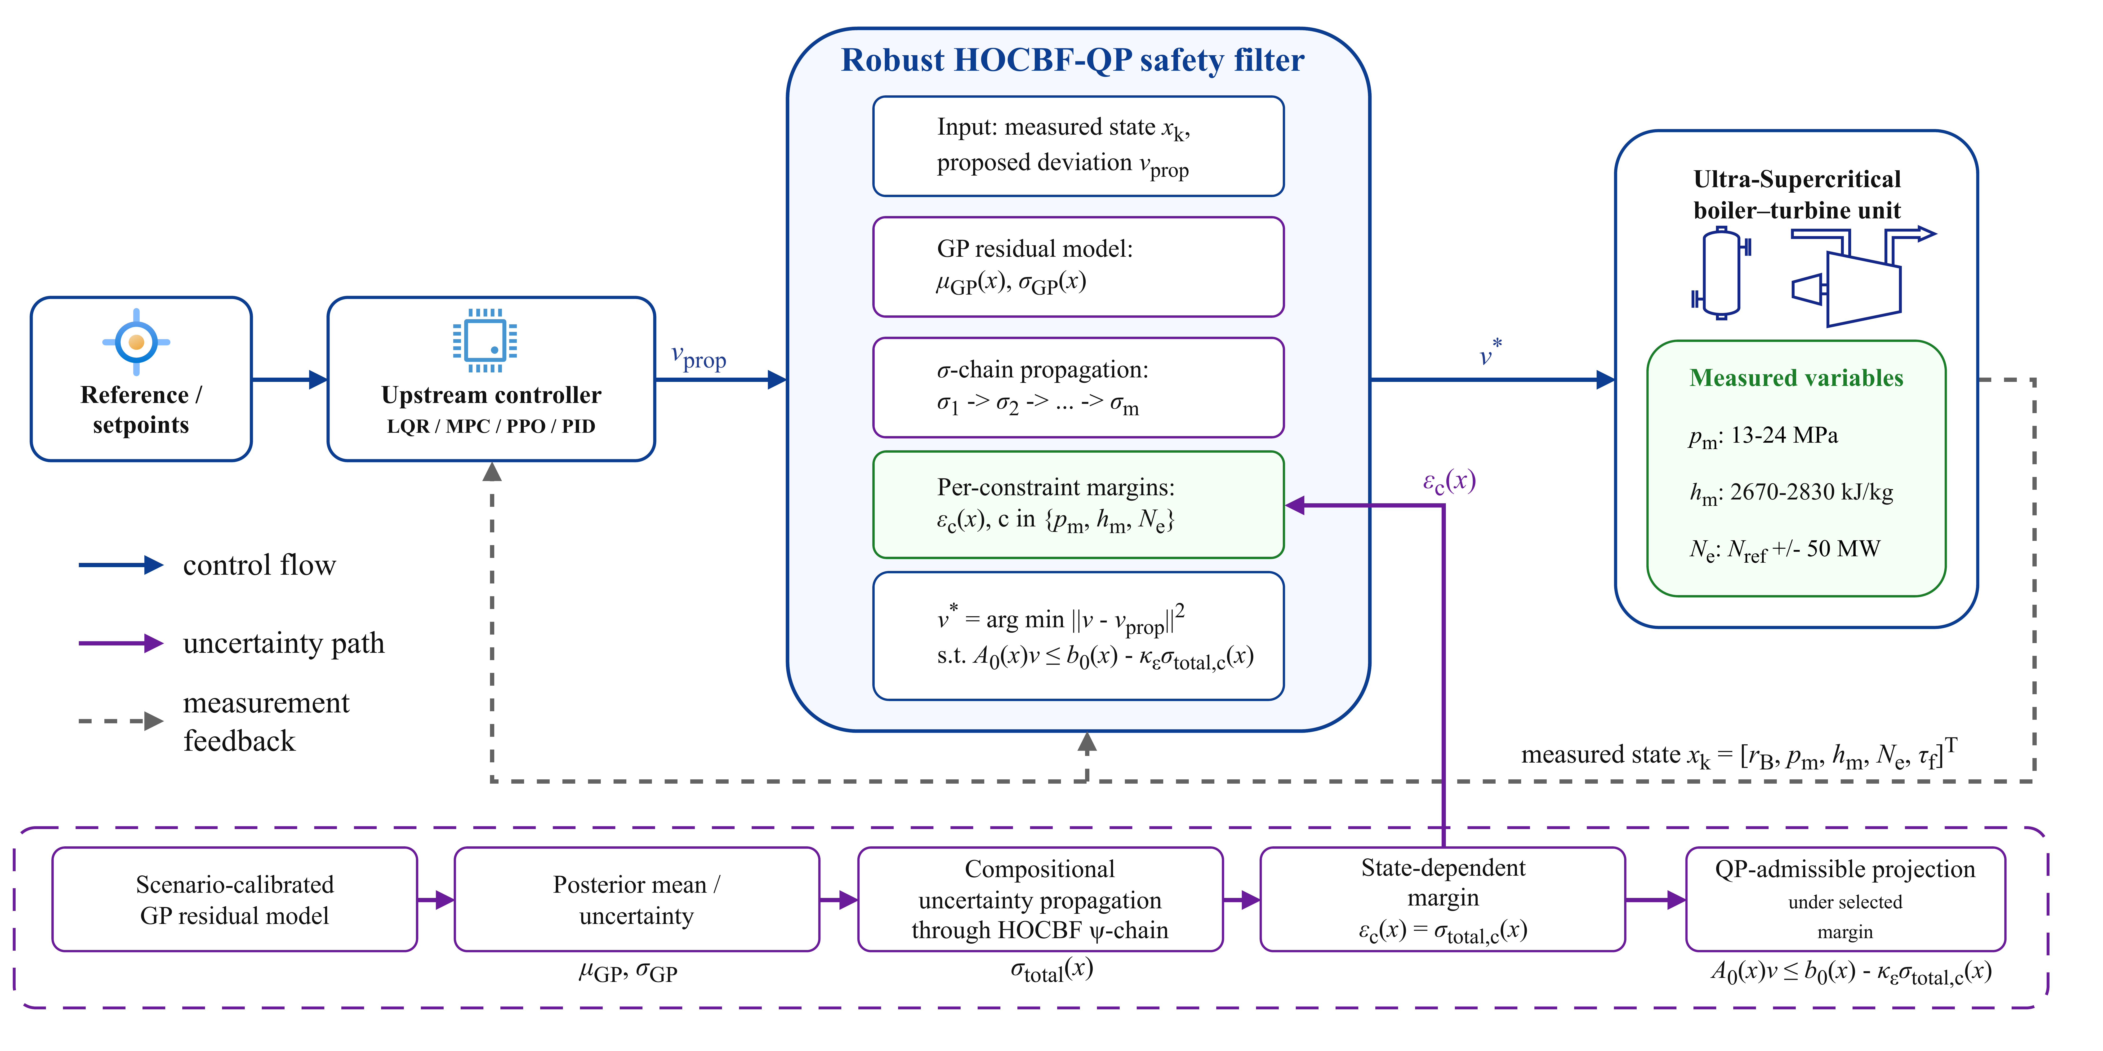
Figure 1. RoCBF-SF safety-filtering architecture. The upstream controller (LQR, MPC, PID, or learned policy) proposes a deviation command $v_{prop}$. The filter evaluates that command against current plant measurements and the GP residual model, then projects it to the nearest QP-admissible deviation command $v^{*}$ under the selected margin through $A(x)v≤b(x)−ϵ_{κ}σ_{total}(x)$. The physical actuator command is then reconstructed by Eq. (1).
Figure 1 provides the system map for the rest of the paper. Figure 2 follows the signal path through plant response and QP intervention, and Fig. 3 checks the residual-model evidence for GP correction.
3.3 GP Residual Correction and Compositional Margin
Each modeled component of $Δf_{j}$, $j∈J_{GP}$, is represented by an independent GP with a Matérn-5/2 kernel. Kernel distances use the frozen training transform ${\tilde{x}}_{i}=(x_{i}−μ_{x_{i}}^{train})/s_{x_{i}}^{train}$; the standard-deviation floor is ${10}^{−6}$ of the corresponding engineering range. Residual targets are standardized separately for each output. The same frozen transforms are used for training, validation, and inference. Given $N$ training points, the posterior provides mean $μ_{GP,j}(x)$ and variance $σ_{GP,j}^{2}(x)$. The GP-UCB bound gives:
$$|Δf_{j}(x)−μ_{GP,j}(x)|≤βσ_{GP,j}(x), \text{w.p.}≥1−δ/n$$ | (8)
with $β=\sqrt{2(γ_{N}+1+ln(n/δ))}$ and maximum information gain $γ_{N}$⁶.
We define the mean-corrected drift $\hat{f}=f_{0}+μ_{GP}$ and posterior residual $Δ\hat{f}=Δf−μ_{GP}$. The induced perturbation is propagated level by level through the HOCBF chain rather than attached only to the final constraint row.
The perturbation at level $i$ is $δ_{i}=ψ_{i}−{\hat{ψ}}_{i}^{0}$, satisfying:
$$\begin{aligned}δ_{1}&=L_{Δ\hat{f}}h \\ δ_{i}&=L_{Δ\hat{f}}{\hat{ψ}}_{i−1}^{0}+(L_{\hat{f}}+k_{i})δ_{i−1}+L_{Δ\hat{f}}δ_{i−1}, i≥2\end{aligned}$$ | (9)
This two-line recursion separates the nominal HOCBF recursion from mismatch residuals.
The compositional margin is constructed as:
σ1(x)&=βj|∂h/∂xj|σGP,j(x),σi(x)&=βj|∂ψi−10/∂xj|σGP,j(x)+(∥Lf∥op+ki)σi−1(x)+σcross(i)(x), i≥2,σtotal(x)&=σm(x)+j=1m−1cjσj(x)+σctrl(x). | (10)
The three margin relations above define the quantity scaled by $ϵ_{κ}$ in the online QP. Here, $∥L_{\hat{f}}∥_{op}$ denotes a uniform upper bound on $∥∂\hat{f}/∂x∥_{2}$ over $X_{op}$, not only the equilibrium value. The implemented cross term is $σ_{cross}^{(i)}(x)=β∥∇{\hat{ψ}}_{i−1}^{0}(x)∥_{2}∥σ_{GP}(x)∥_{2}$, which upper-bounds $|L_{Δ\hat{f}}δ_{i−1}|$ on $X_{op}$ using the RKHS derivative-bound argument in Lemma S1. The control-coupling term is
σctrl(x)=βj∂(LgLfm−1h)∂xjσGP,j(x)umax, | (11)
where $u_{max}=\sup_{u∈U}∥u∥$. The chain weights are $c_{j}=\prod_{ℓ=j+1}^{m−1}{(}∥L_{\hat{f}}∥_{op}+k_{ℓ})$, with the empty product equal to one; thus $c_{1}=1$ for the pressure barriers with $m=2$. The resulting HOCBF constraint is $A_{0}(x)v≤b_{0}(x)−ϵ_{κ}σ_{total}(x)$.
3.4 Commissioning Factor and Implementation Boundary
Assumption 1 (Operating set and relative degree). The state remains in a compact operating set $X_{op}⊂X$, the barriers in Eq. (6) are continuously differentiable to the required HOCBF order, and their relative degrees are known on $X_{op}$.
Assumption 2 (Drift-residual GP event). The input matrix is exact ($Δg=0$). Each modeled component of $Δf$ on $J_{GP}=\{p_{m},h_{m},N_{e}\}$ lies in the RKHS class required by the GP-UCB bound, and the fixed commissioning data give the simultaneous event $|Δf_{j}(x)−μ_{GP,j}(x)|≤βσ_{GP,j}(x)$ for all $x∈X_{op}$ and all modeled components with probability at least $1−δ$. Residuals in the unmodeled $r_{B}$ and $τ_{f}$ rows are zero in the certificate-aligned benchmark or are otherwise covered by Assumption 3.
Assumption 3 (Compositional residual bound). The derivative constants used in Lemma S1 are finite on $X_{op}$, and the margin definitions in Section 3.3, together with Eq. (11), satisfy $|Δ_{ψ}(x,v)|≤σ_{total}(x)$ for every active HOCBF row and every admissible $v∈V$.
Assumption 4 (Robust-QP feasibility). For every $x∈X_{op}$ considered by the certificate, there exists at least one $v∈V$ satisfying $A(x)v≤b(x)−σ_{total}(x)$.
Theorem 1 (Conditional probabilistic forward invariance). Let $Δ_{ψ}(x,v)=ψ_{m}^{true}(x,v)−{\hat{ψ}}_{m}^{0}(x,v)$ denote the induced top-level HOCBF residual after substituting the deviation-input model. Under Assumptions 1–4, the QP in Eq. (3) with $ϵ_{κ}=1$ renders $C$ forward invariant with probability at least $1−δ$.
Proof. The complete proof is given in the Supplemental Material. It conditions on the simultaneous GP-UCB event, bounds each HOCBF-chain residual by induction, uses Assumption 3 to obtain $|Δ_{ψ}(x,v)|≤σ_{total}(x)$, and then applies the HOCBF forward-invariance result to the tightened QP. The certificate is attached to $ϵ_{κ}=1$ and robust-QP feasibility.
Theorem 1 is a conditional worst-case statement. The margin itself does not imply feasibility; feasibility depends on safe-set geometry, actuator limits, and $U$. The online factor $ϵ_{κ}$ therefore has a dual interpretation: it recovers the formal bound at $ϵ_{κ}=1$ and acts as a commissioning parameter when smaller values are selected from replay and operating-envelope diagnostics.
The robustness scaling factor $ϵ_{κ}$ controls the safety-margin/control-authority trade-off:
- $ϵ_{κ}=0$: The QP enforces $A_{0}(x)v≤b_{0}(x)$, i.e., the nominal HOCBF constraint with GP mean correction only. No robustness margin is applied beyond the mean correction itself.
- $ϵ_{κ}=1$: The QP enforces the full compositional margin $σ_{total}(x)$, recovering the worst-case certificate of Theorem 1.
- $0<ϵ_{κ}<1$: The QP enforces a fraction of the compositional margin, trading theoretical coverage for reduced QP conservatism.
The full probabilistic certificate is attached only to $ϵ_{κ}=1$ under Theorem 1. Values $0≤ϵ_{κ}<1$ are calibrated operating points evaluated by finite-sample violation, QP intervention, infeasibility, and deployment-envelope diagnostics. Section 4 tests whether the worst-case endpoint is useful in the actuator-limited benchmark and how the preferred value changes with mismatch structure.
The GP posterior includes a regularization floor $σ_{floor}={10}^{−4}$. Under constant perturbations, $σ_{GP}$ and $σ_{total}(x)$ are nearly uniform, so the margin is floor-driven. Under S3 state-dependent coupling, $σ_{GP}$ becomes heterogeneous and $σ_{total}(x)$ is data-driven. This distinction explains why additive perturbations can use $ϵ_{κ}=0$ in the tested regime: GP mean correction supplies the effective adjustment, while the floor-driven margin mainly adds QP conservatism.
Theorem 1 is continuous-time, whereas the implementation uses $T_{s}=1$ s zero-order hold. One second is the deployed coordinated-control task period and allows the filter to evaluate each upstream command update; it is not intended to imply that the dominant boiler thermal dynamics have a 1 s time constant. The deployed task deadline is 1000 ms and the configured QP timeout is 200 ms; the observed controller-task and QP times are reported separately in Section 4.5. The 5 s spacing in the controller exports is a logging interval rather than the internal execution period. A failed original QP permits at most one reduced-QP attempt after removal of the whitelisted pressure_low row, and only when $∥G_{i}S_{u}∥_{2}<0.01$, the unscaled row right-hand side is below $−{10}^{−6}$, the directly measured pressure margin is at least 2.0 MPa, measurement quality is good, and no protection or interlock is active. Actuator box/rate rows are never removed. A failed retry, hard fault, or timeout returns the live coordinated-control command and latches bypass according to the deployment state machine. The reduced-QP recovery does not satisfy Assumption 4 for the original six-row problem, so Theorem 1 does not apply during those recovered cycles. Inter-sample forward invariance is not established by the reported controller-instant tests and remains outside the formal certificate.
For field commissioning, approximately 14 days of 1 Hz data are divided into days 1–10 for the training candidate pool, day 11 as a 24 h isolation gap, and days 12–14 for validation. Five fixed load strata cover 180–660 MW; each contributes 100 training and 40 validation transitions. Within each stratum, candidates are thinned to at least 60 s spacing and selected by deterministic farthest-point coverage in standardized $(p_{m},h_{m},N_{e})$ coordinates, without quota borrowing. The deployed dictionary is frozen at 500 points. Plant-specific training-block replay fixes $ϵ_{κ}=0.1$, after which the 200 time-isolated validation points are evaluated once without retuning. The public controller exports confirm the implemented value and online execution; the record-level plant replay remains a restricted enterprise asset and is not reconstructed from those exports.
Coverage monitoring combines the input z-score and 0.5th–99.5th training quantiles, the validation-set 99th percentile of posterior standard deviation, and the standardized one-step innovation. Moderate OOD enters full-row nominal-HOCBF operation for at most ten 1 s cycles; GP operation resumes only after ten consecutive healthy cycles. A persistent coverage failure enters latched live-DCS bypass. Innovation above 5, invalid measurements or communication, non-finite/model-load faults, nominal-QP or actuator-constraint infeasibility, violation of a direct physical bound, pressure-low physical margin below 2.0 MPa, or QP/task timeout bypasses the degraded stage immediately. This nominal-HOCBF interval is a bounded transition mode without a GP coverage claim, not a certified substitute for the GP-RHOCBF mode.
4 Experimental Validation
The experiments evaluate RoCBF-SF as a real-time safety layer in an industrial DCS control loop. The validation addresses four issues: GP residual correction under model mismatch, robustness-factor calibration, sampling-budget fit, and post-retrofit execution evidence from plant historian and controller-log records.
4.1 Boiler-Turbine Benchmark and Filter Comparisons
The benchmark is a fifth-order nonlinear model of the boiler-turbine coordinated control loop of an ultra-supercritical power unit with state $x=[r_{B},p_{m},h_{m},N_{e},τ_{f}]^{⊤}$ and three control inputs. The enforced limits are pressure ($m=2$, 13–24 MPa), separator enthalpy ($m=1$, 2670–2830 kJ/kg), and generator active-power tracking around the dispatch target ($m=1$, $N_{ref}±50$ MW). Table 2 is the primary validation corresponding to Theorem 1: the rollout plant and the filter use the same fixed input matrix, so mismatch enters through drift residuals and $Δg=0$.
Six perturbation scenarios model heat-absorption loss (S1), feedwater-induced pressure disturbance (S2), coupled state-dependent drift (S3), nonlinear fouling (S4), valve-related process drift (S5), and fuel-quality variation (S6). S5 is represented as equivalent state drift rather than as an input-gain fault, so the $Δg=0$ condition is maintained. S5 and S6 also perturb the extended power/fuel-delay dynamics of the fifth-order model.
To isolate the safety layer in the $Δg=0$ validation, the fixed-proposal and HOCBF rows in Table 2 use the same seeded, bounded upstream deviation command and differ only in the downstream filter. Each method-condition cell contains five independent 500-sample rollouts (2500 controller samples). All GP variants use 500 scenario-specific training transitions, the common input/output vector $[p_{m},h_{m},N_{e}]^{⊤}$, and a frozen training-input z-score transform. The QP is solved with qpax 0.1.3 in 64-bit arithmetic using row scaling, box constraints, and an acceptance requirement of solver convergence, finite primal values, and maximum normalized primal residual no greater than ${10}^{−6}$. Rejected QP candidates revert to the live upstream proposal and are counted as fallback events. A raw-margin numerical tolerance of ${10}^{−2}$ is used only for counting binary state-limit violations; unrounded minimum margins remain in the result files.
NMPC is evaluated under the same $Δg=0$ rollout conditions as an optimization-based reference. It solves a warm-started SLSQP problem with horizon $N=5$, deviation-input bounds $v_{i}∈[−10,10]$, the same six process constraints, a stabilized linear prediction model, and additive disturbance correction. The output and input weights are $diag(1.0,0.001,0.01)$ and $diag(0.01,0.01,0.01)$, respectively; the disturbance-estimator gain is 0.5, and SLSQP uses maxiter=50 and ftol$={10}^{−4}$. Every one of the 17,500 NMPC solves in Table 2 converged and passed a ${10}^{−6}$ prediction-constraint residual check.
The safety tables use a sample-level violation rate at the controller instants,
$$R_{viol}(η)=\frac{\sum_{s=1}^{N_{seed}}{\sum_{e=1}^{N_{ep}}{\sum_{t=1}^{N_{step}}{1}}}\{\min_{j}h_{j}(x_{s,e,t})<−η\}}{N_{seed}N_{ep}N_{step}},$$ | (12)
where a sample is counted once if any enforced pressure, separator-enthalpy, or power barrier is below the stated numerical tolerance $η$ at that controller sampling instant. Table 2 uses $η={10}^{−2}$ in raw barrier units to avoid counting QP boundary-roundoff as physical violation; the later stress-test diagnostics use the tolerance stated in their result files or captions. This is not an episode-level probability. A single-rollout diagnostic such as 4/300 in Fig. 2 is reported only for that diagnostic rollout. Table 2 aggregates controller samples across seeds and rollouts for the $Δg=0$ validation.
4.2 Closed-Loop Safety and Process Response
Table 2. Primary $Δg=0$ validation: sample-level constraint violation rate (%) at controller instants under a fixed upstream deviation proposal, computed by Eq. (12) with a raw-margin numerical tolerance of ${10}^{−2}$. Each cell aggregates five 500-sample rollouts, i.e., 2500 controller samples. The full-margin row tests the conservative $ϵ_{κ}=1.0$ endpoint under actuator limits; it is not the recommended commissioned operating point.
Method | Nom. | S1 | S2 | S3 | S4 | S5 | S6
Unfiltered fixed upstream proposal | 4.48 | 78.64 | 68.56 | 67.28 | 68.56 | 68.56 | 78.64
HOCBF, no GP ($m=2,1,1$) | 0.00 | 78.64 | 68.56 | 67.28 | 68.56 | 68.56 | 78.64
NMPC ($N=5$) | 0.00 | 0.20 | 0.20 | 0.40 | 0.20 | 0.20 | 0.20
GP-HOCBF mean-only ($ϵ_{κ}=0$) | 0.00 | 0.00 | 0.00 | 1.44 | 0.00 | 0.00 | 0.00
RoCBF-SF commissioned ($ϵ_{κ}=0.02$ in S3; 0 otherwise) | 0.00 | 0.00 | 0.00 | 0.00 | 0.00 | 0.00 | 0.00
Full-margin endpoint ($ϵ_{κ}=1.0$) | 0.00 | 0.00 | 0.00 | 16.76 | 0.48 | 0.00 | 0.00
Table 2 reports the certificate-aligned $Δg=0$ validation. The unfiltered proposal violates 10,756 of 15,000 perturbation samples. Correct relative degree removes all 112 nominal violations but does not compensate drift mismatch: no-GP HOCBF retains the same 10,756 perturbation-sample violations. GP mean correction reduces this count to 36/15,000, all in S3. Applying the independently selected $ϵ_{κ}=0.02$ in S3 gives 0/17,500 observed violations across the nominal and six mismatch conditions. NMPC is also effective, with 35/17,500 violations and no solver failure, but does not eliminate the short boundary transients in the six mismatch cases.
The full-margin row shows why $ϵ_{κ}$ must be commissioned rather than set mechanically to its largest value. The endpoint remains safe in nominal, S1, S2, S5, and S6, but it produces 419 S3 violations and 12 S4 violations when the actuator-bounded robust QP loses feasibility. This does not contradict Theorem 1, which requires feasibility of the original robust QP at every certified step.
Table 3 makes that feasibility mechanism explicit for S3. The revised experiment records every QP attempt, rejected candidate, fallback, intervention, and normalized residual. The commissioned row has four rejected initial-step QPs but no ensuing state-limit violation; the full-margin endpoint rejects 628 of 2500 QPs and reverts to the upstream command in those cycles.
Table 3. S3 solver and intervention diagnostics for the primary $Δg=0$ validation. Each row contains 2500 controller samples. QP rejection requires non-convergence, a non-finite candidate, or normalized primal residual above ${10}^{−6}$; the live upstream proposal is used on a rejected cycle. NMPC uses its own horizon optimization and is therefore omitted from the projection-intervention comparison.
S3 method | Violation | QP rejected | Fallback | QP intervention
HOCBF, no GP | 1682 of 2500 (67.28%) | 0 of 2500 | 0 of 2500 | 4.48%
GP-HOCBF mean-only | 36 of 2500 (1.44%) | 0 of 2500 | 0 of 2500 | 67.08%
RoCBF-SF, $ϵ_{κ}=0.02$ | 0 of 2500 | 4 of 2500 | 4 of 2500 | 67.12%
Full-margin endpoint | 419 of 2500 (16.76%) | 628 of 2500 | 628 of 2500 | 51.12%
The results indicate a mechanism hierarchy: correct HOCBF structure handles nominal constraint geometry, GP residual correction is the principal mismatch-compensation mechanism, and $ϵ_{κ}$ is a finite-sample feasibility–safety trade-off. The following diagnostics separate the time-domain mechanism, residual-model evidence, data-quality gate, and tune/test calibration result.
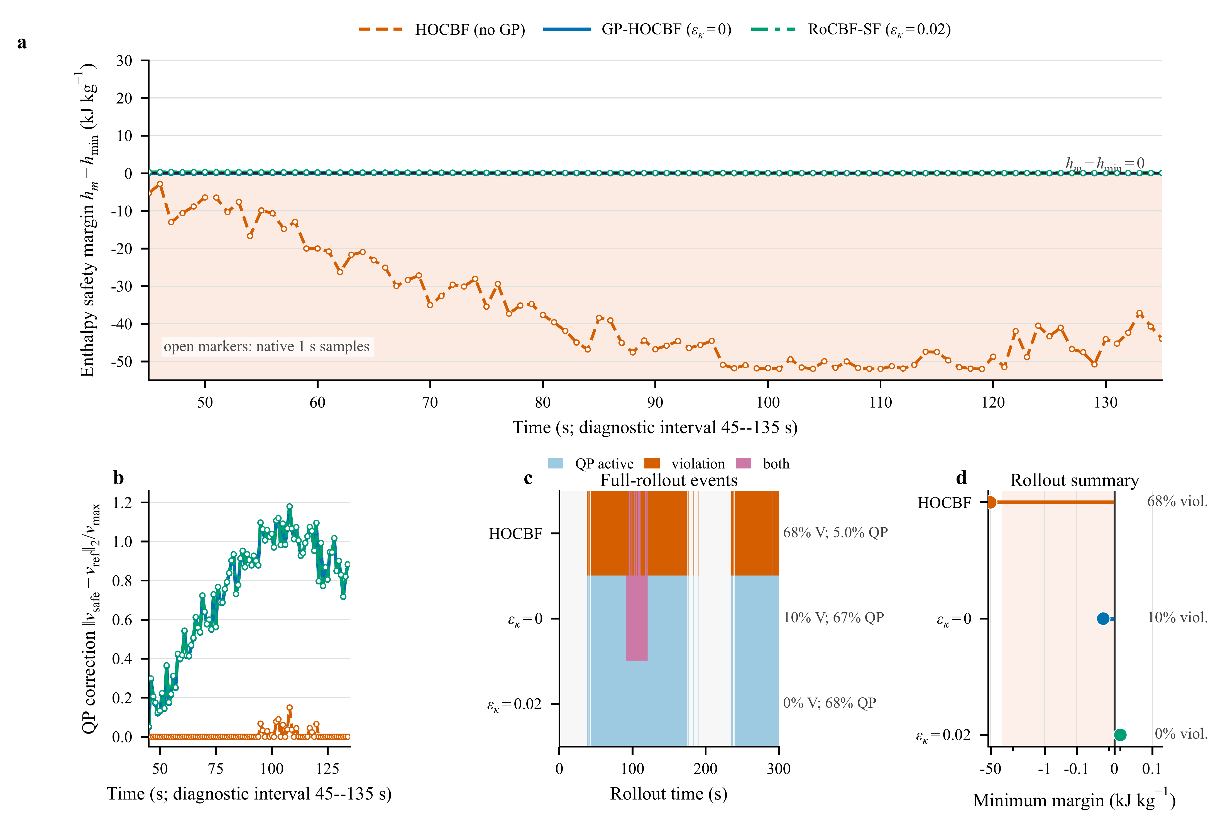
Figure 2. Closed-loop mechanism for representative seed 3 under the certificate-aligned S3 drift perturbation. (a,b) Enthalpy safety margin and normalized QP correction over the 45–135 s interval containing the onset and largest excursion. The shaded region marks violation of the lower enthalpy constraint. (c) Full 300 s event record. (d) Full-rollout minimum enthalpy margin and sample-level violation rate; the symmetric-log horizontal scale resolves the two near-zero margins while retaining the large no-GP excursion. Lines in (a,b) are interpolated on a 0.1 s display grid only for visual continuity; open markers are the native 1 s controller samples, and all statistics use native samples and the ${10}^{−2}$ counting tolerance defined in Eq. (12).
In this representative rollout, the no-GP HOCBF records 203/300 violations, GP mean correction reduces the count to 30/300, and the calibrated setting records 0/300. The corresponding minimum enthalpy margins are -51.993, -0.01996, and +0.01028 kJ/kg. This single-trajectory diagnostic illustrates the mechanism and is not used in place of the five-seed aggregate in Tables 2 and 3.
Figure 2 shows the enthalpy bottleneck directly in a representative S3 rollout. HOCBF without GP correction produces 203/300 violating samples and a minimum enthalpy margin of -51.993 kJ/kg. GP mean correction limits the excursion to -0.01996 kJ/kg but still leaves 30 samples below the stated numerical tolerance, whereas the calibrated $ϵ_{κ}=0.02$ margin keeps the minimum positive at +0.01028 kJ/kg. The correction and event panels show that this change is produced by sustained QP intervention rather than by a different upstream proposal.
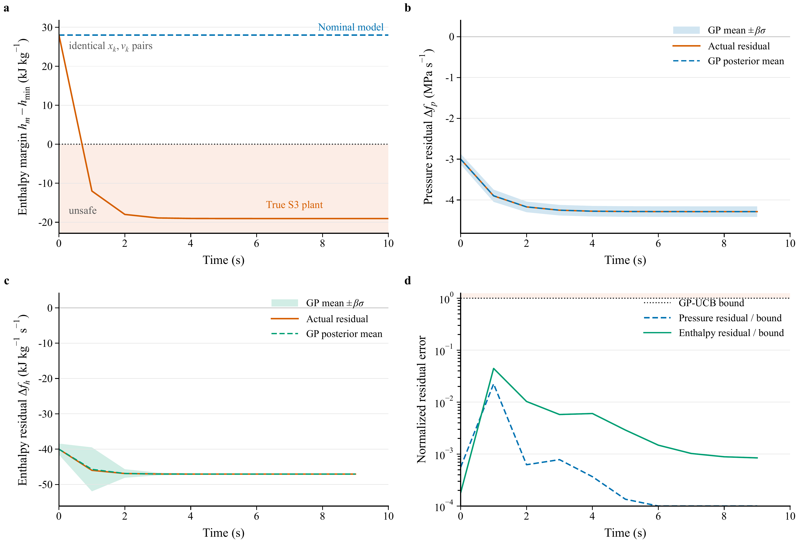
Figure 3. Direct model-mismatch diagnosis under the certificate-aligned S3 drift perturbation. (a) Nominal and true one-step enthalpy-margin responses from identical state-input pairs. (b,c) Pressure and enthalpy residual rates compared with the scenario-specific GP posterior mean and GP-UCB envelope ($μ_{GP}±βσ_{GP}$, $β=12.967$, $N=500$). (d) Posterior residual error normalized by the GP-UCB bound; values below one lie inside the modeled envelope.
Figure 3 makes the model mismatch explicit. For the same state and zero-deviation input, the nominal model predicts a next-step enthalpy margin of 28.0 kJ/kg, whereas the S3 plant drops to -12.0 kJ/kg. The pressure and enthalpy panels show that this discrepancy is structured and learnable: the GP posterior mean tracks the realized drift residual, and the remaining error stays inside the GP-UCB envelope in this diagnostic. The filter therefore corrects a measured residual structure before applying the commissioned margin.
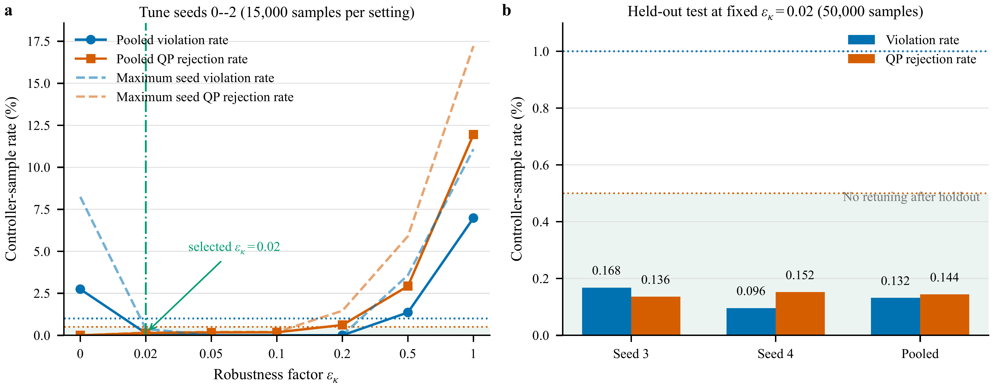
Figure 4. Tune/test calibration of $ϵ_{κ}$ under S3. (a) Pooled and maximum-per-seed violation and QP-rejection rates for tune seeds 0–2 (15,000 native controller samples per setting). The predeclared rule selects the smallest value with pooled and per-seed violation below 1% and QP rejection below 0.5%. (b) Results for held-out seeds 3–4 after fixing $ϵ_{κ}=0.02$; no retuning used the 50,000 holdout samples.
Figure 4 separates calibration from confirmation. On tune seeds 0–2, $ϵ_{κ}=0$ gives 412/15,000 violations (2.747%). The smallest setting passing both gates is 0.02, with 19/15,000 violations (0.127%) and 20/15,000 rejected QPs (0.133%). After fixing this value, held-out seeds 3–4 give 66/50,000 violations (0.132%) and 72/50,000 rejected QPs (0.144%), with both individual seeds below the same gates. The Wilson values in the Supplemental Material are descriptive Bernoulli-reference bounds because adjacent controller samples are serially correlated. These results define a finite-sample operating point, not a zero-violation guarantee.
4.3 Robustness-Factor Commissioning
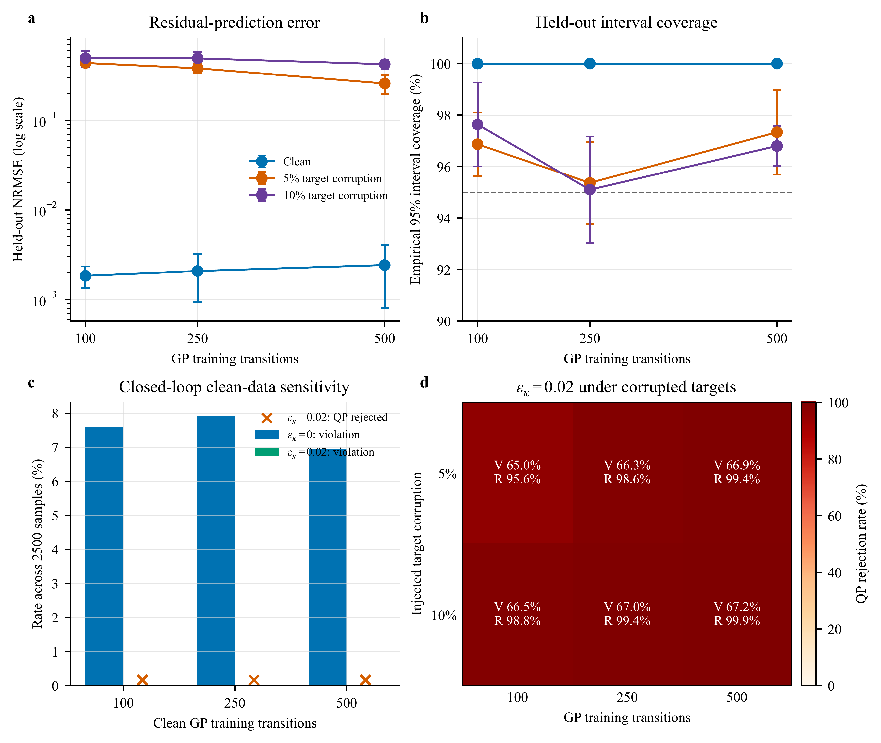
Figure 5. Controlled GP training-data sensitivity under S3. (a,b) Held-out residual NRMSE and empirical 95% interval coverage for 100, 250, and 500 selected transitions. Target corruption replaces a fixed training fraction with signed three-standard-deviation offsets. (c,d) Closed-loop violation and QP-rejection diagnostics under clean and corrupted training data. Each point aggregates five 500-sample rollouts. The 5% and 10% levels are synthetic fault-injection tests, not estimates of plant-data quality.
Figure 5 tests the GP commissioning gate rather than treating every fitted model as deployable. Across 100, 250, and 500 clean training transitions, held-out NRMSE remains between 0.00184 and 0.00243, interval coverage is 100%, and $ϵ_{κ}=0.02$ gives 0/2500 violations with 0.16% QP rejection at each size. Controlled label corruption raises NRMSE by approximately two orders of magnitude and drives QP rejection to 95.64–99.88%; fallback to the upstream proposal then produces 64.96–67.20% violation. These deliberately corrupted models fail the pre-enable quality and feasibility gate. The complete aggregation is reported in the Supplemental Material.
4.4 Real-Time Computation
The deployment configuration specifies an AMD EPYC Embedded 4565P processor, 64 GB (2×32 GB) DDR5-5600 ECC memory, openEuler 24.03 LTS, Python 3.11, qpax 0.1.3 for the online QP, SciPy 1.17.1, Kubernetes workload management, and Modbus TCP data exchange with the DCS. The online controller executes every 1 s. The production-validation files are controller exports at 5 s spacing; therefore, counts reported from those files refer to exported records rather than every internal controller cycle.
The implemented benchmark filter and NMPC reference both fit within the 1 s budget; scenario-level timing and GP storage/training complexity are reported in the Supplemental Material. Field execution time is the deployment-relevant measurement and is reported with the confirmed controller exports in Section 4.5.
4.5 Measured Plant Evidence: Envelope, Matched Windows, and Controller Logs
The simulation benchmark establishes the closed-loop mechanism: GP residual correction closes most of the model mismatch, $ϵ_{κ}$ must be calibrated by uncertainty structure, and the compiled filter satisfies the 1 s sampling budget. Plant data then connect the same design to measured operation. Historian records define the operating envelope, load-matched windows compare pre- and post-retrofit response, and confirmed original plant-controller exports document both routine full-QP execution and a bounded reduced-QP recovery mode under measured operating conditions.
Figure 6 uses a bounded historian snapshot from the 660 MW unit as an operating-envelope check. The grey envelope uses an approximately 24 h loaded operating window from 1 July 2026 02:33 to 2 July 2026 02:28 local time ($n=288$ at 300 s spacing). The colored overlays place three post-retrofit low-to-mid-load historian windows within that measured load–pressure range. This record documents measurement availability and operating variability; the original 5 s historian records in Fig. 7 provide the dynamic resolution for retrofit comparison.
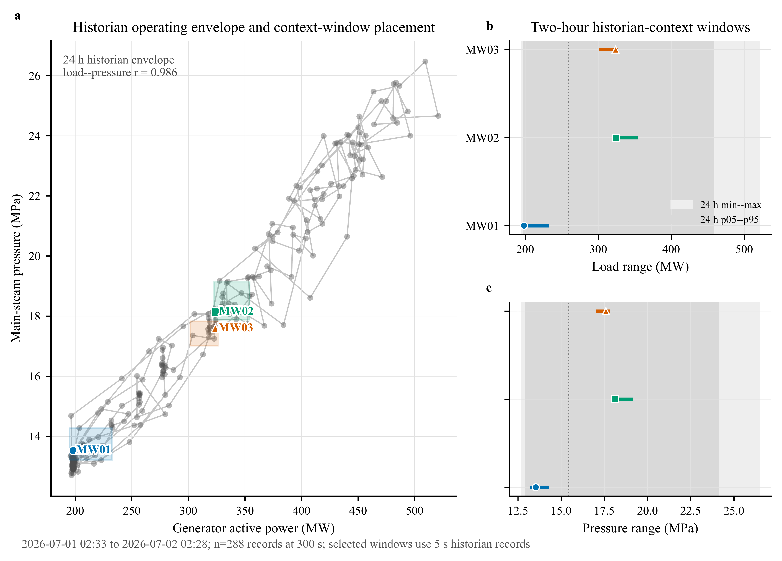
Figure 6. Plant-historian operating-envelope check from the 660 MW ultra-supercritical unit. (a) Five-minute historian samples define the measured load–pressure envelope over an approximately 24 h loaded interval; colored boxes and markers locate three two-hour post-retrofit low-to-mid-load historian windows. (b,c) The same windows are shown as load and pressure ranges against the 24 h min–max and p05–p95 envelopes. The figure places these historian windows within measured plant operation.
During this interval, generator active power varied from 195.7 to 520.8 MW and main-steam pressure ranged from 12.70 to 26.47 MPa. This 24 h range is a historian operating-envelope measurement, not the safety-filter constraint envelope. The three colored overlays in Fig. 6 are low-to-mid-load historian context windows (MW01–MW03), whose main-steam-pressure ranges are 13.21–19.15 MPa. They do not supply controller-internal QP fields. Load was strongly correlated with pressure ($r=0.986$) and fuel flow ($r=0.980$), confirming pressure–combustion coupling during load following. The MW04–MW06 controller exports analyzed below provide the separate execution evidence at 480.7–629.7 MW (72.8–95.4% of nameplate power).
The unit chronology permits a load-matched commissioning comparison. The 660 MW unit used traditional PID before 21 May 2026, was shut down from 21 May to 24 June 2026, and restarted with the proposed RoCBF-SF-based strategy after 24 June 2026. The outage included extensive routine plant maintenance in addition to integration of the proposed algorithm. We screened historical pre-retrofit windows from 2024–2025 and post-retrofit windows after the first 24 h of restart, retaining loaded operation and matching by load trajectory. The audit retained 1950 two-hour windows during loaded operation. Across this matched-window cohort, the period-median pressure setpoint-residual standard deviation and 95th-percentile absolute residual decrease by 12.6% and 23.4%, respectively. The representative pair below uses the original 5 s historian samples, with historian files, source timestamps, and metric JSON preserved in the evidence package. Because routine maintenance occurred during the same outage, the plant-response comparison is interpreted as observational evidence associated with the documented retrofit under matched load movement, rather than as a standalone estimate of the algorithm’s causal effect. Confirmed original plant-controller exports provide the separate evidence that RoCBF-SF executed after restart.
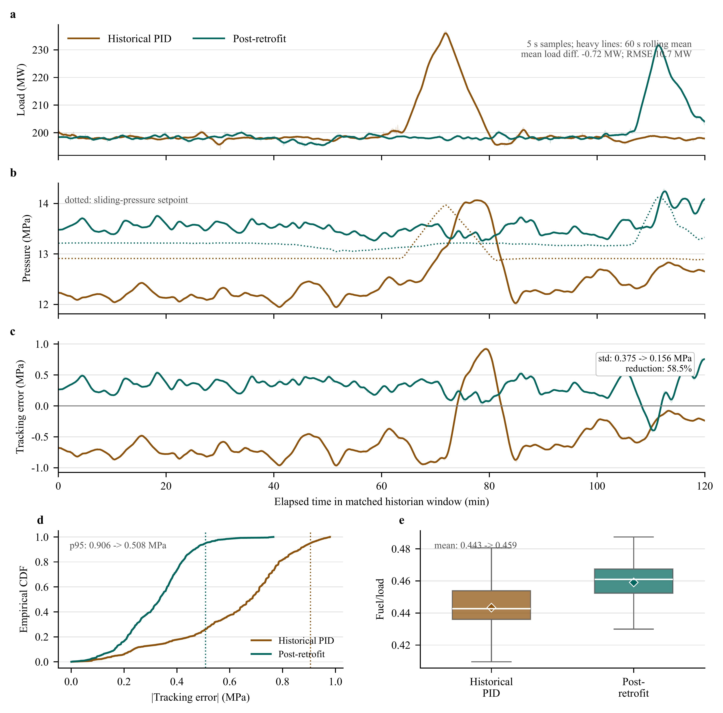
Figure 7. Matched plant-historian retrofit-window diagnostic from the 660 MW ultra-supercritical unit. The historical PID window is 5 November 2025 11:00–12:59:55 local time; the post-retrofit window is 25 June 2026 12:30–14:29:55 local time. Both windows contain 1440 original 5 s historian samples. (a) Generator active-power trajectories used for matching; the mean-load difference is -0.72 MW and the load-profile RMSE is 10.7 MW. (b) Main-steam pressure and the sliding-pressure setpoint. (c) Pressure tracking error, $p_{main}−p_{set}$; the sample-level standard deviation decreases from 0.375 to 0.156 MPa. (d) Empirical CDF of absolute pressure tracking error; dotted lines mark the 95th percentile, which decreases from 0.906 to 0.508 MPa. (e) Fuel/load distribution for the combustion-side operating context; boxes show median, IQR, and 1.5×IQR whiskers, and diamonds show means. Light traces are original samples and heavy traces are 60 s rolling means for readability; all reported metrics use the original 5 s samples.
Figure 7 reports a high-resolution matched pair. The two-hour windows have mean load within 1 MW and load-profile RMSE of 10.7 MW. Pressure tracking-error standard deviation decreases by 58.5% after retrofit, from 0.375 to 0.156 MPa, and the 95th-percentile absolute error decreases from 0.906 to 0.508 MPa. The fuel/load proxy is higher after retrofit (0.443 to 0.459), so the comparison was not obtained under lower combustion-side demand. The load-matched result documents improved pressure response after the retrofit under comparable load movement. Because routine outage maintenance occurred concurrently, this comparison does not by itself attribute the entire improvement to RoCBF-SF; the controller exports independently verify online execution of the proposed filter. The plant evidence complements the controlled model-mismatch tests in Figs. 2–3.
The same 5 s historian query includes main/reheat temperature, air–coal ratio channels, mode/fallback indicators, and turbine-valve demand. Main-steam temperature variability decreases from 2.245 to 0.915°C, while reheat-temperature variability and air–coal ratio dispersion increase, showing that the post-retrofit interval is not uniformly easier. These historian diagnostics are then paired with the post-retrofit controller-log export in Fig. 8; the historical PID window is not assigned QP/CBF fields because no online safety filter was running before retrofit.
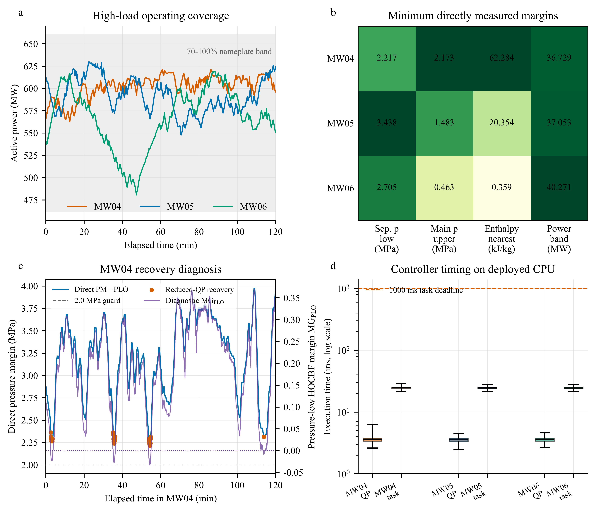
Figure 8. High-load plant-controller evidence from three post-retrofit two-hour windows, each containing 1440 records exported at 5 s spacing from a controller executing at 1 s. (a) Generator active power; the shaded band denotes 70–100% of the 660 MW nameplate rating. (b) Minimum directly measured margins to the separator-pressure lower bound, main-steam-pressure upper replay bound, nearest separator-enthalpy bound, and ±50 MW power band. Cell shading is normalized within each column; annotations retain physical units. (c) MW04 recovery diagnosis: the directly measured separator-pressure margin remains above the 2.0 MPa guard while the pressure-low HOCBF diagnostic row becomes negative; orange markers denote the 43 one-retry reduced-QP records. (d) QP and total task execution times on the deployed CPU; whiskers span the observed ranges and the dashed line marks the 1000 ms task deadline.
Figure 8 supplies the high-load execution evidence requested for the revision. MW05 and MW06 contain 2880 records with online automatic operation, full-QP status optimal, no fallback or saturation flag, positive logged HOCBF margins, and no direct pressure, enthalpy, or power-bound exceedance. MW04 contains 1397 optimal and 43 optimal_recovered records. In those 43 records, the original pressure-low HOCBF row has $MG_{PLO}∈[−0.03266,−0.00561]$, while the directly measured margin remains $PM−PLO∈[2.21654,2.36306]$ MPa and the other five exported HOCBF margins remain positive. The controller therefore removes only the whitelisted pressure-low row and solves one reduced-QP retry. These cycles establish feasibility of the reduced problem, not of the original six-row QP, and the certificate in Theorem 1 does not apply to them. One fuel-saturation flag occurs in MW04; no direct physical bound is exceeded.
Across MW04–MW06, all 4320 records satisfy the logged 1000 ms task deadline. QP time has median/p95/maximum values of 3.557/4.095/6.234 ms, and total task time has corresponding values of 24.564/26.183/28.665 ms. The field robustness factor is fixed at $ϵ_{κ}=0.1$ after plant-specific training-block replay and one-pass time-isolated validation; it is not justified by numerical equality with the benchmark S3 calibration result. Record-level plant replay remains a restricted enterprise asset, whereas the public controller exports independently confirm the implemented value and online execution. The evidence index keeps these three controller exports separate from the MW01–MW03 low-to-mid-load historian context used in Fig. 6.
Table 4. High-load post-retrofit controller-log summary from the 660 MW ultra-supercritical unit. Each row contains 1440 records at 5 s export spacing from a controller executing at 1 s. Direct margins are minimum values over the complete window. $p_{sep,lo}$ is $PM−PLO$; $p_{main,hi}$ is $PST_HI−p_{main}$, where PST_HI is a main-steam-pressure replay bound rather than a separator-pressure limit. “None” denotes no fallback or saturation event.
Window | Local time | Load (MW) | Min. $p_{sep,lo}$ (MPa) | Min. $p_{main,hi}$ (MPa) | Min. $h$ margin (kJ/kg) | QP/recovery status | QP/task p95 (ms)
MW04 | 29 Jun 2026 19:00–20:59:55 | 563.0–621.2 | 2.217 | 2.173 | 62.284 | 1397 optimal; 43 recovered; 1 fuel-sat. | 4.195 / 26.238
MW05 | 30 Jun 2026 14:00–15:59:55 | 547.9–629.7 | 3.438 | 1.483 | 20.354 | 1440 optimal; none | 4.074 / 26.139
MW06 | 26 Jun 2026 23:00–00:59:55 | 480.7–619.3 | 2.705 | 0.463 | 0.359 | 1440 optimal; none | 4.062 / 26.159
Table 4 separates the two high-load execution roles rather than pooling them into a uniformly clean claim. MW05–MW06 show routine full-QP operation; MW04 exposes the recovery mechanism and its certificate boundary. Together, Figs. 6–8 separate three evidence types: controlled simulation and GP residual diagnostics establish the model-mismatch mechanism, matched historian windows compare plant response under comparable load movement, and plant-controller exports verify the deployed execution and recovery paths.
4.6 Stage-Gated Commissioning Protocol
RoCBF-SF is intended as a commissioning-calibrated safety filter. The result sequence implies a staged deployment logic: simulation and replay establish the residual model and margin envelope, supervised tests verify QP/fallback behavior, and production logs verify execution after enablement. Table 5 gives a compact main-text version of this protocol; the supplemental material provides the detailed evidence inventory and window-level status.
Table 5. Compact stage-gated commissioning protocol for deploying RoCBF-SF as a safety-filter overlay.
Stage | Gate | Minimum evidence | Decision rule
Offline | Residual and margin calibration | Held-out GP coverage, representative historian/replay samples, and local $ϵ_{κ}$ sweep with violation, intervention, and infeasibility metrics | Use a scenario-specific GP; select the smallest $ϵ_{κ}$ that meets the local safety gate without QP infeasibility.
Supervised | Pre-enable validation | Time-isolated replay, protection-limit review, alarm/fallback tests, and coverage across the five fixed load strata | Enable online authority only after GP, QP, fallback, and alarm logic pass supervised tests.
Online | Execution logging | Aligned records for $v_{prop}$, $v^{*}$, reconstructed actuator command $u_{k}$, QP status, active CBF rows, $σ_{total}(x)$, fallback, saturation, and solve time | Treat historian traces as plant-response diagnostics; use controller logs such as Fig. 8 to support safety-filter execution.
Online | Drift and boundary monitoring | Drift in residual coverage, intervention rate, active enthalpy margin, fallback frequency, or repeated QP relaxation | Recalibrate the GP and repeat the local sweep; if the envelope boundary is reached, fall back to conservative operation instead of increasing $ϵ_{κ}$.
Margin candidates are evaluated only in offline replay or supervised commissioning windows. The benchmark uses the smallest tune-seed value that passes the predeclared violation and QP-rejection gates and then tests that value without retuning. The plant value $ϵ_{κ}=0.1$ is a separate operating point obtained from the time-separated plant replay; it is not transferred numerically from S3. During operation, moderate coverage loss enters full-row nominal-HOCBF mode for at most ten cycles, whereas persistent coverage loss or a hard fault returns authority to the live DCS command and latches bypass. The $Δg=0$ assumption limits the formal certificate to drift-dominated uncertainty; actuator-gain uncertainty requires additional modeling.
The Supplemental Material provides the full tune/test table, GP data-quality diagnostics, the sampled-data claim boundary, field commissioning and fallback details, production-evidence traceability, computation-time data, and the proof of Theorem 1.
5 Conclusion
This paper developed RoCBF-SF as a commissioning-calibrated GP-HOCBF safety-filter overlay for the boiler-turbine coordinated control loop of an ultra-supercritical power unit. The filter leaves the upstream controller in place and projects its proposed command through pressure, separator-enthalpy, and power constraints using GP drift-residual correction, compositional HOCBF uncertainty propagation, and a real-time QP.
The certificate-aligned $Δg=0$ benchmark separates the contributions of barrier structure, residual learning, and margin selection. Correct-relative-degree HOCBF removes nominal violations but leaves 10,756/15,000 mismatch-sample violations without a GP. Mean correction reduces that count to 36, and the independently selected $ϵ_{κ}=0.02$ setting gives 0/17,500 observed violations in the primary sweep. On held-out seeds, the fixed setting gives 66/50,000 violations and 72/50,000 QP rejections. Conversely, the full-margin endpoint can lose feasibility under actuator limits. The practical setting is therefore a finite-sample commissioning point, whereas the formal forward-invariance certificate remains attached only to $ϵ_{κ}=1$, the GP-UCB event, the compositional residual bound, $Δg=0$, and full-row robust-QP feasibility.
Plant historian and controller records provide complementary measured-operation evidence. The matched-window cohort and representative 5 s pair associate the retrofit with lower pressure-error dispersion under comparable load movement, while the concurrent outage maintenance prevents attributing the entire change to the safety filter alone. Low-to-mid-load historian windows establish operating context, and three confirmed high-load plant-controller exports verify the proposed execution path over 480.7–629.7 MW. Direct pressure, enthalpy, and power margins remain positive over all 4320 exported records; MW05–MW06 use the full QP throughout, and MW04 records 43 guarded reduced-QP recoveries. The observed total task time remains below 28.665 ms against the 1000 ms deadline. These recovered cycles are deliberately excluded from the full-row certificate claim.
Future work should extend time-separated commissioning coverage, evaluate actuator-gain uncertainty beyond the current $Δg=0$ formulation, and develop a sampled-data certificate for the 1 s zero-order-hold implementation. Further field validation should also retain the current separation between historian response evidence, controller-execution evidence, and full-row certificate conditions.
References
[1] Wu L, Huang L, Wang Y, et al. Pressure optimization control of low-pressure vacuum systems based on anti-disturbance Smith predictor compensation. Meas Control. 2026;59(6):870–82. doi:10.1177/00202940251372871
[2] Feng YW, Li YH. Event-triggered voltage regulation and current sharing in neighbors-based second control for DC microgrids. Meas Control. 2026;59(5):630–9. doi:10.1177/00202940251344578
[3] Ames AD, Coogan S, Egerstedt M, et al. Control barrier functions: Theory and applications. In: Proceedings of the 18th european control conference (ECC). 2019. p. 3420–31. doi:10.23919/ECC.2019.8796030
[4] Xiao W, Belta C, Cassandras CG. High-order control barrier functions. IEEE Trans Automat Contr. 2022;67(7):3655–62.
[5] Rasmussen CE, Williams CKI. Gaussian processes for machine learning. MIT Press; 2006.
[6] Srinivas N, Krause A, Kakade SM, et al. Information-theoretic regret bounds for Gaussian process optimization in the bandit setting. IEEE Trans Inf Theory. 2012;58(5):3250–65. doi:10.1109/TIT.2011.2182033
[7] Cheng R, Orosz G, Murray RM, et al. End-to-end safe reinforcement learning through barrier functions for safety-critical continuous control. In: Proceedings of the AAAI conference on artificial intelligence. 2019. p. 3387–95. doi:10.1609/aaai.v33i01.33013387
[8] Fisac JF, Akametalu AK, Zeilinger MN, et al. A general safety framework for learning-based control in uncertain robotic systems. IEEE Trans Automat Contr. 2019;64(7):2737–52.
[9] Castañeda F, Choi JJ, Zhang B, et al. Pointwise feasibility of Gaussian process-based safety-critical control under model uncertainty. In: Proceedings of the 60th IEEE conference on decision and control (CDC). 2021. p. 6762–9. doi:10.1109/CDC45484.2021.9683743
[10] Aali M, Liu J. Learning high-order control barrier functions for safety-critical control with Gaussian processes. In: Proceedings of the american control conference (ACC). 2024. p. 1–6. doi:10.23919/ACC60939.2024.10644311
[11] Zhang Y, Wen L, Bing Z, et al. Adaptive safety-critical control for high-order systems: A real-time Gaussian process approach. IEEE Trans Autom Sci Eng. 2025. doi:10.1109/TASE.2025.3611987
[12] Åström KJ, Bell RD. Benchmark problems for control system design. IFAC Proc Vol. 2000;33(11):27–46.
[13] Li SY, Liu HB, Cai WJ, et al. A new coordinated control strategy for boiler-turbine system of coal-fired power plant. IEEE Trans Control Syst Technol. 2005;13(6):943–54. doi:10.1109/TCST.2005.854319
[14] Tan W, Liu JZ, Fang F. Coordinated control of boiler-turbine unit of supercritical power plant. J Process Control. 2006;16(3):261–7.
[15] Liu X, Guan P, Chan CW. Nonlinear multivariable power plant coordinate control by constrained predictive scheme. IEEE Trans Control Syst Technol. 2010;18(5):1116–25. doi:10.1109/TCST.2009.2034640
[16] Abdelbaky MA, Liu X, Kong X. Stable constrained model predictive control based on IOFL technique for boiler-turbine system. Trans Inst Meas Control. 2025;47(6):1104–16. doi:10.1177/01423312241263911
[17] Liu JZ, Zeng DL, Tian L, et al. Control strategy for operating flexibility of coal-fired power plants in alternate electrical power systems. Proc CSEE. 2015;35(21):5385–94. doi:10.13334/j.0258-8013.pcsee.2015.21.001
[18] Qin SJ, Badgwell TA. A survey of industrial model predictive control technology. Control Eng Pract. 2003;11(7):733–64. doi:10.1016/S0967-0661(02)00186-7
[19] Mayne DQ, Rawlings JB, Rao CV, et al. Constrained model predictive control: Stability and optimality. Automatica. 2000;36(6):789–814.
[20] Morari M, Lee JH. Model predictive control: Past, present and future. Comput Chem Eng. 1999;23(4-5):667–82. doi:10.1016/S0098-1354(98)00301-9
[21] Mayne DQ, Seron MM, Raković SV. Robust model predictive control of constrained linear systems with bounded disturbances. Automatica. 2005;41(2):219–24. doi:10.1016/j.automatica.2004.08.019
[22] Mesbah A. Stochastic model predictive control: An overview and perspectives for future research. IEEE Control Syst Mag. 2016;36(6):30–44. doi:10.1109/MCS.2016.2602087
[23] Hewing L, Kabzan J, Zeilinger MN. Cautious model predictive control using Gaussian process regression. IEEE Trans Control Syst Technol. 2020;28(6):2736–43. doi:10.1109/TCST.2019.2949757
[24] Wieland P, Allgöwer F. Constructive safety using control barrier functions. IFAC Proc Vol. 2007;40(12):462–7.
[25] Jankovic M. Robust control barrier functions for constrained nonlinear systems. Automatica. 2018;96:359–67. doi:10.1016/j.automatica.2018.07.004
[26] Taylor AJ, Singletary A, Yue Y, et al. A control barrier perspective on episodic learning via projection-to-state safety. IEEE Control Syst Lett. 2020;5(3):1019–24. doi:10.1109/LCSYS.2020.3009082
[27] Long Q, Wang YT, Pan J. Safe control synthesis with uncertain dynamics via adaptive control barrier functions. IEEE Robot Autom Lett. 2023;8(3):1615–22.
[28] Zeng J, Zhang B, Li Z, et al. Safety-critical control using optimal-decay control barrier function with guaranteed point-wise feasibility. In: Proceedings of the american control conference (ACC). 2021. p. 3856–63. doi:10.23919/ACC50511.2021.9482626
[29] Agrawal A, Sreenath K. Discrete control barrier functions for safety-critical control of discrete systems with application to bipedal robot navigation. In: Proceedings of robotics: Science and systems (RSS). 2017. p. Paper 073. doi:10.15607/RSS.2017.XIII.073
[30] Taylor AJ, Dorobantu VD, Cosner RK, et al. Safety of sampled-data systems with control barrier functions via approximate discrete time models. In: Proceedings of the 61st IEEE conference on decision and control (CDC). 2022. p. 7127–34. doi:10.1109/CDC51059.2022.9993226
[31] Cosner RK, Yue Y, Ames AD. Robust safety under stochastic uncertainty with discrete-time control barrier functions. In: Proceedings of robotics: Science and systems (RSS). RSS Foundation; 2023. p. Paper 084. doi:10.15607/RSS.2023.XIX.084
[32] Lederer A, Umlauft J, Hirche S. Uniform error bounds for Gaussian process regression with application to safe control. In: Advances in neural information processing systems 32 (NeurIPS). Curran Associates Inc.; 2019. p. 659–69.
[33] Alburayt A, Syam WP. Bayesian machine learning for measurement noise estimation of focus variation microscopy instrument. Meas Control. 2026;59(6):857–69. doi:10.1177/00202940251374964

