**Cloud Application Development**

**Project :** E-Commerce App

**Phase 3 :** Design the platform layout and create a database to store product information

Platform Layout

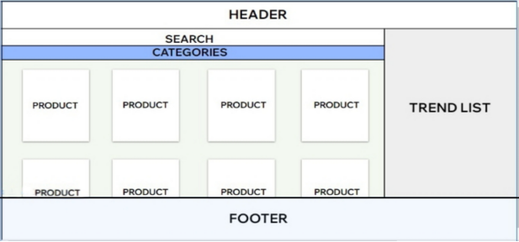

Create a database to store product information

To create a database to store product information using IBM, you can use IBM's database management system, such as IBM Db2 or IBM Cloud Databases. Here's a general overview of the steps you can follow:

1. Select an IBM Database Service:

Choose the IBM database service that suits your needs. You can use IBM Db2 on-premises or select a cloud-based option like IBM Db2 on Cloud or other IBM Cloud Databases services.

2. Create an IBM Cloud Account:

If you're using IBM Cloud Databases, you'll need to create an IBM Cloud account if you don't already have one.

3. Set Up Your Database:

Depending on the service you choose, you may need to set up your database instance. Follow the service-specific instructions for creating a new database.

4. Design Your Database Schema:

Define the structure of your database by creating tables to store product information. Typically, you'll have tables for products, categories, prices, descriptions, and more. Design the schema to meet your specific requirements.

5. Connect to the Database:

You'll need to establish a connection to your IBM database. This might involve obtaining connection credentials and using them in your application or database management tool.

6. Create Tables:

Using SQL or a database management tool, create the tables you designed in step 4. Define the columns and data types that represent the product information.

7. Insert Data:

Populate the tables with product data by running SQL INSERT statements or using data import tools provided by your chosen IBM database service.

8. Access and Query Data:

Build applications or use SQL queries to access and retrieve product information from the database.

9. Implement Security and Access Control:

Ensure that your database is secure by configuring access control, authentication, and authorization to protect your product information.

10. Backup and Maintenance:

Set up regular database backups and perform routine maintenance to keep your database running smoothly.

11.Scale and Optimize:

As your product database grows, you may need to scale your database resources and optimize your queries for better performance.

12. Monitoring and Analytics:

Implement monitoring and analytics tools to track database performance and gain insights into product data usage.