State Transition Diagrams

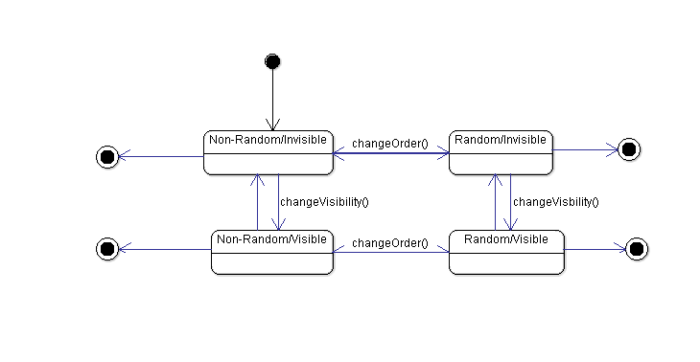

This state transition diagram corresponds to the Exercise class. This class has two independent states, which make four possible states. The instances are always created as non-random/invisible, but there are methods to change those states. Finally, an exercise can be deleted in any given state.

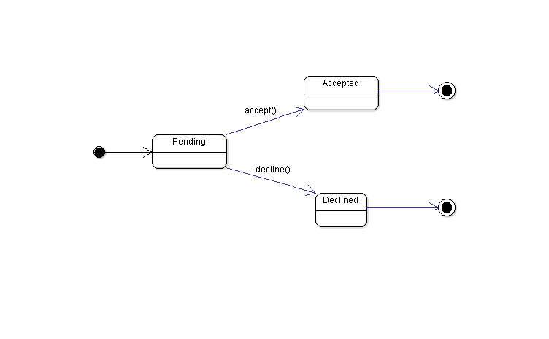

This state transition diagram corresponds to the Application class. This class has an initial state (pending) and then can be accepted or declined. Once it has been accepted or declined it can be deleted.

Sequence Diagrams

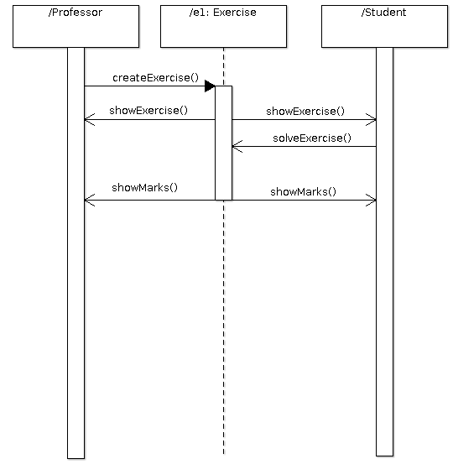

This sequence diagram corresponds to a student solving an exercise. The professor creates the exercise, then it is shown and the students solves it. Finally, the mark is shown.

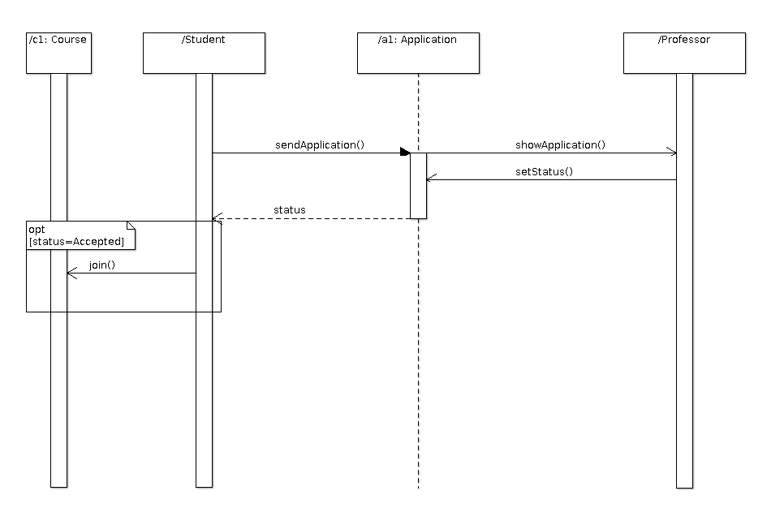

This sequence diagram corresponds to a student applying to a course. First, it sends an application, then the professor accepts or denies it and if the student is accepted, he/she joins the course