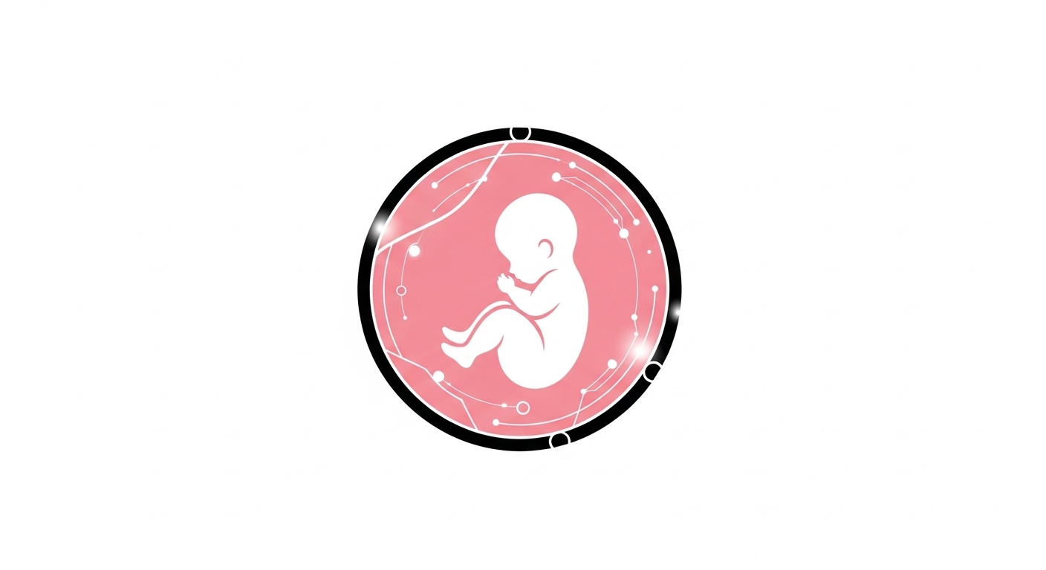
NATAL TOKEN
(NATAL)
Official Whitepaper

Decentralized Maternal Healthcare Financing
Powered by Binance Smart Chain

Version 1.0
Total Supply: 55,000,000 NATAL

Executive Summary

Natal Token (NATAL) is a blockchain-powered digital asset engineered to transform maternal and prenatal healthcare financing globally, with a concentrated focus on underserved and low-resource regions. Deployed as a BEP-20 token on the Binance Smart Chain (BSC), Natal Token bridges the critical gap between healthcare funding inefficiencies and real-world maternal health needs through transparent, decentralized, and incentive-driven mechanisms.

With a fixed total supply of 55,000,000 NATAL tokens, the project enforces a scarcity-backed impact model where every token represents meaningful participation in a globally significant maternal health infrastructure. This controlled supply ensures long-term value alignment between token economics and healthcare outcomes.

Natal Token is not merely a digital currency — it is an end-to-end infrastructure for health financing, accountability, and innovation in maternal care delivery.

1. Project Overview

The core vision of Natal Token is to reduce maternal mortality, improve prenatal care access, and support newborn health outcomes by leveraging decentralized finance (DeFi), tokenized incentives, and community-driven governance. The project connects healthcare providers, pregnant women, researchers, donors, and health institutions into a unified blockchain ecosystem where value flows directly into maternal health impact.

Mission
To create a decentralized, transparent, and sustainable healthcare funding ecosystem dedicated to improving maternal and prenatal health outcomes worldwide.

Key Objectives
- Provide decentralized funding for maternal healthcare services
- Support prenatal education, research, and innovation
- Incentivize healthcare workers and maternal health specialists
- Improve access to affordable maternal care in underserved regions
- Enable transparent donation tracking and healthcare spending accountability
- Build a global community focused on maternal health improvement
- Reduce preventable maternal and infant mortality through innovation

2. The Problem Statement

Maternal healthcare remains one of the most underfunded and inefficiently managed sectors in global healthcare systems. Millions of women, particularly in developing regions, lack access to quality prenatal care, skilled birth attendants, emergency obstetric services, affordable maternal health insurance, and reliable health education and monitoring.

Critical Challenges
- Fragmented and siloed funding systems
- Corruption and lack of transparency in healthcare fund allocation
- High cost of maternal services, especially in rural areas
- Inefficient donor-to-patient fund flow
- Poor accountability in healthcare spending
- Limited access to real-time maternal health data

Natal Token addresses these challenges by introducing a decentralized funding and accountability system built on blockchain infrastructure — enabling end-to-end traceability of every dollar contributed to maternal healthcare.

3. Blockchain Infrastructure

Natal Token is deployed on the Binance Smart Chain (BSC), a high-performance, low-cost blockchain platform that enables smart contract automation, transparent recordkeeping, and scalable healthcare funding operations.

Core Blockchain Capabilities
- Fast and low-cost transactions with minimal network fees
- Smart contract automation for fund disbursement and incentive distribution
- Transparent and immutable financial records
- Scalable infrastructure for global healthcare funding operations
- Fraud prevention through tamper-proof transaction ledgers

This infrastructure ensures that all financial flows related to maternal healthcare are traceable, verifiable, and tamper-proof — establishing a new standard of accountability in health financing.

4. The Natal Ecosystem

The Natal ecosystem is built around two complementary digital assets that serve distinct but interconnected roles within the platform.

4.1 Natal Token (NATAL) — BEP-20 Utility Token
Natal Token is the primary utility and transactional token of the ecosystem. It functions as the economic backbone enabling seamless value transfer between all stakeholders.

Primary Use Cases
- Funding maternal healthcare services and programs
- Rewarding healthcare providers for service delivery
- Paying for prenatal services and health education
- Supporting research and innovation in maternal health
- Facilitating charitable donations and healthcare grants

4.2 Natal Soul Governance Token (NST)
NST is a soul-bound, non-transferable governance asset that represents participation rights within the Natal ecosystem. Unlike NATAL, NST cannot be traded — it is earned through verifiable contributions to the ecosystem.

NST Governance Rights
- Vote on healthcare funding proposals
- Participate in ecosystem governance decisions
- Influence project funding allocation priorities
- Shape ecosystem development roadmap

NST ensures decentralized, community-owned governance of the Natal ecosystem — preventing concentration of decision-making power while ensuring that maternal health priorities are set collectively.

5. Community Governance

Natal Token operates under a decentralized governance structure that prioritizes transparency, inclusivity, and community accountability. Governance is powered by NST holders who collectively determine the direction of ecosystem funding and development.

Governance Mechanisms
- On-chain proposal submission and voting systems
- Community-validated healthcare project approvals
- Transparent reporting of all funded initiatives
- Decentralized funding allocation for high-impact interventions

This model ensures that maternal health priorities are determined by those most committed to the ecosystem, rather than by centralized authorities — strengthening accountability and impact measurement.

6. Incentive System

Natal Token introduces a structured incentive system designed to reward meaningful participation across all ecosystem roles, aligning economic value with healthcare impact.

Incentive Categories
- Token rewards for healthcare providers delivering verified maternal services
- Research grants for maternal health innovators and scientists
- Scholarships and funding for maternal healthcare education programs
- Rewards for community health workers and birth attendants
- Token incentives for verified maternal health data contributions

7. Commercialization of Maternal Health Innovation

Natal Token actively funds the development and commercialization of maternal health innovations. Researchers, developers, and healthcare innovators are incentivized through token rewards to build scalable, real-world maternal health solutions.

Funded Innovation Categories
- Prenatal diagnostic tools and medical devices
- Maternal health mobile applications and digital platforms
- Community health programs and outreach infrastructure
- AI-based pregnancy monitoring and risk detection systems
- Rural maternal care infrastructure development

This commercialization pipeline ensures that innovation is continuously funded, deployed, and scaled — driving measurable improvements in maternal health outcomes worldwide.

8. Tokenomics & Supply Model

8.1 Total Supply
55,000,000 NATAL
Fixed Maximum Supply — Non-Inflationary
Natal Token's fixed supply of 55 million tokens reinforces its long-term vision of scarcity-backed impact funding. This controlled supply ensures that every token represents meaningful participation in a globally significant maternal health infrastructure. By capping total issuance, the ecosystem avoids inflationary pressures that could dilute the value of contributions made by healthcare supporters and donors.

8.2 Distribution Model
The 55 million NATAL tokens are allocated across key ecosystem functions, ensuring that the majority of supply directly supports maternal healthcare outcomes rather than speculative circulation. Each allocation is structured with clear purpose and accountability mechanisms.

 | Allocation Category | Token Amount | % | Primary Purpose
🔥 | Burn Mechanism | 11,000,000 | 20% | Permanently removed from circulation to increase scarcity and long-term value
👨‍💻 | Team Allocation | 5,500,000 | 10% | Core development, operations, salaries, and project maintenance (12–24 month vesting)
🌱 | Ecosystem & Dev Fund | 13,750,000 | 25% | Platform development, partnerships, healthcare integrations, ecosystem expansion
💧 | Liquidity Pool | 11,000,000 | 20% | DEX/CEX listings, price stability, and smooth trading operations
🎁 | Airdrop & Community | 8,250,000 | 15% | Community onboarding, early supporters, awareness campaigns, engagement incentives
🚀 | Presale / Public Sale | 5,500,000 | 10% | Early fundraising, investor participation, and project launch liquidity support

8.3 Circulating Supply Summary
Total Maximum Supply | 55,000,000 NATAL
Burned (Permanent Removal) | 11,000,000 NATAL (20%)
Remaining Circulating Allocation | 44,000,000 NATAL (80%)

8.4 Use of Funds
Funds generated through Natal Token ecosystem activity are allocated directly to maternal health programs and infrastructure:

- Prenatal and antenatal care programs
- Emergency maternal healthcare services
- Health education initiatives and community training
- Rural healthcare infrastructure development
- Maternal nutrition support programs
- Digital health system development and maintenance

9. Security & Compliance

Natal Token prioritizes security and regulatory compliance across all ecosystem operations. Trust, safety, and reliability are foundational requirements for participation in the maternal health ecosystem.

Security Measures
- Comprehensive smart contract audits by independent third-party firms
- Secure multi-signature wallet infrastructure
- Industry-standard data encryption protocols
- Transparent on-chain transaction monitoring
- Regulatory alignment with applicable blockchain frameworks

All token vesting, distribution, and burn mechanisms are enforced on-chain through immutable smart contracts — eliminating the possibility of unilateral fund misappropriation.

10. Development Roadmap

Phase 1 — Foundation
- Token deployment on Binance Smart Chain
- Smart contract development and audit
- Initial community building and awareness campaigns

Phase 2 — Ecosystem Development
- Launch NST governance system
- Integrate healthcare institution partnerships
- Begin funding first cohort of maternal health projects

Phase 3 — Expansion
- Scale global healthcare partnerships
- Expand healthcare provider incentive network
- Deploy maternal health applications on-chain

Phase 4 — Global Adoption
- Cross-border healthcare integration
- Large-scale maternal health funding operations
- Full decentralized governance activation

11. Partnerships & Collaborations

Natal Token actively cultivates partnerships with institutions and organizations whose mandates align with maternal health improvement. These collaborations enhance the credibility, reach, and real-world impact of the ecosystem.

Target Partnership Categories
- Hospitals, clinics, and maternal health facilities
- Maternal and reproductive health NGOs
- Academic research institutions and public health schools
- Government health agencies and ministries of health
- Health technology companies and digital health platforms

12. Future Outlook

Natal Token envisions a future where no woman dies due to preventable childbirth complications, where maternal healthcare is universally accessible regardless of geography or income, and where communities actively participate in health governance. Blockchain technology is poised to become a foundational standard for health financing in the 21st century — and Natal Token is positioned at the vanguard of that transformation.

The long-term goal is to establish a globally recognized maternal health funding infrastructure powered by decentralized technology — making Natal Token synonymous with maternal health innovation and impact.

13. Conclusion

Natal Token represents a new paradigm in maternal healthcare financing and delivery. By combining blockchain technology, decentralized governance, and tokenized incentives within a fixed-supply model of 55,000,000 NATAL tokens, it creates a system where healthcare funding is transparent, efficient, and directly impactful.

Through its ecosystem, Natal Token aims to reduce maternal mortality, improve prenatal care access, and empower communities to actively participate in healthcare transformation. The scarcity-backed supply model ensures that every NATAL token is not just a unit of value — it is a stake in one of the most important humanitarian missions of our time.

Natal Token is not just a cryptocurrency — it is a decentralized maternal health revolution.

NATAL Token | Version 1.0 | Total Supply: 55,000,000 NATAL | Binance Smart Chain (BEP-20)

