Version overview

|  |  |  |  |
| --- | --- | --- | --- |
| Date | Version | Author | Comment |
| 25/10/2019 | 1 | Victor Padurean | First sketch |

System requirements for BeaMercat

1 Introduction 2

2 General view of actors and use cases 2

3 Detailed description of actors and use cases 2

3.1 Actors 2

3.1.1 Administrator 2

3.1.2 Customer 3

3.2 Use cases 3

*3.2.1* Use Case Diagram for *Administrator* 4

3.2.2 Use Case Diagram for *Customer* 5

4 Glossary – used terms 5

# Introduction

The project presented in this document is an e-commerce website. Customers should be able to register with an account, browse products, filter them by category, add them into a shopping cart and then place an order.

# General view of actors and use cases

|  |  |  |
| --- | --- | --- |
| ***Actor*** | ***Type*** | ***Description*** |
| *Administrator* | *Human* | *The person administrating the system.* |
| *Customer* | *Human* | *Performs general operations over the system, such that visiting the Web-pages, browsing products, adding products to their cart and placing an order.* |
| *Courier* | *Human* | *Receives orders based on the designated delivery sector. May mark orders as delivered.* |

# Detailed description of actors and use cases

## Actors

### Administrator

**Type**: human

**Detailed description**:

This actor is the person administrating the system. The administrator is the one responsible for maintenance of the Web-Site. He is the one who adds products or client, remove them or update their infos.

**Where is used:**

This actor is used in the: “*Administrator page*” use case

. “*Log-in*” use case.

“*Log-out*” use case.

“*Order page*” use case

“*Deleting a product from the Database*”use case

“*Editing Product Info in the Database*” *u*se case

“*Entering a New Product into the Database*” use case

“*Deleting a customer from the Database*”use case

“*Editing Customer Info in the Database*” *u*se case

“*Entering a New Customer into the Database*” use case

“*Deleting a category from the Database*”use case

“*Editing Category Info in the Database*” *u*se case

“*Entering a New Category into the Database*” use case

“*Place order”* use case

### Customer

### Type: human

**Detailed description:**

This actor is the person who buys products. The customer may create an account, see all the products or only the products within a certain category and add the desired ones to their shopping cart. When desired, they may place an order with all the products found in their shopping cart. This actor can also update some of its account info.

**Where is used:**

This actor is used in the: “*Main Customer Page*” use case

“*Log-in page*” use case

“*Log-out*” use case

“*Browse Categories*” use case

“*Browse Products*” use case

“*Register*” use case

“*Edit Self Info*” use case

“*Inspect Shopping Cart*” use case

“*Place Order*” use case

“*Add order to Shopping Cart*” use case

### Courier

### Type: human

**Detailed description:**

This actor is the person delivering orders. Their account is already made by an admin and will receive the login credentials. One such actor will receive orders based on the designated delivering area and may mark orders as delivered.

**Where is used:**

This actor is used in the: “*Orders List*” use case

“*Log-in page*” use case

“*Log-out*” use case

“*Inspect order*” use case

“*Update order status*” use case

## Use cases

### **Use Case Diagram for *Administrator***

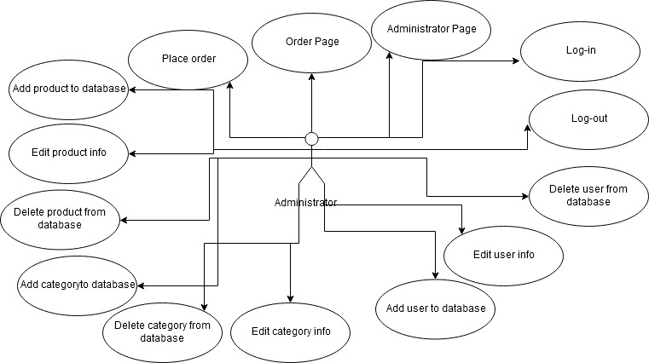

**Description: all the actions that can be done by the Administrator**

**Actor:** Administrator   
**Precondition:** the website is functional  
**Postcondition:** the desired action is completed; if an exception occurs, the administrator will be notified

**Behavior:** the action will reach its completion unless the necessary data provided by the actor is erroneous, in which case they will be notified by the system and asked to try again

### **Use Case Diagram for *Customer***

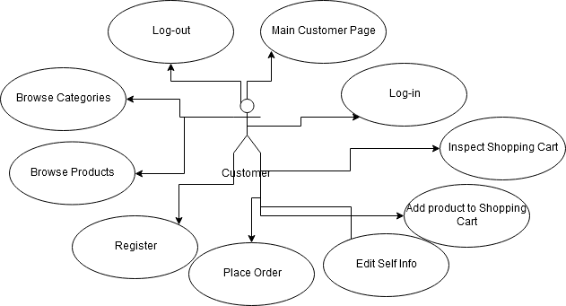

**Description: all the actions that can be done by the Customer**

**Actor:** Customer  
**Precondition:** the website is functional  
**Postcondition:** the desired action is completed; if an exception occurs, the user will be notified

**Behavior:** the desired action will take place, but if some date is introduced erroneously, the user will be notified

### **Use Case Diagram for *Courier***

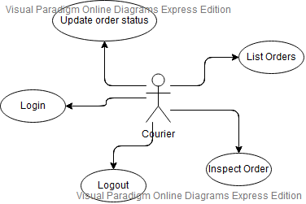

**Description: all the actions that can be done by the Courier**

**Actor:** Courier  
**Precondition:** the website is functional  
**Postcondition:** the desired action is completed; if an exception occurs, the user will be notified

**Behavior:** the desired action will take place, but if wrong credentials are introduced, an exception will occur

# Glossary – used terms

|  |  |  |
| --- | --- | --- |
| **Term** | **Use cases** | **Description** |
| User account  authentication | Administrator Log-in use case, Customer Log-in use case | Contains all the information needed by the user that wants to authenticate itself in the system using a user password schema |
| Shopping Cart | Adding an Article to the Shopping Cart,  Ordering | It is used for reserving and ordering one or more products |
| Register | Register | Create an account using custom credentials |
| Category | Browse Categories,  Add category to database, delete category from database, edit category info | General category a product may fall under, used to better differentiate products and make browsing easier |

|  |  |  |
| --- | --- | --- |
| **Term Groups** | **Included terms and term groups** | **Description** |
| Authentication | Administrator password authentication, Customer password authentication,  Log-in, Log-out | Defines a general group of credentials used in the authentication process |