Digital Signatures for Kernel Modules on Systems Running Windows Vista
July 25, 2007
Abstract
For Windows Vista® and later versions of the Windows® family of operating systems:
- Kernel-mode software must have a digital signature before it will load on x64-based computer systems.
- Boot-start drivers should contain an embedded signature.
- Certain configurations of x86 systems require kernel-mode software to have digital signatures to access next-generation premium content depending on content protection policy.

This paper describes how to manage the signing process for kernel-mode software for Windows Vista.
This information applies for the following operating systems:
Windows Vista
Windows Server® 2008
The current version of this paper is maintained on the Web at:
http://www.microsoft.com/whdc/winlogo/drvsign/kmsigning.mspx
References and resources discussed here are listed at the end of this paper.

Contents
Introduction 3
Digital Signatures as a Best Practice 4
Kernel-Mode Code-Signing Options 4
The Kernel-Mode Code-Signing Process 6
How to Obtain a Software Publishing Certificate 6
Guidance for Safeguarding Code-Signing Keys 7
Using Cross-Certificates with Kernel-Mode Code Signing 7
Verification During Driver Installation and Loading 8
Generating Test Certificates 9
Creating a Signed Catalog File 10
How to Create a Catalog File 10
How to Create a Catalog File By Using Inf2Cat 11
How to Create a Catalog File Manually 12
How to Sign a Catalog File 12
Signing the Self-Extracting Download file 13
How to Install a Signed Catalog File 14
Adding an Embedded Signature to a Driver Image File 14
How to Verify an Embedded Signature 15
How to Disable Signature Enforcement during Development 15
How to Use Test Signing 15
Using the WHQL Test Signature Program 16
Enabling Test Signing 16
Troubleshooting 17
Detecting Driver Load Errors 17
Enabling Code Integrity Diagnostic System Log Events 18
System Audit Log Events 20
Informational Events in the Verbose Log 20
Driver Verification Debugging Options 21
Code Integrity Event Log Messages 21
Resources 22

Disclaimer

This is a preliminary document and may be changed substantially prior to final commercial release of the software described herein.

The information contained in this document represents the current view of Microsoft Corporation on the issues discussed as of the date of publication. Because Microsoft must respond to changing market conditions, it should not be interpreted to be a commitment on the part of Microsoft, and Microsoft cannot guarantee the accuracy of any information presented after the date of publication.

This White Paper is for informational purposes only. MICROSOFT MAKES NO WARRANTIES, EXPRESS, IMPLIED OR STATUTORY, AS TO THE INFORMATION IN THIS DOCUMENT.

Complying with all applicable copyright laws is the responsibility of the user. Without limiting the rights under copyright, no part of this document may be reproduced, stored in or introduced into a retrieval system, or transmitted in any form or by any means (electronic, mechanical, photocopying, recording, or otherwise), or for any purpose, without the express written permission of Microsoft Corporation.

Microsoft may have patents, patent applications, trademarks, copyrights, or other intellectual property rights covering subject matter in this document. Except as expressly provided in any written license agreement from Microsoft, the furnishing of this document does not give you any license to these patents, trademarks, copyrights, or other intellectual property.

Unless otherwise noted, the example companies, organizations, products, domain names, e-mail addresses, logos, people, places and events depicted herein are fictitious, and no association with any real company, organization, product, domain name, email address, logo, person, place or event is intended or should be inferred.

© 2006–2007 Microsoft Corporation. All rights reserved.

Microsoft, Win32, Windows, Windows Server, and Windows Vista are either registered trademarks or trademarks of Microsoft Corporation in the United States and/or other countries.

The names of actual companies and products mentioned herein may be the trademarks of their respective owners.

Introduction
For both consumer and enterprise users of Windows® around the world, protecting personal and corporate data remains a top concern. Microsoft is committed to implementing new ways to help restrict the spread of malicious software. Digital signatures for kernel-mode software are an important way to ensure security on computer systems.
Digital signatures allow the administrator or end user who is installing Windows-based software to know whether a legitimate publisher provided the software package. When users choose to send Windows Error Reporting data to Microsoft after a fault or other error occurs, Microsoft can analyze the data to know which publishers’ software was running on the system at the time of the error. Software publishers can then use the information that Microsoft provides to find and fix problems in their software.
Windows Vista® relies on digital signatures for kernel-mode code to increase the safety and stability of the Windows platform and to enable new customer experiences with next-generation premium content:
- Drivers must be signed for devices that stream protected content. This includes audio drivers that use protected user-mode audio (PUMA) and protected audio path (PAP), and video device drivers that handle protected video path-output protection management (PVP-OPM) commands.
- Unsigned kernel-mode software will not load and will not run on x64-based systems.
- Boot-start drivers must contain an embedded signature.

The scope of the new kernel-mode code-signing policy is far reaching. For developers who publish kernel-mode software, this policy has the following effects:
- For any kernel-mode component that is not already signed, publishers must obtain a software publishing certificate (SPC) and use the SPC to sign all 64-bit kernel-mode software that runs on x64-based computer systems running Windows Vista. This includes kernel-mode services software.
- Publishers that provide 64-bit device driver or other kernel-mode software that is already signed through the Windows Logo Program must have their driver catalog files signed with a Windows Hardware Quality Labs (WHQL) signature. To fully test the driver package before submission to WHQL, they must use an SPC to sign the driver catalog file.
- In the special case of boot-start drivers, publishers must use an SPC to embedded-sign the driver binary image file for optimal system boot performance. This requirement applies to x86 and x64 versions of Windows.
A driver is said to be boot start if it is loaded by the Windows Vista operating system loader. Boot-start drivers are identified when the driver's INF specifies the start type as “Start=0” or a kernel service is configured with a ServiceType as Kernel Driver or File System Driver and StartMode is “boot”.

The kernel-mode code-signing policy applies to all kernel-mode software on x64-based systems running Windows Vista and to boot-start drivers for both x86 and x64 systems. However, Microsoft encourages publishers to digitally sign all software, including device drivers for both 32-bit and 64-bit platforms. Windows Vista performs kernel-mode signature verification on x86 systems to support protected media content.
This paper describes how to manage the signing process for kernel-mode code for Windows Vista, including how to obtain an SPC, guidelines for protecting keys, and how to sign a driver package by using the tools in the Windows Driver Kit (WDK).

Digital Signatures as a Best Practice
Since the release of Windows 98, Microsoft has promoted driver signing for designated device classes as a way to advance driver reliability, to provide a better user experience, to reduce support costs for software and hardware vendors, and to lower the total cost of ownership for customers.
For device drivers and other kernel-mode software, drivers signed as part of the Windows Logo Program increase end-user confidence in the quality of the software and improve the user experience because a driver's Windows logo indicates that the driver was tested and that the digital signature that accompanies the Windows logo confirms has not been altered since testing.
For most kernel-mode driver packages, a digital signature is provided in a signed catalog (.cat) file. WHQL provides a Microsoft-signed catalog file to distribute with a driver package that meets the requirements of the Windows Logo Program.
The process of creating signed kernel-mode software consists of two distinct but related activities. These can be done in parallel because the software usually is not required to be signed until relatively late in the development process.
- Managing the signing process. This is typically handled by publishers’ program management and software release services and includes:
- Selecting the appropriate signing option.
- Obtaining the necessary certificates.
- Managing the digital signature or code-signing keys.
To digitally sign image binary files or catalog files, a software publisher must have a certified code-signing key, which means that a certification authority (CA) has sufficiently established the identity of the publisher.
- Implementing the driver to be signed. This is typically handled by the publisher’s development team and includes:
- Implementing the driver itself.
- Creating a signed driver package for internal testing or release.

These processes are documented for earlier versions of Windows in the WDK and the Platform SDK. This paper describes additional options related to kernel-mode code signing for Windows Vista.

Kernel-Mode Code-Signing Options
Multiple options are available for working with the kernel-mode code signing (KMCS) requirements in Windows Vista. Signing driver files is not required for Windows Vista to load drivers while developing kernel-mode code. Instead, developers can use one of the mechanisms to temporarily disable load-time checks by the kernel on development and nonautomated test systems. However, test signing of driver packages is required to automate installation of a driver package on test systems without having driver installation pop-up menus. The Driver Management Infrastructure (DMI) verifies the driver package signature during installation and warns users of unsigned drivers.
Table 1 compares options for digitally signing kernel modules that Windows Vista supports.
Table 1. Options for Signing Kernel Modules

Signing options | Functionality verified to meet logo requirements | Identity verified | Intended use
Windows Logo Program | Yes | Yes | Release
KMCS by using an SPC | No | Yes | Release
WHQL Test Signature program | No | Yes | Testing
KMCS test signing | No | No | Testing

The Windows Logo Program verifies correct driver functionality and ensures high quality and reliability. Microsoft digitally signs the driver packages that are submitted to this program. The Windows Logo Program accepts device packages that are installed via INF file for hardware that meets the logo requirements. The driver publisher submits the driver package after completing driver verification tests. Drivers that qualify for the logo receive a Microsoft-signed catalog file. For information about the Windows Logo Program, see “Resources” at the end of this paper.
Developers can sign the driver image file or driver catalog file with an SPC for testing before submitting to WHQL to verify that the driver loads and operates correctly.
KMCS that uses an SPC provides identifiability of the publisher of a kernel module loading into Windows Vista. KMCS does not provide any level of certification of functionality or reliability of the kernel module. If drivers do not qualify for the Windows logo or the logo is not one of the product requirements, the publisher can create a catalog file for the driver package and sign it with the publisher’s SPC.
Important: KMCS does not replace the WHQL program. Microsoft encourages publishers to use the Windows Logo Program to ensure driver quality. KMCS does not require the software publisher to pass the Windows Logo Program testing requirements associated with WHQL.
A signed catalog file is all that is necessary for most driver packages to install and load correctly. The only exception is packages that contain a boot-start driver, which is loaded by the Windows Vista boot loader. These drivers must be signed in two ways:
- The kernel-mode driver binary file that is loaded at boot time must have an embedded signature in the binary signed with an SPC. For simplicity, it may be easier to embedded-sign all driver image files in the package.
- The driver package installed by using an INF file must also have a signed catalog file—just like driver packages that do not contain a boot start driver—for signature verification during installation.

Manufacturers should ensure that hardware vendors acquire an SPC and sign any boot-start drivers that will be installed on manufacturer-installed systems.
For testing purposes during the development cycle, code signing using a “test” certificate is recommended instead of signing with a release certificate. Windows Vista systems recognize a test-signed binary only when a boot configuration option that allows use of test signing certificates is enabled. Test signing is not enabled by default, and test signatures are not trusted by the majority of Windows Vista systems.
The WHQL Test Signature program is also supported for test signing. Participants in the program can submit driver packages for WHQL test signing. The signature on the test-signed catalog files are generated by a certificate issued under the Microsoft Test Root Authority. The Microsoft Test Root Authority is accepted when the Windows Vista boot configuration setting enables test signing. For information about the WHQL Test Signature program, see “Resources” at the end of this paper.
For both “test” and “release” signing, the development team should follow best practices for key management, as described in “Guidance for Safeguarding Code-Signing Keys” later in this paper.
Test signing is discussed in more detail in “How to Use Test Signing” later in this paper.

The Kernel-Mode Code-Signing Process
Digitally signing a kernel-mode image file or catalog file establishes the integrity of the signed file or files. Software modules should never be modified after the code-signing operation has been performed. Modification of the image file after code signing results in installation-time and load-time signature verification failures. There is one exception to that rule: you can add an embedded signature to an image file after its hash value has been incorporated into a signed catalog file. This does not invalidate the signed catalog file because the code-signing tools do not include the digital signature section of the file when they calculate the file's hash value.
A driver package containing multiple files may be signed by using a catalog file. The driver package must have a signed catalog file that is used to identify the publisher when the driver package is installed and to verify the driver image when it is loaded into the kernel. The catalog file contains a digital certificate that identifies the publisher, plus hashes of the package contents that allow the system to verify that files in the package have not been altered.
As previously mentioned, boot-start drivers must have embedded signatures in the driver image file. Embedded signatures in boot-start driver image files optimize operating system boot performance by eliminating the need to locate the appropriate catalog file when the operating system loader verifies the driver signature.
Driver signing is not required for every build during the driver development process. Developers can disable driver signing enforcement as described in “How to Disable Signature Enforcement during Development” later in this paper.
For step-by-step instructions for kernel-mode code signing see the white paper titled “Kernel-Mode Code Signing Walkthrough.”
The following sections discuss how to obtain and manage certificates. The mechanics of signing driver packages are discussed later in this paper.

How to Obtain a Software Publishing Certificate
Use the following steps to obtain an SPC for signing your kernel-mode software that meets the mandatory kernel-mode code-signing policy:
1. Obtain an SPC from a commercial CA that issues digital certificates for signing kernel-mode code. The list of CAs who provide SPCs (or code-signing certificates) that can be used for kernel-mode code signing is available at the “Microsoft Cross-certificates for Windows Vista Kernel Mode Code Signing” Web page listed in “Resource” at the end of this paper.
2. Download a corresponding cross-certificate from the “Microsoft Cross-certificates for Windows Vista Kernel Mode Code Signing” Web page for the root CA that issued the SPC. The cross-certificate is used in the digital signature for kernel-mode code so that the signature can be verified up to a trusted root authority known to the Windows Vista kernel.

When you request an SPC from a commercial CA, follow the instructions on the CA’s Web site for how to acquire and install the code-signing certificate on the machine where you will use the private key to sign code.

Guidance for Safeguarding Code-Signing Keys
The cryptographic keys that are the primary part of the code-signing process must be well protected and treated with the same care as a company’s most valuable assets. These keys represent a company’s identity. Any code that is signed with these keys appears to Windows as if it contains a valid digital signature that can be traced to the company. If the keys are stolen, they could be used to fraudulently sign malicious code and possibly result in the delivery of code that contains a Trojan or virus that appears to come from a legitimate publisher.
For detailed information on safeguarding private keys, refer to the white paper titled “Code Signing Best Practices.”

Using Cross-Certificates with Kernel-Mode Code Signing
KMCS uses cross-certificates as part of the code-signing process. A cross-certificate is an X.509 certificate issued by one CA that signs the public key for the root certificate of another CA. The Windows Vista operating system loader and kernel recognize cross-certificates in verifying driver signatures. The cross-certificates allow the kernel to have a single trusted Microsoft root authority, but also provide the flexibility to extend the chain of trust to multiple commercial CAs that issue SPCs.
Cross-certificates are issued by the Microsoft Code Verification Root authority, which is trusted by Windows for kernel-mode validation. Figure 1 illustrates the certificate chains for a cross-certificate issued by the Microsoft Code Verification Root for a commercial certification authority, the “XYZ Root CA”.
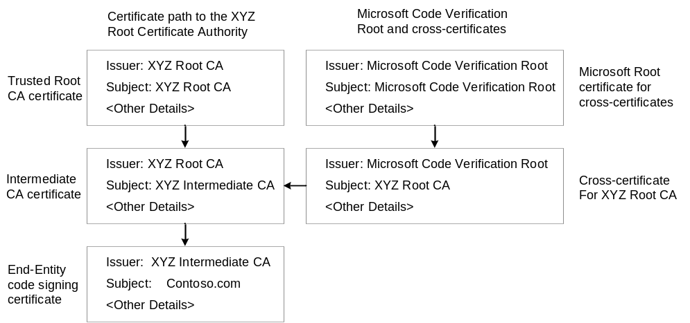
Figure 1. Cross-certificates
Cross-certificates enable developers and publishers to use SPCs to sign kernel-mode software. Developers who use KMCS download the correct cross-certificate (.cer) file to the system where the digital signature operation is performed. Publishers are not required to distribute the cross-certificate file with their software or driver package. The cross-certificate is included with the digital signature on the driver image file or driver package catalog file. Users who install the driver package are not required to do any configuration steps for Windows Vista to verify the digital signature that includes a cross-certificate.
Important: The version of SignTool in the WDK or Windows Vista Platform SDK is the only one that currently supports adding cross-certificates to a digital signature. Previous versions of SignTool in the Windows Server 2003 Platform SDK or DDK do not support adding cross-certificates.
Cross-certificates for multiple CAs to use for kernel-mode code signing are available for download from the Microsoft WHDC Web site. For more information, see “Microsoft Cross-certificates for Windows Vista Kernel Mode Code Signing” in “Resources” at the end of this paper.
Details on how to add the cross-certificate to the digital signature is described in “How to Sign a Catalog File” and “Adding an Embedded Signature to a Driver Image File" later in this paper.

Verification during Driver Installation and Loading
When a driver is installed on a system, Windows verifies the digital signature on the driver package. During installation, the contents of the driver package are copied to the correct system locations and the system configuration is updated. However, the driver is not actually loaded into the running kernel. To verify the driver package, the digital signature on the driver package is verified and each certificate in the certificate path is checked, up to a known trusted root CA. For driver installation checks and Device Manager signature checks, the known trusted root authorities are defined in the local machine Trusted Root Certification Authorities certificate store.
When a driver is loaded into kernel memory, Windows Vista verifies the digital signature of the driver image file. Depending on the type of driver, this can be either the signed hash value in the catalog file or an embedded signature in the image file itself. The cross-certificates that are used when signing the kernel driver package are used for the load-time signature verification; each certificate in the path is checked up to a trusted root in the kernel. The load-time signature check does not have access to the Trusted Root Certificate Authorities certificate store. Instead, it must depend on the root authorities that are built into the Windows Vista kernel. The Microsoft Code Verification Root is one of the root authorities trusted by the Windows Vista kernel and operating system loader.
Figure 2 is an example of how certificate paths are validated during digital signature checks for a driver with a signed catalog file. When the driver package is installed, the certificate path validation verifies up to the Trusted Root Certification Authorities in user mode (shown on the left side of the figure). When the driver image file is loaded into the kernel, the certificate path is validated by using the cross-certificate to the Microsoft Code Verification Root in the kernel-mode trusted roots.
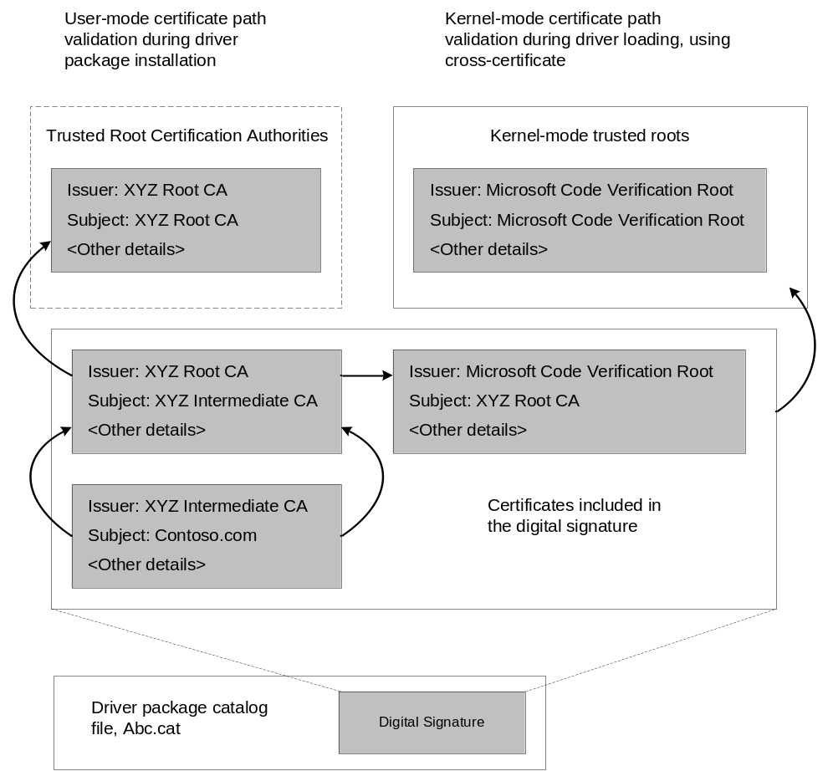
Figure 2. Certificate path verification for driver installation and loading

Generating Test Certificates
Test certificates are used in place of SPCs for test signing kernel-mode software modules that are not for distribution or release outside your organization. Test signing involves applying a digital signature to kernel-mode binaries or driver package catalog files for internal testing purposes. Test signing is discussed in more detail in “How to Use Test Signing” later in this document. A cross-certificate is not required when using a test certificate for kernel-mode code signing.
Test certificates can be generated by using an enterprise CA or using the Certificate Creation Tool (MakeCert). For more information about using an enterprise CA for issuing test-signing certificates within your organization, see the white paper titled “Code Signing Best Practices.”
In the following example, MakeCert generates a test certificate issued by the default test root, stores the private key in a key container, and outputs the certificate to a certificate store and a certificate file:
Makecert -r -pe -ss SubjectCertStoreName -n “CN=CertName” OutputFile.cer
The arguments to MakeCert in the example do the following:
-r
Creates a self-signed certificate, that is, a root certificate.
-pe
Makes the private key that is associated with the certificate exportable.
-ss SubjectCertStoreName
Specifies the name of the certificate store that contains the root certificate.
-n "CN=CertName"
Specifies a name for the certificate. If a certificate name is not supplied, the default name of the certificate is "Joe's Software Emporium".
OutputFile.cer
Denotes the name of the file in which the root certificate is saved.

An example command script that uses MakeCert is available in the WDK. The script file name—selfsign_example.txt—is located under the “bin\selfsign” directory.
Before you can install your driver package, you must add your test certificates into the certificate store on the target test machine. The following example shows how to add the test certificates to the Trusted Root certificate store and the Trusted Publishers certificate store on the target test machine.
certmgr.exe -add OutputFile.cer -s -r localMachine root
certmgr.exe -add OutputFile.cer -s -r localMachine trustedpublisher

The arguments to the Certificate Manager Tool (CertMgr) in the example do the following:
-add
Adds the certificate in the certificate file to a certificate store.
-s
Indicates the certificate store is a system store.
-r
Indicates that the registry location of the system store is under the HKEY_LOCAL_MACHINE key.
Root or trustedpublisher
Indicates the name of the system certificate store.

For more information on MakeCert and CertMgr, see “Resources” at the end of this paper.

Creating a Signed Catalog File
The tools that are used to generate and sign catalog files—MakeCat and SignTool—are provided in the WDK in the %WinDDK%\BuildNumber\bin\ directory.

How to Create a Catalog File
A digitally signed catalog file contains the hashes of all kernel-mode modules that are verified when loaded into the kernel. The catalog file can also include hashes for other files in the software package, such as user-mode application programs (.exe files) and application extensions (.dll files). Microsoft recommends that the catalog file contain the hashes of all files in a software package.
The catalog file contains a list of file hashes that correspond to a specified set of files. A file hash is the product of an SHA1 hash over a target file. A flat file hash is not used for files, such as drivers, that use the portable executable (PE) file format. Instead, relevant sections such as the PE header, executable data, and authenticated attributes are selectively hashed.
When a driver is loaded into memory, the Windows Vista kernel performs an SHA1 hash over the relevant sections of the driver binary image file. Windows verifies that the file has not been tampered with by comparing the resulting hash value to the list of binary hashes in the associated catalog file.
To install a Plug and Play driver with an INF, the simplest way to create a catalog file for the package is by using the Inf2Cat tool, as described in the next section. You can also create the catalog file manually, as described in “How to Create a Catalog File Manually” later in this paper.

How to Create a Catalog File by Using Inf2Cat
Inf2Cat is a Windows Quality Online Services (Winqual) tool that replaces the functionality of the WDK's Signability tool. For driver vendors, Inf2Cat verifies the driver package and uses the information in the package's INF file to create an unsigned catalog file. For convenience, you can also use Signability to create a catalog file from an INF, but Inf2Cat will replace Signability in the future.
Note: Inf2Cat is not currently part of the WDK tools; it is installed with the Winqual Submission Tools. When the Winqual Submission Tools package is installed, Inf2Cat is placed in the Program Files (x86)\Microsoft Winqual Submission Tool folder. To add Inf2Cat to the build environment along with the other signing tools, copy Inf2cat.exe and all DLLs in the folder to the %WinDDK%\BuildNumber\bin\SelfSign folder.
Using Inf2Cat to create a catalog file
1. Create a driver package directory that contains all of the files in your driver package.
2. Create an INF file in your driver package directory and edit it for Windows Vista. Specifically, change the build date to 4/1/2006 or greater and the version to 6. For example:
DriverVer=04/01/2006, 6.0.1.0
3. Run Inf2Cat to create a valid catalog file based on the INF file by using the following command:
Inf2cat.exe /driver:C:\WinDDK\6000\src\general\toaster\toastpkg\toastcd\ /os:Vista_x64

The arguments to Inf2Cat are the following:
/driver:PackagePath
Indicates the path to the folder that contains the driver package files. This command uses the WDK's Toastpkg sample as an example.
/os:OSValue
Indicates the operating systems targeted by the driver package. OSValue is a comma-separated list that contains one or more of the following values: 2000 XP_X86, Server2003_X86, Vista_X86, XP_X64, Server2003_X64, Vista_X64, or Server2003_IA64.

How to Create a Catalog File Manually
To manually create a catalog file, first use a text editor to create a catalog definition file (.cdf). The .cdf file includes a list of the files that are to be cataloged and their attributes.
The following example shows the contents of a typical .cdf file that is named Good.cdf. The package to be cataloged contains two files: File1 and File2. The resulting catalog file is named Good.cat.
[CatalogHeader]
Name=Good.cat
PublicVersion=0x0000001
EncodingType=0x00010001
CATATTR1=0x10010001:OSAttr:2:6.0
[CatalogFiles]
<hash>File1=File1
<hash>File2=File2

A catalog file is created with the MakeCat command-line tool, which is included with the Platform SDK and the WDK. The MakeCat tool:
- Verifies the list of attributes for each listed file.
- Adds the listed attributes to the catalog file.
- Hashes each of the listed files.
- Stores the hashes of each file into the catalog file.
To create a catalog file
1. Use a text editor to create a .cdf file that contains a list of files to be cataloged, with their attributes.
2. Run MakeCat against the .cdf file.

MakeCat does not modify the .cdf file.
The following example shows how to make a catalog file from Good.cdf. The -v flag specifies the verbose version of MakeCat. The hashed files and the newly generated Good.cat file are placed in the same folder as File1 and File2.
MakeCat -v Good.cdf

The catalog file is now ready to be signed.
For more information about MakeCat and the format of .cdf files, see the MakeCat documentation in “Resources” at the end of this paper.

How to Sign a Catalog File
The catalog file that MakeCat generates contains all the required file hashes to install kernel-mode modules on a user’s system. However, the file must also be digitally signed.
A catalog file is signed with the command-line SignTool (Signtool.exe). The digital signature on the catalog file, which is used to verify kernel-mode image files, must contain a cross-certificate. The cross-certificate is added by using a new command option to SignTool.
Important: You must use the version of SignTool from the WDK or the Windows Vista version of the Platform SDK to add a cross-certificate to the digital signature.

The following example shows how to use SignTool to sign a catalog file with an SPC and corresponding private key that is imported into the Windows certificate store:
SignTool sign /v /ac CrossCertificateFile /s SPCCertificateStore /n SPCSubjectName /t http://timestamp.verisign.com/scripts/timestamp.dll Good.cat

For information about how to use SignTool with a hardware security module (HSM), see the documentation in “Resources” at the end of this paper.
This example uses several of the arguments that SignTool supports:
Sign
Configures the tool to sign the catalog file that is named CatFileName.cat.
/v
Specifies the verbose option for successful execution and warning messages.
/ac
Adds the cross-certificate from the CrossCertificateFile file to the digital signature.
/s
Specifies a certificate store that is named SPCCertificateStore.
/n
Specifies a certificate with the subject name SPCSubjectName.
/t URL
Specifies that the digital signature will be timestamped by the Time-Stamp Authority (TSA) indicated by the URL.

Important: The catalog file or driver signature must include a timestamp to provide necessary information for key revocation in case the signer’s code-signing private key is compromised.
During device installation, if the SPC that was used for signing has expired and the signature was not timestamped, the catalog file is not installed and Windows does not allow the driver to be loaded. However, if the signature is timestamped by a trusted TSA, the catalog file is installed and Windows allows the driver to be loaded.

Signing the Self-Extracting Download file
Software that is published for distribution on a product support Web site is usually packaged in a self-extracting archive file. The self-extracting executable is downloaded by using a Web browser, and the contents are extracted before users begin to install the software on their machine. You can also use the SPC that signed the driver package catalog file to digitally sign the self-extracting .exe file.
Digitally signing the self-extracting .exe file identifies the publisher of the archive file and ensures the integrity of the file that is downloaded over the Internet. Users who download the file typically see a trust dialog box—or security warning—when they choose to download and run the self-extracting file.
In Windows Vista, if the user looks at the details of the security warning dialog box and selects Always install software from <publisher name>, this option simplifies the later confirmation when a driver package is installed. When the driver package is installed, user are asked if they trust the publisher of the signed driver package before the driver installation begins. If users select the option to always install software from the driver publisher when they downloaded the self-extracting .exe file, the trust dialog prompt box does not appear during driver installation.

How to Install a Signed Catalog File
For drivers that are installed through Plug and Play, no changes in the installation process are expected. Installation of an embedded-signed driver requires no special processing beyond the standard INF and setup mechanisms. Note that only users who are members of the Administrators group can install driver packages.
Drivers that do not install through Plug and Play must install their catalog files in the system catalog file root folder. Installation of a catalog file in the catalog file root folder can be managed by using existing Microsoft Win32® catalog file API calls, specifically CryptCATAdminAddCatalog.

Adding an Embedded Signature to a Driver Image File
To optimize the performance of driver verification at boot time, boot-start driver binaries must have an embedded signature that uses the SPC in addition to the signed catalog file for the package. The embedded signature saves significant time during operating system boot-up because the operating system loader is not required to locate the driver’s catalog file. A typical Windows Vista system may have over a hundred different catalog files in the catalog file root store. Locating the correct catalog file to verify the image hash of a particular driver can involve a lot of system overhead searching multiple catalog files for the correct file.
Boot-start drivers are identified based on the service StartType value of SERVICE_BOOT_START (0).
Embedded signatures do not interfere with catalog file signing or validation. Note that the hashes in catalog files and embedded signatures selectively exclude the signature portion of the PE file format.
To use SignTool to embed a signature into a boot-start driver binary by using an SPC and a corresponding private key imported into the Windows certificate store, use the following command:
SignTool sign /v /ac CrossCertificateFile /s SPCCertificateStore /n SPCSubjectName /t http://timestamp.verisign.com/scripts/timestamp.dll winloaddriver.sys

This example uses several of the arguments that SignTool supports:
Sign
Configures the tool to sign the driver named winloaddriver.sys.
/v
Specifies the verbose option for successful execution and warning messages.
/ac
Adds the cross-certificate from the file CrossCertificateFile to the digital signature.
/s options
Specifies the certificate store named SPCCertificateStore.
/n
Specifies the certificate with the subject named SPCSubjectName.
/t URL
Specifies that the digital signature should be timestamped by the TSA that is indicated by URL.
Important: The catalog file or driver must be timestamped because this provides necessary information for key revocation if the signer’s key is compromised.

How to Verify an Embedded Signature
The following procedure shows how to verify an embedded signature with Windows Explorer.
To verify embedded signatures
1. While running Windows Vista, right-click the driver’s .sys file and click Properties on the shortcut menu.
2. Click the Digital Signatures tab, if it is present.
If this tab is not present, the file does not have an embedded signature.
3. Select the signer and click Details to open the Signature Details dialog box.
4. Click View Certificate to open the certificate’s property pages.
Verify that there are no warning dialog boxes.
Verify that the certificate’s subject name is Publisher is registered with a recognized certification authority.
5. Click the Certification Path tab and verify that the subject name of the top certificate is Microsoft Code Verification Root.
To verify embedded signatures by using SignTool for kernel-mode code-signing policy
- SignTool can be used to verify the signature on a catalog file by using the following command:
Signtool verify /kp /c tstamd64.cat toaster.sys

Verify that the image hash for the file toaster.sys is found in the catalog file. The tool returns the string “Success”.

How to Disable Signature Enforcement during Development
During the early stages of development, developers can disable enforcement in Windows so that driver signing is unnecessary. The following options are available for developers to temporarily disable kernel-mode code-signing enforcement so that Windows Vista will load an unsigned driver.
- Attaching a kernel debugger. Attaching an active kernel debugger to the target computer disables the enforcement of kernel-mode signatures in Windows Vista and allows the driver to load.
- Using the F8 option. An F8 Advanced Boot Option introduced with Windows Vista—“Disable Driver Signature Enforcement”—is available to disable the kernel-signing enforcement only for the current boot session. This setting does not persist across boot sessions.

How to Use Test Signing
Test signing provides additional options to development organizations for incorporating kernel-mode code signing for prerelease software that is not ready for publication. Test signing allows the use of “test” code-signing certificates to sign drivers that will load on Windows Vista when the Windows Vista boot configuration setting allows test signatures.
Test signing may be appropriate to use in the following scenarios:
- Development teams need to test prerelease versions of a driver on test systems where it is not practical to attach a kernel debugger.
- Automated testing of kernel-mode software makes it impractical to use the F8 Advanced Boot Option to temporarily disable driver-signature enforcement on every machine boot cycle.

Test signing allows developers to sign prerelease versions of kernel-mode binaries so that Windows Vista can verify and load the signed driver. Test signing involves the following differences from normal production or release signing:
- Certificates for test signing can be generated by using the MakeCert code-signing tool or issued by an enterprise CA, instead of using an SPC issued by a commercial CA.
- The Windows Vista boot configuration option to enable test signing must be enabled on the Windows Vista system that will load the test-signed driver.

Development organizations can set up an enterprise public key infrastructure (PKI) and issue their own test code-signing certificates to use for test signing. When Windows Vista enables test signing, verification of the digital signature on the driver binary accepts certificates issued by any CA or issuing authority. Test signing verifies that the driver image is signed, but certificate path validation performed in kernel mode does not require the issuer to be configured as a trusted root authority. This allows organizations to use individual signatures on test binaries, based on the credentials issued for code signing within the organization. Microsoft recommends this form of deployment for test signing within the KMCS.
Using certificates generated by MakeCert is also acceptable for test signing. However, certificates generated by this tool often do not provide useful identity information and offer no way to track which individual developer created a test-signed version of the prerelease binary.
The SignTool instructions in this document work the same way whether you are using an SPC, a certificate generated by MakeCert, or a certificate issued by an enterprise CA. The only difference is typically the issuer and subject name in the certificate.

Using the WHQL Test Signature Program
The WHQL Test Signature program is also supported for test signing. Program participants can submit driver packages for WHQL test signatures. The signature on the test-signed catalog files are generated by a certificate issued under the Microsoft Test Root Authority. In Windows Vista, the Microsoft Test Root Authority is accepted when the Windows Vista boot configuration setting enables test signing.
Test-signed kernel-mode binaries will not load on Windows Vista systems by default. The digital signatures on test-signed binaries are not valid on Windows Vista systems by default because the kernel-mode code-signing policy does not accept and does not trust test-signing certificates.

Enabling Test Signing
Use the BCDEdit command-line tool to enable test signing. To use BCDEdit, the user must be a member of the Administrator group on the system and run the command from an elevated command prompt. An elevated command prompt can be launched by creating a desktop shortcut to cmd.exe, right-clicking the shortcut, and then clicking Run as administrator.
The following shows an example of running BDCEdit at the command prompt:
// Accept test signed kernel mode signatures
Bcdedit.exe –set TESTSIGNING ON

// Do not accept test signed kernel mode signatures
Bcdedit.exe –set TESTSIGNING OFF

The TESTSIGNING boot configuration option determines whether Windows Vista accepts test-signed kernel-mode binaries. The option is not defined by default, which means that digital signatures on test-signed kernel-mode drivers will not verify and will not load. When Windows Vista accepts test-signed kernel-mode binaries, some premium content that is protected may not be accessible on the system.

Troubleshooting
You can take specific steps to identify and troubleshoot potential problems related to verifying kernel-mode code signatures. This section provides information on troubleshooting problems with driver-signing enforcement. The main tools for troubleshooting driver-signing problems are:
- Detecting driver load errors.
- Enabling Code Integrity diagnostic system log events.

The Toaster sample in the WDK is used as an example. It can be found in the WDK under the src\general\toaster directory.

Detecting Driver Load Errors
The Toaster sample installs a device driver (toaster.sys) that, for this example, is not signed. The symptom of a problem with the unsigned driver is that the Toaster device fails to start. By using Device Manager, you can check the status of the Toaster device and view the driver status, as shown in Figure 3.
The device failed to start because the device driver was not signed and kernel-mode signing enforcement blocked the driver from loading into the kernel. To definitively identify the source of the problem, we set up the system to enable signing enforcement diagnostics as described in the following section.
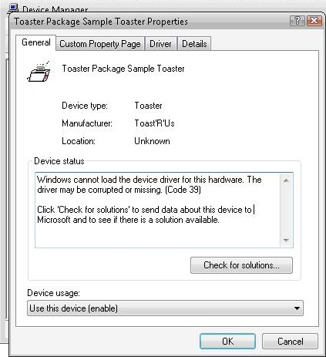
Figure 3. Unsigned driver error

Enabling Code Integrity Diagnostic System Log Events
Kernel-mode code-signing enforcement is implemented by a Windows Vista component known as “Code Integrity.” Code Integrity generates diagnostic events and a system audit log event when the signature of a kernel module fails to verify correctly.
- Code Integrity operational events are always enabled. The operational events are warning events that an image verification check failed when loading a kernel-mode binary file.
- Code Integrity system audit events are generated when the system audit policy is enabled. The system audit policy is not enabled by default.
- Code Integrity verbose events are analytic and debug Information events that show all successful image verification checks when loading kernel-mode binary files. Verbose events are not enabled by default.

You can view Code Integrity events under Event Viewer, which is part of the Computer Management MMC snap-in. On the taskbar click Start, right-click Computer, and select Manage. On the Computer Management dialog box, click Event Viewer, click Applications and Services Logs, click Microsoft, click Windows, and then click CodeIntegrity, as shown in Figure 4.
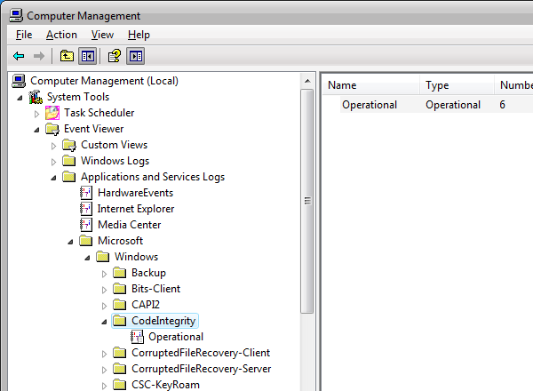

Figure 4. Code Integrity events
The Code Integrity operational log shows events that the kernel generates when a kernel-mode driver fails an image verification check when the driver is loaded. The image verification failure may be due to a number of reasons:
- The driver was unsigned but installed on the system by an administrator, and Code Integrity is not allowing the driver to load.
- The driver was signed, but the driver image file was modified or tampered with, and the modification invalidated the driver signature.
- The system disk device may have device errors when reading the image file for the device from bad disk sectors.

For details on a particular entry, right-click the entry and then select Event Properties on the shortcut menu. Figure 5 shows an operational log entry for an unsigned or modified driver image verification failure.
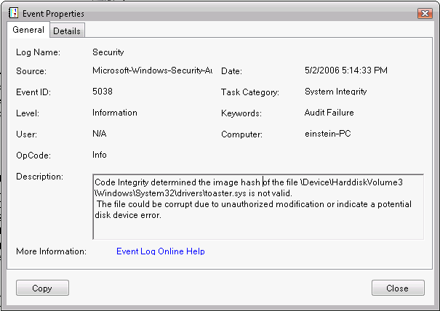
Figure 5. Operational log entry
The event indicates that the Toaster driver (toaster.sys) could not be loaded because it was unsigned (or the toaster.sys image that is trying to load is not the same one that was digitally signed by the publisher).
All Code Integrity event log messages are listed in “Code Integrity Event Log Messages” later in this paper.

System Audit Log Events
Code Integrity generates system audit log events that correspond to the operational warning events when image verification of a kernel-mode driver fails. The system log events are viewable in Event Viewer under the Windows Logs, System log view.
System audit events may not be enabled on all Windows Vista systems. Use the Local Security Settings MMC snap-in to verify or enable Audit system events under the Local Policies, Audit Policy settings.

Informational Events in the Verbose Log
Additional Code Integrity informational events for all kernel-mode image verification checks are available by using the verbose event view. These events show successful image verification of all drivers loaded on the system.
To enable the Code Integrity Verbose event view
1. Left-click Operational view to display current Code Integrity events (if any).
2. Left-click the Code Integrity node to set the focus.
3. Right-click the Code Integrity node, select View, and then select Show Analytic and Debug Logs on the shortcut menu.
This creates a subtree with two additional nodes: Operational and Verbose.
4. Right-click the Verbose node and select Properties on the shortcut menu.
5. On the General tab, select the Enable Logging option. This enables verbose logging mode.
6. Close the dialog boxes and reboot the system to reload all kernel-mode binaries.
7. After reboot, open the Computer Management snap-in and view the Code Integrity verbose event log.

You can check if toaster.sys is correctly signed. In this case, toaster.sys is a Plug and Play driver and is named in a catalog file (tstamd64.cat in “\src\general\toaster\toastpkg\toastcd”). Use SignTool to verify if toaster.sys is correctly catalog file signed by using the following command:
Signtool verify /kp /c tstamd64.cat toaster.sys

Driver Verification Debugging Options
Sometimes, developers may want to enforce mandatory kernel-mode code-signing policy even when a debugger is attached. An example of this is when a driver stack has an unsigned driver (such as a filter driver) that fails to load, which may invalidate the entire stack. Because attaching a debugger allows the unsigned driver to load, the problem appears to vanish as soon as the debugger is attached. Debugging this type of issue may be difficult. To facilitate debugging in this case, Code Integrity supports a registry key that can be set to enforce kernel-mode signing enforcement even when a debugger is attached.
Two DebugFlags values can be specified in the registry to control Code Integrity behavior under the debugger. The flags are not defined by default.
The following example shows the location of the DebugFlags value:
Key: HKEY_LOCAL_MACHINE\SYSTEM\CurrentControlSet\Control\CI
Value: DebugFlags REG_DWORD

Possible settings for DebugFlags include:
00000001
Results in a debug break into the debugger and an unsigned driver being allowed to load with ‘g’.
00000010
Results in CI ignoring the presence of the debugger, and unsigned drivers being blocked from loading.

Any other value results in unsigned drivers loading, which is the default policy.

Code Integrity Event Log Messages
The following are warning events that are logged to the Code Integrity operational log:
Code Integrity is unable to verify the image integrity of the file <file name> because file hash could not be found on the system.

Code Integrity detected an unsigned driver.

This event is related to Software Quality Monitoring (SQM).

The following are information events that are logged to the Code Integrity verbose log:
Code Integrity found a set of per-page image hashes for the file <file name> in a catalog <catalog name>.

Code Integrity found a set of per-page image hashes for the file <file name> in the image embedded certificate.

Code Integrity found a file hash for the file <file name> in a catalog <catalog name>.

Code Integrity found a file hash for the file <file name> in the image embedded certificate.

Code Integrity determined an unsigned kernel module <file name> is loaded into the system. Check with the publisher to see if a signed version of the kernel module is available.

Code Integrity is unable to verify the image integrity of the file <file name> because the set of per-page image hashes could not be found on the system.

Code Integrity is unable to verify the image integrity of the file <file name> because the set of per-page image hashes could not be found on the system. The image is allowed to load because kernel mode debugger is attached.

Code Integrity is unable to verify the image integrity of the file <file name> because a file hash could not be found on the system. The image is allowed to load because kernel mode debugger is attached.

Code Integrity was unable to load the <file name> catalog.

Code Integrity successfully loaded the <file name> catalog.

Resources
WHDC Web site
Code Signing for Protected Media Components in Windows Vista
http://www.microsoft.com/whdc/winlogo/drvsign/Pmp-sign.mspx
Code-Signing Best Practices
http://www.microsoft.com/whdc/winlogo/drvsign/best_practices.mspx
Debugging Tools for Windows
http://www.microsoft.com/whdc/DevTools/Debugging/default.mspx
Driver Package Integrity during Plug and Play Device Installs in Windows Vista
http://www.microsoft.com/whdc/winlogo/drvsign/pnp-driver.mspx
Kernel-Mode Code Signing Walkthrough
http://www.microsoft.com/whdc/winlogo/drvsign/kmcs_walkthrough.mspx
Microsoft Cross-Certificates for Windows Vista Kernel Mode Code Signing
http://www.microsoft.com/whdc/winlogo/drvsign/crosscert.mspx
Windows Driver Kit (WDK)
http://www.microsoft.com/whdc/driver/WDK/aboutWDK.mspx
Windows Logo Program and Driver Signing
http://www.microsoft.com/whdc/winlogo

MSDN
Certificate Creation Tool (Makecert.exe)
http://go.microsoft.com/fwlink/?LinkId=95774
Certificate Manager Tool (Certmgr.exe)
http://go.microsoft.com/fwlink/?LinkId=95775
CryptCATAdminAddCatalog in the SDK documentation on MSDN
http://go.microsoft.com/fwlink/?LinkId=95778
SignTool
http://go.microsoft.com/fwlink/?LinkId=95786
Using MakeCat
http://go.microsoft.com/fwlink/?LinkId=95790
WHQL Test Signature Program
http://go.microsoft.com/fwlink/?LinkId=95791

TechNet
Boot Configuration Data Editor Frequently Asked Questions
http://www.microsoft.com/technet/windowsvista/library/85cd5efe-c349-427c-b035-c2719d4af778.mspx
Deploying Authenticode with Cryptographic Hardware for Secure Software Publishing
http://www.microsoft.com/technet/security/topics/cryptographyetc/authenticodets.mspx

Other
Inf2cat FAQ
https://winqual.microsoft.com/help/Inf2cat_FAQ.htm
Windows Quality Online Services (Winqual)
https://winqual.microsoft.com
Windows Server 2003 SP1 Platform SDK download site
http://www.microsoft.com/downloads/details.aspx?FamilyId=A55B6B43-E24F-4EA3-A93E-40C0EC4F68E5&displaylang=en

