MAD – CYCLE 1

1. Design Login page

**Code:XML**

<**LinearLayout**

**android:layout_width="match_parent"**

**android:layout_height="match_parent"**

**android:orientation="vertical"**

**xmlns:android="http://schemas.android.com/apk/res/android"**>

<**TextView**

**android:id="@+id/tv1"**

**android:layout_width="wrap_content"**

**android:layout_height="wrap_content"**

**android:text="USER NAME"**/>

<**EditText**

**android:id="@+id/et1"**

**android:layout_width="wrap_content"**

**android:layout_height="wrap_content"**

**android:hint="Enter Your Username"**/>

<**TextView**

**android:id="@+id/tv2"**

**android:layout_width="wrap_content"**

**android:layout_height="wrap_content"**

**android:text="PASSWORD"**/>

<**EditText**

**android:id="@+id/et2"**

**android:layout_width="wrap_content"**

**android:layout_height="wrap_content"**

**android:hint="Enter Your Password"**/>

<**Button**

**android:id="@+id/btn1"**

**android:layout_width="wrap_content"**

**android:layout_height="wrap_content"**

**android:text="LOGIN"**

**android:onClick="login"**/>

<**Button**

**android:id="@+id/btn2"**

**android:layout_width="wrap_content"**

**android:layout_height="wrap_content"**

**android:text="CANCEL"**

/>

</**LinearLayout**>

**Code:Java**

**package com.example.sjcet.designloginpage;**

**import** android.support.v7.app.AppCompatActivity;

**import** android.os.Bundle;

**import** android.view.View;

**public class** MainActivity **extends** AppCompatActivity {

@Override

**protected void** onCreate(Bundle savedInstanceState) {

**super**.onCreate(savedInstanceState);

setContentView(R.layout.***activity_main***);

}

**public void** Submit(View view) {

}

}

**Output:**

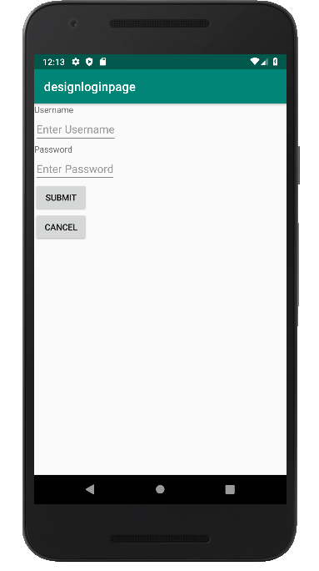

1. Change the content in the textview on a button click.

**Code:XML**

**<LinearLayout android:layout_height="match_parent" android:layout_width="match_parent" android:orientation="vertical" android:gravity="center"**

**xmlns:android="http://schemas.android.com/apk/res/android"**>

<**TextView**

**android:layout_width="wrap_content"**

**android:layout_height="wrap_content"**

**android:id="@+id/tv1"**

**android:text="Label1"**/>

<**Button**

**android:layout_width="wrap_content"**

**android:layout_height="wrap_content"**

**android:id="@+id/b1"**

**android:text="ChangeContent"**

**android:onClick="Chnage"**/>

</**LinearLayout**>

**Code:JAVA**

**package com.example.sjcet.changecontent;**

**import** android.support.v7.app.AppCompatActivity;

**import** android.os.Bundle;

**import** android.view.View;

**import** android.widget.Button;

**import** android.widget.TextView;

**public class** MainActivity **extends** AppCompatActivity {

TextView **tv1**;

@Override

**protected void** onCreate(Bundle savedInstanceState) {

**super**.onCreate(savedInstanceState);

setContentView(R.layout.***activity_main***);

}

**public void** Chnage(View view) {

**tv1**=(TextView) findViewById(R.id.***tv1***);

**tv1**.setText(**"New Content"**);

}

}

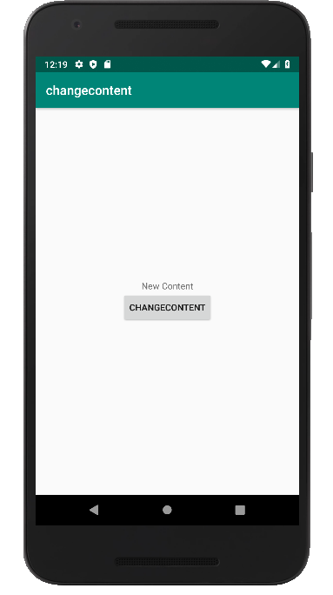**Output:**

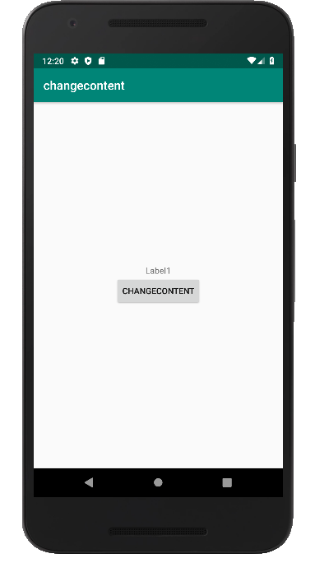

1. Read a content from edittext and print it in a textview.

**Code:XML**

**<LinearLayout**

**android:layout_height="match_parent"**

**android:layout_width="match_parent"**

**android:orientation="vertical"**

**android:gravity="center"**

**xmlns:android="http://schemas.android.com/apk/res/android"**>

<**TextView**

**android:layout_width="wrap_content"**

**android:layout_height="wrap_content"**

**android:id="@+id/tv1"**

**android:text="Text1"**/>

<**EditText**

**android:layout_width="wrap_content"**

**android:layout_height="wrap_content"**

**android:id="@+id/et1"**

**android:hint="Enter the content"**/>

<**Button**

**android:layout_width="wrap_content"**

**android:layout_height="wrap_content"**

**android:id="@+id/b1"**

**android:text="ChangeText"**

**android:onClick="changeLabelContent"**/>

</**LinearLayout>**

**code:JAVA**

**package** com.example.sjcet.printcontentintextview;

**import** android.support.v7.app.AppCompatActivity;

**import** android.os.Bundle;

**import** android.view.View;

**import** android.widget.EditText;

**import** android.widget.TextView;

**public class** MainActivity **extends** AppCompatActivity {

TextView **tv1**;

EditText **et1**;

@Override

**protected void** onCreate(Bundle savedInstanceState) {

**super**.onCreate(savedInstanceState);

setContentView(R.layout.***activity_main***);

}

**public void** changeLabelContent(View view) {

**tv1**=(TextView)findViewById(R.id.***tv1***);

**et1**=(EditText)findViewById(R.id.***et1***);

**tv1**.setText(**et1**.getText());

}

}

**Output:**

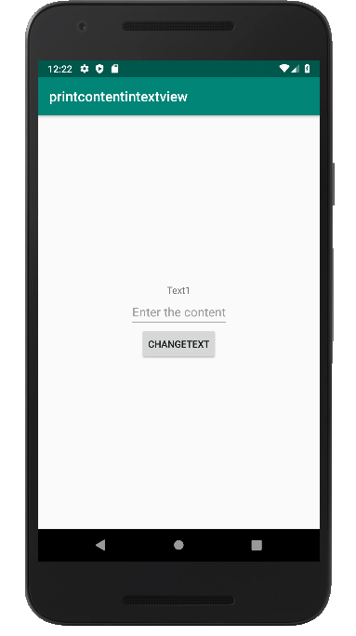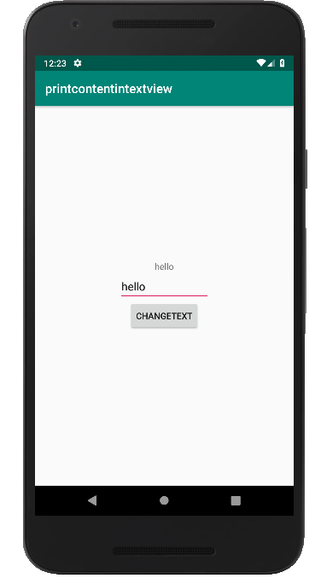

1. Change the background color on a button click.

**Code:XML**

**<LinearLayout**

**android:layout_height="match_parent"**

**android:layout_width="match_parent"**

**android:orientation="vertical"**

**android:gravity="center"**

**android:id="@+id/l1"**

**xmlns:android="http://schemas.android.com/apk/res/android"** >

<**Button**

**android:layout_width="wrap_content"**

**android:layout_height="wrap_content"**

**android:id="@+id/b1"**

**android:text="Change Color"**

**android:onClick="Change"**/>

</**LinearLayout**>

**Code:Java**

**package com.example.sjcet.changebgcolor;**

**import** android.support.v7.app.AppCompatActivity;

**import** android.os.Bundle;

**import** android.view.View;

**import** android.widget.Button;

**import** android.widget.LinearLayout;

**public class** MainActivity **extends** AppCompatActivity {

Button **btn**;

View **v**;

**boolean isColor** = **true**;

LinearLayout **linearLayout**;

@Override

**protected void** onCreate(Bundle savedInstanceState) {

**super**.onCreate(savedInstanceState);

setContentView(R.layout.***activity_main***);

**v** = **this**.getWindow().getDecorView();

**btn** = findViewById(R.id.***b1***);

**linearLayout** = findViewById(R.id.***l1***);

**btn**.setOnClickListener(**new** View.OnClickListener() {

@Override

**public void** onClick(View v) {

**linearLayout**.setBackgroundResource(android.R.color.***holo_blue_dark***);

}

});

}

**public void** ChangeColor(View view) {

**linearLayout**.setBackgroundResource(R.color.***colorPrimary***);

}

}

**Output:**

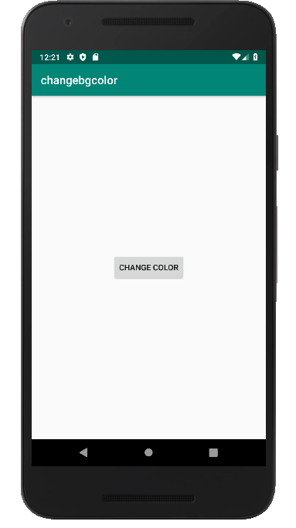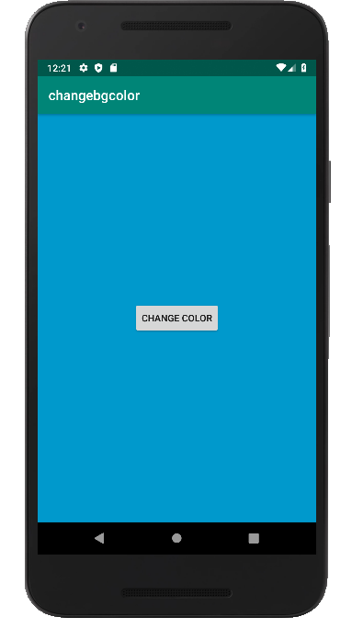

1. Create a sample Calculator.

**Code:XML**

*<****RelativeLayout android:layout_height="match_parent"***

**android:layout_width="match_parent"**

**android:orientation="vertical"**

**android:gravity="center"**

**xmlns:android="http://schemas.android.com/apk/res/android"**>

<**EditText**

**android:id="@+id/edt1"**

**android:layout_width="match_parent"**

**android:layout_height="wrap_content"** />

<**Button**

**android:id="@+id/button1"**

**style="?android:attr/buttonStyleSmall"**

**android:layout_width="wrap_content"**

**android:layout_height="wrap_content"**

**android:layout_alignEnd="@+id/button4"**

**android:layout_alignRight="@+id/button4"**

**android:layout_below="@+id/edt1"**

**android:layout_marginTop="94dp"**

**android:text="1"** />

<**Button**

**android:id="@+id/button2"**

**style="?android:attr/buttonStyleSmall"**

**android:layout_width="wrap_content"**

**android:layout_height="wrap_content"**

**android:layout_alignTop="@+id/button1"**

**android:layout_toLeftOf="@+id/button3"**

**android:layout_toStartOf="@+id/button3"**

**android:text="2"** />

<**Button**

**android:id="@+id/button3"**

**style="?android:attr/buttonStyleSmall"**

**android:layout_width="wrap_content"**

**android:layout_height="wrap_content"**

**android:layout_alignTop="@+id/button2"**

**android:layout_centerHorizontal="true"**

**android:text="3"** />

<**Button**

**android:id="@+id/button4"**

**style="?android:attr/buttonStyleSmall"**

**android:layout_width="wrap_content"**

**android:layout_height="wrap_content"**

**android:layout_below="@+id/button1"**

**android:layout_toLeftOf="@+id/button2"**

**android:text="4"** />

<**Button**

**android:id="@+id/button5"**

**style="?android:attr/buttonStyleSmall"**

**android:layout_width="wrap_content"**

**android:layout_height="wrap_content"**

**android:layout_alignBottom="@+id/button4"**

**android:layout_alignLeft="@+id/button2"**

**android:layout_alignStart="@+id/button2"**

**android:text="5"** />

<**Button**

**android:id="@+id/button6"**

**style="?android:attr/buttonStyleSmall"**

**android:layout_width="wrap_content"**

**android:layout_height="wrap_content"**

**android:layout_alignLeft="@+id/button3"**

**android:layout_alignStart="@+id/button3"**

**android:layout_below="@+id/button3"**

**android:text="6"** />

<**Button**

**android:id="@+id/button7"**

**style="?android:attr/buttonStyleSmall"**

**android:layout_width="wrap_content"**

**android:layout_height="wrap_content"**

**android:layout_below="@+id/button4"**

**android:layout_toLeftOf="@+id/button2"**

**android:text="7"** />

<**Button**

**android:id="@+id/button8"**

**style="?android:attr/buttonStyleSmall"**

**android:layout_width="wrap_content"**

**android:layout_height="wrap_content"**

**android:layout_alignLeft="@+id/button5"**

**android:layout_alignStart="@+id/button5"**

**android:layout_below="@+id/button5"**

**android:text="8"** />

<**Button**

**android:id="@+id/button9"**

**style="?android:attr/buttonStyleSmall"**

**android:layout_width="wrap_content"**

**android:layout_height="wrap_content"**

**android:layout_alignLeft="@+id/button6"**

**android:layout_alignStart="@+id/button6"**

**android:layout_below="@+id/button6"**

**android:text="9"** />

<**Button**

**android:id="@+id/buttonadd"**

**style="?android:attr/buttonStyleSmall"**

**android:layout_width="wrap_content"**

**android:layout_height="wrap_content"**

**android:layout_alignTop="@+id/button3"**

**android:layout_alignEnd="@+id/edt1"**

**android:layout_alignRight="@+id/edt1"**

**android:layout_marginStart="46dp"**

**android:layout_marginLeft="3dp"**

**android:layout_marginTop="5dp"**

**android:layout_marginEnd="43dp"**

**android:layout_marginRight="43dp"**

**android:layout_toRightOf="@+id/button3"**

**android:text="+"** />

<**Button**

**android:id="@+id/buttonsub"**

**style="?android:attr/buttonStyleSmall"**

**android:layout_width="wrap_content"**

**android:layout_height="wrap_content"**

**android:layout_alignEnd="@+id/buttonadd"**

**android:layout_alignLeft="@+id/buttonadd"**

**android:layout_alignRight="@+id/buttonadd"**

**android:layout_alignStart="@+id/buttonadd"**

**android:layout_below="@+id/buttonadd"**

**android:text="-"** />

<**Button**

**android:id="@+id/buttonmul"**

**style="?android:attr/buttonStyleSmall"**

**android:layout_width="wrap_content"**

**android:layout_height="wrap_content"**

**android:layout_alignEnd="@+id/buttonsub"**

**android:layout_alignLeft="@+id/buttonsub"**

**android:layout_alignRight="@+id/buttonsub"**

**android:layout_alignStart="@+id/buttonsub"**

**android:layout_below="@+id/buttonsub"**

**android:text="*"** />

<**Button**

**android:id="@+id/button10"**

**style="?android:attr/buttonStyleSmall"**

**android:layout_width="wrap_content"**

**android:layout_height="wrap_content"**

**android:layout_below="@+id/button7"**

**android:layout_toLeftOf="@+id/button2"**

**android:text="."** />

<**Button**

**android:id="@+id/button0"**

**style="?android:attr/buttonStyleSmall"**

**android:layout_width="wrap_content"**

**android:layout_height="wrap_content"**

**android:layout_alignLeft="@+id/button8"**

**android:layout_alignStart="@+id/button8"**

**android:layout_below="@+id/button8"**

**android:text="0"** />

<**Button**

**android:id="@+id/buttonC"**

**style="?android:attr/buttonStyleSmall"**

**android:layout_width="wrap_content"**

**android:layout_height="wrap_content"**

**android:layout_alignLeft="@+id/button9"**

**android:layout_alignStart="@+id/button9"**

**android:layout_below="@+id/button9"**

**android:text="C"** />

<**Button**

**android:id="@+id/buttondiv"**

**style="?android:attr/buttonStyleSmall"**

**android:layout_width="wrap_content"**

**android:layout_height="wrap_content"**

**android:layout_alignEnd="@+id/buttonmul"**

**android:layout_alignLeft="@+id/buttonmul"**

**android:layout_alignRight="@+id/buttonmul"**

**android:layout_alignStart="@+id/buttonmul"**

**android:layout_below="@+id/buttonmul"**

**android:text="/"** />

<**Button**

**android:id="@+id/buttoneql"**

**android:layout_width="wrap_content"**

**android:layout_height="wrap_content"**

**android:layout_alignEnd="@+id/buttondiv"**

**android:layout_alignLeft="@+id/button10"**

**android:layout_alignRight="@+id/buttondiv"**

**android:layout_alignStart="@+id/button10"**

**android:layout_below="@+id/button0"**

**android:layout_marginTop="37dp"**

**android:text="="** />

</**RelativeLayout**>

**Code:Java**

**package** com.example.sjcet.samplecalculator;

**import** android.os.Bundle;

**import** android.support.v7.app.AppCompatActivity;

**import** android.view.View;

**import** android.widget.Button;

**import** android.widget.EditText;

**public class** MainActivity **extends** AppCompatActivity {

Button **button0**, **button1**, **button2**, **button3**, **button4**, **button5**, **button6**,

**button7**, **button8**, **button9**, **buttonAdd**, **buttonSub**, **buttonDivision**,

**buttonMul**, **button10**, **buttonC**, **buttonEqual**;

EditText **crunchifyEditText**;

**float mValueOne**, **mValueTwo**;

**boolean crunchifyAddition**, **mSubtract**, **crunchifyMultiplication**, **crunchifyDivision**;

@Override

**protected void** onCreate(Bundle savedInstanceState) {

**super**.onCreate(savedInstanceState);

setContentView(R.layout.***activity_main***);

**button0** = findViewById(R.id.***button0***);

**button1** = findViewById(R.id.***button1***);

**button2** = findViewById(R.id.***button2***);

**button3** = findViewById(R.id.***button3***);

**button4** = findViewById(R.id.***button4***);

**button5** = findViewById(R.id.***button5***);

**button6** = findViewById(R.id.***button6***);

**button7** = findViewById(R.id.***button7***);

**button8** = findViewById(R.id.***button8***);

**button9** = findViewById(R.id.***button9***);

**button10** = findViewById(R.id.***button10***);

**buttonAdd** =findViewById(R.id.***buttonadd***);

**buttonSub** = findViewById(R.id.***buttonsub***);

**buttonMul** = findViewById(R.id.***buttonmul***);

**buttonDivision** = findViewById(R.id.***buttondiv***);

**buttonC** =findViewById(R.id.***buttonC***);

**buttonEqual** =findViewById(R.id.***buttoneql***);

**crunchifyEditText** =findViewById(R.id.***edt1***);

**button1**.setOnClickListener(**new** View.OnClickListener() {

@Override

**public void** onClick(View v) {

**crunchifyEditText**.setText(**crunchifyEditText**.getText() + **"1"**);

}

});

**button2**.setOnClickListener(**new** View.OnClickListener() {

@Override

**public void** onClick(View v) {

**crunchifyEditText**.setText(**crunchifyEditText**.getText() + **"2"**);

}

});

**button3**.setOnClickListener(**new** View.OnClickListener() {

@Override

**public void** onClick(View v) {

**crunchifyEditText**.setText(**crunchifyEditText**.getText() + **"3"**);

}

});

**button4**.setOnClickListener(**new** View.OnClickListener() {

@Override

**public void** onClick(View v) {

**crunchifyEditText**.setText(**crunchifyEditText**.getText() + **"4"**);

}

});

**button5**.setOnClickListener(**new** View.OnClickListener() {

@Override

**public void** onClick(View v) {

**crunchifyEditText**.setText(**crunchifyEditText**.getText() + **"5"**);

}

});

**button6**.setOnClickListener(**new** View.OnClickListener() {

@Override

**public void** onClick(View v) {

**crunchifyEditText**.setText(**crunchifyEditText**.getText() + **"6"**);

}

});

**button7**.setOnClickListener(**new** View.OnClickListener() {

@Override

**public void** onClick(View v) {

**crunchifyEditText**.setText(**crunchifyEditText**.getText() + **"7"**);

}

});

**button8**.setOnClickListener(**new** View.OnClickListener() {

@Override

**public void** onClick(View v) {

**crunchifyEditText**.setText(**crunchifyEditText**.getText() + **"8"**);

}

});

**button9**.setOnClickListener(**new** View.OnClickListener() {

@Override

**public void** onClick(View v) {

**crunchifyEditText**.setText(**crunchifyEditText**.getText() + **"9"**);

}

});

**button0**.setOnClickListener(**new** View.OnClickListener() {

@Override

**public void** onClick(View v) {

**crunchifyEditText**.setText(**crunchifyEditText**.getText() + **"0"**);

}

});

**buttonAdd**.setOnClickListener(**new** View.OnClickListener() {

@Override

**public void** onClick(View v) {

**if** (**crunchifyEditText** == **null**) {

**crunchifyEditText**.setText(**""**);

} **else** {

**mValueOne** = Float.*parseFloat*(**crunchifyEditText**.getText() + **""**);

**crunchifyAddition** = **true**;

**crunchifyEditText**.setText(**null**);

}

}

});

**buttonSub**.setOnClickListener(**new** View.OnClickListener() {

@Override

**public void** onClick(View v) {

**mValueOne** = Float.*parseFloat*(**crunchifyEditText**.getText() + **""**);

**mSubtract** = **true**;

**crunchifyEditText**.setText(**null**);

}

});

**buttonMul**.setOnClickListener(**new** View.OnClickListener() {

@Override

**public void** onClick(View v) {

**mValueOne** = Float.*parseFloat*(**crunchifyEditText**.getText() + **""**);

**crunchifyMultiplication** = **true**;

**crunchifyEditText**.setText(**null**);

}

});

**buttonDivision**.setOnClickListener(**new** View.OnClickListener() {

@Override

**public void** onClick(View v) {

**mValueOne** = Float.*parseFloat*(**crunchifyEditText**.getText() + **""**);

**crunchifyDivision** = **true**;

**crunchifyEditText**.setText(**null**);

}

});

**buttonEqual**.setOnClickListener(**new** View.OnClickListener() {

@Override

**public void** onClick(View v) {

**mValueTwo** = Float.*parseFloat*(**crunchifyEditText**.getText() + **""**);

**if** (**crunchifyAddition** == **true**) {

**crunchifyEditText**.setText(**mValueOne** + **mValueTwo** + **""**);

**crunchifyAddition** = **false**;

}

**if** (**mSubtract** == **true**) {

**crunchifyEditText**.setText(**mValueOne** - **mValueTwo** + **""**);

**mSubtract** = **false**;

}

**if** (**crunchifyMultiplication** == **true**) {

**crunchifyEditText**.setText(**mValueOne** * **mValueTwo** + **""**);

**crunchifyMultiplication** = **false**;

}

**if** (**crunchifyDivision** == **true**) {

**crunchifyEditText**.setText(**mValueOne** / **mValueTwo** + **""**);

**crunchifyDivision** = **false**;

}

}

});

**buttonC**.setOnClickListener(**new** View.OnClickListener() {

@Override

**public void** onClick(View v) {

**crunchifyEditText**.setText(**""**);

}

});

**button10**.setOnClickListener(**new** View.OnClickListener() {

@Override

**public void** onClick(View v) {

**crunchifyEditText**.setText(**crunchifyEditText**.getText() + **"."**);

}

});

}

}

**Output:**

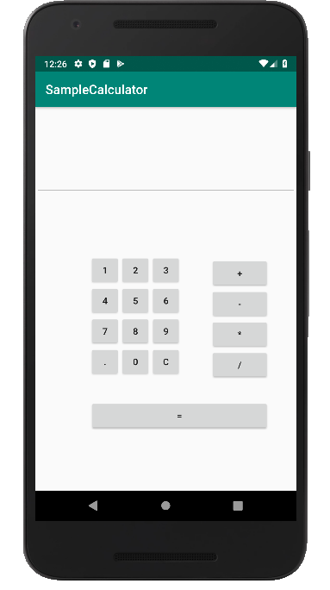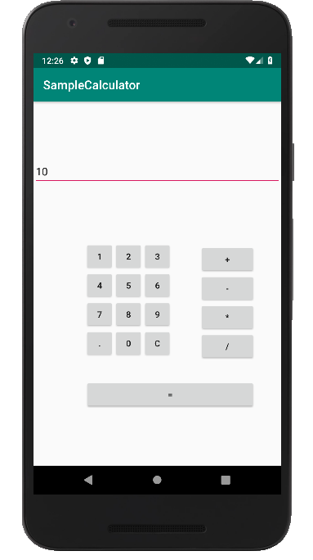

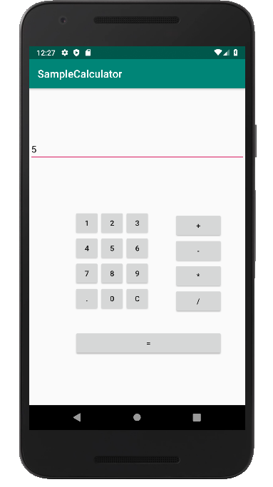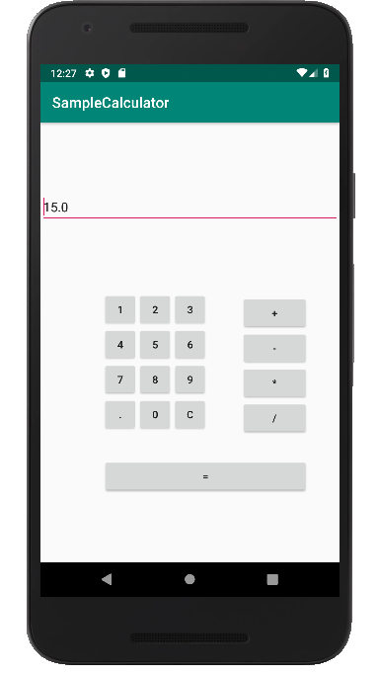

MAD LAB CYCLE -2

**1.** **Create 2 Activities from 1st Activity on click move to 2nd activity (Using Intent)**

**Program code:**

**Xml code**

**Activity_main.xml:**

*<?***xml version="1.0" encoding="utf-8"***?>*

<**LinearLayout xmlns:android="http://schemas.android.com/apk/res/android"**

**android:id="@+id/activity_main"**

**android:layout_width="match_parent"**

**android:layout_height="match_parent"**

**android:orientation="vertical"**>

<**TextView**

**android:layout_width="match_parent"**

**android:layout_height="wrap_content"**

**android:text="First Activity"**

**android:textStyle="bold"**

**android:layout_marginTop="10dp"**

**android:textAlignment="center"**

**style="@style/Animation.AppCompat.Dialog"**

**android:textSize="30dp"**/>

<**Button**

**android:text="Click Me"**

**android:layout_width="match_parent"**

**android:layout_height="wrap_content"**

**android:id="@+id/button"**

**android:onClick="click"**

**android:textStyle="bold"**

**android:layout_marginTop="200dp"**

**android:background="#34eb3a"**

**android:textSize="30dp"**/>

</**LinearLayout**>

**Activity2_main.xml:**

*<?***xml version="1.0" encoding="utf-8"***?>*

<**LinearLayout xmlns:android="http://schemas.android.com/apk/res/android"**

**android:id="@+id/activity_main2"**

**android:layout_width="match_parent"**

**android:layout_height="match_parent"**

**android:orientation="vertical"**>

<**TextView**

**android:layout_width="match_parent"**

**android:layout_height="wrap_content"**

**android:text="Second Activity"**

**android:textStyle="bold"**

**android:layout_marginTop="10dp"**

**android:textSize="30dp"**

**android:textAlignment="center"**/>

<**Button**

**android:text="Go Back"**

**android:layout_width="match_parent"**

**android:layout_height="wrap_content"**

**android:id="@+id/button2"**

**android:onClick="clickback"**

**android:textSize="30dp"**

**android:background="#34eb3a"**

**android:layout_marginTop="200dp"**/>

</**LinearLayout**>

**Java**

**Activity_main.java:**

**package** com.example.sjcet.pgm1_2activity;

**import** android.content.Intent;

**import** android.support.v7.app.AppCompatActivity;

**import** android.os.Bundle;

**import** android.view.View;

**public class** MainActivity **extends** AppCompatActivity {

@Override

**protected void** onCreate(Bundle savedInstanceState) {

**super**.onCreate(savedInstanceState);

setContentView(R.layout.***activity_main***);

}

**public void** click(View view) {

Intent intent = **new** Intent(MainActivity.**this**, Main2Activity.**class**);

startActivity(intent);

}

}

**Activity2_main.java:**

**package** com.example.sjcet.pgm1_2activity;

**import** android.content.Intent;

**import** android.support.v7.app.AppCompatActivity;

**import** android.os.Bundle;

**import** android.view.View;

**public class** Main2Activity **extends** AppCompatActivity {

@Override

**protected void** onCreate(Bundle savedInstanceState) {

**super**.onCreate(savedInstanceState);

setContentView(R.layout.***activity_main2***);

}

**public void** clickback(View view) {

Intent intent = **new** Intent(Main2Activity.**this**, MainActivity.**class**);

startActivity(intent);

}

}

**Output**

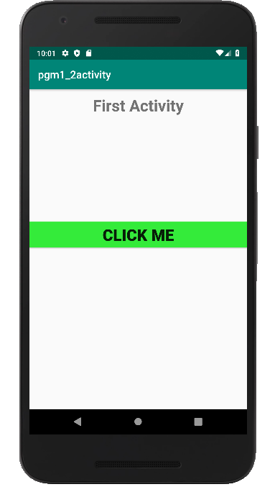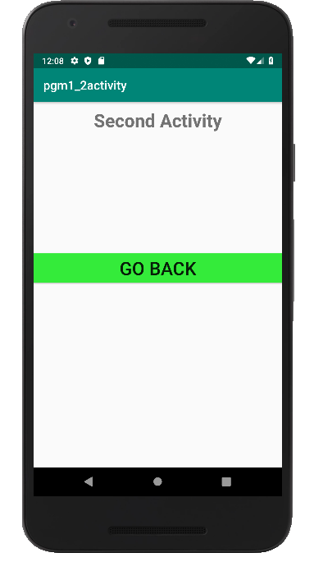

**2. Create an Activity and move to facebook login page on a button click**

**(making use of Intent).**

**Program code:**

**Xml code**

**Activity_main.xml:**

*<?***xml version="1.0" encoding="utf-8"***?>*

<**LinearLayout android:layout_width="match_parent"**

**android:layout_height="match_parent"**

**android:orientation="vertical"**

**xmlns:android="http://schemas.android.com/apk/res/android"**>

<**Button**

**android:onClick="click"**

**android:layout_width="wrap_content"**

**android:layout_height="wrap_content"**

**android:text="Facebook login"**

**android:layout_centerInParent="true"**

**android:textAlignment="center"**

**android:layout_gravity="center"**

**android:background="#006aff"**

**android:textColor="#fff"**/>

</**LinearLayout**>

**Java**

**Activity_main.java:**

**package** com.example.sjcet.pgm2_fbpage;

**import** android.content.Intent;

**import** android.net.Uri;

**import** android.support.v7.app.AppCompatActivity;

**import** android.os.Bundle;

**import** android.view.View;

**public class** MainActivity **extends** AppCompatActivity {

@Override

**protected void** onCreate(Bundle savedInstanceState) {

**super**.onCreate(savedInstanceState);

setContentView(R.layout.***activity_main***);

}

**public void** click(View view) {

String url = **"https://www.facebook.com"**;

Intent i = **new** Intent(Intent.***ACTION_VIEW***);

i.setData(Uri.*parse*(url));

startActivity(i);

}

}

**Output**

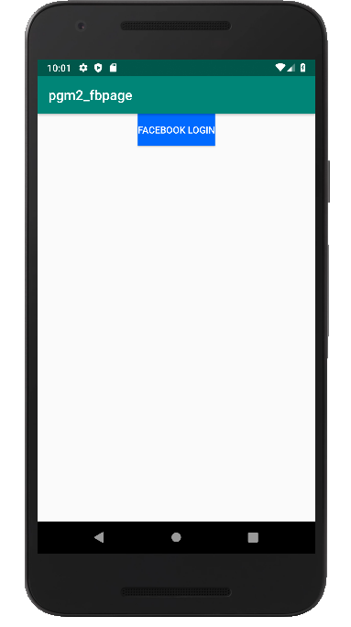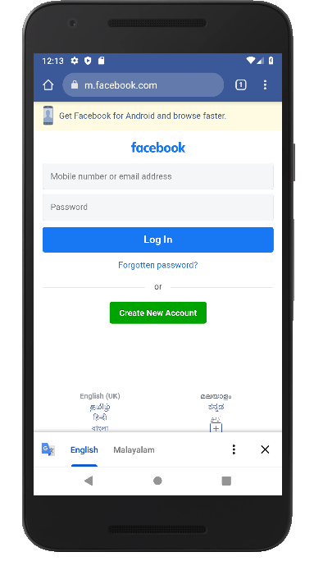

**3. Read message from 1st Activity and pass it onto the 2nd Activity on a button click.**

**Xml code**

**Activity_main.xml:**

***<?*xml version="1.0" encoding="utf-8"*?>***

<**LinearLayout xmlns:android="http://schemas.android.com/apk/res/android"**

**android:id="@+id/activity_main"**

**android:layout_width="match_parent"**

**android:layout_height="match_parent"**

**android:orientation="vertical"**>

<**TextView**

**android:layout_width="match_parent"**

**android:layout_height="wrap_content"**

**android:text="First Activity"**

**android:textStyle="bold"**

**android:layout_marginTop="10dp"**

**android:textAlignment="center"**

**android:textSize="30dp"**/>

<**EditText**

**android:layout_width="match_parent"**

**android:layout_height="wrap_content"**

**android:hint="Text"**

**android:textColor="#000000"**

**android:textSize="20dp"**

**android:textStyle="bold"**

**android:id="@+id/text"** />

<**Button**

**android:text="Click here"**

**android:layout_width="match_parent"**

**android:layout_height="wrap_content"**

**android:id="@+id/button"**

**android:onClick="click"**

**android:textStyle="bold"**

**android:textSize="30dp"**

**android:background="#ff00ae"**

**android:textColor="#fff"**

**android:layout_gravity="center_vertical"** />

</**LinearLayout**>

**Activity2_main.xml:**

***<?*xml version="1.0" encoding="utf-8"*?>***

<**LinearLayout xmlns:android="http://schemas.android.com/apk/res/android"**

**android:id="@+id/activity_main2"**

**android:layout_width="match_parent"**

**android:layout_height="match_parent"**

**android:orientation="vertical"**>

<**TextView**

**android:layout_width="match_parent"**

**android:layout_height="wrap_content"**

**android:text="Second Activity"**

**android:textStyle="bold"**

**android:layout_marginTop="10dp"**

**android:textAlignment="center"**

**android:textSize="30dp"**/>

<**TextView**

**android:layout_width="match_parent"**

**android:layout_height="wrap_content"**

**android:textSize="30dp"**

**android:textColor="#000000"**

**android:id="@+id/textreceived"**

/>

<**Button**

**android:text="Go Back"**

**android:layout_width="match_parent"**

**android:layout_height="wrap_content"**

**android:id="@+id/button2"**

**android:textSize="30dp"**

**android:background="#ff00ae"**

**android:onClick="click"**/>

</**LinearLayout**>

**Java**

**Activity_main.java:**

**package com.example.sjcet.pgm3_copymsg;**

**import** android.content.Intent;

**import** android.support.v7.app.AppCompatActivity;

**import** android.os.Bundle;

**import** android.view.View;

**import** android.widget.Button;

**import** android.widget.EditText;

**public class** MainActivity **extends** AppCompatActivity {

EditText **text**;

Button **clickme**;

String **Texthere**;

@Override

**protected void** onCreate(Bundle savedInstanceState) {

**super**.onCreate(savedInstanceState);

setContentView(R.layout.***activity_main***);

**clickme** = findViewById(R.id.***button***);

**text** = findViewById(R.id.***text***);

**clickme**.setOnClickListener(**new** View.OnClickListener() {

@Override

**public void** onClick(View v) {

**Texthere** = **text**.getText().toString();

Intent intent = **new** Intent(MainActivity.**this**, Main2Activity.**class**);

intent.putExtra(**"Text"**, **Texthere**);

startActivity(intent);

}

});

}

}

**Activity2_main.java:**

**package com.example.sjcet.pgm3_copymsg;**

**import** android.content.Intent;

**import** android.support.v7.app.AppCompatActivity;

**import** android.os.Bundle;

**import** android.view.View;

**import** android.widget.Button;

**import** android.widget.TextView;

**public class** Main2Activity **extends** AppCompatActivity {

TextView **textreceived**;

Button **button2**;

String **text**;

@Override

**protected void** onCreate(Bundle savedInstanceState) {

**super**.onCreate(savedInstanceState);

setContentView(R.layout.***activity_main2***);

**text** = getIntent().getExtras().getString(**"Text"**);

**textreceived** = findViewById(R.id.***textreceived***);

**textreceived**.setText(**text**);

**button2** = findViewById(R.id.***button2***);

**button2**.setOnClickListener(**new** View.OnClickListener() {

@Override

**public void** onClick(View v) {

Intent intent = **new** Intent(Main2Activity.**this**, MainActivity.**class**);

startActivity(intent);

}

});

}

}

**Output**

**4.Create registration page with full validation and pass the information to the second activity (using shared preference)**

**Mandatory fields : fname,lname,gender,email,phone number,password,dob(date picker)**

**Program code:**

**Xml code**

**Activity_main.xml:**

<ScrollView xmlns:tools="http://schemas.android.com/tools"

**android:layout_width="match_parent"**

**android:layout_height="match_parent"**

**xmlns:android="http://schemas.android.com/apk/res/android"**

**tools:context=".MainActivity"**>

<**LinearLayout xmlns:android="http://schemas.android.com/apk/res/android"**

**android:layout_width="match_parent"**

**android:layout_height="match_parent"**

**android:orientation="vertical"**

**android:padding="10dp"**>

<**TextView**

**android:layout_width="match_parent"**

**android:layout_height="wrap_content"**

**android:background="@color/colorAccent"**

**android:text="Register"**

**android:textAlignment="center"**

**android:textColor="#00fff7"**

**android:textSize="15dp"**

**android:textStyle="bold"** />

<**TextView**

**android:layout_width="wrap_content"**

**android:layout_height="wrap_content"**

**android:layout_gravity="center"**

**android:text="Firstname"**

**android:textStyle="bold"** />

<**EditText**

**android:id="@+id/fname"**

**android:layout_width="match_parent"**

**android:layout_height="wrap_content"**

**android:background="#fff"**

**android:hint="Enter Firstname"** />

<**TextView**

**android:layout_width="wrap_content"**

**android:layout_height="wrap_content"**

**android:layout_gravity="center"**

**android:text="Lastname"**

**android:textStyle="bold"** />

<**EditText**

**android:id="@+id/lname"**

**android:layout_width="match_parent"**

**android:layout_height="wrap_content"**

**android:background="#fff"**

**android:hint="Enter Lastname"** />

<**TextView**

**android:layout_width="wrap_content"**

**android:layout_height="wrap_content"**

**android:layout_gravity="center"**

**android:text="Gender"**

**android:textStyle="bold"** />

<**RadioGroup**

**android:id="@+id/gender"**

**android:layout_width="match_parent"**

**android:layout_height="wrap_content"**

**android:orientation="horizontal"**>

<**RadioButton**

**android:id="@+id/male"**

**android:layout_width="139dp"**

**android:layout_height="22dp"**

**android:text="Male"** />

<**RadioButton**

**android:id="@+id/female"**

**android:layout_width="107dp"**

**android:layout_height="22dp"**

**android:text="Female"** />

</**RadioGroup**>

<**TextView**

**android:layout_width="wrap_content"**

**android:layout_height="wrap_content"**

**android:layout_gravity="center"**

**android:text="Email"**

**android:textStyle="bold"** />

<**EditText**

**android:id="@+id/email"**

**android:layout_width="match_parent"**

**android:layout_height="wrap_content"**

**android:background="#fff"**

**android:hint="Enter Email"** />

<**TextView**

**android:layout_width="wrap_content"**

**android:layout_height="wrap_content"**

**android:layout_gravity="center"**

**android:text="Phone Number"**

**android:textStyle="bold"** />

<**EditText**

**android:id="@+id/phoneno"**

**android:layout_width="match_parent"**

**android:layout_height="wrap_content"**

**android:background="#fff"**

**android:hint="Enter Phone Number"** />

<**TextView**

**android:layout_width="wrap_content"**

**android:layout_height="wrap_content"**

**android:layout_gravity="center"**

**android:text="password"**

**android:textStyle="bold"** />

<**EditText**

**android:id="@+id/password"**

**android:layout_width="match_parent"**

**android:layout_height="wrap_content"**

**android:background="#fff"**

**android:hint="Enter password"** />

<**TextView**

**android:layout_width="wrap_content"**

**android:layout_height="wrap_content"**

**android:layout_gravity="center"**

**android:text="Date of Birth"**

**android:textStyle="bold"** />

<**ScrollView xmlns:android="http://schemas.android.com/apk/res/android"**

**android:layout_width="match_parent"**

**android:layout_height="match_parent"**>

<**DatePicker**

**android:id="@+id/dob"**

**android:layout_width="match_parent"**

**android:layout_height="273dp"**

**android:datePickerMode="spinner"**>

</**DatePicker**>

</**ScrollView**>

<**Button**

**android:id="@+id/btsubmit"**

**android:layout_width="match_parent"**

**android:layout_height="23dp"**

**android:layout_marginTop="10sp"**

**android:background="@color/colorAccent"**

**android:text="submit"**

**android:textColor="#00fff7"**

**android:textSize="15dp"**

**android:textStyle="bold"** />

</**LinearLayout**>

</**ScrollView**>

**Activity2_main.xml:**

*<?*xml version="1.0" encoding="utf-8"*?>*

<**LinearLayout android:layout_width="match_parent"**

**android:layout_height="match_parent"**

**xmlns:android="http://schemas.android.com/apk/res/android"**

**android:orientation="vertical"**

**android:layout_gravity="center"**>

<**TextView**

**android:layout_width="match_parent"**

**android:layout_height="wrap_content"**

**android:textSize="25dp"**

**android:textColor="#9eff0000"**

**android:text="welcome"**

**android:textAlignment="center"**/>

<**TextView**

**android:id="@+id/text_fullname"**

**android:layout_width="match_parent"**

**android:layout_height="wrap_content"**

**android:textSize="18dp"**

**android:textColor="#9e001eff"**

**android:text="full_name-"**

**android:layout_gravity="center"**

**android:textStyle="bold"**

**android:layout_margin="20dp"**/>

<**TextView**

**android:id="@+id/text_email"**

**android:layout_width="match_parent"**

**android:layout_height="wrap_content"**

**android:textSize="18dp"**

**android:textColor="#9e001eff"**

**android:text="email-"**

**android:layout_gravity="center"**

**android:textStyle="bold"**

**android:layout_margin="20dp"**/>

<**Button**

**android:id="@+id/blogout"**

**android:layout_width="wrap_content"**

**android:layout_height="wrap_content"**

**android:text="Logout"**

**android:layout_gravity="center"**

**android:layout_margin="20dp"**

**android:background="#00e6ff"**/>

</**LinearLayout**>

**Java**

**Activity_main.java:**

package com.example.sjcet.pgm4_regvalid;

**import** android.content.Intent;

**import** android.content.SharedPreferences;

**import** android.support.v7.app.AppCompatActivity;

**import** android.os.Bundle;

**import** android.view.View;

**import** android.widget.Button;

**import** android.widget.DatePicker;

**import** android.widget.EditText;

**import** android.widget.RadioButton;

**import** android.widget.RadioGroup;

**import** android.widget.Toast;

**public class** MainActivity **extends** AppCompatActivity {

EditText **firstname**, **lastname**, **uemail**, **uphoneno**, **upassword**;

RadioGroup **gender**;

DatePicker **dob**;

Button **btnsubmit**;

SharedPreferences **sharedPreferences**;

**private static final** String ***SHARED_PREF_NAME*** = **"mypref"**;

**private static final** String ***KEY_NAME*** = **"name"**;

**private static final** String ***KEY_EMAIL*** = **"email"**;

@Override

**protected void** onCreate(Bundle savedInstanceState) {

**super**.onCreate(savedInstanceState);

setContentView(R.layout.***activity_main***);

**firstname** = findViewById(R.id.***fname***);

**lastname** = findViewById(R.id.***lname***);

**uemail** = findViewById(R.id.***email***);

**uphoneno** = findViewById(R.id.***phoneno***);

**upassword** = findViewById(R.id.***password***);

**gender** = findViewById(R.id.***gender***);

**dob** = findViewById(R.id.***dob***);

**btnsubmit** = findViewById(R.id.***btsubmit***);

**sharedPreferences** = getSharedPreferences(***SHARED_PREF_NAME***,***MODE_PRIVATE***);

String name = **sharedPreferences**.getString(***KEY_NAME***,**null**);

**if** (name != **null**) {

Intent intent = **new** Intent(MainActivity.**this**,Main2Activity.**class**);

startActivity(intent);

}

**btnsubmit**.setOnClickListener(**new** View.OnClickListener() {

@Override

**public void** onClick(View v) {

SharedPreferences.Editor editor = **sharedPreferences**.edit();

editor.putString(***KEY_NAME***,**firstname**.getText().toString());

editor.putString(***KEY_EMAIL***,**uemail**.getText().toString());

editor.apply();

Intent intent = **new** Intent(MainActivity.**this**,Main2Activity.**class**);

startActivity(intent);

Toast.*makeText*(MainActivity.**this**, **""**, Toast.***LENGTH_SHORT***).show();

}

});

}

}

**Activity2_main.java:**

**package com.example.sjcet.pgm4_regvalid;**

**import** android.content.SharedPreferences;

**import** android.support.v7.app.AppCompatActivity;

**import** android.os.Bundle;

**import** android.view.View;

**import** android.widget.Button;

**import** android.widget.TextView;

**import** android.widget.Toast;

**public class** Main2Activity **extends** AppCompatActivity {

TextView **text_fullname**,**text_email**;

Button **blogout**;

SharedPreferences **sharedPreferences**;

**private static final** String ***SHARED_PREF_NAME*** = **"mypref"**;

**private static final** String ***KEY_NAME*** = **"name"**;

**private static final** String ***KEY_EMAIL*** = **"email"**;

@Override

**protected void** onCreate(Bundle savedInstanceState) {

**super**.onCreate(savedInstanceState);

setContentView(R.layout.***activity_main2***);

**text_email** = findViewById(R.id.***text_email***);

**text_fullname** = findViewById(R.id.***text_fullname***);

**blogout** = findViewById(R.id.***blogout***);

**sharedPreferences** = getSharedPreferences(***SHARED_PREF_NAME***,***MODE_PRIVATE***);

String name = **sharedPreferences**.getString(***KEY_NAME***,**null**);

String email = **sharedPreferences**.getString(***KEY_EMAIL***, **null**);

**if** (name != **null** || email != **null**){

**text_fullname**.setText(**"Full Name- "**+name);

**text_email**.setText(**"Email ID- "**+email);

}

**blogout**.setOnClickListener(**new** View.OnClickListener() {

@Override

**public void** onClick(View v) {

SharedPreferences.Editor editor = **sharedPreferences**.edit();

editor.clear();

editor.commit();

finish();

Toast.*makeText*(Main2Activity.**this**,**"logged out successfully"**,Toast.***LENGTH_SHORT***).show();

}

});

}

}

**Output**

**MAD – CYCLE 3**

1.Design a simple login page using Relative layout

**activity_main.xml**

<?xml version="1.0" encoding="utf-8"?>

<RelativeLayout

xmlns:android="http://schemas.android.com/apk/res/android"

xmlns:tools="http://schemas.android.com/tools"

android:id="@+id/activity_main"

android:layout_width="match_parent"

android:layout_height="match_parent"

android:background="#00CC99">

<EditText

android:id="@+id/text1"

android:hint="Username"

android:layout_width="match_parent"

android:layout_height="wrap_content"

android:layout_marginTop="150dp"

android:layout_marginLeft="18dp"

android:layout_marginRight="18dp"

android:padding="8dp"

android:background="#fff" />

<EditText

android:id="@+id/text2"

android:layout_width="match_parent"

android:layout_height="wrap_content"

android:layout_marginLeft="18dp"

android:layout_marginRight="18dp"

android:padding="8dp"

android:background="#fff"

android:hint="Password"

android:layout_marginTop="12dp"

android:layout_below="@+id/text1" />

<Button

android:id="@+id/b1"

android:layout_width="match_parent"

android:layout_height="wrap_content"

android:text="Login"

android:textColor="#00CC99"

android:layout_below="@+id/text2"

android:layout_marginTop="17dp"

android:layout_alignStart="@+id/text2"

android:layout_alignEnd="@+id/text2" />

<TextView

android:layout_width="wrap_content"

android:layout_height="wrap_content"

android:id="@+id/text3"

android:textColor="#fff"

android:text="Not a member?Sign up now"

android:layout_below="@+id/b1"

android:layout_centerHorizontal="true"

android:layout_marginTop="34dp" />

</RelativeLayout>

**MainActivity.java**

import android.support.v7.app.AppCompatActivity;

import android.os.Bundle;

public class MainActivity extends AppCompatActivity {

@Override

protected void onCreate(Bundle savedInstanceState) {

super.onCreate(savedInstanceState);

setContentView(R.layout.activity_main);

}

}

2.Array adapter with list view

**Activity_main.xml**

<?xml version="1.0" encoding="utf-8"?>

<RelativeLayout

xmlns:android="http://schemas.android.com/apk/res/android"

xmlns:tools="http://schemas.android.com/tools"

android:layout_width="match_parent"

android:layout_height="match_parent"

tools:context=".MainActivity">

<ListView

android:id="@+id/simpleListView"

android:layout_width="match_parent"

android:layout_height="wrap_content" />

</RelativeLayout>

**Layout.xml**

<?xml version="1.0" encoding="utf-8"?>

<LinearLayout

xmlns:android="http://schemas.android.com/apk/res/android"

android:layout_width="match_parent"

android:layout_height="match_parent"

android:orientation="vertical">

<TextView

android:id="@+id/itemTextView"

android:layout_width="match_parent"

android:layout_height="wrap_content"

android:layout_gravity="center" />

</LinearLayout>

**MainActivity.java**

import android.os.Bundle;

import android.widget.ArrayAdapter;

import android.widget.ListView;

import androidx.appcompat.app.AppCompatActivity;

public class MainActivity extends AppCompatActivity {

ListView simpleListView;

// array objects

String courseList[] = {"C-Programming", "Data Structure", "Database", "Python",

"Java", "Operating System", "Compiler Design", "Android Development"};

@Override

protected void onCreate(Bundle savedInstanceState) {

super.onCreate(savedInstanceState);

setContentView(R.layout.activity_main);

simpleListView = (ListView) findViewById(R.id.simpleListView);

ArrayAdapter<String> arrayAdapter = new ArrayAdapter<String>(this,

R.layout.item_view, R.id.itemTextView, courseList);

simpleListView.setAdapter(arrayAdapter);

}

}

3.Develop an application that toggle image using frame layout

**Mainactivity.xml**

<FrameLayout xmlns:android="http://schemas.android.com/apk/res/android"

android:layout_width="fill_parent"

android:layout_height="fill_parent">

<ImageView

android:id="@+id/imageview"

android:layout_width="fill_parent"

android:layout_height="fill_parent"

android:scaleType="fitCenter"

android:src="@drawable/piq1" />

<Button

android:id="@+id/next"

android:layout_width="wrap_content"

android:layout_height="30dp"

android:layout_marginBottom="15dp"

android:layout_marginRight="10dp"

android:layout_gravity="bottom|right"

android:paddingTop="2dp"

android:paddingBottom="2dp"

android:background="@drawable/buttonback"

android:textColor="#000000"

android:text="Next" />

</FrameLayout>

**MainActivity.java**

import android.app.Activity;

import android.os.Bundle;

import android.view.View;

import android.widget.Button;

import android.widget.ImageView;

public class Piqlout extends Activity {

@Override

protected void onCreate(Bundle savedInstanceState) {

// TODO Auto-generated method stub

super.onCreate(savedInstanceState);

setContentView(R.layout.piq);

Button next= (Button) findViewById(R.id.next);

if (next.getText().equals("Next")) {

next.setOnClickListener(new View.OnClickListener() {

@Override

public void onClick(View v) {

// TODO Auto-generated method stub

ImageView img = (ImageView) findViewById(R.id.imageview);

img.setImageResource(R.drawable.piq2);

Button next= (Button) findViewById(R.id.next);

next.setText("Prev");

}

});

}

if (next.getText().equals("Prev")){

next.setOnClickListener(new View.OnClickListener() {

@Override

public void onClick(View v) {

// TODO Auto-generated method stub

ImageView img = (ImageView) findViewById(R.id.imageview);

img.setImageResource(R.drawable.piq1);

Button next= (Button) findViewById(R.id.next);

next.setText("Next");

}

});

}

}

4.Demonstrate activity lifecycle

**Mainactivity.xml**

<?xml version="1.0" encoding="utf-8"?>

<android.support.constraint.ConstraintLayout xmlns:android="http://schemas.android.com/apk/res/android"

xmlns:app="http://schemas.android.com/apk/res-auto"

xmlns:tools="http://schemas.android.com/tools"

android:layout_width="match_parent"

android:layout_height="match_parent"

tools:context="example.javatpoint.com.activitylifecycle.MainActivity">

<TextView

android:layout_width="wrap_content"

android:layout_height="wrap_content"

android:text="Hello World!"

app:layout_constraintBottom_toBottomOf="parent"

app:layout_constraintLeft_toLeftOf="parent"

app:layout_constraintRight_toRightOf="parent"

app:layout_constraintTop_toTopOf="parent" />

</android.support.constraint.ConstraintLayout>

**MainActivity.java**

package example.javatpoint.com.activitylifecycle;

import android.app.Activity;

import android.os.Bundle;

import android.util.Log;

public class MainActivity extends Activity {

@Override

protected void onCreate(Bundle savedInstanceState) {

super.onCreate(savedInstanceState);

setContentView(R.layout.activity_main);

Log.d("lifecycle","onCreate invoked");

}

@Override

protected void onStart() {

super.onStart();

Log.d("lifecycle","onStart invoked");

}

@Override

protected void onResume() {

super.onResume();

Log.d("lifecycle","onResume invoked");

}

@Override

protected void onPause() {

super.onPause();

Log.d("lifecycle","onPause invoked");

}

@Override

protected void onStop() {

super.onStop();

Log.d("lifecycle","onStop invoked");

}

@Override

protected void onRestart() {

super.onRestart();

Log.d("lifecycle","onRestart invoked");

}

@Override

protected void onDestroy() {

super.onDestroy();

Log.d("lifecycle","onDestroy invoked");

}

}

5.Taking camera with list view

**Mainactivity.xml**

<?xml version="1.0" encoding="utf-8"?>

<RelativeLayout xmlns:android="https://schemas.android.com/apk/res/android"

xmlns:app="https://schemas.android.com/apk/res-auto"

xmlns:tools="https://schemas.android.com/tools"

android:id="@+id/content_main"

android:layout_width="match_parent"

android:layout_height="match_parent"

android:paddingBottom="@dimen/activity_vertical_margin"

android:paddingLeft="@dimen/activity_horizontal_margin"

android:paddingRight="@dimen/activity_horizontal_margin"

android:paddingTop="@dimen/activity_vertical_margin"

android:background="#000000"

app:layout_behavior="@string/appbar_scrolling_view_behavior"

tools:context="com.journaldev.imagepicker.MainActivity"

tools:showIn="@layout/activity_main">

<RelativeLayout

android:layout_width="250dp"

android:layout_height="250dp"

android:layout_centerHorizontal="true"

android:layout_centerVertical="true"

android:background="@drawable/image_border"

android:clickable="true"

android:orientation="vertical">

<ImageView

android:id="@+id/imageView"

android:layout_width="match_parent"

android:layout_height="match_parent"

android:adjustViewBounds="true"

android:scaleType="centerCrop" />

</RelativeLayout>

<de.hdodenhof.circleimageview.CircleImageView

android:id="@+id/img_profile"

android:layout_width="100dp"

android:layout_height="100dp"

android:layout_gravity="center_horizontal"

android:src="@drawable/profile"

app:civ_border_width="5dp"

app:civ_border_color="#FFFFFF"

android:layout_alignParentBottom="true"

android:layout_centerHorizontal="true" />

</RelativeLayout>

**MainActivity.java**

public class MainActivity extends AppCompatActivity {

Bitmap myBitmap;

Uri picUri;

private ArrayList permissionsToRequest;

private ArrayList permissionsRejected = new ArrayList();

private ArrayList permissions = new ArrayList();

private final static int ALL_PERMISSIONS_RESULT = 107;

@Override

protected void onCreate(Bundle savedInstanceState) {

super.onCreate(savedInstanceState);

setContentView(R.layout.activity_main);

Toolbar toolbar = (Toolbar) findViewById(R.id.toolbar);

setSupportActionBar(toolbar);

FloatingActionButton fab = (FloatingActionButton) findViewById(R.id.fab);

fab.setOnClickListener(new View.OnClickListener() {

@Override

public void onClick(View view) {

startActivityForResult(getPickImageChooserIntent(), 200);

}

});

permissions.add(CAMERA);

permissionsToRequest = findUnAskedPermissions(permissions);

//get the permissions we have asked for before but are not granted..

//we will store this in a global list to access later.

if (Build.VERSION.SDK_INT >= Build.VERSION_CODES.M) {

if (permissionsToRequest.size() > 0)

requestPermissions(permissionsToRequest.toArray(new String[permissionsToRequest.size()]), ALL_PERMISSIONS_RESULT);

}

}

@Override

public boolean onCreateOptionsMenu(Menu menu) {

// Inflate the menu; this adds items to the action bar if it is present.

getMenuInflater().inflate(R.menu.menu_main, menu);

return true;

}

@Override

public boolean onOptionsItemSelected(MenuItem item) {

// Handle action bar item clicks here. The action bar will

// automatically handle clicks on the Home/Up button, so long

// as you specify a parent activity in AndroidManifest.xml.

int id = item.getItemId();

//noinspection SimplifiableIfStatement

if (id == R.id.action_settings) {

return true;

}

return super.onOptionsItemSelected(item);

}

/**

* Create a chooser intent to select the source to get image from.<br />

* The source can be camera's (ACTION_IMAGE_CAPTURE) or gallery's (ACTION_GET_CONTENT).<br />

* All possible sources are added to the intent chooser.

*/

public Intent getPickImageChooserIntent() {

// Determine Uri of camera image to save.

Uri outputFileUri = getCaptureImageOutputUri();

List allIntents = new ArrayList();

PackageManager packageManager = getPackageManager();

// collect all camera intents

Intent captureIntent = new Intent(android.provider.MediaStore.ACTION_IMAGE_CAPTURE);

List listCam = packageManager.queryIntentActivities(captureIntent, 0);

for (ResolveInfo res : listCam) {

Intent intent = new Intent(captureIntent);

intent.setComponent(new ComponentName(res.activityInfo.packageName, res.activityInfo.name));

intent.setPackage(res.activityInfo.packageName);

if (outputFileUri != null) {

intent.putExtra(MediaStore.EXTRA_OUTPUT, outputFileUri);

}

allIntents.add(intent);

}

// collect all gallery intents

Intent galleryIntent = new Intent(Intent.ACTION_GET_CONTENT);

galleryIntent.setType("image/*");

List listGallery = packageManager.queryIntentActivities(galleryIntent, 0);

for (ResolveInfo res : listGallery) {

Intent intent = new Intent(galleryIntent);

intent.setComponent(new ComponentName(res.activityInfo.packageName, res.activityInfo.name));

intent.setPackage(res.activityInfo.packageName);

allIntents.add(intent);

}

// the main intent is the last in the list (fucking android) so pickup the useless one

Intent mainIntent = allIntents.get(allIntents.size() - 1);

for (Intent intent : allIntents) {

if (intent.getComponent().getClassName().equals("com.android.documentsui.DocumentsActivity")) {

mainIntent = intent;

break;

}

}

allIntents.remove(mainIntent);

// Create a chooser from the main intent

Intent chooserIntent = Intent.createChooser(mainIntent, "Select source");

// Add all other intents

chooserIntent.putExtra(Intent.EXTRA_INITIAL_INTENTS, allIntents.toArray(new Parcelable[allIntents.size()]));

return chooserIntent;

}

/**

* Get URI to image received from capture by camera.

*/

private Uri getCaptureImageOutputUri() {

Uri outputFileUri = null;

File getImage = getExternalCacheDir();

if (getImage != null) {

outputFileUri = Uri.fromFile(new File(getImage.getPath(), "profile.png"));

}

return outputFileUri;

}

@Override

protected void onActivityResult(int requestCode, int resultCode, Intent data) {

Bitmap bitmap;

if (resultCode == Activity.RESULT_OK) {

ImageView imageView = (ImageView) findViewById(R.id.imageView);

if (getPickImageResultUri(data) != null) {

picUri = getPickImageResultUri(data);

try {

myBitmap = MediaStore.Images.Media.getBitmap(this.getContentResolver(), picUri);

myBitmap = rotateImageIfRequired(myBitmap, picUri);

myBitmap = getResizedBitmap(myBitmap, 500);

CircleImageView croppedImageView = (CircleImageView) findViewById(R.id.img_profile);

croppedImageView.setImageBitmap(myBitmap);

imageView.setImageBitmap(myBitmap);

} catch (IOException e) {

e.printStackTrace();

}

} else {

bitmap = (Bitmap) data.getExtras().get("data");

myBitmap = bitmap;

CircleImageView croppedImageView = (CircleImageView) findViewById(R.id.img_profile);

if (croppedImageView != null) {

croppedImageView.setImageBitmap(myBitmap);

}

imageView.setImageBitmap(myBitmap);

}

}

}

private static Bitmap rotateImageIfRequired(Bitmap img, Uri selectedImage) throws IOException {

ExifInterface ei = new ExifInterface(selectedImage.getPath());

int orientation = ei.getAttributeInt(ExifInterface.TAG_ORIENTATION, ExifInterface.ORIENTATION_NORMAL);

switch (orientation) {

case ExifInterface.ORIENTATION_ROTATE_90:

return rotateImage(img, 90);

case ExifInterface.ORIENTATION_ROTATE_180:

return rotateImage(img, 180);

case ExifInterface.ORIENTATION_ROTATE_270:

return rotateImage(img, 270);

default:

return img;

}

}

private static Bitmap rotateImage(Bitmap img, int degree) {

Matrix matrix = new Matrix();

matrix.postRotate(degree);

Bitmap rotatedImg = Bitmap.createBitmap(img, 0, 0, img.getWidth(), img.getHeight(), matrix, true);

img.recycle();

return rotatedImg;

}

public Bitmap getResizedBitmap(Bitmap image, int maxSize) {

int width = image.getWidth();

int height = image.getHeight();

float bitmapRatio = (float) width / (float) height;

if (bitmapRatio > 0) {

width = maxSize;

height = (int) (width / bitmapRatio);

} else {

height = maxSize;

width = (int) (height * bitmapRatio);

}

return Bitmap.createScaledBitmap(image, width, height, true);

}

/**

* Get the URI of the selected image from {@link #getPickImageChooserIntent()}.<br />

* Will return the correct URI for camera and gallery image.

*

* @param data the returned data of the activity result

*/

public Uri getPickImageResultUri(Intent data) {

boolean isCamera = true;

if (data != null) {

String action = data.getAction();

isCamera = action != null && action.equals(MediaStore.ACTION_IMAGE_CAPTURE);

}

return isCamera ? getCaptureImageOutputUri() : data.getData();

}

@Override

protected void onSaveInstanceState(Bundle outState) {

super.onSaveInstanceState(outState);

// save file url in bundle as it will be null on scren orientation

// changes

outState.putParcelable("pic_uri", picUri);

}

@Override

protected void onRestoreInstanceState(Bundle savedInstanceState) {

super.onRestoreInstanceState(savedInstanceState);

// get the file url

picUri = savedInstanceState.getParcelable("pic_uri");

}

private ArrayList findUnAskedPermissions(ArrayList wanted) {

ArrayList result = new ArrayList();

for (String perm : wanted) {

if (!hasPermission(perm)) {

result.add(perm);

}

}

return result;

}

private boolean hasPermission(String permission) {

if (canMakeSmores()) {

if (Build.VERSION.SDK_INT >= Build.VERSION_CODES.M) {

return (checkSelfPermission(permission) == PackageManager.PERMISSION_GRANTED);

}

}

return true;

}

private void showMessageOKCancel(String message, DialogInterface.OnClickListener okListener) {

new AlertDialog.Builder(this)

.setMessage(message)

.setPositiveButton("OK", okListener)

.setNegativeButton("Cancel", null)

.create()

.show();

}

private boolean canMakeSmores() {

return (Build.VERSION.SDK_INT > Build.VERSION_CODES.LOLLIPOP_MR1);

}

@TargetApi(Build.VERSION_CODES.M)

@Override

public void onRequestPermissionsResult(int requestCode, String[] permissions, int[] grantResults) {

switch (requestCode) {

case ALL_PERMISSIONS_RESULT:

for (String perms : permissionsToRequest) {

if (hasPermission(perms)) {

} else {

permissionsRejected.add(perms);

}

}

if (permissionsRejected.size() > 0) {

if (Build.VERSION.SDK_INT >= Build.VERSION_CODES.M) {

if (shouldShowRequestPermissionRationale(permissionsRejected.get(0))) {

showMessageOKCancel("These permissions are mandatory for the application. Please allow access.",

new DialogInterface.OnClickListener() {

@Override

public void onClick(DialogInterface dialog, int which) {

if (Build.VERSION.SDK_INT >= Build.VERSION_CODES.M) {

//Log.d("API123", "permisionrejected " + permissionsRejected.size());

requestPermissions(permissionsRejected.toArray(new String[permissionsRejected.size()]), ALL_PERMISSIONS_RESULT);

}

}

});

return;

}

}

}

break;

}

}

}