CYCLE-1

1.Program to Print all non-Prime Numbers in an Interval
CODE:
#Take the input from the user:
lower = int(input("Enter lower range: "))
upper = int(input("Enter upper range: "))
for num in range(lower,upper + 1):
if num > 1:
for i in range(2,num):
if (num % i) == 0:
break
else: print(num)
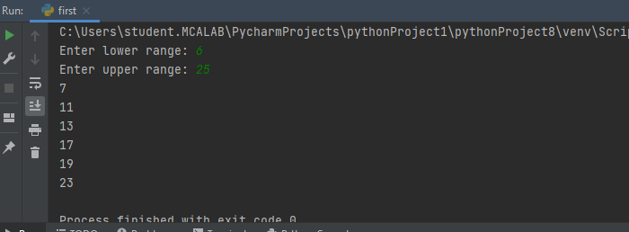
2. Program to print the first N Fibonacci numbers.
CODE:
n = int (input("Enter the number of terms needed in the Fibonacci series: "))
if (n<0):
print ("Enter a positive number")
else:
f1, f2 = 0, 1
if n == 1:
print (f1)
elif n == 2:
print (f1,f2)
else:
print (f1,f2, end = ' ')
for i in range (3, n+1):
f3 = f1 + f2
print (f3, end = ' ')
f1 = f2
f2 = f3
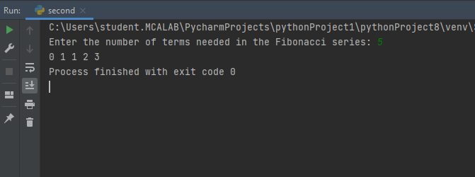

3. Given sides of a triangle, write a program to check whether given triangle is anisosceles, equilateral or scalene.
CODE:
print("Input lengths of the triangle sides: ")
x = int(input("x: "))
y = int(input("y: "))
z = int(input("z: "))

if x == y == z:
print("Equilateral triangle")
elif x==y or y==z or z==x:
print("isosceles triangle")
else:
print("Scalene triangle")

4. Program to check whether given pair of number is coprime
CODE: def are_coprime(a,b):
hcf = 1
for i in range(1, a+1):
if a%i==0 and b%i==0:
hcf = i
return hcf == 1
# Reading two numbers
first = int(input('Enter first number: '))
second = int(input('Enter second number: '))
if are_coprime(first, second):
print('%d and %d are CO-PRIME' %(first, second))
else:
print('%d and %d are NOT CO-PRIME' %(first, second))
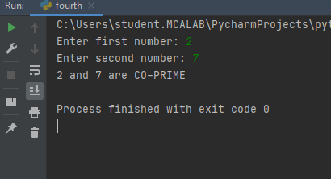

5. Program to find the roots of a quadratic equation(rounded to 2 decimal places)
CODE:
from math import sqrt

print("Quadratic function : (a * x^2) + b*x + c")
a = float(input("a: "))
b = float(input("b: "))
c = float(input("c: "))

r = b**2 - 4*a*c

if r > 0:
num_roots = 2
x1 = (((-b) + sqrt(r))/(2*a))
x2 = (((-b) - sqrt(r))/(2*a))
print("There are 2 roots: %f and %f" % (x1, x2))
elif r == 0:
num_roots = 1
x = (-b) / 2*a
print("There is one root: ", x)
else:
num_roots = 0
print("No roots, discriminant < 0.")
exit()
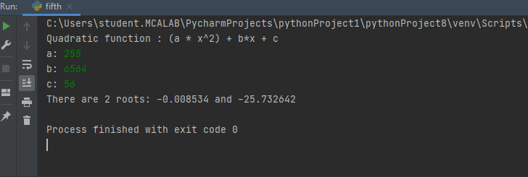

6. Program to check whether a given number is perfect number or not(sum of factors
=number)
CODE:
n = int(input("Enter any number: "))
sum1 = 0
for i in range(1, n):
if(n % i == 0):
sum1 = sum1 + i
if (sum1 == n):
print("The number is a Perfect number!")
else:
print("The number is not a Perfect number!")
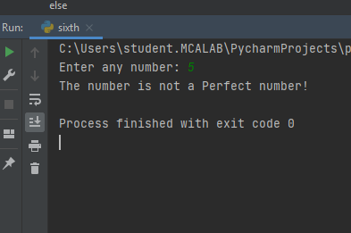
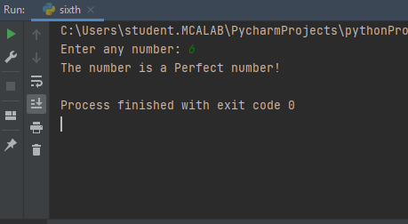

7. Program to display amstrong numbers upto 1000
CODE:
lower = int(input("Enter lower range: "))
upper = int(input("Enter upper range: "))

for num in range(lower,upper + 1):
sum = 0
temp = num
while temp > 0:
digit = temp % 10
sum += digit ** 3
temp //= 10
if num == sum:
print(num)
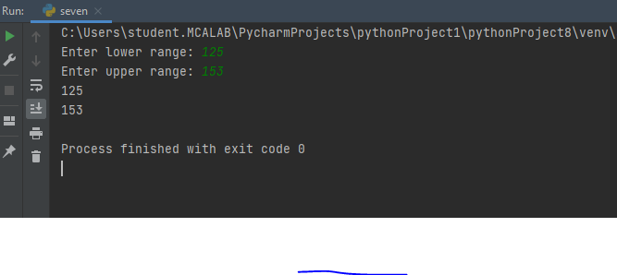

8. Store and display the days of a week as a List, Tuple, Dictionary, Set. Alsodemonstrate different ways to store values in each of them. Display its type also.
CODE:
list = ["Sun","Mon","Tue","Wed","Thu","Fri","Sat"]
print(type(list))
print(list)
tuple = ("Sun","Mon","Tue","Wed","Thu","Fri","Sat")
print(type(tuple))
print(tuple)
set = {"Sun","Mon","Tue","Wed","Thu","Fri","Sat"}
print(type(set))
print(set)
dict = {
"d1" : "Sun",
"d2" : "Mon",
"d3" : "Tue",
"d4" : "Wed",
"d5" : "Thu",
"d6" : "Fri",
"d7" : "Sat"
}
print(type(dict))
print(dict)
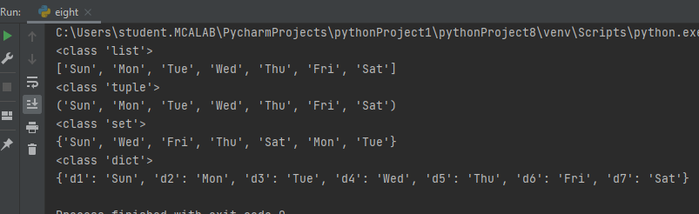

9. Write a program to add elements of given 2 lists
CODE:
# initialize the Python lists
lt1 = [5, 10, 15, 20, 25, 30]
lt2 = [2, 4, 6, 8, 10, 12]

# print the original list element
print ( " Python Original list 1: " + str (lt1))
print ( "Python Original list 2: " + str (lt2))

# use naive method to add two list.
res_lt = [] # declaration of the list
for x in range (0, len (lt1)):
res_lt.append( lt1[x] + lt2[x])
# Display the sum of two list in Python
print ( " Addition of the list lt1 and lt2 is: " + str (res_lt))

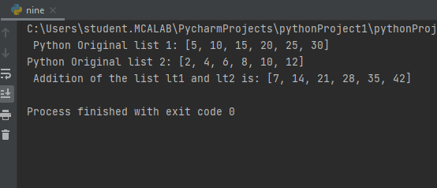

10. Write a program to find the sum of 2 matrices using nested List.
CODE:
matOne = []
print("Enter Elements for First Matrix: ")
for i in range(3):
matOne.append([])
for j in range(3):
num = int(input())
matOne[i].append(num)

matTwo = []
print("Enter Elements for Second Matrix: ")
for i in range(3):
matTwo.append([])
for j in range(3):
num = int(input())
matTwo[i].append(num)

matThree = []
for i in range(3):
matThree.append([])
for j in range(3):
matThree[i].append(matOne[i][j]+matTwo[i][j])

print("\nAddition Result of Two Given Matrix is:")
for i in range(3):
for j in range(3):
print(matThree[i][j], end=" ")
print()
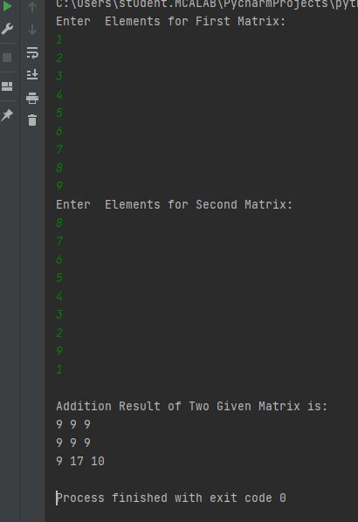

11. Write a program to perform bubble sort on a given set of elements.
CODE: # Creating a bubble sort function
def bubble_sort(list1):
# Outer loop for traverse the entire list
for i in range(0,len(list1)-1):
for j in range(len(list1)-1):
if(list1[j]>list1[j+1]):
temp = list1[j]
list1[j] = list1[j+1]
list1[j+1] = temp
return list1

list1 = [5, 3, 8, 6, 7, 2]
print("The unsorted list is: ", list1)
# Calling the bubble sort function
print("The sorted list is: ", bubble_sort(list1))
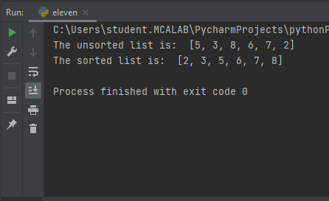

12. Program to find the count of each vowel in a string(use dictionary)
CODE:
def Check_Vow(string, vowels):

# The term "casefold" has been used to refer to a method of ignoring cases.

string = string.casefold()

count = {}.fromkeys(vowels, 0)

# To count the vowels

for character in string:

if character in count:

count[character] += 1

return count

# Driver Code

vowels = 'aeiou'

string = "Hi, I AM KRISHNAVENI CHANDRABOSE AND I AM FROM KOTTAYAM"

print (Check_Vow(string, vowels))
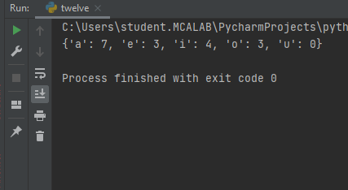

13. Write a Python program that accept a positive number and subtract from this number the sum of its digits and so on. Continues this operation until the number is
Positive
CODE:
code: def repeat_times(n):
s = 0
n_str = str(n)
while (n > 0):
n -= sum([int(i) for i in list(n_str)])
n_str = list(str(n))
s += 1
return s
print(repeat_times(9))
print(repeat_times(21))
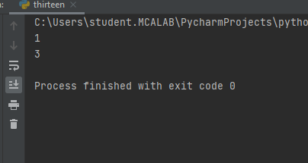
14. Write a Python program that accepts a 10 digit mobile number, and find the digitswhich are absent in a given mobile number
def absent_digits(n):
all_nums = set([0,1,2,3,4,5,6,7,8,9])
n = set([int(i) for i in n])
n = n.symmetric_difference(all_nums)
n = sorted(n)
return n
print(absent_digits([9,5,2,6,0,1,4,6,8,4]))
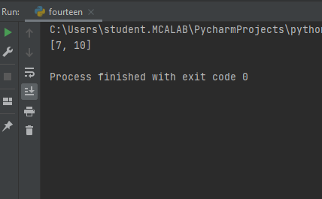

CYCLE-2

DATA SCIENCE & MACHINE LEARNING-LAB CYCLE 2

- Create a three dimensional array specifying float data type and print it.

CODE:
import numpy as np
a3d_array=np.array([[[1.1,2.1],[3.1,4.1]],[[5.1,6.1],[7.1,8.1]]],dtype=float)
print(a3d_array)
OUTPUT:
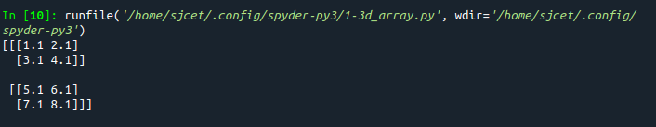
- Create a 2 dimensional array (2X3) with elements belonging to complex data type and print it. Also display
- the no: of rows and columns
- dimension of an array
- reshape the same array to 3X2

CODE:
import numpy as np
x=np.array([[1+2j,1+3j,2+3j],[5+6j,3+8j,4+5j]])
print(x)
print("Number of Rows and Columns:",x.shape)
print("Reshaped matrix is:")
print(x.reshape(3,2))
print("Dimensions:",x.ndim)
OUTPUT:
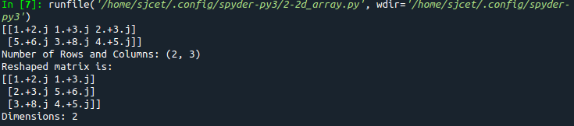
- Familiarize with the functions to create
- an uninitialized array
- array with all elements as 1,
- all elements as 0

CODE:
import numpy as np
x=np.empty([2, 2])
print(x)
y=np.full((2, 2), 1)
print(y)
z=np.full((2, 2), 0)
print(z)
OUTPUT:
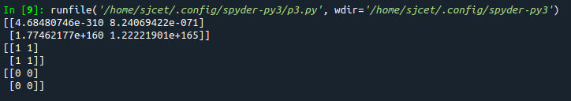
- Create an one dimensional array using arange function containing 10 elements.
Display
- First 4 elements
- Last 6 elements
- Elements from index 2 to 7

CODE:
import numpy as np
a = np.arange(1, 11, 1)
print(a)
first_element = a[:4]
print(first_element)
first_element1 = a[5:]
print(first_element1)
first_element2 = a[1:7]
print(first_element2)
OUTPUT:
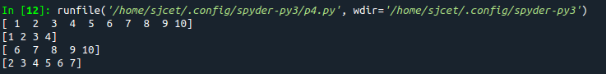
- Create an 1D array with arange containing first 15 even numbers as elements
- Elements from index 2 to 8 with step 2(also demonstrate the same using slice function)
- Last 3 elements of the array using negative index
- Alternate elements of the array
- Display the last 3 alternate elements
CODE:
import numpy as np

array_1d=np.arange(0,30,2)
print("array is:",array_1d)
print("Elements from index 2 to 8 with step 2",array_1d[2:8:2])
s=slice(2, 8, 2)
print("Elements from index 2 to 8 with step 2 using slice",array_1d[s])
print("Last 3 elements of the array using negative index",array_1d[-3:-1])
print("Alternate elements of the array",array_1d[::2])
print("Display the last 3 alternate elements",array_1d[-3:-1:2])
print("Display the elements from indices 4 to 10 in descending order(use-values)")
print(array_1d[10:4:-1])
OUTPUT:
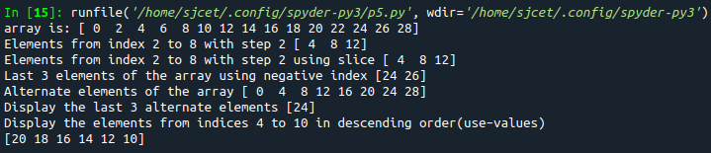
- Create a 2 Dimensional array with 4 rows and 4 columns.
- Display all elements excluding the first row
- Display all elements excluding the last column
- Display the elements of 1st and 2nd column in 2nd and 3rd row
- Display the elements of 2nd and 3rd column
- Display 2nd and 3rd element of 1st row
- Display the elements from indices 4 to 10 in descending order(use –values)
CODE:
import numpy as np

array_2d=np.array([[1,2,3,4],[5,6,7,8],[9,10,11,12],[13,14,15,16]])
print(array_2d)

print("Display all elements excluding the first row")
print(array_2d[1:4,:])
print("Display all elements excluding the last column")
print(array_2d[:,0:3])
print("Display the elements of 1 st and 2 nd column in 2 nd and 3 rd row")
print(array_2d[1:3,0:2])
print("Display the elements of 2 nd and 3 rd column")
print(array_2d[:,1:3])
print("Display 2 nd and 3 rd element of 1 st row")
print(array_2d[0,1:3])
OUTPUT:
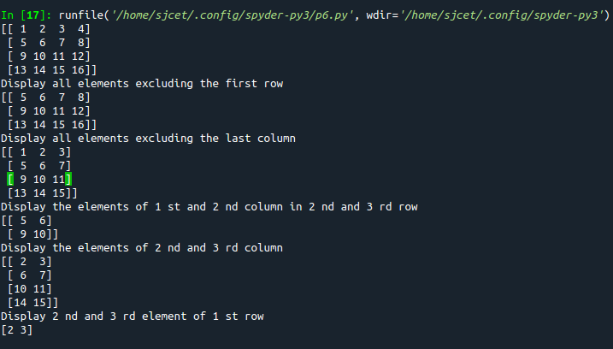
- Create two 2D arrays using array object and
- Add the 2 matrices and print it
- Subtract 2 matrices
- Multiply the individual elements of matrix
- Divide the elements of the matrices
- Perform matrix multiplication
- Display transpose of the matrix
- Sum of diagonal elements of a matrix

CODE:
import numpy as np

M1 = np.array([[3, 6], [14, 21]])
M2 = np.array([[9, 27], [11, 22]])

M3 = M1 + M2
print("Matrix addition")
print(M3)

M3 = M1 - M2
print("Matrix Substract")
print(M3)

M4 = np.array([[3, 6], [5, -10]])
M5 = np.array([[9, -18], [11, 22]])
M3 = M4 * M5
print("Multiply the individual elements of matrix")
print(M3)

M3 = M1 / M2
print("Divide the elements of the matrices")
print(M3)

M3 = M4.dot(M5)
print("matrix multiplication")
print(M3)

M6 = np.array([[3, 6, 9], [5, -10, 15], [4,8,12]])
M7 = M6.transpose()
print("Transpose of the matrix")
print(M2)

print("Sum of diagonal elements of a matrix")
print(np.trace(M6))
OUTPUT:
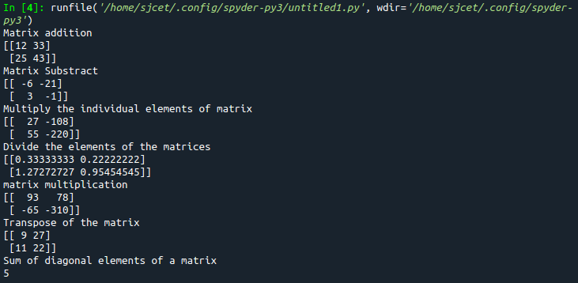
- Demonstrate the use of insert() function in 1D and 2D array

CODE:
import numpy as np

arr = np.arange(5)
print("1D arr : \n", arr)

a = np.insert(arr, 1, 9)
print("Array after inserting '9' : \n", a)

arr = np.arange(12).reshape(3, 4)
print("2D arr : \n", arr)

a = np.insert(arr, 1, 9, axis = 1)
print("Array after inserting '9' : \n", a)
OUTPUT:
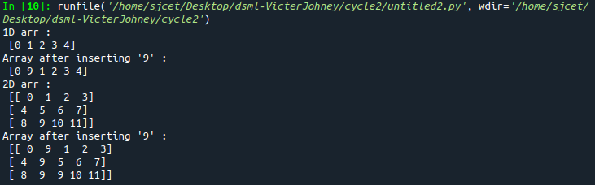
- Demonstrate the use of diag() function in 1D and 2D array.

CODE:
import numpy as np

arr = np.arange(1,6).reshape(1,5)
print("1D arr : \n", arr)

a = np.diag(arr)
print("1D Array Diagonal values : \n", a)

arr = np.arange(12).reshape(4, 3)
print("2D arr : \n", arr)

a = np.diag(arr)
print("2D Array diagonal values : \n", a)
OUTPUT:
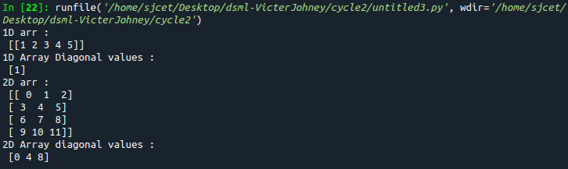
- Demonstarte the use of append() function in 1D and 2D array
CODE:
import numpy as np

arr = np.array([1, 2, 3, 4, 5, 6, 7])

a = np.append(arr, 88)
print("1D Array Diagonal values : \n", a)

arr = np.array( [ [1, 2, 3],[ 4, 5, 6] ])
print("2D arr : \n", arr)

a = np.append(arr, [22, 23, 24])
print("2D Array diagonal values : \n", a)
OUTPUT:
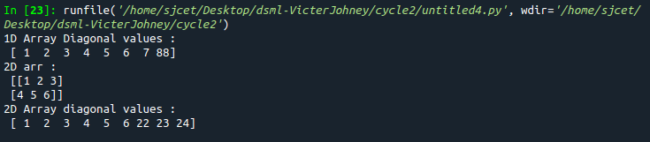
- Demonstarte the use of sum() function in 1D and 2D array.
CODE:
import numpy as np

arr = np.array([1, 2, 3, 4, 5, 6, 7])
print("1D arr : \n", arr)

a = np.sum(arr)
print("1D Array Sum : \n", a)

arr = np.array( [ [1, 2, 3],[ 4, 5, 6],[7, 8, 9] ])
print("2D arr : \n", arr)

a = np.sum(arr)
print("2D Array Sum : \n", a)
OUTPUT:
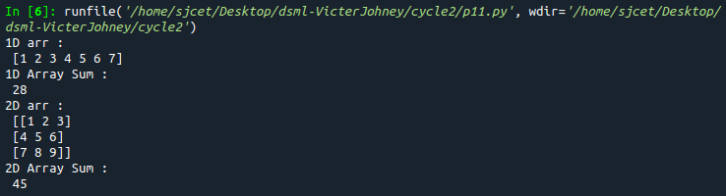

12. Create a square matrix with random integer values(use randint()) and use
appropriate functions to find:
i) inverse
ii) rank of matrix
iii) Determinant
iv) transform matrix into 1D array
v) eigen values and vectors
CODE:
import numpy as np
from numpy import random as r

x = r.randint(100, size=(3, 3))
print ("Square matrix with random numbers: \n",x)

print("Inverse: \n", np.linalg.inv(x))

print("Matrix Rank: \n", np.linalg.matrix_rank(x))

print("Determinant: \n", np.linalg.det(x))

print("Transform matrix into 1D: \n", np.ravel(x))

print("Eigen Value: \n", np.linalg.eig(x))
OUTPUT:
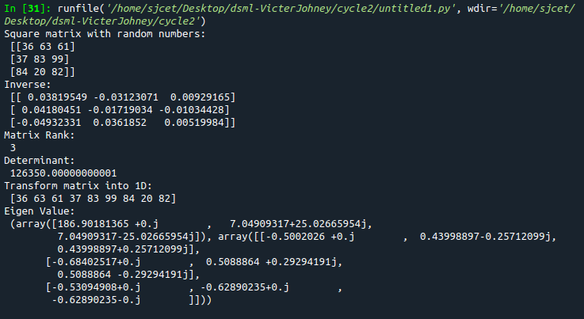
13. Create a matrix X with suitable rows and columns
i) Display the cube of each element of the matrix using different methods
(use multiply(), *, power(),**)
ii) Display identity matrix of the given square matrix.
iii) Display each element of the matrix to different powers.
iv) Create a matrix Y with same dimension as X and perform the operation X^2 +2Y
CODE:
import numpy as np

x = np.arange(1,10).reshape(3,3)
print(x)

print("Matrix cube using multiply(): \n",np.multiply(x,(x*x)))

print("Matrix cube using pow()): \n",np.power(x,3))

print("Matrix cube using *: \n",x*x*x)

print("Matrix cube using **: \n",x**3)

print("Identity Matrix of 3x3: \n",np.identity(3,dtype=int))

print("each element of the matrix to different powers: \n",np.power(x,x))

y = np.arange(11,20).reshape(3,3)
#print("x : \n ",x)
#print("y : \n ",y)
#print("x^2 : \n ",np.power(x,2))
#print("2y : \n ",np.multiply(y,2))
print("perform the operation X^2 +2Y: \n",np.add((np.power(x,2)),(np.multiply(y,2))))
OUTPUT:
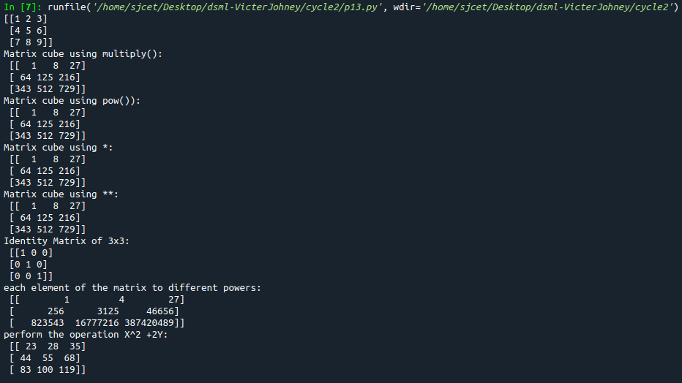
14. Multiply a matrix with a submatrix of another matrix and replace the same in larger
matrix.
CODE:
import numpy as np;

x = np.arange(1,31).reshape(5,6)
print("x-> big matrix :\n",x)
#x[column,row]
y=x[1:4,2:5]

#print("y-> sub matrix of x : \n",y)

z = np.arange(2,11).reshape(3,3)
#print("matrix z :\n",z)

y = np.multiply(y,z)

#print("multiplied matrix : \n",y)

x[1:4,2:5] = y

print("final replaced matrix:\n ",x)
OUTPUT:
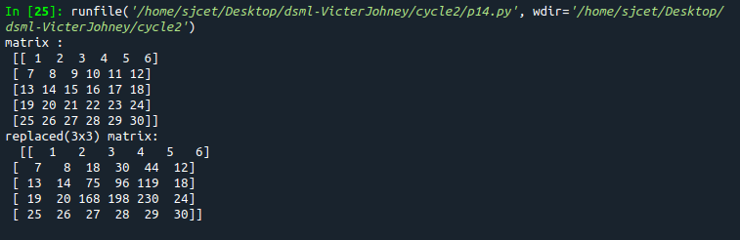
15. Given 3 Matrices A, B and C. Write a program to perform matrix multiplication of
the 3 matrices.
CODE:
import numpy as np

A =np.array( [[12, 7, 3],[4, 5, 6],[7, 8, 9]])
print("Matrix A:\n ",A)
B = np.array([[5, 8, 1, 2],[6, 7, 3, 0],[4, 5, 9, 1]])
print("Matrix B:\n ",B)
C = np.array([[1, 7, 3],[3, 5, 6],[6, 8, 9],[2, 9, 1]])
print("Matrix C:\n ",C)
result=np.dot(A,B)
#print(result)
new=np.dot(result,C)
print("Products of 3 mtrices is: \n", new)
#print(np.dot(np.dot(A,B),C))
OUTPUT:
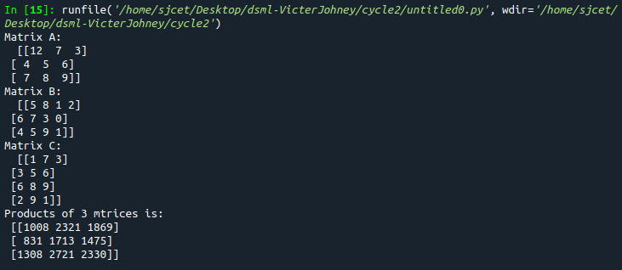
16. Write a program to check whether given matrix is symmetric or Skew Symmetric.
CODE:
import numpy as np;

x = np.arange(1,10).reshape(3,3)
print("Matrix x: \n", x)
# Transposing the Matrix M
y=x.transpose();
print("Transpose of x :\n ",y)
# -1(Transpose)
skew=np.multiply(y,-1);
print("negative of transpose :\n ",skew)
if x.all() == y.all():
print("Matrix is symmetric")
else:
print("Matrix is not symmetric")
if x.all() == ~y.all():
print("Matrix is skew symmetric")
else:
print("Matrix is not skew matrix")
OUTPUT:
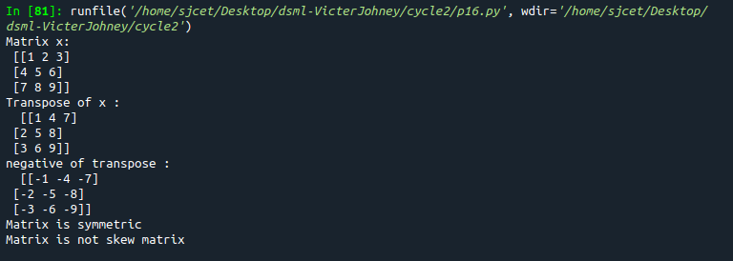
17. Write a program to find out the value of X using solve(), given A and b as above
CODE:
import numpy as np;

A=np.array([[2,1,-2],[3,0,1],[1,1,-1]])
b=np.array([[-3],[5],[2]])

print("A:\n",A)
print("b:\n",b)

X=np.multiply((np.linalg.inv(A)),b)
print("X is : \n",X)
OUTPUT:
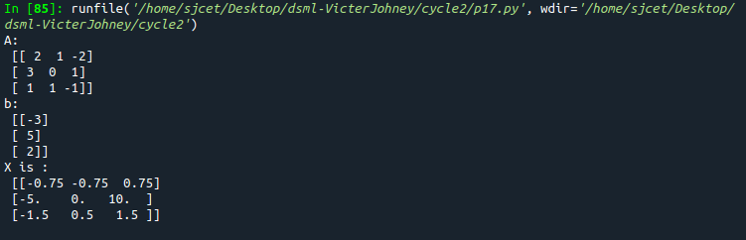
18. Write a program to perform the SVD of a given matrix. Also reconstruct the given matrix from the 3 matrices obtained after performing SVD.
CODE:
import numpy as np;

A = np.array([[1, 2], [3, 4], [5, 6]])
print("Matrix:\n",A)
# SVD
U, s, VT = np.linalg.svd(A)
print("U:\n", U)
print("Sigma:\n",s)
print("V^T:\n",VT)
OUTPUT:
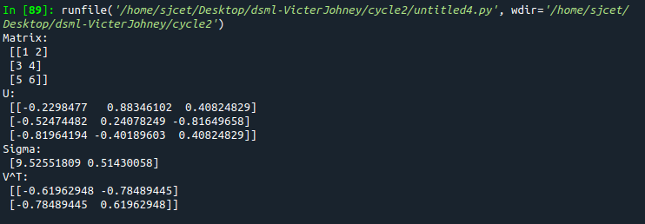

CYCLE-3

1. Sarah bought a new car in 2001 for $24,000. The dollar value of her car changed each year as shown in
the table below.
Value of Sarah’s Car
Year Value
2001 $24,000
2002 $22,500
2003 $19,700
2004 $17,500
2005 $14,500
2006 $10,000
2007 $ 5,800
Represent the following information using a line graph with following style properties
- X- axis - Year
- Y –axis - Car Value
- title –Value Depreciation (left Aligned)
- Line Style dashdot and Line-color should be red
- point using * symbol with green color and size 20

CODE:
import matplotlib.pyplot as plt
import numpy as np

xaxis = np.array([2007, 2006, 2005, 2004, 2003, 2002, 2001])
yaxis = np.array([5800, 10000, 14500, 17500, 19700, 22500, 24000])

plt.plot(xaxis, yaxis, linestyle="dashdot", c='r', marker= '*', ms='20', mfc='green', mec='green')
plt.title("Value Depreciation", loc='left')
plt.xlabel("Year")
plt.ylabel("Car Value")
plt.show()

OUTPUT:
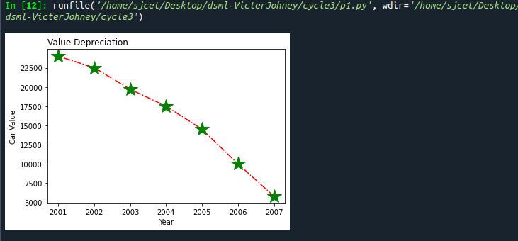
2. Following table gives the daily sales of the following items in a shop.
Subplot() provides multiple plots in one figure.
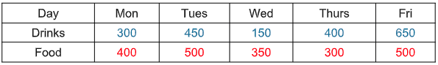
Use subplot function to draw the line graphs with grids(color as blue and line style dotted) for the
above information as 2 separate graphs in two rows
a) Properties for the Graph 1:

- X label- Days of week
- Y label-Sale of Drinks
- Title-Sales Data1 (right aligned)
- Line –dotted with cyan color
- Points- hexagon shape with color magenta and outline black
b) Properties for the Graph 2:
- X label- Days of Week
- Y label-Sale of Food
- Title-Sales Data2 ( center aligned)
- Line –dashed with yellow color
- Points- diamond shape with color green and outline red

CODE:
import matplotlib.pyplot as plt
import numpy as np

#xaxis = np.array([300, 450, 150, 400, 650])
#yaxis = np.array([400, 500, 350, 300, 500])

#plot1
xaxis = np.array(['Mon', 'Tues', 'Wed', 'Thurs', 'Fri'])
yaxis = np.array([300, 450, 150, 400, 650])
plt.subplot(1, 2, 1)
plt.plot(xaxis, yaxis, ':c', )
plt.plot(xaxis,yaxis,'Hm',mec='k')
plt.grid(color = 'blue', linestyle = 'dotted')
plt.title("Sales Data1", loc='right')
plt.xlabel("Days of Week")
plt.ylabel("Sale of Drinks")
plt.show()

#plot2
xaxis = np.array(['Mon', 'Tues', 'Wed', 'Thurs', 'Fri'])
yaxis = np.array([400, 500, 350, 300, 500])
plt.subplot(1, 2, 1)
plt.plot(xaxis, yaxis)
plt.plot(xaxis,yaxis,'--y')
plt.plot(xaxis,yaxis,'Dg',mec='r')
plt.grid(color = 'blue', linestyle = 'dotted')
plt.title("Sales Data2", loc='center')
plt.xlabel("Days of Week")
plt.ylabel("Sale of Food")
plt.show()

OUTPUT:
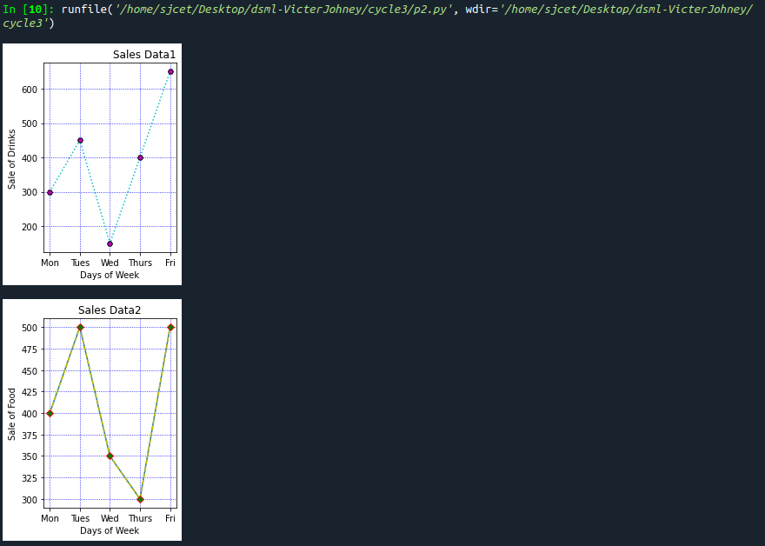
3. Create scatter plot for the below data:(use Scatter function)
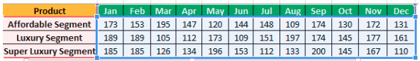
Create scatter plot for each Segment with following properties within one graph
- X Label- Months of Year with font size 18
- Y-Label- Sales of Segments
- Title –Sales Data
- Color for Affordable segment- pink
- Color for Luxury Segment- Yellow
- Color for Super luxury segment-blue

CODE:
import matplotlib.pyplot as plt
import numpy as np
plt.title("Sales Data")
plt.xlabel("Months of Year")
plt.ylabel("Sale of Food")
x = np.array(['Jan','Feb','Mar','Apr','May','Jun','Jul','Aug','Sep','Oct','Nov','Dec'])
y1 = np.array([173,153,195,147,120,144,148,109,174,130,172,131])
plt.scatter(x,y1, color = 'hotpink')

y2 = np.array([185,185,126,134,196,153,112,133,200,145,167,110])
plt.scatter(x, y2, color = 'yellow')

y3 = np.array([189,189,105,112,173,109,151,197,174,145,177,161])
plt.scatter(x, y3, color = 'blue')
plt.show()

OUTPUT:
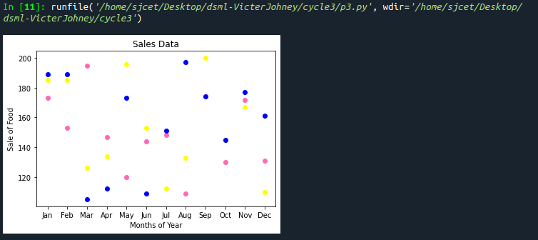
4. Display the above data using multiline plot( 3 different lines in same graph)
- Display the description of the graph in upper right corner(use legend())
- Use different colors and line styles for 3 different lines

CODE:
import matplotlib.pyplot as plt
import numpy as np
# create data
x = [1,2,3,4,5]
y = [3,3,3,3,3]
z = [4,4,4,4,4]

# plot lines
plt.plot(x, y, label = "line 1")
plt.plot(y, x, label = "line 2")
plt.plot(z, x, label = "line 3")
plt.legend()
plt.show()

OUTPUT:
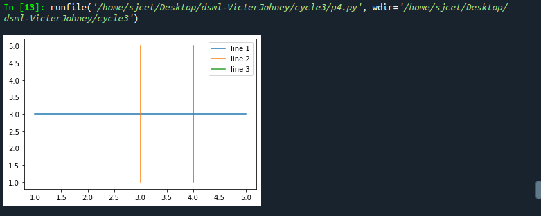
5. 100 students were asked what their primary mode of transport for getting to school was. The results of
this survey are recorded in the table below. Construct a bar graph representing this information.
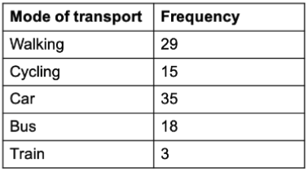

Create a bar graph with
- X axis -mode of Transport and Y axis ‘frequency’
- Provide appropriate labels and title
- Width .1, color green

CODE:
import matplotlib.pyplot as plt
import numpy as np

x = np.array(["walking", "cycling", "car", "bus","train"])
y = np.array([29,15,35,18,3])

plt.bar(x,y, color="#4CAF50",width=0.1)
plt.show()

OUTPUT:
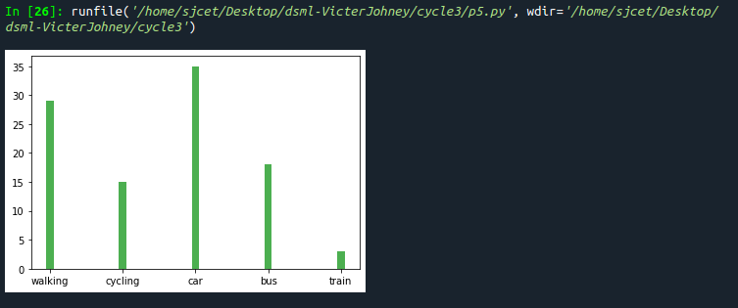
6. We are provided with the height of 30 cherry trees.
The height of the trees (in inches): 61, 63, 64, 66, 68, 69, 71, 71.5, 72, 72.5, 73, 73.5, 74, 74.5, 76, 76.2,
76.5, 77, 77.5, 78, 78.5, 79, 79.2, 80, 81, 82, 83, 84, 85, 87.Create a histogram with a bin size of 5

CODE:
import matplotlib.pyplot as plt
height = [61, 63, 64, 66, 68, 69, 71, 71.5,
72, 72.5, 73, 73.5, 74, 74.5, 76,
76.2,76.5, 77, 77.5, 78, 78.5, 79,
79.2, 80, 81, 82, 83, 84, 85, 87]
plt.hist(height, edgecolor="red", bins=5)
plt.show()

OUTPUT:
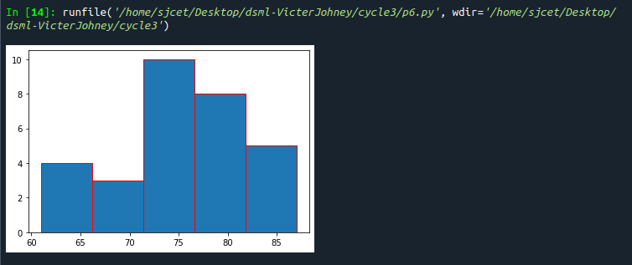
DATA HANDLING USING ‘Pandas’ and DATA VISUALIZATION USING ‘Seaborn’
Using the pandas function read_csv(), read the given ‘iris’ data set.

7. Use appropriate functions in pandas to display
(i) Shape of the data set
(ii) First 5 and last five rows of data set(head and tail)
(iii) Size of dataset
(iv) No:of samples available for each variety
(v) Description of the data set( use describe )
CODE:
import numpy as np
import matplotlib.pyplot as plt
import seaborn as sns
import pandas as pd
col=['sepal_length','sepal_width','petal_length','petal_width','type']
iris=pd.read_csv("iris.csv",names=col)

print("shape:",iris.shape)
print("*********")
print("First five rows")
print(iris.head())
print("*********")
print("First five rows")
print(iris.tail())
print("*********")
print("Size:",iris.size)
print("*********")
print("no of samples available for each type")
print(iris["type"].value_counts())
print("*********")
print(iris.describe())
OUTPUT:
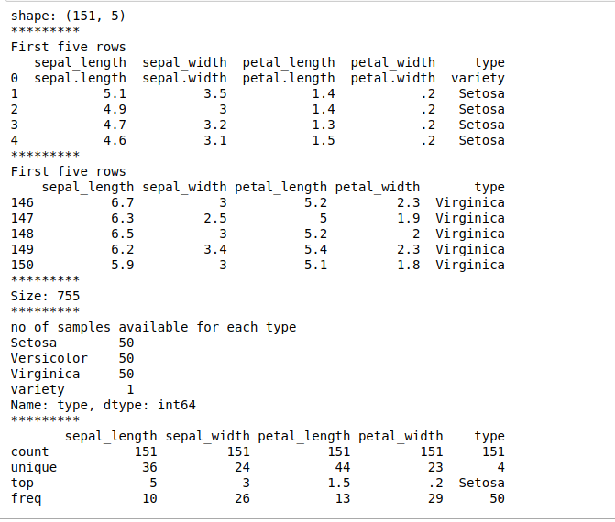
8. Use pairplot() function to display pairwise relationships between attributes. Try
different kind of plots {‘scatter’, ‘kde’, ‘hist’, ‘reg’} and different kind of markers

CODE:
iris = sns.load_dataset("iris")
sns.pairplot(iris)

sns.pairplot(iris, kind="scatter" , hue="species")

sns.pairplot(iris, kind="kde", hue="species")

sns.pairplot(iris, kind="hist", hue="species")

sns.pairplot(iris, kind="reg", hue="species")

g = sns.PairGrid(iris)
g.map_upper(sns.regplot, color='red', marker='+')
g.map_lower(sns.scatterplot, color='green', marker='s')
g.map_diag(plt.hist, color='skyblue')
OUTPUT:
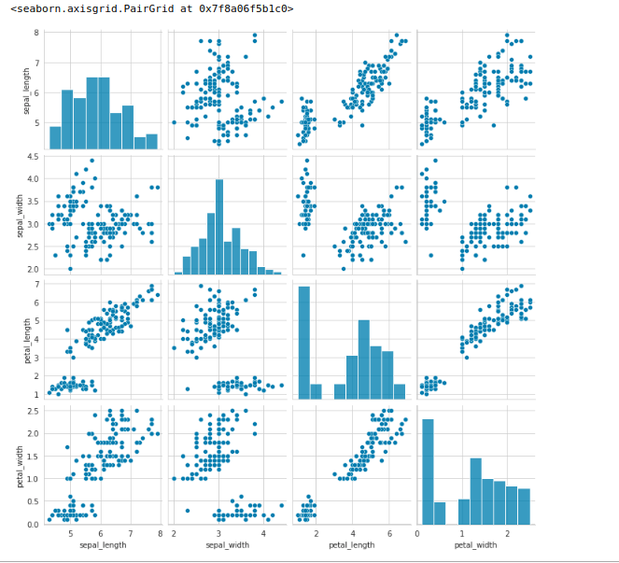
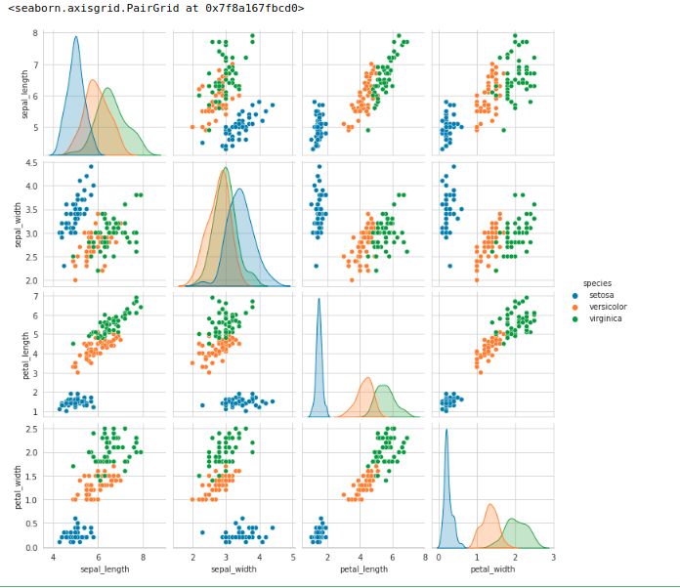

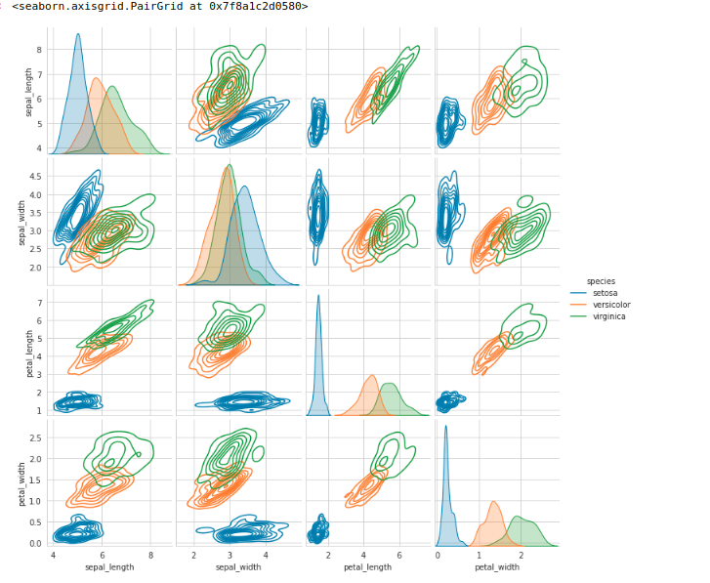
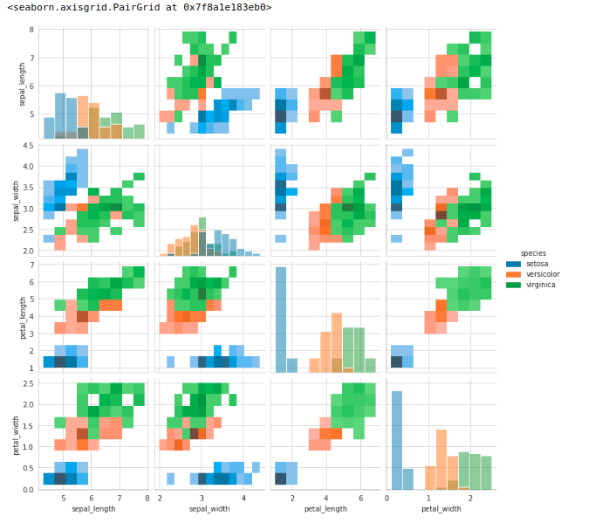

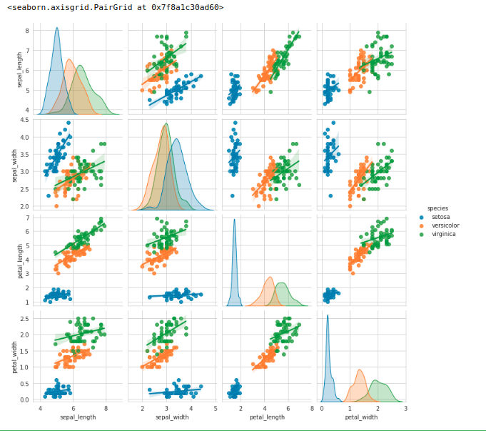
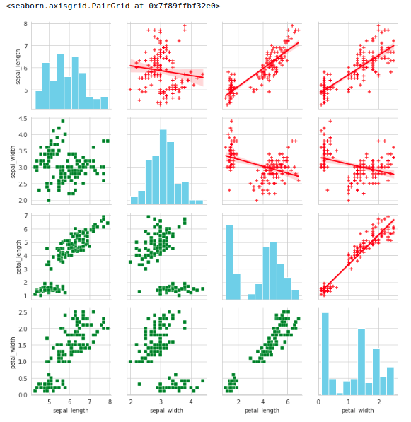

9. using the iris data set,get familiarize with functions:
1)displot()
2) histplot()
3) relplot()

CODE:
sns.displot(data=iris)

sns.histplot(data=iris)

sns.relplot(data=iris, kind="line", x="sepal_length", y="petal_width")
OUTPUT:
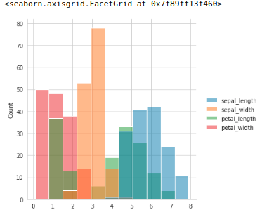
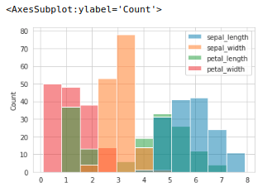
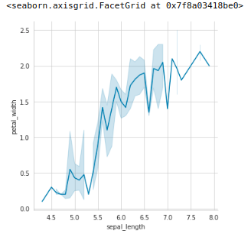

CYCLE-4

kNN

1.Using the iris data set implement the KNN algorithm. Take different values for Test and training data set. Also use different values for k. Also find the accuracy level.

import numpy as np
import matplotlib.pyplot as plt
import pandas as pd

dataset = pd.read_csv("iris.csv")
X = dataset.iloc[:, :-1].values
y = dataset.iloc[:, 4].values

from sklearn.model_selection import train_test_split
X_train, X_test, y_train, y_test = train_test_split(X, y, test_size=0.20)

from sklearn.neighbors import KNeighborsClassifier
classifier = KNeighborsClassifier(n_neighbors=5)
classifier.fit(X_train, y_train)
y_pred = classifier.predict(X_test)

from sklearn.metrics import classification_report, confusion_matrix
print(classification_report(y_test, y_pred))

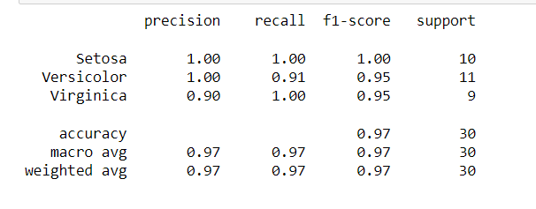
from sklearn.metrics import accuracy_score
print ("Accuracy : ", accuracy_score(y_test, y_pred))
df = pd.DataFrame({'Real Values':y_test, 'Predicted Values':y_pred})

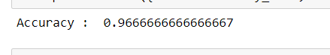

Reference: https://stackabuse.com/k-nearest-neighbors-algorithm-in-python-and-scikit-learn/

2.Download another data set suitable for the KNN and implement the KNN algorithm. Take different values for Test and training data set. Also use different values for k.

import numpy as np
import matplotlib.pyplot as plt
import pandas as pd

dataset = pd.read_csv("cancer.csv")
dataset.head()
dataset.info()
X = dataset.iloc[:, 2:35].values
print(X)
y = dataset.iloc[:, 1].values
print(y)

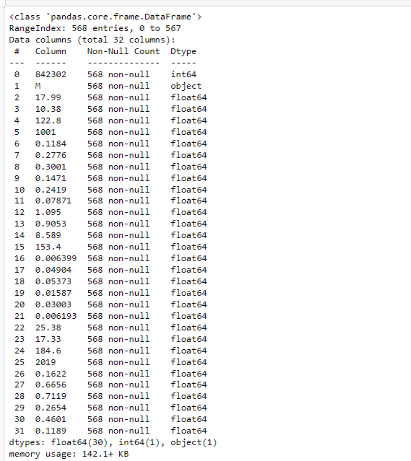
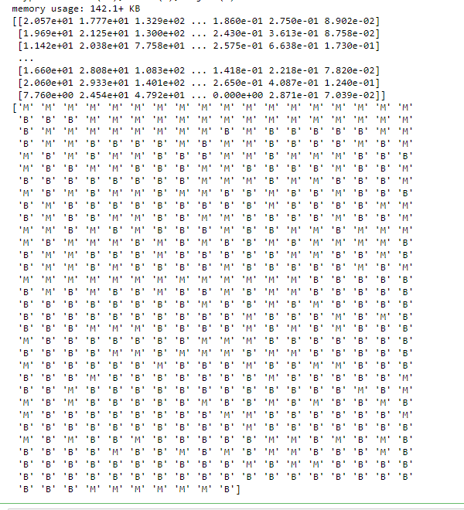

from sklearn.model_selection import train_test_split
X_train, X_test, y_train, y_test = train_test_split(X, y, test_size=0.20)

from sklearn.neighbors import KNeighborsClassifier
classifier = KNeighborsClassifier(n_neighbors=5)
classifier.fit(X_train, y_train)
y_pred = classifier.predict(X_test)

from sklearn.metrics import classification_report, confusion_matrix
print(classification_report(y_test, y_pred))

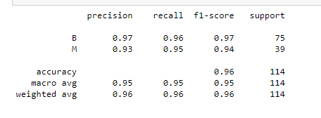

from sklearn.metrics import accuracy_score
print ("Accuracy : ", accuracy_score(y_test, y_pred))
df = pd.DataFrame({'Real Values':y_test, 'Predicted Values':y_pred})

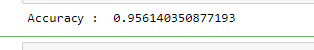

Naive Bayes

3.Using iris data set, implement naive bayes classification for different naive Bayes classification algorithms. ((i) gaussian (ii) bernoulli etc)
- Find out the accuracy level w.r.t to each algorithm
- Display the no:of mislabeled classification from test data set
- List out the class labels of the mismatching records

import numpy as np
import matplotlib.pyplot as plt
import pandas as pd

dataset = pd.read_csv('iris.csv')
X = dataset.iloc[:,:4].values
y = dataset['variety'].values
dataset.head(5)

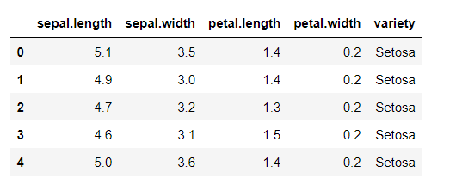

from sklearn.model_selection import train_test_split
X_train, X_test, y_train, y_test = train_test_split(X, y, test_size = 0.2)

from sklearn.naive_bayes import GaussianNB
classifier = GaussianNB()
classifier.fit(X_train, y_train)
y_pred = classifier.predict(X_test)
y_pred

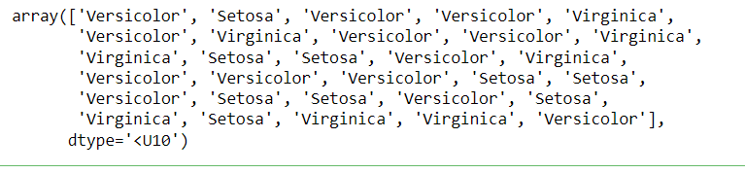

from sklearn.metrics import confusion_matrix
cm = confusion_matrix(y_test, y_pred)

from sklearn.metrics import accuracy_score
print ("Accuracy : ", accuracy_score(y_test, y_pred))
cm

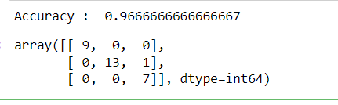

df = pd.DataFrame({'Real Values':y_test, 'Predicted Values':y_pred})
df

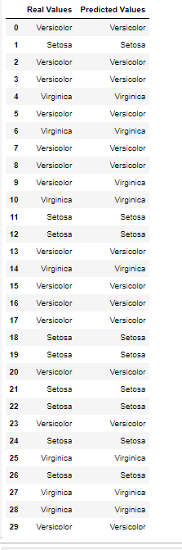
References:
- https://towardsdatascience.com/machine-learning-basics-naive-bayes-classification-964af6f2a965
- https://scikit-learn.org/stable/modules/classes.html#module-sklearn.naive_bayes

Decision Tree
4.Use car details CSV file and implement decision tree algorithm
- Find out the accuracy level.
- Display the no: of mislabelled classification from test data set
- List out the class labels of the mismatching records

import os
import numpy as np
import pandas as pd
import numpy as np, pandas as pd
import matplotlib.pyplot as plt
from sklearn import tree, metrics, model_selection

data = pd.read_csv('car.csv',names=['buying','maint','doors','persons','lug_boot','safety','class'])
data.head()

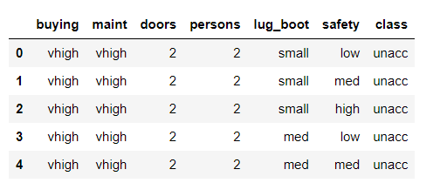

data.info()

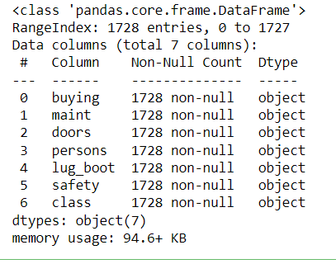

data['class'],class_names = pd.factorize(data['class'])

print(class_names)
print(data['class'].unique())

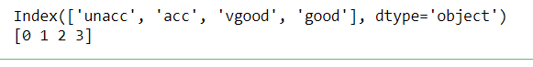

data['buying'],_ = pd.factorize(data['buying'])
data['maint'],_ = pd.factorize(data['maint'])
data['doors'],_ = pd.factorize(data['doors'])
data['persons'],_ = pd.factorize(data['persons'])
data['lug_boot'],_ = pd.factorize(data['lug_boot'])
data['safety'],_ = pd.factorize(data['safety'])
data.head()

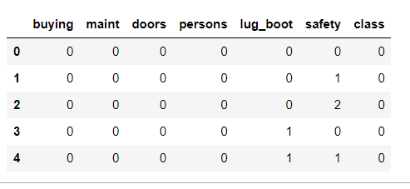

data.info()

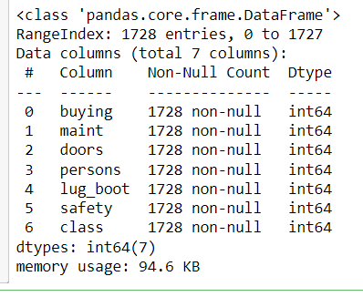

X = data.iloc[:,:-1]
y = data.iloc[:,-1]

# split data randomly into 70% training and 30% test
X_train, X_test, y_train, y_test = model_selection.train_test_split(X, y, test_size=0.3, random_state=0)

# train the decision tree
dtree = tree.DecisionTreeClassifier(criterion='entropy', max_depth=3, random_state=0)
dtree.fit(X_train, y_train)

# use the model to make predictions with the test data
y_pred = dtree.predict(X_test)
# how did our model perform?
accuracy = metrics.accuracy_score(y_test, y_pred)
print('Accuracy: {:.2f}'.format(accuracy))

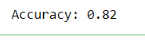

count_misclassified = (y_test != y_pred).sum()
print('Misclassified samples: {}'.format(count_misclassified))

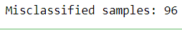

Single Linear Regression

import numpy as np
import pandas as pd
import matplotlib.pyplot as plt
#data set contains details of no.of hours spend by students for studt and their marks
student = pd.read_csv('student_scores.csv')
student.head()

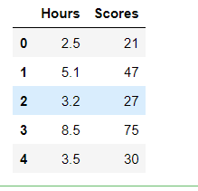

student.describe()

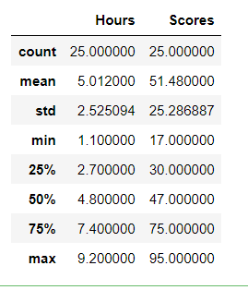

student.info()

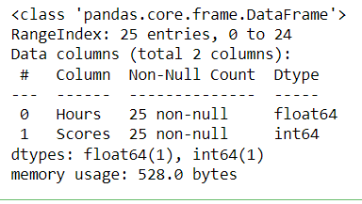

import matplotlib.pyplot as plt
Xax=student.iloc[:,0]
Yax=student.iloc[:,1]
plt.scatter(Xax,Yax)
plt.xlabel("No.of hours")
plt.ylabel("Score")
plt.title("Student scores")
plt.show()

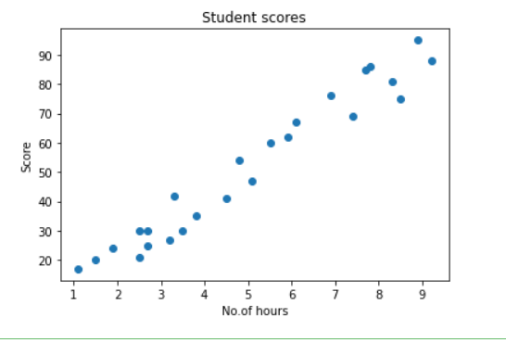

#Perform the simple linear regression model
#Equation: Y=w0+w1.x
#Here Y(marks)=w0+w1.x
#Create x as hours and Y as marks
X = student.iloc[:, :-1]
y = student.iloc[:, 1]
print(X)

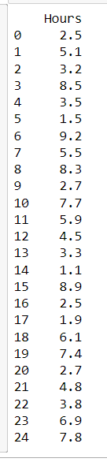

print(y)

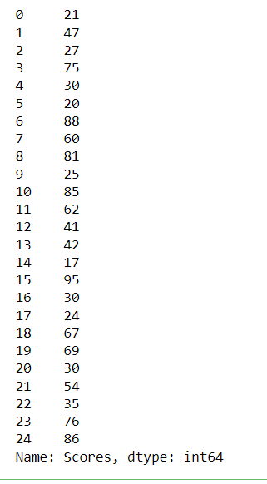

from sklearn.model_selection import train_test_split
X_train, X_test, y_train, y_test = train_test_split(X, y, test_size=0.2)
print(X_train)

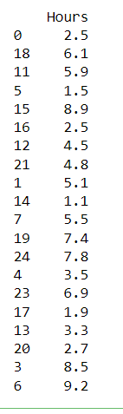

from sklearn.linear_model import LinearRegression
regressor = LinearRegression()
regressor.fit(X_train, y_train)

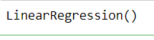

print(regressor.intercept_)

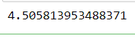

print(regressor.coef_)

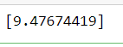
y_pred = regressor.predict(X_test)
for(i,j) in zip(y_test,y_pred):
if i!=j:
print("Actual value :",i,"Predicted value :",j)
print("Number of mislabeled points from test data set :", (y_test != y_pred).sum())

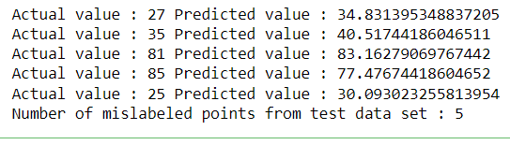

from sklearn import metrics
print("Mean Absolute error :", metrics.mean_absolute_error(y_test,y_pred))
print("Mean Squared error :", metrics.mean_squared_error(y_test,y_pred))
print("Root Mean Squared error :", np.sqrt(metrics.mean_squared_error(y_test,y_pred)))

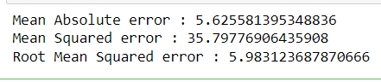

import matplotlib.pyplot as plt
c=X_test['Hours'].count()
xax=np.arange(c)
print(xax)
X_axis = np.arange(len(xax))
plt.bar(X_axis-0.2, y_test, 0.6, label='Actual')
plt.bar(X_axis+0.2, y_pred, 0.6, label='Predicted')
plt.xlabel("Test Records")
plt.ylabel("Marks")
plt.title("Student Score prediction")
plt.legend()
plt.show()

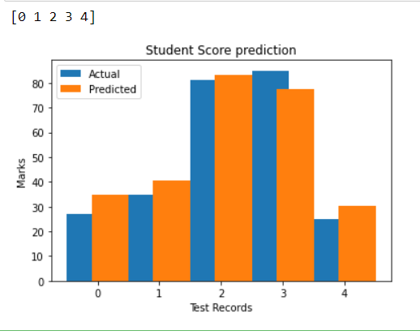

Multiple Linear Regression

import pandas as pd
import numpy as np
import matplotlib.pyplot as plt
advertising = pd.read_csv('Company_data.csv')
advertising.head()

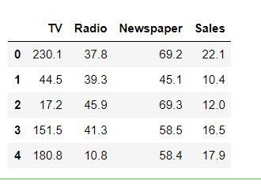

advertising.describe()

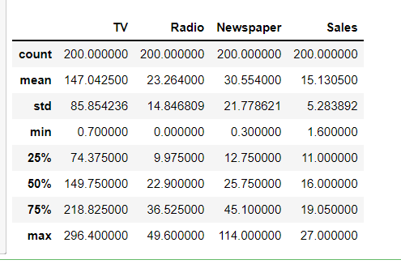

advertising.info()

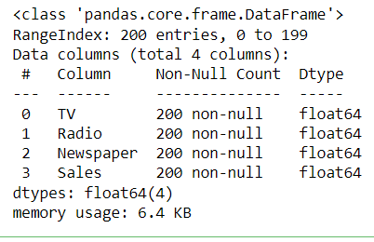

import matplotlib.pyplot as plt
import seaborn as sns
sns.pairplot(advertising, x_vars=['TV', 'Radio', 'Newspaper'],
y_vars='Sales', height=5, aspect=1, kind='scatter')
plt.show()

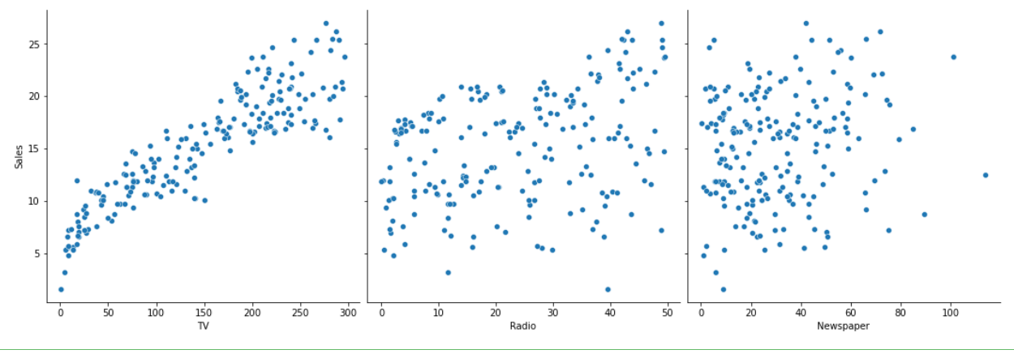

#perform the multiple linear regression model
#Equation : Y=w0+w1.x1 + w2.x2 + w3.x3
#Here Y(sales)=w0+w1.x1(TV)+w2.x2(Radio)+w3.x3(Newspaper)
#create x and Y as sales
X = advertising.iloc[:, :-1]
print(X)

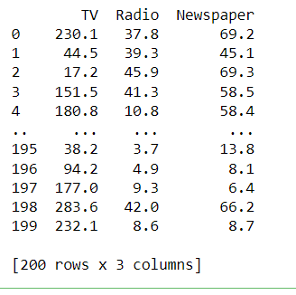

y = advertising.iloc[:, -1]
print(y)

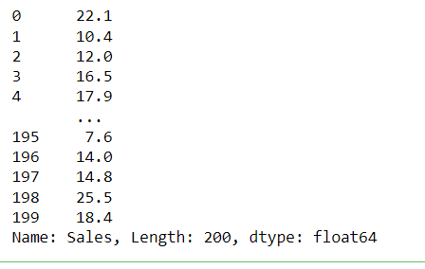

from sklearn.model_selection import train_test_split
X_train, X_test, y_train, y_test = train_test_split(X, y, test_size=0.3)
print(X_train)

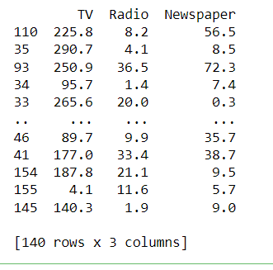

from sklearn.linear_model import LinearRegression
regressor = LinearRegression()
regressor.fit(X_train, y_train)

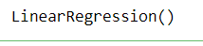

print(regressor.intercept_)

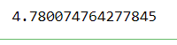

print(regressor.coef_)

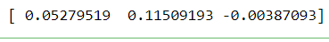

y_pred = regressor.predict(X_test)
for(i,j) in zip(y_test,y_pred):
if i!=j:
print("Actual value :",i,"Predicted value :",j)
print("Number of mislabeled points from test data set :", (y_test != y_pred).sum())

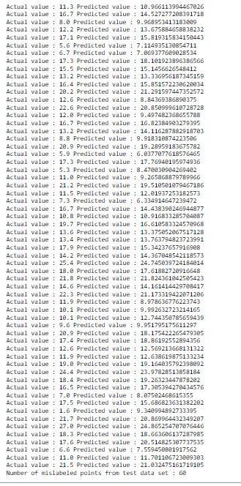

from sklearn import metrics
print("Mean Absolute error :", metrics.mean_absolute_error(y_test,y_pred))
print("Mean Squared error :", metrics.mean_squared_error(y_test,y_pred))
print("Root Mean Squared error :", np.sqrt(metrics.mean_squared_error(y_test,y_pred)))

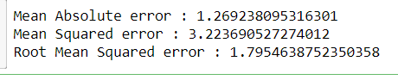

import matplotlib.pyplot as plt
c=X_test['TV'].count()
xax=np.arange(c)
print(xax)
X_axis = np.arange(len(xax))
plt.bar(X_axis-0.2, y_test, 0.6, label='Actual')
plt.bar(X_axis+0.2, y_pred, 0.6, label='Predicted')

plt.xlabel("Sales")
plt.ylabel("Actual/Predicted")
plt.title("Sales prediction")
plt.legend()
plt.show()

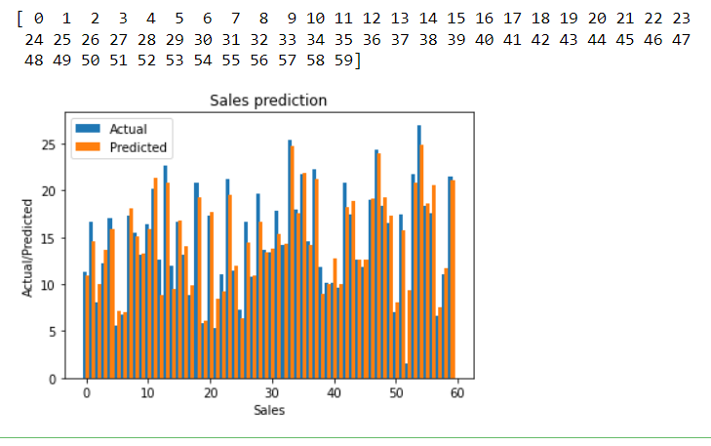

Neural Networks

- Create a neural network for the given ‘houseprice.csv’ to predict the whether price of the house is above or below median value or not

import pandas as pd

df = pd.read_csv('housepricedata.csv')
df

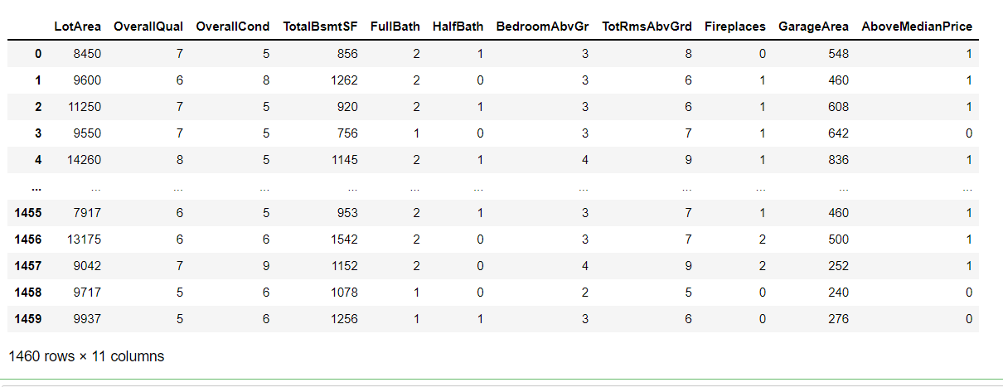

dataset = df.values
dataset

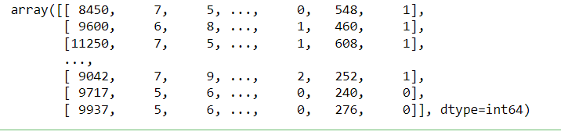

X = dataset[:,0:10]
Y = dataset[:,10]

from sklearn import preprocessing
min_max_scaler = preprocessing.MinMaxScaler()
X_scale = min_max_scaler.fit_transform(X)
X_scale

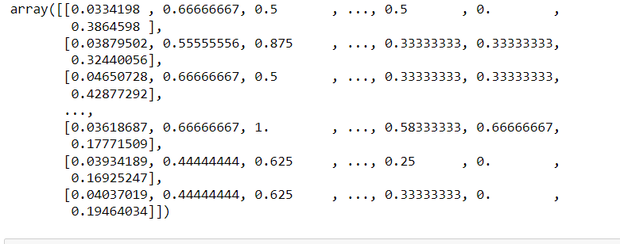

from sklearn.model_selection import train_test_split
X_train, X_val_and_test, Y_train, Y_val_and_test = train_test_split(X_scale, Y, test_size=0.3)
X_val, X_test, Y_val, Y_test = train_test_split(X_val_and_test, Y_val_and_test, test_size=0.5)
print(X_train.shape, X_val.shape, X_test.shape, Y_train.shape, Y_val.shape, Y_test.shape)

from keras.models import Sequential
from keras.layers import Dense

model = Sequential([
Dense(32, activation='relu', input_shape=(10,)),
Dense(32, activation='relu'),
Dense(1, activation='sigmoid'),
])
model.compile(optimizer='sgd',
loss='binary_crossentropy',
metrics=['accuracy'])
hist = model.fit(X_train, Y_train,
batch_size=32, epochs=100,
validation_data=(X_val, Y_val))

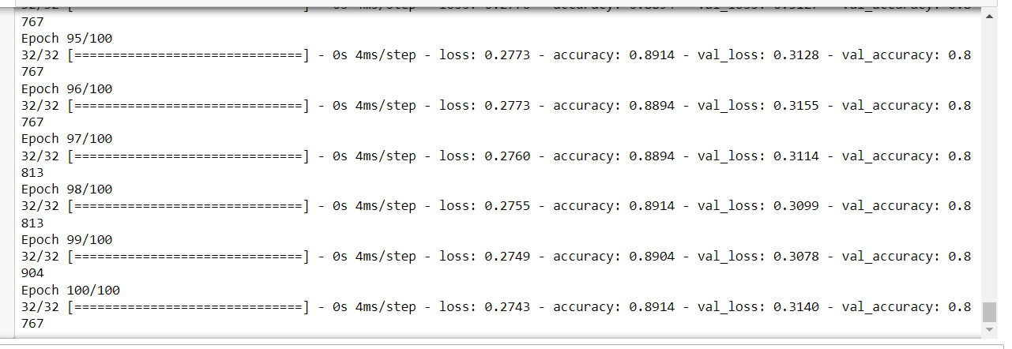

model.evaluate(X_test, Y_test)[1]

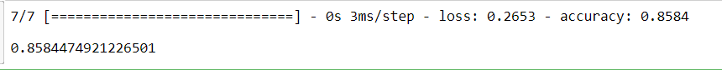

import matplotlib.pyplot as plt

plt.plot(hist.history['loss'])
plt.plot(hist.history['val_loss'])
plt.title('Model loss')
plt.ylabel('Loss')
plt.xlabel('Epoch')
plt.legend(['Train', 'Val'], loc='upper right')
plt.show()

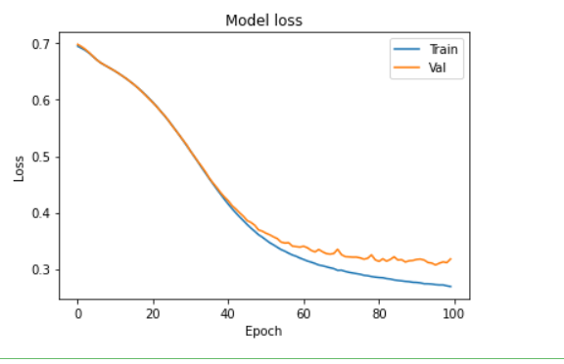

plt.plot(hist.history['accuracy'])
plt.plot(hist.history['val_accuracy'])
plt.title('Model accuracy')
plt.ylabel('Accuracy')
plt.xlabel('Epoch')
plt.legend(['Train', 'Val'], loc='lower right')
plt.show()

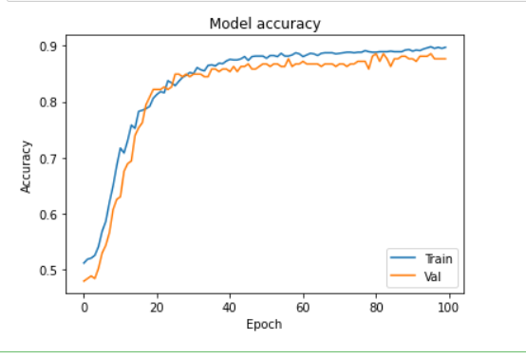

model_2 = Sequential([
Dense(1000, activation='relu', input_shape=(10,)),
Dense(1000, activation='relu'),
Dense(1000, activation='relu'),
Dense(1000, activation='relu'),
Dense(1, activation='sigmoid'),
])
model_2.compile(optimizer='adam',
loss='binary_crossentropy',
metrics=['accuracy'])
hist_2 = model_2.fit(X_train, Y_train,
batch_size=32, epochs=100,
validation_data=(X_val, Y_val))

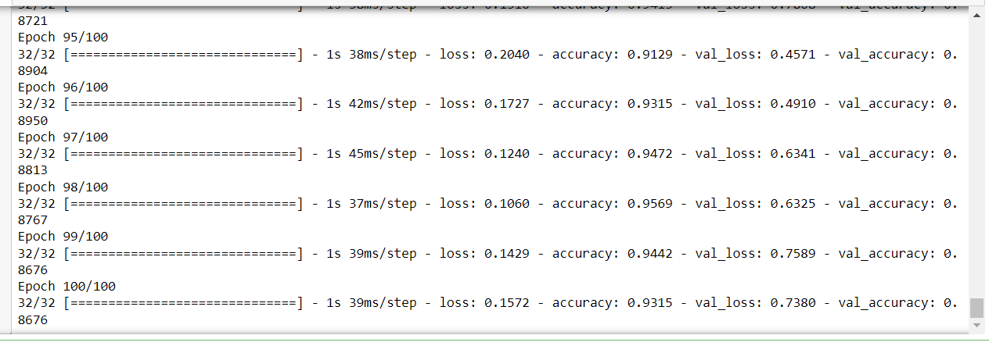

plt.plot(hist_2.history['loss'])
plt.plot(hist_2.history['val_loss'])
plt.title('Model loss')
plt.ylabel('Loss')
plt.xlabel('Epoch')
plt.legend(['Train', 'Val'], loc='upper right')
plt.show()

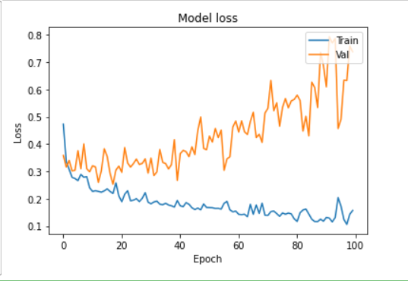

plt.plot(hist_2.history['accuracy'])
plt.plot(hist_2.history['val_accuracy'])
plt.title('Model accuracy')
plt.ylabel('Accuracy')
plt.xlabel('Epoch')
plt.legend(['Train', 'Val'], loc='lower right')
plt.show()

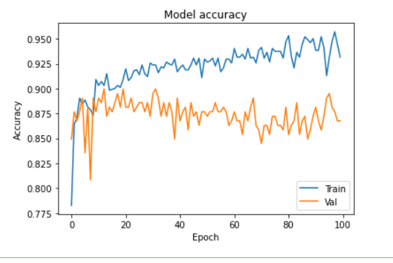

from keras.layers import Dropout
from keras import regularizers

model_3 = Sequential([
Dense(1000, activation='relu', kernel_regularizer=regularizers.l2(0.01), input_shape=(10,)),
Dropout(0.3),
Dense(1000, activation='relu', kernel_regularizer=regularizers.l2(0.01)),
Dropout(0.3),
Dense(1000, activation='relu', kernel_regularizer=regularizers.l2(0.01)),
Dropout(0.3),
Dense(1000, activation='relu', kernel_regularizer=regularizers.l2(0.01)),
Dropout(0.3),
Dense(1, activation='sigmoid', kernel_regularizer=regularizers.l2(0.01)),
])

model_3.compile(optimizer='adam',
loss='binary_crossentropy',
metrics=['accuracy'])

hist_3 = model_3.fit(X_train, Y_train,
batch_size=32, epochs=100,
validation_data=(X_val, Y_val))

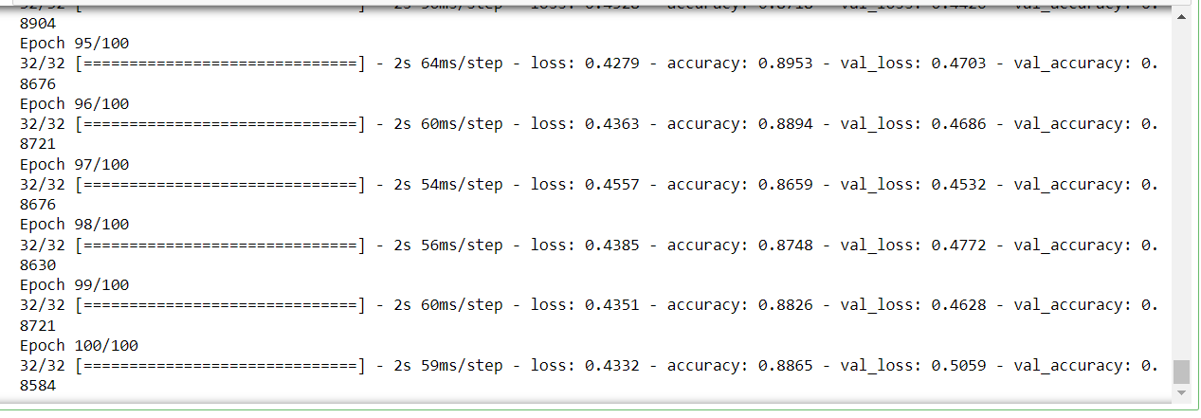

plt.plot(hist_3.history['loss'])
plt.plot(hist_3.history['val_loss'])
plt.title('Model loss')
plt.ylabel('Loss')
plt.xlabel('Epoch')
plt.legend(['Train', 'Val'], loc='upper right')
plt.ylim(top=1.2, bottom=0)
plt.show()

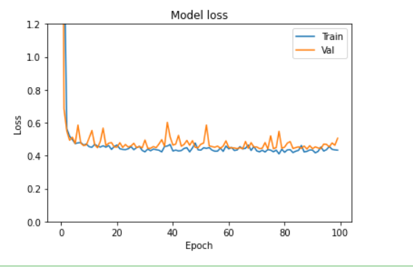

plt.plot(hist_3.history['accuracy'])
plt.plot(hist_3.history['val_accuracy'])
plt.title('Model accuracy')
plt.ylabel('Accuracy')
plt.xlabel('Epoch')
plt.legend(['Train', 'Val'], loc='lower right')
plt.show()

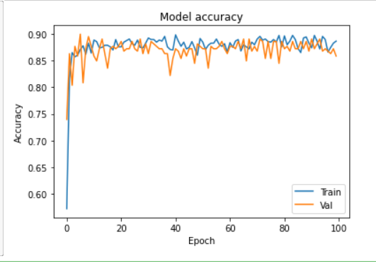

CYCLE-5

<comment>
Functions to familiarize:
1. Linear SVC The objective of a Linear SVC (Support Vector Classifier) is to fit to the
data you provide, returning a "best fit" hyperplane that divides, or categorizes,
your data. From there, after getting the hyperplane, you can then feed some features
to your classifier to see what the "predicted" class is.

2. CountVectorizer:
Creates a matrix in which each unique word is represented by a column of the
matrix, and each text sample from the document is a row in the matrix. The value of
each cell is nothing but the count of the word in that particular text sample.
<comment>

Given a data set of support tickets. Each ticket also has an associated
"urgency score" of between 0 and 3, and where 0 is "very urgent" and 3
is "not urgent". It would be useful if we could have a machine guess
how urgent a ticket is, based on the description, so the urgent tickets
can be resolved first

1. For the given data set, perform text classification using SVM and
find out the accuracy of the model.

Code:

from sklearn.feature_extraction.text import TfidfVectorizer, CountVectorizer

from sklearn.metrics import confusion_matrix
from sklearn.metrics import classification_report

from sklearn.model_selection import cross_val_score
from sklearn.model_selection import cross_val_predict
from sklearn.model_selection import train_test_split

from sklearn.svm import LinearSVC
from sklearn.tree import DecisionTreeClassifier
from sklearn import tree

with open("tickets.txt") as f:
tickets = f.read().strip().split("\n")

with open("labels_4.txt") as f:
labels = f.read().strip().split("\n")

X_train, X_test, y_train, y_test = train_test_split(tickets, labels, test_size=0.1, random_state=1337)

vectorizer = CountVectorizer()
svm = LinearSVC()
X_train = vectorizer.fit_transform(X_train)
X_test = vectorizer.transform(X_test)
_ = svm.fit(X_train, y_train)
y_pred = svm.predict(X_test)
print(classification_report(y_test, y_pred))

Output:

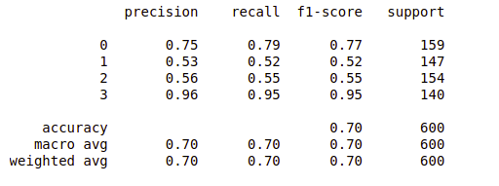
Reference:
- https://www.codementor.io/blog/text-classification-6mmol0q8oj

Given dataset contains 200 records and five columns, two of which describe the
customer’s annual income and spending score. The latter is a value from 0 to
100. The higher the number, the more this customer has spent with the company
in the past:
Functions to familiarize:
- • The purpose of Kmeans.fit() is to train the model with data.
- • The purpose of Kmeans.predict() is to apply a trained model to data

2.Using k means clustering create 6 clusters of customers based on their
spending pattern.
- • Visualize the same in a scatter plot with each cluster in a different color scheme.
- • Display the cluster labels of each point.(print cluster indexes)
- • Display the cluster centers.
- • Use different values of K and visualize the same using scatter plot

Code & Output:

from sklearn.cluster import KMeans
import matplotlib.pyplot as plt
import pandas as pd
customers = pd.read_csv('customer_data.csv')
customers.head()

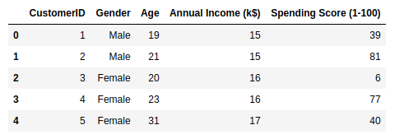

points, cluster_indexes = make_blobs(n_samples=300, centers=4, cluster_std=0.8, random_state=0)
x = points[:, 0]
y = points[:, 1]
kmeans = KMeans(n_clusters=4, random_state=0)
kmeans.fit(points)
predicted_cluster_indexes = kmeans.predict(points)
plt.scatter(x, y, c=predicted_cluster_indexes, s=50, alpha=0.7, cmap='viridis')

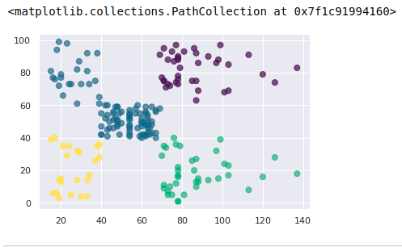

kmeans = KMeans(n_clusters=6, random_state=0)
kmeans.fit(points)
predicted_cluster_indexes = kmeans.predict(points)
plt.scatter(x, y, c=predicted_cluster_indexes, s=50, alpha=0.7, cmap='viridis')
centers = kmeans.cluster_centers_
plt.scatter(centers[:, 0], centers[:, 1], c='red', s=100)

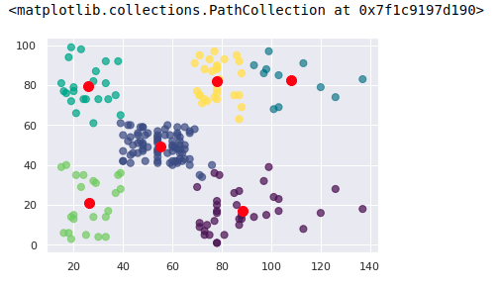

centers = kmeans.cluster_centers_
plt.scatter(centers[:, 0], centers[:, 1], c='red', s=100)

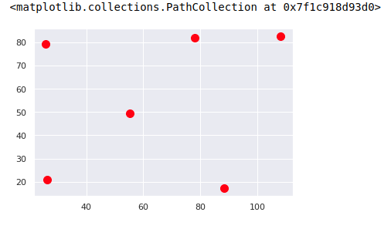

kmeans = KMeans(n_clusters=9, random_state=0)
kmeans.fit(points)
predicted_cluster_indexes = kmeans.predict(points)
plt.scatter(x, y, c=predicted_cluster_indexes, s=50, alpha=0.7, cmap='viridis')
centers = kmeans.cluster_centers_
plt.scatter(centers[:, 0], centers[:, 1], c='red', s=100)

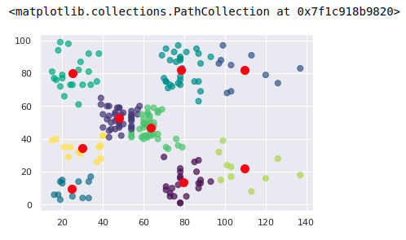

#Display the cluster labels of each point.(print cluster indexes)
print(predicted_cluster_indexes)

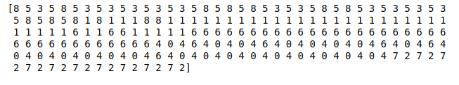

References:
- https://www.atmosera.com/blog/unsupervised-learning-with-k-means-clustering-part-ii/
- https://nickmccullum.com/python-machine-learning/k-means-clustering-python/

3.Natural Language Processing(NLP)

Code & Output:

from nltk.corpus import stopwords
import nltk
from nltk.tokenize import sent_tokenize,word_tokenize
# nltk.download('punkt')
text1 = "The data set given satisfies the requirement for model generation. This is used in Data Science Lab"
print(sent_tokenize(text1))

print(word_tokenize(text1))

# nltk.download('stopwords')
print(stopwords.words('english'))

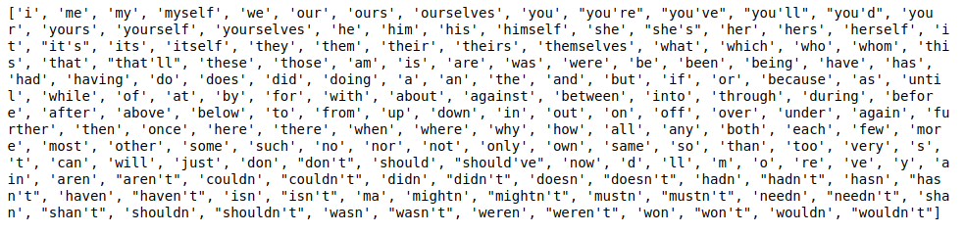

text = word_tokenize(text1)
text= [word for word in text if word not in stopwords.words('english')]
print(text)

# nltk.download('averaged_perceptron_tagger')
print(nltk.pos_tag(text))

temp=zip(*[text[i:] for i in range(0,2)])
ans=[' '.join(ngram) for ngram in temp]
print(ans)

temp=zip(*[text[i:] for i in range(0,4)])
ans=[' '.join(ngram) for ngram in temp]
print(ans)

