דוגמאות

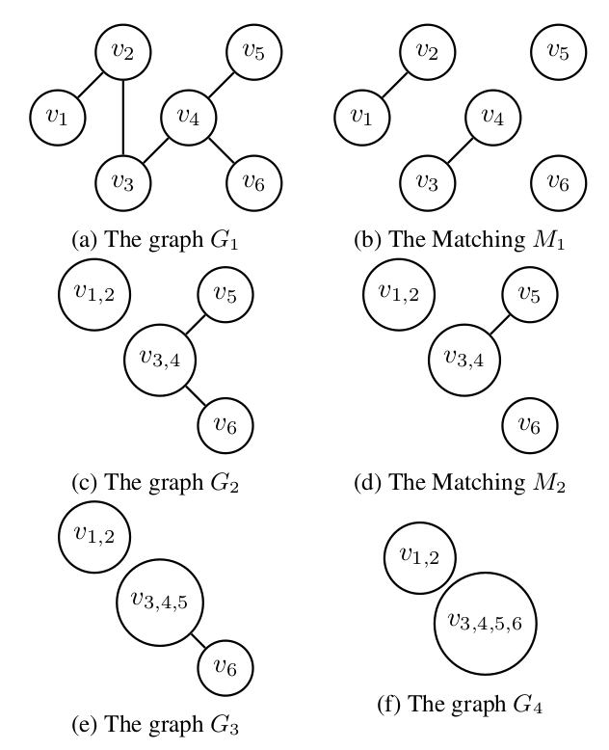

Given the graph in Figure a and k=4, the algrithm finds a maximum matching shown in Figure b. It then creates the graph , as shown in Figure c, and finds a maximum matching for it, shown in Figure d. It then creates the graph , as shown in Figure e, and finds a maximum match-ing for it, . Finally, MnM created the graph , as shown in Figure f, and returns the partition . We note that by the algorithm construction, a unified node , is created by merging nodes and , and then by merging and , and so on.

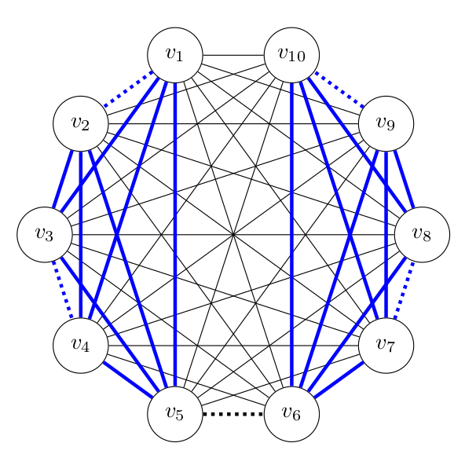

The following figure presents a case where k=5, and G is a complete graph with 10 nodes. Here, , as shown in the dotted lines, and thus . However, , as shown in the blue lines, and .

The following image presents a case where k = 5, and Arbmax may provide an approximation ratio of 1/5 .
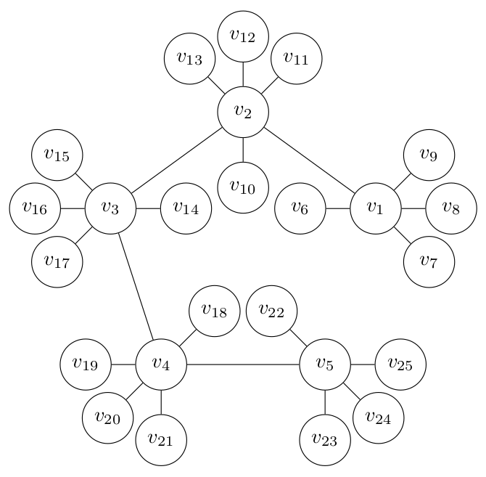
Here, Arbmax may return the partition and thus , while and thus .

