APUTNS T06 - T07
# Constructor
public Asignatura(int id) {
this.id = id;
}
# Getter y setter
private double calificacion;

public double getCalificacion() { #OJO:Devolver variable static = método static
return calificacion;
}
public void setCalificacion(double calificacion) {
this.calificacion = calificacion;
}
# Override toString()
@Override
public String toString() {
return String.format("Alumno -> %d", idAlumno + 1);
}
# For each
private Alumno[] grupo;

for (Alumno alumno : this.grupo) {
if (alumno.getVotos() >= masVotos) {
masVotos = alumno.getVotos();
}
}
## NOTA: Codigo después de throw, si se lanza NO SE EJECUTA, es como return
# Excepción TRATADA, NO PROPAGA
static void dividirEntreArray(int entero, int[] array) {
for (int i : array) {
try {
if (i == 0 || entero == 0) throw new Exception("ERROR:Entre 0");
}
catch (Exception e) {
System.out.println(e.getMessage());
}
}
}
# Excepción NO TRATADA, PROPAGA al main() o otros métodos
public static int getEntero(int num) throws Exception {
try { if (num % 2 == 0) throw new Exception("Lanzando excepcion rana");}
catch (IOException io) {
System.out.println(io.getMessage());
return 2;
}
}

# Excepción personalizada
public class AgotadoException extends Exception {
public AgotadoException(String message) {
super(message);
}
}
public class Corredor {

public void correr() throws AgotadoException {
if (energia < 10) throw new AgotadoException("Sin energia");
}
}
# TIPOS DE EXPEPCIONES
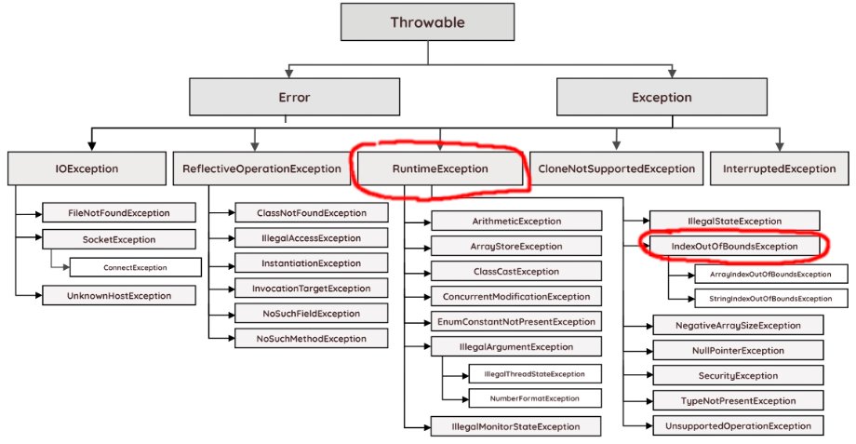
ArithmeticException
It is thrown when an exceptional condition has occurred in an arithmetic operation.
ArrayIndexOutOfBoundsException
It is thrown to indicate that an array has been accessed with an illegal index. The index is either negative or greater than or equal to the size of the array.
FileNotFoundException
This Exception is raised when a file is not accessible or does not open.
IOException
It is thrown when an input-output operation failed or interrupted
NullPointerException
This exception is raised when referring to the members of a null object. Null represents nothing
NumberFormatException
This exception is raised when a method could not convert a string into a numeric format.
RuntimeException
This represents any exception which occurs during runtime.
StringIndexOutOfBoundsException
It is thrown by String class methods to indicate that an index is either negative or greater than the size of the string

