**Linear Layout**

*<?*xml version="1.0" encoding="utf-8"*?>*

<LinearLayout xmlns:android="http://schemas.android.com/apk/res/android"

android:layout_width="match_parent"

android:layout_height="match_parent"

android:baselineAligned="false"

android:orientation="horizontal">

<LinearLayout

android:layout_width="match_parent"

android:layout_height="match_parent"

android:layout_weight="1"

android:background="#0000FF">

</LinearLayout>

<LinearLayout

android:layout_width="match_parent"

android:layout_height="match_parent"

android:layout_weight="1"

android:background="#FFFFFF">

</LinearLayout>

<LinearLayout

android:layout_width="match_parent"

android:layout_height="match_parent"

android:layout_weight="1"

android:background="#0000FF">

</LinearLayout>

</LinearLayout>

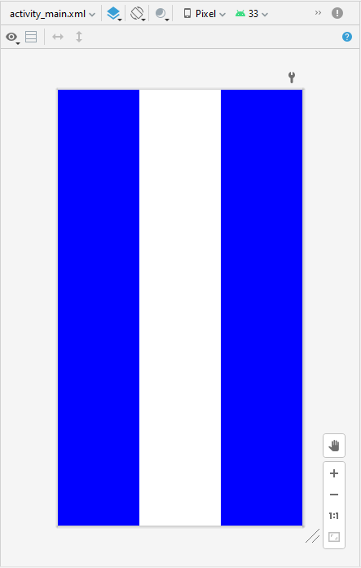

*<?*xml version="1.0" encoding="utf-8"*?>*

<LinearLayout xmlns:android="http://schemas.android.com/apk/res/android"

android:layout_width="match_parent"

android:layout_height="match_parent"

android:baselineAligned="false"

android:orientation="horizontal">

<LinearLayout

android:layout_width="match_parent"

android:layout_height="match_parent"

android:layout_weight="1.5"

android:background="#00FF00">

</LinearLayout>

<LinearLayout

android:layout_width="match_parent"

android:layout_height="match_parent"

android:layout_weight="0.5"

android:background="#FFFFFF">

</LinearLayout>

<LinearLayout

android:layout_width="match_parent"

android:layout_height="match_parent"

android:layout_weight="1.5"

android:background="#00FF00">

</LinearLayout>

</LinearLayout>

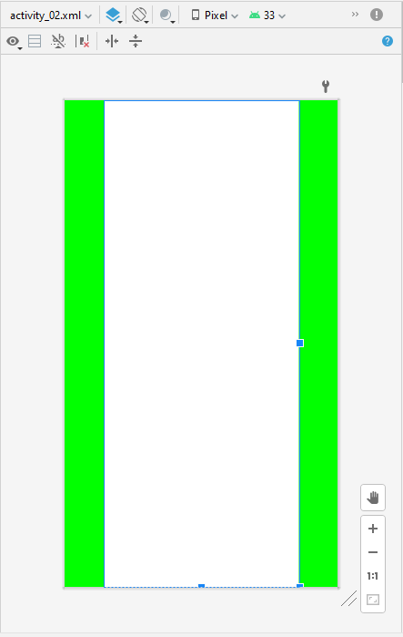

*<?*xml version="1.0" encoding="utf-8"*?>*

<LinearLayout xmlns:android="http://schemas.android.com/apk/res/android"

android:layout_width="match_parent"

android:layout_height="match_parent"

android:orientation="vertical">

<LinearLayout

android:layout_width="match_parent"

android:layout_height="wrap_content"

android:layout_weight="1"

android:baselineAligned="false">

<LinearLayout

android:layout_width="match_parent"

android:layout_height="match_parent"

android:layout_weight="1"

android:background="#FF0000">

</LinearLayout>

<LinearLayout

android:layout_width="match_parent"

android:layout_height="match_parent"

android:layout_weight="1"

android:background="#FFFFFF">

</LinearLayout>

<LinearLayout

android:layout_width="match_parent"

android:layout_height="match_parent"

android:layout_weight="1"

android:background="#FF0000">

</LinearLayout>

</LinearLayout>

<LinearLayout

android:layout_width="match_parent"

android:layout_height="wrap_content"

android:layout_weight="1"

android:baselineAligned="false">

<LinearLayout

android:layout_width="match_parent"

android:layout_height="match_parent"

android:layout_weight="1"

android:background="#FFFFFF">

</LinearLayout>

<LinearLayout

android:layout_width="match_parent"

android:layout_height="match_parent"

android:layout_weight="1"

android:background="#FF0000">

</LinearLayout>

<LinearLayout

android:layout_width="match_parent"

android:layout_height="match_parent"

android:layout_weight="1"

android:background="#FFFFFF">

</LinearLayout>

</LinearLayout>

</LinearLayout>

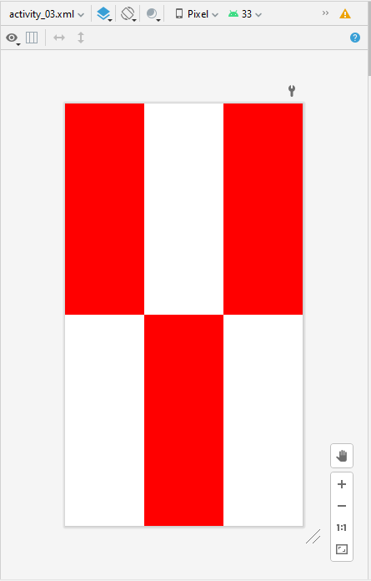

*<?*xml version="1.0" encoding="utf-8"*?>*

<LinearLayout xmlns:android="http://schemas.android.com/apk/res/android"

android:layout_width="match_parent"

android:layout_height="match_parent"

android:orientation="vertical">

<LinearLayout

android:layout_width="match_parent"

android:layout_height="wrap_content"

android:layout_weight="1"

android:baselineAligned="false"

android:orientation="horizontal">

<LinearLayout

android:layout_width="match_parent"

android:layout_height="match_parent"

android:layout_weight="1"

android:background="#FFFFFF">

</LinearLayout>

<LinearLayout

android:layout_width="match_parent"

android:layout_height="match_parent"

android:layout_weight="1"

android:background="#FF0000">

</LinearLayout>

<LinearLayout

android:layout_width="match_parent"

android:layout_height="match_parent"

android:layout_weight="1"

android:background="#FFFFFF">

</LinearLayout>

</LinearLayout>

<LinearLayout

android:layout_width="match_parent"

android:layout_height="wrap_content"

android:layout_weight="1"

android:baselineAligned="false"

android:orientation="vertical">

<LinearLayout

android:layout_width="match_parent"

android:layout_height="match_parent"

android:layout_weight="1"

android:background="#0000FF">

</LinearLayout>

<LinearLayout

android:layout_width="match_parent"

android:layout_height="match_parent"

android:layout_weight="1"

android:background="#FFFFFF">

</LinearLayout>

<LinearLayout

android:layout_width="match_parent"

android:layout_height="match_parent"

android:layout_weight="1"

android:background="#0000FF">

</LinearLayout>

</LinearLayout>

</LinearLayout>

