**NAME:……………………………………… INDEX NO. ……………..…….…**

**SIGNATURE: ………………….... ……….. DATE: ...........................................**

**121/2**

**MATHEMATICS**

**PAPER 2**

**TIME: 2 ½ HOURS**

**FORM IV**

**DR. ALOO GUMBI SECONDARY**

**MIDTERM EXAMS TERM 2 2023**

## INSTRUCTIONS TO CANDIDATES

* Write your name and Admission number in the spaces provided at the top of this page.
* This paper consists of two sections: Section I and Section II.
* Answer ALL questions in section 1 and ONLY FIVE questions from section II
* All answers and workings must be written on the question paper in the spaces provided below each question.
* Show all the steps in your calculation, giving your answer at each stage in the spaces below each question.
* Non – Programmable silent electronic calculators and KNEC mathematical tables may be used, except where stated otherwise.

**FOR EXAMINERS USE ONLY**

**SECTION I**

|  |  |  |  |  |  |  |  |  |  |  |  |  |  |  |  |  |
| --- | --- | --- | --- | --- | --- | --- | --- | --- | --- | --- | --- | --- | --- | --- | --- | --- |
| **1** | **2** | **3** | **4** | **5** | **6** | **7** | **8** | **9** | **10** | **11** | **12** | **13** | **14** | **15** | **16** | **TOTAL** |
|  |  |  |  |  |  |  |  |  |  |  |  |  |  |  |  |  |

**SECTION II GRAND TOTAL**

|  |  |  |  |  |  |  |  |  |
| --- | --- | --- | --- | --- | --- | --- | --- | --- |
| **17** | **18** | **19** | **20** | **21** | **22** | **23** | **24** | **TOTAL** |
|  |  |  |  |  |  |  |  |  |

***This paper consists of 15 printed pages. Candidates should check the question paper to ascertain that all pages are printed as indicated and that no pages are missing.***

**SECTION A: (50MARKS)**

**Answer all questions in this section in the spaces provided.**

1. Use logarithms tables to evaluate. (4mks)
$\sqrt[3]{\frac{\text{36}\text{.}\text{72}×{\left(0\text{.}\text{46}\right)}^{2}}{\text{185}\text{.}4}}$

2. If A = 2.3, B = 8.7 and C = 2.0. Find the percentage error in calculating $\frac{A+B}{C}$ (3mks)
3. Given that *M=i – 3j + 4k, W= 6i + 3j – 5k* and *Q =* 2M + 5W, find the magnitude of Q to 3 significant figures. (3mks)
4. Solve the following equation 22x + 3 –2x +4 = 17(2x) –4 (4mks)
5. If $\frac{1}{3−\sqrt{5}}−\frac{2+2\sqrt{5}}{3+\sqrt{5}}=a+b\sqrt{c}$, find the value of a, b and c (3mks)
6. Pipe A can fill an empty water tank in 3hrs while Pipe B can fill the same tank in 6hrs. When the tank is full it can be emptied by Pipe C in 8hrs. Pipe A and B are opened at the same time when the tank is empty. If one hour later Pipe C is also opened, find the total time taken to fill the tank. (3mks)
7. The figure below shows a circle center O, radius 10 cm. The chord PQ = 16cm. Calculate the area of the unshaded region. (4mks)

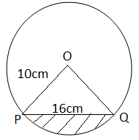

1. The mean weight of 36 students is 45kg; two of the students leave and the mean weight increases by 0.5kg. If one of the students who left weighed 43kg, find the weight of the other one. (3mks)
2. Use the trapezium rule to estimate the area bounded by the curve y + x2 = 4 and the lines y = 0, x = 2 and x = 2 using four strips. (3mks)
3. 4x2 - 10x + 4y2+ 12y - 1 = 0 represents a circle centre C (a, b) and of radius K. Find the values of a, b and K. (3mks)
4. Make *x* the subject of the equation (3mks)
$\frac{t}{s}=\frac{b}{\sqrt{x−4}}$

5. Use reciprocal, square and cube root tables to evaluate to 4 significant figures, the expression. (3mks)



1. (a)Expand the expression (1 + ½x) 5 in ascending powers of x, leaving the coefficients as fractions in their simplest form. (2mks)

(b) Use the first three terms of the expansion in (a) above to estimate the value of (l1/20)5. (2mks)

1. In the diagram below, BT is a tangent to the circle at B. AXCT and BXD are straight lines. AX = 6cm, CT = 8cm, BX = 4.8cm and XD = 5cm.

5cm

4.8cm

6cm

8cm

X

D

B

A

C

Find the length of BT. (2mks)

1. Find x if Cos x = $\frac{\sqrt{3}}{2}$ for -1800  x  1800. (2mks)
2. The following were recorded on a field note book by a surveyor. Taking the base line as 550m. Find the area in m². (3mks)

|  |  |  |  |  |  |  |
| --- | --- | --- | --- | --- | --- | --- |
|  |  |  | B |  |  |  |
|  |  |  | 550 | 120 | TO | A |
|  | C | 150 | 450 |  |  |  |
|  |  |  | 250 | 90 | T O | D |
|  | E | 60 | 40 |  |  |  |
|  |  |  | F |  |  |  |

**SECTION II (50mrks)**

**Attempt any FIVE questions from this section**

1. Mr. Kobe is a civil servant who earns a monthly salary of Ksh. 21200. He has a house allowance of Ksh. 12000 per month, other taxable allowances are commuter Ksh. 1100, medical allowance Ksh. 2000. He is entitled to a personal relief of Ksh. 1240 per month.

Using the income rates below, solve the questions that follow.

|  |  |
| --- | --- |
| Income in Ksh. per month | Rates in Ksh per sh 20 |
| 1 – 8,400  8401 – 18,000  18001 – 30,000  30001 – 36,000  36001 – 48,000  Above 48,000 | 2  3  4  5  6  7 |

Determine;

1. i) His monthly taxable income. (2mks)

ii) Net tax (PAYE) (5mks)

1. In addition to the PAYE, the following deductions were made. Ksh. 250 for NHIF, Ksh. 120 service charges, he repays a loan at sh. 4500 and contributes towards savings at sh. 1800 every month. Calculate his net salary per month. (3mks)
2. The figure below is a square based pyramid ABCDV with AD=DC = 6cm and height V = 10cm

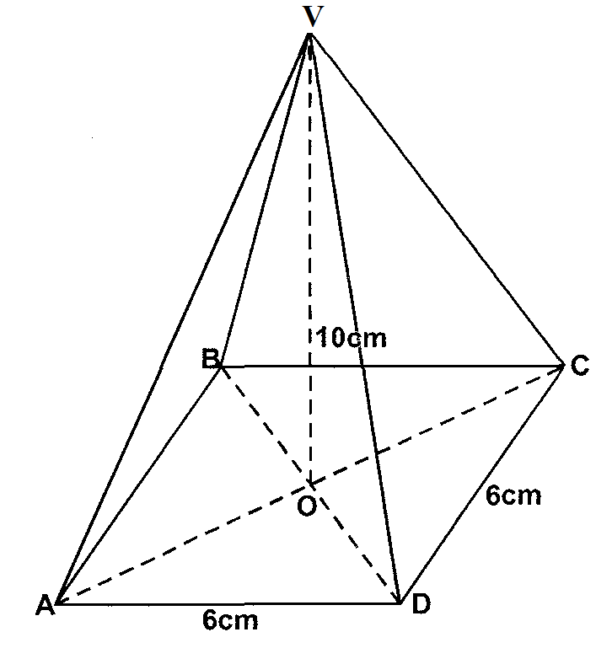

1. State the projection of VA on the base ABCD. (1mk)

b) Find:

i) The length of VA (3mks)

ii) The angle between VA and ABCD (2mks)

iii) The angle between the planes VDC and ABCD (2mks)

iv) Volume of the pyramid (2mks)

1. a) Complete the table below for y=sin 2x and y=sin ( 2x + 30) giving values to 2d.p.(2mks)

|  |  |  |  |  |  |  |  |  |  |  |  |  |  |
| --- | --- | --- | --- | --- | --- | --- | --- | --- | --- | --- | --- | --- | --- |
| X | 0 | 15 | 30 | 45 | 60 | 75 | 90 | 105 | 120 | 135 | 150 | 165 | 180 |
| Sin 2x | 0 |  |  |  | 0.87 |  |  |  | -0.87 |  |  |  | 0 |
| Sin ( 2x +30) | 0.5 |  |  |  | 0.5 |  |  |  | -1 |  |  |  | 0.5 |

b) Draw the graphs of y=sin 2x and y = sin (2x + 30) on the axis. (4mks)

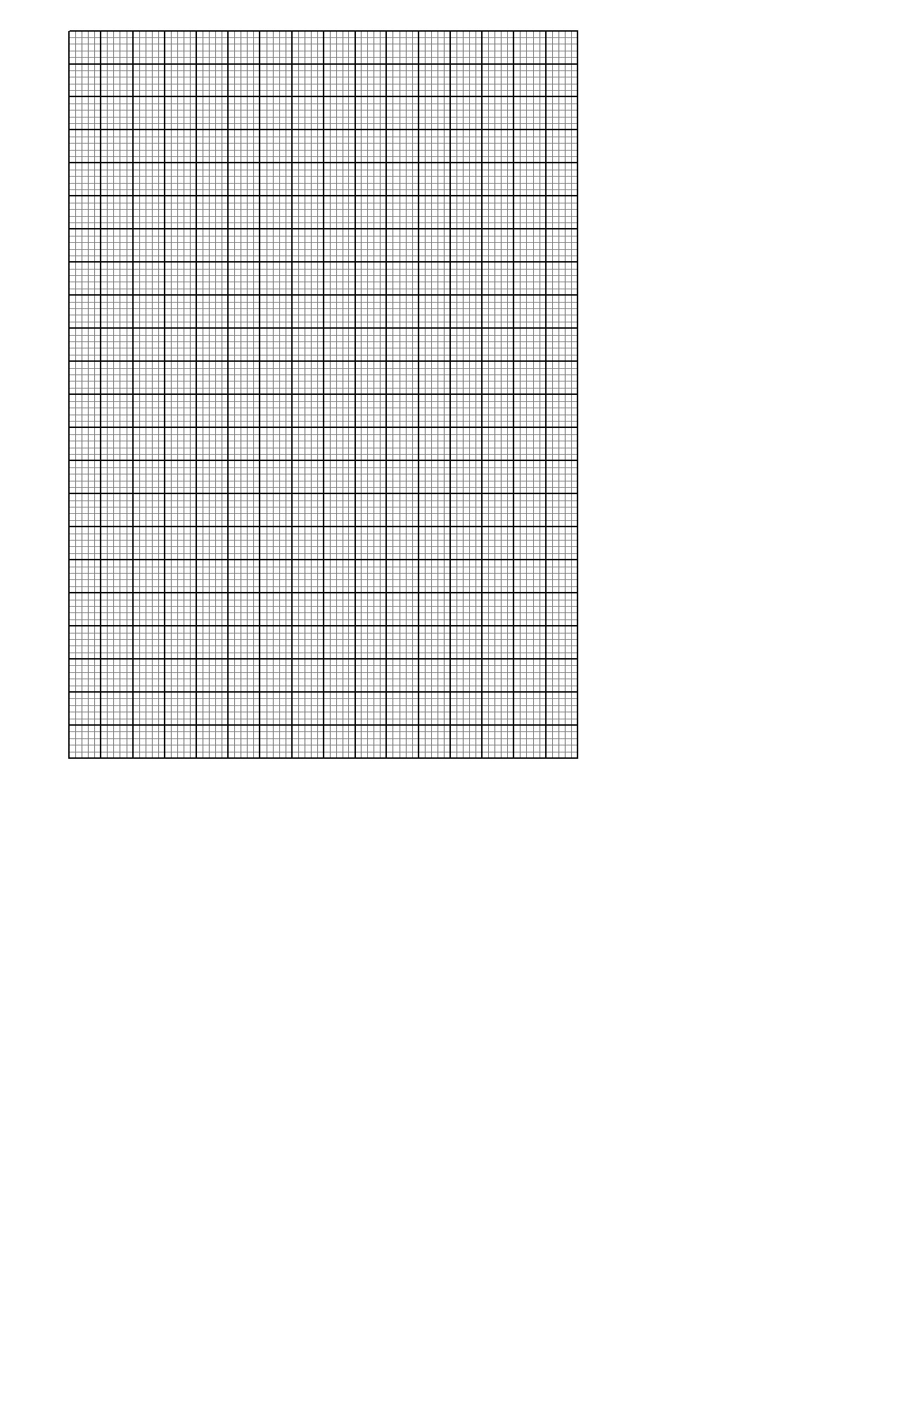

c) Use the graph to solve  (1mk)

d) Determine the transformation which maps  (1mk)

e) State the period and amplitude of  (2mks)

1. In the figure below E is the midpoint of BC. AD: DC 3:2 and F is the meeting point of BD and AE.

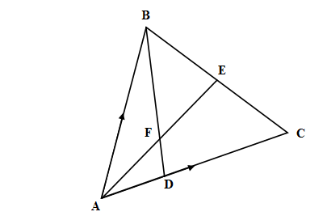

1. If AB = **b** and AC = **c,** find:
2. BD (2mks)

1. AE (2mks)
2. If BF = *t* BD and AF = *n* AE. Find the value of t and n. (5mks)

1. State the ratio of BD to BF. (1mk)
2. The position of two towns **X** and **Y** are given to the nearest degree as **X** (450 N, 1100 W) and

**Y** (450 N, 700 E)**.** Take  = 3.142, **R** = 6370km.Find:

1. The distance between the two towns along the parallel of latitude in km. (3mks)

(b) The distance between the towns along a parallel of latitude in nautical miles. (3mks)

(c) A plane flew from **X** to **Y** taking the shortest distance possible. It took the plane 15hrs to

move from **X** and **Y**. Calculate its speed in Knots. (4mks)

1. If the plane left town **X** on Monday 12:45PM. Find the local time it arrived at town **Y**. (3mks)

1. The 2nd and 5th terms of an arithmetic progression are 8 and 17 respectively. The 2nd, 10th and 42nd terms of the A.P. form the first three terms of a geometric progression. Find

(a) The 1st term and the common difference. (3mks)

(b) The first three terms of the G.P and the 10th term of the G.P. (4mks)

(c) The sum of the first 10 terms of the G.P. (3mks)

1. The diagram below, not drawn to scale shows part of the curve $y=x^{2}+5$ and the line y = 8-2x. The line intersects the curve at points C and D. Lines AC and BD are parallel to the y-axis.

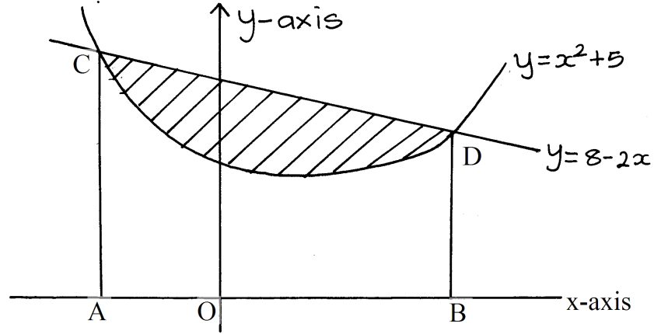

1. Determine the coordinates of C and D. (4mks)

(b) Use integration to calculate the area bounded by the curve and the x-axis between the

points C and D. (3mks)

(c) Calculate the area enclosed by the lines CD, CA, BD and the x-axis. (3mks)

(d) Hence determine the area of the shaded region. (1mk)

1. Using a ruler and pair of compasses only.
2. Construct triangle ABC in which AB = 9cm, AC = 8cm and angle BAC = 600. Measure BC (2mks)
3. On the same side of AB as C, draw the locus of a point such that angle APB = 600 (3mks)
4. A region T is within the triangle ABC such that AT > 4cm and angle ACT ≥ angle BCT. Show the region T by shading it. (5mks)