

DIRECTORATE OF PLANNING, RESEARCH AND COMPLIANCE
PLANNING AND ROAD MANAGEMENT DEPARTMENT

TRAFFIC CENSUS STATION VALIDATION AND ASSESSMENT FOR CONTINUOUS TRAFFIC MONITORING
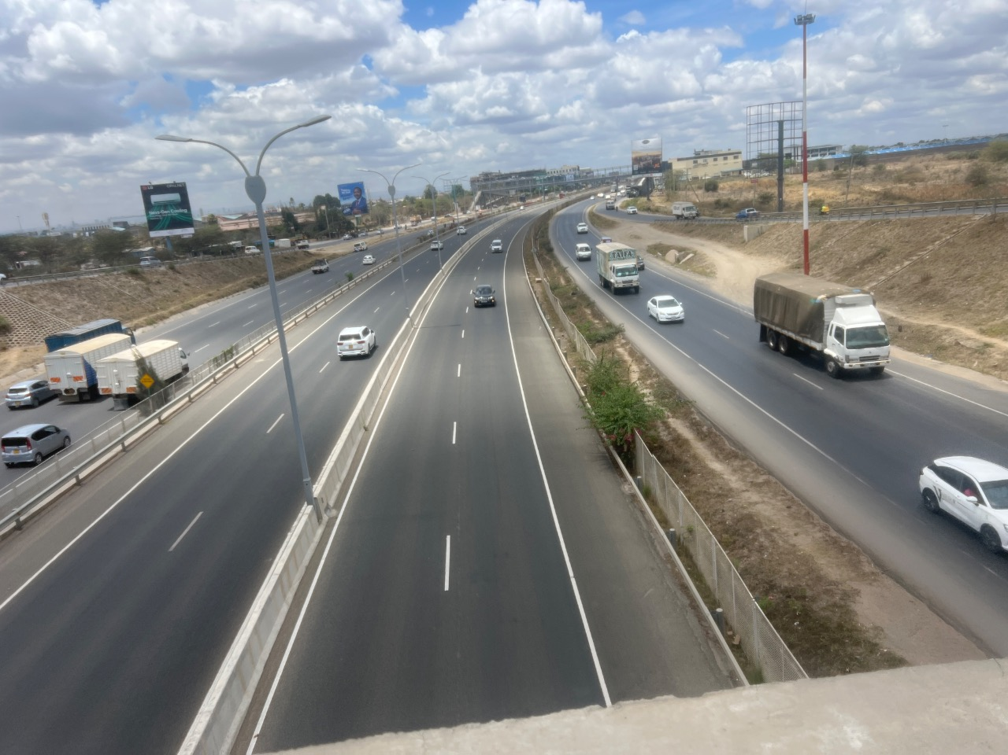
OCTOBER 2026
DIRECTOR GENERAL  KENYA NATIONAL HIGHWAYS AUTHORITY  P.O.BOX 49712-0100  NAIROBI | DIRECTORATE OF PLANNING RESEARCH & COMPLIANCE  P.O.BOX 49712-0100  NAIROBI

TABLE OF CONTENTS
EXECUTIVE SUMMARY v
1.0 INTRODUCTION 1
1.1 Exercise Description 1
1.2 Objectives of the Exercise 3
1.2.1 Main Objective 3
1.2.2 Specific Objectives 3
2.0 SCOPE OF WORK 4
3.0 METHODOLOGY 5
3.1 Review of Existing Information 5
3.2 Selection Criteria of the 60 Proposed CTC Stations 5
3.3 Selection of Locations for the First Validation Phase 6
3.4 Station and Coordinate Validation 6
3.5 Assessment of Site Suitability 6
3.6 Classified Traffic Counting 6
4.0 SITE VALIDATION AND FINDINGS 7
4.1 East Station Findings 7
4.2 West Station Findings 10
4.3 Site Suitability Assessment 12
4.3.1 East Site Suitability Matrix 12
4.3.2 West Site Suitability Matrix 13
4.4 Summary of Outcomes 14
5.0 TRAFFIC COUNT ANALYSIS 15
6.0 CONCLUSIONS 16
7.0 RECOMMENDATIONS 17
APPENDIX A STATION SELECTION AND PROPOSED 60 STATIONS 18
A.1 Detailed Desktop Scoring Rules 18
A.2 Selected Stations East 20
A.3 Selected Stations West 25
APPENDIX B MAPS OF THE PROPOSED CTC STATIONS 29
APPENDIX C KOBO SITE VALIDATION FORM 32
APPENDIX D TRAFFIC COUNT ANALYSIS SUMMARIES 36
D.1 East Analysis Summary 36
D.2 West Analysis Summary 37
APPENDIX E SELECTED SITE PHOTOGRAPHS 38

LIST OF TABLES
Table 1.1 Stations visited during first-phase validation 2
Table 3.1 Desktop selection criteria and maximum scores 5
Table 4.1 East station location validation findings 7
Table 4.2 West station location validation findings 10
Table 4.3 Summary of field validation outcomes 14
Table 5.1 East observed and estimated traffic volumes 15
Table 5.2 West observed and estimated traffic volumes 15
Table A.1 Detailed desktop scoring rules 18
Table A.2 East stations selection scores and field status 20
Table A.3 West stations selection scores and field status 25
Table D.1 East traffic count analysis summary 36
Table D.2 West traffic count analysis summary 37

LIST OF FIGURES
Figure B.1 National map of the 60 proposed stations 29
Figure B.2 Proposed East stations 30
Figure B.3 Proposed West stations 31
Figure E.1 Kokotoni (A8) 38
Figure E.2 Mukuyuni (B63) 38
Figure E.3 Maungu (A8) 38
Figure E.4 Mwanjila Youth Polytechnic (A6) 38
Figure E.5 Kereri (B6) 39
Figure E.6 Bukembe (A8) 39
Figure E.7 Chimoi (A8) 39
Figure E.8 Molem (A1) 39

LIST OF ABBREVIATIONS
AADT | Annual Average Daily Traffic
ADT | Average Daily Traffic
CTC | Continuous Traffic Count
ESA | Equivalent Standard Axle
GIS | Geographic Information System
GPS | Global Positioning System
HEF | Hourly Expansion Factor
ICTMP | Integrated Continuous Traffic Monitoring Programme
KeNHA | Kenya National Highways Authority
NMT | Non-Motorised Transport
O–D | Origin–Destination
TVC | Traffic Volume Count
UTM | Universal Transverse Mercator
VWB | Virtual Weighbridge
WGS 84 | World Geodetic System 1984

EXECUTIVE SUMMARY
This report presents the findings of an exercise undertaken by the Kenya National Highways Authority to validate selected 2023 traffic census records and assess locations for permanent Continuous Traffic Count (CTC) stations. The exercise sought to confirm station locations, compare field traffic counts with the historical data and identify conditions affecting future monitoring.
A desktop review of the 460 stations from the 2023 records identified 60 proposed stations, comprising 30 in East and 30 in West. 24 stations were visited during the first validation phase, with 12 covered in each lot. The visits involved checking road references and landmarks, recording coordinates, assessing road and roadside conditions, taking photographs and conducting one-hour classified traffic counts.
The location assessments identified differences between some registered coordinates and the positions considered appropriate on the ground. Several stations required relocation to avoid junctions, bends, bus stops, school entrances, petrol-station accesses and other local influences.
The traffic analysis compared the observed one-hour volumes with the 2023 hourly data. Direction-specific hourly expansion factors were then used to estimate daily volumes for comparison with the 2023 24-hour counts.

At Mukuyuni, no vehicles were recorded during the one-hour observation. Its inclusion among the proposed 60 stations should be reviewed through a confirmatory count and consideration of the road section it represents. Across the visited locations, the suitability matrix recorded 19 stations as suitable and 5 as not suitable.
If the first phase of CTC installation proceeds, Gateway Mall Syokimau, Kokotoni, Mtito Andei and Matsangoni in East, and Kereri, Eldoret–Nakuru (A8), Molem and Bukembe in West, are recommended for prioritisation, subject to confirmation of suitable equipment positions and resolution of the recorded constraints.

1.0 INTRODUCTION
The Kenya National Highways Authority (KeNHA) undertook a National Traffic Survey in 2023, which identified approximately 460 traffic census points across the road network. The survey provides a reference for traffic monitoring, transport planning, pavement design, maintenance programming, road asset management and economic evaluation of road projects.
To build on the survey, the Planning and Road Management Department intends to establish permanent Continuous Traffic Count (CTC) stations at selected locations. Continuous monitoring will complement periodic surveys by recording changes in traffic volumes and vehicle composition. This will provide a stronger basis for estimating Annual Average Daily Traffic (AADT), assessing traffic growth and loading patterns, and determining road investment and maintenance needs.
The proposed stations form part of the Integrated Continuous Traffic Monitoring Programme (ICTMP). The programme seeks to bring together information from existing traffic census stations, Virtual Weighbridges, static weighbridges and new permanent counters. This approach will support the use of available datasets while identifying road sections where additional monitoring is needed.
A desktop review of the 2023 census records identified 60 candidate CTC stations nationally, comprising 30 in East and 30 in West. The first phase of field validation covered 24 of the 60 locations, with 12 assessed in both East and West. The locations included major trunk-road sections and selected regional links representing different traffic and operating conditions.
Field validation was necessary because a position previously used for a temporary manual count may not meet the requirements of a permanent monitoring installation. Road improvements, roadside development and changes in access or traffic movements may also affect the suitability of the original census position. Each location therefore required assessment of its ability to capture representative traffic and accommodate equipment that can be safely installed, operated and maintained.
The exercise involved verification of station positions, capture of field coordinates, inspection of road and roadside conditions, photographic documentation and classified traffic counting. Where constraints affected the original position, an adjusted location was recorded or further assessment of an alternative position was recommended.
This report presents the findings from the field validation of 24 proposed CTC stations, comprising 12 locations in East and 12 in West. It compares the station information recorded in the Traffic Census Register with the coordinates and site conditions observed during the field exercise. The report identifies stations that may be retained, relocated or subjected to further technical assessment and provides recommendations to support the selection of suitable locations for the proposed CTC network. The findings will also support the review and updating of the Traffic Census Register and the GIS Traffic Monitoring Database.

1.1 Exercise Description
The exercise comprised desktop selection of 60 candidate CTC stations nationally, with 30 in East and 30 in West, followed by first-phase field validation of 24 locations. The remaining 36 candidates were retained for subsequent validation. Appendix A gives the selected stations
and the selection basis.
The East validated locations were on A5, A6, A7, A8 and B63. The West validated locations were on A1, A8, A12, B3 and B6.

Table 1.1 Stations visited during first-phase validation
No. | East | West
1 | Matsangoni | Isebania
2 | Ukunda | Kogwe
3 | Lunga Lunga Police | Kereri
4 | Kokotoni | Oyugis
5 | Mkomani | Bumala
6 | Maungu | Bukembe
7 | Mwanjila Youth Polytechnic | Kiungani
8 | Mtito Andei | Webuye
9 | Kiboko | Chimoi
10 | Kimana | Eldoret–Nakuru
11 | Mukuyuni | Molem
12 | Gateway Mall Syokimau | Awasi
At each station, the team located the registered census point and inspected the surrounding road and roadside conditions. The assessment considered visibility, alignment, gradients, lane configuration and features that could influence traffic passing the counting position.
The teams also reviewed access for installation and maintenance, available roadside space, drainage, security, lighting and mobile network availability. Coordinates, landmarks, photographs and site observations were recorded using the KoboToolbox validation form.
Where the original position was affected by unsuitable geometry or local traffic movements, the team identified an adjusted position along the road section and recorded the reason for relocation. Classified traffic counts were undertaken alongside the site inspections to record traffic during the survey period and support subsequent comparison with historical records.

1.2 Objectives of the Exercise

1.2.1 Main Objective
To validate selected 2023 traffic census locations and supporting traffic records, and assess their suitability for permanent Continuous Traffic Count monitoring.

1.2.2 Specific Objectives
1. To verify station positions, road references and identifiers against the traffic census register.
2. To assess whether the locations represent the intended traffic flow and are suitable in terms of road geometry, visibility and roadside conditions for establishment of permanent Continous Traffic Count Stations.
3. To assess access, safety, security, drainage, potential power supply and network requirements for permanent monitoring.
4. To establish traffic volumes and vehicle composition during the field survey periods and compare them with historical records.
5. To review potential duplication with existing weighbridge monitoring.

2.0 SCOPE OF WORK
The exercise comprised the desktop selection of 60 proposed Continuous Traffic Count stations across the country and field validation of 24 locations during the first phase. The 60 stations consisted of 30 stations in East and 30 in West, of which 12 from each group were assessed on the ground in the first phase.
1. Review of existing traffic census records
Examination of the 2023 census records, station coordinates, road sections, historical AADT and available vehicle classification and axle-loading information to establish the proposed 60 CTC stations.
2. Selection of the 60 proposed CTC stations
Assessment using traffic volumes, freight or axle-loading, road classification, completeness of historical data, existing monitoring coverage and road-section coverage. The stations were reviewed for national distribution and representation of distinct traffic links. Class A roads were prioritised, with selected Class B stations included where justified by their contribution to network coverage.
3. Planning of the first validation phase
Identification of 24 locations from the proposed 60 stations, comprising 12 in East and 12 in West, and preparation of field schedules taking account of road-link coverage and travel logistics.
4. Verification of station locations
Identification of the selected points on the ground, confirmation of road references and landmarks, and capture of field coordinates for comparison with the register.
5. Assessment of site suitability
Inspection of road geometry, visibility, lane configuration and nearby activities that could affect representative counting. Access, roadside space, drainage, flood exposure, security, lighting, mobile network availability and visible power infrastructure were also considered.
6. Identification of revised positions
Recording of adjusted locations where constraints affected the original census positions, together with the reasons for relocation and recommendations for further assessment where necessary.
7. Classified traffic counting and analysis
Collection of classified counts during the survey periods to establish observed volumes and vehicle composition and support comparison with historical records.

3.0 METHODOLOGY
The assignment was undertaken in two stages: desktop selection of the 60 proposed CTC stations and field validation of 24 locations during the first phase. The methodology combined review of historical traffic records, mapping, site inspections, coordinate capture and classified traffic counting.

3.1 Review of Existing Information
The 2023 traffic census records were reviewed to establish 60 candidate stations. Information examined included station names and codes, road sections, road classification, registered coordinates, historical AADT and available vehicle classification and axle-loading data.
The station coordinates were mapped against the road network to examine their distribution and support field planning. Location of Virtual Weighbridges was also considered when reviewing existing monitoring coverage to prevent coverage overlap.

3.2 Selection Criteria of the 60 Proposed CTC Stations
Table 3.1 Desktop selection criteria and maximum scores
Criterion | Max.  points | Basis
Strategic importance of the road link | 15 | Priority was given to major trunk corridors, international approaches and links serving important regional traffic movements.
Representativeness of the location | 10 | Road-section length, apparent influence of settlements or junctions, and alignment of the registered coordinates with the mapped road were considered.
Historical AADT | 10 | Stations were scored according to the percentile ranking of their AADT values.
Freight share or axle-loading indicator | 5 | Recorded freight share was used for West. Recorded daily Equivalent Standard Axles (ESA) were used as a loading indicator for East, where an equivalent freight-share field was unavailable. Missing values received zero points.
Gap in existing monitoring coverage | 5 | Estimated road-network distance to a Virtual Weighbridge on the same road was used to assess additional monitoring coverage.
Completeness of historical survey data | 3 | Higher scores were assigned where classified traffic counts were supported by additional surveys, including axle loading, origin–destination, non-motorised transport or emissions surveys.
Geographic coverage | 2 | A small weighting recognised road and county combinations with fewer candidate records, supporting a wider distribution of monitoring locations.
Total | 50

3.3 Selection of Locations for the First Validation Phase
From the 60 Proposed CTC Stations, 24 locations were selected for first-phase validation using road-link priorities and field logistics. The field assessment covered 24 proposed CTC locations, comprising 12 in East and 12 in West.
East prioritised A7 and A8 and associated coastal links, with additional coverage on A5, A6 and B63. West covered A1, A8, A12, B3 and B6 around the western and lake-region network.
The other 36 remained pending validation in other phases.

3.4 Station and Coordinate Validation
The teams used the registered coordinates and road references to identify each census location on the ground. Field coordinates, nearby landmarks and site observations were recorded using the KoboToolbox validation form attached in Appendix C.
Kobo coordinates were recorded as latitude and longitude using mobile-phone GPS.

3.5 Assessment of Site Suitability
Each location was inspected to determine whether it could capture representative traffic and accommodate permanent monitoring equipment such as cameras and pneumatic counters. The assessment considered:
- Road alignment, bends, gradients, climbing lanes and lane configuration.
- Visibility of approaching and passing traffic across the lanes to be monitored.
- The influence of junctions, access roads, bus stops, school entrances, markets, petrol stations and other roadside activities.
- Available roadside space, parking and access for installation and maintenance.
- Drainage, flood exposure, security and lighting.
- Mobile network availability and visible infrastructure indicating potential power supply.
Where constraints affected the original position, an adjusted location was identified along the road section or further assessment of an alternative position was recommended.

3.6 Classified Traffic Counting
Classified traffic counts were undertaken using the traffic count form alongside the site assessments. For analysis, station identifiers, survey dates, start and finish times, direction labels and vehicle categories were reconciled with the historical records.

4.0 SITE VALIDATION AND FINDINGS
The field assessment covered 24 proposed CTC locations, comprising 12 in East and 12 in West. The assessment compared the registered census positions with actual field coordinates and examined suitability for permanent traffic monitoring.

4.1 East Station Findings
Table 4.1 East station location validation findings
No. | Station and reference | Road | Road section | Field latitude  longitude | Register latitude  longitude | Assessment of location
1 | Lunga Lunga Police Station  CST_002_A7_013  Class A | Coast | A7 | Horo Horo–Mgombezi Junction | -4.559504  39.127508 | -4.559065  39.127179 | Field and register coordinates are relatively close. The police station landmark supports identification. A nearby junction and bus stop may influence traffic at the proposed monitoring position.
2 | Ukunda  CST_002_A7_015  Class A | Coast | A7 | Mwabungu–Kombani | -4.267670  39.569747 | -4.267123  39.569808 | Field and register coordinates are relatively close. The road section and Shell petrol station landmark support identification.
3 | Mkomani  CST_003_A7_026  Class A | Coast | A7 | Mtwapa–Mavueni | -3.754709  39.823900 | -3.748254  39.823878 | Field and register coordinates are relatively close
4 | Matsangoni  CST_003_A7_024  Class A | Coast | A7 | Tezo–Malindi | -3.388110  39.925556 | -3.388980  39.925030 | Monitoring location was shifted approximately 300 m from the registered position because the original position lies within a forest.
5 | Kokotoni  CST_002_A8_017  Class A | Coast | A8 | Mazeras–Mariakani | -3.922762  39.528830 | -3.922203  39.527158 | Field and register coordinates are relatively close. The road section and Kokotoni petrol station landmark support identification.
6 | Maungu  CST_006_A8_043  Class A | Corridor A | A8 | Mariakani–Voi | -3.559300  38.752561 | -3.558135  38.750254 | Monitoring location was moved approximately 300 m from the registered position to avoid turning movements at a roadside station and interference from a boda boda shed.
7 | Mwanjila Youth Polytechnic  CST_006_A6_042  Class A | Corridor A | A6 | Holili–Voi | -3.497912  38.314440 | -3.500654  38.317664 | Field and register coordinates are relatively close. The road section and polytechnic landmark support identification.
8 | Kimana  NRB_034_A5_152  Class A | Lower Eastern | A5 | Amboseli Junction–Mbirikani | -2.813108  37.531745 | -2.812288  37.531664 | Field and register coordinates are relatively close. The road section and AIC Bethel Church landmark support identification. Shoulder erosion was reported at the location.
9 | Mtito Andei  LEST_017_A8_110  Class A | Corridor A | A8 | Tsavo–Kibwezi | -2.689942  38.163202 | -2.693016  38.166215 | Monitoring location was moved approximately 500 m from the registered position to avoid turning movements at a nearby petrol station.
10 | Kiboko  LEST_017_A8_109  Class A | Corridor A | A8 | Kibwezi–Emali | -2.211328  37.715083 | -2.211070  37.715880 | Field and register coordinates are relatively close. The road section and Trojans petrol station landmark support identification.
11 | Mukuyuni  LEST_016_B63_106  Class B | Lower Eastern | B63 | Kanyuuku–Kangundo | -1.342423  37.390939 | -1.342260  37.390949 | Field and register coordinates closely agree. The road section and Mukuyuni Primary School landmark support identification. Very low traffic volumes were observed on the gravel road. Reconsider the location’s priority for a permanent CTC station.
12 | Gateway Mall Syokimau  LEST_016_A8_098  Class A | Corridor A | A8 | Kitengela Interchange–Cabanas | -1.361993  36.909173 | -1.364105  36.911337 | Field and register coordinates are relatively close. The Gateway Mall landmark supports identification.

4.2 West Station Findings
Table 4.2 West station location validation findings
No. | Station and reference | Road | Road section | Field latitude  longitude | Register latitude  longitude | Assessment of location
1 | Isebania  A1.TCP23  Class A | Nyanza | A1 | Suna–Isebania | -1.109526  34.455147 | -1.109511  34.455263 | Field and register coordinates are close. Electricity poles are present, but street lighting is unavailable.
2 | Kogwe  B3.TCP1  Class B | Nyanza | B3 | Homa Bay–Rongo | -0.638262  34.514674 | -0.638525  34.515352 | The location was moved approximately 100m to avoid a junction, bus stop and curve.
3 | Kereri  B6.TCP1  Class B | Corridor B | B6 | Kisii–Keumbu | -0.684632  34.780310 | -0.684482  34.779651 | The location was moved approximately 100m to reduce the influence of the school entrance.
4 | Oyugis  A1.TCP20  Class A | Nyanza | A1 | Katito–Kisii | -0.456604  34.878624 | -0.456735  34.878366 | The location was moved approximately 100m to avoid a bus stop, a curve on the approach from Kisii and turning movements at an access road.
5 | Bumala  A12.TCP1  Class A | Corridor B | A12 | Busia–Ugunja | 0.311518  34.199006 | 0.308461  34.200286 | The location was moved approximately 400m because of a nearby junction and bend within a reported accident blackspot.
6 | Bukembe  A8.TCP1  Class A | Corridor B | A8 | Malaba–Webuye | 0.608049  34.645315 | 0.607516  34.644629 | The location was moved approximately 200m because of a steep climb towards Malaba. Proximity to Webuye weighbridge.
7 | Kiungani  A1.TCP9  Class A | Western | A1 | Kitale–Kamukuywa | 0.934762  34.947087 | 0.934026  34.947045 | Field and register positions were described as close. Electricity is reported as available, but street lighting is absent.
8 | Webuye  A1.TCP10  Class A | Western | A1 | Kamukuywa–Malava | 0.612022  34.761017 | 0.612528  34.761062 | An alternative location is recommended because of a nearby junction and bend. Only a few streetlights are functional. Assess an alternative position and potential overlap with weighbridge monitoring.
9 | Chimoi  A8.TCP3  Class A | Corridor B | A8 | Jn A1 Chimoi–Eldoret Maili Tisa | 0.576084  34.810209 | 0.575478  34.824246 | The location was moved approximately 1.5km towards the interchange to avoid sharp bends. Road marking works were ongoing.
10 | Eldoret–Nakuru  A8.TCP7  Class A | Corridor B | A8 | Ngeria–Timboroa–Mau Summit | 0.091203  35.509987 | 0.094013  35.507847 | Field and register coordinates are relatively close.Electricity is reported as present, but streetlights are absent. Confirm the monitoring position and power arrangements.
11 | Molem  A1.TCP18  Class A | Nyanza | A1 | Nyamasaria–Ahero | -0.146415  34.804520 | -0.136500  34.796658 | The location was moved 1.2km away from petrol stations to reduce turning-movement influence. River-overflow flooding was reported. Assess flood exposure before confirming the equipment position.
12 | Awasi  A12.TCP6  Class A | Corridor B | A12 | Ahero–Kapsoit | -0.236809  35.155144 | -0.225822  35.155031 | The location was moved 1km towards Kapsoit to avoid the town centre and climbing-lane section. Confirm the revised position against lane configuration, visibility and nearby accesses.

4.3 Site Suitability Assessment
The suitability matrix summarises the conditions recorded at each station during the field assessment, using the KoboToolbox validation form.

4.3.1 East Site Suitability Matrix
Recorded Kobo responses for 12 East stations.
Station | Visibility adequate | Clear of sharp bends | Free of steep gradient | Away from junctions | Away from bus stages | Away from markets | No road works | Security acceptable | Mobile network | Lighting | Drainage adequate | Emergency access | Sign space | Constraints | Suitability
Lunga Lunga Police Station | ✓ | ✗ | ✗ | ✗ | ✗ | ✗ | ✓ | ✓ | ✓ | ✓ | ✗ | ✗ | ✓ | 7 | Not Suitable
Ukunda | ✓ | ✓ | ✓ | ✓ | ✗ | ✓ | ✓ | ✓ | ✓ | ✓ | ✗ | ✓ | ✗ | 3 | Suitable
Mkomani | ✓ | ✓ | ✓ | ✓ | ✓ | ✓ | ✓ | ✓ | ✓ | ✗ | ✗ | ✗ | ✓ | 3 | Suitable
Matsangoni | ✓ | ✓ | ✓ | ✓ | ✓ | ✓ | ✓ | ✓ | ✓ | ✗ | ✗ | ✓ | ✗ | 3 | Suitable
Kokotoni | ✓ | ✓ | ✓ | ✓ | ✓ | ✓ | ✗ | ✓ | ✓ | ✗ | ✓ | ✓ | ✓ | 2 | Suitable
Maungu | ✓ | ✓ | ✓ | ✓ | ✗ | ✓ | ✓ | ✓ | ✓ | ✓ | ✗ | ✓ | ✓ | 2 | Suitable
Mwanjila Youth Polytechnic | ✓ | ✗ | ✗ | ✓ | ✓ | ✓ | ✓ | ✓ | ✓ | ✗ | ✗ | ✗ | ✓ | 5 | Not Suitable
Kimana | ✓ | ✓ | ✓ | ✓ | ✓ | ✓ | ✓ | ✓ | ✓ | ✗ | ✗ | ✓ | ✓ | 2 | Suitable
Mtito Andei | ✓ | ✓ | ✓ | ✓ | ✓ | ✓ | ✓ | ✓ | ✓ | ✗ | ✗ | ✗ | ✓ | 3 | Suitable
Kiboko | ✓ | ✓ | ✓ | ✓ | ✓ | ✓ | ✓ | ✓ | ✓ | ✗ | ✗ | ✗ | ✓ | 3 | Suitable
Mukuyuni | ✓ | ✗ | ✓ | ✓ | ✓ | ✓ | ✓ | ✗ | ✓ | ✗ | ✗ | ✗ | ✗ | 6 | Not suitable
Gateway Mall Syokimau | ✓ | ✓ | ✓ | ✓ | ✓ | ✓ | ✓ | ✓ | ✓ | ✗ | ✗ | ✓ | ✗ | 3 | Suitable
Key: ✓ = favourable response; ✗ = constraint recorded; — = not recorded.
Not Suitable: More than 3 Constraints, Suitable: Less than 3 Constraints

4.3.2 West Site Suitability Matrix
Recorded Kobo responses for 12 West stations.
Station | Visibility adequate | Clear of sharp bends | Free of steep gradient | Away from junctions | Away from bus stages | Away from markets | No road works | Security acceptable | Mobile network | Lighting | Drainage adequate | Emergency access | Sign space | Constraints | Suitability
Isebania | ✓ | ✓ | ✓ | ✓ | ✓ | ✓ | ✓ | ✓ | ✓ | ✗ | ✓ | ✓ | ✓ | 1 | Suitable
Kogwe | ✓ | ✓ | ✓ | ✓ | ✓ | ✓ | ✓ | ✓ | ✓ | ✗ | ✓ | ✓ | ✓ | 1 | Suitable
Kereri | ✓ | ✓ | ✓ | ✓ | ✓ | ✓ | ✓ | ✓ | ✓ | ✓ | ✓ | ✓ | ✓ | 0 | Suitable
Oyugis | ✓ | ✓ | ✓ | ✓ | ✗ | ✓ | ✓ | ✓ | ✓ | ✗ | ✓ | ✓ | ✓ | 2 | Suitable
Bumala | ✓ | ✓ | ✓ | ✓ | ✓ | ✓ | ✓ | ✓ | ✓ | ✗ | ✓ | ✓ | ✓ | 1 | Suitable
Bukembe | ✓ | ✓ | ✗ | ✓ | ✓ | ✓ | ✓ | ✓ | ✓ | ✗ | ✓ | ✓ | ✓ | 2 | Suitable
Kiungani | ✓ | ✓ | ✓ | ✓ | ✓ | ✓ | ✓ | ✓ | ✓ | ✗ | ✓ | ✓ | ✓ | 1 | Suitable
Webuye | ✓ | ✗ | ✓ | ✗ | ✓ | ✗ | ✓ | ✓ | ✓ | ✗ | ✓ | ✓ | ✓ | 4 | Not suitable
Chimoi | ✓ | ✗ | ✓ | ✗ | ✓ | ✓ | ✗ | ✓ | ✓ | ✗ | ✓ | ✓ | ✓ | 4 | Not Suitable
Eldoret–Nakuru | ✓ | ✗ | ✗ | ✓ | ✓ | ✓ | ✓ | ✓ | ✓ | ✗ | ✓ | ✓ | ✓ | 3 | Suitable
Molem | ✓ | ✓ | ✓ | ✓ | ✓ | ✓ | ✓ | ✓ | ✓ | ✗ | ✗ | ✓ | ✓ | 2 | Suitable
Awasi | ✓ | ✓ | ✓ | ✓ | ✓ | ✓ | ✓ | ✓ | ✓ | ✗ | ✓ | ✓ | ✓ | 1 | Suitable
Key: ✓ = favourable response; ✗ = constraint recorded; — = not recorded.

4.4 Summary of Outcomes
The first phase covered 24 of the 60 proposed CTC stations, comprising 12 in East and 12 in West. Table 4.3 summarises the outcomes recorded in the station assessments and site suitability matrices.
Table 4.3 Summary of field validation outcomes
Assessment outcome | East | West | Total
Stations assessed | 12 | 12 | 24
Registered position retained | 9 | 3 | 12
Position adjusted within the same road section | 3 | 8 | 11
Alternative position recommended | 0 | 1 | 1
Rated suitable | 9 | 10 | 19
Rated not suitable | 3 | 2 | 5
Drainage inadequate or absent | 11 | 1 | 12
Lighting available | 3 | 1 | 4
Security assessed as acceptable | 11 | 12 | 23
Mobile network availability reported | 12 | 12 | 24
Emergency access available | 6 | 12 | 18
Space for signs available | 8 | 12 | 20
The five stations rated not suitable were Lunga Lunga Police Station, Mwanjila Youth Polytechnic and Mukuyuni in East, and Webuye and Chimoi in West. The ratings reflect the recorded constraints.
An alternative position was recommended at Webuye. Potential overlap with static weighbridge monitoring was noted at Bukembe and Webuye. The remaining 36 candidate stations, comprising 18 in East and 18 in West, await field validation.

5.0 TRAFFIC COUNT ANALYSIS
This section presents the one-hour traffic counts recorded at the East and West stations and their comparison with the 2023 survey records. Direction-specific hourly expansion factors derived from the historical data were applied to estimate daily traffic volumes. Tables 5.1 and 5.2 show the observed counts, historical reference volumes, estimated daily volumes and percentage differences between the estimated daily volumes and the 2023 24-hour totals. Supporting calculations are provided in Appendix D.

Table 5.1 East observed and estimated traffic volumes
Station | Station code | Count hour | Observed  1-hour | 2023  reference hour | 2023  24-hour | Estimated  ADT | Change  (%)
Matsangoni | CST_003_A7_024 | 09:00–10:00 | 532 | 401 | 5,698 | 7,590 | +33.2
Ukunda | CST_002_A7_015 | 09:00–10:00 | 1,395 | 638 | 11,046 | 24,180 | +118.9
Lunga Lunga Police Station | CST_002_A7_013 | 13:00–14:00 | 251 | 168 | 1,811 | 2,696 | +48.8
Kokotoni | CST_002_A8_017 | 17:00–18:00 | 943 | 575 | 9,188 | 15,156 | +65.0
Mkomani | CST_003_A7_026 | 09:00–10:00 | 519 | 542 | 10,284 | 10,948 | +6.5
Maungu | CST_006_A8_043 | 13:00–14:00 | 492 | 298 | 4,917 | 8,130 | +65.4
Mwanjila Youth Polytechnic | CST_006_A6_042 | 17:00–18:00 | 492 | 98 | 1,988 | 9,188 | +362.2
Mtito Andei | LEST_017_A8_110 | 09:00–10:00 | 547 | 108 | 2,552 | 13,409 | +425.4
Kiboko | LEST_017_A8_109 | 12:00–13:00 | 469 | 258 | 2,939 | 5,360 | +82.4
Kimana | NRB_034_A5_152 | 16:00–17:00 | 508 | 238 | 2,842 | 6,259 | +120.2
Gateway Mall Syokimau | LEST_016_A8_098 | 13:00–14:00 | 3,532 | 5,197 | 44,085 | 30,071 | -31.8
Mukuyuni | LEST_016_B63_106 | 13:00–14:00 | 0 | — | — | — | —

Table 5.2 West observed and estimated traffic volumes
Station | Station code | Count hour | Observed  1-hour | 2023  reference hour | 2023  24-hour | Estimated  ADT | Change  (%)
A1 Isebania | A1.TCP23 | 09:30–10:30 | 631 | 711 | 7,040 | 6,616 | -6.0
B3 Kogwe | B3.TCP1 | 15:30–16:30 | 426 | 577 | 10,035 | 7,502 | -25.2
B6 Kereri | B6.TCP1 | 16:40–17:40 | 944 | 1,214 | 14,671 | 11,428 | -22.1
A1 Oyugis | A1.TCP20 | 08:30–09:30 | 334 | 255 | 3,731 | 4,911 | +31.6
A12 Bumala | A12.TCP1 | 14:00–15:00 | 364 | 359 | 6,330 | 6,435 | +1.7
A8 Bukembe | A8.TCP1 | 16:00–17:00 | 630 | 1,190 | 12,972 | 7,149 | -44.9
A1 Kiungani | A1.TCP9 | 09:00–10:00 | 508 | 452 | 5,936 | 6,894 | +16.1
A1 Webuye | A1.TCP10 | 09:00–10:00 | 626 | 814 | 11,773 | 9,054 | -23.1
A8 Chimoi | A8.TCP3 | 11:30–12:30 | 675 | 430 | 6,442 | 10,199 | +58.3
A8 Eldoret Nakuru | A8.TCP7 | 15:00–16:00 | 600 | 1,004 | 15,043 | 9,080 | -39.6
A1 Molem | A1.TCP18 | 11:00–12:00 | 1,152 | 1,774 | 25,376 | 17,971 | -29.2
A12 Awasi | A12.TCP6 | 13:30–14:30 | 380 | 423 | 7,275 | 6,545 | -10.0

6.0 CONCLUSIONS
The first phase of validation covered 24 of the 60 proposed CTC stations, comprising 12 in East and 12 in West. The field assessment identified road conditions and roadside constraints affecting the suitability of the proposed locations for permanent CTC installation.
The registered position was retained at 12 stations and adjusted at 11, while an alternative position was recommended at Webuye. The positions were adjusted within the same road sections to improve conditions for permanent traffic monitoring.
The site suitability matrix classified 19 stations as suitable and 5 as not suitable. These classifications provided an initial screening based on the number of recorded constraints and should be read alongside the station remarks. The ratings were based on the number of constraints recorded at each station.
The availability of supporting infrastructure varied across the assessed locations. Drainage was inadequate or absent at 12 stations, while lighting was available at only four. Security was assessed as acceptable at 23 stations, with Mukuyuni being the exception, and mobile network coverage was reported at all 24.These findings indicate that the assessed locations have different infrastructure requirements that will influence equipment selection, installation costs and operating arrangements.
Potential overlap with existing static weighbridge monitoring was identified at Bukembe and Webuye.
Eight stations were identified for consideration under the first phase of installation: Gateway Mall Syokimau, Kokotoni, Mtito Andei and Matsangoni in East, and Kereri, Eldoret–Nakuru (A8), Molem and Bukembe in West. These locations would contribute to monitoring strategically important road sections. The final equipment positions should address the constraints identified during the field assessment. The findings will guide the selection of stations for phased CTC installation. This phase covered 24 stations, while the remaining 36 require field validation. Completion of these assessments and resolution of the issues identified at the visited stations will support finalisation of the proposed network.

7.0 RECOMMENDATIONS
1. Prioritise selected stations for the first phase of CTC installation
If the first phase of CTC installation proceeds, the following stations should be prioritised:
- East: Gateway Mall Syokimau, Kokotoni, Mtito Andei and Matsangoni.
- West: Kereri, Eldoret–Nakuru (A8), Molem and Bukembe.
Installation should use positions that address the constraints identified during validation and capture representative traffic on the intended road sections.
2. Reconsider Mukuyuni among the proposed 60 stations
Mukuyuni’s inclusion among the proposed 60 stations should be reviewed following the observation of no vehicles during the one-hour count. Any replacement should serve a clearly identified monitoring need.
3. Complete field validation of the remaining 36 stations
The remaining candidate stations should be assessed in subsequent phases before being considered for installation. The findings from the first exercise should guide these visits, particularly in identifying positions affected by roadside activities, unsuitable road geometry or changes since the 2023 census. Where a proposed position is unsuitable, an alternative on the same road section should be considered.
4. Test the proposed counting technology before wider deployment
The initial installations should provide an opportunity to assess equipment performance under local traffic and operating conditions. Testing should establish whether the system reliably counts and classifies vehicles, including motorcycles and heavy vehicles, during both daytime and night-time operation. The results should inform equipment specifications and subsequent deployment.
5. Prepare a phased implementation and operating plan
A phased plan should identify the stations to be installed, implementation timelines, indicative costs and responsible teams. It should also provide for routine servicing, fault response, equipment replacement and retrieval of traffic data. Staff responsible for operating the stations and reviewing the outputs should receive practical training to support reliable monitoring beyond the installation stage.

APPENDIX A STATION SELECTION AND PROPOSED 60 STATIONS

A.1 Detailed Desktop Scoring Rules
The framework below records the scoring rules used.
Table A.1 Detailed desktop scoring rules
Criterion | Max.  points | Definition and scoring rule
Strategic importance of the road link | 15 | Assesses the station’s role in the national road network. Stations on A1, A2, A3, A7, A8, A12, A13 and A14 received 15 points; other Class A roads received 13; identified strategic Class B links received 10; and other Class B roads received 7. Strategic Class B links required a stated network justification, such as representing a traffic stream not adequately covered by selected Class A stations.
Representativeness of the location | 10 | Uses road-section length and preliminary indicators of local activity and coordinate reliability. The score started at 5 points, with additional section-length points: ≥40 km = 5; 20–<40 km = 4; 10–<20 km = 3; 5–<10 km = 2; <5 km = 1. Coordinate offsets from the mapped road attracted a deduction of 1 point for >100–500 m, or 4 points for >500 m. The final score was limited to 0–10. These indicators required field verification.
Historical AADT | 10 | Assesses relative traffic demand using the percentile rank of each station’s positive historical AADT within its source lot. The score was 10 × the percentile rank expressed as a fraction between 0 and 1. Higher traffic volumes therefore attracted higher scores.
Freight share or axle-loading indicator | 5 | Assesses the relative importance of freight or loading. West used recorded freight share; East used recorded daily Equivalent Standard Axles (ESA), as an equivalent freight-share field was unavailable. The score was 5 × the percentile rank of the applicable indicator within its source lot. Missing observations received zero points and were excluded from the numerical ranking pool. The percentile convention and rounding require confirmation against the calculation record.
Gap in existing monitoring coverage | 5 | Uses estimated road-network distance to a reliable VWB scheduled on the same road. Scores were: >70 km = 5; 50–70 km = 4; 30–<50 km = 2; 15–<30 km = 1; <15 km = 0. Where no reliable same-road VWB was identified, 5 points were assigned. VWB coordinates over 500 m from their mapped road were excluded from reliable same-road scoring. Absence of a reliable same-road record does not prove absence of monitoring.
Completeness of historical survey data | 3 | Assesses the supporting information available at the station. TVC with axle-loading or origin–destination information and NMT or emissions information = 3 points; TVC with at least one additional survey component = 2; TVC alone = 1; otherwise = 0. TVC denotes classified traffic volume counts, while NMT denotes non-motorised transport surveys.
Geographic coverage | 2 | Provides a small allowance for less-represented road and county combinations. A combination containing no more than two candidate records received 2 points; combinations containing more than two received 1 point. This supported network distribution without imposing equal county allocations.
Total | 50 | Sum of the seven component scores.

A.2 Selected Stations East
The schedule contains 30 East stations.
Table A.2 East stations selection scores and field status
No. | Station and code | Road section | County | 2023 AADT | Score /50 | Phase I | Selection reason
1 | Bisil Medical Centre  NRB_034_A2_149  Road A2 | Ngatataik - Kajiado | Kajiado | 4,498 | 39.9 | Pending | Represents the southern A2 link beyond the Kajiado VWB influence and avoids a second nearby A2 station.
2 | Rubis Juja Town  CET_022_A2S_139  Road A2S | Ruiru - Thika | Kiambu | 52,713 | 37.7 | Pending | Represents the outer Nairobi–Thika traffic stream with high recorded AADT; preferred to several closely spaced inner-urban records.
3 | Kivaini  LEST_015_A3_081  Road A3 | Kanyonyo - Mbondoni | Kitui | 2,540 | 40.1 | Pending | Represents the long Kanyonyo–Mbondoni A3 link between the metropolitan and northeastern sections.
4 | Iklas Integrated Sch  NEST_007_A3_052  Road A3 | Kafi Junction - Modika | Garissa | 979 | 37.1 | Pending | Represents the Garissa approach on A3 at a useful distance from Madogo VWB.
5 | KRCS Dadaab Office  NEST_007_A3_053  Road A3 | Sardho - Dadaab | Garissa | 315 | 36.8 | Pending | Extends continuous monitoring along the A3 Dadaab section, a distinct remote traffic link.
6 | Suera Star Point  CET_018_A4_116  Road A4 | Ol Kalou - Nyahururu | Nyandarua | 11,837 | 39.7 | Pending | Represents the Ol Kalou–Nyahururu A4 link and central highland traffic.
7 | Kimana  NRB_034_A5_152  Road A5 | Amboseli Junction - Mbirikani | Kajiado | 4,025 | 38.3 | Visited | Represents the Amboseli / Taveta approach on A5 where no reliable same-road VWB coordinate is available.
8 | Mwanjila Youth Polytechnic  CST_006_A6_042  Road A6 | Holili - Voi | Taita Taveta | 2,692 | 36.5 | Visited | Only positive-AADT census record representing the Holili–Voi A6 international corridor.
9 | Lunga Lunga Police Station  CST_002_A7_013  Road A7 | Horo Horo - Mgombezi Junction | Kwale | 2,115 | 35.2 | Visited | Represents the Lunga Lunga border approach on the southern A7 corridor.
10 | Ukunda  CST_002_A7_015  Road A7 | Mwabungu - Kombani | Kwale | 13,078 | 38.7 | Visited | Represents the higher-volume Kwale coastal A7 section north of Msambweni.
11 | Mkomani  CST_003_A7_026  Road A7 | Mtwapa - Mavueni | Kilifi | 12,752 | 44.3 | Visited | Highest-scoring candidate on the Mtwapa–Mavueni A7 link, north of Mombasa.
12 | Matsangoni  CST_003_A7_024  Road A7 | Tezo - Malindi | Kilifi | 8,386 | 39 | Visited | Represents the Tezo–Malindi A7 link without duplicating the Mavueni location.
13 | Masjid Taqwa  CST_003_A7_023  Road A7 | Malindi - Minjila | Kilifi | 13,336 | 40.8 | Pending | Represents Malindi - Minjila on A7 with recorded AADT; Lamu coverage remains through Madina Mosq Lamu on A10.
14 | Gateway Mall Syokimau  LEST_016_A8_098  Road A8 | Kitengela Interchange - Cabanas | Machakos | 82,530 | 40.3 | Visited | Outer Nairobi A8 with very high AADT, beyond the inner urban locations.
15 | Kiboko  LEST_017_A8_109  Road A8 | Kibwezi - Emali | Makueni | 3,856 | 40.7 | Visited | Represents the Kibwezi–Emali A8 link. The same-road VWB coverage assessment requires confirmation.
16 | Mtito Andei  LEST_017_A8_110  Road A8 | Tsavo - Kibwezi | Makueni | 3,926 | 36.2 | Visited | Represents the Tsavo–Kibwezi A8 link, separate from Kiboko and the coastal sections.
17 | Maungu  CST_006_A8_043  Road A8 | Mariakani - Voi | Taita Taveta | 10,118 | 41.4 | Visited | Represents the long Mariakani–Voi A8 freight corridor.
18 | Kokotoni  CST_002_A8_017  Road A8 | Mazeras - Mariakani | Kwale | 11,353 | 41.7 | Visited | Represents the Mazeras–Mariakani A8 approach to the port corridor.
19 | Mutunduri  LEST_014_A9_078  Road A9 | Embu - Runyenjes | Embu | 11,163 | 39.1 | Pending | Highest-scoring candidate on the Embu–Runyenjes A9 section.
20 | Emmanuel ACK Ikanga  LEST_015_A9_085  Road A9 | Mutomo - Chuluni | Kitui | 5,333 | 35.5 | Pending | Represents the Mutomo–Chuluni A9 section south of the selected Embu link.
21 | Ijara  NEST_007_A10_047  Road A10 | Bodhei - Ijara | Garissa | 604 | 30.9 | Pending | Represents the remote Bodhei–Ijara A10 link.
22 | Madina Mosq Lamu  CST_005_A10_039  Road A10 | Lamu - Hindi | Lamu | 2,188 | 33 | Pending | Represents the Lamu–Hindi A10 approach and provides a terminal coastal link.
23 | Habaswein  NEST_008_A13_058  Road A13 | Modogashe - Laga Bogol | Wajir | 957 | 35.6 | Pending | Represents Modogashe - Laga Bogol on A13 away from the Wajir-town cluster. Lower AADT accepted for distinct corridor coverage.
24 | El Wak  NEST_009_A13_069  Road A13 | Kotulo - El Wak/Lafey Junction | Mandera | 1,376 | 38.7 | Pending | Represents the Kotulo–El Wak A13 section.
25 | Quds Mosque  NEST_009_A13_071  Road A13 | Qumbiso - Mandera | Mandera | 262 | 39.3 | Pending | Represents the terminal A13 approach to Mandera.
26 | Sheikh Mohamud Farm  NEST_008_A14_064  Road A14 | Wajir - Giriftu | Wajir | 8,379 | 43.5 | Pending | Highest-scoring A14 candidate and represents Wajir–Giriftu traffic.
27 | Nguni  LEST_015_A3_082  Road A3 | Mwingi - Bangali | Kitui | 3,028 | 36.7 | Pending | Represents Mwingi - Bangali on A3, a different register section from Kivaini.
28 | Prioma Agrovet  CET_020_B24_127  Road B24 | Makutano - Kianjiru | Kirinyaga | 39,611 | 39.4 | Pending | Strategic Class B exception: high-volume Makutano–Kianjiru feeder not represented by the selected Class A screenlines.
29 | Mukuyuni  LEST_016_B63_106  Road B63 | Kanyuuku - Kangundo | Machakos | 5,746 | 36.1 | Visited | Strategic Class B exception: captures the Kanyuuku–Kangundo feeder before traffic disperses into metropolitan Nairobi.
30 | Sombo Dispensary  CST_004_B89_037  Road B89 | Hola - Kafi Junction | Tana River | 7,246 | 36.4 | Pending | Strategic Class B exception: represents substantial Tana River interior traffic on Hola–Kafi Junction, distinct from the coastal A7 stations.

A.3 Selected Stations West
Table A.3 West stations selection scores and field status
No. | Station and code | Road section | County | 2023 AADT | Score /50 | Phase I | Selection reason
1 | A1 Isebania  A1.TCP23  Road A1 | Suna - Isebania | Migori | 10,191 | 41.6 | Visited | Represents the Isebania border approach and the southern end of A1.
2 | A1 Oyugis  A1.TCP20  Road A1 | Katito - Kisii | Homa Bay | 5,578 | 40 | Visited | Represents the Katito–Kisii A1 link between the lake region and Kisii.
3 | A1 Molem  A1.TCP18  Road A1 | Nyamasaria - Ahero | Kisumu | 47,653 | 41.4 | Visited | High-volume A1 screenline between Kisumu and Ahero.
4 | A1 Webuye  A1.TCP10  Road A1 | Kamukuywa - Malava | Bungoma | 12,880 | 41 | Visited | Represents the Kamukuywa–Malava A1 link north of Webuye.
5 | A1 Kiungani  A1.TCP9  Road A1 | Kitale -Kamukuywa | Trans Nzoia | 7,267 | 40.4 | Visited | Represents the Kitale–Kamukuywa A1 link before traffic reaches the western urban network.
6 | A1 Marich Pass  A1.TCP5  Road A1 | Kainuk - Marichpass | West Pokot | 1,747 | 36.6 | Pending | Represents the Kainuk–Marich Pass transition on the northern A1 corridor.
7 | A1 Lokichar  A1.TCP4  Road A1 | Lokichar- Kainuk | Turkana | 821 | 39.4 | Pending | Represents the long Lokichar–Kainuk A1 link.
8 | A1 Stegra  A1.TCP3  Road A1 | Lodwar - Lokichar | Turkana | 3,486 | 38.7 | Pending | Represents the Lodwar–Lokichar A1 link and northern corridor traffic.
9 | A1 Lokichoggio  A1.TCP1  Road A1 | Nadapal-Makutano | Turkana | 1,650 | 33.8 | Pending | Represents the remote Nadapal border approach at the northern end of A1.
10 | A2 Thika  A2.TCP1  Road A2 | Thika-kenol | Murang'a | 27,795 | 41.4 | Pending | High-volume southern A2 screenline between Thika and Kenol.
11 | A2 Narumoru  A2.TCP4  Road A2 | Sagana - Marua - Nanyuki | Nyeri | 6,157 | 42.8 | Pending | Represents the Sagana–Nanyuki A2 link beyond the Sagana VWB area.
12 | A2 Isiolo  A2.TCP7  Road A2 | Isiolo - Archer's Post | Isiolo | 14,216 | 43.5 | Pending | High-volume A2 screenline north of Isiolo before the sparse northern corridor.
13 | A2 Archers Post  A2.TCP8  Road A2 | Archer's Post - Lerata | Samburu | 2,752 | 37.6 | Pending | Represents the Archer’s Post–Lerata A2 link.
14 | A2 Marsabit  A2.TCP10  Road A2 | Marsabit - Bubisa - Turbi | Marsabit | 5,172 | 38.8 | Pending | Represents the Marsabit–Turbi A2 section.
15 | A2 Turbi  A2.TCP11  Road A2 | Turbi - Sololo - Moyale | Marsabit | 450 | 39 | Pending | Represents the terminal A2 approach from Turbi to Moyale.
16 | A4 Barracks  A4.TCP1  Road A4 | Gilgil - Olkalou - Nyahururu | Nakuru | 7,779 | 40.2 | Pending | Represents the Gilgil–Nyahururu A4 link.
17 | A4 Maralal  A4.TCP5  Road A4 | Kisima - Maralal | Samburu | 9,483 | 39.2 | Pending | Represents the Kisima–Maralal A4 link.
18 | A4 North Horr  A4.TCP8  Road A4 | North Horr - Darathe - Illeret - Bubuari | Marsabit | 1,665 | 31.4 | Pending | Represents the North Horr–Illeret A4 link, which is otherwise absent from the network.
19 | A8 Bukembe  A8.TCP1  Road A8 | Malaba - Webuye | Bungoma | 20,164 | 44 | Visited | Represents the Malaba–Webuye A8 international freight link.
20 | A8 Chimoi  A8.TCP3  Road A8 | Jn A1 Chimoi_Eldoret Maili Tisa | Kakamega | 8,247 | 41.6 | Visited | Represents the Webuye–Eldoret A8 link between western and Rift Valley traffic.
21 | A8 Eldoret Nakuru  A8.TCP7  Road A8 | Ngeria - Timboroa - Mau Summit | Uasin Gishu | 7,962 | 40.6 | Visited | Represents the Eldoret–Mau Summit A8 link.
22 | A8 Barnabas  A8.TCP12  Road A8 | Lanet - Gilgil | Nakuru | 24,280 | 44.2 | Pending | Represents the Lanet–Gilgil A8 link east of Nakuru.
23 | A8 Keroche  A8.TCP14  Road A8 | Naivasha - Rironi | Nakuru | 18,382 | 46.6 | Pending | Highest-scoring A8 candidate and represents the Naivasha–Rironi approach to Nairobi.
24 | A12 Bumala  A12.TCP1  Road A12 | Busia - Ugunja | Busia | 7,135 | 45.2 | Visited | Represents the Busia–Ugunja A12 international approach.
25 | A12 Awasi  A12.TCP6  Road A12 | Ahero - Kapsoit | Kericho | 11,533 | 42.9 | Visited | Highest-scoring A12 candidate and represents the Ahero–Kapsoit link.
26 | A9 Keria  A9.TCP2  Road A9 | Nkubu Thuchi - Embu - Kangonde | Meru | 4,744 | 39.6 | Pending | Represents the Meru–Embu A9 link; the relevant VWB coverage requires confirmation.
27 | A14 Moyale  A14.TCP1  Road A14 | Moyale - Dabel | Marsabit | 798 | 33.8 | Pending | Represents the Moyale–Dabel A14 link, distinct from the A2 border approach.
28 | B3 Kogwe  B3.TCP1  Road B3 | Homa Bay - Rongo | Homa Bay | 14,719 | 41.3 | Visited | Strategic Class B exception: high-volume Homa Bay–Rongo traffic is not represented by nearby A1 stations.
29 | B6 Kereri  B6.TCP1  Road B6 | Kisii - Keumbu | Kisii | 17,286 | 40.1 | Visited | Strategic Class B exception: high-volume Kisii–Keumbu traffic connects the A1 and Kericho road networks.
30 | B7 Ilmashariani  B7.TCP4  Road B7 | Narok - Ntulele | Narok | 11,338 | 40 | Pending | Strategic Class B exception: represents the Narok–Ntulele route carrying tourism and regional freight traffic.

APPENDIX B MAPS OF THE PROPOSED CTC STATIONS
Figure B.1 National map of the 60 proposed stations
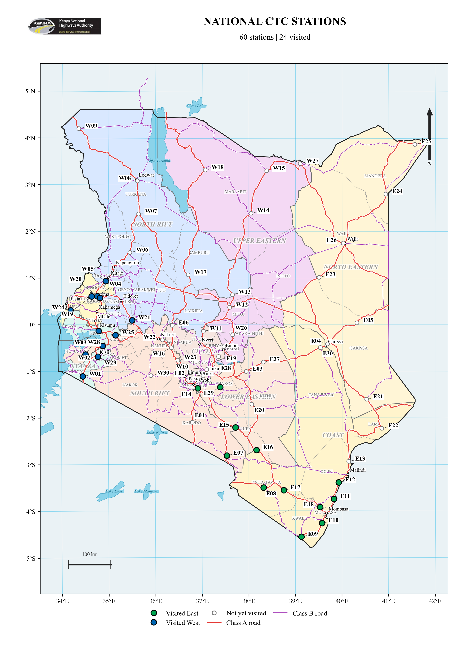

Figure B.2 Proposed East stations
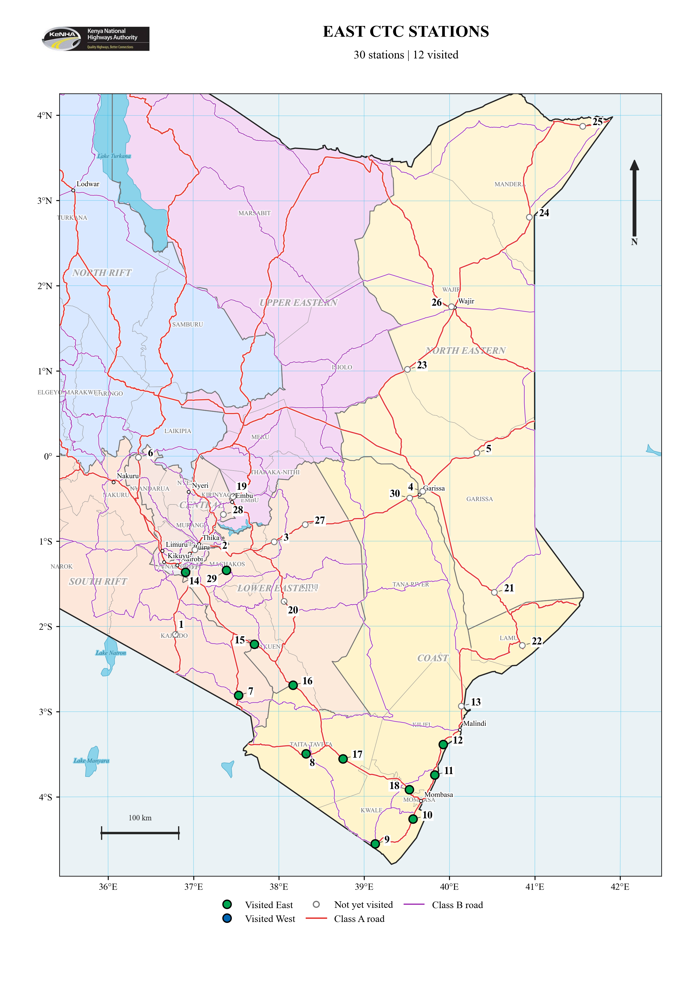

Figure B.3 Proposed West stations
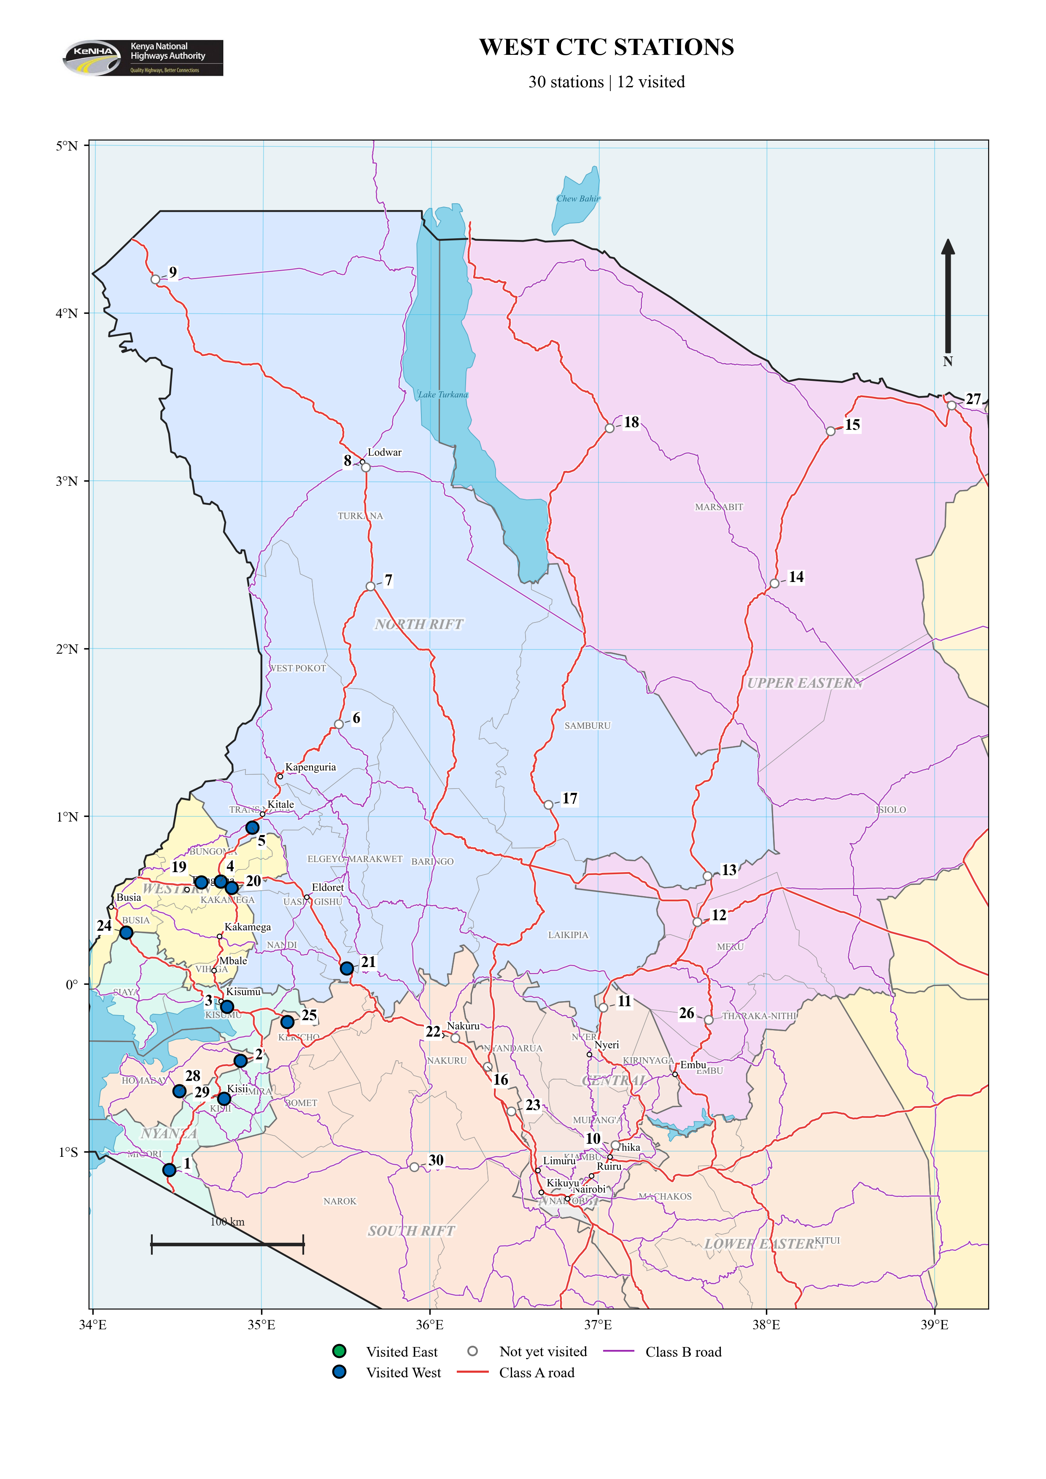

APPENDIX C KOBO SITE VALIDATION FORM
Kenya National Highways Authority Traffic Census Location Validation Form
The following is a blank reference copy of the electronic form used to record station details, site conditions, coordinates and photographs during the field validation exercise. An asterisk (*) identifies a required field.
Electronic form: https://ee.kobotoolbox.org/x/WcfauZdU
A. GENERAL INFORMATION
Field | Response / entry
Road Name * | Select a road section from the itinerary.
Census Station Code (if assigned) | ________________________________
Road Section * | ________________________________
Exercise Location * | West / East
Validation Date * | YYYY-MM-DD: ____________________
Team Leader * | ________________________________
GPS Location (Latitude and Longitude) * | Capture at the proposed census station.  Latitude (x.y degrees): __________________  Longitude (x.y degrees): ________________  Altitude (m): ______ Accuracy (m): ______
Weather | Clear / Sunny; Cloudy; Overcast; Rainy; Other

B. LOCATION DETAILS
Field | Response / entry
Nearest Landmark * | ________________________________
Distance (m) | ________________________________
Area Type * | Urban; Peri-Urban; Rural; Other
Road Class * | Class S; Class A; Class B; Other / Not Applicable
Number of Lanes * | ________________________________
Carriageway * | Single Carriageway; Dual Carriageway; Other
Surface Type * | Paved; Gravel; Earth; Other
Road Width (m) * | ________________________________
Speed Limit (km/h) | ________________________________
Speed bumps * | Yes / No  Are there speed bumps at or near the proposed census location?
Annual Average Daily Traffic (AADT), if known | ________________________________
Terrain * | Flat; Rolling; Hilly; Mountainous; Other
Drainage * | Adequate; Inadequate; No Drainage; Other
Remarks | ________________________________  ________________________________

C. SUITABILITY OF PROPOSED CENSUS LOCATION
Assessment item | Response
Accessible to staff * | Yes / No
Adequate visibility * | Yes / No
Free from sharp bends * | Yes / No
Free from steep gradient * | Yes / No
Away from junctions * | Yes / No
Away from bus stages * | Yes / No
Away from markets * | Yes / No
Ongoing road works * | Yes / No  Select Yes if road works are currently ongoing.
Mobile network available * | 5G / 4G / 3G
Security acceptable * | Yes / No

E. FIELD SAFETY ASSESSMENT
Field | Response / entry
Parking Area * | Available / Not Available
Width of shoulders in metres * | ________________________________
Remarks | ________________________________  ________________________________
Sign placement space * | Available / Not Available
Emergency Access * | Available / Not Available
Police station available within 5 km * | Yes / No
Lighting * | Available / Not Available
G. PHOTOGRAPHIC RECORD
Photograph | Electronic form attachment
Photo - Increasing Chainage View * | Upload image (less than 10 MB).
Photo - Decreasing Chainage View * | Upload image (less than 10 MB).
Photo - Cross Section * | Upload image (less than 10 MB).
Photo - Equipment Point | Upload image (less than 10 MB).

APPENDIX D TRAFFIC COUNT ANALYSIS SUMMARIES

D.1 East Analysis Summary
Table D.1 East traffic count analysis summary
Station | Station code | Count hour | Observed  1-hour | 2023  reference hour | 2023  24-hour | HEF  Dir. 1 | HEF  Dir. 2 | Estimated  ADT¹ | Change  (%)²
Matsangoni | CST_003_A7_024 | 09:00–10:00 | 532 | 401 | 5,698 | 14.60 | 13.83 | 7,590 | +33.2
Ukunda | CST_002_A7_015 | 09:00–10:00 | 1,395 | 638 | 11,046 | 17.55 | 17.08 | 24,180 | +118.9
Lunga Lunga Police Station | CST_002_A7_013 | 13:00–14:00 | 251 | 168 | 1,811 | 9.06 | 12.46 | 2,696 | +48.8
Kokotoni | CST_002_A8_017 | 17:00–18:00 | 943 | 575 | 9,188 | 15.58 | 16.43 | 15,156 | +65.0
Mkomani | CST_003_A7_026 | 09:00–10:00 | 519 | 542 | 10,284 | 15.80 | 24.89 | 10,948 | +6.5
Maungu | CST_006_A8_043 | 13:00–14:00 | 492 | 298 | 4,917 | 17.97 | 15.21 | 8,130 | +65.4
Mwanjila Youth Polytechnic | CST_006_A6_042 | 17:00–18:00 | 492 | 98 | 1,988 | 12.36 | 42.23 | 9,188 | +362.2
Mtito Andei | LEST_017_A8_110 | 09:00–10:00 | 547 | 108 | 2,552 | 18.08 | 30.83 | 13,409 | +425.4
Kiboko | LEST_017_A8_109 | 12:00–13:00 | 469 | 258 | 2,939 | 11.85 | 10.88 | 5,360 | +82.4
Kimana | NRB_034_A5_152 | 16:00–17:00 | 508 | 238 | 2,842 | 9.98 | 14.47 | 6,259 | +120.2
Gateway Mall Syokimau | LEST_016_A8_098 | 13:00–14:00 | 3,532 | 5,197 | 44,085 | 9.29 | 8.02 | 30,071 | -31.8
Mukuyuni | LEST_016_B63_106 | Not supplied | 0 | — | — | — | — | — | —

D.2 West Analysis Summary
Table D.2 West traffic count analysis summary
Station | Station code | Count hour | Observed  1-hour | 2023  reference hour | 2023  24-hour | HEF  Dir. 1 | HEF  Dir. 2 | Estimated  ADT¹ | Change  (%)²
A1 Isebania | A1.TCP23 | 09:30–10:30 | 631 | 711 | 7,040 | 8.24 | 13.53 | 6,616 | -6.0
B3 Kogwe | B3.TCP1 | 15:30–16:30 | 426 | 577 | 10,035 | 24.91 | 12.12 | 7,502 | -25.2
B6 Kereri | B6.TCP1 | 16:40–17:40 | 944 | 1,214 | 14,671 | 12.28 | 11.98 | 11,428 | -22.1
A1 Oyugis | A1.TCP20 | 08:30–09:30 | 334 | 255 | 3,731 | 13.70 | 15.63 | 4,911 | +31.6
A12 Bumala | A12.TCP1 | 14:00–15:00 | 364 | 359 | 6,330 | 18.40 | 16.82 | 6,435 | +1.7
A8 Bukembe | A8.TCP1 | 16:00–17:00 | 630 | 1,190 | 12,972 | 9.05 | 13.75 | 7,149 | -44.9
A1 Kiungani | A1.TCP9 | 09:00–10:00 | 508 | 452 | 5,936 | 11.69 | 15.43 | 6,894 | +16.1
A1 Webuye | A1.TCP10 | 09:00–10:00 | 626 | 814 | 11,773 | 13.91 | 15.06 | 9,054 | -23.1
A8 Chimoi | A8.TCP3 | 11:30–12:30 | 675 | 430 | 6,442 | 15.43 | 14.68 | 10,199 | +58.3
A8 Eldoret Nakuru | A8.TCP7 | 15:00–16:00 | 600 | 1,004 | 15,043 | 12.03 | 21.08 | 9,080 | -39.6
A1 Molem | A1.TCP18 | 11:00–12:00 | 1,152 | 1,774 | 25,376 | 12.73 | 18.49 | 17,971 | -29.2
A12 Awasi | A12.TCP6 | 13:30–14:30 | 380 | 423 | 7,275 | 17.47 | 16.98 | 6,545 | -10.0

APPENDIX E SELECTED SITE PHOTOGRAPHS

E.1 East
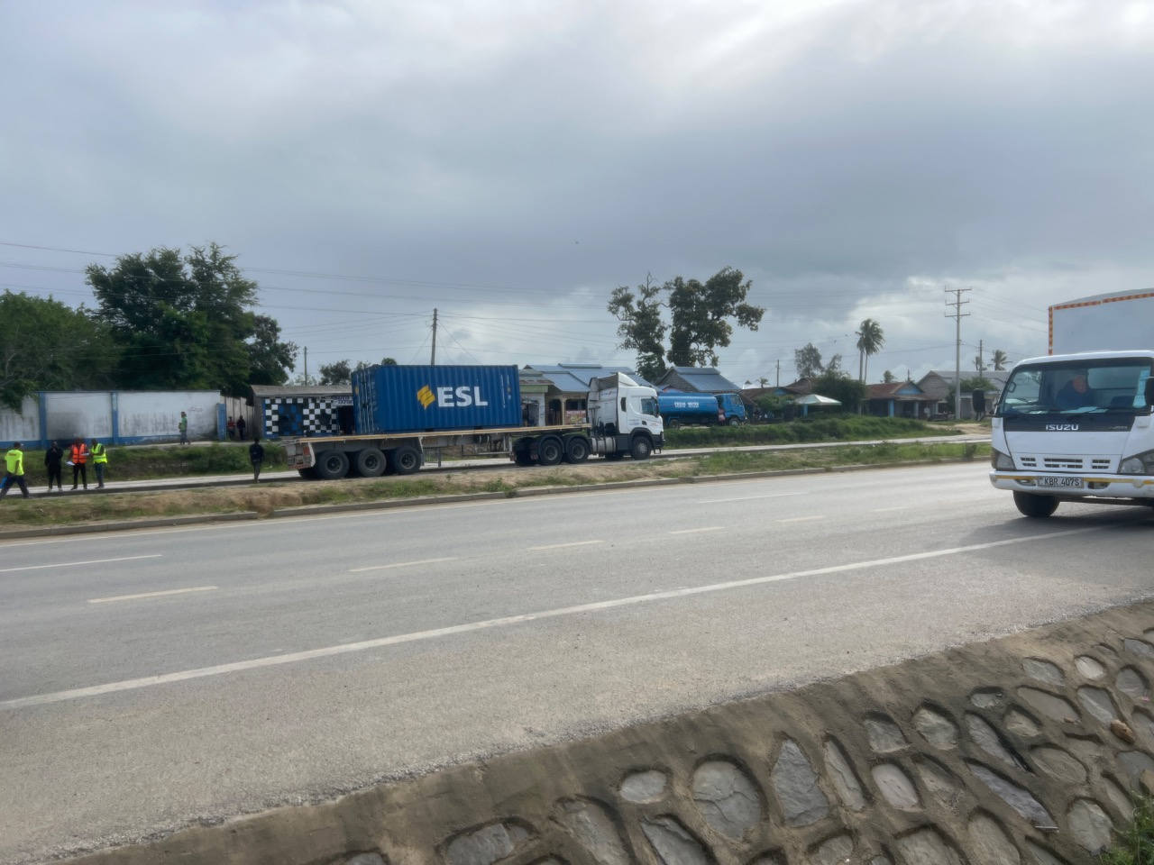  Figure E.1 Kokotoni (A8)  Cross-section view | 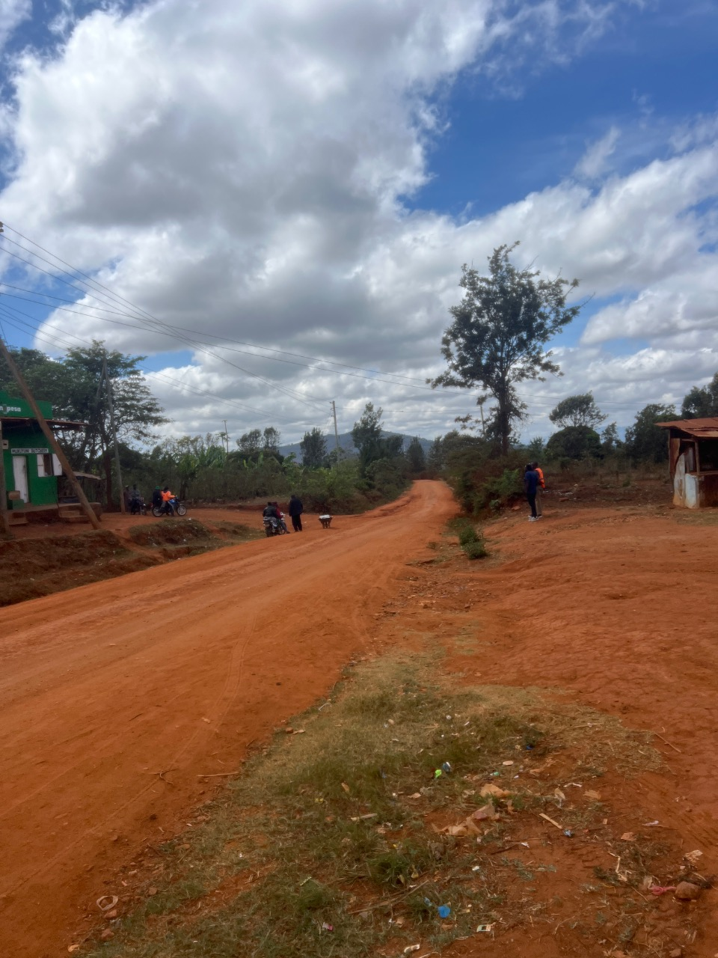  Figure E.2 Mukuyuni (B63)  Gravel road at the assessed location
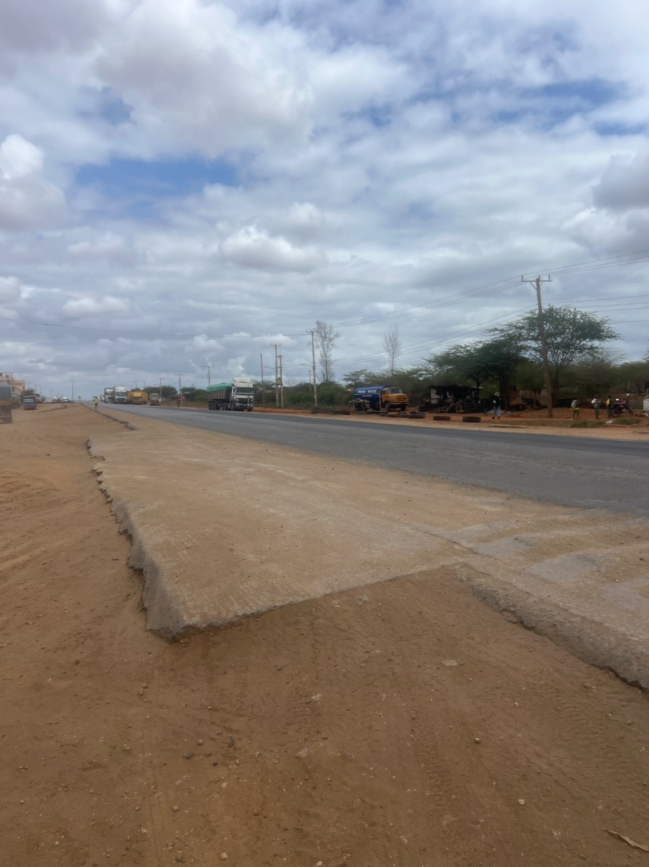  Figure E.3 Maungu (A8)  Decreasing chainage view | 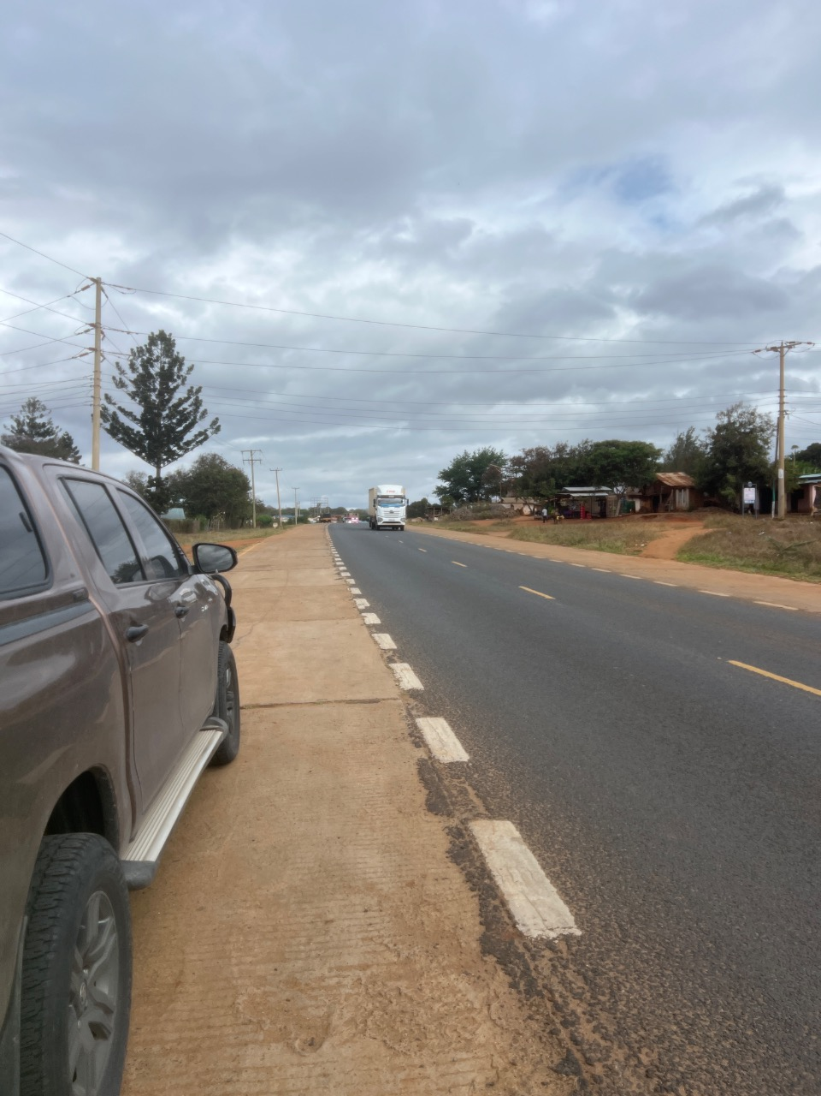  Figure E.4 Mwanjila Youth Polytechnic (A6)  Decreasing chainage view

E.2 West
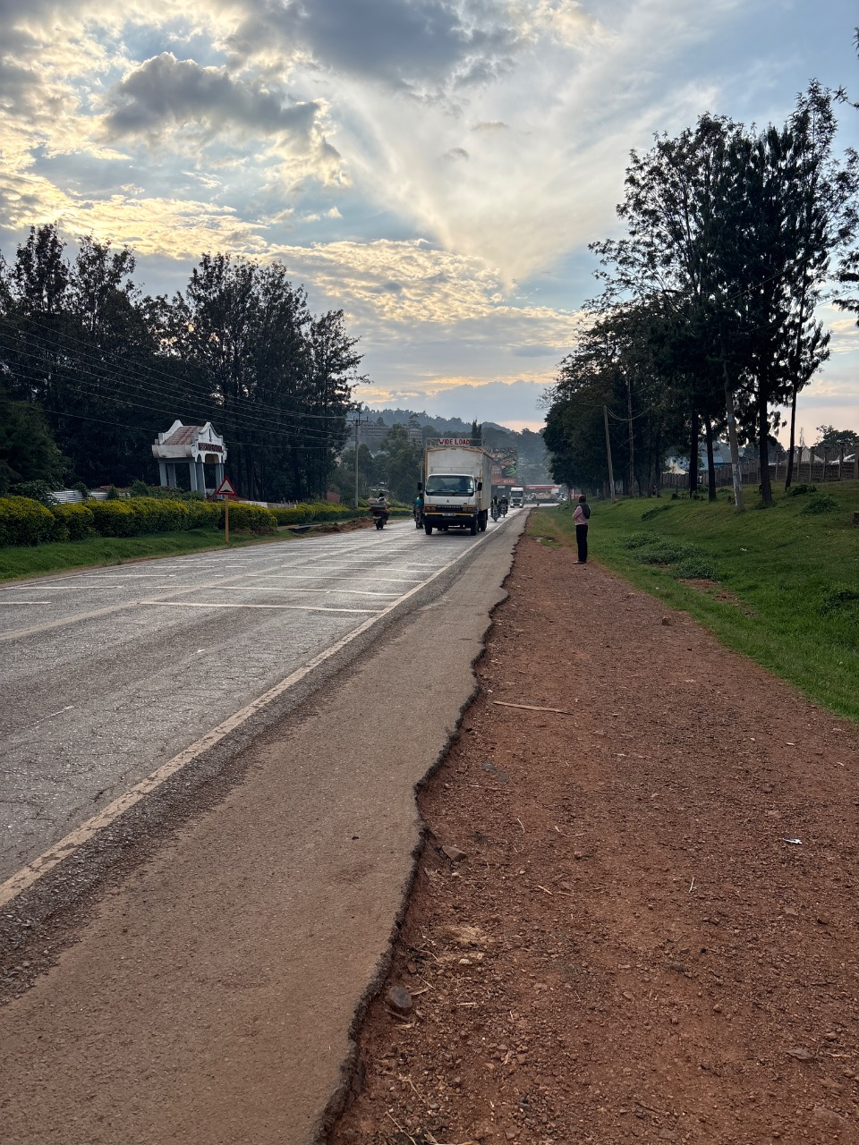  Figure E.5 Kereri (B6)  Decreasing chainage view | 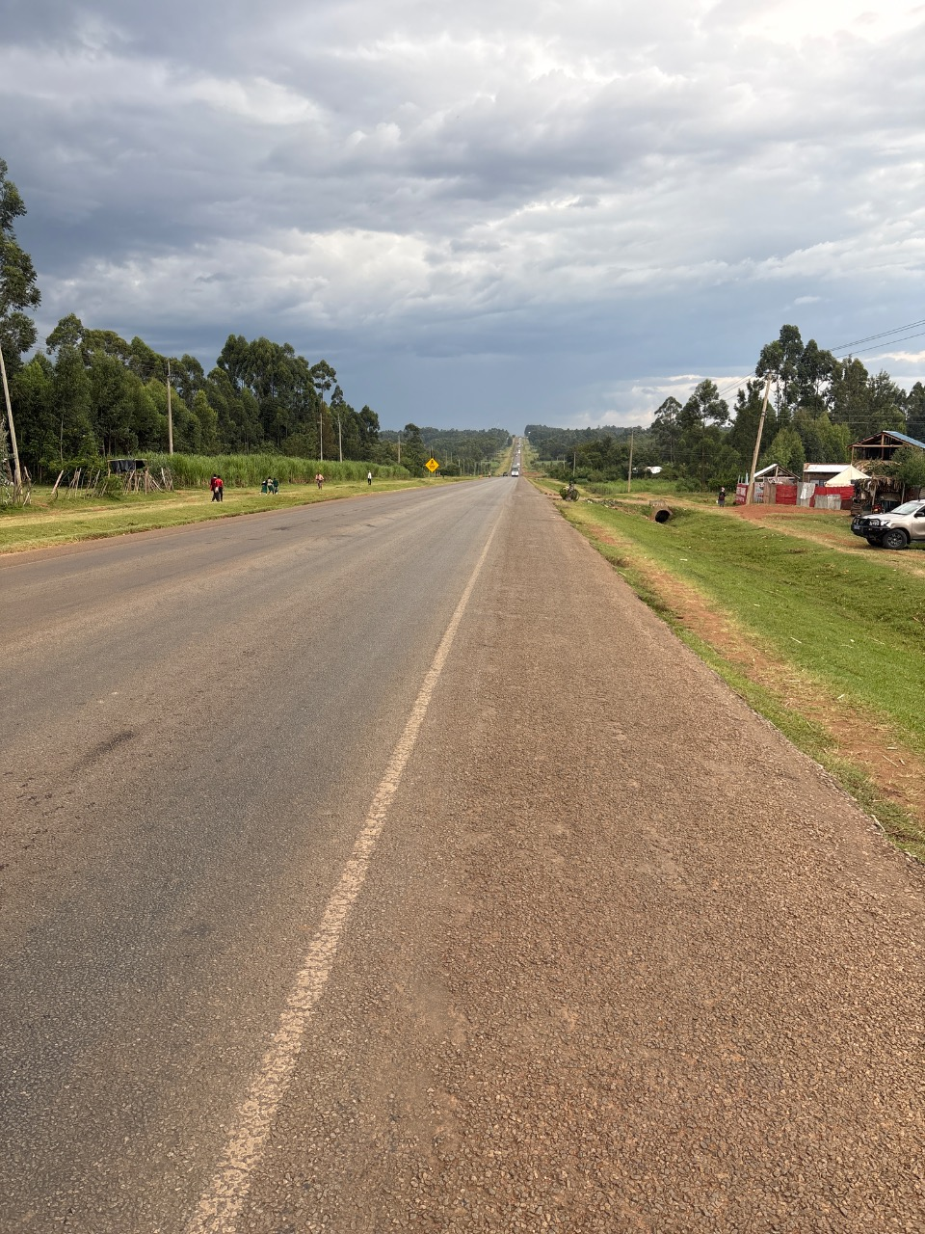  Figure E.6 Bukembe (A8)  Decreasing chainage view
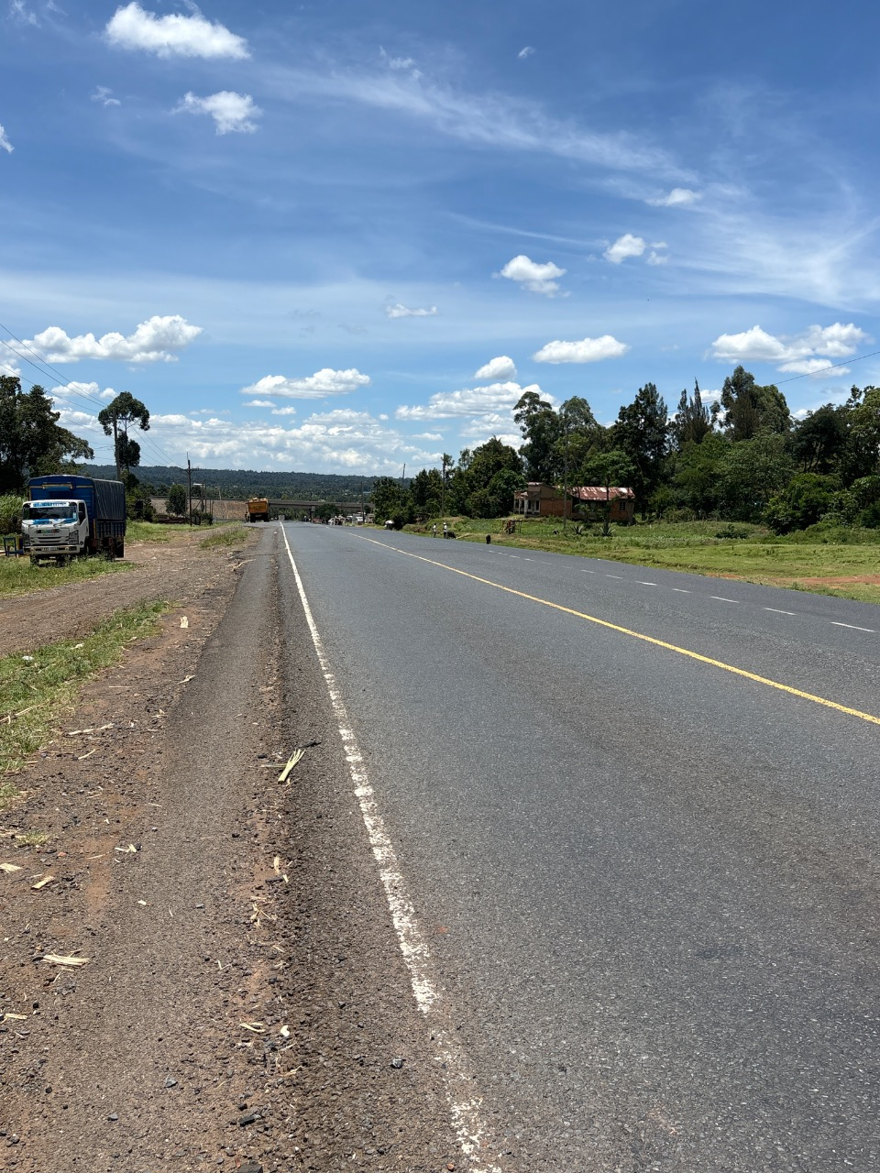  Figure E.7 Chimoi (A8)  Decreasing chainage view | 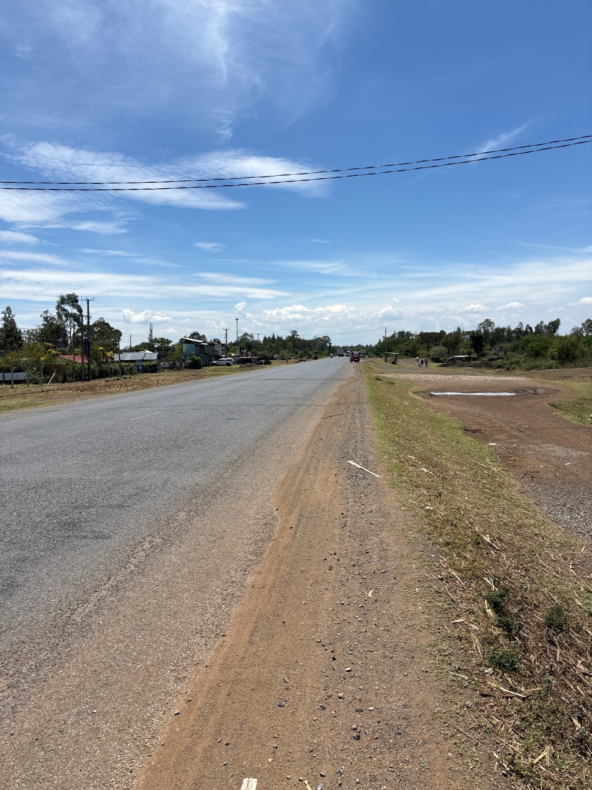  Figure E.8 Molem (A1)  Increasing chainage view

