# **Contents**

## **Chapter 1 Overview**

### **Introduction**

### **Purpose**

### **Unit User Interface**

#### Front View of Unit

#### Back View of Unit

## **Chapter 2 Initial Set-Up**

### **Connect to Power Supply**

### **Power Up the Unit**

### **Unit Initiation**

#### Set Current Time

## **Chapter 3 System Operations**

### **Setting Alarms**

#### Time Alarm

#### Temperature Alarm

#### Humidity Alarm

#### CO2 Alarm

### **Resetting Time and Date**

### **Resetting Unit**

## **Chapter 4 Troubleshooting**

# **Chapter 1: Overview**

### **1A. Introduction**

Maintaining an environment that supports growth and development used to be a difficult task. There are many factors that must be monitored to ensure that plants are in a healthy environment.

Temperature, humidity, and CO2 levels are among the conditions that are necessary to maintaining a healthy plant environment. While checking these conditions every once in a while, is simple, it is not sufficient to ensuring healthy plants. This is why our system constantly monitors these conditions so that the user can be notified immediately about the state of their plants. This is essential for after hours or during the off-season, when staff cannot check these factors frequently. By monitoring these conditions, we give the user ease of mind and ensure that the plants suffer the minimum amount of stress due to a change in the conditions.

Here are some reasons why the following conditions are important:

**Temperature**

The climate in your greenhouse must be warm enough to nurture photosynthesis and the growth of your plants. A low temperature will minimize the growth of your plant, but too high a temperature can lead to heat stress for your plants. Depending on the stage of plant and desired growth, the temperature range of the greenhouse needs to be adjusted accordingly.

**Humidity Levels**

Humidity affects a plants ability to perform photosynthesis and transpiration. A low humidity level can cause water to evaporate too quickly for photosynthesis, while a humidity level that is too high can cause poor growth and possible mold and fungal disease. Monitoring the moisture content in the air of your greenhouse will help the plants during the transpiration process, increasing absorption of nutrients and overall health.

**CO2 Levels**

All plants require CO2 to breathe. Greenhouse managers must set and monitor the CO2 levels in their facility to make sure that there is the right amount for the plants to develop, grow and be healthy. The amount of carbon dioxide required for your plant depends of the size of the facility and the amount of light the plants are receiving. When a plant is provided too little CO2 it can result in slower growth of the plants. While there are not any detrimental effects to pumping too much CO2 to a plant, there is an increase in cost. Pumping unnecessary CO2 into a greenhouse will result in an unnecessary waste of money.

### **1B. Purpose**

This product is a plant monitoring system, which means that it constantly takes different measurements in order to make sure that the environment is compatible with the optimum environmental needs of any specific plant.

***Note:*** *This device does not contain a database of optimal environmental needs for specific plants. This means that it is up to the user to properly define the environmental needs of the plant, that they wish to be monitored. Once the user has defined the specific needs for their plant, this product will monitor the environmental conditions.*

If the conditions that the user had defined are not met, then the product will set off an alarm to notify the user of what conditions are not being met. This plant monitor is part of the anti-noise pollution line of products. This means that instead of ringing a buzzer for the alarm, this product makes the display blink in order to get the attention of the user. The LCD display in the front panel will show the user the measurement values that triggered the alarm to go off, as well as the time that those measurements were taken.

### **1C. Unit User Interface**

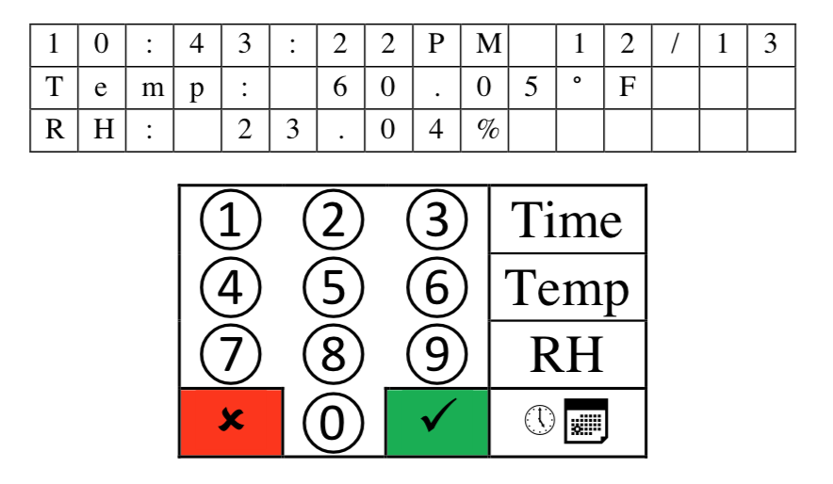

Here we can see the front panel of the product. On top we have the LCD which is composed of 3 lines of 16 characters each. Below the LCD is the 4x4 Keypad which is the main way for the user to input data into the product. Here the number buttons represent numbers and the buttons on the right most columns starting from the top represent, time, temperature, humidity and alarms.

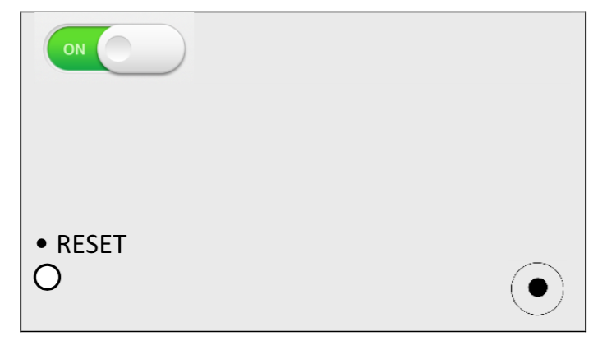

Here we see the back panel of the product. It is composed of an On/Off switch at the top left corner. On the bottom left corner, we see a Reset button which is how the user can reset the system without having to power off the product. Lastly on the bottom right we have a power supply which connects to 120 V AC.

# **Chapter 2: Initial Set-Up**

### **1A. Connect to Power Supply**

This product gets its power supply from a standard 120V AC outlet. Please use the wire that is included in the package to connect the product to the power supply.

### **1B. Power Up the Unit**

We power on the unit by flipping the top left switch in the back panel to the On position.

### **1C. Unit Initiation**

Once the unit receives power the LCD will ask the user to input the current time and date. The user must use the keypad to input this information. They will only be using the numerical buttons and the green check mark button on the keypad to perform this task.

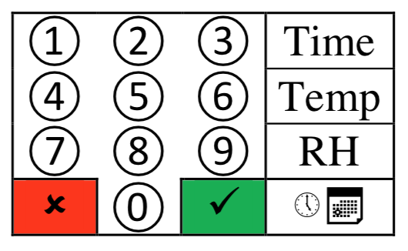

# **Chapter 3: System Operations**

### **1A. Setting Alarms**

**Setting alarms Time alarm**

In order to set these alarms users should be in the display_state. From here the user can press the set_time_alarm_key. This will then call and initialization function and from here a display function is called to display the prompt to the user. The prompt will show them the two alarms that are possible to set. They can choose either one by pressing the number keys ‘0’ and ‘1’. Once chosen, the users will be walked through a series of prompts asking them for what time and day they would like to set the given alarm.

**Temperature alarm and humidity alarm**

These two alarms are set in a very similar fashion, so they will be described together. The user must be in the display_state to be able to set these alarms. They can do this by pressing the appropriate button for each. Marked as TEMP and RH. When one of these buttons is pressed the FSM will call an initialization function and call a display function to prompt the user for a range. The low bound should be input first, as per the prompt, and then the high bound. Once the users have put in their desired range, the FSM will ask them for confirmation of the information (This happens when setting the time alarm as well).

If users decide to confirm what they entered, then the system will call a confirm function to save the data to a more permanent space. If users cancel, then the data entered will be ignored; when users try to set the alarm again, the data that was previously ignored will be over written by the new data entered.

### **1B. Resetting Time and Date**

To reset the time and date users should be in the display_state. From here users can press the time and date button. From here the FSM will call an initialization function and display a prompt for Month. From here users can follow the prompts inputting their desired info in. once the users reach the end of all the prompts the system will ask the user to confirm the data that was input.

### **1C. Resetting Unit**

In order to reset the unit, one may press the Reset button in the back panel or unplug the unit.

# **Chapter 4: Troubleshooting**

