- Assume that we have n d-dimensional samples x1, x2, ... , xn; n1 of which are in the subset D1 labeled w1, n2 of which are in the subset D2 labeled w2.
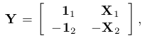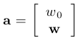and with 