- How to use the prior and likehood to calculate the posterior ? What is the formula ?
We can use the Bayes’ formula to answer the question:
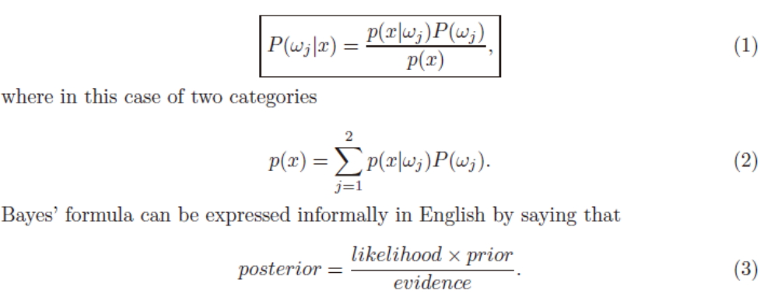
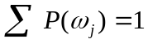, 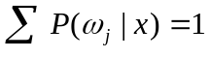
- What’s the difference in the ideas of the minimum error Bayesian decision and minimum risk Bayesian decision? What’s the condition that makes the minimum error Bayesian decision identical(相等) to the minimum risk Bayesian decision?
The minimum error Bayesian decision: to minimize the classification error of the Bayesian decision.
The minimum risk Bayesian decision: to minimize the risk of the Bayesian decision.
if R(α₁ | x) < R(α₂ | x), action α₁: “decide ω₁” is taken
R(α₁ | x) = λ₁₁P(ω₁ | x) + λ₁₂P(ω₂ | x)
R(α₂ | x) = λ₂₁P(ω₁ | x) + λ₂₂P(ω₂ | x)
If R(α1 | x)= R(α2 | x), the minimum error Bayesian decision identical(相等) to the minimum risk Bayesian decision

- A person takes a lab test of nuclear radiation and the result is positive. The test returns a correct positive result in 99% of the cases in which the nuclear radiation is actually present, and a correct negative result in 95% of the cases in which the nuclear radiation is not present. Furthermore, 3% of the entire population are radio actively contaminated. Is this person contaminated(感染)?
Solution:
Given: P(+|cancer)=0.99
P(-|no cancer)=0.95
P(cancer)=0.03
P(-cancer)=0.97
Compute: P(no cancer | +) , P(cancer | +),
P(cancer | +)=P(+|cancer)* P(cancer)/p(+)
P(cancer |+)=0.99×0.03/p(+)=0.99×0.03/p(+)
P(cancer |+)= 0.0297 /p(+)
P(no cancer|+)=P(+|no cancer)*P(no cancer)/P(+)
P(no cancer|+)=(1-0.95)*(1-0.03)/ P(+)
P(no cancer|+)=0.0485 / P(+)
Since P(no cancer | +) > P(cancer | +), we decide that the patient does not have cancer (Bayse decision rule)

- Please present the basic ideas of the maximum likelihood estimation method and Bayesian estimation method. When do these two methods have similar results ?
The maximum likelihood estimation method: Let D = {x₁, x₂, …, x_{n}}, p(x₁,…, x_{n} | θ) = Π^{1,…,n}P(x_{k} | θ); |D| = n, Our goal is to determine, the formula is:
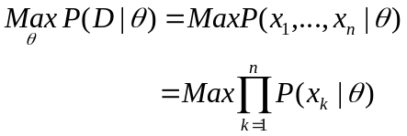
Bayesian estimation method: compute P(ω_{i} | x, D), the formula is:
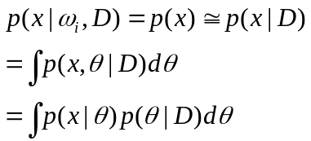
The priori probability ensures the problem is solvable, and the training samples are infinite, then these two methods have similar results.

(1)General principle
  - Assume we have c classes and p(x | ωj) ~ N( μj, Σj)
p(x | ωj) ≡ p (x | ωj, θj) where: 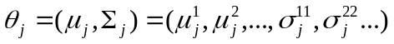
Use the information
Provided by the training samples D = (D1, D2, …, Dc) to estimate θ = (θ1, θ2, …, θc), each θi (i = 1, 2, …, c) is associated with each category
Assume Di give no information about θj if i<>j
Suppose that D contains n samples, x1, x2,…, xn
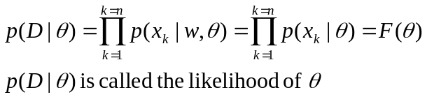
ML estimation of θ is, by definition, the value that maximizes p(D | θ)
Let D = {x1, x2, …, xn}
p(x1,…, xn | θ) = Π1,…,nP(xk | θ); |D| = n
Our goal is to determine (value of θ that makes this sample the most representative!)
(2)Goal: compute P(ωi | x, D)
Given the sample D, Bayes formula can be written
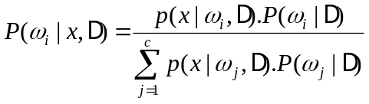
To demonstrate the preceding equation, use:
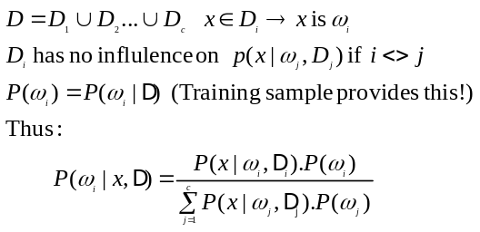
Parameter Distribution
P(x) is unknown, we assume it has a known parametric form P(x|θ) , and value of parameter θ is unknown
Know prior density P(θ)
Training data convert P(θ) to a posterior density P(θ|D)
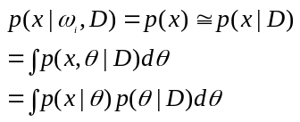Our path:

In virtually every case, maximum likelihood and Bayes solutions are equivalent in the asymptotic limit of infinite training data.

- Please present the nature of principal component analysis.(PCA主成分析)
  - Capture the component that varies the most.
    - i.e. capture the component that has the maximum variance.
  - The component that varies the most contains main information of the samples.
  - We also say that PCA is the optimal representation method, which allows us to obtain the minimum reconstruction error.
  - As the transform axes(轴) of PCA are orthogonal(正交的), it is also referred to as an orthogonal transform method(正交变换方法).
  - PCA is also a de-correlation(去相关) method.
  - PCA can be also used as a compression method and is able to obtain a high compression ratio.
etc……
A good dimension reduction method. Usually, even if the dimension of the sample is greatly reduced, the main information can be still stored.
An unsupervised method
PCA is also a de-correlation method. After the PCA transform, the obtained components are statistically uncorrelated.
PCA can be used as a compression method. PCA can achieve a high compression ratio.
Disadvantage: need to a training phase.

- Describe the basic idea and possible advantage of Fisher discriminant analysis.（fisher判别分析）
Basic idea: All k-general of the p-dimensional space projected onto the sample points on a one-dimensional space, the projection between the groups as possible after the separation, and analysis of variance method using discriminant function introduced(将k个总体的所有p维空间的样本点投影到一维空间上，使投影后组与组之间尽可能的分开，然后利用方差分析的方法推出判别函数)
Supervised
Maximize the between-class distance and minimize the within-class distance.
Exploit the training sample to produce transform axes.
……(number of effective Fisher transform axes, c-1; how to avoid singular within-class
scatter matrix---PCA+FDA)

- What is the K nearest neighbor classifier ? Is it reasonable(合理) ?
K nearest neighbor classifier: The idea is to make a decision by examining the labels of the K-nearest neighbors and taking a vote. It is reasonable.
Specify kn as some function of n, such as kn = √n; the volume Vn is grown until it encloses kn neighbors of x. This is called “the kn-nearest neighbor estimation method”.
We can center a cell about x and let it grow until it captures kn samples, where kn is some specified function of n. These samples are the kn nearest-neighbors of x.
If the density is high near x, the cell will be relatively small, which leads to good resolution. If the density is low, it is true that the cell will grow large, but it will stop soon after it enters regions of higher density.
Classify x by assigning it the label most frequently represented among the k nearest samples and use a voting scheme.
The nearest-neighbor rule leads to an error rate greater than the minimum possible value of the Bayes rate.
If the number of prototype is large (unlimited), the error rate of the nearest-neighbor classifier is never worse than twice the Bayes rate (it can be demonstrated!)

- Is it possible that a classifier can obtain a higher accuracy for any dataset than any other classifier?
It is impossible, from NFL theorem we know Lack of inherent superiority of any classifier.
For all possible objective functions F, e1(E| F,n )–e2(E| F,n )=0 says that uniformly averaged over all target functions the expected error for all learning algorithms is the same.
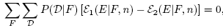
Assuming the training set can be learned by all algorithms in question, then Part 2 states that even if we know D, then averaged over all target functions no learning algorithm yields an off-training set error that is superior to any other, i.e.,
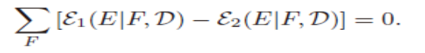

- Please describe the over-fitting problem.
Sample is inadequate(不充足的).
Reduce dimensionality( select a subset of features or combine features)
All c classes share the same covariance matrix(协防差矩阵) (can better to evaluate the covariance)
Look for a better estimate for covariance matrix
An extreme case: statistical independence

In order to get the same assumptions make the assumptions to become too complex called over-fitting.( 为了得到一致假设而使假设变得过于复杂称为过拟合)
Over-fitting generally occurs when a model is excessively complex, such as having too many parameters relative to the number of observations. A model which has been over-fit will generally have poor predictive performance, as it can exaggerate minor fluctuations in the data.

- Usually a more complex learning algorithm can obtain a higher accuracy in the training stage. So, should a more complex learning algorithm be favored ?
No, from NFL theorem we know a more complex learning algorithm can obtain a higher accuracy in the training stage can not do better than a less complex learning algorithm.
No context-independent or usage-independent reasons to favor one learning or classification method over another to obtain good generalization performance.
When confronting a new pattern recognition problem, we need focus on the aspects — prior information, data distribution, amount of training data and cost or reward functions.
Ugly Duckling Theorem: an analogous theorem, addresses features and patterns. shows that in the absence of assumptions we should not prefer any learning or classification algorithm over another.

- Under the condition that the number of the training samples approaches to the infinity(无穷大), the estimation of the mean obtained using Bayesian estimation method is almost identical to that obtained using the maximum likelihood estimation method. Is this statement correct ?
Yes, it is correct.（见中文版课本81页）
In virtually every case, maximum likelihood and Bayes solutions are equivalent in the asymptotic limit of infinite training data.
However since practical pattern recognition problems invariably have a limited set of training data, it is natural to ask when maximum likelihood and Bayes solutions may be expected to differ, and then which we should prefer. There are several criteria that will influence our choice.
One is computational complexity and here maximum likelihood methods are often to be preferred since they require merely differential calculus techniques or gradient search for, rather than a possibly complex multidimensional integration needed in Bayesian estimation.
Another consideration: interpretability. In many cases the maximum likelihood solution will be easier to interpret and understand since it returns the single best model from the set the designer provided (and presumably understands).
Another consideration is our confidence in the prior information, such as in the form of the underlying distribution p(x|θ).
Source of classification error
Bayes Error
Model Error
Estimation Error

- Can the minimum squared error procedure be used for binary classification ?
Yes, the minimum squared error procedure can be used for binary classification.
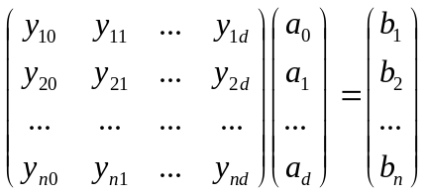
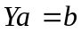, 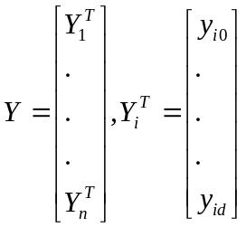.
A simple way to set : if 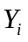 is from the first class, then is set to 1; if is from the second class, then is set to -1.
Another simple way to set : if is from the first class, then is set to 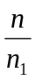; if is from the second class, then is set to -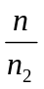.
- Can you devise(设计、想出) a minimum squared error procedure to perform multiclass classification ?
Perhaps the simplest way to obtain a natural generalization of the MSE procedures to the multiclass case is to consider the problem as a set of c two-class problems. The ith problem is to obtain a weight vector ai that is minimum-squared-error solution to the equations
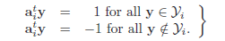

- Which kind of applications is the Markov model suitable for ?
The evaluation problem: Suppose we have an HMM, complete with transition probabilites a_{ij} and b_{jk}. Determine the probability that a particular sequence of visible states V^{T} was generated by that model.
The decoding problem: Suppose we have an HMM as well as a set of observations V^{T}. Determine the most likely sequence of hidden states w^{T} that led to those observations.
The learning problem: Suppose we are given the coarse structure of a model (the number of states and the number of visible states) but not the probabilities a_{ij} and b_{jk}. Given a set of training observations of visible symbols, determine these parameters.
In problems that have an inherent temporality— that is, consist of a process that unfolds in time — we may have states at time t that are influenced directly by a state at t − 1.
Applications: speech recognition, gesture recognition, parts of speech tagging and DNA sequencing.

- For minimum squared error procedure based on Ya=b (Y is the matrix consisting of all the training samples), if we have proper(适当的) b and criterion function, then this minimum squared error procedure might be equivalent to Fisher discriminant analysis. Is this presentation correct ?
Yes, it is correct.(见中文版课本198页)
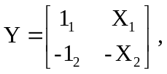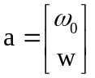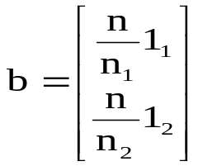
Yields：
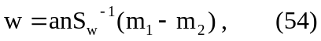

except for an unimportant scale factor, is identical to the solution for Fisher’s linear discriminant
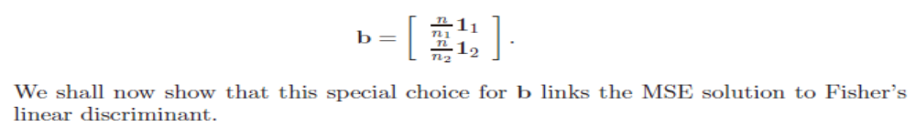
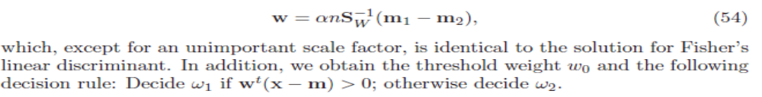
- Suppose that the number of the training samples approaches to the infinity(无穷大), then the minimum error Bayesian decision will perform better than any other classifier achieving a lower classification error rate. Do you agree on this ?
I agree on it. The premise is the number of the training samples approaches to the infinity.
No, No free lunch and ugly duck theorem.
- What are the upper and lower bound of the classification error rate of the K nearest neighbor classifier ?
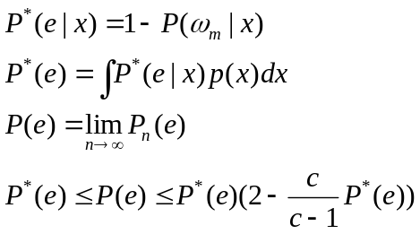
(1)The nearest-neighbor rule leads to an error rate greater than the minimum possible value of the Bayes rate
(2)If the number of prototype is large (unlimited), the error rate of the nearest-neighbor classifier is never worse than twice the Bayes rate (it can be demonstrated!)
- Can you demonstrate(证明、说明) that a statistics-based classifier(基于统计的分类) usually cannot lead to a classification accuracy of 100% ?

- What is representation-based classification(基于描述分类)? Please present the characteristics(规格参数) of representation-based classification.
A simple representation-based classification method is presented as follows:
This method seeks to represent the test sample as a linear combination of all training samples and uses the representation result to classify the test sample:
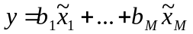, (1)
Where 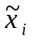 (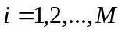) denote all the training samples and 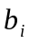() are the coefficients. We rewrite equation.(1) into
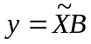 (2)
Where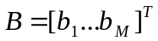, 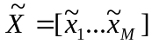. If 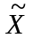 is not singular, we can solveusing 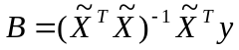; otherwise, we can solve it using
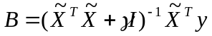, (3)
where is a positive constant and is the identity matrix. After we obtain, we refer to 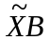as the representation result of our method. We can convert the representation result into a two-dimensional image having the same size of the original sample image.
We exploit the sum of the contribution, to representing the test sample, of the training samples from a class, to classify the test sample. For example, if all the training samples from the th (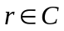) class are 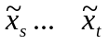, then the sum of the contribution, to representing the test sample, of the th class will be
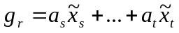. (4)
We calculate the deviation of 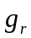 from using
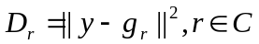. (5)
We can also convert 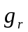into a two-dimensional matrix having the same size of the original sample image. If we do so, we refer to the matrix as the two-dimensional image corresponding to the contribution of the th class. The smaller the deviation 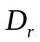, the greater the contribution to representing the test sample of the th class. In other words, if 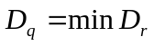(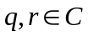), the test sample will be classified into the th class.
From the above presentation, we know that representation-based classification method is a novel method and totally different from previous classifiers ! It performs very well in image-based classification, such as face recognition and palm-print recognition.
We should understand its nature and advantages.
- Please describe the difference between linear and nonlinear discriminant(判别式) functions? What potential(潜在的) advantage does nonlinear discriminant function have in comparison with linear discriminant function?
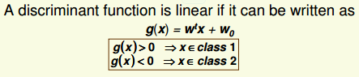
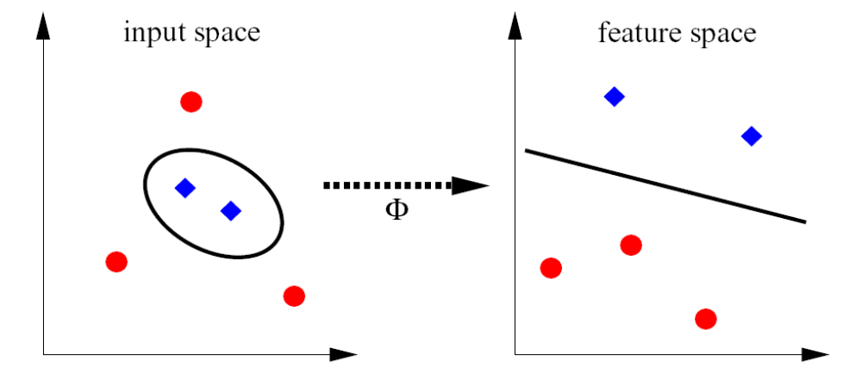
The above figure is just auxiliary(辅助的，补充的) for the question !

- What is the naïve Bayes rule ?
• V=[v1, v2, …, vm]
• P(v|wi)= P(v1|wi)… P(vm|wi)
• For natural language processing, v1, v2, …, vm denote different words
- What is the difference between supervised and unsupervised learning methods（监督、无监督学习方法）? Please show two examples of supervised and unsupervised learning methods.
Difference: sample data set is labeled in supervised learning methods and not labeled in unsupervised learning methods
Examples of unsupervised: the maximum likelihood estimation method and Bayesian estimation method
Examples of supervised: data grouping and data clustering

In supervised learning, a teacher provides a category label or cost for each pattern in a training set, and we seek to reduce the sum of the costs for these patterns
In unsupervised learning or clustering there is no explicit teacher, and the system forms clusters or “natural groupings” of the input patterns. “Natural” is always defined explicitly or implicitly in the clustering system itself, and given a particular set of patterns or cost function, different clustering algorithms lead to different clusters. Often the user will set the hypothesized number of different clusters ahead of time.

- In some special real-world classification applications, the Bayesian decision theory might perform badly. What are possible reasons（理由原因） ?
The possible reasons will be that we can not get all the knowledge of the probability structure of the problem or only get some fuzzy or general knowledge about the problem.
- Suppose that we are applying a linear discriminant function to a nonlinear separable(可分离) problem, what means can we adopt to obtain an optimal solution?

- Please present possible generalization capability in the sample space of a method.

27. Apply model Ya=b to perform classification.

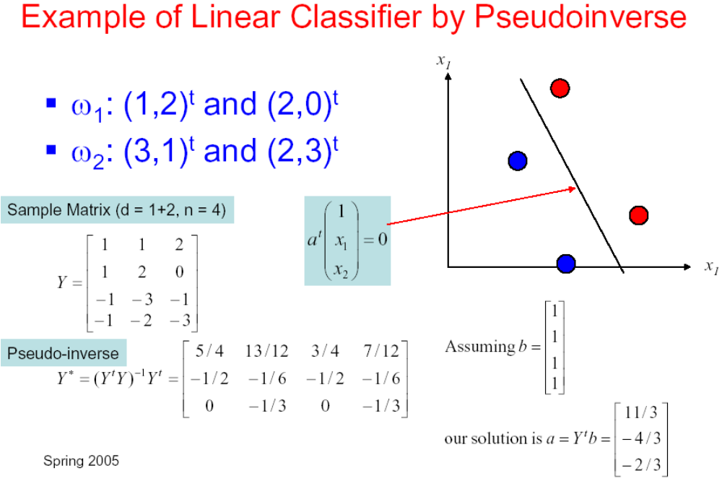

28. How to extend the binary minimum squared error procedure to the multiclass minimum squared error procedure?

