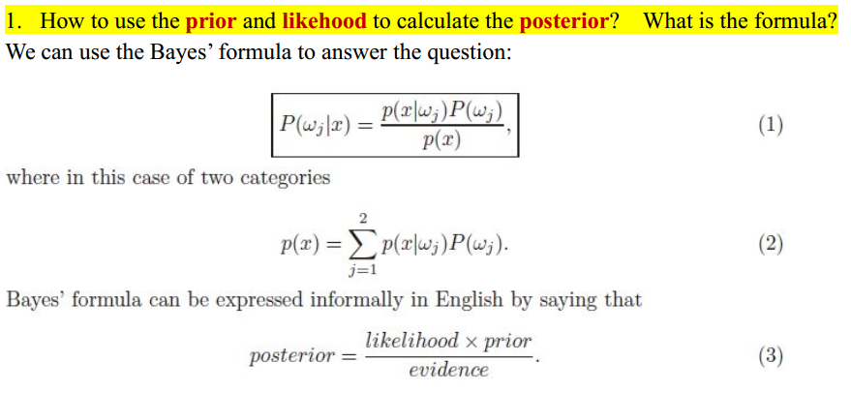

*λ(αi | ωj)* be the loss incurred for taking action *αi* when the state of nature is *ωj.*

action *αi* assign the sample into any class-

Conditional **risk**  for i = 1,…,a

Select the action αi for which *R(αi | x)* is minimum

R is minimum and R in this case is called the Bayes risk = best reasonable result that can be achieved!

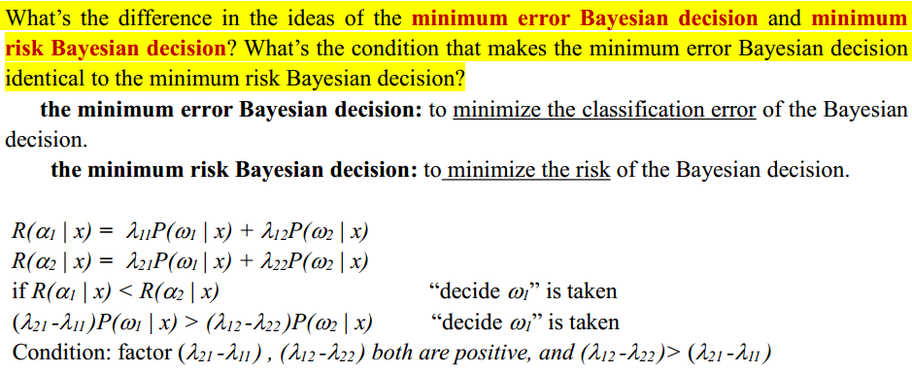

*λij* :loss incurred for deciding *ωi*when the true state of nature is *ωj*

*gi(x) = - R(αi | x)*

max. discriminant corresponds to min. risk

*gi(x) = P(****ω****i | x)*

max. discrimination corresponds to max. posterior

*gi(x) ≡ p(x |* ***ωi****) P(****ω****i) gi(x) = ln p(x |* ***ω****i) + ln P(****ω****i)*

问题由估计似然概率变为估计正态分布的参数问题

极大似然估计和贝叶斯估计结果接近相同，但方法概念不同

Please present the basic ideas of the maximum likelihood estimation method and Bayesian estimation method. When do these two methods have similar results ?

请描述最大似然估计方法和贝叶斯估计方法的基本概念。什么情况下两个方法有类似的结果？

I．Maximum-likelihood view the parameters as quantities whose values are fixed but unknown. The best estimate of their value is defined to be the one that maximizes the probability of obtaining the samples actually observed.

II．Bayesian methods view the parameters as random variables having some known prior distribution. Observation of the samples converts this to a posterior density, thereby revising our opinion about the true values of the parameters.

III．Under the condition that the number of the training samples approaches to the infinity, the estimation of the mean obtained using Bayesian estimation method is almost identical to that obtained using the maximum likelihood estimation method.

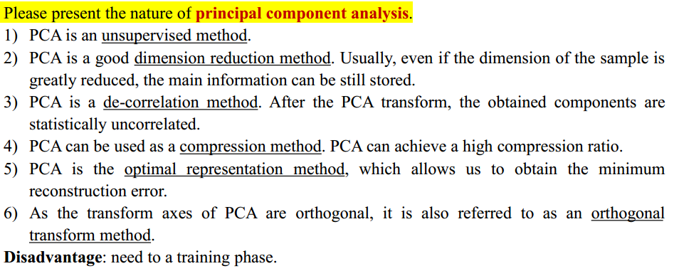

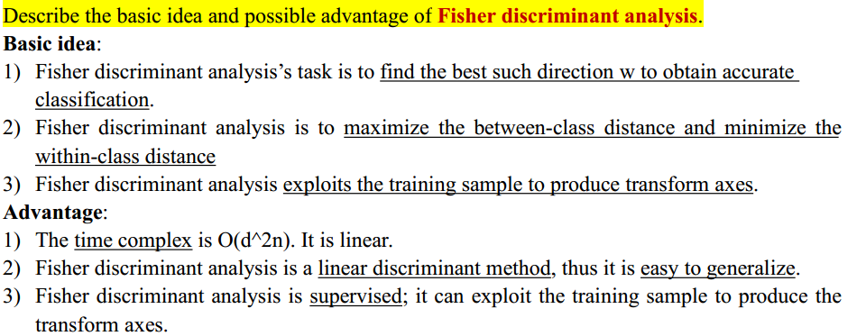

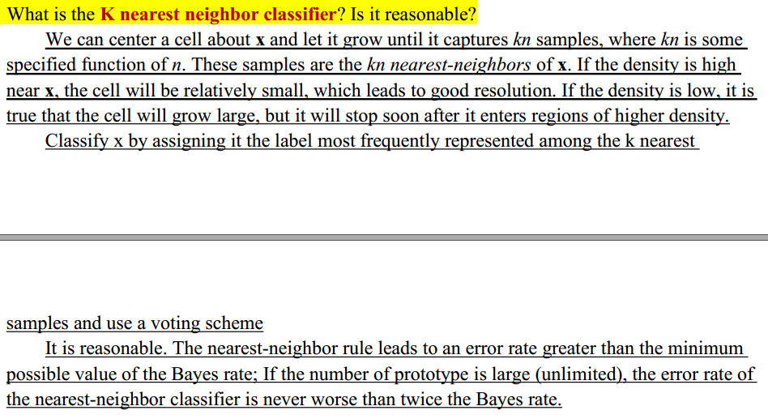

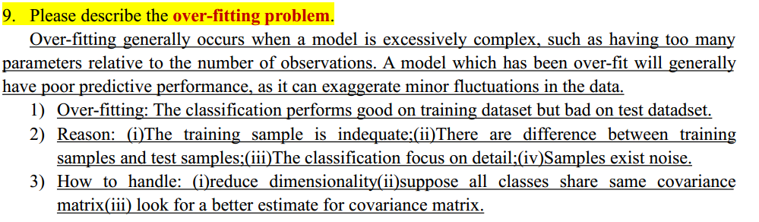

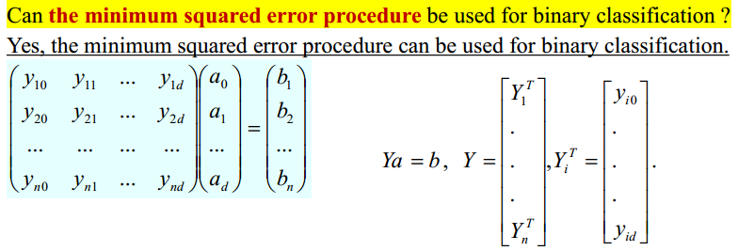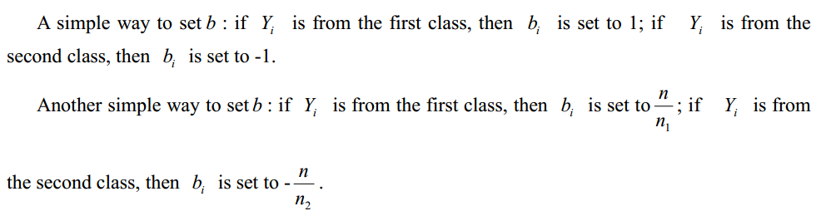

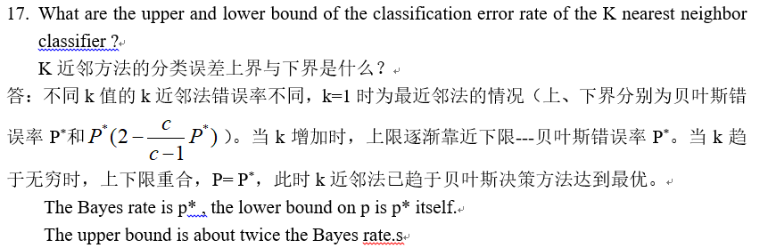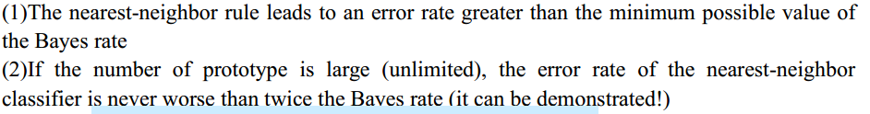

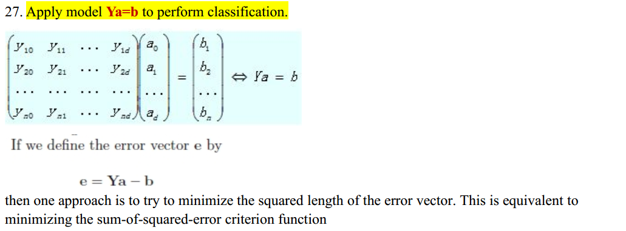

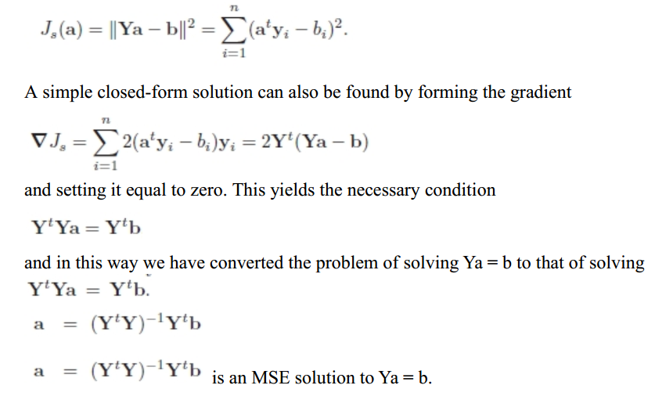

最小风险决策通常有一个更低的分类准确度相比于最小错误率贝叶斯决策。然而，最小风险决策能够避免可能的高风险和损失。

贝叶斯参数估计方法。

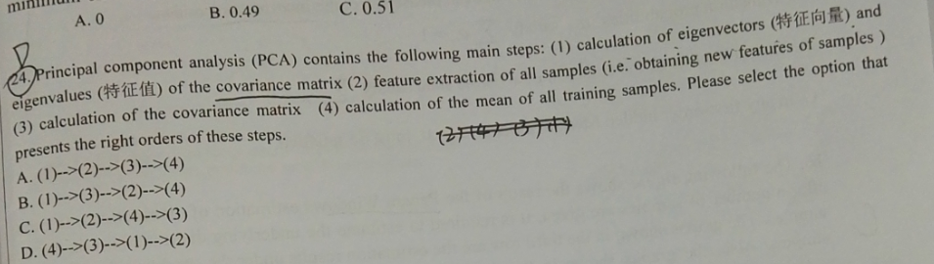

Vectorize the samples.

Calculation of the mean of all training samples.

Calculation of the covariance matrix

Calculation of eigenvectors and eigenvalue of the covariance matrix. Build the feature space.

Feature extraction of all samples. Calculation the feature value of every sample.

Calculation of the test sample feature value.

Calculation of the samples of training samples like the above step.

Find the nearest training sample as the result.

写在最后（彩蛋）： 2017年考试题最后两个大题，一个是关于一阶马尔科夫模型，另一个是LDA目标及步骤。