CMPEN 331 Final Project
Section 1
Victor Xu
12/17/25
Dr. Mohamed Almekkawy

Abstract
In this final project for CMPEN 331, I am adding hazard detection capabilities to a data path consisting of 5 stages: instruction fetch, instruction decode, execute, memory access, and write back. The detection logic identifies data hazards that occur between dependent instructions. In addition, I am adding forwarding modules that enable operands from earlier instructions to the more recent instructions without waiting for write-back. These improvements reduce unnecessary stalls and ensure proper execution of dependent instructions.

Introduction

Sometimes when people are in a hurry, they brush their teeth in the shower. Or they eat their breakfast while driving. Or they borrow the work done by a colleague. This sort of behavior is like pipelining that allows for overlapping execution in modern processors. Rather than waiting for the first instruction’s completion before the next, a processor with pipelined architecture divides execution into stages allowing instructions to be processed simultaneously at different stages of execution. This project implements a five-stage pipelined Datapath consisting of Instruction Fetch (FD), Instruction Decode (ID) , Execute (EXE), Memory Access (MEM).
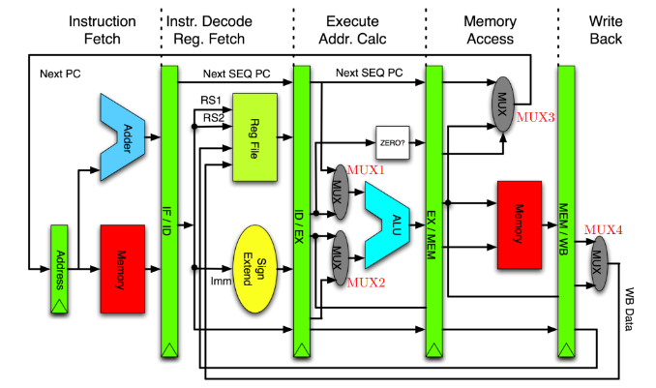
The IF stage gets the instruction from the memory via the PC. The PC value is then increased to prepare for the next cycle. This instruction, through a register, is passed to ID stage which, through its control unit, translates what the instruction value wants to do. It also reads values from the register file. Control signals and these register values are then passed to the EXE stage through another register. In the EXE stage, the Arithmetic Logic Unit (ALU) performs whatever operation was decoded from the ID stage. The result and the data to be stored are passed to the MEM stage. The MEM stage then reads or writes to the data memory depending on what the control signals from the ID stage dictate. Sometimes this stage does nothing for operations like “add”. The data read from memory is then passed to the WB stage. Depending on the instruction, the WB stage selects between the memory data and ALU result to write back the result into the destination register in the register file.
Figure 1; 5-stage Datapath with no Hazard Detection
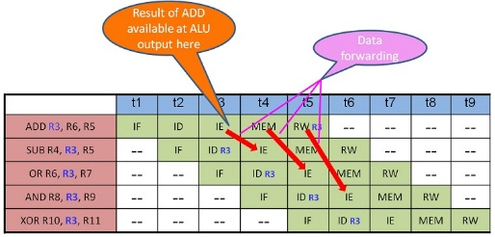
However, pipelining comes with its dangers. When instructions depend on previous instructions that have yet to be complete, dependencies create data hazards where the data from one instruction is not ready when it is needed for another. The solution for this issue is hazard detection and data forwarding. Hazard detection logic identifies cases where there is overlap in past and current instructions. The forwarding unit goes off this logic to then directly route results from later pipeline stages to earlier ones.
Figure 2; Several instructions in sequence demonstrating data forwarding

Verilog Design Code

`timescale 1ns / 1ps
//////////////////////////////////////////////////////////////////////////////////
// Company:
// Engineer:
//
// Create Date: 11/03/2025 10:27:38 AM
// Design Name:
// Module Name: TopModule
// Project Name:
// Target Devices:
// Tool Versions:
// Description: CMPEN 331 Lab 3 - IF and ID Pipeline Implementation
//
//////////////////////////////////////////////////////////////////////////////////

module TopModule(
input wire clock,
output wire [31:0] wbData
);

// IF/ID outputs
wire[31:0] pc;
wire [31:0] dinstOut;

// ID/EXE outputs
wire ewreg, em2reg, ewmem;
wire [3:0] ealuc;
wire ealuimm;
wire [4:0] edestReg;
wire [31:0] eqa, eqb, eimm32;

// EXE/MEM outputs
wire mwreg, mm2reg, mwmem;
wire [4:0] mdestReg;
wire [31:0] mr, mqb;

// MEM/WB outputs
wire wwreg, wm2reg;
wire [4:0] wdestReg;
wire [31:0] wr, wdo;

wire [31:0] wbData;

wire [31:0] pc_next;
wire [31:0] pc_current;
wire [31:0] out_inst;
wire [31:0] out_dinst;

ProgramCounter PC_inst (
.clock (clock),
.nextPc (pc_next),
.pc (pc_current)
);

Adder Add_inst (
.pc (pc_current),
.nextPc (pc_next)
);

InstructionMemory InstructionMem_inst (
.pc (pc_current),
.instOut (out_inst)
);

IF_ID_Register IFID_inst (
.clock (clock),
.instOut (out_inst),
.dinstOut (out_dinst)
);

// Field extraction
wire [5:0] inst_op = out_dinst[31:26];
wire [5:0] inst_func = out_dinst[5:0];
wire [4:0] inst_rs = out_dinst[25:21];
wire [4:0] inst_rt = out_dinst[20:16];
wire [4:0] inst_rd = out_dinst[15:11];
wire [15:0] inst_imm = out_dinst[15:0];

// Control signals
wire out_wreg;
wire out_m2reg;
wire out_wmem;
wire [3:0] out_aluc;
wire out_aluimm;
wire out_regrt;

wire [1:0] fwdaw;
wire [1:0] fwdbw;
ControlUnit Control_inst (
.op (inst_op),
.func (inst_func),
.rs(inst_rs),
.rt(inst_rt),
.ern(edestRegw),
.mrn(mdestRegw),
.mm2reg(mm2regw),
.mwreg(mwregw),
.em2reg(out_m2reg),
.ewreg(out_wreg),
.wreg (out_wreg),
.m2reg (out_m2reg),
.wmem (out_wmem),
.aluc (out_aluc),
.aluimm (out_aluimm),
.regrt (out_regrt),
.fwda(fwdaw),
.fwdb(fwdbw)
);

wire [31:0] MUXaw;
wire [31:0] MUXbw;
fwdMux fwdMuxA (
.q(out_qa),
.r(ALU_r),
.mr(mrw),
.do(mdow),
.select(fwdaw),
.fwd(MUXaw)
);

fwdMux fwdMuxB (
.q(out_qb),
.r(ALU_r),
.mr(mrw),
.do(mdow),
.select(fwdbw),
.fwd(MUXbw)
);

// regrt mux (RegDst)
wire [4:0] out_destReg;
Mux_RegDst MuxRegDst_inst (
.rt (inst_rt),
.rd (inst_rd),
.regrt (out_regrt),
.destReg (out_destReg)
);

// Register File
wire [31:0] out_qa, out_qb;
RegisterFile Register_inst (
.rs (inst_rs),
.rt (inst_rt),
.wdestReg(wdestRegw),
.wbData(wbDataw),
.wwreg(wwregw),
.clk(clock), //clock signal is inverted within register
.qa (out_qa),
.qb (out_qb)
);

// Sign Extension
wire [31:0] out_imm32;
SExtend Extend_inst (
.imm (inst_imm),
.imm32 (out_imm32)
);

wire ealuimmw;
wire [31:0] eqaw;
wire [31:0] eqbw;
wire [31:0] eimm32w;
wire [3:0] ealucw;
wire ewregw;
wire em2regw;
wire ewmemw;
wire [4:0] edestRegw;

ID_EXE_Register IDEXE_inst (
.wreg (out_wreg),
.m2reg (out_m2reg),
.wmem (out_wmem),
.aluc (out_aluc),
.aluimm (out_aluimm),
.destReg (out_destReg),
.qa (MUXaw),
.qb (MUXbw),
.imm32 (out_imm32),
.clock (clock),
.ewreg (ewregw),
.em2reg (em2regw),
.ewmem (ewmemw),
.ealuc (ealucw),
.ealuimm (ealuimmw),
.edestReg (edestRegw),
.eqa (eqaw),
.eqb (eqbw),
.eimm32 (eimm32w)
);
assign ealuimm = ealuimmw;
assign eqa = eqaw;
assign eqb = eqbw;
assign eimm32 = eimm32w;
assign ealuc = ealucw;
assign ewreg = ewregw;
assign em2reg = em2regw;
assign ewmem = ewmemw;
assign edestReg = edestRegw;

wire [31:0] mux_alu_b;
Mux_ALU Mux_ALU_inst (
.eqb (eqbw),
.eimm32 (eimm32w),
.ealuimm (ealuimmw),
.b (mux_alu_b)
);

wire [31:0] ALU_r;
ALU ALU_inst (
.eqa (eqaw),
.b (mux_alu_b),
.ealuc (ealucw),
.r (ALU_r)
);

wire [4:0] mdestRegw;
wire [31:0] mrw;
wire [31:0] mqbw;
wire mwregw;
wire mm2regw;
wire mwmemw;

EXE_MEM_Register EXEMEM_inst (
.ewreg (ewregw),
.em2reg (em2regw),
.ewmem (ewmemw),
.clk (clock),
.edestReg (edestRegw),
.r (ALU_r),
.eqb (eqbw),
.mwreg (mwregw),
.mm2reg (mm2regw),
.mwmem (mwmemw),
.mdestReg (mdestRegw),
.mr (mrw),
.mqb (mqbw)
);
assign mwreg = mwregw;
assign mm2reg = mm2regw;
assign mwmem = mwmemw;
assign mdestReg = mdestRegw;
assign mr = mrw;
assign mqb = mqbw;

wire [31:0] mdow;
DataMemory DataMemory_inst(
.mr (mrw),
.mqb (mqbw),
.mwmem (mwmemw),
.clk (clock),
.mdo (mdow)
);

wire [31:0] wrw;
wire [31:0] wdow;
wire [4:0] wdestRegw;
wire wwregw;
wire wm2regw;
MEM_WB_Register MEMWB_inst (
.mwreg (mwregw),
.mm2reg (mm2regw),
.clk (clock),
.mr (mrw),
.mdo (mdow),
.mdestReg (mdestRegw),
.wwreg (wwregw),
.wm2reg (wm2regw),
.wdestReg (wdestRegw),
.wr (wrw),
.wdo (wdow)
);
assign dinstOut = out_dinst;
assign pc = pc_current;
assign wr = wrw;
assign wdo = wdow;
assign wm2reg = wm2regw;
assign wwreg = wwregw;
assign wdestReg = wdestRegw;

wire [31:0] wbDataw;
WbMux WbMuxInst (
.wr(wrw),
.wdo(wdow),
.wm2reg(wm2regw),
.wbData(wbDataw)
);
assign wbData = wbDataw;
endmodule

module ProgramCounter(
input clock,
input [31:0] nextPc,
output reg [31:0] pc
);
initial begin
pc = 32'd100;
end
always @(posedge clock) begin
pc <= nextPc;
end
endmodule

module Adder(
input [31:0] pc,
output [31:0] nextPc
);
assign nextPc = pc + 4;
endmodule

module InstructionMemory(
input [31:0] pc,
output reg [31:0] instOut
);
reg [31:0] memory [0:63];
initial begin
memory[25] = 32'h00221820; //add $3, $1, $2
memory[26] = 32'h01232022; //sub $4, $9, $3
memory[27] = 32'h00692825; //or $5, $3, $9
memory[28] = 32'h00693026; //xor $6, $3, $9
memory[29] = 32'h00693824; //and $7, $3, $9
end
always @(*) begin
instOut <= memory[pc[7:2]]; //Only need 6 bits since we only have 64 wods in memory
end
endmodule

`timescale 1ns / 1ps
module ControlUnit(
input [5:0] op, func,

//new inputs for hazard detection and forwarding
input [4:0] rs, rt,
input [4:0] ern, mrn,
input mm2reg, mwreg, em2reg, ewreg,

output reg wreg,
output reg m2reg,
output reg wmem,
output reg [3:0] aluc,
output reg aluimm,
output reg regrt,

//new outputs for hazard detections and worwarding
output reg [1:0] fwda, fwdb
);

always @(*) begin
//defaults
wreg = 1'b0;
m2reg = 1'b0;
wmem = 1'b0;
aluc = 4'b0010; // default to ADD
aluimm= 1'b0;
regrt = 1'b0;
fwda = 2'b00;
fwdb = 2'b00;

case(op)
6'b000000: //R-Format
begin
wreg = 1'b1;
m2reg = 1'b0;
wmem = 1'b0;
aluimm = 1'b0;
regrt = 1'b0; //rd
case (func)
6'b100000: //ADD Instruction
aluc = 4'b0010;
6'b100010: //SUB instruction
aluc = 4'b0110;
6'b100100: //AND instruction
aluc = 4'b0000;
6'b100101: //OR instruction
aluc = 4'b0001;
6'b100110: //XOR instruction
aluc = 4'b0011;

endcase
end

6'b100011: //lw
begin
wreg = 1'b1;
m2reg = 1'b1;
wmem = 1'b0;
aluimm = 1'b1;
regrt = 1'b1; //rt
aluc = 4'b0010;
end
endcase

//00 -> no hazards, forward qa or qb depending on multiplexer
//01 -> forward r
//10 -> forward mr
//11 -> forward do
//fwrda
if (mwreg && (mrn != 5'b00000) && (mrn == rs)) begin
fwda = (mm2reg) ? 2'b11 : 2'b10;
end
else if (ewreg && (ern != 5'b00000) && (ern == rs)) begin
fwda = 2'b01;
end

//fwrdb
if (mwreg && (mrn != 5'b00000) && (mrn == rt)) begin
fwdb = (mm2reg) ? 2'b11 : 2'b10;
end
else if (ewreg && (ern != 5'b00000) && (ern == rt)) begin
fwdb = 2'b01;
end
end
endmodule

module Mux_RegDst(
input [4:0] rt,
input [4:0] rd,
input regrt,
output [4:0] destReg
);
assign destReg = (regrt) ? rt : rd;
endmodule

module RegisterFile(
input [31:0] wbData,
input [4:0] rs,rt,wdestReg,
input wwreg, clk,
output reg [31:0] qa, qb
);
reg [31:0] regs [0:31];

initial begin: init_regs
integer i;
for (i=0; i < 32; i = i + 1)
regs[i] = 0;
end

always @(*) begin
if (rs == 5'd0)
qa = 32'b0;
else
qa = regs[rs];
if (rt == 5'd0)
qb = 32'b0;
else
qb = regs[rt];
end
always @(negedge clk) begin
if (wwreg)
regs[wdestReg] = wbData;
end
endmodule

module SExtend(
input [15:0] imm,
output reg [31:0] imm32
);
always @(*) begin
imm32 = {{16{imm[15]}}, imm};
end
endmodule

module ID_EXE_Register(
input wreg,
input m2reg,
input wmem,
input [3:0] aluc,
input aluimm,
input [4:0] destReg,
input [31:0] qa,
input [31:0] qb,
input [31:0] imm32,
input clock,
output reg ewreg,
output reg em2reg,
output reg ewmem,
output reg [3:0] ealuc,
output reg ealuimm,
output reg [4:0] edestReg,
output reg [31:0] eqa,
output reg [31:0] eqb,
output reg [31:0] eimm32
);
always @(posedge clock) begin
ewreg <= wreg;
em2reg <= m2reg;
ewmem <= wmem;
ealuc <= aluc;
ealuimm <= aluimm;
edestReg <= destReg;
eqb <= qb;
eqa <= qa;
eimm32 <= imm32;
end
endmodule
module Mux_ALU(
input [31:0] eqb, eimm32,
input ealuimm,
output reg [31:0] b
);
always @(*) begin
case (ealuimm)
1'b0: b = eqb;
1'b1: b = eimm32;
endcase
end
endmodule

module ALU(
input [31:0] eqa, b,
input [3:0] ealuc,
output reg [31:0] r
);
always @(*) begin
case (ealuc)
4'b0010: r = eqa + b; //ADD
4'b0110: r = eqa - b; //SUB
4'b0000: r = eqa & b; //AND
4'b0001: r = eqa | b; //OR
4'b0111: r = (eqa < b) ? 32'd1 : 32'd0; //SLT
default: r = 32'b0; //safety
endcase
end
endmodule
module EXE_MEM_Register(
input ewreg, em2reg, ewmem, clk,
input [4:0] edestReg,
input [31:0] r, eqb,
output reg mwreg, mm2reg, mwmem,
output reg [4:0] mdestReg,
output reg [31:0] mr, mqb
);

always @(posedge clk) begin
mwreg <= ewreg;
mm2reg <= em2reg;
mwmem <= ewmem;
mdestReg <= edestReg;
mr <= r;
mqb <= eqb;
end
endmodule

module DataMemory(
input [31:0] mr, mqb,
input mwmem, clk,
output reg [31:0] mdo
);
reg [31:0] memory [0:63];
initial begin
memory[0] = 32'hA00000AA;
memory[1] = 32'h10000011;
memory[2] = 32'h20000022;
memory[3] = 32'h30000033;
memory[4] = 32'h40000044;
memory[5] = 32'h50000055;
memory[6] = 32'h60000066;
memory[7] = 32'h70000077;
memory[8] = 32'h80000088;
memory[9] = 32'h90000099;
end
always @(*) begin
mdo = memory[mr[7:2]];
end

always @(negedge clk) begin
if (mwmem)
memory[mr[7:2]] <= mqb;
end
endmodule

module MEM_WB_Register(
input mwreg, mm2reg, clk,
input [4:0] mdestReg,
input [31:0] mr, mdo,
output reg wwreg, wm2reg,
output reg [4:0] wdestReg,
output reg [31:0] wr, wdo
);

always @(posedge clk) begin
wwreg <= mwreg;
wm2reg <= mm2reg;
wdestReg <= mdestReg;
wr <= mr;
wdo <= mdo;
end
endmodule

module WbMux(
input [31:0] wr, wdo,
input wm2reg,
output reg [31:0] wbData
);
always @(*) begin
wbData = wm2reg ? wdo:wr;
end
endmodule

module fwdMux(
input [31:0] q, //can be qa or qb
input [31:0] r, mr, do,
input [1:0] select,
output reg [31:0] fwd
);
always @(*) begin
case(select)
00: fwd = q;
01: fwd = r;
10: fwd = mr;
11: fwd = do;
endcase
end
endmodule

Testbench Code
`timescale 1ns / 1ps

module testbench;

reg clock;

// IF/ID
wire [31:0] pc, dinstOut;

// ID/EXE
wire ewreg, em2reg, ewmem;
wire [3:0] ealuc;
wire ealuimm;
wire [4:0] edestReg;
wire [31:0] eqa, eqb, eimm32;

// EXE/MEM
wire mwreg, mm2reg, mwmem;
wire [4:0] mdestReg;
wire [31:0] mr, mqb;

// MEM/WB
wire wwreg, wm2reg;
wire [4:0] wdestReg;
wire [31:0] wr, wdo;

//FWD
wire [1:0] fwda;
wire [1:0] fwdb;
wire [31:0] qa;
wire [31:0] qb;
wire [31:0] MUXaw;
wire [31:0] MUXbw;

wire [31:0] wbData;
// DUT
TopModule dut(
.clock(clock),
.wbData(wbData)
);

assign pc = dut.pc;
assign dinstOut = dut.dinstOut;
assign ewreg = dut.ewreg;
assign em2reg = dut.em2reg;
assign ewmem = dut.ewmem;
assign ealuc = dut.ealuc;
assign ealuimm = dut.ealuimm;
assign edestReg = dut.edestReg;
assign eqa = dut.eqa;
assign eqb = dut.eqb;
assign eimm32 = dut.eimm32;
assign mwreg = dut.mwreg;
assign mm2reg = dut.mm2reg;
assign mwmem = dut.mwmem;
assign mdestReg = dut.mdestReg;
assign mr = dut.mr;
assign mqb = dut.mqb;
assign wwreg = dut.wwreg;
assign wm2reg = dut.wm2reg;
assign wdestReg = dut.wdestReg;
assign wr = dut.wr;
assign wdo = dut.wdo;
assign qa = dut.out_qa;
assign qb = dut.out_qb;
assign fwda = dut.fwdaw;
assign fwdb = dut.fwdbw;
assign MUXaw = dut.MUXaw;
assign MUXbw = dut.MUXbw;
assign qa = dut.out_qa;
assign qb = dut.out_qb;

initial begin
clock = 0;
forever #1 clock = ~clock;
end

initial begin
$monitor("%t | PC=%h | EX/MEM: mr=%h mqb=%h mdest=%d | MEM/WB: wr=%h wdo=%h wdest=%d",
$time, pc, mr, mqb, mdestReg, wr, wdo, wdestReg, MUXaw, MUXbw);
end

initial begin
#200 $finish;
end

endmodule

Waveform
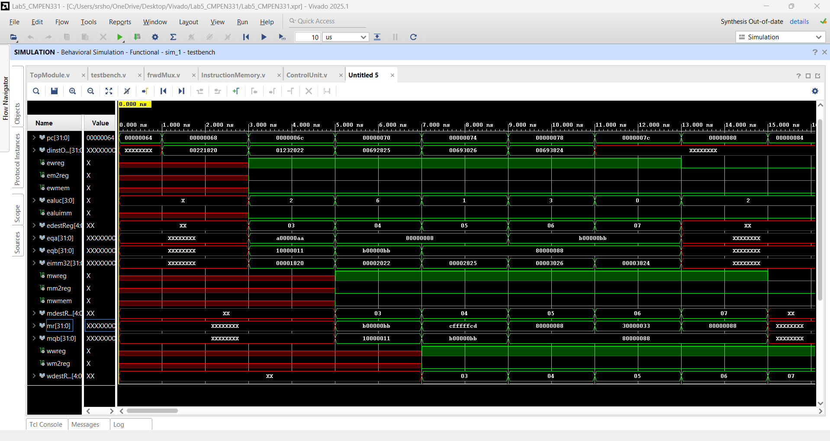
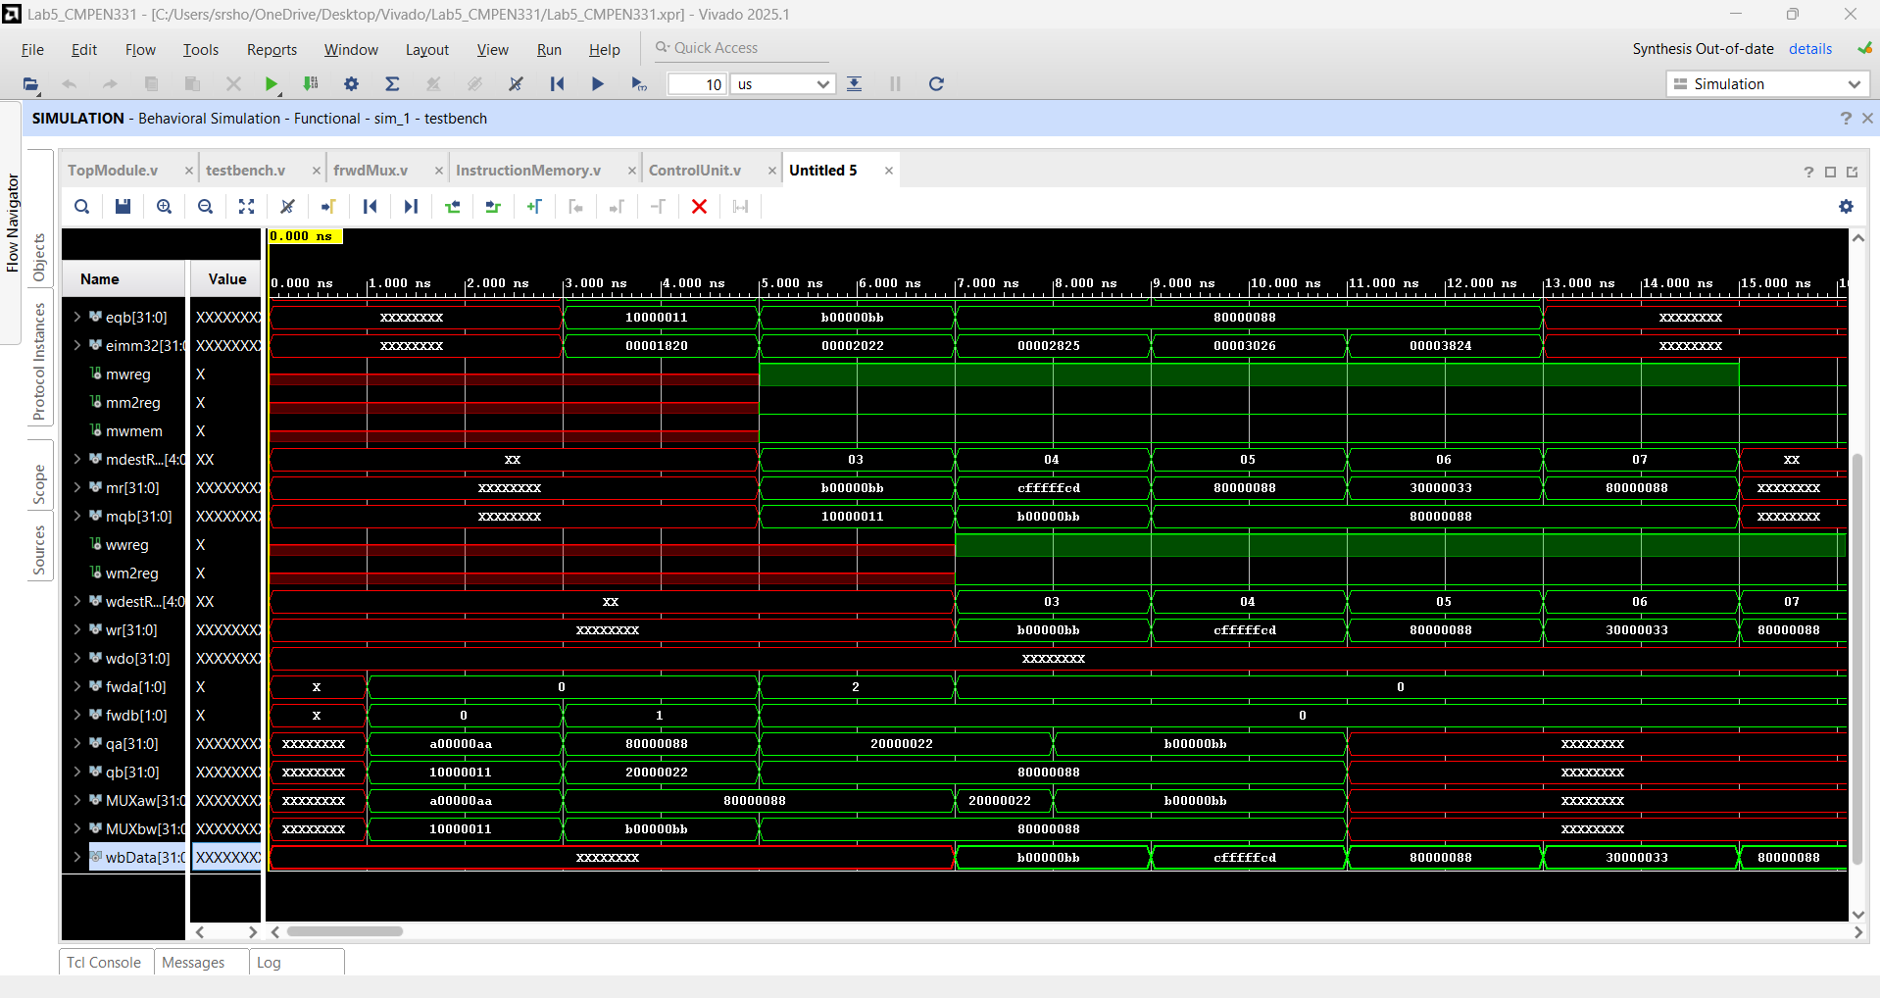

Design Schematic
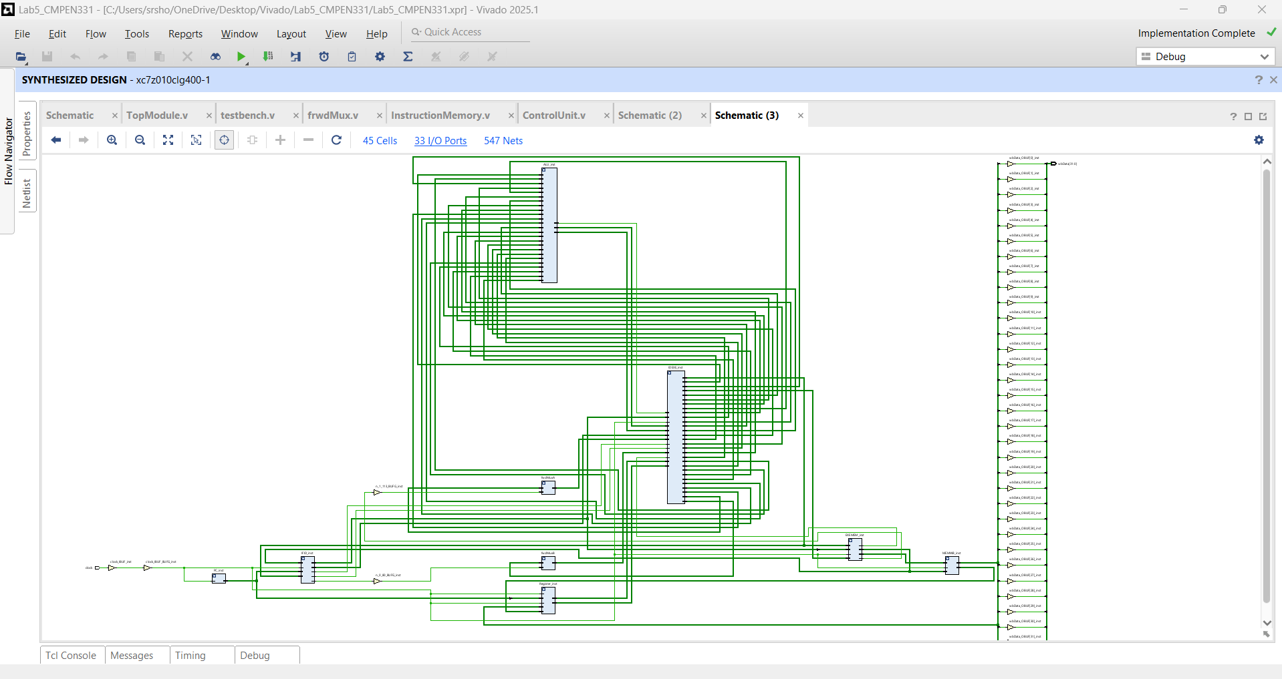
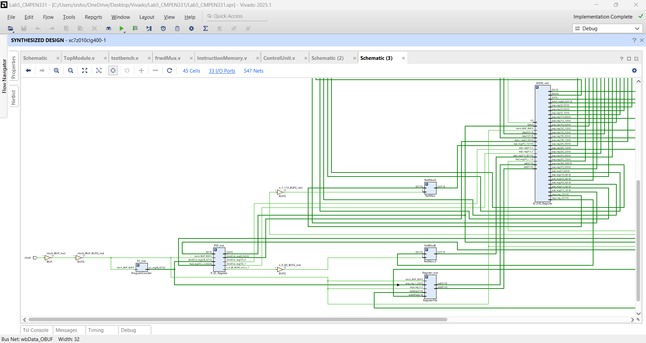

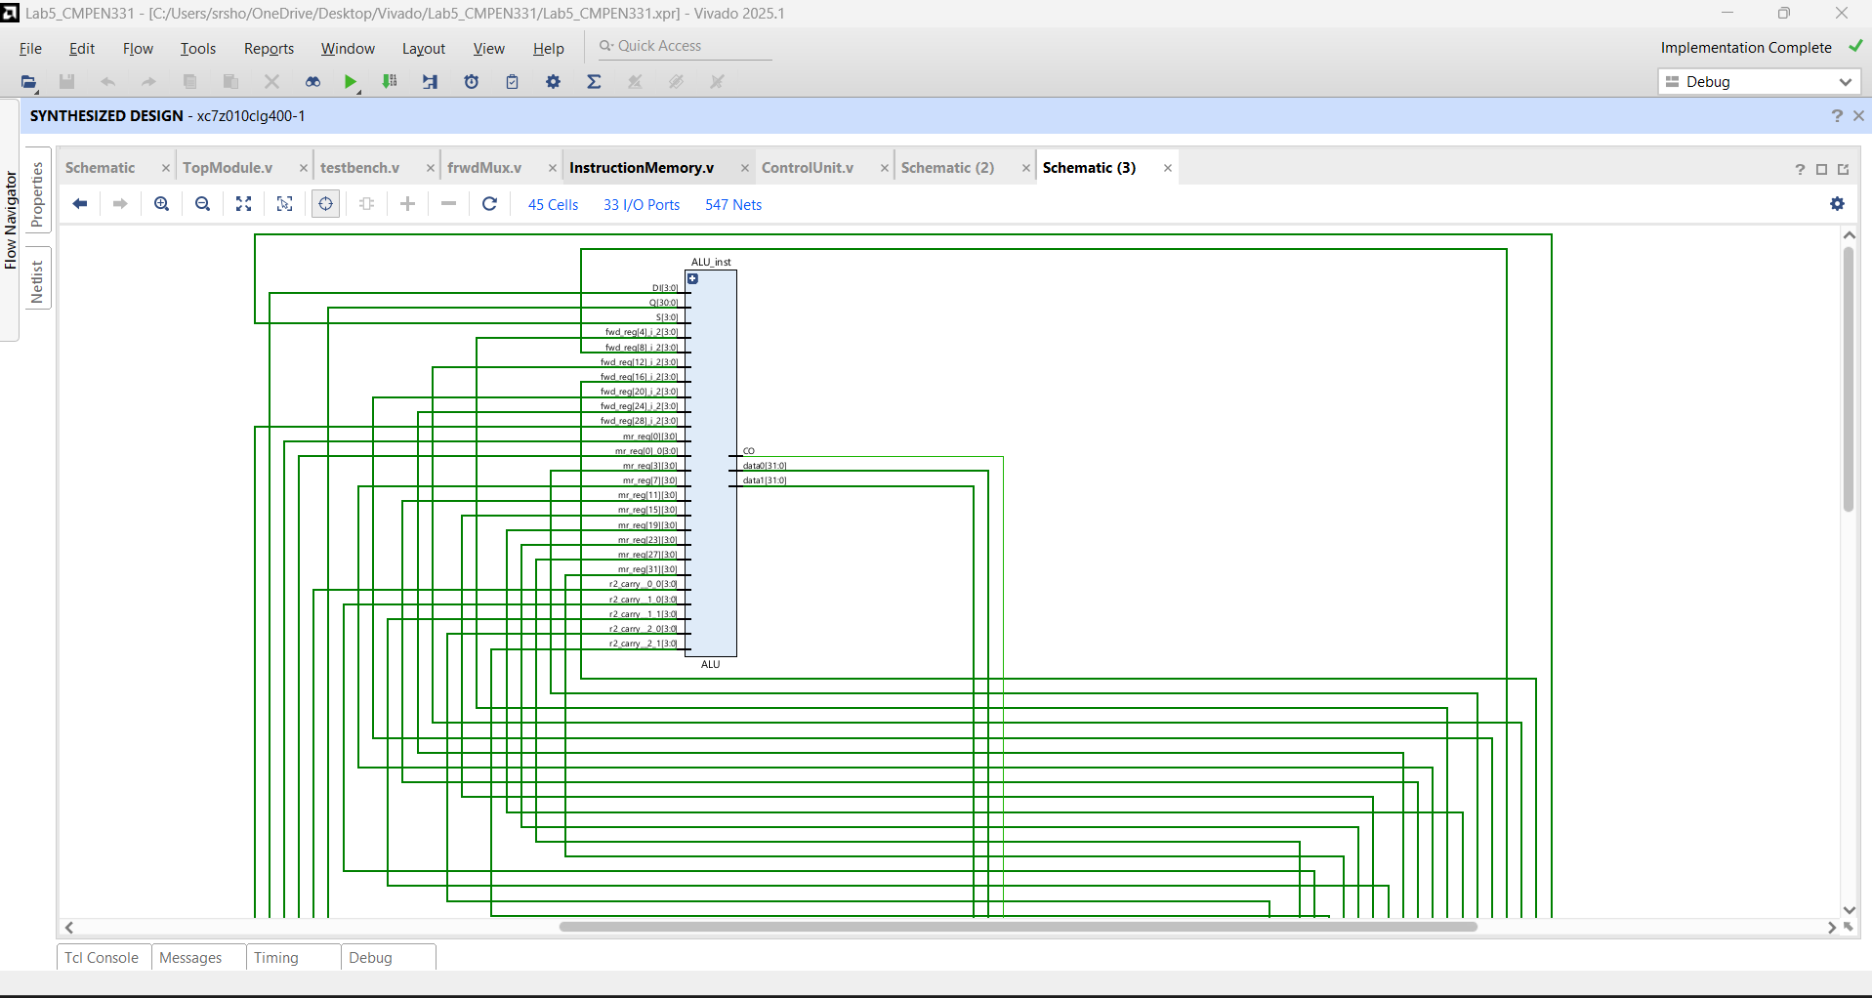
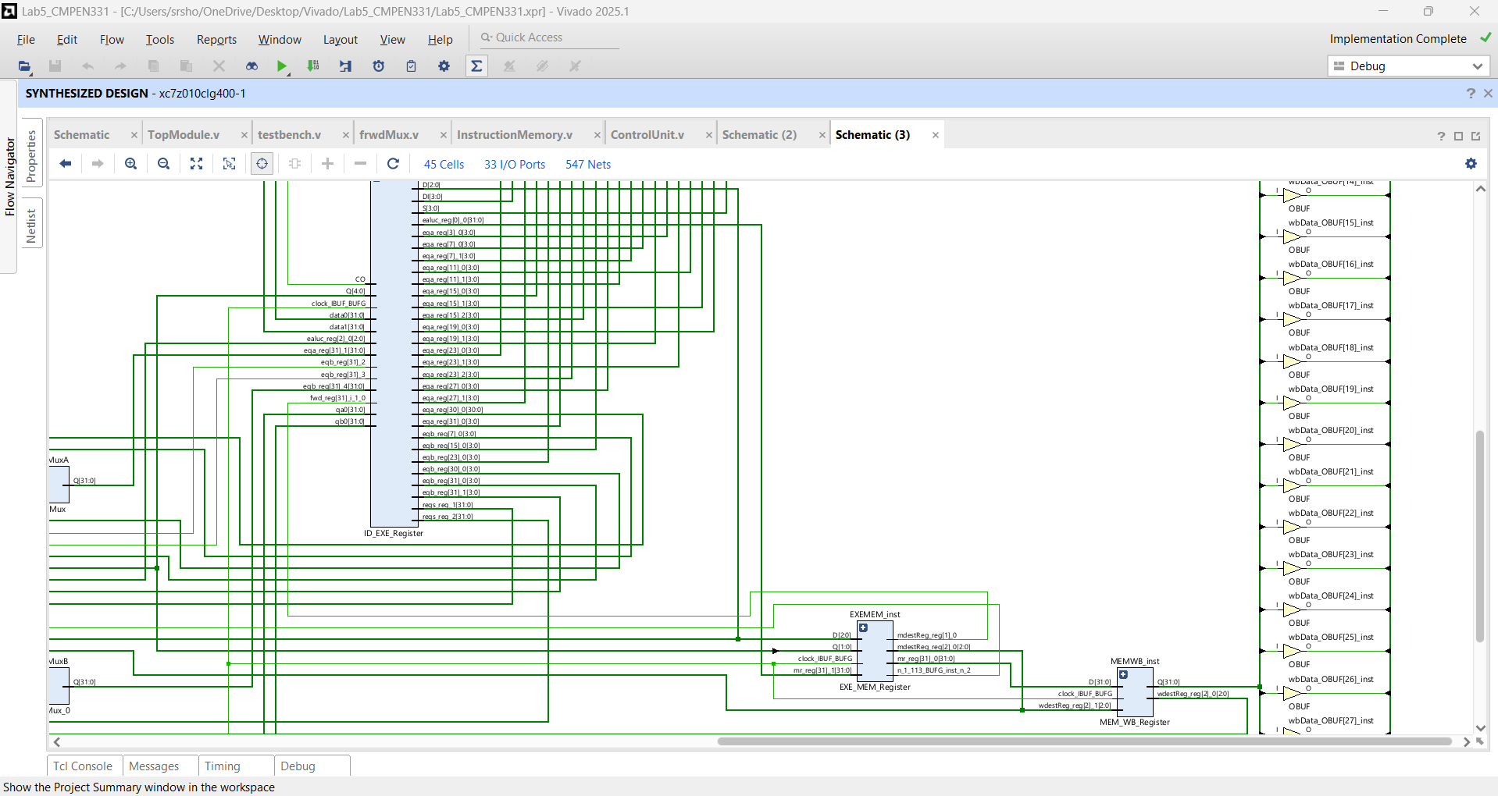
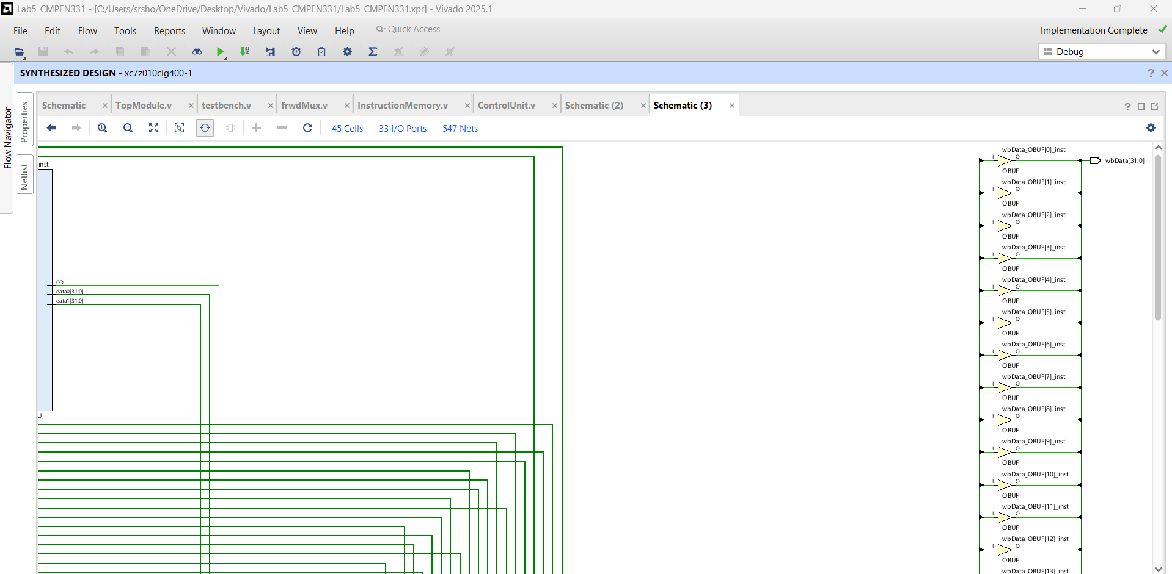

I/O Planning
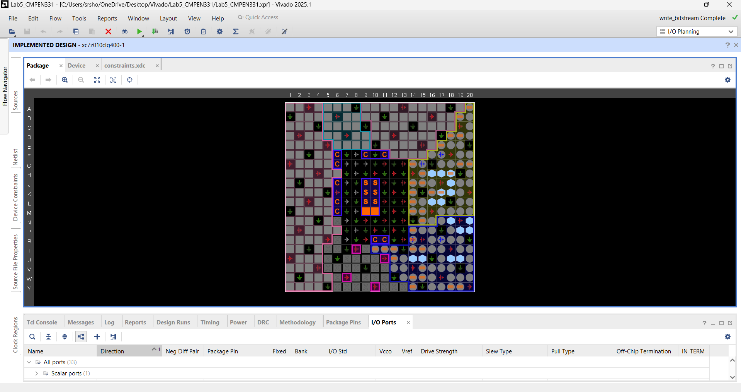

Floor planning
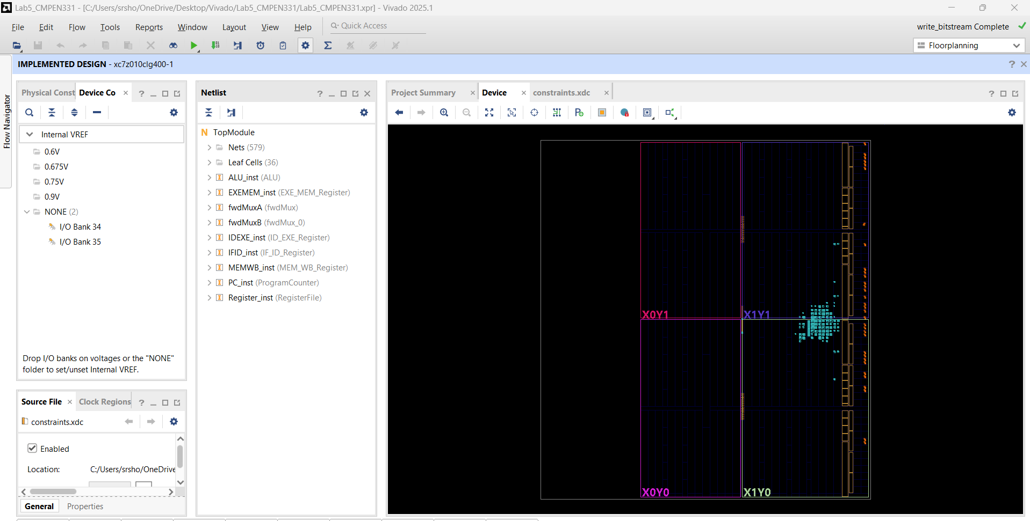

Proof of Bitstream and Implementation:
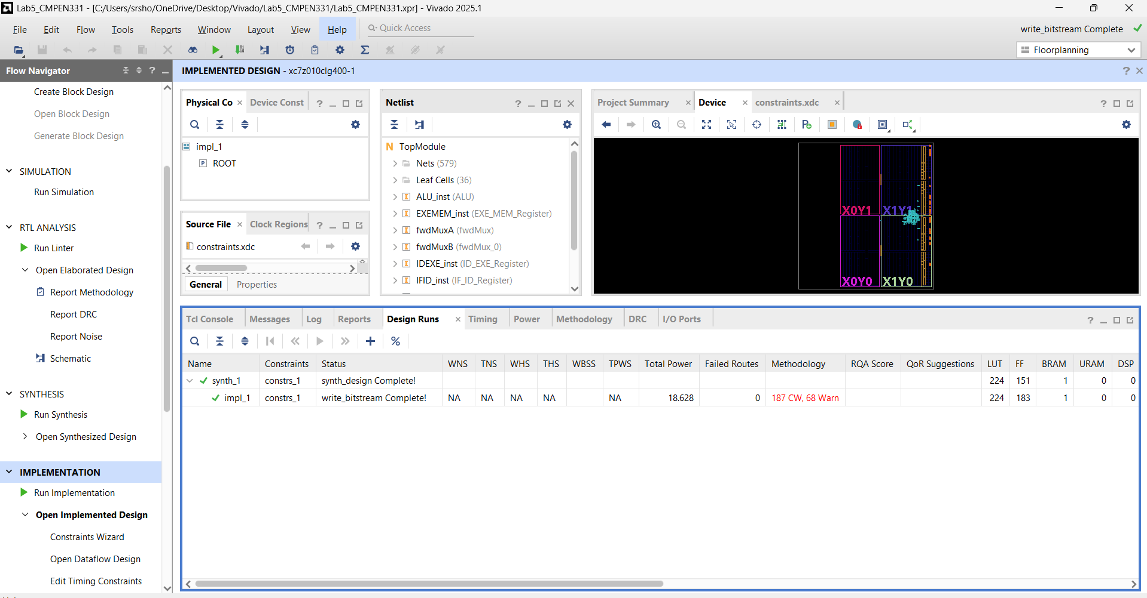

EXTRA CREDIT

