Chapter 5

6．Assuming that all routers and hosts are working properly and that all software in both is free of all errors, is there any chance, however small, that a packet will be delivered to the wrong destination?

9．Consider the subnet of Fig 5-13(a). Distance vector routing is used, and the following vectors have just come in to router C: from B:(5,0,8,12,6,2); from D:(16,12,6,0,9,10); and from E:(7,6,3,9,0,4). The measured delays to B, D and E, are 6, 3, and 5, respectively. What is C’ s new routing table? Give both the outgoing line to use and the expected delay.
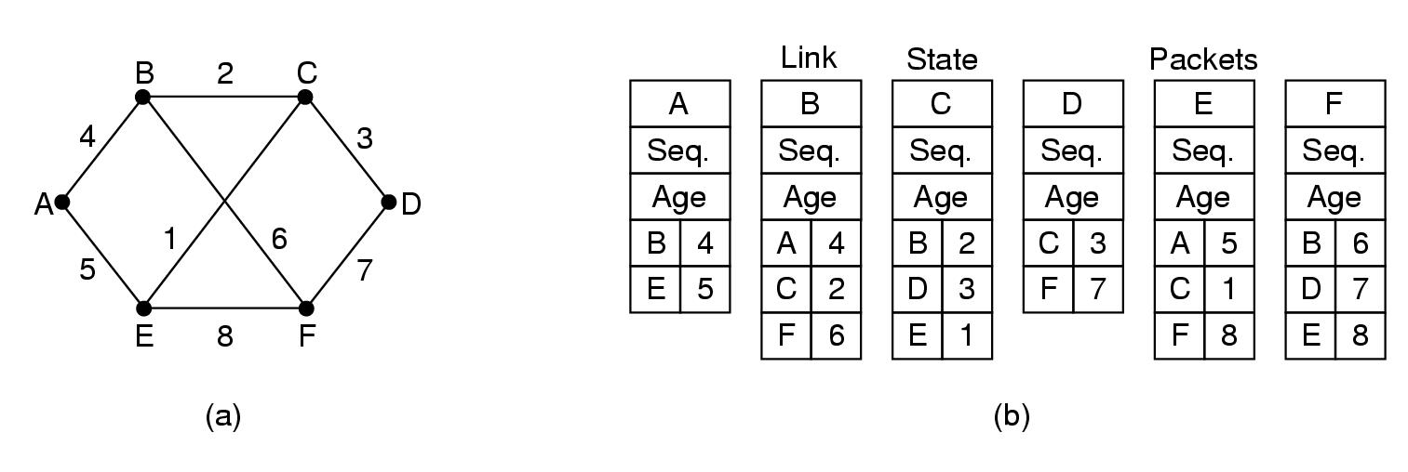
Fig. 5-13. (a) A subnet. (b) The link state packets for this subnet.

34．Suppose that both host A is connected to a router R1, R1 is connected to another router R2, and R2 is connected to host B. Suppose that a TCP message that contains 900 bytes of data and 20 bytes of TCP header is passed to the IP code at host A for delivery to B. Show the Total length, Identification, DF, MF, and Fragment offset fields of the IP header in each packet transmitted over the three links. Assume that link A-R1 can support a maximum frame size of 1024 bytes including a 14-byte frame header, link R1-R2 can support a maximum frame size of 512 bytes, including an 8-byte frame header, and link R2-B can support a maximum frame size of 512 bytes including a 12-byte frame header.

38．Convert the IP address whose hexadecimal representation is C22F1582 to dotted decimal notation.

43. A router has the following (CIDR) entries in its routing table:
Address/mask Next hop
135.46.56.0/22 Interface 0
135.46.60.0/22 Interface 1
192.53.40.0/23 Router 1
Default Router 2
For each of the following IP address, what does the router do if a packet with that address arrives?
- 135.46.63.10
- 135.46.57.14
- 135.46.52.2
- 192.53.40.7
- 192.53.56.7

Chapter 6
25．The maximum payload of a TCP segment is 65495 bytes. Why was such a strange number chosen?

30．If the TCP round-trip time RTT is currently 30 msec and the following acknowledgements come in after 26, 32 and 24 msec, respectively, what is the new RTT estimate using the Jacobson algorithm? Use a = 0.9.

33．In a network that has a maximum TPDU size of 128 bytes, a maximum TPDU lifetime of 30 sec, and an 8-bit sequence number, what is the maximum data rate per connection?

36．To get around the problem of sequence number wrapping around while old packets still exist, one could use 64-bit sequence number. However, theoretically, an optical fiber can run at 75 Tbps. What maximum packet lifetime is required to make sure that future 75 Tbps networks do not have wraparound problems even with 64-bit sequence numbers? Assume that each byte has its own sequence number, as TCP does.

Chapter 7
- Can a machine with a single DNS name have multiple IP addresses? How could this occur?

- A binary file is 3072 bytes long. How long will it be if encoded using base64 encoding, with a CR+LF pair inserted after every 80 bytes sent and at the end?

- Consider the quoted-printable MIME encoding scheme. Mention a problem not discussed in the text and propose a solution.

- From an ISP's point of view, POP3 and IMAP differ in an important way. POP3 users generally empty their mailboxes every day. IMAP users keep their mail on the server indefinitely. Imagine that you were called in to advise an ISP on which protocol it should support. What considerations would you bring up?

- The standard http URL assumes that the Web server is listening on port 80. However, it is possible for a Web server to listen to some other port. Devise a reasonable syntax for a URL accessing a file on a nonstandard port

- Imagine that someone in the CS Department at Stanford has just written a new program that he wants to distribute by FTP. He puts the program in the FTP directory ftp/pub/freebies/newprog.c. What is the URL for this program likely to be?

Chapter 8
7. In Fig. 8-6, the P-boxes and S-boxes alternate. Although this arrangement is esthetically pleasing, is it any more secure than first having all the P-boxes and then all the S-boxes?

11. Suppose that a message has been encrypted using DES in ciphertext block chaining mode. One bit of ciphertext in block C_{i} is accidentally transformed from a 0 to a 1 during transmission. How much plaintext will be garbled as a result?

14. Using the RSA public key cryptosystem, with a = 1, b = 2, etc.,
  - If p = 7 and q = 11, list five legal values for d.
  - If p = 13, q = 31, and d = 7, find e.
  - Using p = 5, q = 11, and d = 27, find e and encrypt ''abcdefghij''.

