第六章作业题参考答案
6.7
decl → var-list: type var-list.dtype = type.dtype
var-list1 → var-list2, id var-list2.dtype = var-list1.dtype
id.dtype = var-list1.dtype
var-list → id id.dtype = var-list.dtype
type → integer type.dtype = int
type → real type.dtype = float

6.8
decl → id var-list id.dtype = var-list.dtype
var-list1→, id var-list2 var-list1.dtype = var-list2.dtype
id.dtype = var-list2.dtype
var-list → : type var-list.dtype = type.dtype
type→integer type.dtype = int
type →real type.dtype = float

6.13
a)
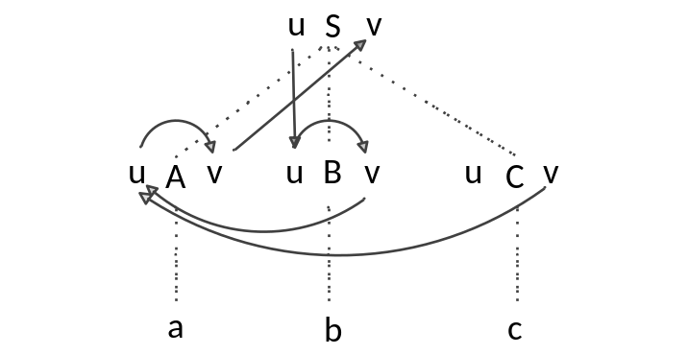
b) S.v = 8
c)
S.v 无法计算图内有环