Chapter 3 Context Free Grammars
注意：
- 每次作业10分，分数分为五个等级：A+，A，B+，B，C，分别对应：10分，9分，8分，7分, 5分。
- 每位同学提交的本子都会有相应的等级作为平时成绩记录。

Homework Analysis：
No. 3.2
3.2
(a) It generates the string of all balanced parentheses, including the empty string.
(b) Consider the string ( ), it has two different parse trees.
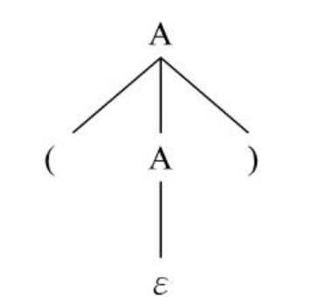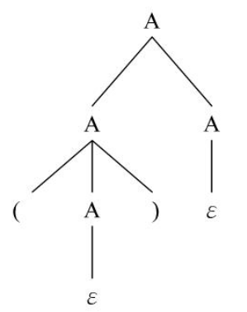
存在的问题：
- 对产生语言的描述不是很准确
No. 3.3
3.3
(a) exp=>exp addop term
=>exp addop term addop term
=>term addop term addop term
=>factor addop term addop term
=>3 addop term addop term
=>3 + term addop term
=>3 + term mulop factor addop term
=>3 + factor mulop factor addop term
=>3 + 4 mulop factor addop term
=>3 + 4 * factor addop term
=>3 + 4 * 5 addop term
=>3 + 4 * 5 – term
=>3 + 4 * 5 – factor
=>3 + 4 * 5 – 6
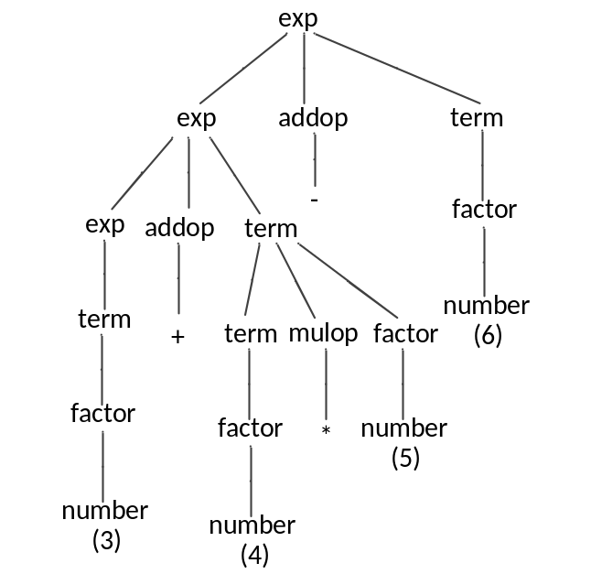
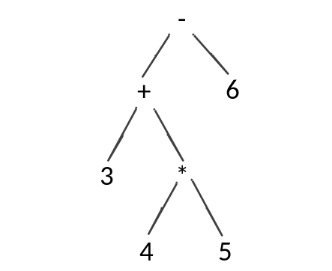
(b) exp=>term
=>term mulop factor
=>factor mulop factor
=>3 mulop factor
=>3 * factor
=>3 * (exp)
=>3 * (exp addop term)
=>3 * (exp addop term addop term)
=>3 * (term addop term addop term)
=>3 * (factor addop term addop term)
=>3 * (4 addop term addop term)
=>3 * (4 – term addop term)
=>3 * (4 – factor addop term)
=>3 * (4 – 5 addop term)
=>3 * (4 – 5 + term)
=>3 * (4 – 5 + factor)
=>3 * (4 – 5 + 6)
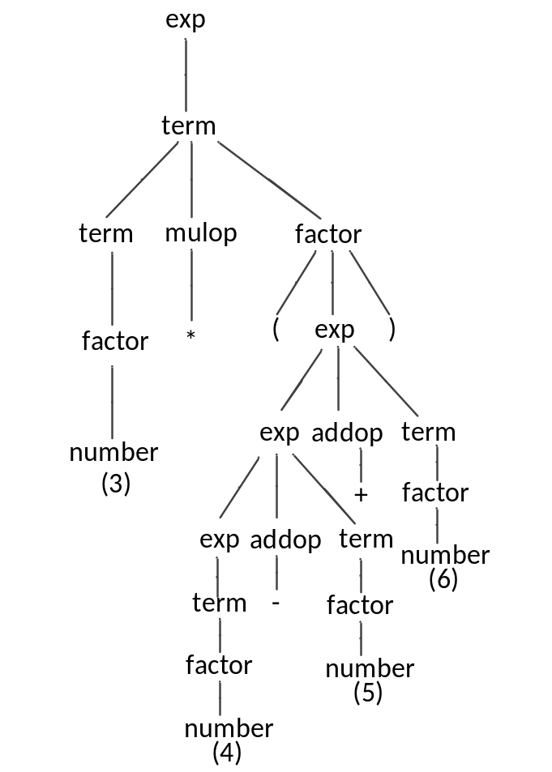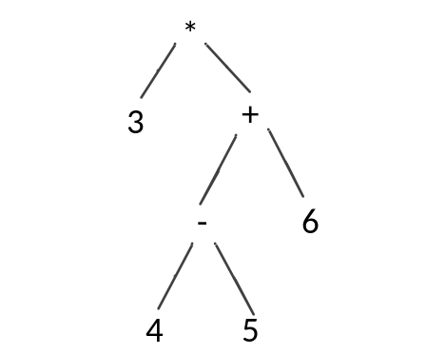
(c) exp=>exp addop term
=>term addop term
=>factor addop term
=>3 addop term
=>3 – term
=>3 – factor
=>3 – (exp)
=>3 – (exp addop term)
=>3 – (term addop term)
=>3 – (factor addop term)
=>3 – (4 addop term)
=>3 – (4 + term)
=>3 – (4 + term mulop factor)
=>3 – (4 + factor mulop factor)
=>3 – (4 + 5 mulop factor)
=>3 – (4 + 5 * factor)
=>3 – (4 + 5 * 6)
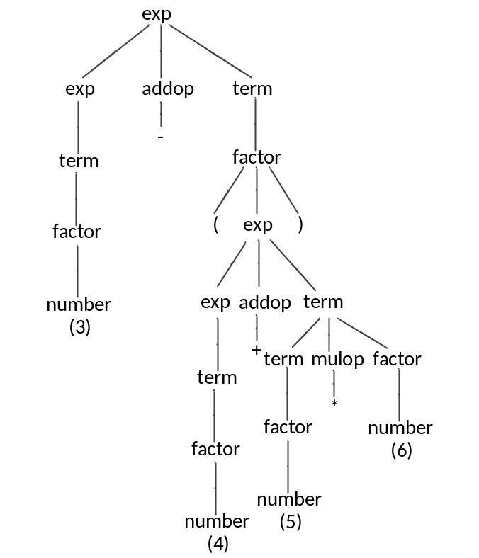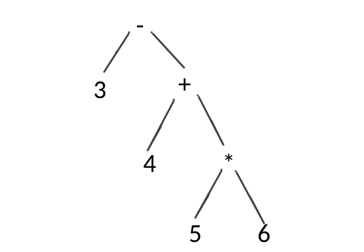

存在的问题：
- 很多同学在最左推导时 直接用term –> number，这是不对的，要严格按照文法来推导，number只能通过非终结符factor得到

No. 3.4
答案：
- 有多种推导方式，这里只写出一种：
rexp =>rexp*=> (rexp)* =>( rexp | rexp)*
=>(rexp rexp | rexp) *
=>(a rexp | rexp )*
=>(a b | rexp)*
=>(ab|b)*
(b) 文法存在二义性最好的证明方式是画出两棵parse tree，存在两种推导方式并不能充分说明文法二义，给出以下两种parse tree：
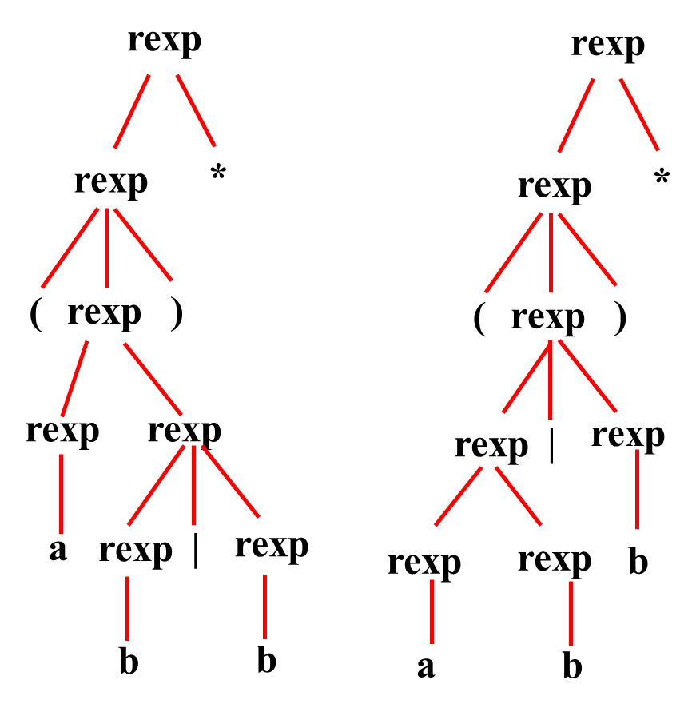

(c) 可能不止一种表达方式，此处给出一种较标准的写法：
rexp -> rexp “|” rexp1 | rexp1
rexp1 -> rexp1 rexp2 | rexp2
rexp2 -> rexp3 * | rexp3
rexp3 -> (rexp) | letter
存在的问题：
- 第二问很多同学只写出了两种推导方式，这里最好将两种形式的parse tree 画出来才能最好的证明文法是二义的
- 第三问 最后一条规则很多同学会漏掉，或者将括号里面的非终结符写成 其他的，这里一定要注意括号里面的表达式一定要与一开始的推导符号一致，表明所有过程可以再递归进行下去。这个写法同学们可以在参考下书中关于算术计算的例子

