**Databases Laboratory Work Nr. 1**

**Title:** Installation and Configuration of SQL Server 2017

**Prerequisites:** “Microsoft SQL Server 2017 pas cu pas” course book.

**Objectives:**

Installation and Configuration of SQL Server 2017

Establishing connection to servers

Creation of Logins in SQL Server

**Tasks:** Learn to perform

Server Registration

Server Exclusion

Server registration modification

Windows Authentication

Mixed Authentication

Creation of Logins

**Implementation:**

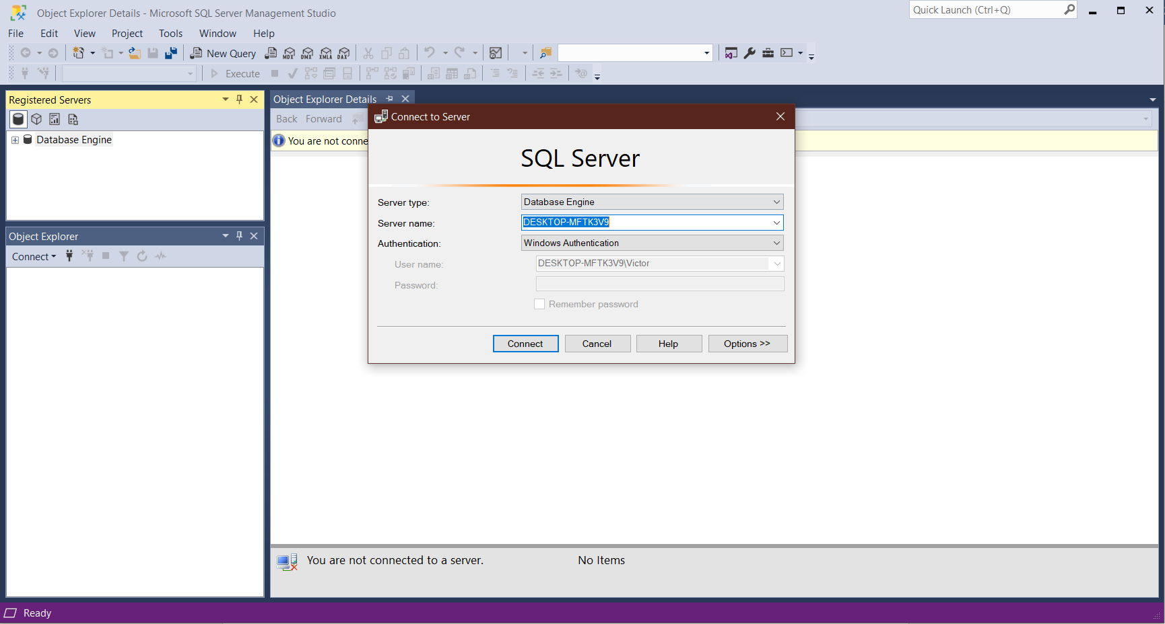

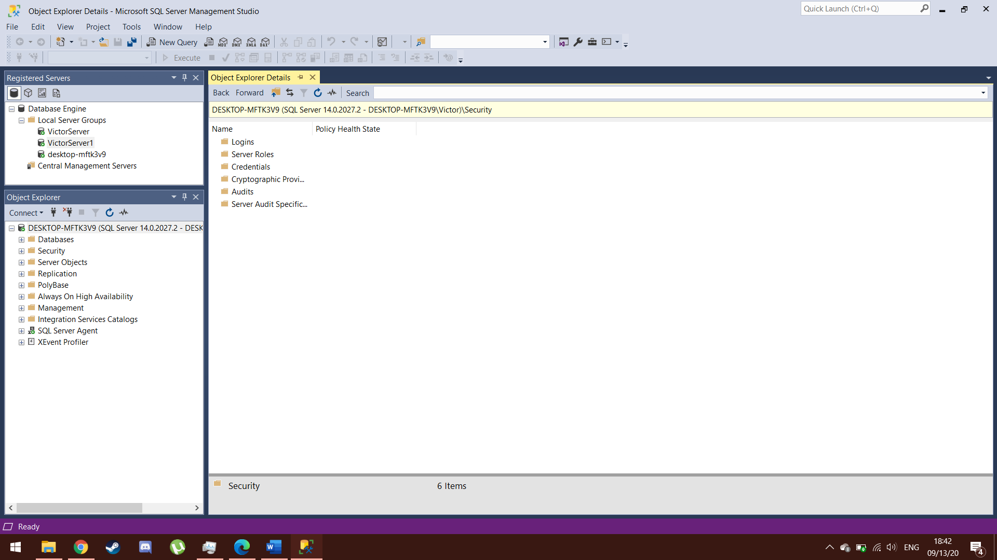

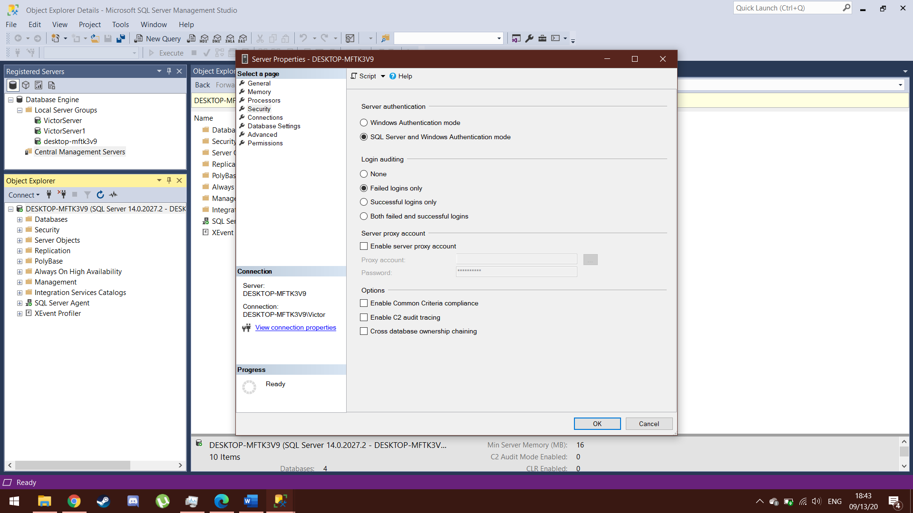

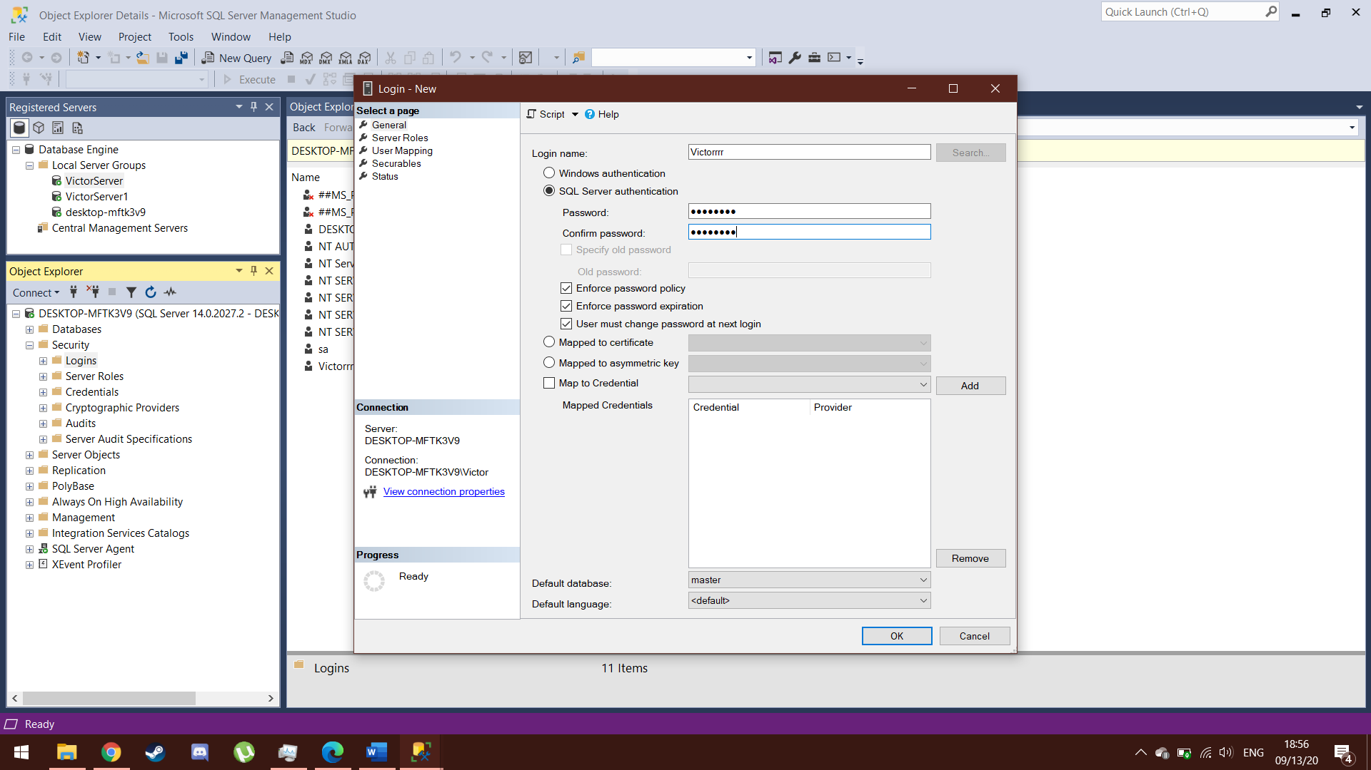

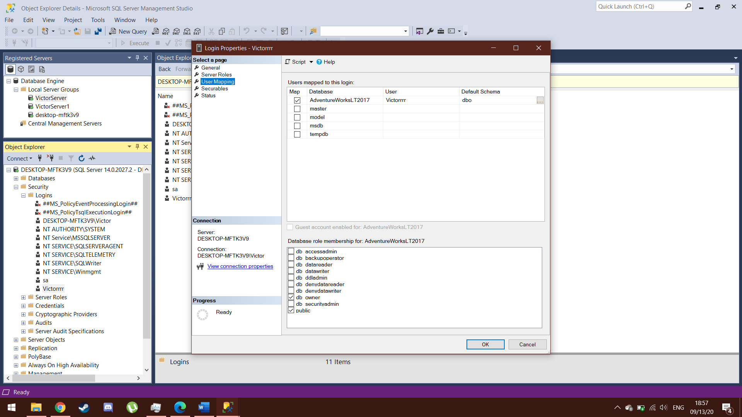

**Conclusion:**

The installation and configuration of the SQL Server Manager 2017 is a quick and easy process. It is an integrated environment for managing SQL infrastructures. It can be used to access, configure, manage, administer and develop all components of SQL Server, such as: databases, tables, diagrams, indexes, views, schemes, triggers, functions, rules, etc.