🏦 Bank Customer Churn Analysis using SQL - Report

EXPLORATORY DATA ANALYSIS
- Dimensions Exploratory
a) Analyze the distinct surnames and identify the data quality check
There’re many different continent names listed in the column.
b) Identify the names of the countries in the column that are distinct
In the Results, Three Countries are listed – Spain, France, Germany.
c) Modify the data standardization in the Surname column. These names contain signs and symbols; update ‘?’ to ‘u’. Basically, there are Chinese names
d) Understand the total number of male and female are in our dataset: MALE is 5457 & FEMALE is 4543
Measure Exploratory
a) Total number of Row Number are 1000.
b) Total number of products sold is 15302.
c)Max age group is 92 and Min age group is 18
d) Total Balance left in the data is 764858892.88
e) Total number of active members is 5151
Magnitude analysis
a) Total number of active members by country
France = 2591
Spain = 1312
Germany = 1248
b) Average tenure by customer (How many years the customer has a relationship with the bank)
5 years Average tenure by customer
c) Total credit card holders are 7055
Ranking Analysis
- Top customer by highest number of orders
- Lu – 36
- Smith – 32
- Hu – 31
- Martin – 29
- Scott – 29
- TOP THREE with the highest balances in their own account.
- Lo – 250898
- To Rot – 238387
- Haddon – 222267

Solving Business Problems

1. Customer Churn Rate Analysis (Beginner)
Business Problem:
The bank's leadership wants to know the overall customer churn rate to understand how serious the retention problem is.
Question:
What percentage of customers have exited the bank?
have exited the bank?
SELECT
CONCAT(CAST(SUM(CASE WHEN Exited = 1 THEN 1 ELSE 0 END) * 100.0 / COUNT(*) AS DECIMAL (10,2)), '%') AS Percentage_Exited
FROM Bank_churn;
In this Query, Finding the percentage of customers who exited the bank. The percentage is 20.37% of the number of customers who exited the bank. To solve this problem, the CASE WHEN Statement calculated those who exited, and a percentage formula was used in it. My suggestion for the business is to verify the reason for the exit; if this can increase future identification of the root cause, resolve the issues of the existing customers


2. Geography Performance Analysis (Beginner)
Business Problem:
The marketing team believes certain countries are losing significantly more customers than others.
Question:
Which geographical region has the highest churn rate, and how many customers were lost from each region?
SELECT
Country,
SUM(CASE WHEN Exited = 1 THEN 1 ELSE 0 END) AS Customers_Exited,
CONCAT(SUM(CASE WHEN Exited = 1 THEN 1 ELSE 0 END) * 100 /COUNT(*), '%') AS Churn_rate
FROM Bank_churn
GROUP BY Country
Even though Germany has just 4 more customers than France overall, the total number of exits is lower than in France. Germany's customer base is much smaller. That means nearly all of Germany's customers left. There are more retention problems. Among those, France lost almost the same number of customers, but its churn rate is lower. My suggestion to the organization that controls customer engagement is to identify the root cause of the problem for existing customers.
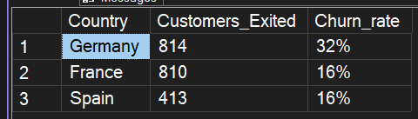

3. Customer Age Risk Analysis (Intermediate)
Business Problem:
Management suspects older customers are leaving more frequently than younger customers.
Question:
Divide customers into age groups and identify which age group has the highest churn rate.?
SELECT
CASE
WHEN Age BETWEEN 18 AND 25 THEN 'Young Adults'
WHEN Age BETWEEN 26 AND 40 THEN 'Early Adulthood'
WHEN Age BETWEEN 41 AND 60 THEN 'Middle Adulthood'
ELSE 'Older Adulthood'
END AS Age_group,
CONCAT(CAST(SUM(CASE WHEN Exited = 1 THEN 1 ELSE 0 END) * 100.0 / COUNT(*) AS DECIMAL(10,2)),'%') AS Exited_customer
FROM Bank_churn
GROUP BY CASE
WHEN Age BETWEEN 18 AND 25 THEN 'Young Adults'
WHEN Age BETWEEN 26 AND 40 THEN 'Early Adulthood'
WHEN Age BETWEEN 41 AND 60 THEN 'Middle Adulthood'
ELSE 'Older Adulthood'
END
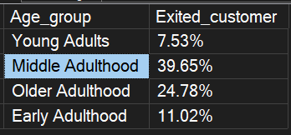
Analyzing customer age risk helps better determine the age group division accordingly. The insights indicate that Middle Adulthood has the highest number of exits from the bank at 39.65%, followed by Older Adulthood. The age group that exited the bank the least is Young Adulthood with 7.53%. The business needs to conduct a feedback survey to the active customers to collect the keys of the most disadvantaged points about the bank.

4. Product Retention Analysis (Intermediate)
Business Problem:
The product team wants to know whether owning multiple bank products improves customer retention.
Question:
How does churn vary based on the number of products a customer owns?
SELECT *,
CAST(Customer_exited * 100.0 / Total_Customer AS DECIMAL(10,2))AS Churn_rates
FROM(
SELECT
DISTINCT Num_of_Products,
COUNT(*) AS Total_Customer,
SUM(CASE WHEN Exited = 1 THEN 1 ELSE 0 END) AS Customer_exited
FROM dbo.Bank_churn
GROUP BY Num_of_Products
)t

In This Query, it determines the number of products held by the customer. If the customer retention rate is high, it indicates that the highest number of products is the customer retention rate is high or less. Analyze and calculate the churn rate: the highest number of product holders are likely to exit, there is a 100% rate, followed by three product holders are likely exit rate of 82.71%. At least 2 and 1 product holders are below 30% and seem happier to engage with the bank. My suggestion is that the bank must research the product holdings of up to 3, have seemed unhappier with the bank's policy.
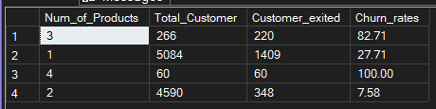

5. Active Customer Behavior (Intermediate)
Business Problem:
The customer success team believes inactive members are more likely to leave the bank.
Question:
Compare churn rates between active and inactive members.
SELECT *,
CONCAT(CAST(Customer_exited * 100.0 / Total_customer AS DECIMAL (18,2)),'%')AS Churn_rate
FROM (
SELECT
CASE WHEN Active_member = 1 THEN 'Active'
ELSE 'Inactive'
END AS Member,
COUNT(*) AS Total_customer,
SUM(CASE WHEN Exited = 1 THEN 1 ELSE 0 END) AS Customer_exited
FROM Bank_churn
GROUP BY CASE WHEN Active_member = 1 THEN 'Active'
ELSE 'Inactive'
END
)t
Resolving the problem between customer behavior by calculating the churn rate based on active and Inactive. To solve the problem and find the outcome result, separate the active and inactive in each row using a CASE STATEMENT and excluded customers and other columns with the total number of customers. Implementing the churn rate formula here it the final results are: Active members are 14.26% of the churn rate, and Inactive members are the highest churn rate with 26.85% . The more customers are inactive means they have exited the bank. The bank is more likely to follow up with inactive members might have a different concern for being inactive for a while. To grow the bank, Customer engagement needs to make things work and avoid exiting the bank.
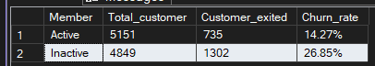

6. High-Value Customer Risk Analysis (Intermediate)
Business Problem:
Losing customers with large account balances hurts the bank's profitability.
Question:
Identify the balance ranges with the highest customer churn and determine whether high-balance customers are at greater risk.
SELECT
RANK() OVER( ORDER BY Customer_exited * 100.0 /Total_Customer DESC) AS RANK_,
Balance_info,
CONCAT(CAST(Customer_exited * 100.0 /Total_Customer AS DECIMAL(10,2)), '%') AS Churn_rate
FROM(
SELECT
CASE
WHEN Balance BETWEEN 1 AND 50000 THEN '1-50K'
WHEN Balance BETWEEN 50001 AND 100000 THEN '50K - 100K'
WHEN Balance BETWEEN 100001 AND 200000 THEN '100K - 200K'
WHEN Balance > 200001 THEN '200K +'
ELSE 'No Balance'
END AS Balance_info,
SUM(CASE WHEN Exited = 1 THEN 1 ELSE 0 END) AS Customer_exited,
COUNT(*) AS Total_Customer
FROM Bank_churn
GROUP BY
CASE
WHEN Balance BETWEEN 1 AND 50000 THEN '1-50K'
WHEN Balance BETWEEN 50001 AND 100000 THEN '50K - 100K'
WHEN Balance BETWEEN 100001 AND 200000 THEN '100K - 200K'
WHEN Balance > 200001 THEN '200K +'
ELSE 'No Balance'
END
)t
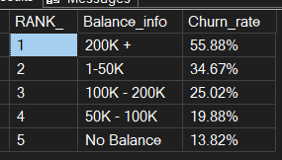
In this query, the finding is that high-value customer risk analysis based on the balance amount in there are most likely to exit the bank. Among these, it has been identified a who have the highest balance in the bank are the ones most likely to exit the bank, with 55.88%, followed by the low balance range of 1-50K are the second most likely to exit the bank at 34.67% and at the lowest churn rate with no balance aren’t exit the bank. In this, churn rates are according to the balance and analysis of customer behavior. The bank recommendation will be that higher balances exit the bank; the bank must provide benefits to maintain huge balances.

7. Customer Loyalty vs Churn (Intermediate)
Business Problem:
The retention department wants to know whether longer customer relationships reduce churn.
Question:
Analyze customer churn across different tenure groups and determine whether customer loyalty reduces the likelihood of leaving.
WITH Base_query AS(
SELECT
CASE WHEN Tenure BETWEEN 0 AND 2 THEN '0-2'
WHEN Tenure BETWEEN 3 AND 5 THEN '3-5'
WHEN Tenure BETWEEN 6 AND 8 THEN '6-8'
ELSE '9-10'
END AS Customer_tenure,
SUM(CASE WHEN Exited = 1 THEN 1 ELSE 0 END) AS Customer_exited,
SUM(CASE WHEN Exited = 0 THEN 1 ELSE 0 END) AS Customer_retention,
COUNT(*) AS Total_customer
FROM Bank_churn
GROUP BY CASE WHEN Tenure BETWEEN 0 AND 2 THEN '0-2'
WHEN Tenure BETWEEN 3 AND 5 THEN '3-5'
WHEN Tenure BETWEEN 6 AND 8 THEN '6-8'
ELSE '9-10'
END)
SELECT *,
CONCAT(CAST(Customer_exited * 100.0 / Total_customer AS DECIMAL(10,2)),'%') AS Churn_rate
FROM Base_query
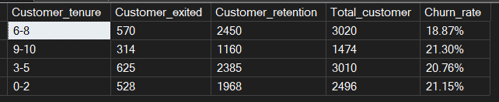
Customer churn rates are similar to the tenure who are at the highest level of 9-10 and lowest 0-2 are at the same churn rate are 21%. The Customer retention rate is higher for customers with 6-8 tenure. My suggestion is that the bank provide savings benefits Other cash back deals that customers will be happier to protect their accounts.

8. Credit Score Impact on Churn (Advanced)
Business Problem:
The risk department wants to understand whether customers with different credit score ranges behave differently.
Question:
Group customers into credit score categories and determine which category experiences the highest churn.
WITH Basequery_1 AS
(
SELECT
CASE WHEN CreditScore BETWEEN 350 AND 579 THEN 'Very poor'
WHEN CreditScore BETWEEN 580 AND 669 THEN 'Fair'
WHEN CreditScore BETWEEN 670 AND 739 THEN 'Good'
WHEN CreditScore BETWEEN 740 AND 799 THEN 'Very Good'
ELSE 'Exceptional'
END AS Creditscore_range,
SUM(CASE WHEN Exited = 1 THEN 1 ELSE 0 END) AS Customer_exited,
COUNT(*) AS Total_customers
FROM Bank_churn
GROUP BY CASE WHEN CreditScore BETWEEN 350 AND 579 THEN 'Very poor'
WHEN CreditScore BETWEEN 580 AND 669 THEN 'Fair'
WHEN CreditScore BETWEEN 670 AND 739 THEN 'Good'
WHEN CreditScore BETWEEN 740 AND 799 THEN 'Very Good'
ELSE 'Exceptional'
END
)

SELECT *,
CAST( Customer_exited * 100.0 / Total_customers AS DECIMAL(10,2)) AS Churn_rates
FROM Basequery_1
ORDER BY Churn_rates DESC
Customers with poor credit scores experienced the highest churn rates, While customers with higher credit scores are most likely to remain with the bank. The bank should investigate whether financial difficulties, credit-related policies, or customer experience are contributing to higher churn among lower credit score customers.
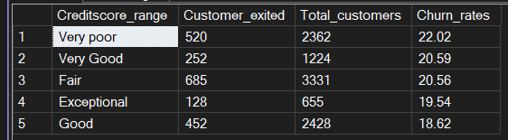

9. High-Risk Customer Profile (Advanced)
Business Problem:
The executive team wants to identify the profile of customers most likely to leave so retention campaigns can be targeted effectively.
Question:
Identify the combination of customer characteristics (Age, Geography, Gender, Credit Score, Products, Active Status, Balance, Tenure) that produces the highest churn rate.
WITH base_query AS
(
SELECT
CASE WHEN CreditScore BETWEEN 350 AND 579 THEN 'Very poor'
WHEN CreditScore BETWEEN 580 AND 669 THEN 'Fair'
WHEN CreditScore BETWEEN 670 AND 739 THEN 'Good'
WHEN CreditScore BETWEEN 740 AND 799 THEN 'Very Good'
ELSE 'Exceptional'
END AS Creditscore_range,
Country,
Gender,
CASE WHEN Age BETWEEN 18 AND 30 THEN 'Young'
WHEN Age BETWEEN 31 AND 45 THEN 'Middle'
WHEN Age BETWEEN 46 AND 60 THEN 'Senior'
ELSE 'Elder'
END AS Age_group,
CASE WHEN Tenure BETWEEN 0 AND 2 THEN 'New'
WHEN Tenure BETWEEN 3 AND 5 THEN 'Regular'
WHEN Tenure BETWEEN 6 AND 8 THEN 'Loyal'
ELSE 'Very Loyal'
END AS Customer_tenure,
CASE
WHEN Balance = 0 THEN 'Zero'
WHEN Balance BETWEEN 1 AND 50000 THEN 'Low'
WHEN Balance BETWEEN 50001 AND 100000 THEN 'Medium'
WHEN Balance BETWEEN 100001 AND 200000 THEN 'High'
ELSE 'Very High'
END AS Balance_info,
Num_of_Products,
CASE WHEN Active_member = 1 THEN 'Yes'
ELSE 'No'
END AS active_members,
Exited
FROM Bank_churn
)

SELECT
Gender,
Country,
Age_group,
Creditscore_range,
Customer_tenure,
Balance_info,
Num_of_Products,
active_members,
COUNT(*) AS Total_customers,
SUM(CASE WHEN Exited = 1 THEN 1 ELSE 0 END) AS Customer_exited,
CAST(SUM(CASE WHEN Exited = 1 THEN 1 ELSE 0 END) * 100.0 / COUNT(*)AS DECIMAL (10,2)) AS Churn_rate
FROM base_query
GROUP BY
Gender,
Age_group,
Country,
Creditscore_range,
Customer_tenure,
Balance_info,
Num_of_Products,
active_members
HAVING COUNT(*) > 10
ORDER BY Churn_rate DESC
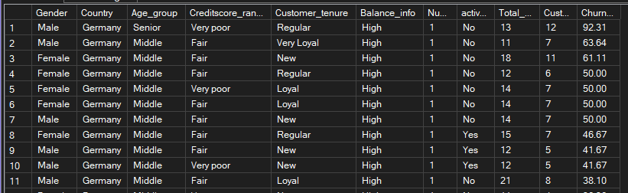
The Highest churn rate are 92.31 customers around 13 out of 12 customers exiting, having a high balance, a very poor credit score, from Germany country all are male, and are in the senior age group. This suggests the bank should prioritize customer engagement and cross-selling strategies for inactive, high-value customers to reduce attrition and protect revenue.

10. Executive Retention Dashboard (Expert)
Business Problem:
The CEO wants a dashboard highlighting where the bank is losing customers and where retention efforts should be focused.
Question:
Create a ranked report showing the top customer segments with the highest churn rates based on multiple business dimensions such as Geography, Age Group, Product Count, Active Status, Credit Score Range, and Balance Range.
WITH base_query_2 AS
(SELECT
Gender,
Country,
CASE WHEN Age BETWEEN 18 AND 30 THEN 'Young'
WHEN Age BETWEEN 31 AND 45 THEN 'Middle'
WHEN Age BETWEEN 46 AND 60 THEN 'Senior'
ELSE 'Elder'
END AS Age_group,
CASE WHEN CreditScore BETWEEN 350 AND 579 THEN 'Very poor'
WHEN CreditScore BETWEEN 580 AND 669 THEN 'Fair'
WHEN CreditScore BETWEEN 670 AND 739 THEN 'Good'
WHEN CreditScore BETWEEN 740 AND 799 THEN 'Very Good'
ELSE 'Exceptional'
END AS Creditscore_range,
CASE
WHEN Balance = 0 THEN 'Zero'
WHEN Balance BETWEEN 1 AND 50000 THEN 'Low'
WHEN Balance BETWEEN 50001 AND 100000 THEN 'Medium'
WHEN Balance BETWEEN 100001 AND 200000 THEN 'High'
ELSE 'Very High'
END AS Balance_info,
Exited,
Num_of_Products,
CASE WHEN Active_member = 1 THEN 'Yes'
ELSE 'No'
END AS active_member
FROM Bank_churn),

base_query_3 AS
(
SELECT
Gender,
Country,
Age_group,
Creditscore_range,
Balance_info,
Num_of_Products,
active_member,
COUNT(*) AS Total_customers,
SUM(CASE WHEN Exited = 1 THEN 1 ELSE 0 END) AS Customer_exited,
CAST(SUM(CASE WHEN Exited = 1 THEN 1 ELSE 0 END) * 100.0 / COUNT(*)AS DECIMAL (10,2)) AS Churn_rate
FROM base_query_2
GROUP BY
Gender,
Age_group,
Country,
Creditscore_range,
Balance_info,
Num_of_Products,
active_member
HAVING COUNT(*) >= 10

)

SELECT *,
RANK () OVER(ORDER BY Churn_rate DESC) AS Rank_
FROM base_query_3
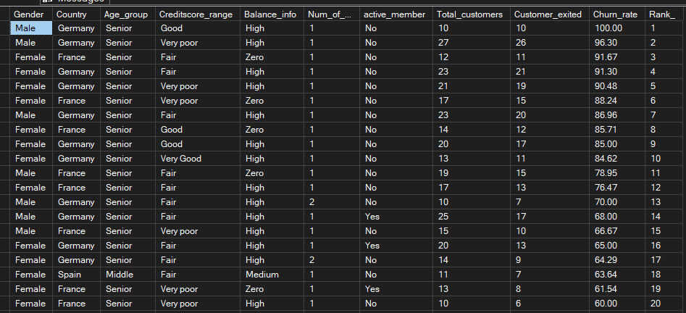

In this final report, all the columns are included and given a case statement to identify in detail and get a proper overview of the report. The insights here about the highest churn rate are ranked, adding all the columns in the group Age group, Credit score range, and Balance info, Number of products, Customer exited, and Churn rate. In these findings, male gender from the Germany country, senior aged with a good credit score and high balance are the excepting the highest churn rate, 100%, followed by the same category, only very poor credit score ones and high balance. Both are category only 1 product, and no active members are there. My recommendation to the bank countries like Germany and France, customers are exiting the bank with lower credit scores, the senior group of people, maintaining higher bank balances. Bankers need to investigate senior are receiving lower benefits; even if they have high balance bank must provide savings and fixed deposits for those who have the highest balances. Finding out the other bank options for their benefits.

