COFFEE SHOP SALES REPORT USING SQL

1. Calculate the total number of sales for each month
SELECT
CONCAT(ROUND(SUM(unit_price * transaction_qty),0)/1000,'k') AS Total_sales
FROM dbo.coffee_shop
WHERE MONTH(transaction_date) = 3 -- MARCH MONTH
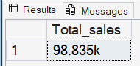
2. Determine the month-on-month increase or decrease in the number of transactions.
SELECT
Month,
Sum_transaction,
CAST((Sum_transaction/Previous_sales * 100) – 100 AS DECIMAL(5,2)
) AS MoM_percentage__sales
FROM
(
SELECT
CAST(SUM(unit_price * transaction_qty) AS DECIMAL(10,2))AS Sum_transaction,
LAG(SUM(unit_price * transaction_qty))OVER(ORDER BY MONTH(transaction_date)) AS Previous_sales,
MONTH(transaction_date) AS Month
FROM dbo.coffee_shop
GROUP BY MONTH(transaction_date)
)t
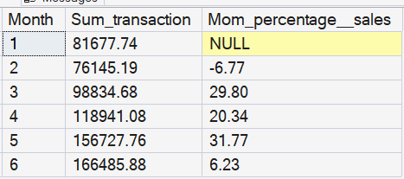

This query is used to calculate the month-on-month percentage change in total sales value from the coffee_shop dataset.
First, I aggregated total sales for each month by multiplying unit_price and transaction_qty, then applying the SUM() function and grouping the results by month. This provides the total sales per month.
Next, I used the LAG() window function to retrieve the previous month’s total sales value based on the chronological order of months. This allows comparison between the current month and the previous month.
After that, I calculated the month-on-month percentage change using the formula:
Finally, I cast the result into a DECIMAL(10,2) format to maintain consistency and readability in numeric output.
3. Calculate the total number of orders for each month
SELECT
COUNT(transaction_id) AS Total_number_order
FROM dbo.coffee_shop
WHERE MONTH(Transaction_date) = 3;
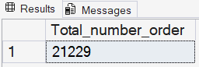
4. Determine the month-on-month increase or decrease in the number of orders.
SELECT
months,
number_of_order,
previous_order,
CONCAT(ROUND(
((number_of_order - previous_order) * 100)/previous_order, 2), '%') AS percentage_change
FROM
(
SELECT
months,
number_of_order,
LAG(number_of_order) OVER(ORDER BY months) AS previous_order
FROM
(
SELECT
MONTH(transaction_date) AS months,
COUNT(transaction_id) AS number_of_order
FROM dbo.coffee_shop
GROUP BY MONTH(transaction_date)
) t1
)t2;
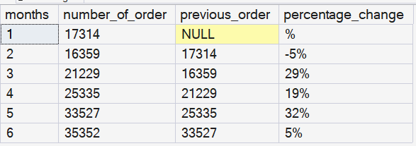
This query calculates the month-on-month percentage change in the number of orders.
First, I grouped the data by month using MONTH(transaction_date) and counted the total number of transactions using COUNT(transaction_id), which represents the number of orders per month.
Then, I applied the LAG() window function to fetch the previous month’s order count for comparison.
After retrieving both current and previous values, I calculated the percentage change using the formula:
To make the output more user-friendly, I used ROUND() to limit decimal precision to two places and CONCAT() to append the % symbol, making it visually interpretable as a percentage.

5. Total Quantity Sold Analysis:
SELECT
SUM(transaction_qty) AS Total_quantity
FROM dbo.coffee_shop
WHERE
MONTH(transaction_date) = 5
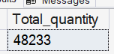

6. Determine the month-on-month increase or decrease in the quantity.
SELECT
months,
Total_quantity,
CONCAT(CAST((Total_quantity - previous_quatity) * 100 /previous_quatity AS DECIMAL(5,2)),' ','%') AS Percentage_
FROM
(
SELECT
months,
Total_quantity,
LAG(Total_quantity)OVER (ORDER BY months) AS previous_quatity
FROM
(
SELECT
MONTH(transaction_date) AS months,
SUM(transaction_qty) AS Total_quantity
FROM dbo.coffee_shop
GROUP BY MONTH(transaction_date)
)t1)t2
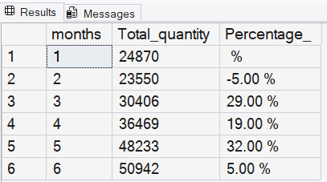

This SQL query calculates the month-on-month percentage increase or decrease in total quantities. First, I used the SUM() function to calculate the total number of transactions and grouped the data by month. Then, in a subquery, I applied the LAG() window function to retrieve the previous month’s quantity value. After that, I used another subquery to calculate the month-on-month percentage change using the formula:
((Current Order - Previous Order) / Previous Order) * 100
The LAG() function was used to obtain the previous month’s order count for comparison. I also used CAST() to convert the result into a DECIMAL(5,2) format because the column contained float values. Finally, I applied the CONCAT() function to append the % symbol to the output, making the result more readable and realistic
7.Finding the key metrics of the store (sales, Orders, Quantity) over a specific date
SELECT
CONCAT(ROUND(SUM(transaction_qty * unit_price)/1000,1), '' )AS total_sales,
CONCAT(CAST(COUNT(transaction_id)/1000.0 AS DECIMAL(3,1)), 'k') AS Total_order,
CONCAT(CAST(SUM(transaction_qty)/1000.0 AS DECIMAL(3,1)), 'k') AS Total_qty_sold
FROM dbo.coffee_shop
WHERE transaction_date = '2023-03-27'
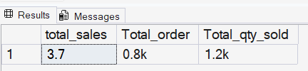
For a specific date, pulling the info with query writing in aggregate and round/cast with simpler to read using CONCAT ‘k’

8.Sales Analysis by Weekdays and Weekends:
SELECT
CASE WHEN DATEPART(weekday,transaction_date)IN (1,7) THEN 'Weekends'
ELSE 'Weekdays'
END AS day_of_week,
CONCAT(ROUND(SUM(transaction_qty * unit_price)/1000,1), 'k' )AS total_sales
FROM dbo.coffee_shop
WHERE MONTH(transaction_date) = 2
GROUP BY CASE WHEN DATEPART(weekday,transaction_date)IN (1,7) THEN 'Weekends'
ELSE 'Weekdays'
END
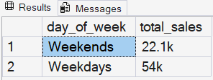
Finding the result of Total sales in Weekends and Weekdays using the CASE WHEN function and filtering weekdays through the DATEPART function. Hence, we can see the result over here: the total sales of weekends and weekdays.

-- 9. Sales Analysis by store location:
SELECT
store_location,
CONCAT(ROUND(SUM(transaction_qty * unit_price)/1000,1), 'k') AS total_sales
FROM dbo.coffee_shop
WHERE MONTH(transaction_date) = 5
GROUP BY store_location
ORDER BY total_sales DESC
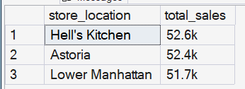
Analyzing total sales per store location in the data set, Calculating the sum of the sales with formula Sum(quantity * Unit price) by the store location to see what the total sales per store.

10. Daily Sales Analysis with Average Line

SELECT
AVG(Total_sales) AS Avg_sales
FROM(
SELECT
month(transaction_date) AS months,
SUM(transaction_qty * unit_price) AS Total_sales
FROM dbo.coffee_shop
WHERE month(transaction_date) = 5
GROUP BY transaction_date
)t
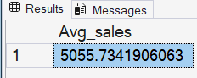
Calculating the average sales for the whole month of May. Option to filter the month and choose whatever month of average sales
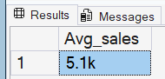
After writing the CONCAT function and ROUND, it now looks more understandable.
11.Daily Average of sales

SELECT
Day_of_month,
CASE
WHEN Total_sales > Avg_sales THEN 'Above Average'
WHEN Total_sales < Avg_sales THEN 'Below Average'
ELSE 'Average'
END AS sales_status,
total_sales
FROM(
SELECT
DAY(transaction_date) AS Day_of_month,
SUM(transaction_qty * unit_price) AS Total_sales,
AVG(SUM(transaction_qty * unit_price)) OVER()AS Avg_sales
FROM dbo.coffee_shop
WHERE Month(transaction_date) = 5
GROUP BY DAY(transaction_date)
)t
ORDER BY Day_of_month

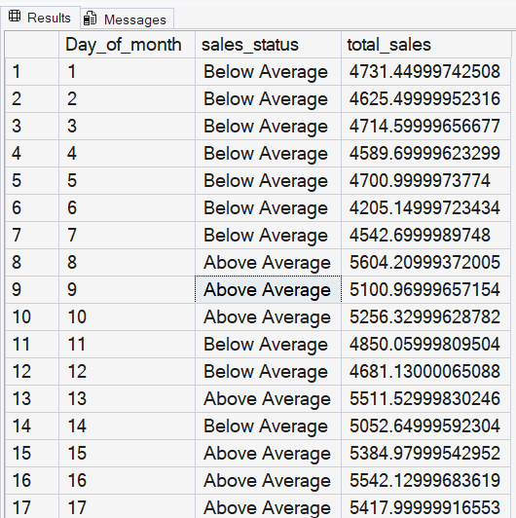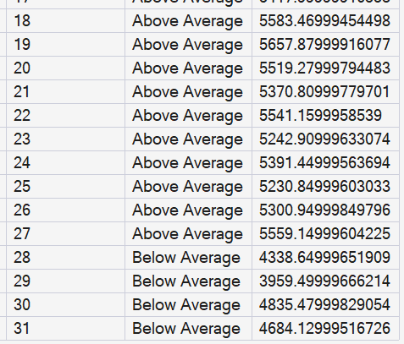
Calculating the SUM(quantity * unit price) and then later the average (AVG) to obtain average sales for each day of the month using a WHERE clause to assign the specific month. Using Subquery to write CASE when to create a derived columns to specifically mention more details on Greater than Avg Sales would be above average, and Less than Avg sales from total sales would be below average else it will throw Equal average.
12. Sales Analysis by Product Category
SELECT
product_category,
CONCAT(ROUND(SUM(transaction_qty * unit_price)/1000,1),'K') AS Total_sales
FROM dbo.coffee_shop
WHERE MONTH(transaction_date) = 5
GROUP BY product_category
ORDER BY Total_sales DESC
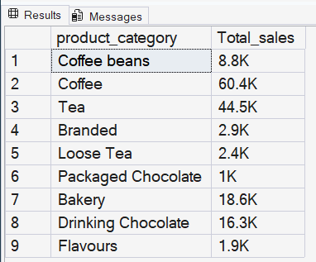

Analyze the product categories writing the product category, sum statement multiplying quantity upon unit price to get the total sales and Where clause to list the month of requirement. Here is the result of the query and the table.
13. Total 10 products by sales
SELECT TOP 10
product_type,
ROUND(SUM(transaction_qty * unit_price),2) AS Total_sales
FROM dbo.coffee_shop
GROUP BY product_type
ORDER BY SUM(transaction_qty * unit_price) DESC

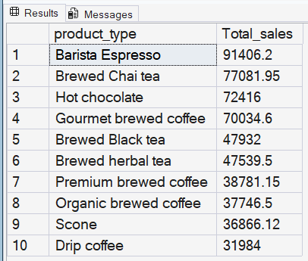
This query works to check the top 10 product types on the basis of SUM of Total sales. Same query as above question modified to TOP 10 product types with total sales

14. Sales Analysis by days and hours

SELECT
CASE WHEN DATEPART(weekday ,transaction_date)= 2 THEN 'Monday'
WHEN DATEPART(weekday ,transaction_date)= 3 THEN 'Tuesday'
WHEN DATEPART(weekday ,transaction_date)= 4 THEN 'Wednesday'
WHEN DATEPART(weekday ,transaction_date)= 5 THEN 'Thursday'
WHEN DATEPART(weekday ,transaction_date)= 6 THEN 'Friday'
WHEN DATEPART(weekday ,transaction_date)= 7 THEN 'Saturday'
ELSE 'Sunday'
END AS Week_day,
ROUND(SUM(transaction_qty * unit_price),1)AS Total_sales
FROM dbo.coffee_shop
WHERE DATEPART(month,transaction_date) = 5 -- May month
GROUP BY CASE WHEN DATEPART(weekday ,transaction_date)= 2 THEN 'Monday'
WHEN DATEPART(weekday ,transaction_date)= 3 THEN 'Tuesday'
WHEN DATEPART(weekday ,transaction_date)= 4 THEN 'Wednesday'
WHEN DATEPART(weekday ,transaction_date)= 5 THEN 'Thursday'
WHEN DATEPART(weekday ,transaction_date)= 6 THEN 'Friday'
WHEN DATEPART(weekday ,transaction_date)= 7 THEN 'Saturday'
ELSE 'Sunday'
END
ORDER BY ROUND(SUM(transaction_qty * unit_price),1) DESC
---Another query without CASE WHEN:
SELECT
DATENAME(weekday, transaction_date) AS Week_day,
ROUND(SUM(transaction_qty * unit_price), 1) AS Total_sales
FROM dbo.coffee_shop
WHERE DATEPART(month, transaction_date) = 5 -- May month
GROUP BY DATENAME(weekday, transaction_date)
ORDER BY Total_sales DESC;
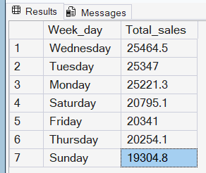
This query drives the business insight of Total sales according to Weekday. Can filter the required month and find the sales throughout the weekdays.
This concludes that the start of the week, Monday, Tuesday, and Wednesday, are the highest among the other days in the week. So, the business insights for May show the results.

