**CHAPTER THREE: SOFTWARE ANALYSIS**

3.0 INTRODUCTION

Choice of methodology

3.1 Describe the existing system

3.2 Analysis of the proposed system

{Case Diagram, ER Model, UML Diagram}

3.3 Design of the proposed system

Database Design

System Architecture

Input Design

Output Design

Algorithm Design

**ACTIVITY DIAGRAM**

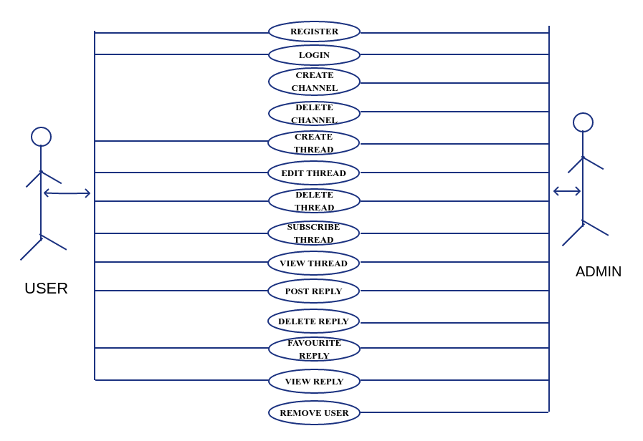

DATABASE DESIGN

**TABLE 1: USER**

|  |  |  |  |  |  |
| --- | --- | --- | --- | --- | --- |
| **NAME** | **TYPE** | **ATTRIBUTES** | **NULL** | **DEFAULT** | **EXTRA** |
| Id | int(10) | UNSIGNED | No | None | AUTO_INCREMENT |
| name | varchar(191) |  | No | None |  |
| email | varchar(191) |  | No | None |  |
| password | varchar(191) |  | No | None |  |
| remember_token | varchar(100) |  | Yes | NULL |  |
| created_at | timestamp |  | Yes | NULL |  |
| updated_at | timestamp |  | Yes | NULL |  |
| status | varchar(191) |  | Yes | NULL |  |

**TABLE 2: THREADS TABLE**

|  |  |  |  |  |  |
| --- | --- | --- | --- | --- | --- |
| **NAME** | **TYPE** | **ATTRIBUTES** | **NULL** | **DEFAULT** | **EXTRA** |
| id | int(10) | UNSIGNED | No | None | AUTO_INCREMENT |
| user_id | int(10) | UNSIGNED | No | None |  |
| channel_id | int(10) | UNSIGNED | No | None |  |
| title | varchar(191) |  | No | None |  |
| body | text |  | No | None |  |
| created_at | timestamp |  | Yes | NULL |  |
| updated_at | timestamp |  | Yes | NULL |  |

**TABLE 3: REPLIES TABLE**

|  |  |  |  |  |  |
| --- | --- | --- | --- | --- | --- |
| **NAME** | **TYPE** | **ATTRIBUTES** | **NULL** | **DEFAULT** | **EXTRA** |
| Id | int(10) | UNSIGNED | No | None | AUTO_INCREMENT |
| thread_id | int(11) |  | No | None |  |
| user_id | int(11) |  | No | None |  |
| body | text |  | No | None |  |
| created_at | timestamp |  | Yes | NULL |  |
| updated_at | timestamp |  | Yes | NULL |  |

**TABLE 4: PASSWORD RESETS TABLE**

|  |  |  |  |  |  |
| --- | --- | --- | --- | --- | --- |
| **NAME** | **TYPE** | **ATTRIBUTES** | **NULL** | **DEFAULT** | **EXTRA** |
| email | varchar(191) |  | No | None |  |
| token | varchar(191) |  | No | None |  |
| created_at | timestamp |  | Yes | NULL |  |

**TABLE 5: ACTIVITIES TABLE**

|  |  |  |  |  |  |
| --- | --- | --- | --- | --- | --- |
| **NAME** | **TYPE** | **ATTRIBUTES** | **NULL** | **DEFAULT** | **EXTRA** |
| Id | int(10) | UNSIGNED | No | None | AUTO_INCREMENT |
| type | varchar(50) |  | No | None |  |
| user_id | int(10) |  | No | None |  |
| subject_id | int(10) |  | No | None |  |
| subject_type | varchar(50) |  | No | None |  |
| created_at | timestamp |  | Yes | NULL |  |
| updated_at | timestamp |  | Yes | NULL |  |

**TABLE 6: CHANNELS TABLE**

|  |  |  |  |  |  |
| --- | --- | --- | --- | --- | --- |
| **NAME** | **TYPE** | **ATTRIBUTES** | **NULL** | **DEFAULT** | **EXTRA** |
| id | int(10) | UNSIGNED | No | None | AUTO_INCREMENT |
| name | varchar(50) |  | No | None |  |
| slug | varchar(50) |  | No | None |  |
| created_at | timestamp |  | Yes | NULL |  |
| updated_at | timestamp |  | Yes | NULL |  |

**TABLE 7: FAVOURITES TABLE**

|  |  |  |  |  |  |
| --- | --- | --- | --- | --- | --- |
| **NAME** | **TYPE** | **ATTRIBUTES** | **NULL** | **DEFAULT** | **EXTRA** |
| id | int(10) | UNSIGNED | No | None |  |
| user_id | int(10) | UNSIGNED | No | None |  |
| favorited_id | int(10) | UNSIGNED | No | None |  |
| favorited_type | varchar(50) |  | No | None |  |
| created_at | timestamp |  | Yes | NULL |  |
| updated_at | timestamp |  | Yes | NULL |  |

INPUT DESIGN

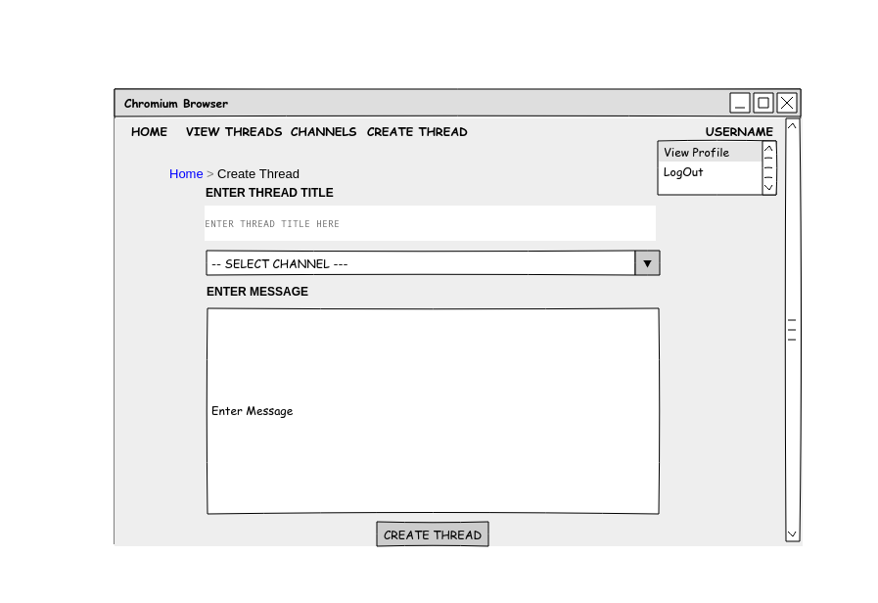

ALGORITHM DESIGN

HomePage FlowChart

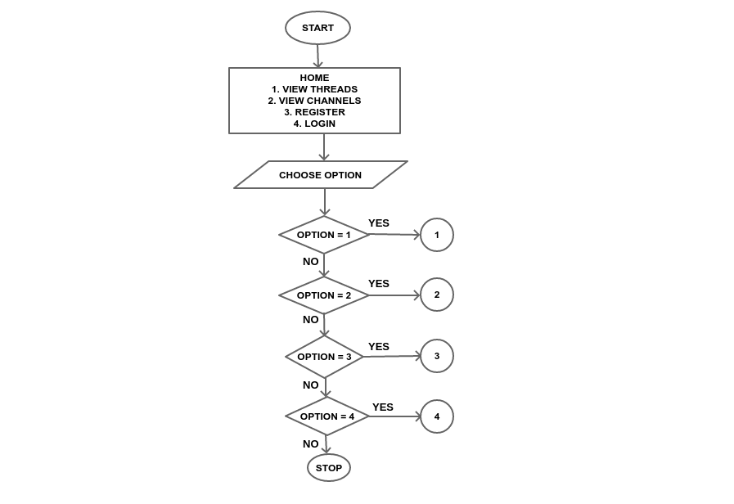

REGISTRATION PAGE

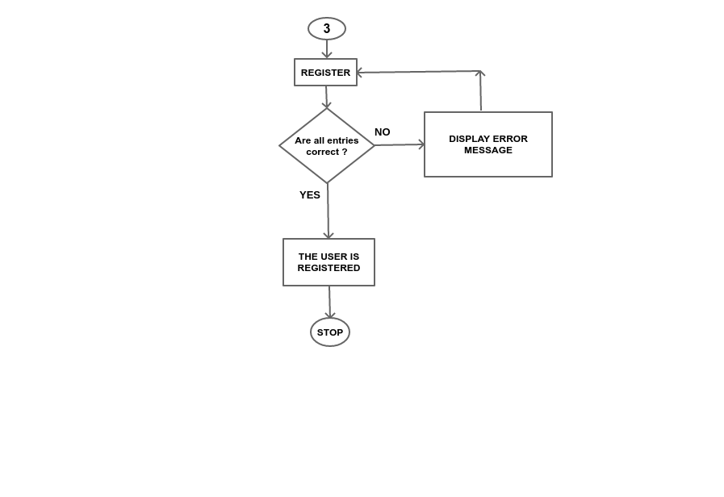

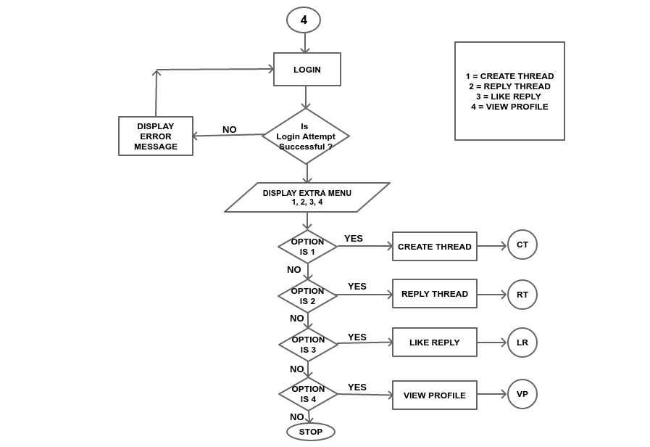LOGIN PAGE FLOWCHART