

Software Engineering 2

Travlendar DD

DESIGN DOCUMENT

Version 1.0 - 27/10/2017

Plamen Pasliev – 898793

Victor Álvaro Gonzalez - 897700

Table of contents

1. Introduction 3

1.1 Objectives 3

1.2 Scope 3

1.3 Definitions, acronyms and abbreviations 3

1.3.1 Definitions 3

1.3.2 Acronyms 4

1.3.3 Abbreviations 4

1.4 Reference documents 4

1.5 Document Structure 4

2. ARCHITECTURAL DESIGN 5

2.1 OVERVIEW 5

2.2 High level components and their interaction 6

2.3 Component view 7

2.4 DEPLOYMENT VIEW 9

3.Algorithm Design 10

4.User Interface Design 11

5.Requirements Traceability 12

6.Implementation, Integration and Test plan 13

7. Effort spent 14

8. References 15

# 1. Introduction

## 1.1 Objectives

This document represents the Design Document (DD). The main goals of this document is to give more details about the development of the application and its design. This way it will be specify the architectural design, algorithm design and user interface design. In addition to this, the order in which the application will be implemented and the tests will be identified. This document is addressed to the developers who have to implement the requirements.

## 1.2 Scope

In this project we are going to develop and implement an application called Travlendar. It is a calendar-based application which allows you to create a calendar according to the events you have such as appointments related to work or personal reasons. On top of calculating the time that the user has between meetings so that he does not arrive late, the application will suggest the best mobility option between events and will alert him when it is impossible to reach a specific event on time. In addition to these functionalities, the system will allow the user to buy public transportation tickets and locating the nearest point to hire another type of service (bike of a bike sharing system, car of a car-sharing service, etc.). Users could define their transportation preferences, they can activate or deactivate any kind of transportation (including walking). The application will also take into account the weather in the location of the user. If it is raining at the time the user has to move to another event, the system will take this into account and will change the way of transport if it is necessary. The application will also allow the user to define breaks to eat or to develop other types of activities. In this way the system will organize the meetings of the user according to their breaks and the time they need to do these activities. Finally, users should also be able, if they wish to, to select combinations of transportation means that minimize carbon footprint.

## 1.3 Definitions, acronyms and abbreviations

### 1.3.1 Definitions

* *Meeting:* personal or work-related appointment. In some parts of the text, meetings are referred as appointments.
* *User*: a user of the Travlendar system
* *Calendar:* a timetable containing meetings sorted by date
* *Alert:* a notification or a pop-up screen.
* *Customer:* user that downloads the application.

### 1.3.2 Acronyms

* *RASD*: Requirement Analysis and Specification Document.
* *API*: Application Programming Interface

### 1.3.3 Abbreviations

* [Gn]: n-goal.
* [Dn]: n-domain assumption.
* [Rn]: n-functional requirement.
* [Pn]: n-performance requirement.

## 1.4 Reference documents

## 1.5 Document Structure

1. In the first part of the document specify what the design document is about. In the same way is explained, without going into much detail, how the application works. Finally, is given some information about definitions and abbreviations to better understand the rest of the document.
2. In the second part it is given an overall description of the system including the functions of the application, clarifying some concepts of the system. Also list the actors who are going to take part of the system. In the same way the constraints and limitations of the system will be defined. Finally, are specified text and domain assumptions to resolve certain types of doubts that may arise by reading the document.
3. The third part of the document refers to specific requirements. We have defined both functional and non-functional requirements. In this part of the document we will go into more detail in the aspects mentioned in section 2.

# 2. ARCHITECTURAL DESIGN

## 2.1 OVERVIEW

In our system we only have one element, the user application that will serve as an intermediary between the user and Google servers to perform certain queries. Thus, the user will interact with the application, the application will communicate the request to the servers. The servers will return information that the system will process and display to the user through the graphic interface of the application:

1. User application: represents the user who has downloaded the Travlendar application. The application allows the user to create their own calendar in such a way that they can create, edit and delete events. Within the events, the user will have to specify when creating a new one if this is a break or a meeting. Therefore, the only actors of the application will be the user and the software of the application. The user makes queries to the application through a graphical interface and the software responds with notifications, creating, deleting or editing new events, calculating how to reach the destination taking into account parameters acquired by the user's location (bad weather, strikes, distances, etc.) and user preferences. The application does not have a server or a database because the information is stored directly in the Google account of the user. For this reason, the user must have a google account which must be logged in, in such a way that the Google Calendar API can be accessed through the Google servers. This way we can avoid the purchase and maintenance of a server using this way a safe and cheap data storage such as Google. Saving the information in the user's account so that if the user changes the device they can continue using their calendar and do not have to create the events again.

In addition, in the diagram there are also represented the external actors involved in the process of providing the service:

- Google Maps: representation of the Google Maps Web Services. In particular:

* GeoCoding API for the conversion of a string of text into a GPS position.
* GeoLocation API for the GPS localization of devices.

- Google Calendar API: manipulates events and other calendar data.

To store the information in the google account, the user must register with a Google account and the user's authentication with google will be done through the Firebase platform. In order to use this platform, the application must have installed Firebase SDK that will provide us with the authentication service through Google (FirebaseAuth).

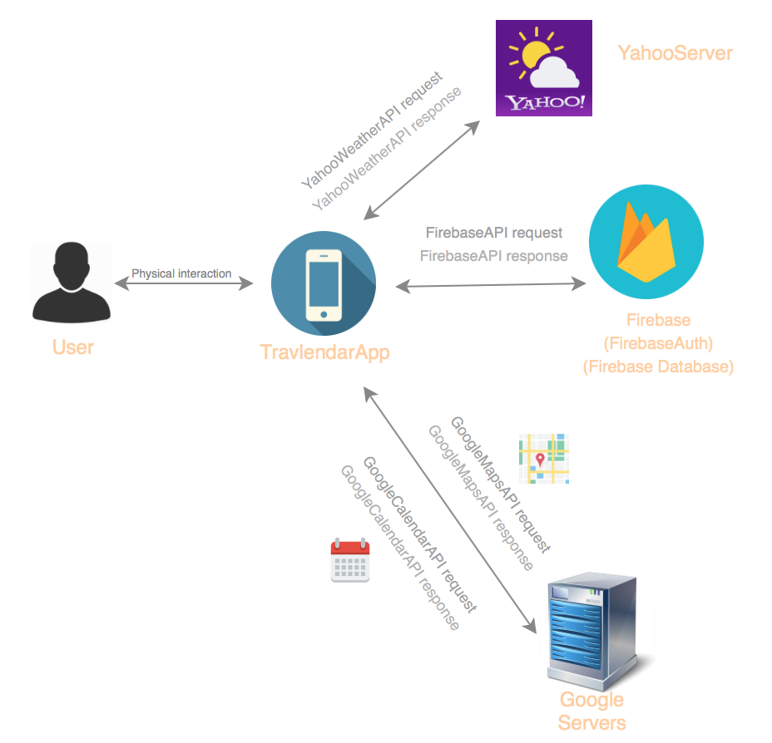

## 2.2 High level components and their interaction

The overview scheme presented in the last point naturally leads to the high-level components view. The application is just composed by three tiers, the customer mobile application, the server we use to access and compute some information (Google server) and the database to storage some information about each user as the travel preferences. All the information related to the calendar is storage in the Google account of the user.

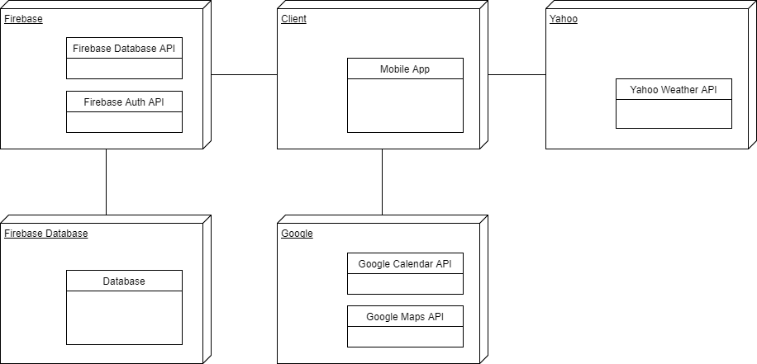

## 2.3 Component view

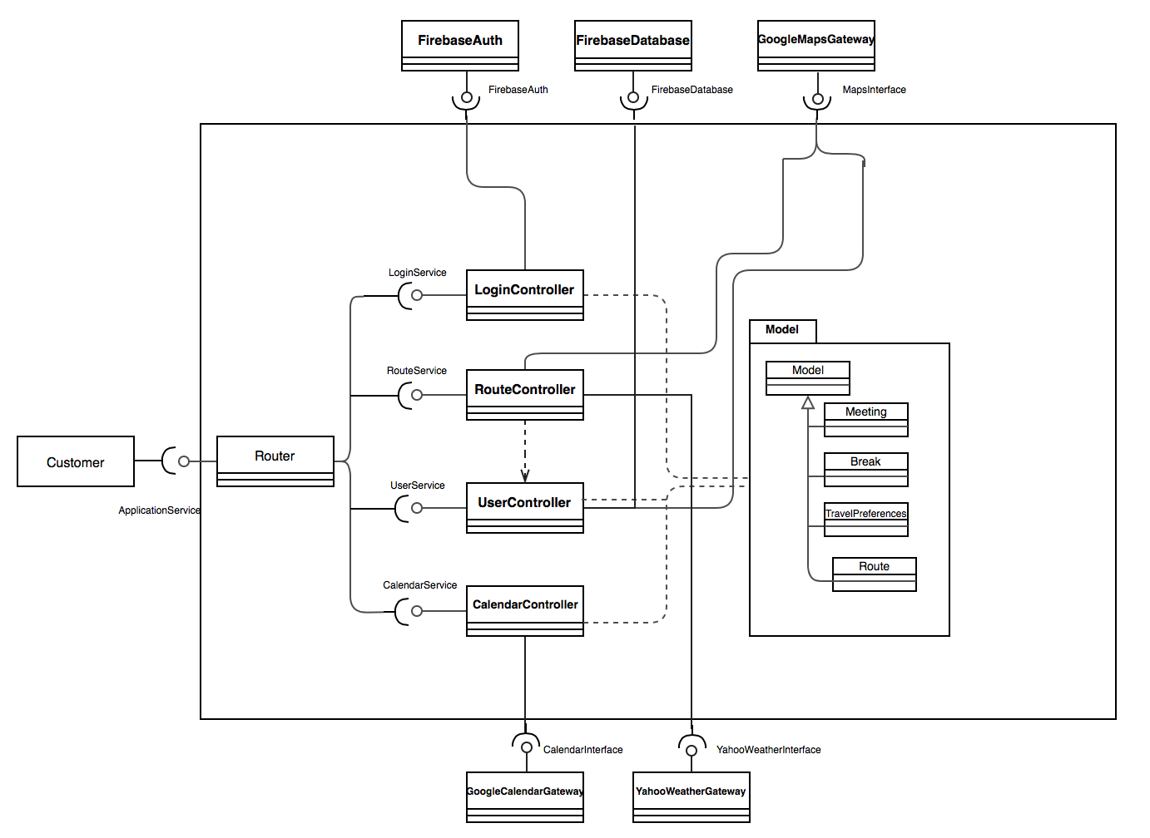

- ApplicationService: interface through which the user and the system communicate. For this it is necessary that the user has activated both the geolocation and the internet on his smartphone.

- Router: routes the requests to the appropriate system component.

- Customer: the customer´s smartphone application.

- LoginController: requires the resources of FirebaseAuth to authenticate the user correctly with his Google account. Also provides the user a Googlelogin token to access the calendar resources.

- FirebaseAuth: provides the resources for user authentication.

-RouteController: requires information about the possible routes to reach the destination to the Google API and provides the router and then the user with a route to reach their destination according to the travel preferences of the user. Also the RouteController get the location of the user through the UserController.

- UserController: requires the information about the location of the user and get the information about the user travel preferences so that the system takes it into account when offering the user the routes.

- GoogleMapsGateway: Google Maps API providing the services which enable the system to locate devices and convert a string of text provided by the customer into a location.

- MapsInterface : Internet interface providing a standard HTTPS requests handler.

- Model: representation of the world and the information with which the system operates.

- CalendarController: requires the services of the Google Calendar API and provides the calendar of the user to the router. To access to the Google Calendar the user must have previously logged in.

- GoogleCalendarGateway: Google Calendar API providing the services which enable the system to access and modify the private calendar of the user.

- FirebaseDatabase: provides the resources to store information about the user.

- YahooWeatherGateway: Yahoo Weather API providing services which enable the system to get access to the weather at the location of the user to inform him about what routes the system does not recommend.

The notifications that the application wants to give to the user will be carried out by the Google Calendar API.

## 2.4 DEPLOYMENT VIEW

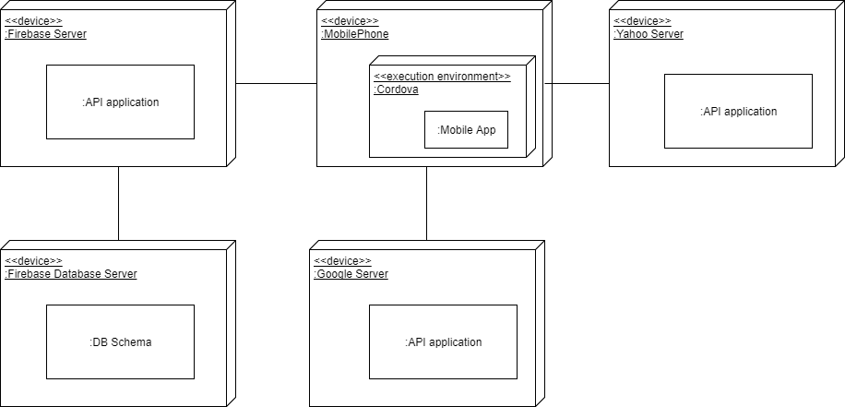

## COmponent Interfaces

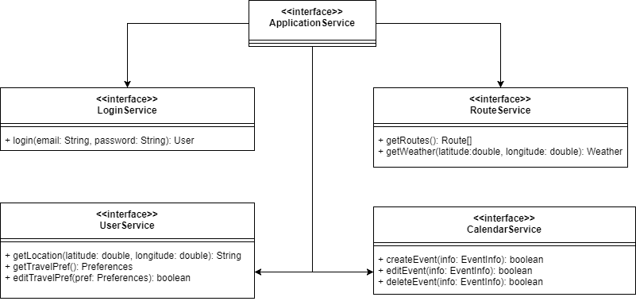

## Captura%20de%20pantalla%202017-11-15%20a%20las%208.59.53.pngRUNING VIEW

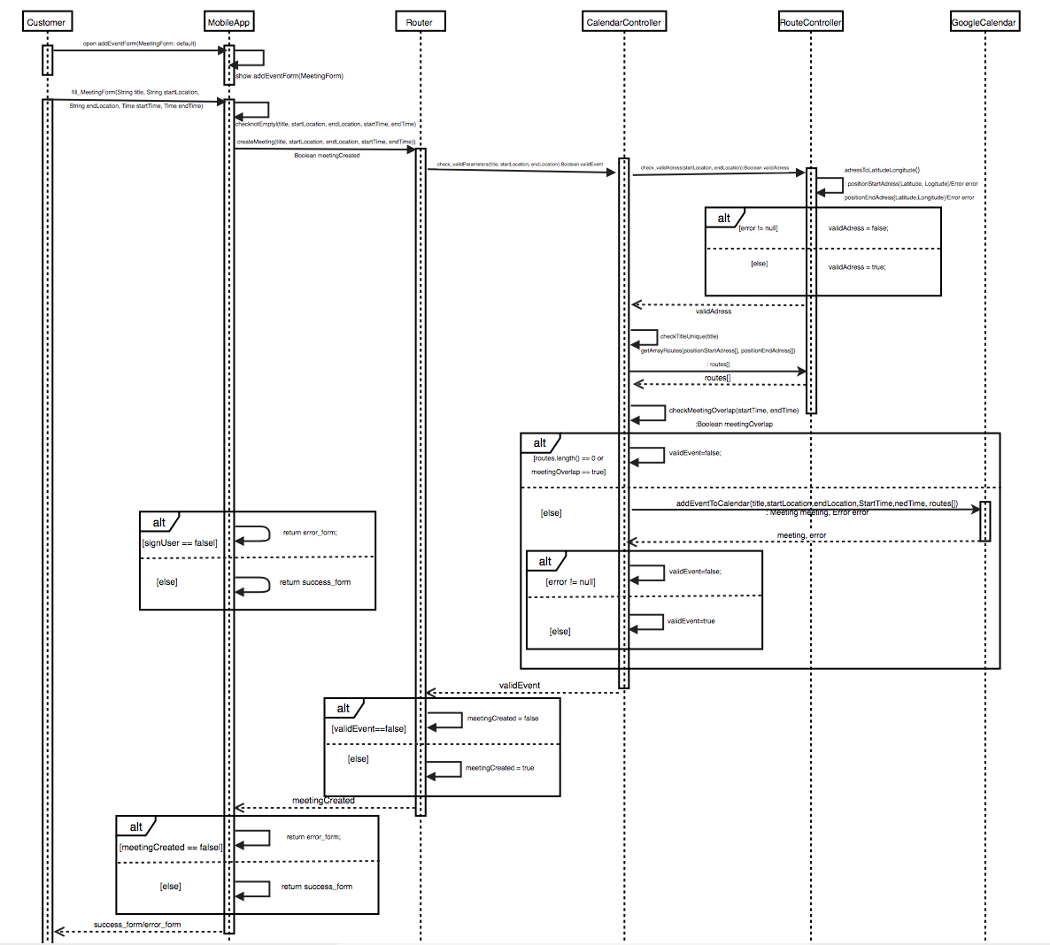

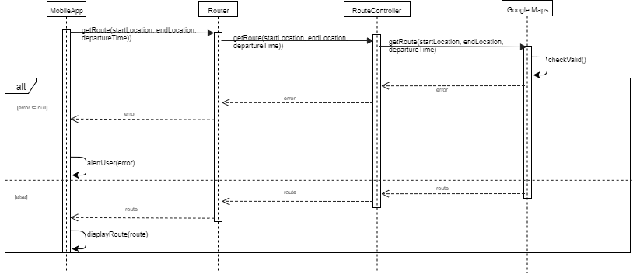

# 3.Algorithm Design

# 4.User Interface Design

# 5.Requirements Traceability

# 6.Implementation, Integration and Test plan

# 7. Effort spent

|  |  |  |
| --- | --- | --- |
| Name | Date | Hours spend |
| Plamen | 12/10/17 | 2 |
| Plamen | 15/10/17 | 5.5 |
| Plamen | 16/10/17 | 4 |
| Plamen | 17/10/17 | 1.5 |
| Plamen | 19/10/17 | 4 |
| Plamen | 21/10/17 | 5 |
| Plamen | 22/10/17 | 2 |
| Plamen | 24/10/17 | 6 |
| Plamen | 27/10/17 | 1 |
| Victor | 12/10/17 | 2 |
| Victor | 14/10/17 | 7 |
| Victor | 15/10/17 | 2 |
| Victor | 16/10/17 | 4 |
| Victor | 19/10/17 | 7 |
| Victor | 21/10/17 | 3 |
| Victor | 22/10/17 | 3.5 |
| Victor | 24/10/17 | 3 |

Total: Plamen: 31 hours

Victor:31.5 hours

# 8. References