Budget 2026 Load and Energy Forecast

2029-2031 All Source RFP and Supplemental Resources for 2028-2031 Capacity Certifications

Docket Nos. 56298 and 56310

1.0 EXECUTIVE SUMMARY OVERVIEW

In support of Georgia Power Company’s (“Georgia Power” or the “Company”) Applications for the Certification of Capacity from the 2029-2031 All-Source RFP (Docket No. 56298) and Certification of Supplemental Resources for 2028-2031 Capacity (Docket No. 56310), this document presents the Budget 2026 Load and Energy Forecast (“Budget 2026” or “B2026”).

Pursuant to the Company’s annual planning process, a twenty-year forecast of energy sales and peak demand was developed to meet Georgia Power’s planning needs. Budget 2026 includes the following retail classes: residential; commercial; industrial; Metropolitan Atlanta Rapid Transit Authority (“MARTA”); and governmental lighting. The baseline forecast was started in the spring of 2025 and completed in the fall of 2025.

As previously described in Georgia Power’s 2025 Integrated Resource Plan (“IRP”) in Docket No. 56002 and 2023 IRP Update in Docket No. 55378, Georgia has seen unprecedented growth in economic development activity since Georgia Power’s 2022 IRP was filed. Numerous new businesses and industries have come to Georgia, including significant new load related to data centers, manufacturing, and clean energy technology. This growth was incorporated into the initial 2025 IRP Load Forecast and the February 2025 Load Forecast, which was included in the Company’s 2025 IRP Rebuttal Testimony.

Since the 2025 IRP was approved in July 2025, the growth in large loads has continued. The latest data supports Georgia Power’s expectation for continued and robust economic growth in the state. Figure 1.0-1 reflects the changes since the 2025 IRP was approved.

Since the February 2025 Load Forecast, the pipeline of large load economic development projects through the mid-2030s has increased by 2,700 MW, from 48,400 MW to 51,100 MW, even after the withdrawal of numerous projects from the pipeline due to non-compliance with the Company’s rules and regulations. In addition, the size of the portfolio of large load customers that have committed to receive service from Georgia Power has increased from 8,300 MW to 8,800 MW, representing 26 committed large load projects. Of these 26 projects, 13 have broken ground and 13 are pending construction. These project additions and advancements indicate continued strong economic development activity in the state.
Figure 1.0-1: Announced Loads Considering Georgia and Georgia Power Through the Mid-2030s
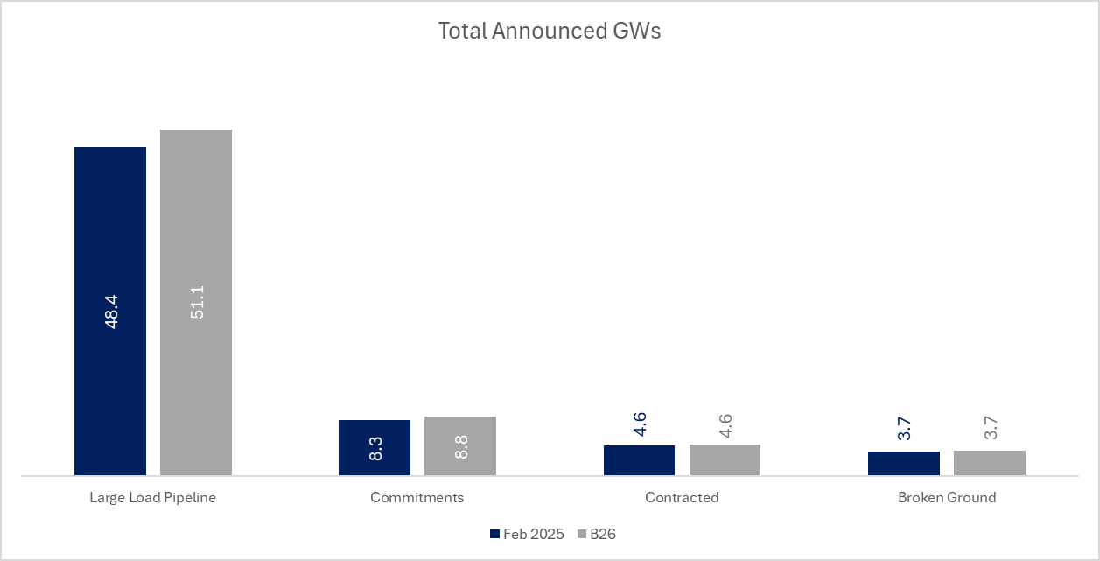

The B2026 Load and Energy Forecast projects continued extraordinary customer load growth stemming from the rapid economic development taking place in Georgia. The projected demand in Budget 2026 exceeds the demand previously projected in both the 2025 IRP and the 2023 IRP Update. A more detailed discussion of customer class energy sales and peak demand forecast results is presented below.

SUMMER AND WINTER PEAK DEMAND

Each year, Georgia Power produces a 20-year load and energy forecast in which the Company analyzes both summer and winter peak demands. The Company’s all-time peak demand of 17,985 MW occurred on August 9, 2007. Since then, Georgia Power’s total peak demand has not surpassed this level. Georgia Power’s highest winter peak demand of 16,458 MW occurred on January 17, 2024.

The summer and winter peak demand forecasts are based on normal weather. Both forecasts include the impacts of electric vehicles and behind-the-meter solar. In addition, external adjustments have been made to reflect the impacts of new large load customers, cogeneration, and the impacts of Company-sponsored Demand Side Management (“DSM”) programs approved in the 2025 IRP.

Importantly, the organic portion of the forecast, which captures growth brought by traditional lines of business and residential customers, continues to be developed using econometric and end-use models, as the Company has traditionally done. However, with the introduction of new large loads due to the extraordinary economic development taking place in Georgia, the Company developed a new forecasting methodology to reflect the unique characteristics of the new loads. First used in the 2023 IRP Update, the Company used this new methodology to incorporate the large load characteristics, as appropriate, in the form of an additional external adjustment to its organic, baseline load forecast. To account for the potential large loads resulting from economic development, the Company continues to use the Load Realization Model (“LRM”), which is a probabilistic model that evaluates one hundred thousand potential combinations of existing and potential economic development loads. These combinations can then be sorted and ranked to create a probability distribution. This distribution helps the Company assess the likelihood of the expected loads it will need to serve. The output of this probabilistic model is the basis for the external adjustment applied to the Company’s organic load forecast. Georgia Power currently anticipates a rapid increase in its summer and winter peak demands due to the new loads expected in the Commercial and Industrial classes.

The high-level impacts on peak demands resulting from new large customer loads are presented in Figures 1.1-1 and 1.1-2. These charts provide a comparison of the Budget 2025 Load Forecast (“Budget 2025”) peak demands, which were initially filed in the 2025 IRP, with the peak demands that were included in the February 2025 Load Forecast and those in the Budget 2026 Load Forecast.
As seen in Figure 1.1-1, for the period from 2026 through 2031, Budget 2026 predicts similar summer peaks when compared to the February 2025 summer peak forecast, with the growth difference being approximately 100 MW higher by 2031.
Figure 1.1-1: Summer Peak Demand Forecast
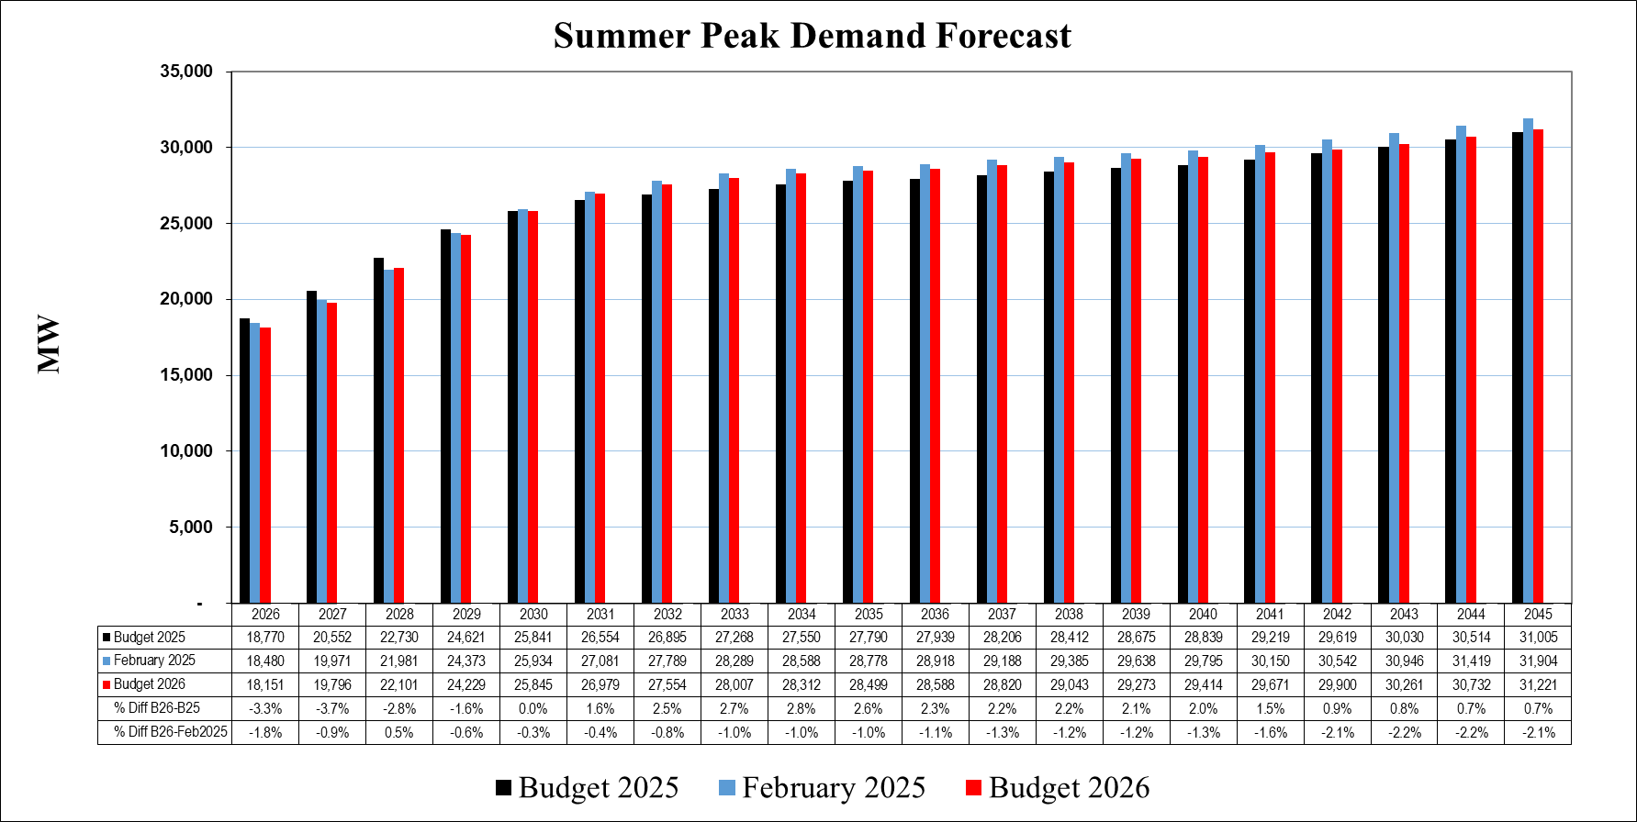
Figure 1.1-2: Winter Peak Demand Forecast
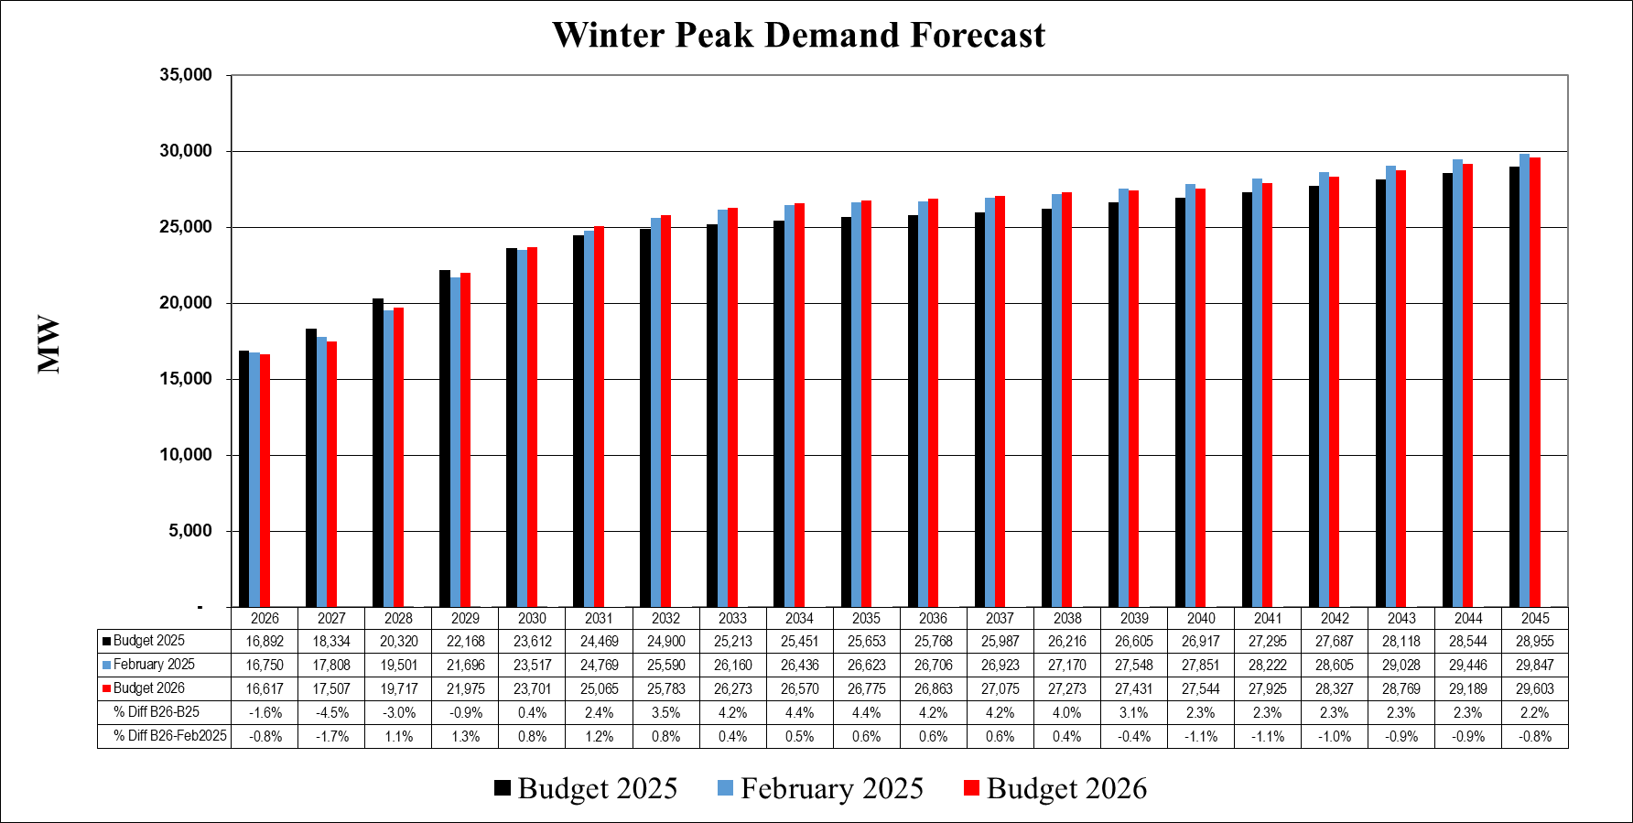
The comparisons in Figure 1-1.2 show a pattern similar to summer peak demand, with Budget 2026 winter peaks growing similarly to those presented in the February 2025 Load Forecast and Budget 2025. For the period from 2026 through 2031, Budget 2026 reflects winter load growth of approximately 8,450 MW. This growth is approximately 400 MW more than the winter load growth for the same period included in the February 2025 Load Forecast.
Comparing the summer and winter peaks in Figures 1.1-1 and 1.1-2, it is evident that Georgia Power is expected to remain a summer-peaking utility over the forecast horizon. The difference between summer and winter peaks in Budget 2026 ranges from approximately 1,500 MW to over 2,300 MW.

1.2 ENERGY SALES

1.2.1 Territorial
Figure 1.2.1-1 shows the expected growth in territorial energy sales over the forecast horizon. In absolute terms, the amount of gigawatt hour (“GWh”) growth is indicated by the average annual growth rate (“AAGR”). During the historical period from 2014 to 2024, which includes the Covid-19 pandemic, average growth increased by 363 GWh per year. The Budget 2026 Load Forecast anticipates an average growth of 8,492 GWh each year from 2025-2035, compared to the February 2025 Load Forecast and Budget 2025, which predicted growth of 8,633 GWh and 7,770 GWh per year, respectively, over this same period.

Figure 1.2.1-1: Territorial Energy Forecast
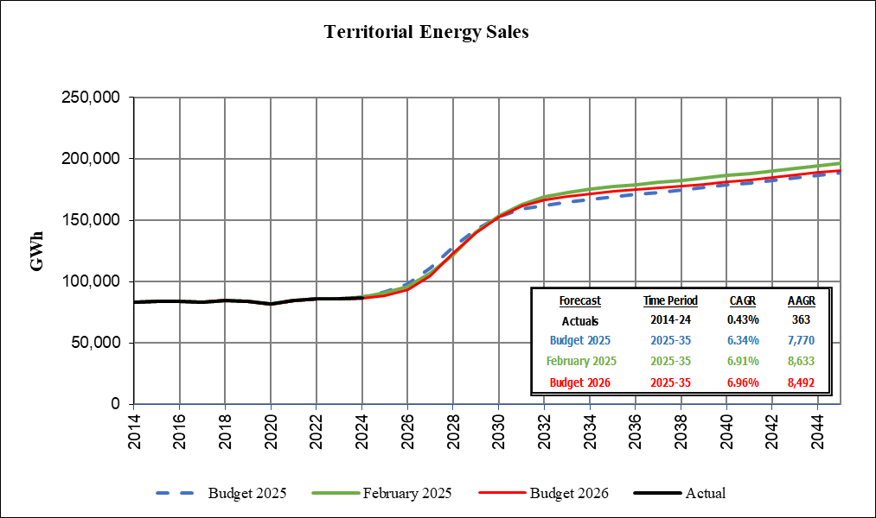

Territorial energy is a combination of the following classes: Residential; Commercial; Industrial; Governmental Lighting; and MARTA. Understanding the forecasts for each respective class provides insight into the total territorial forecast. The forecasts for each of these classes are discussed in the sections below.

1.2.2 Residential

Figure 1.2.2-1 shows the comparison of Budget 2025 and the February 2025 Load Forecast against Budget 2026 for residential energy. Over the 2014-2024 historical period, residential sales grew by an average rate of 235 GWh per year. Because there were no changes in the residential class forecasts between the original Budget 2025 and the February 2025 Load Forecast, the growth as shown in Figure 1.2.2-1 is the same. Growth is slightly lower in the B2026 Residential Energy Forecast, by roughly 60 GWh per year, due to more recent historical data. Since the new large load activity only impacts the Commercial and Industrial classes, there is no large load external adjustment needed or applied to the baseline Residential, Governmental Lighting, or MARTA classes.
Figure 1.2.2-1 Residential Energy Forecast

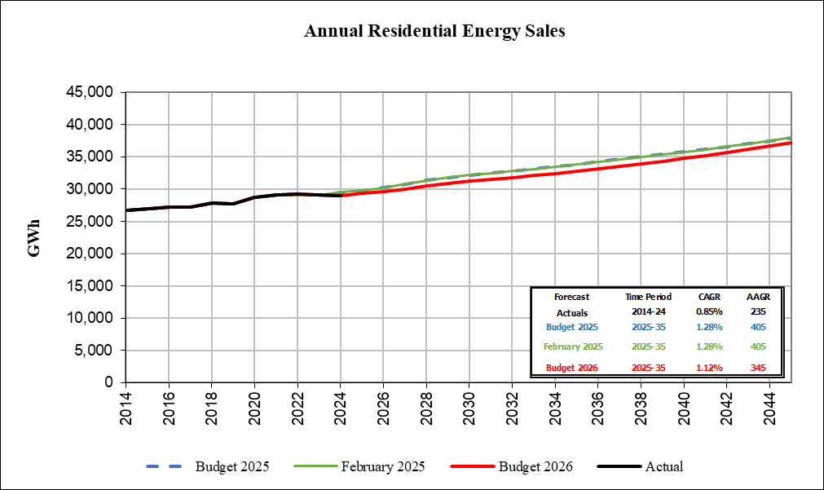

1.2.3 Commercial
From 2014-2024, average annual growth in commercial sales rose slightly, rising by an average of 147 GWh per year. Due to increases in demand from commercial electric vehicles and large load data centers, all forecasts predict a large increase in average annual growth between 2025 and 2035. For Budget 2025, this average annual growth was expected to be approximately 6,800 GWh per year. However, with an updated large load energy forecast, both the February 2025 Load Forecast and the B2026 Load Forecast for the commercial sector are predicting an even larger increase of around 7,800 GWh per year from 2025-2035.
Figure 1.2.3-1: Commercial Energy Forecast

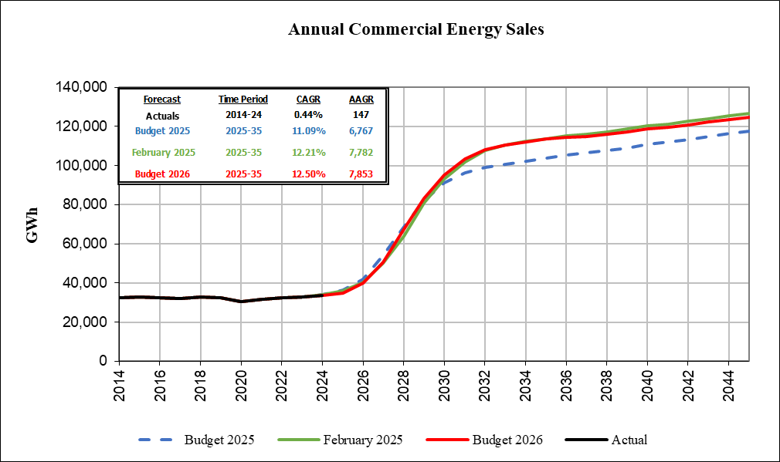

1.2.4 Industrial
Historical industrial sales from 2014-2024 rose by an average of 3 GWh per year. Figure 1.2.4-1 shows a comparison of Budget 2025, the February 2025 Load Forecast, and Budget 2026.
With new industrial historical data and an updated economic outlook, the Budget 2026 Industrial Energy Forecast is predicting an annual average growth of 305 GWh between 2025-2035, which is approximately 150 GWh lower than the February 2025 Load Forecast and 300 GWh lower than the Budget 2025 forecast.
Figure 1.2.4-1: Industrial Energy Forecast

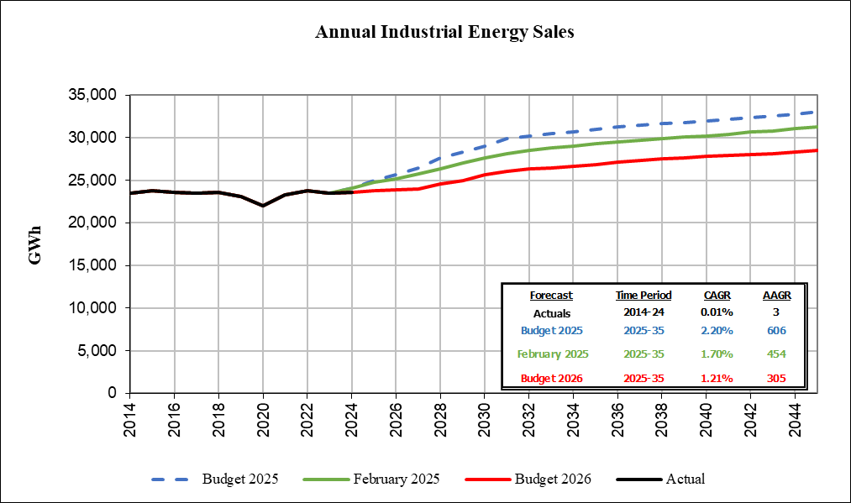

1.2.5 Other Retail: Governmental Lighting, MARTA
Regulated Governmental Lighting and MARTA are Georgia Power’s two smallest classes. Combined, they account for about 0.5% of total sales. The regulated governmental lighting forecast is comprised of roadway lighting and traffic control. Governmental lighting sales have declined significantly since 2014 as Georgia Power worked with local municipalities to convert traditional streetlights to LED lights, which use less energy. Budget 2025 and the February 2025 Load Forecast recognized that over time traditional streetlights will be replaced with LEDs as they reach the end of their useful lives. The Budget 2026 governmental lighting forecast follows a similar trajectory over the forecast horizon for the same reason, as shown in Figure 1.2.5-1.
Figure 1.2.5-1: Governmental Lighting Energy Forecast

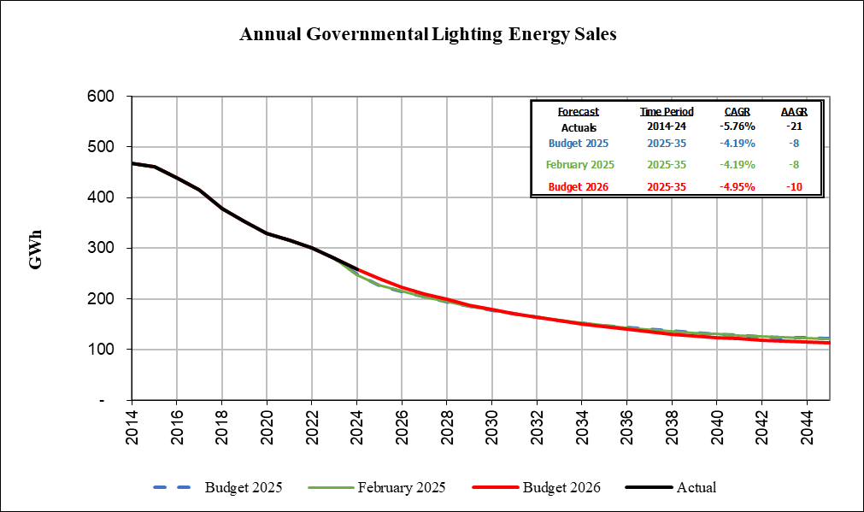

Energy sales to MARTA dropped significantly in 2020 as ridership fell due to the Covid-19 pandemic. As seen in Figure 1.2.5-2, actual sales were relatively flat from 2020-2023 as workers travelled to the office less, but recently, ridership has increased slightly. Energy use is expected to remain at a slightly higher level over the Budget 2026 Load Forecast horizon when compared to Budget 2025 and the February 2025 Load Forecast.
Figure 1.2.5-2: MARTA Energy Forecast
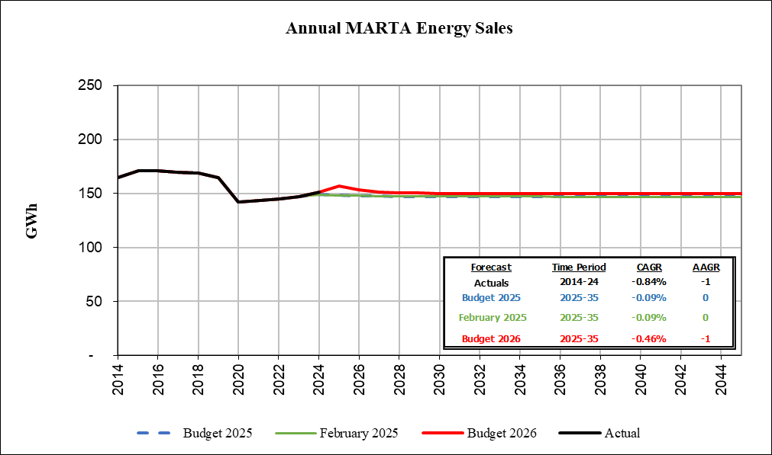

1.2.6 Forecast Summary

Figure 1.2.6-1 B2026 Load Forecast Annual Summary

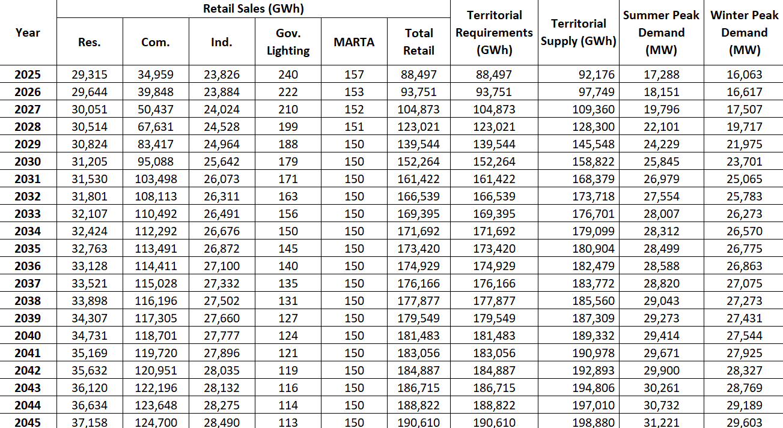

Figure 1.2.6-2 B2026 Load Forecast Customer Annual Summary (Year End)

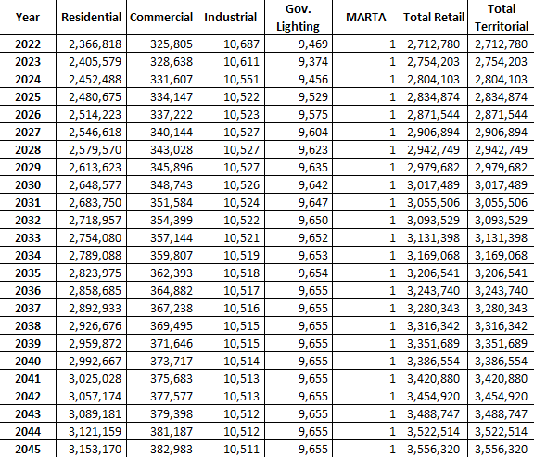

1.3 ECONOMICS
Georgia’s economy remains on solid footing and is on par or outperforming the United States in the unemployment rate and Gross State Product (“GSP”) growth. Georgia’s unemployment rate, at 3.4% in July 2025, is well below the U.S. rate of 4.2%. With respect to real (i.e., inflation adjusted) output, Georgia continues to outpace the overall U.S. economy. Real GSP for Georgia grew at 2.2% for 2025 Q1 year over year, compared to 2.0% growth in U.S. Gross Domestic Product (“GDP”) over the same period.

Georgia’s economy is benefitting from strong population growth and is currently the eighth most populous state in the nation. Since 2020 the state has added 457,000 residents, which is the fourth highest increase in the U.S. In terms of percentage growth, Georgia’s population has grown 4.3% from 2020-2024 compared to 2.7% growth for the U.S. Net domestic migration accounted for 42% of the population increase since 2020, as Georgia welcomed 190,000 residents from other states. This is the seventh highest increase in residents among the 50 states. International migration added over 194,000 residents, while natural growth, calculated as births minus deaths, increased by nearly 93,000 from 2020-2024, the fifth highest increase in the nation. Robust population growth over the past few years has supported a steady increase in Georgia’s labor force, which fuels continued economic growth.

Georgia remains an attractive place to do business. Area Development has ranked Georgia the top state for doing business for the past eleven years. The state ranks in the top five in 10 of the 14 categories used for evaluation. Most recently, Georgia was named the number one state for Best Business Climate by a survey of site selection experts in Site Selection magazine’s January 2025 edition. Georgia’s strong reputation as a state favorable for business, combined with its excellent economic development efforts have made it very successful in attracting new businesses to the state, as well as expansions of existing businesses. Corporate relocations and expansions will help fuel growth in employment, population, and incomes. Examples of businesses the state has attracted include electric vehicle battery and automobile manufacturers, solar panel manufacturers, and data centers.

Georgia is expected to experience robust economic growth over the forecast period of 2025-2045. The state has several positive attributes that will continue to attract businesses. Businesses are drawn to the state by its low cost of doing business and low cost of living, the deep pool of knowledge and technical workers coming from its university system, its globally connected airport and transportation infrastructure (e.g. ports, highways), and its business-friendly government policies. Positive demographic trends will also drive economic growth in the state. As businesses relocate and expand in Georgia, the state will experience solid employment growth, which will attract new residents. Over the forecast period, Georgia’s population is expected to grow at an average annual rate of 0.6%, double the U.S. average of 0.3%.

While changes in federal economic policy under the new administration may introduce some uncertainty, Georgia’s relative economic strength is expected to remain intact. The state is well-positioned to maintain its advantage over the national economy.

1.4 FORECAST ASSUMPTIONS AND METHODS

The assumptions underlying Budget 2026 were developed by Southern Company Services (“SCS”). The forecast was developed through careful consideration and methodical examination of key demographic and economic variables that historically have been significant indicators of energy consumption. Major assumptions include the economic outlook for the U.S. and Georgia, energy prices, and market profiles for class end uses.

The economic forecast provides a description of the economy for the next 20 years and includes many elements of the economy such as gross product, population, employment, commercial building square footage, and industrial production. The economic and demographic forecasts for Budget 2026 were obtained from S&P Global, a national provider of economic data and forecasts.

The models used to produce both the short- and long-term energy forecasts include a variety of economic and demographic variables as drivers of energy use. Weather, income, employment, historical load data, and industry standards for electrical equipment are among the variables used in the forecasting models. “Normal” weather is defined as the average of Cooling Degree Hours (“CDH”) and Heating Degree Hours (“HDH”) from 1980-2024.

Short-term energy projections for the residential, commercial, industrial, and MARTA are based on linear regression models. The short-term energy projections for the government lighting class use a simple growth rate, based on a 5-year compound annual growth rate, to capture the short-term trend. Cubic spline interpolation is used to moderate the rate of decline over the long-term forecast horizon. Except for MARTA, which is a single customer, projections of customers by class also utilize linear regression methods.

Except for governmental lighting and MARTA, the long-term forecast models are end-use models. The Budget 2026 forecast uses the Load Management Analysis and Planning (“LoadMAP”) model to produce the long-term residential, commercial, and industrial forecasts. The governmental lighting and MARTA long-term forecasts use the same models developed for the short-term forecast.

The results of the short-term and long-term models are integrated into a unified forecast. In Budget 2026, the short-term forecast results were used for the years 2025 through 2030 and the long-term results were used for 2031 to 2045. Additional information on methodology can be found in Section 3.

Budget 2026 uses hourly Metrix Peak Demand models (“MPD”) for each class to predict Georgia Power’s weather-normal peak demands over the 2025 – 2045 forecast period.

Budget 2026 utilizes the Load Realization Model (“LRM”) to estimate how new large loads will materialize over the forecast horizon. The LRM is a probabilistic model that utilizes Monte Carlo simulation to estimate expected loads for new large load customers. These estimates are used as external adjustments to the baseline commercial and industrial forecasts. A description of the model and assumptions can be found in Section 1.5.

1.5 FORECAST ADJUSTMENTS FOR LARGE CUSTOMERS

Budget 2026 continues to utilize the LRM approved in the 2025 IRP to capture the impact of large load customers on the Company’s forecast. This model uses a probabilistic approach to evaluate the range and likelihood of future potential outcomes of the load growth from new large-load customers. The results of this approach support the external adjustment applied to the commercial and industrial load and energy forecasts. This section describes the methodology and assumptions behind the probabilistic approach.

Consistent with the approach used in the 2025 IRP, Budget 2026 includes an external adjustment to its baseline, organic forecast to account for the increased large load additions described herein. An external adjustment is needed for these loads since Georgia’s unprecedented economic development growth would not otherwise be captured in the historical trends underlying the baseline forecast.

Georgia Power developed a method to estimate the impacts of large projects on its system while also addressing the inherent uncertainties around whether such projects will ultimately locate in Georgia, select Georgia Power as the electric service provider, and come online with the anticipated load. The probabilistic model Georgia Power developed to address these considerations, the LRM, is discussed in the section below.

1.5.1 LOAD REALIZATION MODEL (LRM) OVERVIEW
1.5.1.1 Customer-Provided Inputs
For each large load project the Company evaluated and included in the B2026 Load Forecast, the following information is provided:
- Commercial Operation Date (“COD”): When the initial load is expected to start.
- Ramp-Up: A year-by-year load trajectory.
- Announced Load: The design capacity for the project load, which corresponds to the maximum load of the ramp-up schedule provided by each customer. The Company’s Power Delivery organization uses this information to properly size the facilities and purchase equipment to serve the new load.
- Class: Industrial or commercial.
- Segment: This criterion corresponds to the particular segment of a business within a customer class, such as cryptocurrency, datacenter, warehouse, battery manufacturing, chemicals, or solar.
1.5.1.2 Modeling Project Uncertainty
Each large load project contains multiple dimensions of uncertainty that must be considered and analyzed. The first element of uncertainty to consider is whether the potential customers will choose to locate in Georgia. A customer may ultimately end up choosing a different state as the location of a project despite initial indications of interest in Georgia. If a large load customer elects to locate in Georgia, there is still uncertainty due to the competitive nature of the bidding process for large load customers among electric service providers in the state, and a customer may choose to sign a contract for electric service (“CES”) with an electric service provider other than Georgia Power. There is even some uncertainty once a customer signs a CES with Georgia Power, as the project could fail to materialize due to unforeseen circumstances such as financial or other economic conditions. In addition, based on Georgia Power’s experience, the load announced by a customer is only an estimate of its metered load, and can materialize at a level lower than announced or anticipated. Finally, the commercial operation date of a project can be delayed, thus causing load to materialize later than initially expected. Figure 1.5.1.2-1 below illustrates the Company’s process and sequencing for the evaluation of uncertainties related to large load projects.
Figure 1.5.1.2-1: Sequencing of Large Load and Sources of Uncertainty
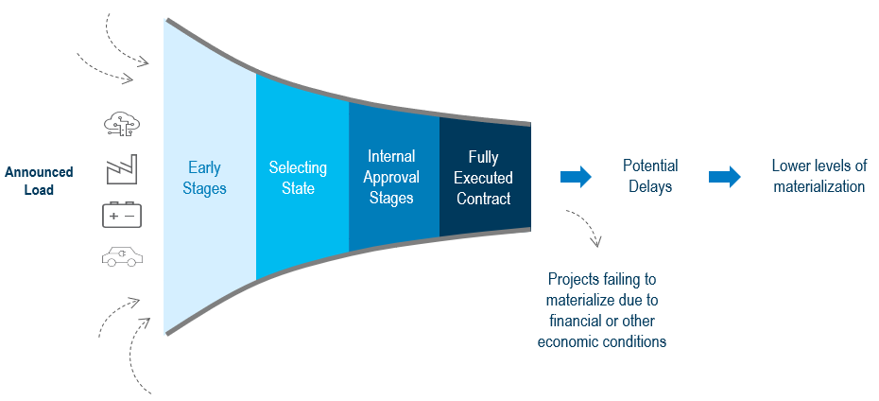
1.5.1.3 Project Success
The Company uses a probabilistic approach to account for the uncertainties described in the previous section to determine the likelihood of success or failure of an individual project. The success of a project requires each of the following three events:
- Georgia is chosen as the location of the project by customer obtaining site control
- The customer signs a Contract for Electric Service with Georgia Power for the project.
- The project remains financially viable such that commercial operation can be achieved after a contract has been signed with Georgia Power.

1.5.1.4 State Selection
Customers often evaluate sites in multiple states before finalizing the location of a project. Mathematically, state selection can be treated as a binary event, with one (1) assigned for customers that select Georgia and zero (0) for customers that select a different state. For those customers contemplating Georgia as a place for doing business, a probability (referred to as P1) can be assigned for the likelihood of state selection. Likelihood for projects without site control can be estimated based on a historical selection rate that is calculated based on the number of projects that chose Georgia versus the number of projects that did not.
1.5.1.5 Electric Service Provider
Whether a customer signs a CES with Georgia Power can also be treated as a binary event. The probability of the customer signing a CES with Georgia Power (referred to as P2) is determined by the Company based on the following criteria and milestones (see Figure 1.5.1.5-1 for a visual illustration):
- REDACTED for customers that have signed a CES
- REDACTED for customers that have submitted a request for electric service (“RFS”) but have not yet signed a CES
- REDACTED for projects that have completed Timeline Review but have yet to submit an RFS
- REDACTED for projects that have completed Transmission Study but have yet to complete Timeline Review
- REDACTED for projects that haven’t completed Transmission Study and are not on hold
- REDACTED for projects that are on hold

Figure 1.5.1.5-1: Criteria/Milestones for P2 (Probability of Signing a CES with Georgia Power)
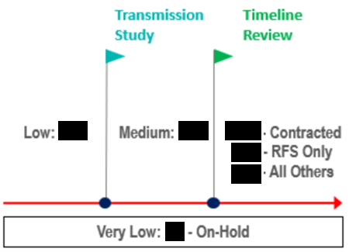
1.5.1.6 Project Reaching Commercial Operation
The probability of projects remaining financially viable such that commercial operations after signing a CES can be achieved (referred to as P3) is based on a historical financial default analysis of companies rated BBB+ or above.
For a new large load project to be considered successful, all three of the above events (i.e., state selection, signing a CES with Georgia Power, and the project remaining financially viable) must occur. In other words, project success or failure is a binary event that is reflected by the probability formula P = P1*P2*P3.
1.5.1.7 Announced Load vs. Metered Load
In addition to a project’s ability to reach commercial operations, measured by P1, P2 and P3, the company must also account for the potential difference between the metered load being served, as measured at the customer’s meter, versus the load announced by the customer. Georgia Power defines load materialization as the percentage of load (MW or GW) at the meter at full operation compared to the customer’s announced load (e.g., the sum of all planned interconnected equipment behind-the-meter or design capacity). The ratio (in %) between metered load and announced load is treated as a range. In the absence of relevant and robust historical data, the Company identifies minimum and maximum values for this range, as well as a most likely outcome. For example, in the case of data centers (hyperscaler), the range is between REDACTED and REDACTED of the customer’s announced load, with a most likely outcome of REDACTED. Mathematically, this is modeled with a triangular distribution (see Section 1.5.3 for more technical details).
Table 1.5.1.7-1 below demonstrates the parameter inputs for modeling the metered load compared to the announced load, based on the customer class and segment.
Table 1.5.1.7-1: Specifications of Triangular Distributions for Metered vs. Announced
Class | Segment | Low | Mid | High
Commercial | Cryptocurrency | REDACTED | REDACTED | REDACTED
 | Data Center (Hyperscaler) | REDACTED | REDACTED | REDACTED
 | Data Center (Colocator with Tenants) | REDACTED | REDACTED | REDACTED
 | Data Center (Colocator without Tenants) | REDACTED | REDACTED | REDACTED
 | Data Center (Developers with Data Center Experience) | REDACTED | REDACTED | REDACTED
 | Data Center (Developers without Data Center Experience) | REDACTED | REDACTED | REDACTED
 | Segments Other than Data Center and Cryptocurrency | REDACTED | REDACTED | REDACTED
Industrial | All Segments | REDACTED | REDACTED | REDACTED

1.5.1.8 Commercial Operation Date Delays
Project construction delays are both normal and expected. As such, the Company evaluates whether each customer in the forecast will reach commercial operation by its requested commercial operation date. The LRM assumes a range of delays in months to account for the possibility that commercial operation might occur later than requested by the potential customer. If the customer provides new information indicating that its load may now manifest later than originally requested, the Company will apply the aforementioned range of delays to the latest available information. The expected delays are shown in Table 1.5.1.8-1 and can range between REDACTED months, with a most likely delay of REDACTED months. The parameter inputs for modeling the probability of delays in commercial operation are based on the Company’s estimates.
Table 1.5.1.8-1: Specifications of Triangular Distributions for Delay
Class | Segment | Low | Mid | High
Commercial | All segments | REDACTED | REDACTED | REDACTED
Industrial | All Segments | REDACTED | REDACTED | REDACTED
1.5.2 MODELING THE PORTFOLIO
The portfolio of large load projects being assessed by the Company consists of projects in numerous phases of development, ranging from early stages, such as the state selection or site selection phases, to those under construction and projected to be served by the Company. This creates multiple dimensions of uncertainty for each project that requires a Monte Carlo simulation model to quantify a range of expected load to serve.
Monte Carlo simulation is a mathematical technique that is used to estimate the possible outcomes of a portfolio with uncertain events. Unlike a normal forecasting model, Monte Carlo simulation predicts a set of outcomes based on an estimated range of values versus a set of fixed input values. The simulation assigns random values to input variables with uncertainty based on probability distributions, such as the triangular distributions discussed in Section 1.5.1.7, and calculates an outcome. It then repeats the process over and over, each time using a different set of random inputs, to produce 100,000 different outcomes.
1.5.2.1 Model Implementation
The model described herein is implemented in Excel with a third-party add-in called @Risk. @Risk allows the incorporation of probability distributions into an Excel spreadsheet so that Monte Carlo simulation and analysis can be done to track the range of potential outcomes and calculate a wide array of statistics (average, standard deviation, percentiles, etc.).
For each project in the model, there are three random numbers being drawn for success/failure, metered/announced ratio, and delay in COD from the distributions described in Section 1.5.1. For a particular draw, if the success/failure random number is 0, or failure, the load of the project is 0 and the project is excluded from the portfolio. If the success/failure random number is 1, or success, the announced load ramp-up gets scaled by the metered/announced ratio random number and then shifted according to the timing of the ramp-up by the number of months determined by the delay in COD random number. Finally, this adjusted and shifted ramp-up is aggregated year by year into the portfolio level.
1.5.2.2 Simulation Results
The procedure described in Section 1.5.2.1 is repeated 100,000 times. Then, these 100,000 load iterations get ranked for each year to calculate load percentiles, which helps the Company to understand the load range and compare the likelihood of load outcomes for the portfolio. Table 1.5.2.3-1 shows the external adjustments included in the B2026 Load Forecast, which are consistent with the 50th percentile of simulated load.
1.5.2.3 External Peak Adjustments for Large Loads
The large load data center energy forecast from the LRM (i.e., the 50th percentile of simulated load described in Section 1.5.2.2) gets a data center load shape applied to it to produce hourly load values. These values are then added to the organic hourly load forecast values for the commercial class load and resulting class peak. Similarly, the energy forecast for new large load industrial customers gets an industrial load shape applied to it, and the hourly values are added to the baseline organic hourly load forecast to produce the total industrial class peak.
Table 1.5.2.3-1 B2026 LRM Output (Q4 of each year) and External Summer Peak Adjustments for Large Loads
1.5.3 TRIANGULAR DISTRIBUTION
The triangular distribution is a continuous probability distribution with the following parameters:
a: a ∈ (-∞, ∞)
b: a < b
c: a ≤ c ≤ b
In the case of metered versus announced uncertainty, a represents the minimum metered/announced ratio, b represents maximum metered/announced ratio, and c represents the most likely metered/announced ratio.
Figure 1.5.3-1: Probability Density Function for a Triangular Distribution
REDACTED

Figure 1.5.3-2: Illustration of Probability Density Function of Triangular Distribution with a=REDACTED, c= REDACTED and b= REDACTED
REDACTED

Triangular distributions are chosen for this model for the following reasons:
- A triangular distribution has a finite range while other commonly used probability distributions such as normal and lognormal distributions have an infinite range and can even be negative, which is inappropriate to depict the actual/announced ratio.
- The min/max/most likely parametric setup of triangular distributions is intuitive and straightforward to interpret. In contrast, the parameters of some other commonly used distributions are somewhat opaque. For example, normal distributions are defined in terms of mean and standard deviation. Additional calculations are needed to translate those into the range of outcomes that are more appropriate for the context of actual vs. announced load.
- Other than the standard min/max/most likely parametric setup, triangular distributions can also be defined by a combination of percentiles, min, max and most likely, which offers more flexibility to fine tune the model.

The Budget 2026 Load and Energy Forecast is based on data from the Company’s large load economic development pipeline as of the end of Q2 2025 capturing changes through mid-August.
Committed large load projects have signed a Request for Electric Service from Georgia Power.
The Company denotes the winter of 2025/2026 as 2026 and applies this treatment to future seasons and years in Figure 1.1-2. This designation is because the Company’s projected peak winter demand is in January of each year.
⁴ Press Release, Brian P. Kemp, Governor of Georgia, Gov. Kemp Celebrates Top State for Business Ranking at Workforce Summit (September 13, 2024), https://georgia.org/press-release/gov-kemp-celebrates-top-state-business-ranking-workforce-summit.
Ron Starner, Site Selectors Survey: Why Site Selectors Love the South, Site Selection (January 2025) https://siteselection.com/site-selectors-survey-why-site-selectors-love-the-south/?utm_source=InvestorWatch&utm_medium=email&utm_campaign=Editorialllll.

