Stochastic TOC modeling for East African Rift System Lakes, a possible pre-salt analogous.

**CARREIRA, V.R.** a\***, VENANCIO, I.M.** b**, BELEM A.L.** c**, NASCIMENTO, R.A.**a**, SOUZA, I.V.A.F.**d**, SPIGOLON, A.L.D**d**, ALBUQUERQUE, A.L.S.** a

a**PROGRAMA DE PÓS-GRADUAÇÃO DINÂMICA DOS OCEANOS E DA TERRA, UNIVERSIDADE FEDERAL FLUMINENSE, NITERÓI, BRASIL**

**b PROGRAMA DE PÓS-GRADUAÇÃO EM GEOCIÊNCIAS (GEOQUÍMICA), UNIVERSIDADE FEDERAL FLUMINENSE, NITERÓI, BRASIL**

**c **DEPARTAMENTO DE ENGENHARIA AGRÍCOLA E MEIO AMBIENTE (OBSERVATÓRIO OCEANOGRÁFICO), UNIVERSIDADE FEDERAL FLUMINE**N**SE, NITERÓI, BRASIL****

**d **Division of Geochemistry, Petrobras Research and Development Center (CENPES), Av. Horácio Macedo, 950, Cidade Universitária, 21.941-915 Rio de Janeiro, RJ, Brazil, c PETROBRAS Exploração (EXP/TPGG/TDGEO)****

*correspondence: victorcarreira@id.uff.br

**Copyright 2023, ALAGO.**

This paper was selected for presentation by an ALAGO Scientific Committee following review of information contained in an abstract submitted by the author(s).

**Introduction**

In Brazil, one of the key challenges concerning ultra-deepwater exploitation is the complete understanding of the paleoenvironment and its variables that compose Total Organic Content (TOC), in lake systems [1]. Brazilian geoscientists aim for the part of this goal by defining pre-salt sequence as sedimentary rich organic rocks formed in great rift lake systems during Lower Cretaceous Period [2]. According to the uniformitarianism principle, a structural pre-salt analogous is suggested, in this work, from TOC’s studies of the East African Rift Lakes [3,4].

Fuzzy systems models are great metaheuristic tools that can enlighten TOC modeling while the lake's function is not known and its variables have a strong statistical dependence [5]. One case is the TOC’s predictive modeling problem. In this case, it is possible to simulate over a sequence of different lakes scenarios of accumulation and preservation of the organic carbon before diagenetic processes, generating fundamental information about the potential lacustrine source rocks.

This work aims to validate a direct fuzzy model that predicts the Total Organic Content (TOC) inside Rift Lake Systems. In this sense, we use as a geological analogous to pre-salt Rift System the East African Lakes that have TOC data available and compare two different membership functions[7].

**Experimental**

For the total organic carbon simulation, we use a data set composed of lake variables such as dissolved oxygen (mg/L), sedimentation rate (cm/kyear), grain size deposit (mm), grain selection(mm), primary productivity (gC/m²/year), lake depth (m), and TOC (%) of five great African lakes known as Lakes Edward, Mobutu, Kivu, Tanganyika, and Victoria.

The methodology is described in Figure 1.

Antecedents and consequent variables

Linguistic universe

Fuzzy Rules

Membership functions

Triangular

Trapezoidal

Aggregation

Aggregation

Defuzzification

Defuzzification

TOC

TOC

Error

Error

Comparison

**Figure 1. Methodological flowchart.**

In the defuzzification stage, two membership functions (trapezoidal and triangular) were selected to estimate the original TOC value. Defuzzification is the process in which a fuzzy set can be represented by a real number [6]. Figure 2 shows defuzzification the process for Victoria Lake.

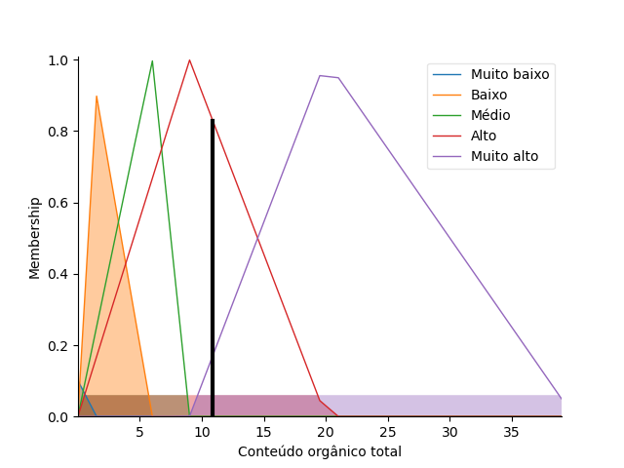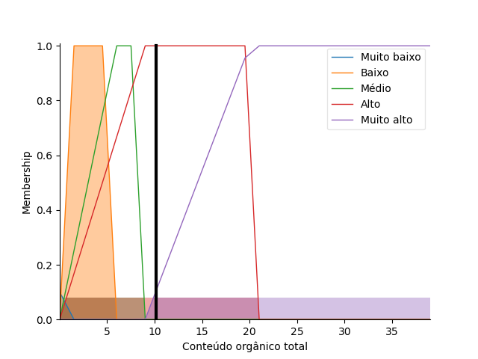 (a) (b)

**Figure 2. (a) defuzzification process using a trapezoidal membership function. (b) defuzzification process using a triangular membership function.**

The error was determined by the calculation of the Loss function between the observed TOC data and the calculated TOC fuzzy data.

**Results and Discussion**

The tests carried out with the previously selected lake data, in the East African Rift System show that the results obtained by the fuzzy model are in agreement with the measured TOC. In Lake Victoria, calculated TOC shows values up to 11%. This value coincides with the observed TOC.

In most of the lakes studied membership function tests show a better performance for triangular function. Victoria Lakes presents an error of 0.35% for the triangular function and 1.89% for the trapezoidal function.

**F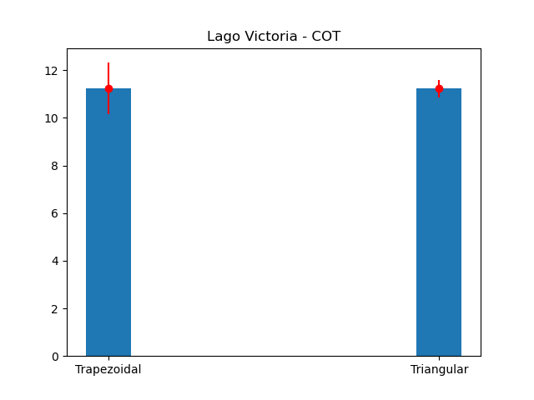igure 3. Predictive TOC comparison between two memberships functions in Victoria Lake.**

**Conclusions**

The simulations held for the East African Lake Systems showed good results for TOC estimation when a lake TOC function is not known. The TOC concentration is better estimated when triangular membership functions are applied. The data indicates that the organic matter contents can be estimated considering important environmental variables such as primary productivity (maximum of 600 gC/m²/year) and dissolved oxygen, but also when geological parameters such as sedimentation rate, granulometry, and selection are considered.

**Acknowledgments**

The authors thank ANP (Brazilian Petroleum Agency), Petrobras S/A, UFF and PR4 project for financial support.

**References**

[1] Xue, Y.; Clarke, D.; Wang, K. 2022. Multiscenario-based deep learning workflow for high-resolution seismic inversion on Brazil presalt 4D. Second International Meeting for Applied Geoscience & Energy. <https://doi.org/10.1190/image2022-3739686.1>

[2] Neves, I., Lupinacci, W., Ferreira, D., Zambrini, J., Oliveira, L., Azul, M., Ferrari, A., Gambôa, L. (2019). Presalt reservoirs of the Santos Basin: Cyclicity, electrofacies, and tectonic-sedimentary evolution. Interpretation. 7. 1-37. [10.1190/int-2018-0237.1](http://dx.doi.org/10.1190/int-2018-0237.1).

[3] Cazier, E. C., Bargas, C., Buambua, L., Cardoso, S., Ferreira, H., Inman, K., ... & Shinol, J. (2014, September). Petroleum geology of Cameia field, deepwater pre-salt Kwanza basin, Angola, West Africa. In *AAPG International Conference and Exhibition, Istanbul, Turkey. Actas* (Vol. 4, pp. 14-176)

[4] Reinterpreting the South Atlantic Pre-Salt ‘Microbialite’ reservoirs: petrographic, isotopic and seismic evidence for a shallow evaporitic lake depositional model (2018). First Break. <https://doi.org/10.3997/1365-2397.n0094>

[5] Siddig, O., Gamal, H., Soupios, P. Utilization of adaptive neuro-fuzzy interference system and functional network in prediction of total organic carbon content. *SN Appl. Sci.* **4**, 16 (2022). https://doi.org/10.1007/s42452-021-04899-5

[6] Jafelice, R. S. M., Fuzzy teory set applications (in Portuguese) – São Carlos, SP. SBMAC, 2012, 119p., v 17, second edition. ISBN: 978-85-86883-62-0

[7] Wright, P. and Tosca, N. A Geochemical Model for the Formation of the Pre-Salt Reservoirs, Santos Basin, Brazil: Implications for Understanding Reservoir Distribution, 2016. APPG Annual Convention and Exhibition.