**ME 610 – HW2**

**Static and Modal reduction of a 92-DOF Space Station Model**

**Victor Cavalcanti**

**OBJECTIVE**

The objective of this assignment is to briefly compare two reduction techniques, with the end goal of recommending how many accelerometers should be placed on the structure. Both Static (Guyan) and Modal reduction will be performed. These two techniques will be applied to a simple 92-DOF model of a space station, whose information has been provided in the file ‘Station.mat’. The provided FEM will first be reduced to a 25DOF static TAM, then a 15 DOF static TAM. The frequencies and the cross/self-orthogonality of the modes will be compared. The model will then be subjected to a prescribed force at node 117y. A simulation will run for 1000 time-steps of 0.01s, and the acceleration response of node 206x will be recorded and compared between these various TAMs.

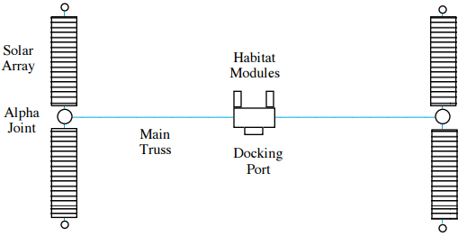

Figure 1- Simple model of a space station.

**PROCEDURE**

|  |  |
| --- | --- |
| 15 DOF | 25 DOF |
| 101.2 | 101.1 |
| 110.2 | 101.2 |
| 117.2 | 106.2 |
| 122.2 | 110.1 |
| 203.1 | 110.2 |
| 206.1 | 111.2 |
| 213.1 | 117.2 |
| 216.1 | 122.1 |
| 216.2 | 122.2 |
| 303.1 | 203.1 |
| 306.1 | 203.2 |
| 306.2 | 206.1 |
| 313.1 | 206.2 |
| 316.1 | 213.1 |
| 316.2 | 213.2 |
| - | 216.1 |
| - | 216.2 |
| - | 303.1 |
| - | 303.2 |
| - | 306.1 |
| - | 306.2 |
| - | 313.1 |
| - | 313.2 |
| - | 316.1 |
| - | 316.2 |

The initial process involves choosing a set of 25 and then 15 DOFs to keep for the static reduction. The list of DOFs chosen for both sets is shown to the right, while the graphical representation of their location on a simplified rendering of the FEM is shown below. The procedure for static reduction can be found in **APPENDIX A**.

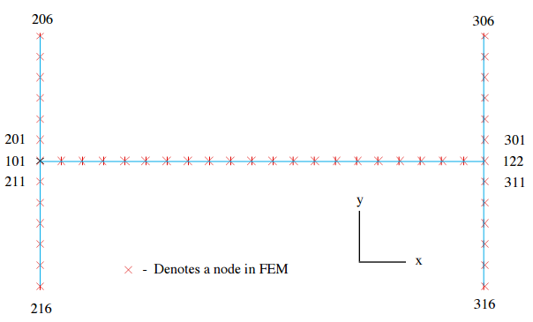

Figure 2-Node and accelerometer locations of the station model. The black arrows represent the 15 DOF chosen for reduction, while the black AND red represent the 25 DOF chosen.

Besides the two static TAM, a modal TAM will also be generated using the first 11 modes (3 rigid body and 8 elastic) of the FEM target modes. The same set of 15DOF will be used for this reduction. The process for doing a modal reduction is described in **APPENDIX A.** After the reduction, the modes will be compared using self and cross-orthogonality. The procedure for which can be found in **APPENDIX B.**

After the system has been reduced and modes compared, a simulation will be run for 1000 timesteps of 0.01s. This can be done using MATLAB’s lsim command, after a state space system has been created. To do this, first begin by representing the physical displacement of our system as a product of our Eigenmodes, $Φ$ and our modal coordinates, $η$:

$u\left(t\right)=\sum_{r=1}^{N}{ϕ_{r}η_{r}\left(t\right)}=Φη$ (1)

Which when plugged into our differential equation:

$M\ddot{u}+Ku=p(t)$ (2)

Gives us, after some manipulation:

$\ddot{η}+M^{-1}Kη={M^{-1}Φ}^{T}p(t)$ (3)

Where $M and K$ are now our modal mass and stiffness matrices. We can model this equation in a state space system by setting up:

$z= \left\lfloor \begin{aligned}z_{1} \\ z_{2}\end{aligned}\right\rfloor =\left\lfloor \begin{aligned}η \\ \dot{η}\end{aligned}\right\rfloor$ (4)

$\dot{z}=\left\lfloor \begin{aligned}\dot{z_{1}} \\ \ddot{z_{2}}\end{aligned}\right\rfloor = \left\lfloor \begin{aligned}0 \\ -M^{-1}Kη\end{aligned} | \begin{aligned}I \\ 0\end{aligned}\right\rfloor +\left\lfloor \begin{aligned}0 \\ Φ^{T}\end{aligned}\right\rfloor p(t)$ (5)

$a\left(t\right)= -M^{-1}Kη+{M^{-1}Φ}^{T}p(t)=\left\lfloor \begin{aligned}-M^{-1}Kη\end{aligned} | 0\right\rfloor \left\lfloor \begin{aligned}z_{1} \\ z_{2}\end{aligned}\right\rfloor +M^{-1}Φ^{T}p(t)$ (6)

This simulation will be run for the 15DOF TAM, the FEM and the Modal TAM. For both the 15DOF TAM and the Modal TAM, only the first 11 modes will be used (3 Rigid Body and 8 flexible).

**RESULTS**

Below are the results for the self and cross orthogonality of the modes (excluding rigid body modes). The numerical values are presented in **APPENDIX C.**



Figure 3-Cross and Self Orthogonality of the 25DOF TAM.



Figure 4-Cross and Self Orthogonality of the 15DOF TAM.

As seen from the **self-orthogonality** above, both the 25 and 15 DOF static TAMs have **reasonably independent modes, with all diagonal terms being 1 while there are 7 independent terms which are >.1 for the 15 DOF TAM and 11 terms (in the target mode range) for the 25DOF TAM.**

For the **cross-orthogonality, both the 15 DOF TAM and the 25 DOF TAM have ‘bad’ results. There are no matching terms >.9 for the target modes of either TAM, while there are 11 (for the 15 DOF TAM) and 12 (for the 25DOF TAM) off diagonal terms which are >.1.**

|  |  |  |  |  |  |  |  |
| --- | --- | --- | --- | --- | --- | --- | --- |
| Mode # | $$ω_{n}-FEM$$ | $$ω_{n}-15TAM$$ | %error | $$ω_{n}-25TAM$$ | %error | $$ω_{n}-MTAM$$ | %error |
| 4 | 0.070 | 0.070 | -0.067 | 0.070 | -0.066 | 0.070 | 0.000 |
| 5 | 0.076 | 0.076 | -0.081 | 0.076 | -0.081 | 0.076 | 0.000 |
| 6 | 0.077 | 0.077 | -0.077 | 0.077 | -0.076 | 0.077 | 0.000 |
| 7 | 0.087 | 0.092 | -5.336 | 0.087 | -0.088 | 0.087 | 0.000 |
| 8 | 0.169 | 0.170 | -0.308 | 0.169 | -0.046 | 0.169 | 0.000 |
| 9 | 0.482 | 0.486 | -0.878 | 0.485 | -0.747 | 0.482 | 0.000 |
| 10 | 0.493 | 0.497 | -0.888 | 0.497 | -0.782 | 0.493 | 0.000 |
| 11 | 0.500 | 0.504 | -0.785 | 0.504 | -0.785 | 0.500 | 0.000 |
| 12 | 0.524 | 0.870 | -66.129 | 0.528 | -0.741 | 31.953 | -5999.039 |
| 13 | 0.810 | 11.085 | -1267.988 | 0.817 | -0.828 | 33.479 | -4031.576 |
| 14 | 1.309 | 12.848 | -881.487 | 1.396 | -6.623 | 34.892 | -2565.524 |
| 15 | 1.432 | 16.202 | -1031.140 | 3.950 | -175.767 | 42.836 | -2890.648 |

Figure 5-Frequency errors for the various TAMs. All frequencies are in Hertz.

From the results above, one can deduce that to safely conduct a static reduction in a frequency range of interest, **you should keep at least 1.5x the number of DOF as the number of modes involved** (Although in this case, keeping 1.35x the number of modes provided good frequency results). **To be on the safe side, one should be keeping at least 2x the number of DOF than the number of modes for the frequencies of interest.** It can also be seen that the **modal TAM perfectly predicts the frequencies of interest.** All other frequencies outside this range will be highly susceptible to small contributions from higher modes, as shown by the extremely large frequency errors. **It’s worth noting that, although the self and cross-orthogonality results yielded a plethora of terms which categorize it as ‘bad’ modes, the results achieved from the reduction still seem reasonable.**

The acceleration response of node 206x due to the loading at 117y is plotted below. One can see that both the 15DOF static TAM and the 11Mode 15DOF Modal TAM **accurately** predict the general trend of the true response (the low frequency response).



Figure 5- Acceleration response of DOF 206x. The FEM, 15DOF Static TAM and Modal TAM are depicted.

It seems that the Modal TAM more accurately approximates the true low-frequency response (as can be seen by the red line, in general, intersecting the middle of the high frequency peaks of the FEM response**). In conclusion, generating a static or modal TAM with as few DOF as 1.5x the number of modes of interest can provide good frequency results, even when the generated TAM possesses less than ideal self and cross-orthogonality.** This serves as another example that these test should be accompanied by good engineering judgment in order to interpret the results.

**APPENDIX A – STATIC AND MODAL REDUCTION**

**Static Reduction**

To statically reduce a system, begin by partitioning your DOF vector into the DOF you wish to keep, and those you wish to reduce out of your system: ($u_{a}- Kept DOF , u_{d}- Condensed DOF)$

$$u=\left\{\begin{matrix}u_{a} \\ u_{d}\end{matrix}\right\}$$

We assume the DOF being reduced possess little mass and that no load is applied to them. The EOM for an undamped system with this new partitioned DOF vector, it will look as follows:

$$\left[\begin{matrix}M_{aa} & M_{ad} \\ M_{da} & M_{dd}\end{matrix}\right]\left\{\begin{matrix}{\ddot{u}}_{a} \\ {\ddot{u}}_{d}\end{matrix}\right\}+\left[\begin{matrix}K_{aa} & K_{ad} \\ K_{da} & K_{dd}\end{matrix}\right]\left\{\begin{matrix}u_{a} \\ u_{d}\end{matrix}\right\}= \left\{\begin{matrix}P_{a} \\ 0\end{matrix}\right\} \\ M-sorted K-sorted$$

Working with the second equation, we can derive the following Ritz transformation matrix:

$$T=[ I_{N_{a}xN_{a}} ; -K_{dd}^{-1} K_{da} ]$$

Which, when applied to our sorted Mass and Stiffness matrices, will yield the matrices for our reduced system:

$$\hat{M}=T^{T}MT \\ \hat{K}=T^{T}KT$$

**Modal Reduction**

To generate a modal TAM, begin by partitioning your DOF vector and modes into the DOF you wish to keep, and those you wish to reduce out of your system: ($u_{m}- Master DOF , u_{s}- Slave DOF)$

$$u=\left\{\begin{matrix}u_{m} \\ u_{s}\end{matrix}\right\} \& ϕ=\left\{\begin{matrix}ϕ_{m} \\ ϕ_{s}\end{matrix}\right\}$$

We then generate a Ritz transformation of the form:

$$T=[ I_{N_{m}xN_{m}} ; ϕ_{s}{\left(ϕ_{m}^{T}ϕ_{m}\right)}^{-1}ϕ_{m}^{T} ]$$

Which, when applied to our sorted Mass and Stiffness matrices, will yield the matrices for our reduced system:

$$\hat{M}=T^{T}MT \\ \hat{K}=T^{T}KT$$

**APPENDIX B – MaC, self and cross-orthogonality**

Modal comparison between FEM and test modes can be made by computing the Modal Assurance Criterion (MAC). MAC stems from the inequality of vector products:

$$\left|ϕ^{T}ϕ\right|≤\left|ϕ\right||ϕ|$$

$$\frac{\left|ϕ^{T}ϕ\right|}{\left|ϕ\right|\left|ϕ\right|}≤1$$

Which, in our case, we are working with the squares of the modes, so our expression becomes:

$$0≤\frac{{\left(ϕ_{FEM}^{T}ϕ_{TEST}\right)}^{2}}{{(ϕ}_{FEM}^{T}ϕ_{FEM})(ϕ_{TEST}^{T}ϕ_{TEST})}≤1$$

Where a value of 0 indicates that modes are orthogonal and a value of 1 indicates modes are parallel.

After modes have been matched by using MAC, a mass-weighted cross and self-orthogonality test will can done. The expressions used will be:

$$ϕ_{TEST}^{T}Mϕ_{TEST} \& ϕ_{TEST}^{T}Mϕ_{FEM}$$

In an ideal world, the self-orthogonality check for test modes will yield an identity; however, this will rarely be the case. In the cross-orthogonality computation, the criteria for ideal mode matching is to have diagonal values of $≥0.9$ and off-diagonal values of $≤0.1$.

Frequency errors will be computed between the FEM and TEST frequencies (in Hertz), by using the formula:

$$\frac{ω_{FEM}-ω_{TEST}}{ω_{TEST}}*100$$

**APPENDIX C – SELF AND CROSS ORTHOGONALITY RESULTS (values >.1 highlighted)**

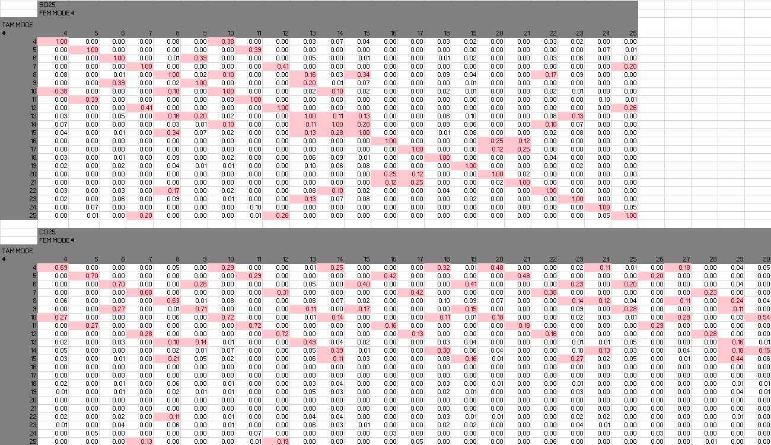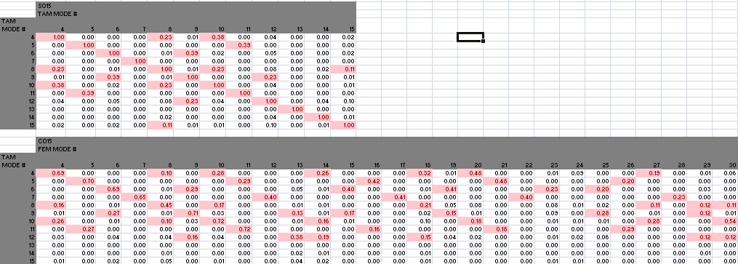

**APPENDIX D – MATLAB CODE**

clear all; clc; close all;

load('station.mat');

%PICKED DOF FOR REDUCTION

DOF25 = [101.2 110.2 122.2 203.1 117.2 206.1 213.1 216.1 216.2 303.1 ...

306.1 306.2 313.1 316.1 316.2 101.1 106.2 110.1 111.2 206.2 122.1 ...

203.2 213.2 303.2 313.2]';

DOF15 = [101.2 110.2 122.2 203.1 117.2 206.1 213.1 216.1 216.2 303.1 ...

306.1 306.2 313.1 316.1 316.2]';

DOF25 = sort(DOF25,'ascend');

DOF15 = sort(DOF15,'ascend');

%% HARD CODING, IMPLEMENTED FUNCTION FOR STATIC TAM INSTEAD

% DOF25ind = zeros(25,1);

% DOF15ind = zeros(15,1);

% for i = 1:25

% [tmpind,~] = find(DOF==DOF25(i));

% DOF25ind(i) = tmpind;

% if i<=15

% [tmpind,~] = find(DOF==DOF15(i));

% DOF15ind(i) = tmpind;

% end

% end

% DOF25COMP = setxor([1:92],DOF25ind);

% DOF15COMP = setxor([1:92],DOF15ind);

%

% K25sort = [K(DOF25ind,DOF25ind) K(DOF25ind,DOF25COMP);...

% K(DOF25COMP,DOF25ind) K(DOF25COMP, DOF25COMP)];

% M25sort = [M(DOF25ind,DOF25ind) M(DOF25ind,DOF25COMP);...

% M(DOF25COMP,DOF25ind) M(DOF25COMP, DOF25COMP)];

%

% K15sort = [K(DOF15ind,DOF15ind) K(DOF15ind,DOF15COMP);...

% K(DOF15COMP,DOF15ind) K(DOF15COMP, DOF15COMP)];

% M15sort = [M(DOF15ind,DOF15ind) M(DOF15ind,DOF15COMP);...

% M(DOF15COMP,DOF15ind) M(DOF15COMP, DOF15COMP)];

%

% T25 = [eye(25); -inv(K(DOF25COMP,DOF25COMP))*K(DOF25COMP,DOF25ind)];

% T15 = [eye(15); -inv(K(DOF15COMP,DOF15COMP))*K(DOF15COMP,DOF15ind)];

%

% K25 = T25'*K25sort*T25;

% M25 = T25'*M25sort*T25;

%

% K15 = T15'*K15sort*T15;

% M15 = T15'*M15sort*T15;

%%

%STATIC REDUCTION VIA FUNCTION

[K25,M25,DOFind25,DOFcomp25,~,~] = getStaticTAM(K,M,DOF,DOF25);

[K15,M15,DOFind15,DOFcomp15,K15sort,M15sort] = getStaticTAM(K,M,DOF,DOF15);

%EIGENPROBLEMS

[phi25,lam25] = eig(K25,M25);

wn25 = sqrt(abs(diag(lam25)));

[wn25,wn25ind] = sort(wn25,'ascend');

phi25 = phi25(:,wn25ind);

wn25hz = wn25./(2*pi);

[phi15, lam15] = eig(K15,M15);

wn15 = sqrt(abs(diag(lam15)));

[wn15,wn15ind] = sort(wn15,'ascend');

phi15 = phi15(:,wn15ind);

wn15hz = wn15./(2*pi);

% %MASS NORMALIZE MODES

% for i = 1:25

% mnorm(i) = 1/(sqrt(phi25(:,i)'*M25*phi25(:,i)));

% phi25(:,i) = mnorm(i)*phi25(:,i);

% end

% for i = 1:15

% mnorm(i) = 1/(sqrt(phi15(:,i)'*M15*phi15(:,i)));

% phi15(:,i) = mnorm(i)*phi15(:,i);

% end

%%

%TAM-FEM COMPARISON

%Get the mode shapes (exclude rigid body)

%for all the DOF in the 25 and 15 DOF TAM

phi25 = phi25(:,4:end); %Remove rigid body modes

phi15 = phi15(:,4:end);

PHIfem25 = PHI(DOFind25,4:end);

PHIfem15 = PHI(DOFind15,4:end);

M25corl8 = M(DOFind25,DOFind25);

M15corl8 = M(DOFind15,DOFind15);

%MASS NORMALIZE MODES TO ORIGINAL M

for i = 1:22

mnorm(i) = 1/(sqrt(phi25(:,i)'*M25corl8*phi25(:,i)));

phi25(:,i) = mnorm(i)*phi25(:,i);

end

for i = 1:12

mnorm(i) = 1/(sqrt(phi15(:,i)'*M15corl8*phi15(:,i)));

phi15(:,i) = mnorm(i)*phi15(:,i);

end

% SO25 = corl8(phi25,phi25,M25);

% CO25 = corl8(phi25, PHIfem25,M25);

% SO15 = corl8(phi15,phi15,M15);

% CO15 = corl8(phi15,PHIfem15,M15);

SO25 = corl8(phi25,phi25,M25corl8);

CO25 = corl8(phi25, PHIfem25,M25corl8);

SO15 = corl8(phi15,phi15,M15corl8);

CO15 = corl8(phi15,PHIfem15,M15corl8);

label25 = 4:2:24;

label15 = 4:2:14;

%Cross orthogonality for 25DOF static reduction

figure;

imagesc(abs(CO25));

colormap(parula(32)); colorbar;

caxis([0 1]);

axis equal;

ylim([0.5, 22.5]);

xlim([0.5,27.5]);

set(gca,'YTick',1:2:22);

set(gca, 'YTickLabel', label25); % Change y-axis ticks labels.

set(gca,'XTick',0:5:30);

xlabel('FEM Mode #');

ylabel('TAM Mode #');

title('Cross-Orthogonality 25 dof TAM-FEM');

% labels = [100 200 400 1000 2000 5000 10000 20000 50000];

% plot(y);

% set(gca, 'YTick', 1:length(labels)); % Change x-axis ticks

%Self orthogonoality for 25DOF static reduction

figure;

imagesc(abs(SO25));

colormap(parula(32)); colorbar;

caxis([0 1]);

axis equal;

ylim([0.5, 22.5]);

xlim([0.5,22.5]);

set(gca,'YTick',1:2:22);

set(gca, 'YTickLabel', label25); % Change y-axis ticks labels.

set(gca,'XTick',0:5:25);

xlabel('FEM Mode #');

ylabel('TAM Mode #');

title('Self-Orthogonality 25 dof TAM');

%Cross-O for 15DOF

figure;

imagesc(abs(CO15));

colormap(parula(32)); colorbar;

caxis([0 1]);

axis equal;

ylim([0.5, 12.5]);

xlim([0.5,27.5]);

set(gca,'YTick',1:2:12);

set(gca, 'YTickLabel', label15); % Change y-axis ticks labels.

set(gca,'XTick',0:5:30);

xlabel('FEM Mode #');

ylabel('TAM Mode #');

title('Cross-Orthogonality 15 dof TAM-FEM');

%Self orthogonoality for 15DOF static reduction

figure;

imagesc(abs(SO15));

colormap(parula(32)); colorbar;

caxis([0 1]);

axis equal;

ylim([0.5, 12.5]);

xlim([0.5,12.5]);

set(gca,'YTick',1:2:12);

set(gca, 'YTickLabel', label15); % Change y-axis ticks labels.

set(gca,'XTick',0:5:15);

xlabel('FEM Mode #');

ylabel('TAM Mode #');

title('Self-Orthogonality 15 dof TAM-FEM');

%%

%LSIM WITH FORCE VECTOR PROVIDED

% https://ay16-17.moodle.wisc.edu/prod/pluginfile.php/118403/ ...

% mod_resource/content/1/Matlab%20Simulation.pdf

%15DOF TAM- First 11 modes

%Setting up force vectors, Force is applied at node 117.2.

F15 = [zeros(2,1000); F'; zeros(12,1000)];

phi11 = phi15(:,1:11);

m = phi11'*M15*phi11; %get modal mass and stiffness with 11 modes

k = phi11'*K15*phi11;

A11 = [zeros(11), eye(11); -m\k zeros(11)]; %Set up state space

B11 = [zeros(11);inv(m)];

G11 = [ -m\k zeros(11)];

D11 = inv(m);

sys11 = ss(A11,B11,G11,D11); %Set up sys

% u = (m\(phi11'))*F15;

u = phi11'*F15; %Set up input channel vector

x0 = zeros(22,1);

t = 0:0.01:(10-0.01);

[y] = lsim(sys11,u',t,x0);

yphys = phi11*y';

% FEM LSIM

kfem = PHI'*K*PHI;

mfem = PHI'*M*PHI;

ufem = PHI'*[zeros(33,1000); F'; zeros(58,1000)];

A = [zeros(30), eye(30); -mfem\kfem zeros(30)];

B = [zeros(30); inv(mfem)];

G = [-mfem\kfem zeros(30)];

D = inv(mfem);

sysfem = ss(A,B,G,D);

x0fem = zeros(60,1);

[yfem] = lsim(sysfem,ufem',t,x0fem);

yfemphys = PHI*yfem';

%MODAL TAM

% phitam = PHI([DOFind15, DOFcomp15],:);

PHITs = PHI(DOFcomp15,1:11);

PHITm = PHI(DOFind15,1:11);

TTam = [eye(15); PHITs*inv(PHITm'*PHITm)*PHITm'];

KT = TTam'*K15sort*TTam;

MT = TTam'*M15sort*TTam;

[phiT,lamT] = eig(KT,MT);

wnT = sqrt(abs(diag(lamT)));

[wnT,wnTind] = sort(wnT,'ascend');

phiT = phiT(:,wnTind);

wnThz = wnT./(2*pi);

%LSIM WITH MODAL TAM

kT = phiT(:,1:11)'*KT*phiT(:,1:11); %Only use first 11 modes from modal TAM

mT = phiT(:,1:11)'*MT*phiT(:,1:11);

uT = phiT(:,1:11)'*[zeros(2,1000); F'; zeros(12,1000)];

At = [zeros(11), eye(11); -mT\kT zeros(11)];

Bt = [zeros(11); inv(mT)];

Gt = [-mT\kT zeros(11)];

Dt = inv(mT);

sysT = ss(At,Bt,Gt,Dt);

x0t = zeros(22,1);

[yT] = lsim(sysT,uT',t,x0t);

yTphys = phiT(:,1:11)*yT';

%PLOTTING ALL LSIM RESULTS

figure;

plot(t,yfemphys(55,:),'k--','LineWidth',1.5); hold on;

plot(t, yphys(6,:),'b','LineWidth',1);

plot(t,yTphys(6,:),'r','LineWidth',1);

xlabel('Time (s)');

ylabel('Physical Displacement (units not provided)');

legend('FEM', '15DOF Static TAM', '11 Mode 15DOF Modal TAM');

title('Physical Acceleration of DOF 206x due to loading at 117y');

%PLOTTING FREQUENCY ERRORS

%Novel way doesn't seem very good here. Tabule results instead.

% figure; hold on;

% plot(w(1:11),wn15hz(1:11),'k-x');

% plot(w(1:11),wn25hz(1:11),'r-o');

% plot(w(1:11),wnThz(1:11),'b-o');