Installation

Use at least SQLDeveloper 1.1. Within the reports tab, right click on the user defined reports node and select import, find the OWBReports.xml file and select this file. You should see the OWB node under the user defined reports node.  The reports are primarily reports on the OWB runtime, there are some simple reports for the design and data quality, but the reports are mostly centered on the runtime; analysis of map/flow timings, audit details etc. | 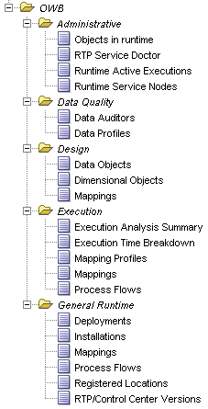

Summary of reports

Execution
Execution Analysis Summary | Summary statistics for executables including execution count, min/max time.
Execution Time Breakdown | Master detail for executables grouped by execution length.
Mappings | Master detail for mapping executables, drill to; throughput, audit, errors, parameters and timing analysis.
Process Flows | Master detail for process flow executables, drill to; activity status, general overview, execution parameters, activity parameters and timing analysis.
Mapping Profiles | Various reports of PLSQL profiled mapping executions, based on usage of the DBMS_PROFILER.The PLSQL profiles can be queried (in master detail form - view map profiles, drill to top 20, profile summary etc). The following reports are available:  - Top 20 statements (in terms of most time spent)  - Summary report giving time taken for the package and dependent functions/procedures outside of package.  - Profile detail, line by line detail of occurrences and time (exportable to Excel etc.)  - % code coverage  The start/stop of PLSQL profiling has to be manually performed before/after the map execution. So to utilize you will have to perform the following steps (for example):  1. execute the database server's rdbms/admin/proftab.sql script on your target schema  2. execute the deployed OWB map using PLSQL profiling enabled as in example below;  declare  v varchar2(4000);  begin  v :=dbms_profiler.start_profiler;  PLSQL_MAP.main(v);  v := dbms_profiler.stop_profiler;  end;  You will see maps that have been profiled when you click on Mapping Profiles.

General Runtime
Deployments | Simple deployment report order by most recent deployments.
Installations | Installed version information.
Mappings | Master detail see deployed maps, default parameters and deployments.
Process Flows | Master detail see deployed flows, default parameters and deployments.
Registered Locations | View locations registered in the runtime, drill to location parameters and physical realization details (db link/SQL directory for example).
RTP/Control Center | Control center info.

Data Quality
Data Profiles | (Repos Owner) Performance analysis of profile phases, throughput of the staging maps and timing analysis of profiles.
Data Auditors | Drill to throughput and parameters including data auditor result parameters.

Administrative
Objects in runtime | (Control center owner) Row count of major runtime tables.
RTP Service Doctor | (Control center owner) The service_doctor.sql script in a report.
Runtime Active Executions | (Control center owner) The active executions in the runtime.
Runtime Service Nodes | The nodes registered in the runtime, useful for checking RAC configuration.

