**QuickShip**

**Trinh Nguyen (developer)**

**Victor Fateh Firouz (developer)**

**David Navarro (developer)**

**Emmanuel Mendoza (developer)**

# Version History

| Date | Author | ` | Changes made | Rationale |
| --- | --- | --- | --- | --- |
| 03/12/17 | TN | 1.0 | * Converted template to Project Team Version | * Must erase all template and non-project related contents. |

# Table of Contents

Operational Concept Description (OCD) i

Version History ii

Table of Contents iii

Table of Tables iv

Table of Figures v

1. Introduction 1

1.1 Purpose of the OCD 1

1.2 Status of the OCD 1

2. Shared Vision 2

2.1 Benefits Chain 3

2.2 System Capability Description 4

2.3 System Boundary and Environment 4

3. System Transformation 6

3.1 Information on Current System 6

3.2 System Objectives, Constraints and Priorities 6

3.3 Proposed New Operational Concept 8

3.4 Organizational and Operational Implications 12

# Table of Tables

Table 1: The Program Model 2

Table 2: Level of Service Goals 7

Table 3: Relation to Current System 8

# Table of Figures

Figure 1: Benefits Chain Diagram of Volunteer Tracking System 3

Figure 2: Benefits Chain Diagram 4

Figure 3: System Boundary and Environment Diagram of Volunteer Tracking System 5

Figure 4: System Boundary and Environment Diagram 5

Figure 5: Element Relationship Diagram of Transportation Grant Fund system (NDI-intensive project) 9

Figure 6: Element Relationship Diagram of the Los Angeles Community Garden Inventory and Locator (Architected agile project) 9

Figure 7: Element Relationship Diagram 10

Figure 8: Business Workflow Diagram of Volunteer Tracking System 11

Figure 9: Business Workflows Diagram 12

### Introduction

#### Purpose of the OCD

This document provides details on the vision and goals of the stakeholders of the android application, QuickShip. The stakeholders include members of the development team, DEV-T. Professor Ramin Moazeni is also a stakeholder/sponsor who assigned the project and will be evaluating the final product.

#### Status of the OCD

This document is currently in draft phase and will have brief, general information on the overall project. It will show design goals, planned features, and status. More content will be added to this document as the development process moves along.

### Shared Vision

Our program model bellows lists the different aspects of our project and how they relate to our project.

Table : The Program Model

|  |  |  |  |
| --- | --- | --- | --- |
| **Assumptions: Our application is for beginner Android developers** | | | |
| **Stakeholders** (Who is accountable for the initiatives) | **Initiatives**  (What to do to realize benefits) | **Value Propositions**  (Benefits i.e Why) | **Beneficiaries**  (Who derives value) |
| * DEV-T Developers is responsible for all implementation and testing of product * Professor Moazeni, the sponsor, responsible for miscellaneous needs | * Developers must set aside time to complete assigned tasks * Developers must learn and research basic Android programming * Developers may require obtaining physical devices for testing purposes * Sponsor is responsible for giving advices and suggestions on the best way to complete initiatives | * Completion of this project should help team members built basic Android Development skillset * This project will also provide members with experience in working on a group project and managing all of its aspects * Members will also have a completed application they can share and showcase to employers * Quality of product should improve with increased effort | * Developers and users will benefit from the completed application which will be a game they can play for fun * Developers will also become better programmers after completion of this project |

**Legend:**

Initiatives that need to be undertaken to help beneficiaries **derive value** from the expected benefits/value propositions

Initiatives that need to be undertaken to help **deliver value** to the beneficiaries (i.e. “how” will the benefits reach the beneficiaries?)

#### Benefits Chain

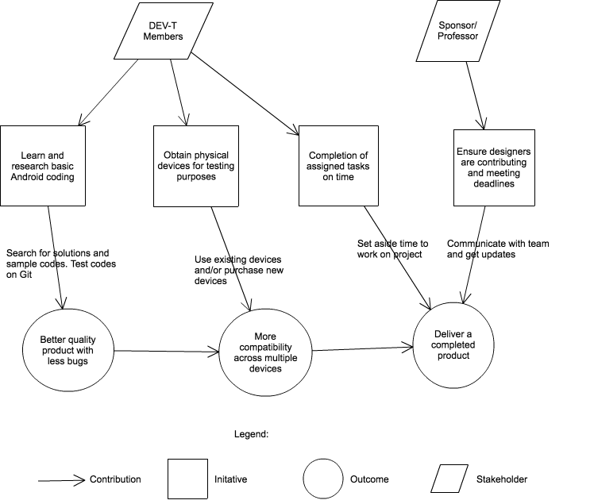

Figure : Benefits Chain Diagram of QuickShip Program Model

#### System Capability Description

The product is a game build with Android. It is designed to work with all Android mobile devices and tablets. It allows the player to play a quick game of Battleship with other nearby players using Bluetooth. The game is intended to be played in quick small sessions and will be designed to be as efficient as possible in achieving that goal. Our target customers are casual gamers and fan of board games. People are always looking for a short game to play when they have spare time. This game may fill that void. We hope that the quick and easy set-up, the simple UI, and fun gameplay will keep the customer playing.

#### System Boundary and Environment

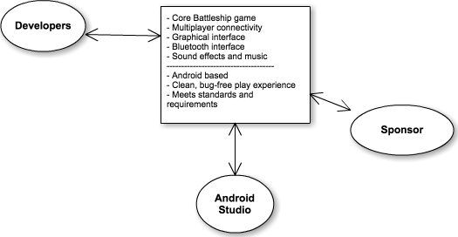

Figure : System Boundary and Environment Diagram of QuickShip

### System Transformation

#### Information on Current System

##### Infrastructure

* Built with Android Studio
* Core backend built with custom java classes
* Utilizes Android Bluetooth API for connectivity
* May use third-party API for rendering audio and visuals

##### Artifacts

* QuickShip ship drawings and animation
* Sound effects and music. May plan to use free, fair-use audio assets

##### Current Business Workflow

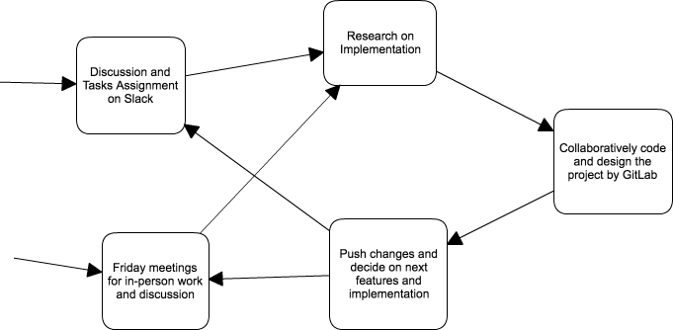

**Figure 4: Activity Diagram of workflow**

#### System Objectives, Constraints and Priorities

##### Capability Goals

|  |  |
| --- | --- |
| **Capability Goals** | **Priority Level** |
| **QS-1 Core Batleship Gameplay:** The basic game that tracks all game and board states | Must have |
| **QS-2 Bluetooth:** Allows multiplayer connectivity | Must have |
| **QS-3 Chat:** Send chat message among players during play session | Nice-to have |
| **QS-4 GUI:** Visual representation of the game | Must have |
| **QS-5 Emoji Animations:** Taunt players with emojis, send emoji missiles | Nice-to-have |
| **QS-6 Sound effects and music:** music and sound effects that goes with the gameplay | Nice-to-have |
| **QS-7 Compatibility:** works on all Android Bluetooth devices | Should-have |
| **QS-8 Single Player:** play offline against AI | Optional |

##### Level of Service Goals

Table : Level of Service Goals

|  |  |  |
| --- | --- | --- |
| **Level of Service Goals** | **Priority Level** | **Referred WinWin Agreements** |
| Functional game | high | CO-1 |
| Single player | low | CO-2 |
| GUI | high | CO-3 |
|  |  |  |

##### Organizational Goals

**QS-1:** Ensures a finished product for release

**QS-2:** Allows multiplayer capability is the core aspect of the product

**QS-3:** More social interaction encourages returning customer

**QS-4:** Well-designed GUI engages the players

**QS-5:** Customizable feature adds more personality to the game which keeps the players engaged

**QS-6:** Nice to have for those that plays the game with sound. Adds more production value to the game

**QS-7:** Maximizes potential for gaining the most amount of customers

**QS-8:** Allows players to practice the game offline. May not be necessary

##### Constraints

**CO-1:** Only around 2 months to deliver the product. May not have time to implement all features

**CO-2:** Would need to come up with algorithm for AI

**CO-3:** Developers may not have experience on designing rendered visuals

##### Relation to Current System

Table : Relation to Current System

|  |  |  |
| --- | --- | --- |
| **Capabilities** | **Current System** | **New System** |
| Roles and Responsibilities |  | Developers, Sponsor |
| User Interactions |  | Product playable on Android Devices |
| Infrastructure |  | Local multiplayer requires no infrastructure |
| Stakeholder Essentials and Amenities |  | Physical testing devices, Android development knowledge |
| Future Capabilities |  | Refined UI, visuals, and performance |

#### Proposed New Operational Concept

Since this is a new development team. We are starting fresh and have no prior operational concept. Instead, this section will explain our current accepted Operational Concept.

##### Element Relationship Diagram

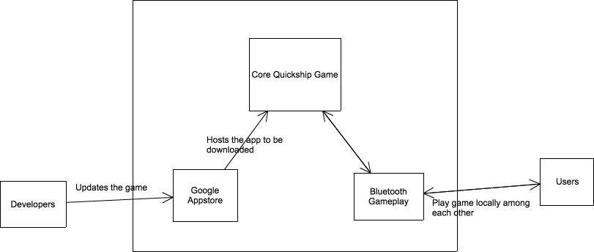

Figure : Element Relationship Diagram Of QuickShip

##### Business Workflows

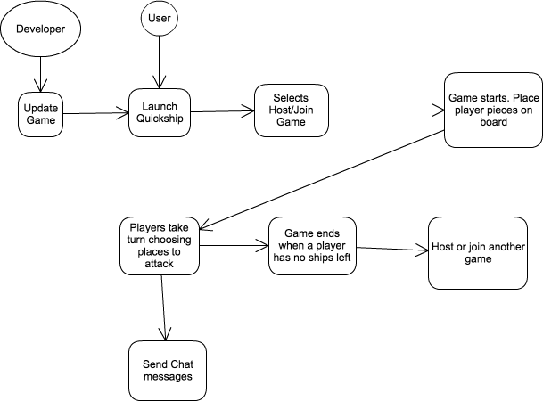

Figure : Business Workflow Diagram of Volunteer Tracking System

#### Organizational and Operational Implications

##### Organizational Transformations

There are no organizational transformations. We are settling on an agreed upon organization. We anticipate some changes in the future as we figure out the best, most efficient way to accomplish our goals. There are no hierarchal roles in the team except the Sponsor, who can decide on the direction the project should go. Currently, all members on the team are developers who are responsible for knowing how to implement all features. They will then implement the features assigned to them.

##### Operational Transformations

There are no operational transformations. Our new team have decided to operate mainly with Slack and Gitlab with some in-person meeting on days of the week to update each other on the status of the project.