# Prototype Report

**QuickBattleship**

**Trinh Nguyen (developer)**

**Victor Fateh Firouz (developer)**

**David Navarro (developer)**

**Emmanuel Mendoza (developer)**

**14 March 2017**

# Version History

| Date | | Author | | Version | | Changes made | | Rationale | |
| --- | --- | --- | --- | --- | --- | --- | --- | --- | --- |
| 03/14/17 | | EM | | 1.0 | | * Converted template to Project Team Version | | * Must erase all template and non-project related contents. | |

# Table of Contents

Prototype Report i

Version History ii

Table of Contents iii

Table of Tables iv

Table of Figures v

1. Introduction 1

2. Navigation Flow 2

3. Prototype 3

4. Final Build 5

# Table of Tables

Table 1: Setup Gameboard 3

Table 2: Live Gameplay 4

# Table of Figures

Figure 1: Navigation Flow of QuickShip 2

Figure 2: Prototype Setup Gameboard 3

Figure 3: Prototype Live Gameplay 4

Figure 4: Main Screen 5

Figure 5: Choose Ship Screen 6

Figure 6: Play Screen 6

Figure 7: Game Over Screen 7

### Introduction

The purpose of the prototype report is to provide a visual representation of the main features that will be supported by the QuickShip game.

* Prototype report version 1 draft.

### Navigation Flow

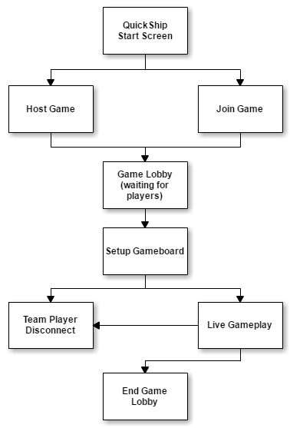

Figure 1: Navigation Flow of QuickShip

### Prototype

Table 1: Setup Gameboard

|  |  |
| --- | --- |
| Description | This screen allows the player to setup their gameboard before the game begins. |
| Related Capability | QS-2  QS-3 |
| Pre-condition | Game Lobby screen |
| Post condition | Live Gameplay screen |

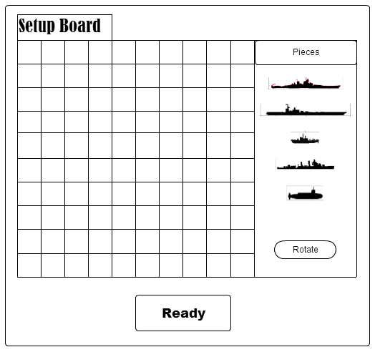

Figure 2: Prototype Setup Gameboard

Table 2: Live Gameplay

|  |  |
| --- | --- |
| Description | This screen contains a configuration setup of a 2 vs 2 game (may be supported; first milestone goal is 1 vs 1). This screen is not to scale with the mobile app screen but may be implemented as a touch screen scrollable environment. This screen allows players to view the status of their ship fleet as well as their enemies explored areas. |
| Related Capability | QS-4, QS-5, QS-6 |
| Pre-condition | Setup Gameboard screen |
| Post condition | Team Player Disconnect state OR End Game Lobby screen |

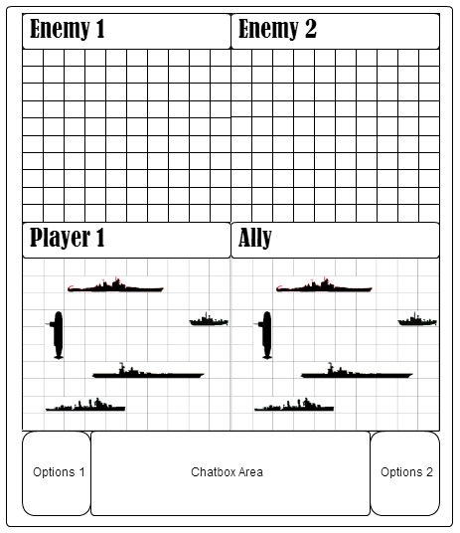

Figure 3: Prototype Live Gameplay

### Final Build

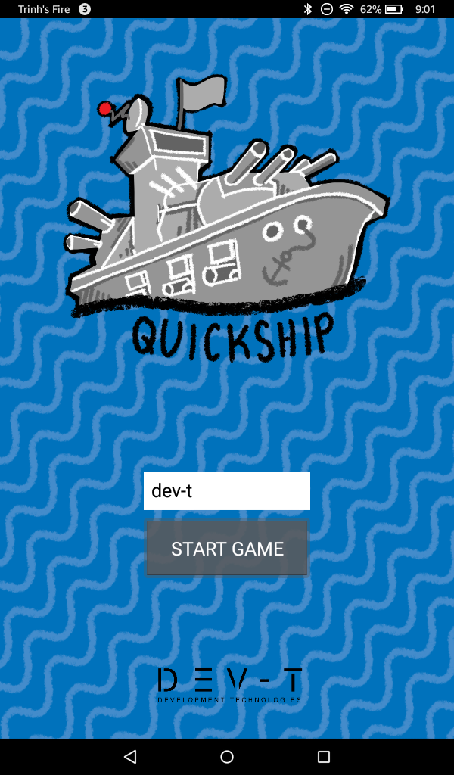

Figure 4: Main Screen

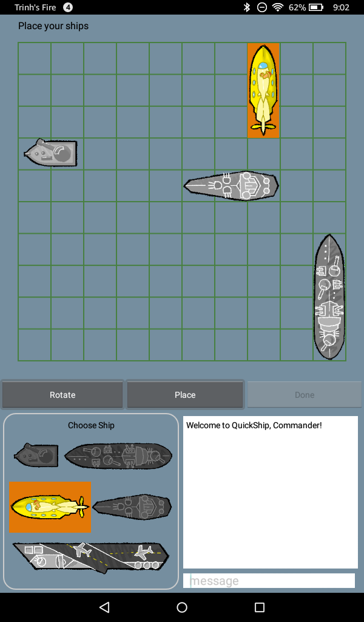

Figure 5: Choose Ship Screen

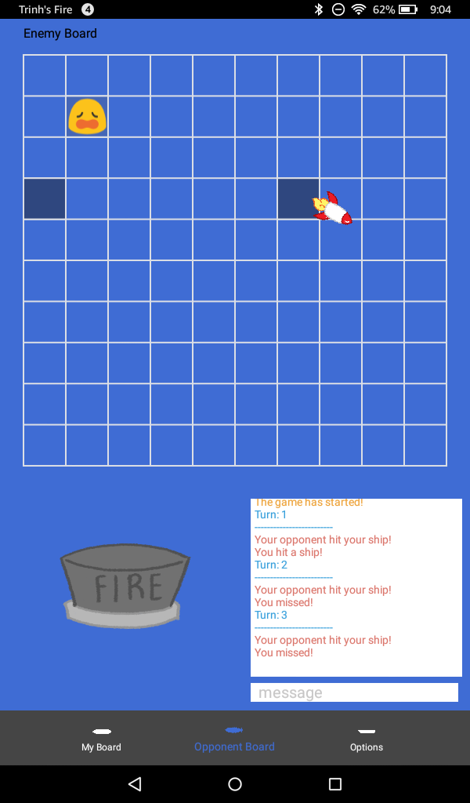

Figure 6: Play Screen

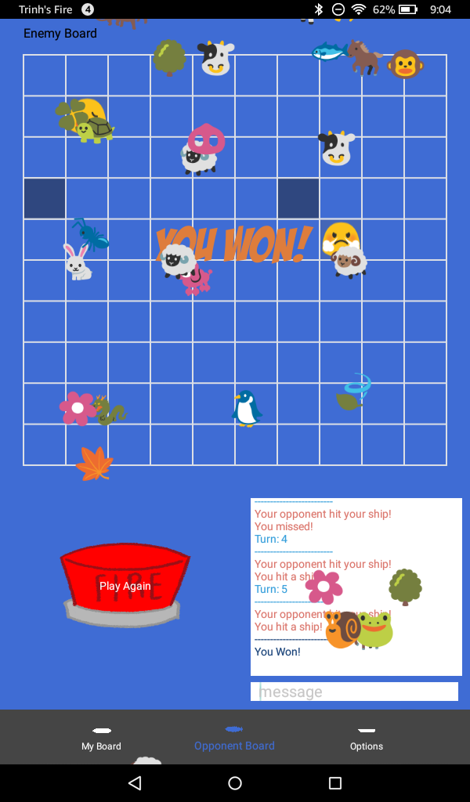

Figure 7: Game Over Screen