# QuickShip - System and Software Architecture Description (SSAD)

**DEV-T**

**Victor Fateh (developer)**

**Trinh Nguyen (developer)**

**Emmanuel Mendoza (developer)**

**David Navarro (developer)**

**05/15/2017**

# Version History

| Date | Author | Version | Changes made |
| --- | --- | --- | --- |
| 03/13/17 | Victor Fateh | 1.0 | * Initial Version |
| 05/15/17 | David Navarro | 2.0 | * Diagram updates * Behavior updates |

# Table of Contents

System and Software Architecture Description (SSAD) i

Version History ii

Table of Contents iii

Table of Tables iv

Table of Figures v

1. Introduction 1

1.1 Purpose of the SSAD 1

1.2 Status of the SSAD 1

2. System Analysis 2

2.1 System Analysis Overview 2

2.2 System Analysis Rationale 5

3. Technology-Independent Model 6

3.1 Design Overview 6

3.2 Design Rationale 8

4. Technology-Specific System Design 9

4.1 Design Overview 9

4.2 Design Rationale 10

5. Architectural Styles, Patterns and Frameworks 11

# Table of Tables

Table 1: Actors Summary 22

Table 2: Artifacts and Information Summary 33

Table 3: Process Description 44

Table 4: Typical Course of Action 44

Table 5: Alternate Course of Action 44

Table 6: Exceptional Course of Action 44

Table 7: Hardware Component Description 77

Table 8: Software Component Description 77

Table 9: Supporting Software Component Description 77

Table 10: Design Class Description 88

Table 11: Hardware Component Description 99

Table 12: Software Component Description 99

Table 13: Supporting Software Component Description 1010

Table 14: Design Class Description 1010

Table 15: Architectural Styles, Patterns, and Frameworks 1111

# Table of Figures

Figure 1: System Context Diagram 22

Figure 2: Artifacts and Information Diagram 33

Figure 3: Process Diagram 44

Figure 4: Conceptual Domain Model 66

Figure 5: Hardware Component Class Diagram 66

Figure 6: Software Component Class Diagram 66

Figure 7: Deployment Diagram 66

Figure 8: Supporting Software Component Class Diagram 77

Figure 9: Design Class Diagram 88

Figure 10: Robustness Diagram 88

Figure 11: Sequence Diagram 88

Figure 12: Hardware Component Class Diagram 99

Figure 13: Software Component Class Diagram 99

Figure 14: Deployment Diagram 99

Figure 15: Supporting Software Component Class Diagram 99

Figure 16: Design Class Diagram 1010

Figure 17: Process Realization Diagram 1010

### Introduction

#### Purpose of the SSAD

The purpose of this SSAD is to document the results of the analysis and design of the **QuickShip**. The developers use the SSAD as a reference to the software architecture. **QuickShip** will remain faithful to the architecture specified in this SSAD. Furthermore, the maintainer and client will use this SSAD in order to understand the structure of the software upon final delivery.

#### Status of the SSAD

This SSAD will be continuously updated to sync with the current software development stage. Version 1.0 is the first iteration of this document and therefore will only have the early stages of architecture and design.

### System Analysis

#### System Analysis Overview

The primary purpose of QuickShip is to wirelessly connect two potential players on a singular system to play a game. QuickShip matches two players into one game of battleships, each person will have an individual board hidden from the other participant. The turn based game will give power to each player respectively to place attack moves and affect the opponents ships. The game will update for all individuals after a player submits their choice for an attack. After the UI is updated on both sides, the power of move making switches to the next player and the cycle continues. Moves will be restricted by time limits to reduce the necessity for continuous push notifications.

##### System Context

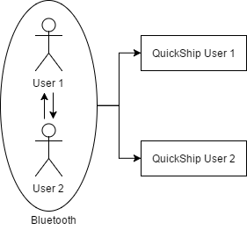

Figure : System Context Diagram

Table : Actors Summary

| **Actor** | **Description** | **Responsibilities** |
| --- | --- | --- |
| User 1 | Mutual pairing with User 2 | Establish Bluetooth connection |
| User 2 | Mutual pairing with User 1 | Establish Bluetooth connection |

##### Artifacts & Information

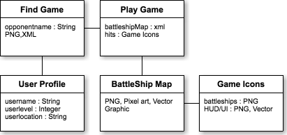

Figure : Artifacts and Information Diagram

Table : Artifacts and Information Summary

|  |  |
| --- | --- |
| **Artifact** | **Purpose** |
| User Profile | Displays appropriate user's current information to be displayed to other players |
| Finding Game | Main splash screen used as loading area before initializing local connection |
| Battleship Map | Static built grids used and populated by vector icons |
| Game Icons | Android built icons used in game |
| Play Game | Live running screen once connection established. Displays current battleship map with appropriate game icons. |

##### Behavior

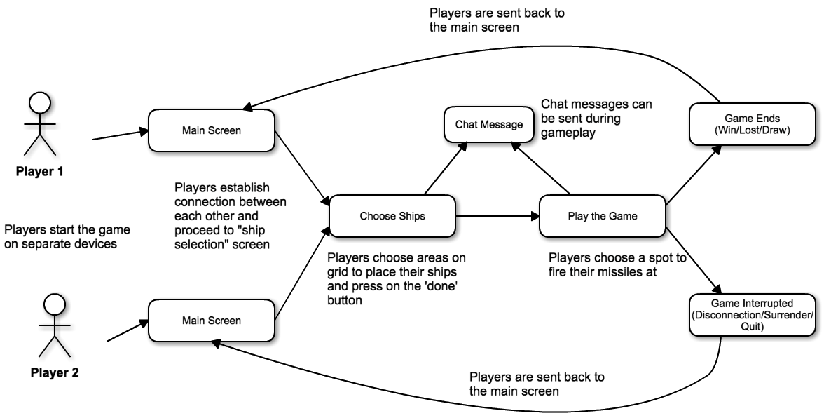

Figure : Process Diagram

###### Connecting Players

Hosting a Game

Table : Process Description

|  |  |
| --- | --- |
| **Identifier** | Creating a Game |
| **Purpose** | To allow users to join a game and play together. |
| **Requirements** | Bluetooth Connectivity |
| **Development Risks** | High Priority |
| **Pre-conditions** | The player must have Bluetooth  The player must then select “Start Game” to attempt to pair with opponent phone |
| **Post-conditions** | The player is then taken to the ship placement screen |

Table : Typical Course of Action

|  |  |  |
| --- | --- | --- |
| **Seq#** | **Actor’s Action** | **System’s Response** |
| **1** | User selects to "Start Game" | Application sets up in Host (server) mode and allows other players to connect. |
| **2** | Player waits for other player to connect | Application stays in standby. |
| **3** | Other players connect to the host game. | Application displays a player has connected. |
| **4** | All players place ships. | Application saves ship configurations. |
| **5** | All players select to start game | Application confirms all configurations are set |

Table : Alternate Course of Action

|  |  |  |
| --- | --- | --- |
| **Seq#** | **Actor’s Action** | **System’s Response** |
| **1** | Player decides to end game. | Application is on standby. |
| **2** | Player hits back / home button. | Application disconnects and terminates |

Table : Exceptional Course of Action

|  |  |  |
| --- | --- | --- |
| **Seq#** | **Actor’s Action** | **System’s Response** |
| **1** | Host Bluetooth connection is lost. | Application prompts an error prompt and returns to the Start Screen state. |

###### Gameplay

Setting Up Game Board

Table 3: Process Description

|  |  |
| --- | --- |
| **Identifier** | Setting Up Game Board |
| **Purpose** | To allow all players to setup their game board before starting the game. |
| **Requirements** | Touch activated GUI |
| **Development Risks** | High Priority |
| **Pre-conditions** | Host and Clients have been assigned a team.  All players have selected "Start Game" from the Game Lobby state. |
| **Post-conditions** | All players are taken to the Live Gameplay state. |

Table 4: Typical Course of Action

|  |  |  |
| --- | --- | --- |
| **Seq#** | **Actor’s Action** | **System’s Response** |
| **1** | Player selects a game piece. | Application highlights selected piece. |
| **2** | Player clicks rotate button, if needed. | Game piece is rotated 90 degrees. |
| **3** | Player selects an empty ocean location. | Application loads selected piece into the empty location on the game board. Application then checks if more game pieces are available. If yes; Repeat step 1. If no; move to step 4. |
| **4** | Player selects the "Ready" button | Application prevents any further actions from the player and sets the game board into a "Ready" state. The game board configuration is then transmitted to the host server. |
| **5** | All Players have setup their game board and selected the "Ready" button | Host server initializes the Master Game Board and transitions all Players to the Live Gameplay state. |

Table 5: Alternate Course of Action

|  |  |  |
| --- | --- | --- |
| **Seq#** | **Actor’s Action** | **System’s Response** |
| **1** | Player tries to place a game piece on top of another game piece or out of bounds on the game board. | Application responds with an error prompt. |

Table 6: Exceptional Course of Action

|  |  |  |
| --- | --- | --- |
| **Seq#** | **Actor’s Action** | **System’s Response** |
| **1** | Host or Client Bluetooth connection is lost. | Application prompts an error prompt and returns to the Start Screen state or Game Lobby state. |

Figure 3: Process Diagram

###### Gameplay

Live Gameplay

Table 3: Process Description

|  |  |
| --- | --- |
| **Identifier** | Live Gameplay |
| **Purpose** | To allow all players to now play the game. |
| **Requirements** | Touch activated GUI |
| **Development Risks** | High Priority |
| **Pre-conditions** | Host and Clients have setup their game board and have selected the "Ready" button in the Setup Gameboard state. |
| **Post-conditions** | A team wins/loses and all players are taken to the End Game Lobby. |

Table 4: Typical Course of Action

|  |  |  |
| --- | --- | --- |
| **Seq#** | **Actor’s Action** | **System’s Response** |
| **1** | Player selects a square on the opponent's game board via touch screen to engage an attack. | Application records the attack and sends the instructions to the Host Server. |
| **2** | Player waits for all players to make their move. Each move is bound by a timer, all players will have to decide their move within the time restraint. | Application is in standby mode. |
| **3** | Once all players have made their move and or the time restraint has expired. | The Host server will update the Master Game Board and send update instructions to all clients as well as initialize the game play animations for that round. If a team has been declared victorious; move to step 4. If no team has been declared victorious, repeat step 1. |
| **4** | Team has been declared victorious or defeated | Application transitions to the End Game Lobby. |

Table 5: Alternate Course of Action

|  |  |  |
| --- | --- | --- |
| **Seq#** | **Actor’s Action** | **System’s Response** |
| **1** | Player tries to attack a preciously attacked square. | Application responds with a prompt stating the square has already been attacked. |

Table 6: Exceptional Course of Action

|  |  |  |
| --- | --- | --- |
| **Seq#** | **Actor’s Action** | **System’s Response** |
| **1** | Host or Client Bluetooth connection is lost. | Application prompts an error prompt and returns to the Start Screen state. |

### Technology-Independent Model

#### Design Overview

##### System Structure

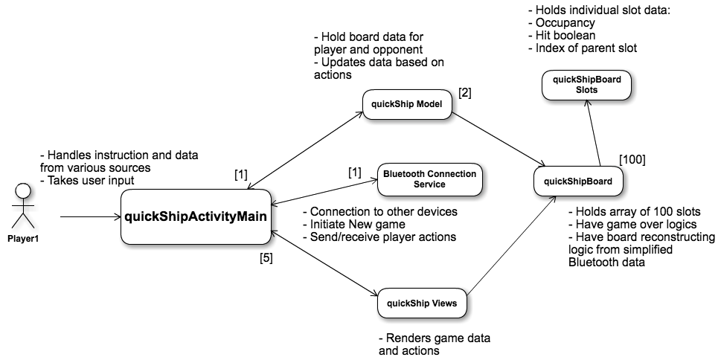

Figure : Conceptual Domain Model

Table : Hardware Component Description

|  |  |
| --- | --- |
| **Hardware Component** | **Description** |
| Android Device | Android device running API level 16 or a newer |

##### Design Classes

#### Design Rationale

The QuickShip architecture was designed to be as lightweight as possible to maximize playtime. Using PVP sockets reduces the necessity for rapid and constant database queries which consume memory and time. Bluetooth provides a localized means of data exchange between the nearby players. This architecture reduces the stress implemented on the database and allows gameplay and connection issues to be resolved into the Bluetooth breakpoint. Lightweight and uncluttered, this design provides for the most rapid and reliable PVP gameplay experience.

### Technology-Specific System Design

#### Design Overview

##### System Structure

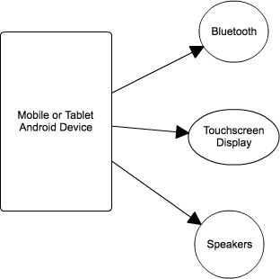

Figure : Hardware Component Class Diagram

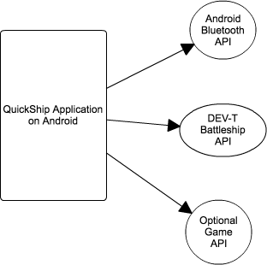

Figure : Software Component Class Diagram

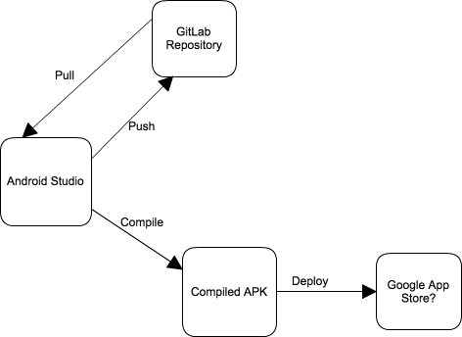

Figure : Deployment Diagram

Table : Hardware Component Description

|  |  |
| --- | --- |
| **Hardware Component** | **Description** |
| Bluetooth | Uses standard Bluetooth signal to send game data between devices |
| Touchscreen Display | Device Screen must be normal size (470dp x 320dp) to allow viewing complete game content. Touch is also required to operate the game |
| Speakers | Basic mono/stereo speaker to output game audio |

Table : Software Component Description

|  |  |
| --- | --- |
| **Software Component** | **Description** |
| Android Bluetooth API | Using free Bluetooth API provided by Google |
| DEV-T Battleship API | Will contain all the backend codes required to run and keep track of game state |
| Optional Game API | May be required to render the game's graphics if Android's standard display API is insufficient |

##### Design Classes

###### <Classes n>

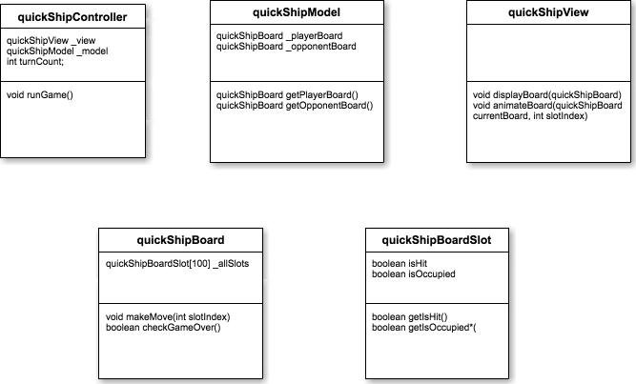

Figure : Design Class Diagram

Table : Design Class Description

|  |  |  |
| --- | --- | --- |
| **Class** | **Type** | **Description** |
| quickShipController | Controller | Implements thread(s) that keeps track of user input and apply changes to the model |
| quickShipModel | Model | Holds boardgame data of all players to be read by the view or the controller |
| quickShipView | View | Displays game state and data to the screen. Can be done from scratch or use an API to render the visuals |
| quickShipBoard | Model Assets | Holds an array of all individual slots, has functions to modify these slots |
| quickShipBoardSlot | Model Assets | Individual slots that has Boolean to keep track of whether it is hit or occupied |

##### Process Realization



Figure : Process Realization Diagram

#### Design Rationale

We hope to implement MVC model to organize the game's classes.

The controller will hold the model of the current game session and maintain the flow of the game. It should implement a thread that checks the status of the game and alert, animate, update, the game as changes are made.

The model will hold data for the board state, what is occupied, what has been hit, etc.

The view will read in the board game in the model and visually represent it on screen.

We hope that this strategy will make the program easier to maintain and implement.

### Architectural Styles, Patterns and Frameworks

Table : Architectural Styles, Patterns, and Frameworks

|  |  |  |
| --- | --- | --- |
| **Name** | **Description** | **Benefits, Costs, and Limitations** |
| Android Studio | The main IDE we are using to design the game | The program is free and easy to use. May not be ideal for gaming development |
| Slack | Cloud based communication and project management | Free web-based communication program that tracks Git changes |
| Optional game API | We may choose to use a third party game API if Android Studio Code is limited | These game APIs are usually free but requires some learning |