Appendix
Table S1. Taxon sampling for ddRAD sequence data collection. Institutional abbreviations for museums and collections follow Sabaj (2023), except for MZFZ (Museo de Zoología of the Facultad de Estudios Superiores Zaragoza, Universidad Nacional Autónoma de Mexico); ANMO, AEVB, JAC and CIG numbers are field numbers for specimens to be catalogued in the MZFZ.
Species | Historically assigned subspecies | Voucher | Locality | Latitude | Longitude
Storeria dekayi | S. d. dekayi | AMNH R-501522 | United States: New York: Orange | 41.3906 | -74.2749
Storeria dekayi | S. d. dekayi | AMNH R-501526 | United States: Georgia: Glynn | 31.2328 | -81.5692
Storeria dekayi | S. d. temporalineata | AEVB 20 | Mexico: Puebla: Ahuacatlan-Tepango Highway | 20.004 | -97.8144
Storeria dekayi | S. d. texana | MZFC 14226 | Mexico: Hidalgo: Tenango of Doria | 20.3303 | -98.2324
Storeria dekayi | S. d. temporalineata | ANMO 1655 | Mexico: Hidalgo: At the Santa Cecilia Seminary, ahead of Tlanchinol | 21.0017 | -98.6528
Storeria dekayi | S. d. temporalineata | ANMO 3688 | Mexico: Puebla: Approximately 800 meters (straight line) to the NNW of San José Chagclatzin | 19.9212 | -97.5069
Storeria dekayi | S. d. texana | ANMO 4345 | Mexico: San Luis Potosí: 4 km. N of La Pimienta | 21.5644 | -99.0049
Storeria dekayi | S. d. texana | CIG 1566 | Mexico: Querétaro: El Madroño | 21.2858 | -99.1425
Storeria dekayi | S. d. texana | CIG 1753 | Mexico: Querétaro: El Lobo | 21.2922 | -99.1237
Storeria dekayi | S. d. texana | CIG 816 | Mexico: Tamaulipas: El Limón, E of Ocampo | 22.8361 | -99.0262
Storeria dekayi | S. d. texana | CIG 817 | Mexico: Tamaulipas: 2 km W of Hwy. 85 on road to Gomez Gómez Farías | 23.0196 | -99.1112
Storeria dekayi | S. d. texana | OMNH 42677 | United States: Arkansas: 9.64 km W of Norman, S of Hwy 8 on FR73/CR11 (N. Polk Creek Rd) | 34.4431 | -93.7841
Storeria dekayi | S. d. tropica | MZFZ 5190 | Guatemala: Baja Verapaz: Aldéa Santa Cruz | 15.1059 | -90.1012
Storeria dekayi | S. d. texana | TNHC 63072 | United States: Texas: Austin, Avenue G, 50 m N of 45th St. | 31.0957 | -97.3682
Storeria dekayi | S. d. texana | TNHC 67584 | United States: Texas: Austin, Lake Austin Blvd in front of Univ. Texas Brackenridge Field Lab | 30.2870 | -97.7790
Storeria dekayi | S. d. texana | MZFC 26163 | Mexico: Puebla: Ilita | 19.8530 | -97.4726
Storeria dekayi | S. d. temporalineata | MZFC 26160 | Mexico: Puebla: Tlatlauquitepec, Xocayucan | 19.8966 | -97.4788
Storeria dekayi | S. d. texana | ITAH 1672 | Mexico: Hidalgo: Tlanchinol | 20.9924 | -98.65815
Storeria dekayi | S. d. texana | UTA R-14694 | Mexico: Hidalgo: 2.1 km NE Tlanchinol | 21.0064 | -98.6390
Storeria dekayi | S. d. texana | MZFC 19275 | Mexico: Querétaro: El lobo Highway - La vuelta | 21.2943 | -99.1195
Storeria dekayi | S. d. texana | UTA R-25865 | Mexico: Hidalgo: Tlanchinol Municipality: La Cabaña | 21.0203 | -98.6422
Storeria dekayi | S. d. texana | JAC 26668 | Mexico: Hidalgo | 20.5973 | -98.6260
Storeria dekayi | S. d. texana | OMNH 42747 | United States: Oklahoma: Packsaddle WMA, E0770 Rd | 35.8975 | -99.6401
Storeria dekayi | S. d. texana | UTA R- 65993 | United States: Texas: Jack | 33.1361 | -97.9373
Storeria dekayi | S. d. texana | UTA R-65992 | United States: Texas: Cooper Lake State Park - South Sulphur Unit, Hopkins | 33.2889 | -95.6611
Storeria dekayi | S. d. texana | PAN 574 | United States: Texas | 39.9535 | -96.4700
Storeria dekayi | S. d. texana | UTA R-65994 | United States: Texas: Oakmont Park, Fort Worth, Tarrant | 32.6669 | -97.4295
Storeria dekayi | S. d. texana | TNHC 89901 | United States: Texas: 13600 FM 1826, Hays | 30.1806 | -97.9687
Storeria dekayi | S. d. texana | TNHC 66469 | United States: Texas: Bosque Co. Rd 418, ~2 rd mi E TX FM 2490, just N McLennan Co. line | 31.9570 | -97.6257
Storeria dekayi | S. d. texana | TNHC 65600 | United States: Texas: Austin, NW, jct Tamarack Trail and Manhasset Rds | 30.4292 | -97.7118
Storeria dekayi | S. d. texana | TNHC 89436 | United States: Texas: Hawkins, ~7 mi NE (AOR on FM 1002, 4.1 mi S TX Hwy 154) | 32.7024 | -95.1375
Storeria dekayi | S. d. texana | TNHC 89494 | United States: Texas: Hawkins, ~12 mi N on FM 312, 5.6 mi N FM 49 | 32.8017 | -95.2751
Storeria dekayi | S. d. texana | TNHC 60277 | United States: Texas: TX Hwy 141, 4.4 rd mi E U.S. Hwy 281 (~9 mi W Kingsville) | 27.5405 | -98.0148
Storeria dekayi | S. d. texana | TNHC 61269 | United States: Texas: International Falcon Reservoir, at end of Hwy P46, outside Falcon State Pk. | 26.5797 | -99.1425
Storeria dekayi | S. d. texana | TNHC 65587 | United States: Texas: TX Hwy 202, 0.3 rd mi E TX FM 2441 | 28.3904 | -97.4227
Storeria dekayi | S. d. texana | TNHC 66076 | United States: Texas: Cow Creek Rd, 4.6 mi N TX Hwy 35 | 29.3371 | -95.6225
Storeria dekayi | S. d. temporalineata | MZFZ 5189 | Mexico: Veracruz: Naolinco-Misantla Highway, km 52, Yecuatla | 19.8322 | -96.8204
Storeria dekayi | S. d. temporalineata | MZFZ 5188 | Mexico: Veracruz: Naolinco-Misantla Highway, Yecuatla | 19.8322 | -96.8204
Storeria occipitomaculata |  | OMNH 42959 | United States: Arkansas: Fourche Mountain, N slope of Blue Mtn along FR 54 | 34.7000 | -94.0587
Storeria occipitomaculata |  | OMNH 42678 | United States: Arkansas: Along Ouachita Trail ~1.5 km W of Brushy Creek Campground trailhead | 34.6785 | -93.8240
Storeria occipitomaculata |  | JAC 29762 | Mexico: Tamaulipas: Rd from La Pena north to Las Joyas (to Aserradero) | 23.6650 | -99.7140
Storeria occipitomaculata |  | OMNH 43824 | United States: Oklahoma: Robbers Cave State Park, collected in woods next to campground lake | 34.9834 | -95.3608
Storeria occipitomaculata |  | UOGV 526 | Mexico: Nuevo León: Pablillo | 24.5839 | -99.9678
Storeria sp. CCB |  | MZFC 29652 | Mexico: Coahuila: Road Cuatro Ciénegas-Nueva Atalaya | 26.9189 | -102.1362
Storeria sp. CCB |  | MZFC 29651 | Mexico: Coahuila: Road Cuatro Ciénegas-Churince | 26.9189 | -102.1362
Storeria storerioides |  | RICB 574
Storeria storerioides |  | UOGV 3061 | Mexico: Puebla: Ejido San Juan, Tlahuapan | 19.3875 | -98.5988
Storeria storerioides |  | UOGV 3062 | Mexico: Puebla: Ejido San Juan, Tlahuapan | 19.3875 | -98.5988
Storeria storerioides |  | UOGV 737 | Mexico: CDMX: Third-Second Dynamo Highway, Km. 4.5 | 19.2809 | -99.2814
Storeria victa |  | UF-FLMNH 157949 | United States: Florida: Graham Dairy Road | 27.0640 | -81.4794
Thamnophis scalaris |  | AEVB 5 | Mexico: Puebla: Valle de Piedras encimadas | 20.0450 | -98.0201

Table S2 Description of ddRAD data assemblies constructed for STRUCTURE analyses under a 94% sequence similarity threshold.
Assembly name | Number of individuals | Number of loci | Number of SNPs | Missing data (%)
dekayi94_85min | 40 | 1,163 | 6,537 | 12.57
dekayi94_875min | 40 | 817 | 4,544 | 10.89
dekayi94_90min | 40 | 522 | 2,966 | 9.15
dekayi94_925min | 40 | 317 | 1,805 | 7.51
dekayi94_95min | 40 | 145 | 779 | 5.35

Table S3. Description of ddRAD data assemblies constructed for genomic analyses under a 92% sequence similarity threshold.
Assembly name | Number of individuals | Number of loci | Number of SNPs | Missing data (%)
dekayi92_20min | 50 | 14,916 | 123,552 | 54.93
dekayi92_30min | 50 | 11,116 | 99,177 | 47.61
dekayi92_40min | 50 | 8,613 | 80,633 | 42.04
dekayi92_50min | 50 | 6,309 | 61,779 | 36.57
dekayi92_60min | 50 | 4,135 | 42,488 | 30.76
dekayi92_70min | 50 | 2,190 | 23,881 | 24.42
dekayi92_80min | 50 | 783 | 8,832 | 17.50

Table S4. Specimens of S. dekayi examined for morphology. Institutional abbreviations for museums and collections follow Sabaj (2023), except for MZFZ (Museo de Zoología of the Facultad de Estudios Superiores Zaragoza, Universidad Nacional Autónoma de Mexico). The abbreviations ANMO, AEVB, ENS, and CIG refer to field numbers for specimens to be catalogued in the MZFZ.
ID | Species | Locality | Latitude | Longitude
AEVB 020 | S. dekayi | Mexico: Puebla: Ahuacatlan-Tepango Highway | 20.0107 | -97.8302
ANMO 1442 | S. sp. CCB | Mexico: Coahuila: Cuatro Cienegas | 26.9189 | -102.1362
ANMO 4322 | S. dekayi | Mexico: San Luis Potosí: 1 km S of Huichihuayan | 21.4781 | -98.9614
ANMO 4345 | S. dekayi | Mexico: San Luis Potosí: 4 km N of La Pimienta | 21.5644 | -99.0049
ANMO 4380 | S. dekayi | Mexico: Puebla: Zaragoza | 19.7829 | -97.5215
IBH 104 | S. dekayi | Mexico: San Luis Potosí: Valles | 22.0146 | -99.0060
IBH 922 | S. dekayi | Mexico: Veracruz: Ingenio de el Higo | 21.7805 | -98.4550
IBH 15164 | S. dekayi | Mexico: Tamaulipas: Matamoros | 25.6574 | -97.5260
IBH 1569 | S. dekayi | United States: Pennsylvania: Warren Co. Linestone Twp. along U. S. Rt. 62, miles N. of Ticlioute | 36.3830 | -93.5850
IBH 19734 | S. dekayi | Mexico: Veracruz: Coscomatepec | 19.07109 | -97.0450
IBH 2303 | S. dekayi | Mexico: Puebla: Rancho Las Margaritas | 19.3499 | -98.5840
IBH 31445 | S. dekayi | Mexico: Veracruz: Tlacuilolan | 19.4150 | -97.0506
IBH 7492 | S. dekayi | Mexico: Tamaulipas: Ejido Conrado Castillo | 23.5114 | -99.3470
ITAH 329 | S. dekayi | Mexico: Hidalgo: Huejutla | 21.1602 | -98.4164
ITAH 105 | S. dekayi | Mexico: Hidalgo: Huejutla | 21.0306 | -98.6682
ITAH 1369 | S. dekayi | Mexico: Hidalgo: 5km S of La cabaña, Tlanchinol | 20.9798 | -98.6650
ITAH 1384 | S. dekayi | Mexico
ITAH 1389 | S. dekayi | Mexico
ITAH 168 | S. dekayi | Mexico: Hidalgo: Tlanchinol | 21.0306 | -98.6682
ITAH 171 | S. dekayi | Mexico: Hidalgo: Huejutla | 21.1652 | -98.4189
ITAH 172 | S. dekayi | Mexico: Hidalgo: Jalcotan | 21.1671 | -98.5393
ITAH 233 | S. dekayi | Mexico
ITAH 414 | S. dekayi | Mexico: Hidalgo: Huejutla | 21.1392 | -98.4098
ITAH 610 | S. dekayi | Mexico: Hidalgo: Atlapexco | 21.0476 | -98.3446
ITAH 934 | S. dekayi | Mexico: Hidalgo: Atlapexco | 21.0476 | -98.3446
MZFC 29641 | S. sp. CCB | Mexico: Coahuila: Cuatro Ciénegas | 26.9189 | -102.1362
MZFC 29643 | S. sp. CCB | Mexico: Coahuila: Cuatro Ciénegas | 26.9189 | -102.1362
MZFC 29644 | S. sp. CCB | Mexico: Coahuila: Cuatro Ciénegas | 26.9189 | -102.1362
MZFC 29646 | S. sp. CCB | Mexico: Coahuila: Cuatro Ciénegas | 26.9189 | -102.1362
MZFC 29647 | S. sp. CCB | Mexico: Coahuila: Cuatro Ciénegas | 26.9189 | -102.1362
MZFC 29650 | S. sp. CCB | Mexico: Coahuila: Cuatro Ciénegas | 26.9189 | -102.1362
MZFC 29651 | S. sp. CCB | Mexico: Coahuila: Cuatro Ciénegas | 26.9189 | -102.1362
MZFC 14226 | S. dekayi | Mexico: Hidalgo: Tenango de Noria | 20.3492 | -98.2062
MZFC 14227 | S. dekayi | Mexico: Hidalgo: Tenango de Noria | 20.3492 | -98.2062
MZFC 19275 | S. dekayi | Mexico: Querétaro | 21.2955 | -99.1192
MZFC 21019 | S. dekayi | Mexico: Hidalgo: Tlanchinol | 21.0608 | -98.6311
MZFC 21020 | S. dekayi | Mexico: Hidalgo: Tlanchinol | 21.0608 | -98.6311
MZFC 21021 | S. dekayi | Mexico: Hidalgo: Tlanchinol | 21.0608 | -98.6311
MZFC 21022 | S. dekayi | Mexico: Hidalgo
MZFC 21258 | S. dekayi | Mexico: Hidalgo
UANL 2049 | S. dekayi | Mexico
UANL 2490 | S. dekayi | Mexico: Nuevo León: Col. Nogalar | 25.7229 | -100.2880
UANL 4119 | S. dekayi | Mexico: Tamaulipas: Tula-Ocampo road | 22.9184 | -99.5636
UANL 4138 | S. dekayi | Mexico: Tamaulipas: Aldama-Soto la Marina road | 23.4055 | -98.0276
UANL 4455 | S. dekayi | Mexico: Tamaulipas: 80 Antiguos Morelos- Nuevo Morelos road | 22.5542 | -99.0919
UANL 6127 | S. dekayi | Mexico: Nuevo León: Aldama- Soto la Marina road | 26.1640 | -98.6483
UANL 6417 | S. dekayi | Mexico: Tamaulipas: Soto la Marina road | 23.7045 | -98.2070
UANL 6441 | S. dekayi | Mexico: Tamaulipas: Soto la Marina-Casas road | 23.7102 | -98.2076
UANL 6442 | S. dekayi | Mexico: Tamaulipas: Soto la Marina-Casas road | 23.7102 | -98.2076
UANL 6449 | S. dekayi | Mexico: Tamaulipas: Mezquital, km 26 S of Matamoros | 25.6181 | -97.5040
UANL 6558 | S. dekayi | Mexico: Tamaulipas: La Pesca | 27.4235 | -99.5687
UANL 6587 | S. dekayi | Mexico: Tamaulipas: Arcabuz | 27.4235 | -99.5687
UTACV 13071 | S. dekayi | United States: New York: Albany | 42.6511 | -73.7528
UTACV 18307 | S. dekayi | United States: South Carolina: Edgefield | 33.7896 | -81.9309
UTACV 21770 | S. dekayi | Guatemala: Baja Verapaz: Vicinity La Unión Barrios | 15.1775 | -90.2054
UTACV 21771 | S. dekayi | Guatemala: Baja Verapaz: Vicinity La Unión Barrios | 15.1775 | -90.2054
UTACV 26585 | S. dekayi | Guatemala: Baja Verapaz | 15.1746 | -90.3708
UTACV 28526 | S. dekayi | Guatemala: Baja Verapaz: Vicinity La Unión Barrios | 15.1775 | -90.2054
UTACV 28527 | S. dekayi | Guatemala: Baja Verapaz: Niño Perdido | 15.1362 | -90.1809
UTACV 28528 | S. dekayi | Guatemala: Baja Verapaz: Niño Perdido | 15.1362 | -90.1809
UTACV 32634 | S. dekayi | United States: Texas: Titus | 33.1816 | -95.1022
UTACV 32686 | S. dekayi | United States: Texas: Titus | 33.1816 | -95.1022
UTACV 32687 | S. dekayi | United States: Texas: Titus | 33.1664 | -94.9721
UTACV 33084 | S. tropica | Guatemala: Baja Verapaz: Vicinity La Unión Barrios | 15.1775 | -90.2054
UTACV 33819 | S. dekayi | United States: Arkansas | 34.6937 | -94.4541
UTACV 33925 | S. dekayi | United States: Texas: Young | 31.8880 | -96.0626
UTACV 34113 | S. dekayi | United States: Illinois | 41.8306 | -88.0104
UTACV 35994 | S. dekayi | United States: Texas: Milam | 31.4630 | -93.8195
UTACV 38249 | S. dekayi | Guatemala: Baja Verapaz: Vicinity La Unión Barrios | 15.1775 | -90.2054
UTACV 54319 | S. dekayi | Mexico: San Luis Potosí | 21.4956 | -98.9929
UTACV 7074 | S. dekayi | Guatemala: Baja Verapaz: Cerro Quisis | 15.1800 | -90.2205
UTACV 7076 | S. dekayi | Guatemala: Baja Verapaz: Cerro Quisis | 15.1800 | -90.2205
UTACV 7080 | S. dekayi | Guatemala: Baja Verapaz: Cerro Verde | 15.1716 | -90.2002
UTACV 7743 | S. dekayi | Guatemala: Baja Verapaz: Cerro Quisis | 15.1800 | -90.2205
UTACV 7744 | S. dekayi | Guatemala: Baja Verapaz: Cerro Verde | 15.1716 | -90.2002
UTACV 7745 | S. dekayi | Guatemala: Baja Verapaz: Vicinity La Unión Barrios | 15.1775 | -90.2054
UOGV 4767 | S. dekayi | Mexico: Hidalgo: Tiaguistnego | 20.7257 | -98.6261
MZFZ 5189 | S. dekayi | Mexico: Veracruz: Yecuatla | 19.8322 | -96.8204
MZFZ 5188 | S. dekayi | Mexico: Veracruz: Yecuatla | 19.8322 | -96.8204
MZFZ 5190 | S. dekayi | Guatemala: Baja Verapaz: Aldea Santa Cruz | 15.1059 | -90.1013
CIG 816 | S. dekayi | Mexico: Tamaulipas: El Limón, E of Ocampo | 22.8361 | -99.0263
CIG 817 | S. dekayi | Mexico: Tamaulipas: 2 km W of Hwy. 85 on road to Gomez Farías | 23.0367 | -99.1482
CIG 1160 | S. dekayi | Mexico: Veracruz | 19.7425 | -96.8186
CIG 1566 | S. dekayi | Mexico: Querétaro: El Madroño | 21.2858 | -99.1426

Table S5. Descriptions of traits measured and counted for morphological analyses.
Character type | Character description
Morphometric characters | Snout-vent length (SVL), measured from the tip of the snout to the anterior margin of the cloaca.
 | Tail length (TL), measured from the posterior margin of the cloaca to the tip of the tail.
 | Head length (HL), from the tip of the nose to the margin of the parietal scales.
 | Head width (HW).
 | Distance from the midline between the frontal and rostral scales (DFroRo).
 | Length of prefrontal scales along the midline (LPre).
 | Length of frontal scale (LFro).
 | Width of frontal scale (WFro).
 | Maximum length of parietal scale (LP).
 | Horizontal diameter of the eye (HD).
 | Vertical diameter of the eye (VD)
 | Length of supraocular scale (LS).
 | Distance from the eye to the nostril (DEN).
 | Length of mandible (LM), from the tip of the snout to the end of the last supralabial scale.
 | Interorbital distance (ID).
 | Width of rostral scale (WR).
Meristic characters | Number of ventral scales (Ven).
 | Number of subcaudal scales (Sub).

Table S7. Estimates of migration rates between S. dekayi populations from the merge algorithm of hhsd, excluding admixed samples.
Donor | Recipient | M (95% HPD CI)
S. dekayi U.S.A. East | S. dekayi U.S.A. South-Central | 0.190 (0.0, 0.237)
S. dekayi Mexico and Central America | S. sp. CCB | 0.010 (0.0, 0.018)
S. dekayi Mexico and Central America | S. dekayi U.S.A. South-Central | 0.028 (0.0, 0.060)
S. sp. CCB | S. dekayi Mexico and Central America | 0.002 (0.0, 0.009)
S. sp. CCB | S. dekayi U.S.A. South-Central | 0.0008 (0.0, 0.005)
S. dekayi U.S.A. South-Central | S. dekayi U.S.A. East | 0.003 (0.0, 0.017)
S. dekayi U.S.A. South-Central | S. dekayi Mexico and Central America | 0.066 (0.0, 0.084)
S. dekayi U.S.A. South-Central | S. sp. CCB | 0.049 (0.0, 0.065)

Table S8. Estimates of migration rates between S. dekayi populations from the split algorithm of hhsd, excluding admixed samples
Donor | Recipient | M (95% HPD CI)
S. dekayi U.S.A. East | S. dekayi Mexico and Central America + S. sp. CCB + S. dekayi U.S.A. South-Central | 0.106 (0.0, 0.131)
S. dekayi Mexico and Central America + S. sp. CCB + S. dekayi U.S.A. South-Central | S. dekayi U.S.A. East | 0.002 (0.0, 0.013)

Table S9. Estimates of migration rates between S. dekayi populations from the merge algorithm of hhsd, with admixed samples.
Donor | Recipient | M (95% HPD CI)
S. dekayi U.S.A. East | S. dekayi Mexico and Central America + S. sp. CCB + S. dekayi U.S.A. South-Central | 0.174 (0.145, 0.204)
S. dekayi Mexico and Central America + S. sp. CCB + S. dekayi U.S.A. South-Central | S. dekayi U.S.A. East | 0.001 (0.0, 0.007)

Table S10. Estimates of migration rates between S. dekayi populations from the split algorithm of hhsd, with admixed samples.
Donor | Recipient | M (95% HPD CI)
S. dekayi U.S.A. East | S. dekayi Mexico and Central America + S. sp. CCB + S. dekayi U.S.A. South-Central | 0.175 (0.145, 0.204)
S. dekayi Mexico and Central America + S. sp. CCB + S. dekayi U.S.A. South-Central | S. dekayi U.S.A. East | 0.001 (0.0, 0.006)

Table S11. Eigenvalues, percentage of variance explained, cumulative percentage of variance explained and eigenvectors (loadings) of each morphological trait for each of the principal components. Traits with the heaviest loadings are in bold.

Eigenvalues | PC1 | PC2 | PC3 | PC4 | PC5
Variance | 9.567 | 1.799 | 1.387 | 1.077 | 0.680
% variance | 53.148 | 9.993 | 7.694 | 5.986 | 3.779
Cum. % variance | 53.148 | 63.141 | 70.835 | 76.821 | 80.599
Eigenvectors | PC1 | PC2 | PC3 | PC4 | PC5
SVL | 0.24604133 | 0.26621152 | -0.05255157 | 0.24624963 | -0.19930148
TL | 0.19689449 | 0.31584052 | 0.45429252 | 0.02981611 | -0.01819487
HL | 0.30717746 | -0.02502439 | 0.01609737 | -0.00570768 | -0.16285230
HW | 0.25457346 | 0.09540670 | -0.04690259 | 0.26928406 | 0.26779319
DFroRo | 0.26793787 | -0.09022106 | -0.06438639 | -0.11592825 | -0.23784117
Lpre | 0.25554725 | -0.18944486 | -0.12689815 | -0.10901219 | -0.30445461
Lfro | 0.25594285 | -0.19790379 | 0.18119172 | 0.06625116 | -0.10158826
WFro | 0.24786065 | -0.17799568 | 0.12296391 | -0.11638493 | 0.27657336
LP | 0.27266899 | -0.03356381 | 0.07089631 | 0.15551303 | -0.28080335
HD | 0.19905504 | 0.33641401 | -0.23205550 | -0.43071907 | 0.10595239
VD | 0.18484299 | 0.37427380 | -0.21858043 | -0.48027955 | 0.05793174
LS | 0.27115699 | -0.13873454 | -0.01998967 | -0.02739625 | 0.01652149
DEN | 0.26260172 | 0.01188965 | 0.00370372 | -0.19581768 | 0.15542572
LM | 0.28889817 | -0.01926627 | 0.01255115 | 0.12356479 | -0.06242477
ID | 0.25758836 | -0.24774387 | 0.03837199 | 0.14222955 | 0.08648775
WR | 0.19125100 | 0.05081922 | -0.24582785 | 0.34341008 | 0.64006217
Ven | -0.02132607 | 0.52687298 | -0.23720874 | 0.43133467 | -0.26337029
Sub | 0.00492202 | 0.29845199 | 0.70342188 | -0.06102115 | 0.13174470

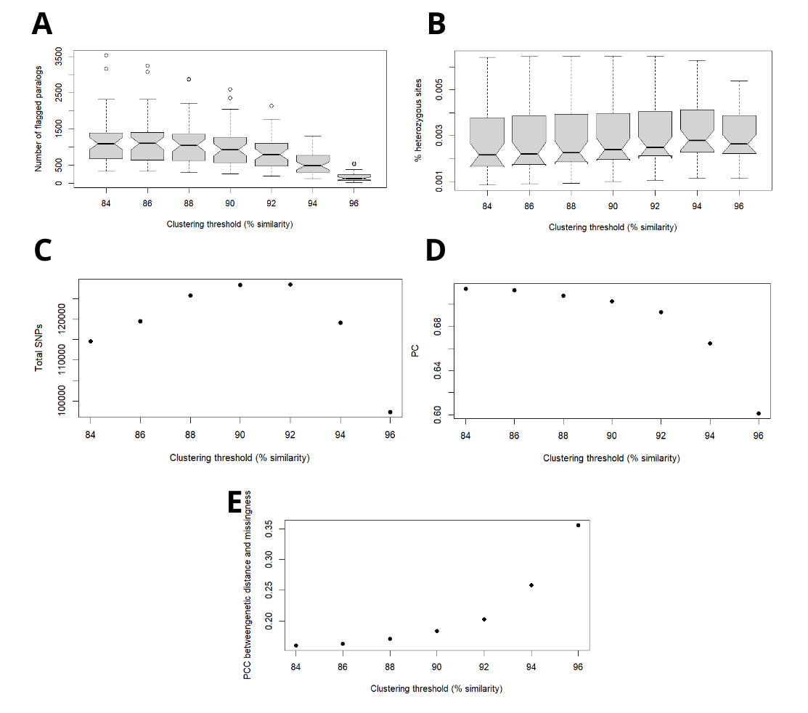

Figure S1. Visualization of metrics calculated for sequence-similarity thresholds ranging from 88% to 96%. (A) Percentage of loci inferred as paralogues, (B) per-individual heterozygosity, (C) total number of SNPs recovered, (D) cumulative variance of biallelic SNPs explained by the first 8 principal components and (E) Pearson's correlation coefficient between pairwise genetic distance and data missingness.

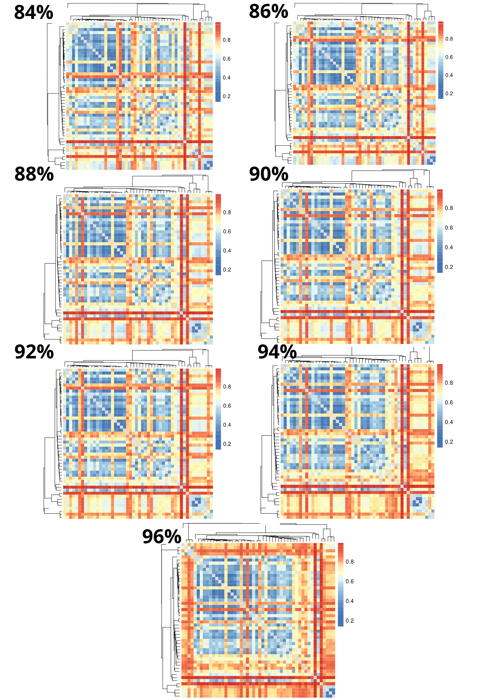
Figure S2. Heat maps visualizing pairwise missing data at clustering thresholds of 88% to 96%. Rows/columns represent individual samples, and dendrograms represent samples clustered by genetic similarity. Colors indicate pairwise fractions of missing data, with cool colors representing low fractions and warm colors representing high fractions.
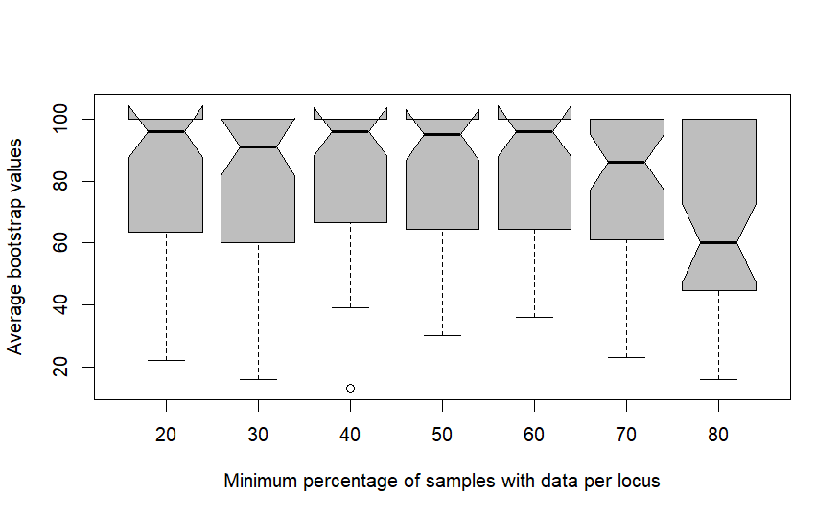
Figure S3. Average bootstrap values for trees inferred from assemblies with varying minimum percentage of samples with data per locus.
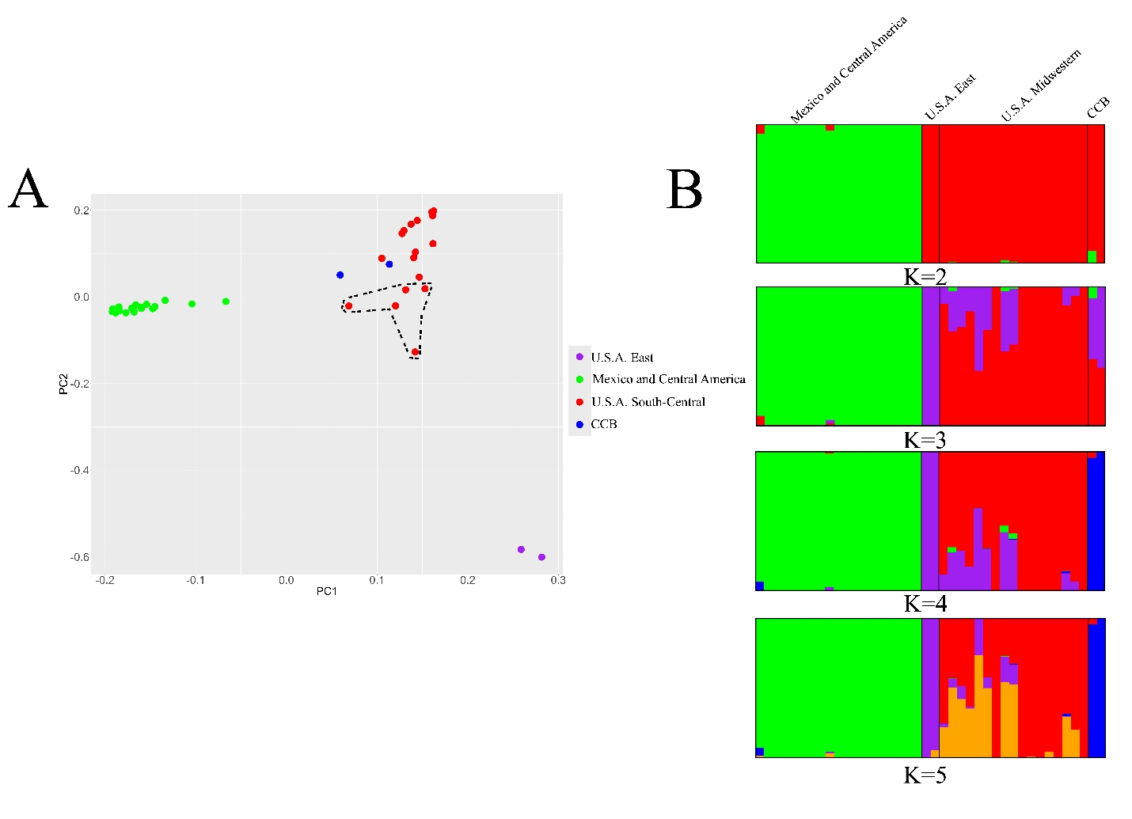
Figure S4. Population structure in Storeria dekayi excluding singletons in VCF file A. Population structure inferred using Principal Component Analysis (PCA), with points representing the different individuals colored by cluster. Note the presence of five highly admixed individuals from U.S.A. enclosed by the dashed line. B. Barplot visualization of population structure inferred by STRUCTURE. Each vertical bar represents an individual.

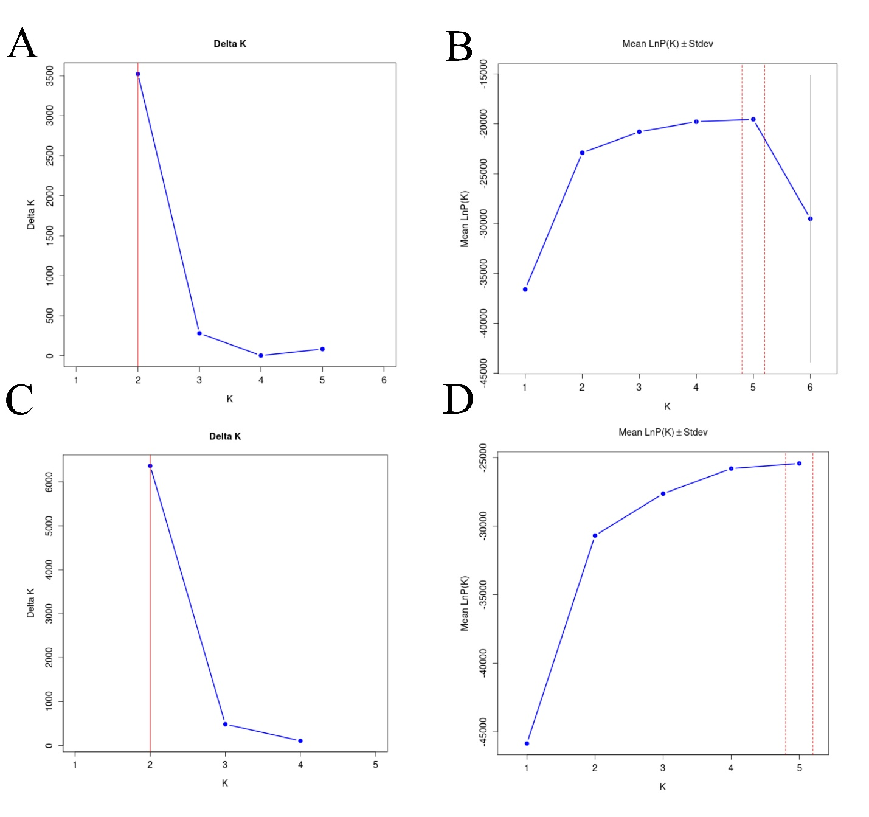
Figure S5. Delta K and ln Pr(D|K) values for varying numbers of K in STRUCTURE analyses of a SNP dataset filtered using different options. A and C: Delta K values in analyses of the SNP dataset filtered with the --maf option and excluding singletons, respectively. B and D: ln Pr(D|K) values in analyses of the SNP dataset filtered with the --maf option and excluding singletons, respectively.

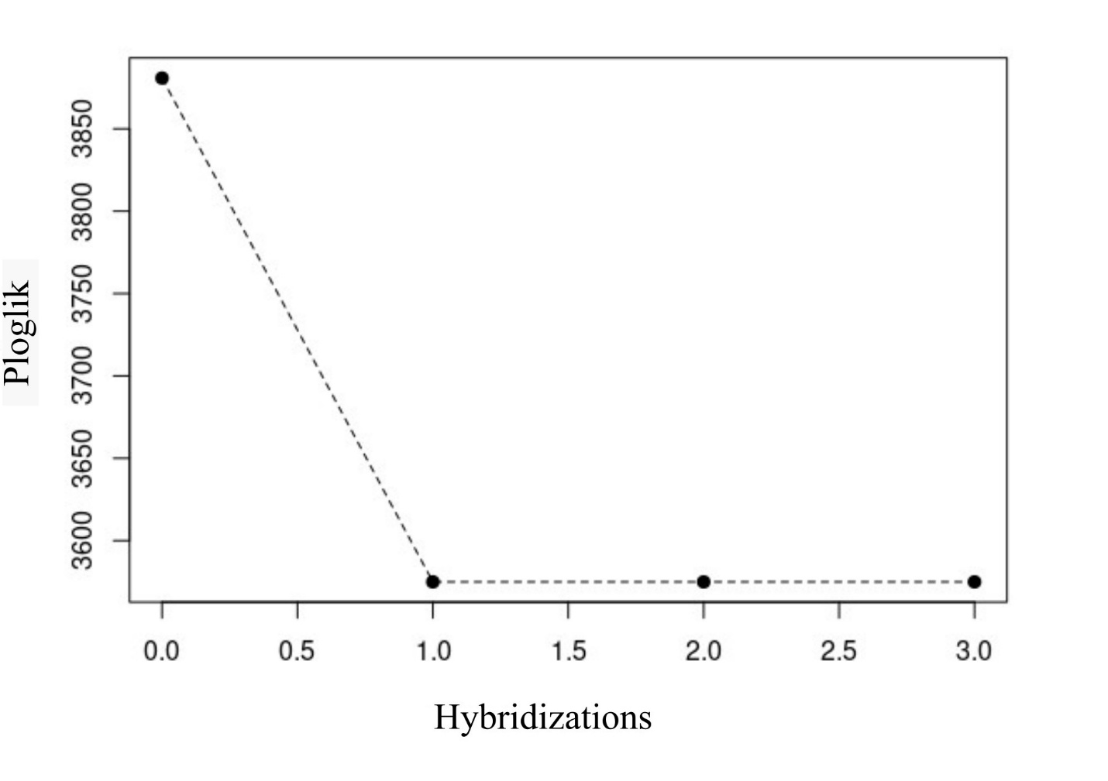
Figure S6. Log-likelihood scores of phylogenetic networks with varying numbers of hybridization events estimated with PhyloNetworks.

