Appendix
Table S1 Specimens of S. dekayi examined for morphology. Institutional abbreviations for museums and collections follow Sabaj (2023), except for MZFZ (Museo de Zoología of the Facultad de Estudios Superiores Zaragoza, Universidad Nacional Autónoma de Mexico); ANMO, AEVB, ENS and CIG numbers are field numbers for specimens to be catalogued in the MZFZ.
ID | Species | Locality | Latitude | Longitude
AEVB 020 | S. tropica | Mexico: Puebla: Ahuacatlan-Tepango Highway | 20.0107 | -97.8302
ANMO 1442 | S. sp. CCB | Mexico: Coahuila: Cuatro Cienegas | 26.9189 | -102.1362
ANMO 4322 | S. tropica | Mexico: San Luis Potosi: 1 km S of Huichihuayan | 21.4781 | -98.9614
ANMO 4345 | S. tropica | Mexico: San Luis Potosí: 4 km N of La Pimienta | 21.5644 | -99.0049
ANMO 4380 | S. tropica | Mexico: Puebla: Zaragoza | 19.7829 | -97.5215
IBH 104 | S. tropica | Mexico: San Luis Potosi: Valles | 22.0146 | -99.0060
IBH 922 | S. tropica | Mexico: Veracruz: Ingenio de el Higo | 21.7805 | -98.4550
IBH 15164 | S. tropica | Mexico: Tamaulipas: Matamoros | 25.6574 | -97.5260
IBH 1569 | S. dekayi | United States: Pennsylvania: Warren Co. Linestone Twp. along U. S. Rt. 62, miles N. of Ticlioute | 36.3830 | -93.5850
IBH 19734 | S. tropica | Mexico: Veracruz: Coscomatepec | 19.07109 | -97.0450
IBH 2303 | S. tropica | Mexico: Puebla: Rancho Las Margaritas | 19.3499 | -98.5840
IBH 31445 | S. tropica | Mexico: Veracruz: Tlacuilolan | 19.4150 | -97.0506
IBH 7492 | S. tropica | Mexico: Tamaulipas: Ejido Conrado Castillo | 23.5114 | -99.3470
ITAH 329 | S. tropica | Mexico: Hidalgo: Huejutla | 21.1602 | -98.4164
ITAH 105 | S. tropica | Mexico: Hidalgo: Huejutla | 21.0306 | -98.6682
ITAH 1369 | S. tropica | Mexico: Hidalgo: 5km S of La cabaña, Tlanchinol | 20.9798 | -98.6650
ITAH 1384 | S. tropica | Mexico
ITAH 1389 | S. tropica | Mexico
ITAH 168 | S. tropica | Mexico: Hidalgo: Tlanchinol | 21.0306 | -98.6682
ITAH 171 | S. tropica | Mexico: Hidalgo: Huejutla | 21.1652 | -98.4189
ITAH 172 | S. tropica | Mexico: Hidalgo: Jalcotan | 21.1671 | -98.5393
ITAH 233 | S. tropica | Mexico
ITAH 414 | S. tropica | Mexico: Hidalgo: Huejutla | 21.1392 | -98.4098
ITAH 610 | S. tropica | Mexico: Hidalgo: Atlapexco | 21.0476 | -98.3446
ITAH 934 | S. tropica | Mexico: Hidalgo: Atlapexco | 21.0476 | -98.3446
MZFC 29641 | S. sp. CCB | Mexico: Coahuila: Cuatro Cienegas | 26.9189 | -102.1362
MZFC 29643 | S. sp. CCB | Mexico: Coahuila: Cuatro Cienegas | 26.9189 | -102.1362
MZFC 29644 | S. sp. CCB | Mexico: Coahuila: Cuatro Cienegas | 26.9189 | -102.1362
MZFC 29646 | S. sp. CCB | Mexico: Coahuila: Cuatro Cienegas | 26.9189 | -102.1362
MZFC 29647 | S. sp. CCB | Mexico: Coahuila: Cuatro Cienegas | 26.9189 | -102.1362
MZFC 29650 | S. sp. CCB | Mexico: Coahuila: Cuatro Cienegas | 26.9189 | -102.1362
MZFC 29651 | S. sp. CCB | Mexico: Coahuila: Cuatro Cienegas | 26.9189 | -102.1362
MZFC 14226 | S. tropica | Mexico: Hidalgo: Tenango de Noria | 20.3492 | -98.2062
MZFC 14227 | S. tropica | Mexico: Hidalgo: Tenango de Noria | 20.3492 | -98.2062
MZFC 19275 | S. tropica | Mexico: Queretaro | 21.2955 | -99.1192
MZFC 21019 | S. tropica | Mexico: Hidalgo: Tlanchinol | 21.0608 | -98.6311
MZFC 21020 | S. tropica | Mexico: Hidalgo: Tlanchinol | 21.0608 | -98.6311
MZFC 21021 | S. tropica | Mexico: Hidalgo: Tlanchinol | 21.0608 | -98.6311
MZFC 21022 | S. tropica | Mexico: Hidalgo
MZFC 21258 | S. tropica | Mexico: Hidalgo: 3 km E Zul
UANL 2049 | S. tropica | Mexico
UANL 2490 | S. tropica | Mexico: Nuevo Leon: Col. Nogalar | 25.7229 | -100.2880
UANL 4119 | S. tropica | Mexico: Tamaulipas: Tula-Ocampo road | 22.9184 | -99.5636
UANL 4138 | S. tropica | Mexico: Tamaulipas: Aldama- Soto la Marina road | 23.4055 | -98.0276
UANL 4455 | S. tropica | Mexico: Tamaulipas: 80 Antiguos Morelos- Nuevo Morelos road | 22.5542 | -99.0919
UANL 6127 | S. tropica | Mexico: Nuevo León: Aldama- Soto la Marina road | 26.1640 | -98.6483
UANL 6219 | S. tropica | Mexico: Nuevo León: Villas Campestres | 25.9186 | -100.2170
UANL 6417 | S. tropica | Mexico: Tamaulipas: Soto marina road | 23.7045 | -98.2070
UANL 6439 | S. tropica | Mexico: Tamaulipas: Soto la Marina-Casas road | 23.7102 | -98.2076
UANL 6441 | S. tropica | Mexico: Tamaulipas: Soto la Marina-Casas road | 23.7102 | -98.2076
UANL 6442 | S. tropica | Mexico: Tamaulipas: Soto la Marina-Casas road | 23.7102 | -98.2076
UANL 6445 | S. tropica | Mexico: Nuevo León: Zona de pino | 26.4973 | -100.1750
UANL 6449 | S. tropica | Mexico: Tamaulipas: Mezquital, km 26 S of Matamoros | 25.6181 | -97.5040
UANL 6558 | S. tropica | Mexico: Tamaulipas: La Pesca | 27.4235 | -99.5687
UANL 6587 | S. tropica | Mexico: Arcabuz: Tamaulipas | 27.4235 | -99.5687
UTACV 13071 | S. dekayi | United States: New York: Albany | 42.6511 | -73.7528
UTACV 18307 | S. dekayi | United States: South Carolina: Edgefield | 33.7896 | -81.9309
UTACV 21770 | S. tropica | Guatemala: Baja Verapaz: Vircinity La Union Barrios | 15.1775 | -90.2054
UTACV 21771 | S. tropica | Guatemala: Baja Verapaz: Vircinity La Union Barrios | 15.1775 | -90.2054
UTACV 26585 | S. tropica | Guatemala: Baja Verapaz | 15.1746 | -90.3708
UTACV 28526 | S. tropica | Guatemala: Baja Verapaz: Vircinity La Union Barrios | 15.1775 | -90.2054
UTACV 28527 | S. tropica | Guatemala: Baja Verapaz: Niño Perdido | 15.1362 | -90.1809
UTACV 28528 | S. tropica | Guatemala: Baja Verapaz: Niño Perdido | 15.1362 | -90.1809
UTACV 32634 | S. dekayi | United States: Texas: Titus | 33.1816 | -95.1022
UTACV 32686 | S. dekayi | United States: Texas: Titus | 33.1816 | -95.1022
UTACV 32687 | S. dekayi | United States: Texas: Titus | 33.1664 | -94.9721
UTACV 33084 | S. tropica | Guatemala: Baja Verapaz: Vircinity La Union Barrios | 15.1775 | -90.2054
UTACV 33819 | S. dekayi | United States: Arkansas | 34.6937 | -94.4541
UTACV 33925 | S. dekayi | United States: Texas: Young | 31.8880 | -96.0626
UTACV 34113 | S. dekayi | United States: Illinois | 41.8306 | -88.0104
UTACV 35994 | S. dekayi | United States: Texas: Milam | 31.4630 | -93.8195
UTACV 38249 | S. tropica | Guatemala: Baja Verapaz: Vircinity La Union Barrios | 15.1775 | -90.2054
UTACV 38630 | S. dekayi | United States: Texas: Fanin | 33.7766 | -96.1557
UTACV 54319 | S. tropica | Mexico: San Luis Potosí | 21.4956 | -98.9929
UTACV 7074 | S. tropica | Guatemala: Baja Verapaz: Cerro Quisis | 15.1800 | -90.2205
UTACV 7076 | S. tropica | Guatemala: Baja Verapaz: Cerro Quisis | 15.1800 | -90.2205
UTACV 7077 | S. tropica | Guatemala: Baja Verapaz: Cerro Quisis | 15.1800 | -90.2205
UTACV 7080 | S. tropica | Guatemala: Baja Verapaz: Cerro Verde | 15.1716 | -90.2002
UTACV 7743 | S. tropica | Guatemala: Baja Verapaz: Cerro Quisis | 15.1800 | -90.2205
UTACV 7744 | S. tropica | Guatemala: Baja Verapaz: Cerro Verde | 15.1716 | -90.2002
UTACV 7745 | S. tropica | Guatemala: Baja Verapaz: La Union Barrios | 15.1775 | -90.2054
UTACV 7747 | S. tropica | Guatemala: Baja Verapaz: La Union Barrios | 15.1775 | -90.2054
UTACV 7748 | S. tropica | Guatemala: Baja Verapaz: La Union Barrios | 15.1775 | -90.2054
UOGV 4767 | S. tropica | Mexico: Hidalgo: Tiaguistnego | 20.7257 | -98.6261
MZFZ 5189 | S. tropica | Mexico: Veracruz: Yecuatla | 19.8322 | -96.8204
MZFZ 5188 | S. tropica | Mexico: Veracruz: Yecuatla | 19.8322 | -96.8204
MZFZ 5190 | S. tropica | Guatemala: Baja Verapaz: Aldéa Santa Cruz | 15.1059 | -90.1013
CIG 816 | S. tropica | Mexico: Tamaulipas: El Limón, E of Ocampo | 22.8361 | -99.0263
CIG 817 | S. tropica | Mexico: Tamaulipas: 2 km W of Hwy. 85 on road to Gomez Farías | 23.0367 | -99.1482
CIG 1160 | S. tropica | Mexico: Veracruz | 19.7425 | -96.8186
CIG 1566 | S. tropica | Mexico: Querétaro: El Madroño | 21.2858 | -99.1426

Table S2 Description of ddRAD data assemblies constructed for genomic analyses under a 92% sequence similarity threshold.
Assembly Name | Number of individuals | Number of loci | Number of SNPs | Missing data (%)
dekayi92_20min | 50 | 14,916 | 123,552 | 54.93
dekayi92_30min | 50 | 11,116 | 99,177 | 47.61
dekayi92_40min | 50 | 8,613 | 80,633 | 42.04
dekayi92_50min | 50 | 6,309 | 61,779 | 36.57
dekayi92_60min | 50 | 4,135 | 42,488 | 30.76
dekayi92_70min | 50 | 2,190 | 23,881 | 24.42
dekayi92_80min | 50 | 783 | 8,832 | 17.50

Table S3 Description of ddRAD data assemblies constructed for STRUCTURE analyses under a 94% sequence similarity threshold.
Assembly Name | Number of individuals | Number of loci | Number of SNPs | Missing data (%)
dekayi94_85min | 40 | 1,163 | 6,537 | 12.57
dekayi94_875min | 40 | 817 | 4,544 | 10.89
dekayi94_90min | 40 | 522 | 2,966 | 9.15
dekayi94_925min | 40 | 317 | 1,805 | 7.51
dekayi94_95min | 40 | 145 | 779 | 5.35

Table S4. Estimates of migration rates between S. dekayi populations from the merge algorithm
Donor | Recipient | M (95% HPD CI)
S. dekayi U.S.A. East | S. dekayi U.S.A. West | 0.190 (0.0, 0.237)
S. dekayi Mexico and Central America | S. sp. CCB | 0.010 (0.0, 0.018)
S. dekayi Mexico and Central America | S. dekayi U.S.A. West | 0.028 (0.0, 0.060)
S. sp. CCB | S. dekayi Mexico and Central America | 0.002 (0.0, 0.009)
S. sp. CCB | S. dekayi U.S.A. West | 0.0008 (0.0, 0.005)
S. dekayi U.S.A. West | S. dekayi U.S.A. East | 0.003 (0.0, 0.017)
S. dekayi U.S.A. West | S. dekayi Mexico and Central America | 0.066 (0.0, 0.084)
S. dekayi U.S.A. West | S. sp. CCB | 0.049 (0.0, 0.065)

Table S5. Estimates of migration rates between S. dekayi populations from the split algorithm
Donor | Recipient | M (95% HPD CI)
S. dekayi U.S.A. East | S. dekayi Mexico and Central America + S. sp. CCB + S. dekayi U.S.A. West | 0.106 (0.0, 0.131)
S. dekayi Mexico and Central America + S. sp. CCB + S. dekayi U.S.A. West | S. dekayi U.S.A. East | 0.002 (0.0, 0.013)

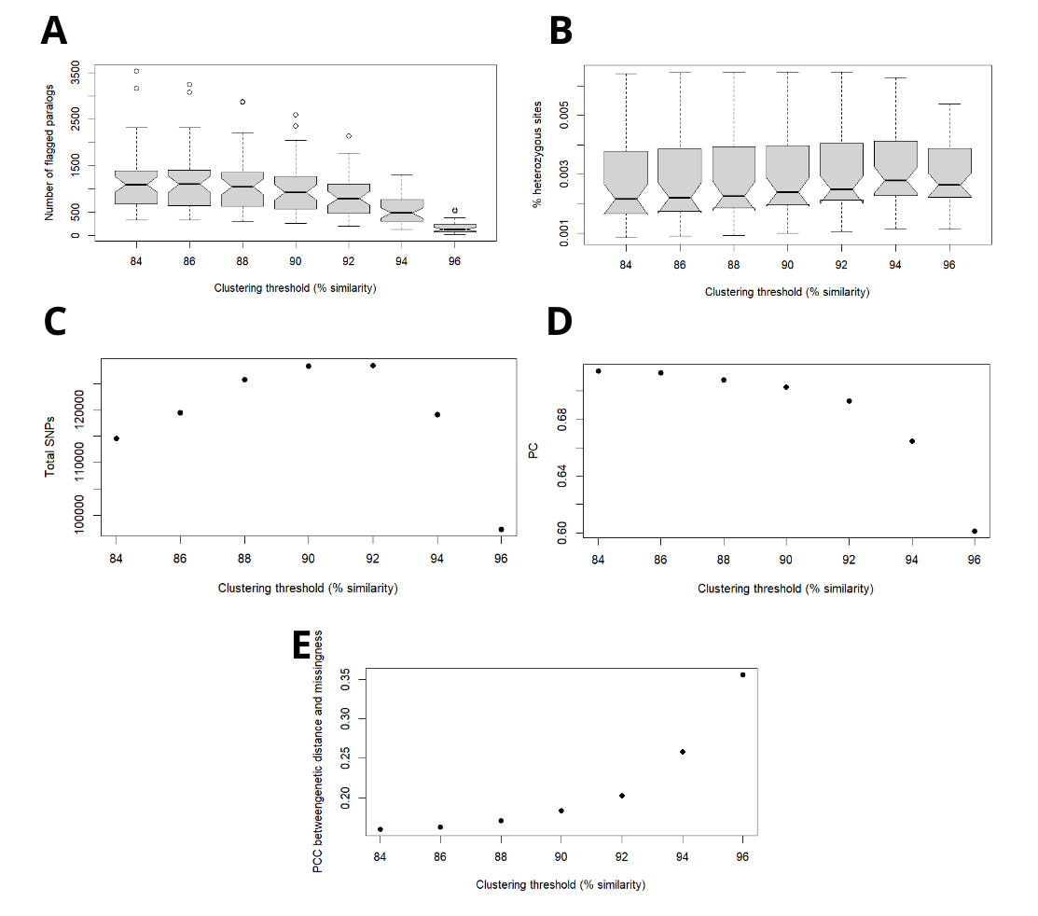
Figure S1. Visualization of metrics calculated for sequence similarity thresholds ranging from 88% to 96%. (A) Percentage of loci inferred as paralogues, (B) per-individual heterozygosity, (C) total number of SNPs recovered, (D) cumulative variance of biallelic SNPs explained by the first 8 principal components (E) Pearson's correlation coefficient between pairwise genetic distance and data missingness.

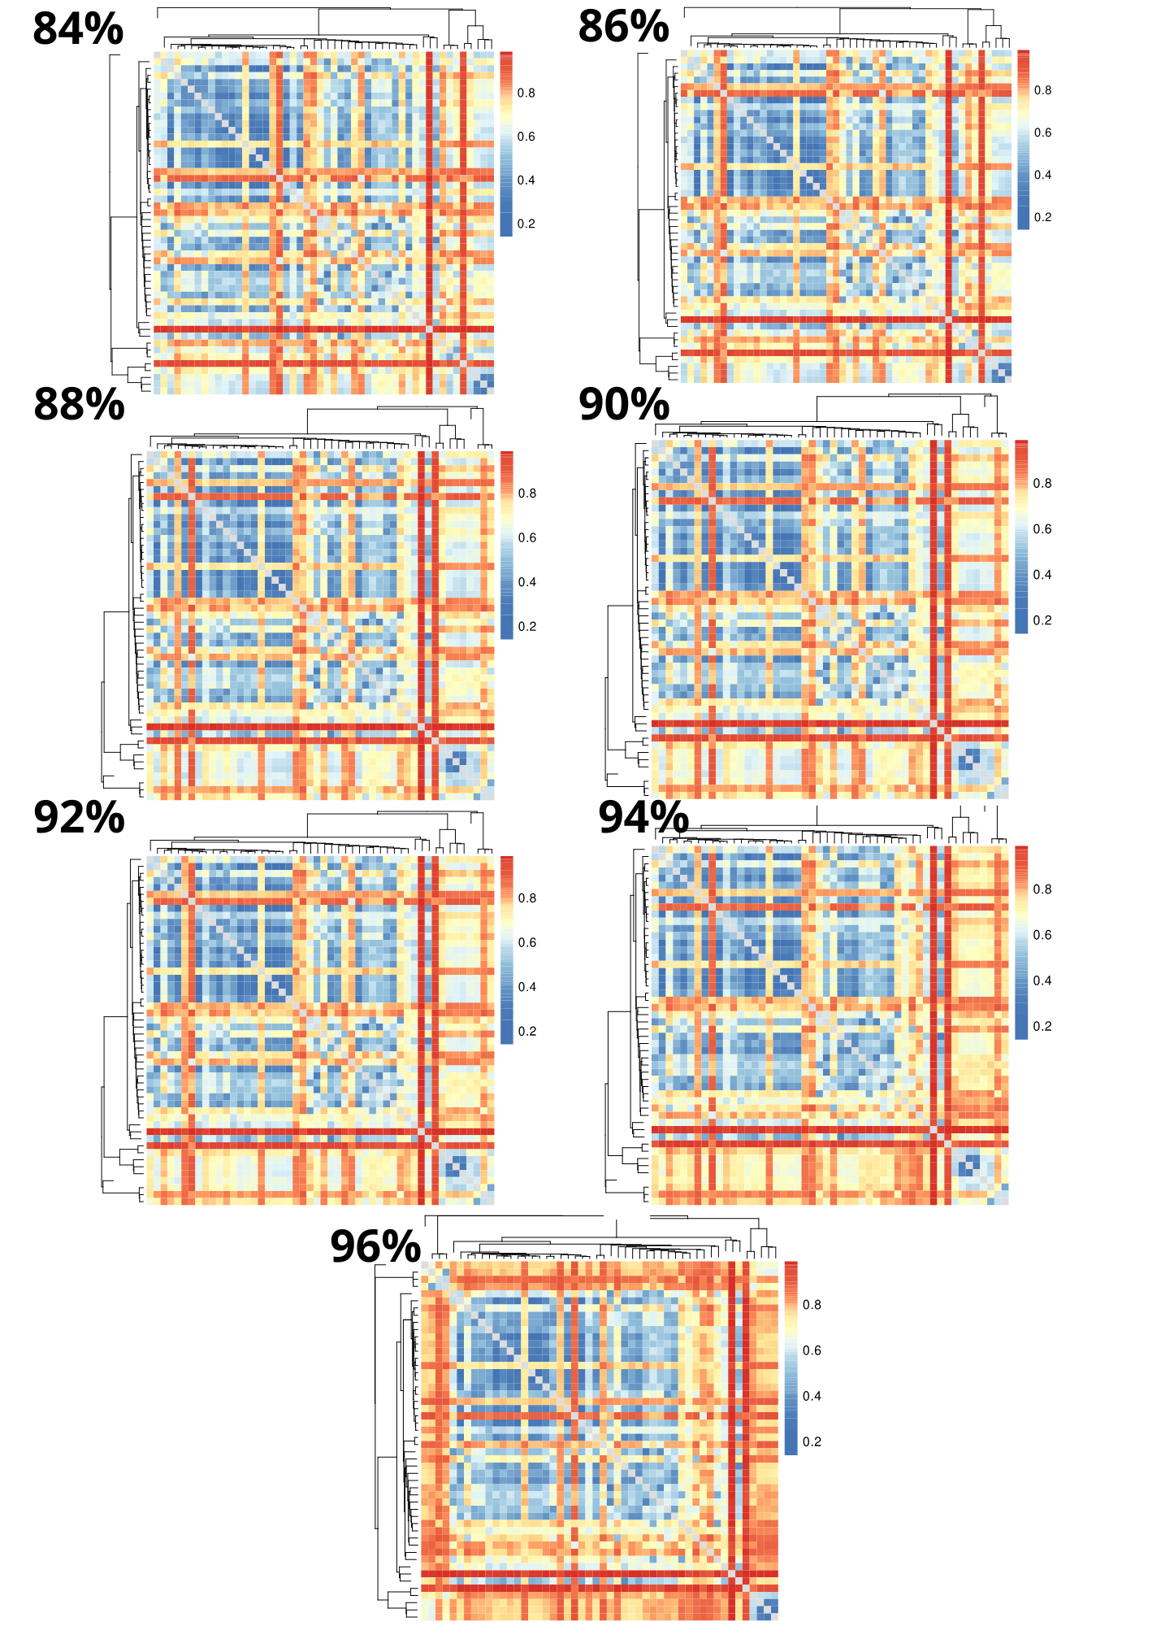
Figure S2. Heat maps visualizing pairwise missing data at clustering thresholds of 88% to 96%. Rows/columns represent individual samples, and dendrograms represent samples clustered by genetic similarity. Colors indicate pairwise fractions of missing data, with cool colors representing low fractions and warm colors representing high fractions.
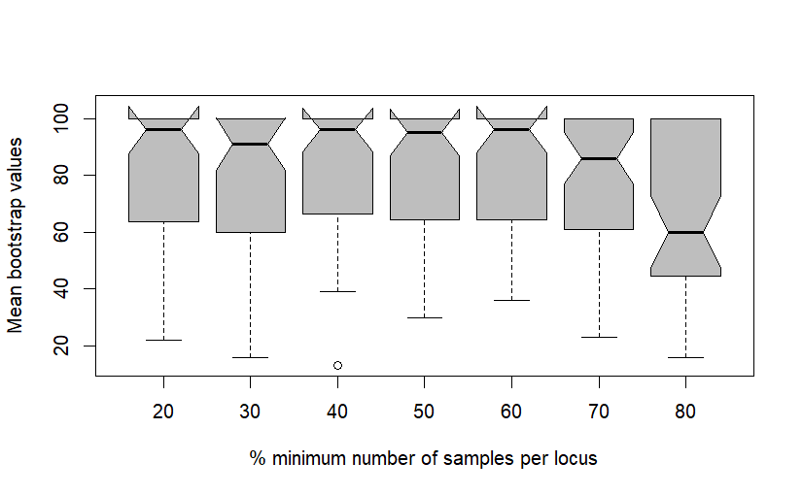
Figure S3. Average bootstrap values from different trees with varying the param percentages of minimum samples per locus in ipyrad.
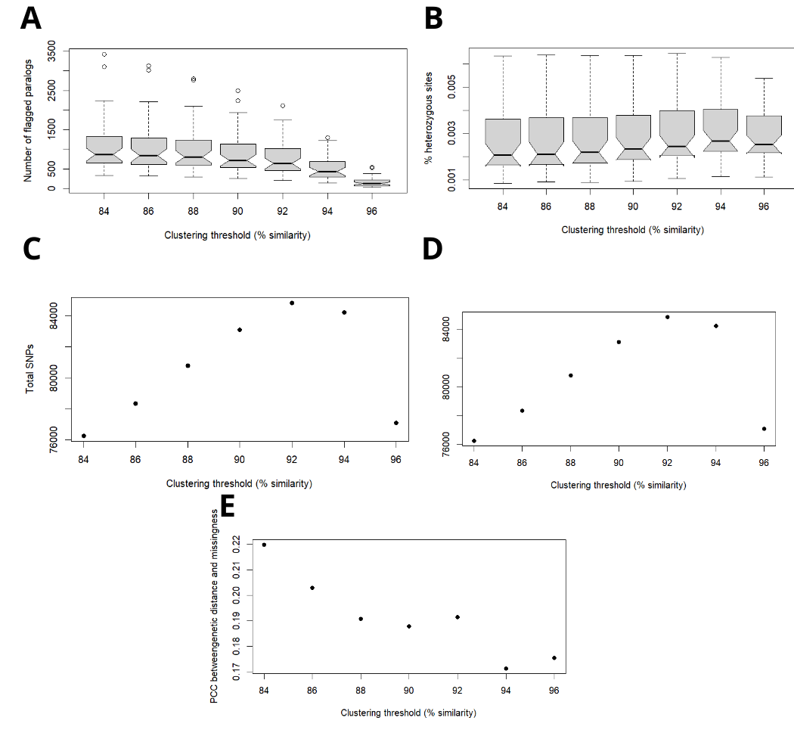
Figure S4. Visualization of metrics calculated for sequence similarity thresholds ranging from 88% to 96%, using samples exclusively from S. dekayi. (A) Percentage of inferred loci as paralogues, (B) per-individual heterozygosity, (C) total number of SNPs recovered, (D) cumulative variance of biallelic SNPs explained by the first 8 principal components, and (E) Pearson's correlation coefficient between pairwise genetic distance and data missingness.
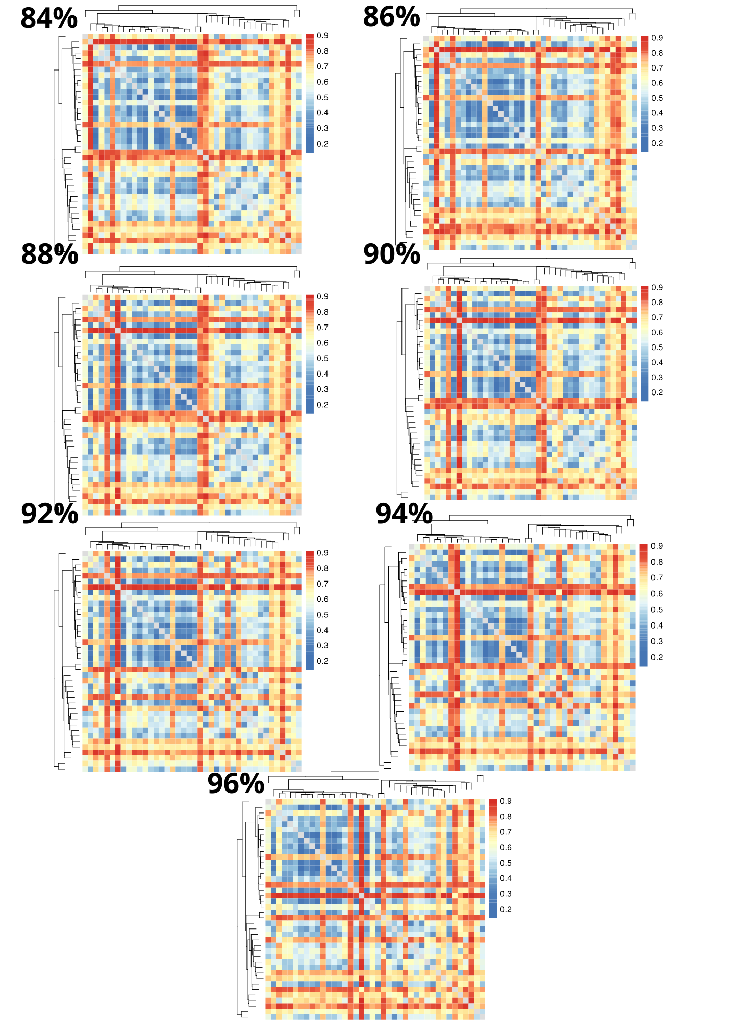
Figure S5. Heat maps visualizing pairwise missing data fractions at clustering thresholds of 88% to 96%, using samples exclusively from S. dekayi. Rows/columns represent individual samples, and dendrograms represent samples clustered by genetic similarity. Colors indicate pairwise data fractions, with cool colors representing low fractions and warm colors representing high fractions.
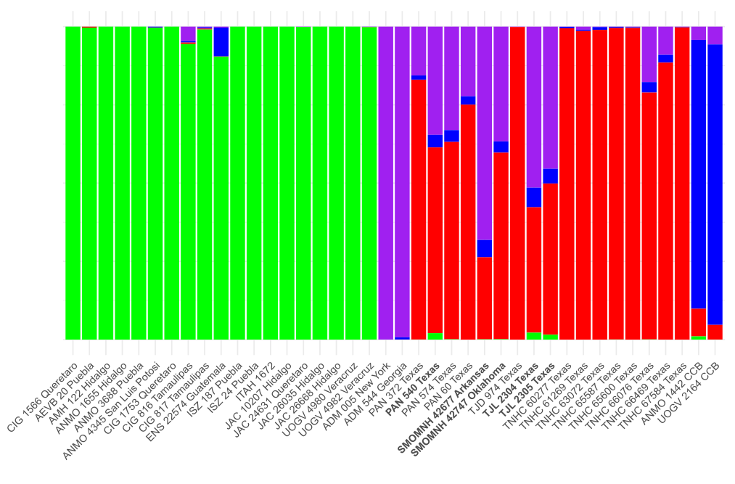
Figure S6. Barplot visualization of results of hierarchical Bayesian clustering analyses in STRUCTURE. Each vertical bar represents an individual. Samples in bold showed less than 60% ancestry and were therefore excluded to avoid phylogenetic uncertainty arising from the inclusion of potential hybrids.

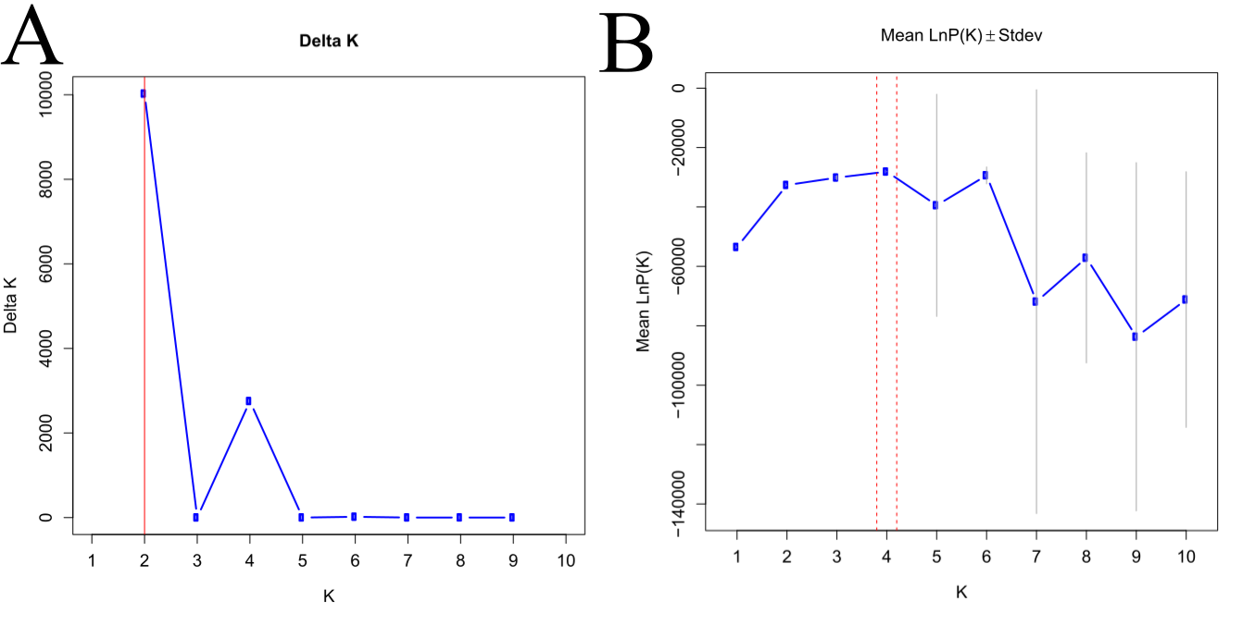
Figure S7. Optimal clusters obtained in STRUCTURE by two different methods A. Optimal K obtained by delta K method. B. Optimal K obtained by ln Pr(D|K) method

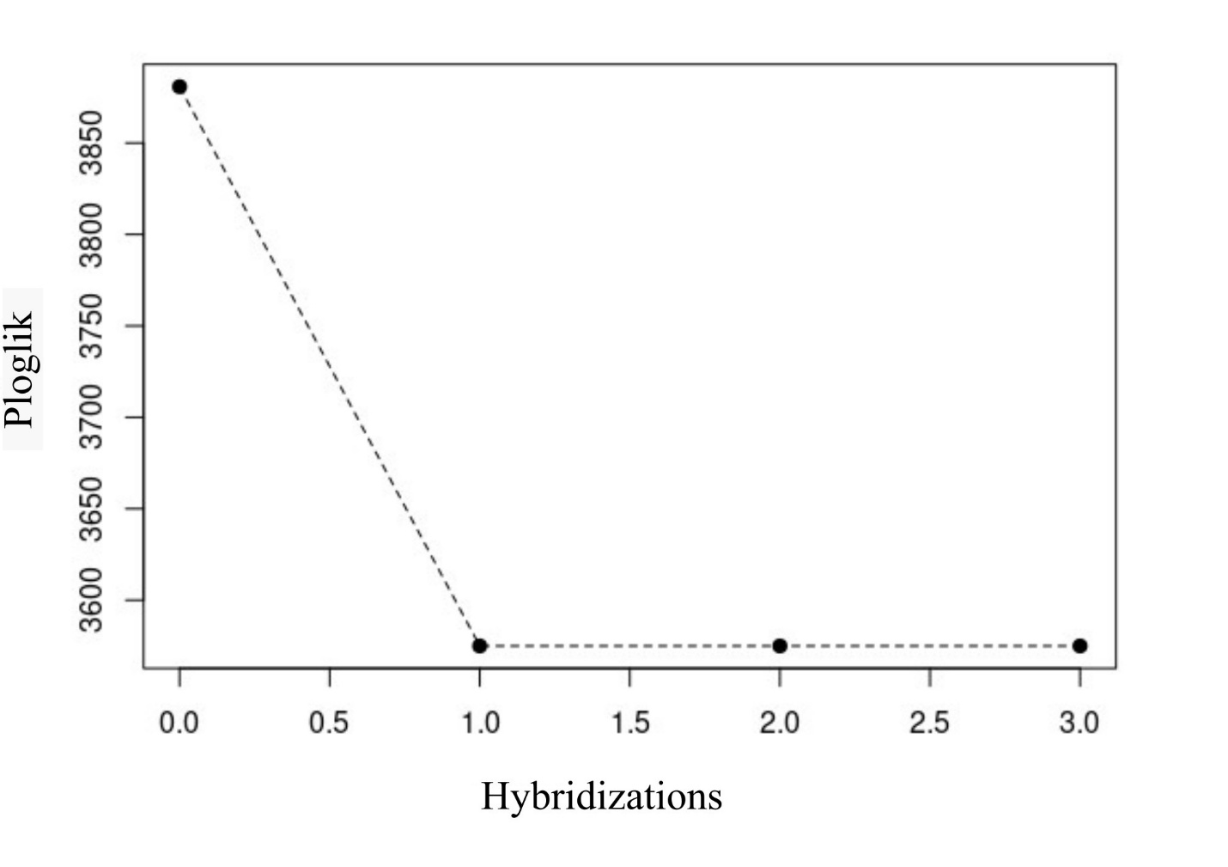
Figure S8. Score of a candidate network with optimized branch lengths and inheritance values

