django-admin startproject f1_project .
python manage.py migrate
python manage.py createsuperuser

victor
victor.gonjua@gmail.com
42424242

python manage.py startapp f1_app

---------------
After this step:
(advanced_web_dev) victor@surface:~/Project/midterm$ pwd
/home/victor/Project/midterm
(advanced_web_dev) victor@surface:~/Project/midterm$ ls
db.sqlite3 f1_app f1_project manage.py
(advanced_web_dev) victor@surface:~/Project/midterm$ cd f1_app
(advanced_web_dev) victor@surface:~/Project/midterm/f1_app$ ls
admin.py apps.py __init__.py migrations models.py tests.py views.py
(advanced_web_dev) victor@surface:~/Project/midterm/f1_app$ cd ..
(advanced_web_dev) victor@surface:~/Project/midterm$ cd f1_project
(advanced_web_dev) victor@surface:~/Project/midterm/f1_project$ ls
asgi.py __init__.py __pycache__ settings.py urls.py wsgi.py
---------------

models.py

from django.db import models

# Create your models here.

class Circuit(models.Model):
circuitId = models.IntegerField(primary_key=True)
circuitRef = models.CharField(max_length=255)
name = models.CharField(max_length=255)
location = models.CharField(max_length=255)
country = models.CharField(max_length=255)
lat = models.FloatField()
lng = models.FloatField()
alt = models.CharField(max_length=255)
url = models.CharField(max_length=255, default="")

class Constructor(models.Model):
constructorId = models.IntegerField(primary_key=True)
constructorRef = models.CharField(max_length=255)
name = models.CharField(max_length=255)
nationality = models.CharField(max_length=255)
url = models.CharField(max_length=255, default="")

class Driver(models.Model):
driverId = models.IntegerField(primary_key=True)
driverRef = models.CharField(max_length=255)
number = models.CharField(max_length=255)
code = models.CharField(max_length=255)
forename = models.CharField(max_length=255)
surname = models.CharField(max_length=255)
dob = models.DateField()
nationality = models.CharField(max_length=255)
url = models.CharField(max_length=255, default="")

class Status(models.Model):
statusId = models.IntegerField(primary_key=True)
status = models.CharField(max_length=255)

class Race(models.Model):
raceId = models.IntegerField(primary_key=True)
year = models.IntegerField()
round = models.IntegerField()
circuit = models.ForeignKey(Circuit, on_delete=models.CASCADE)
name = models.CharField(max_length=255)
date = models.DateField()
time = models.CharField(max_length=255, null=True, blank=True) # If some races don't have times
url = models.CharField(max_length=255, default="")
fp1_date = models.CharField(max_length=255, null=True, blank=True)
fp1_time = models.CharField(max_length=255, null=True, blank=True)
fp2_date = models.CharField(max_length=255, null=True, blank=True)
fp2_time = models.CharField(max_length=255, null=True, blank=True)
fp3_date = models.CharField(max_length=255, null=True, blank=True)
fp3_time = models.CharField(max_length=255, null=True, blank=True)
quali_date = models.CharField(max_length=255, null=True, blank=True)
quali_time = models.CharField(max_length=255, null=True, blank=True)
sprint_date = models.CharField(max_length=255, null=True, blank=True)
sprint_time = models.CharField(max_length=255, null=True, blank=True)

class Result(models.Model):
resultId = models.IntegerField(primary_key=True)
race = models.ForeignKey(Race, on_delete=models.CASCADE)
driver = models.ForeignKey(Driver, on_delete=models.CASCADE)
constructor = models.ForeignKey(Constructor, on_delete=models.CASCADE)
number = models.CharField(max_length=255, null=True, blank=True)
grid = models.IntegerField()
position = models.CharField(max_length=255, null=True, blank=True)
positionText = models.CharField(max_length=255)
positionOrder = models.IntegerField()
points = models.FloatField()
laps = models.IntegerField()
time = models.CharField(max_length=255, null=True, blank=True)
milliseconds = models.CharField(max_length=255, null=True, blank=True)
fastestLap = models.CharField(max_length=255, null=True, blank=True)
rank = models.CharField(max_length=255, null=True, blank=True)
fastestLapTime = models.CharField(max_length=255, null=True, blank=True)
fastestLapSpeed = models.CharField(max_length=255, null=True, blank=True)
status = models.ForeignKey(Status, on_delete=models.CASCADE)

class Season(models.Model):
year = models.IntegerField(primary_key=True)
url = models.CharField(max_length=255, default="")

-----------------
python manage.py makemigrations
python manage.py migrate

python manage.py dbshell

----------------

load_data.py

import os
import django
import pandas as pd

os.environ.setdefault('DJANGO_SETTINGS_MODULE', 'f1_project.settings')
django.setup()

from f1_app.models import Circuit, Constructor, Driver, Race, Result, Season, Status

def load_circuits():
Circuit.objects.all().delete()
df = pd.read_csv('data_files/circuits.csv')
for _, row in df.iterrows():
Circuit.objects.create(
circuitId=row['circuitId'],
circuitRef=row['circuitRef'],
name=row['name'],
location=row['location'],
country=row['country'],
lat=row['lat'],
lng=row['lng'],
alt=row['alt'],
url=row['url']
)

def load_constructors():
Constructor.objects.all().delete()
df = pd.read_csv('data_files/constructors.csv')
for _, row in df.iterrows():
Constructor.objects.create(
constructorId=row['constructorId'],
constructorRef=row['constructorRef'],
name=row['name'],
nationality=row['nationality'],
url=row['url']
)

def load_drivers():
Driver.objects.all().delete()
df = pd.read_csv('data_files/drivers.csv')
for _, row in df.iterrows():
Driver.objects.create(
driverId=row['driverId'],
driverRef=row['driverRef'],
number=row['number'],
code=row['code'],
forename=row['forename'],
surname=row['surname'],
dob=pd.to_datetime(row['dob']).date(),
nationality=row['nationality'],
url=row['url']
)

def load_status():
Status.objects.all().delete()
df = pd.read_csv('data_files/status.csv')
for _, row in df.iterrows():
Status.objects.create(
statusId=row['statusId'],
status=row['status']
)

def load_seasons():
Season.objects.all().delete()
df = pd.read_csv('data_files/seasons.csv')
for _, row in df.iterrows():
Season.objects.create(
year=row['year'],
url=row['url']
)

def load_races():
Race.objects.all().delete()
df = pd.read_csv('data_files/races.csv')
for _, row in df.iterrows():
circuit_instance = Circuit.objects.get(circuitId=row['circuitId'])
Race.objects.create(
raceId=row['raceId'],
year=row['year'],
round=row['round'],
circuit=circuit_instance,
name=row['name'],
date=pd.to_datetime(row['date']).date(),
time=row['time'],
url=row['url'],
fp1_date=row['fp1_date'],
fp1_time=row['fp1_time'],
fp2_date=row['fp2_date'],
fp2_time=row['fp2_time'],
fp3_date=row['fp3_date'],
fp3_time=row['fp3_time'],
quali_date=row['quali_date'],
quali_time=row['quali_time'],
sprint_date=row['sprint_date'],
sprint_time=row['sprint_time']
)

def load_results():
Result.objects.all().delete()
df = pd.read_csv('data_files/results.csv')
for _, row in df.iterrows():
try:
race_instance = Race.objects.get(raceId=row['raceId'])
driver_instance = Driver.objects.get(driverId=row['driverId'])
constructor_instance = Constructor.objects.get(constructorId=row['constructorId'])
status_instance = Status.objects.get(statusId=row['statusId'])
except (Race.DoesNotExist, Driver.DoesNotExist, Constructor.DoesNotExist, Status.DoesNotExist) as e:
print(f"Referenced record does not exist: {e}. Skipping result {row['resultId']}.")
continue

Result.objects.create(
resultId=row['resultId'],
race=race_instance,
driver=driver_instance,
constructor=constructor_instance,
number=row['number'],
grid=row['grid'],
position=row['position'],
positionText=row['positionText'],
positionOrder=row['positionOrder'],
points=row['points'],
laps=row['laps'],
time=row['time'],
milliseconds=row['milliseconds'],
fastestLap=row['fastestLap'],
rank=row['rank'],
fastestLapTime=row['fastestLapTime'],
fastestLapSpeed=row['fastestLapSpeed'],
status=status_instance
)

def main():
load_circuits()
load_constructors()
load_drivers()
load_status()
load_seasons

--------------------------

python load_data.py

--------------------------

sqlite> SELECT COUNT(*) FROM f1_app_circuit;
77
sqlite> SELECT COUNT(*) FROM f1_app_constructor;
211
sqlite> SELECT COUNT(*) FROM f1_app_driver;
857
sqlite> SELECT COUNT(*) FROM f1_app_status;
139
sqlite> SELECT COUNT(*) FROM f1_app_race;
1102
sqlite> SELECT COUNT(*) FROM f1_app_result;
25840
sqlite> SELECT COUNT(*) FROM f1_app_season;
74

sqlite> SELECT f1_app_Race.year, COUNT(*) as result_count
FROM f1_app_Result
INNER JOIN f1_app_Race ON f1_app_Result.race_id = f1_app_Race.raceId
GROUP BY f1_app_Race.year;
1950|160
1951|179
1952|215
1953|246
1954|230
1955|180
1956|190
1957|171
1958|241
1959|195
1960|223
1961|220
1962|223
1963|254
1964|207
1965|205
1966|166
1967|205
1968|233
1969|177
1970|294
1971|263
1972|309
1973|357
1974|436
1975|363
1976|434
1977|477
1978|471
1979|403
1980|383
1981|449
1982|465
1983|424
1984|430
1985|406
1986|412
1987|419
1988|495
1989|620
1990|542
1991|539
1992|478
1993|412
1994|444
1995|418
1996|340
1997|376
1998|349
1999|352
2000|373
2001|374
2002|362
2003|320
2004|360
2005|376
2006|396
2007|374
2008|368
2009|340
2010|456
2011|456
2012|480
2013|418
2014|407
2015|378
2016|462
2017|400
2018|420
2019|420
2020|340
2021|440
2022|440

DELETE FROM f1_app_Result
WHERE race_id IN (
SELECT raceId
FROM f1_app_Race
WHERE year < 2010
);

sqlite> SELECT COUNT(*) FROM f1_app_circuit;
77
sqlite> SELECT COUNT(*) FROM f1_app_constructor;
211
sqlite> SELECT COUNT(*) FROM f1_app_driver;
857
sqlite> SELECT COUNT(*) FROM f1_app_status;
139
sqlite> SELECT COUNT(*) FROM f1_app_race;
1102
sqlite> SELECT COUNT(*) FROM f1_app_result;
5517
sqlite> SELECT COUNT(*) FROM f1_app_season;
74

-------------------------------

List All Circuits
Endpoint: /api/circuits/
Method: GET
Description: Retrieve a list of all racing circuits.
URL: http://127.0.0.1:8000/api/circuits/

Get Detailed Information About a Specific Circuit
Endpoint: /api/circuit/{circuitId}/
Method: GET
Description: Fetch detailed information about a specific circuit by its ID.
URL: http://127.0.0.1:8000/api/circuit/1/

List All Races for a Specific Year
Endpoint: /api/races/year/{year}/
Method: GET
Description: Retrieve all races that occurred in a specified year.
URL: http://127.0.0.1:8000/api/races/year/2020/

List All Drivers
Endpoint: /api/drivers/
Method: GET
Description: Retrieve a list of all F1 drivers.
URL: http://127.0.0.1:8000/api/drivers/

Get Career Summary of a Driver
Endpoint: /api/driver/summary/{driverId}/
Method: GET
Description: Get a summary of a driver’s career, including wins, teams, and years active.
URL: http://127.0.0.1:8000/api/driver/summary/1/

Add a New Driver
Endpoint: /api/driver/add/
Method: POST
Description: Add a new driver entry.
URL: http://127.0.0.1:8000/api/driver/add/
URL added driver: http://127.0.0.1:8000/api/driver/summary/859/

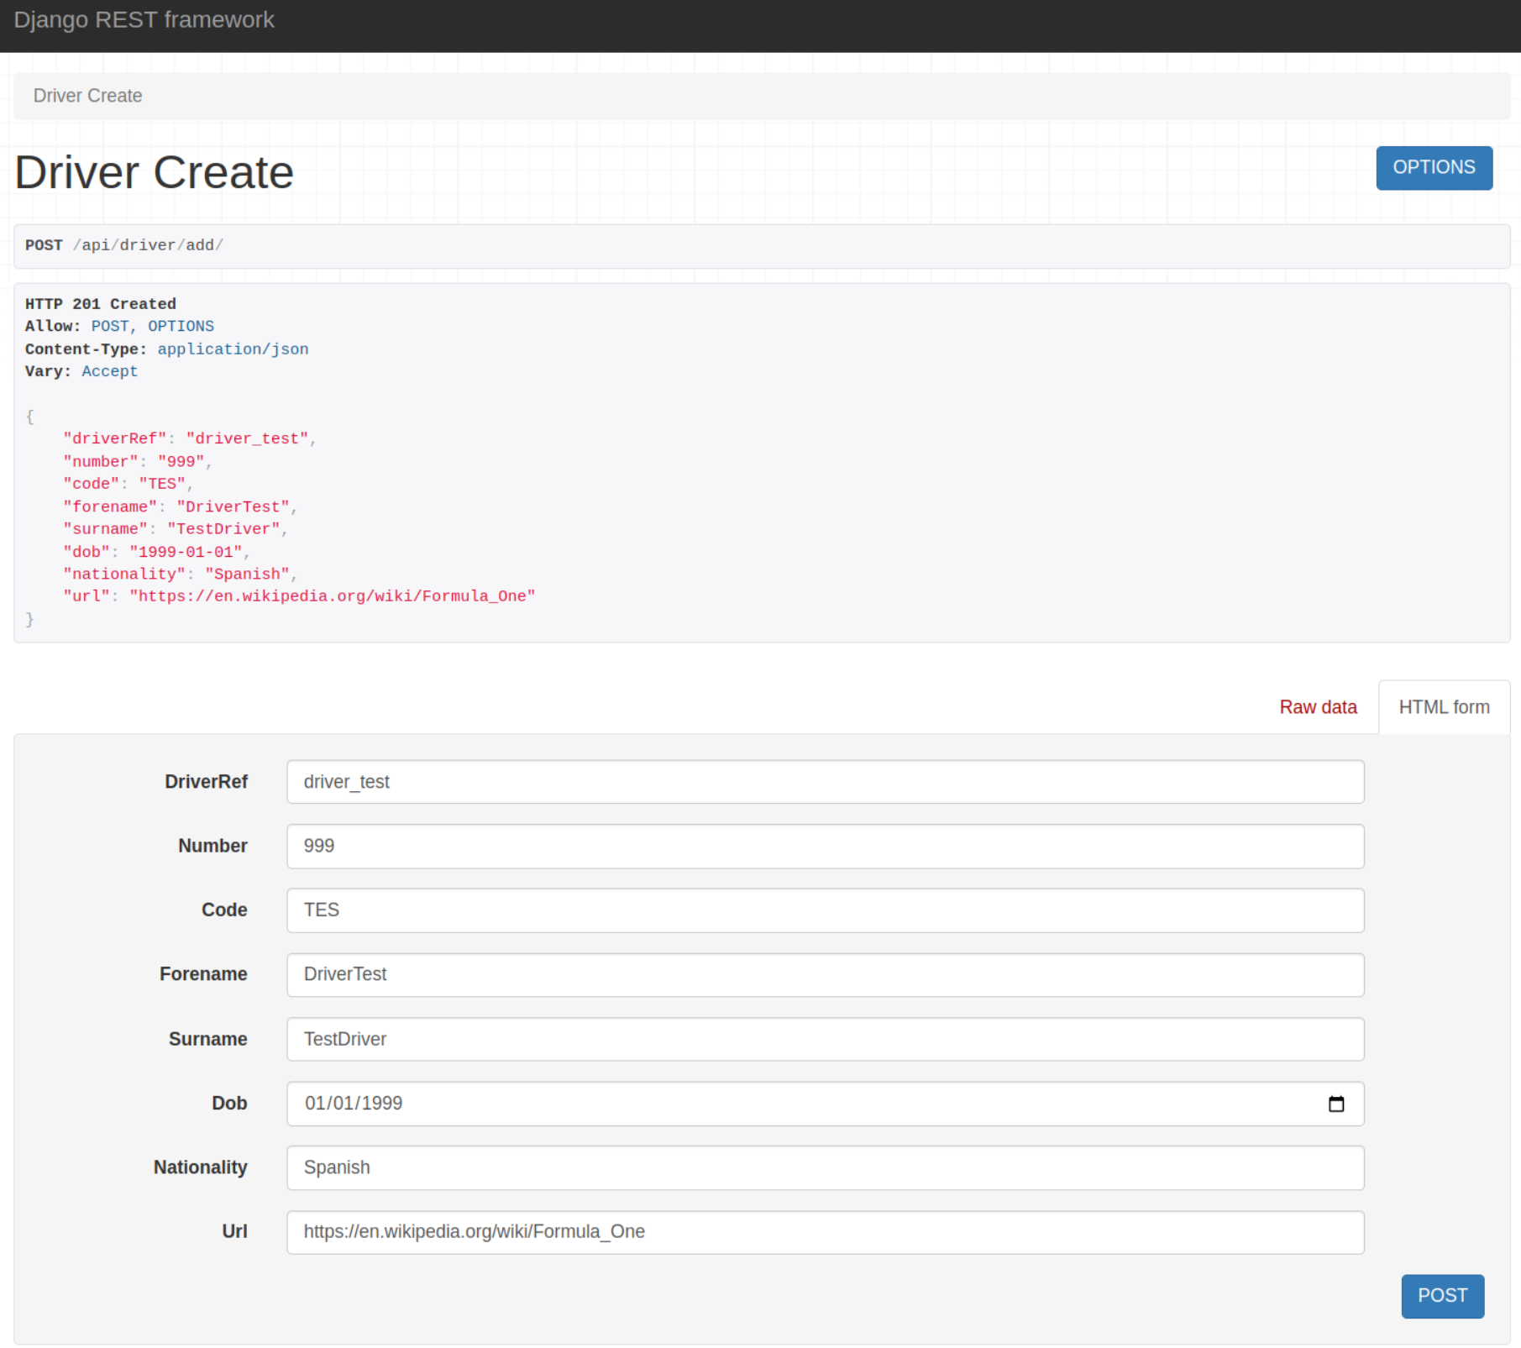

Update a Driver's Information
Endpoint: /api/driver/update/{driverId}/
Method: PUT
Description: Update information about a driver. Useful for editing driver details like team changes or status updates.
URL: http://127.0.0.1:8000/api/driver/update/860/

Original driver:
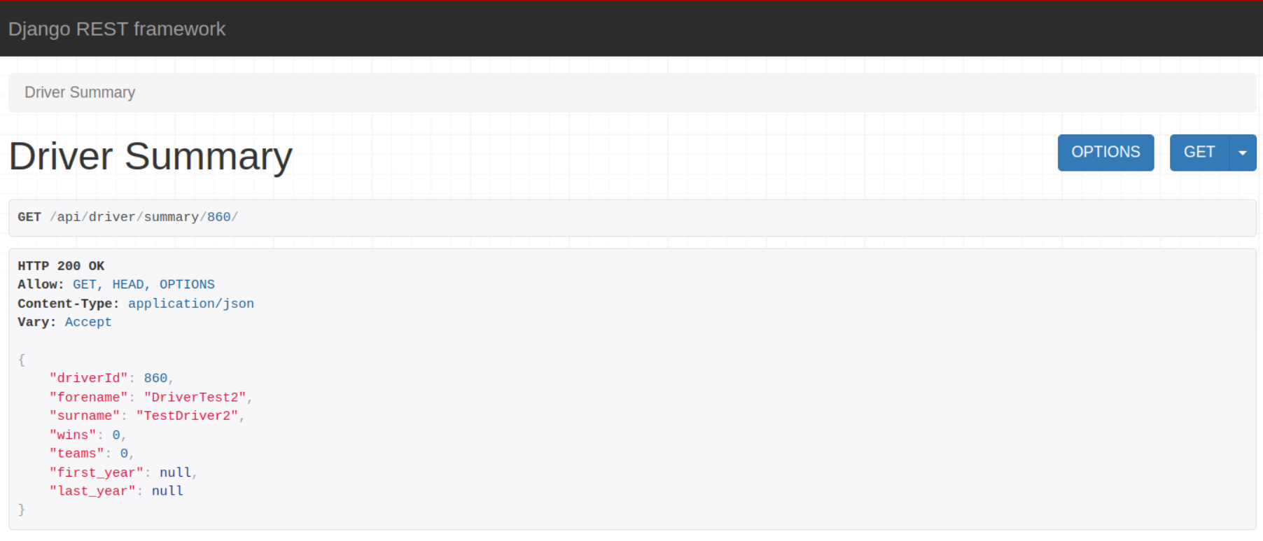
Modification:
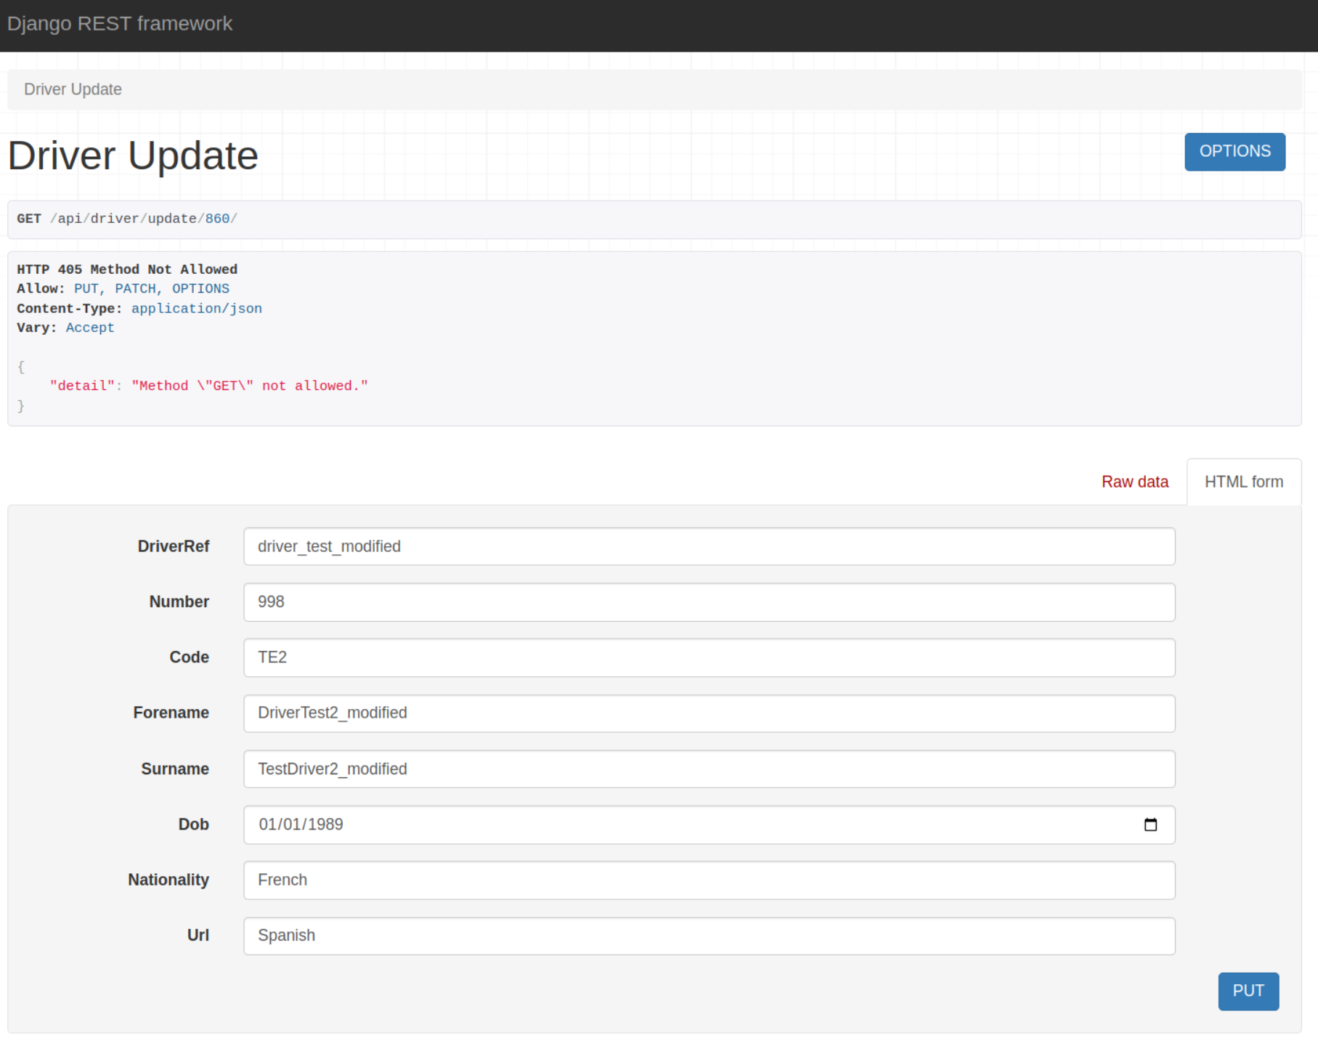

Modified driver:
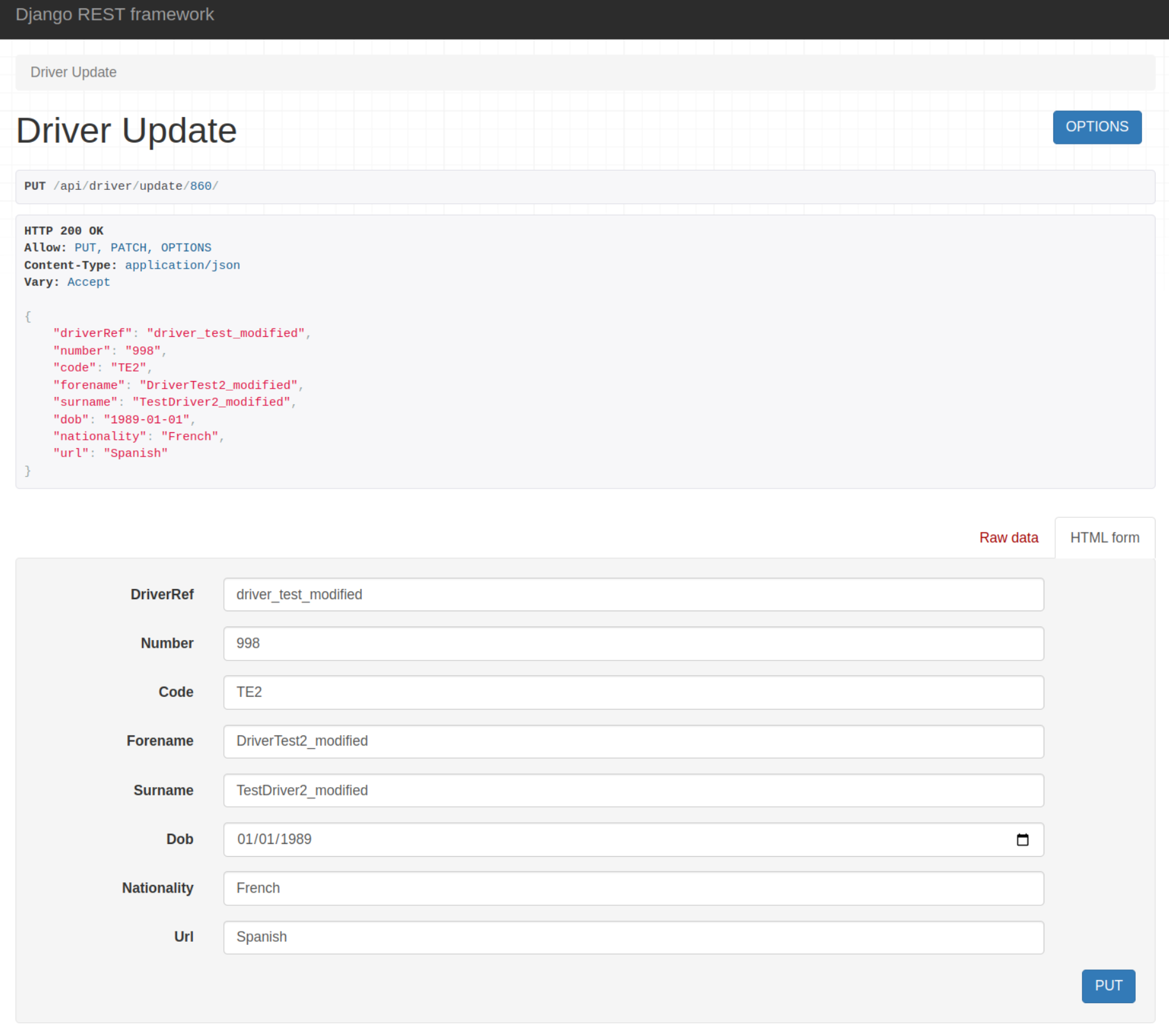

Delete a Driver's Information
Endpoint: /api/driver/delete/{driverId}/
Method: DELETE
Description: Delete information about a driver.
URL:

Driver created for deletion test

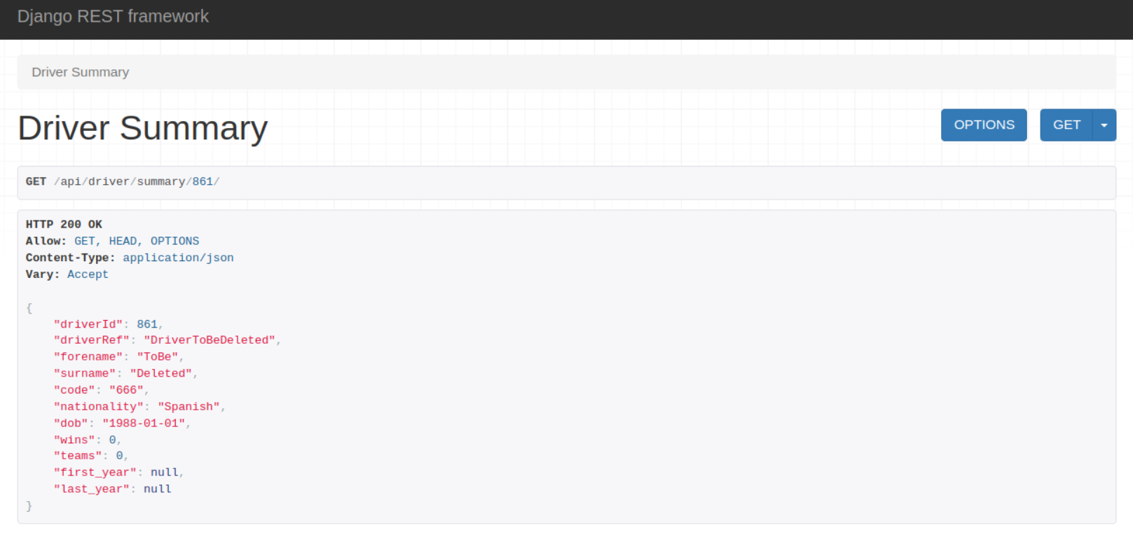
Deleted driver

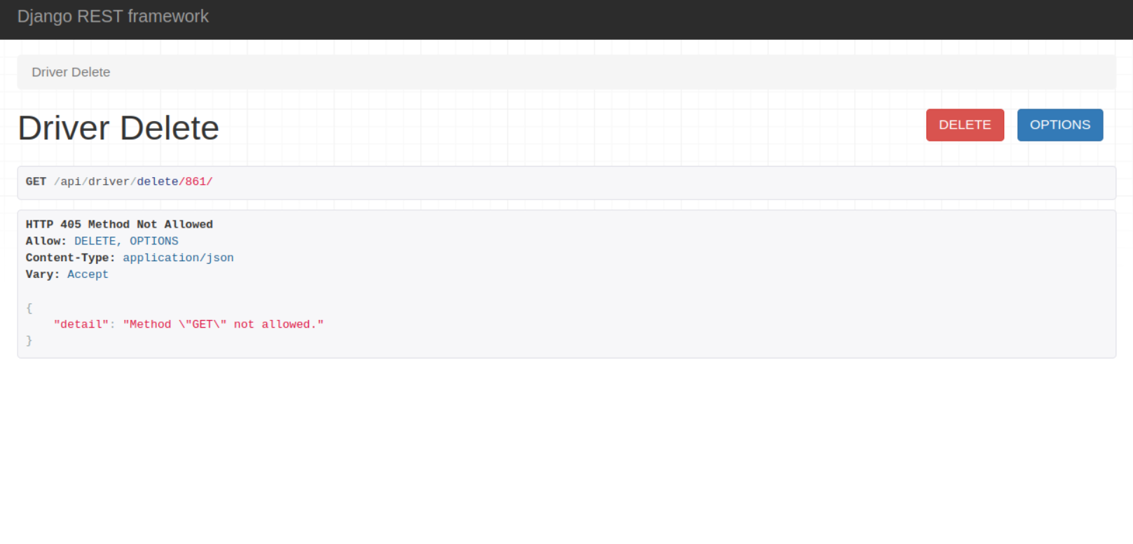
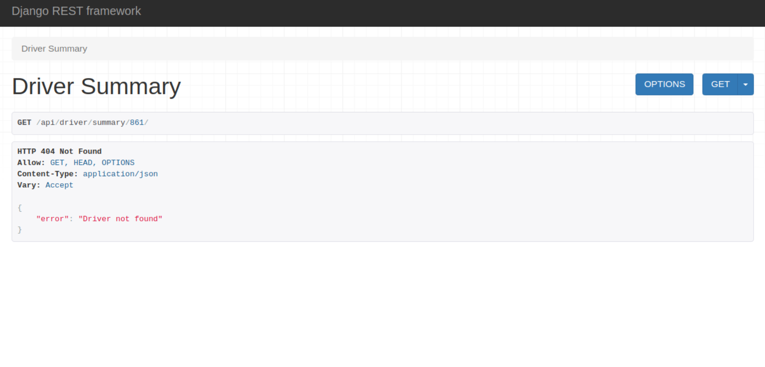

--------------------

1. Writing Tests for Models
Create tests to ensure your models are saving data correctly and any methods in the models are functioning as intended.

2. Writing Tests for Views
Test your API endpoints to ensure they are returning the correct data and status codes.

3. Testing Serializers
Ensure your serializers correctly handle valid and invalid data.

4. Writing Tests for URL Configurations

