|  |
| --- |
| ESILV |
| Report Final project |
| Design Pattern & Soft dev |

|  |
| --- |
| GOUBET Victor - Daems Chloé – DIA2  01/12/2020 |



**Exercice 1 – CustomQueue – Generics**

1. Introduction

The goal here is to create from scratch an entire generic queue class. It must have all the major functions and characteristics of the provided queue as the capacity to be used in a foreach loops.

1. Design Hypotheses

For this problem, we use the model of a queue composed of nodes. Each Nodes have a generic value and a next node. A queue has a root which is the foot of the queue. In order to make the custom queue iterable, we have implemented the iterator model. Thus, we can iterate throw the nodes of a queue.

1. UML diagrams

**Class diagramm :**

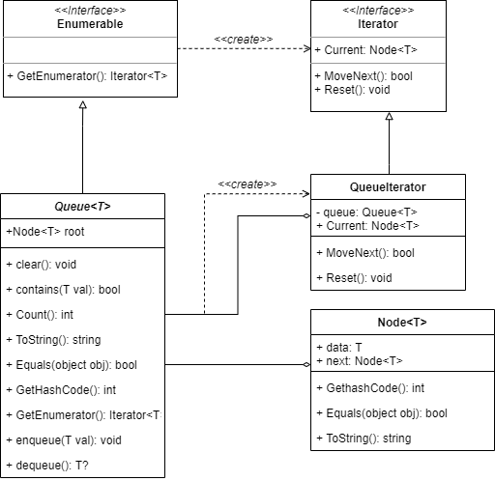

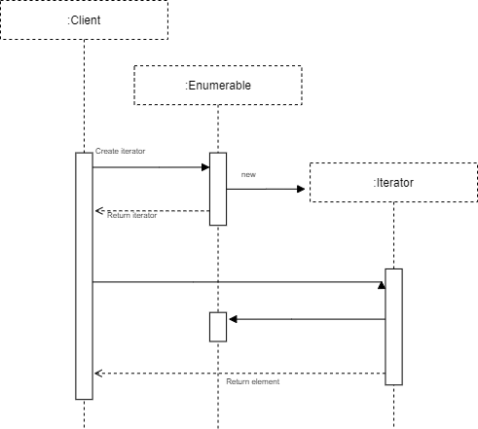

**Sequence diagramm :**

1. Test cases

We made a total of 10 tests in order to assert that our Custom queue and its methods works properly. We checked that dequeue(), clear(), enqueue(), count(),contains() works well even with empty queues. We’re happy to say that all our tests appeared to be correct, which lets us think that our code works properly.

1. Additional / Final remarks

We add the constraint where T: struct to be able to return a nullable type when we dequeue an empty queue. Thus, the dequeue method return a T? type.

Moreover, an improvement would be to add the possibility to iterate throw the T data instead of Node<T>

**Exercice 2 – CustomQueue – Generics**

1. Introduction
2. Design Hypotheses
3. UML diagrams
4. Test cases
5. Additional / Final remarks

**Exercice 3 – CustomQueue – Generics**

1. Introduction
2. Design Hypotheses
3. UML diagrams
4. Test cases
5. Additional / Final remarks