

**PODER EXECUTIVO**

**MINISTÉRIO DA EDUCAÇÃO**

**UNIVERSIDADE FEDERAL DE RORAIMA**

**DEPARTAMENTO DE CIÊNCIA DA COMPUTAÇÃO**

**TUTORIAL DO PROJETO: IMPLEMENTAÇÃO DA POLÍTICA SCHEDULE BACKGROUND**

**ALUNOS:**

**Victor Hugo Souza Costa**

**Giovana Oliveira Moraes de Lima**

**Ryan Kayky Marques Rolins Bastos**

**Setembro de 2024**

**Boa Vista/Roraima**



**PODER EXECUTIVO**

**MINISTÉRIO DA EDUCAÇÃO**

**UNIVERSIDADE FEDERAL DE RORAIMA**

**DEPARTAMENTO DE CIÊNCIA DA COMPUTAÇÃO**

**SISTEMAS OPERACIONAIS I**

**TUTORIAL DO PROJETO: IMPLEMENTAÇÃO DA POLÍTICA SCHEDULE BACKGROUND**

**Setembro de 2024**

**Boa Vista/Roraima**

**Resumo**

Este projeto tem como objetivo modificar o escalonador de processos do Linux para implementar uma nova classe de escalonador chamada SCHED_BACKGROUND. Esta nova política é projetada para suportar processos que só precisam ser executados quando o sistema não possui outras tarefas ativas. O escalonador em background deve garantir que processos com essa política sejam executados apenas na ausência de processos nas classes SCHED_OTHER, SCHED_RR, ou SCHED_FIFO. Quando múltiplos processos SCHED_BACKGROUND estão prontos para execução, eles competem pela CPU de forma semelhante aos processos da classe SCHED_OTHER.

**PRIMEIROS PASSOS:**

1. **Verificar a versão do kernel**

uname -r

1. **Baixar o código fonte (estou usando a 5.15.0)**

wget https://git.kernel.org/pub/scm/linux/kernel/git/stable/linux.git/snapshot/linux-5.15.tar.gz

1. **Extraia o código fonte**

tar -xzvf linux-5.15.tar.gz

1. **Instale as dependências necessárias**

sudo apt-get install build-essential libncurses-dev bison flex libssl-dev libelf-dev

1. **Modificar arquivos relevantes:**

* **/INCLUDE/UAPI/LINUX/SCHED.H**: Defina a nova política

#define SCHED_BACKGROUND 7

* **/KERNEL/SCHED:** criar dois novos arquivos, *sched_background.c e sched_background.h* (especificados nas imagens abaixo)

**/KERNEL/SCHED/SCHED_BACKGROUND.C:**

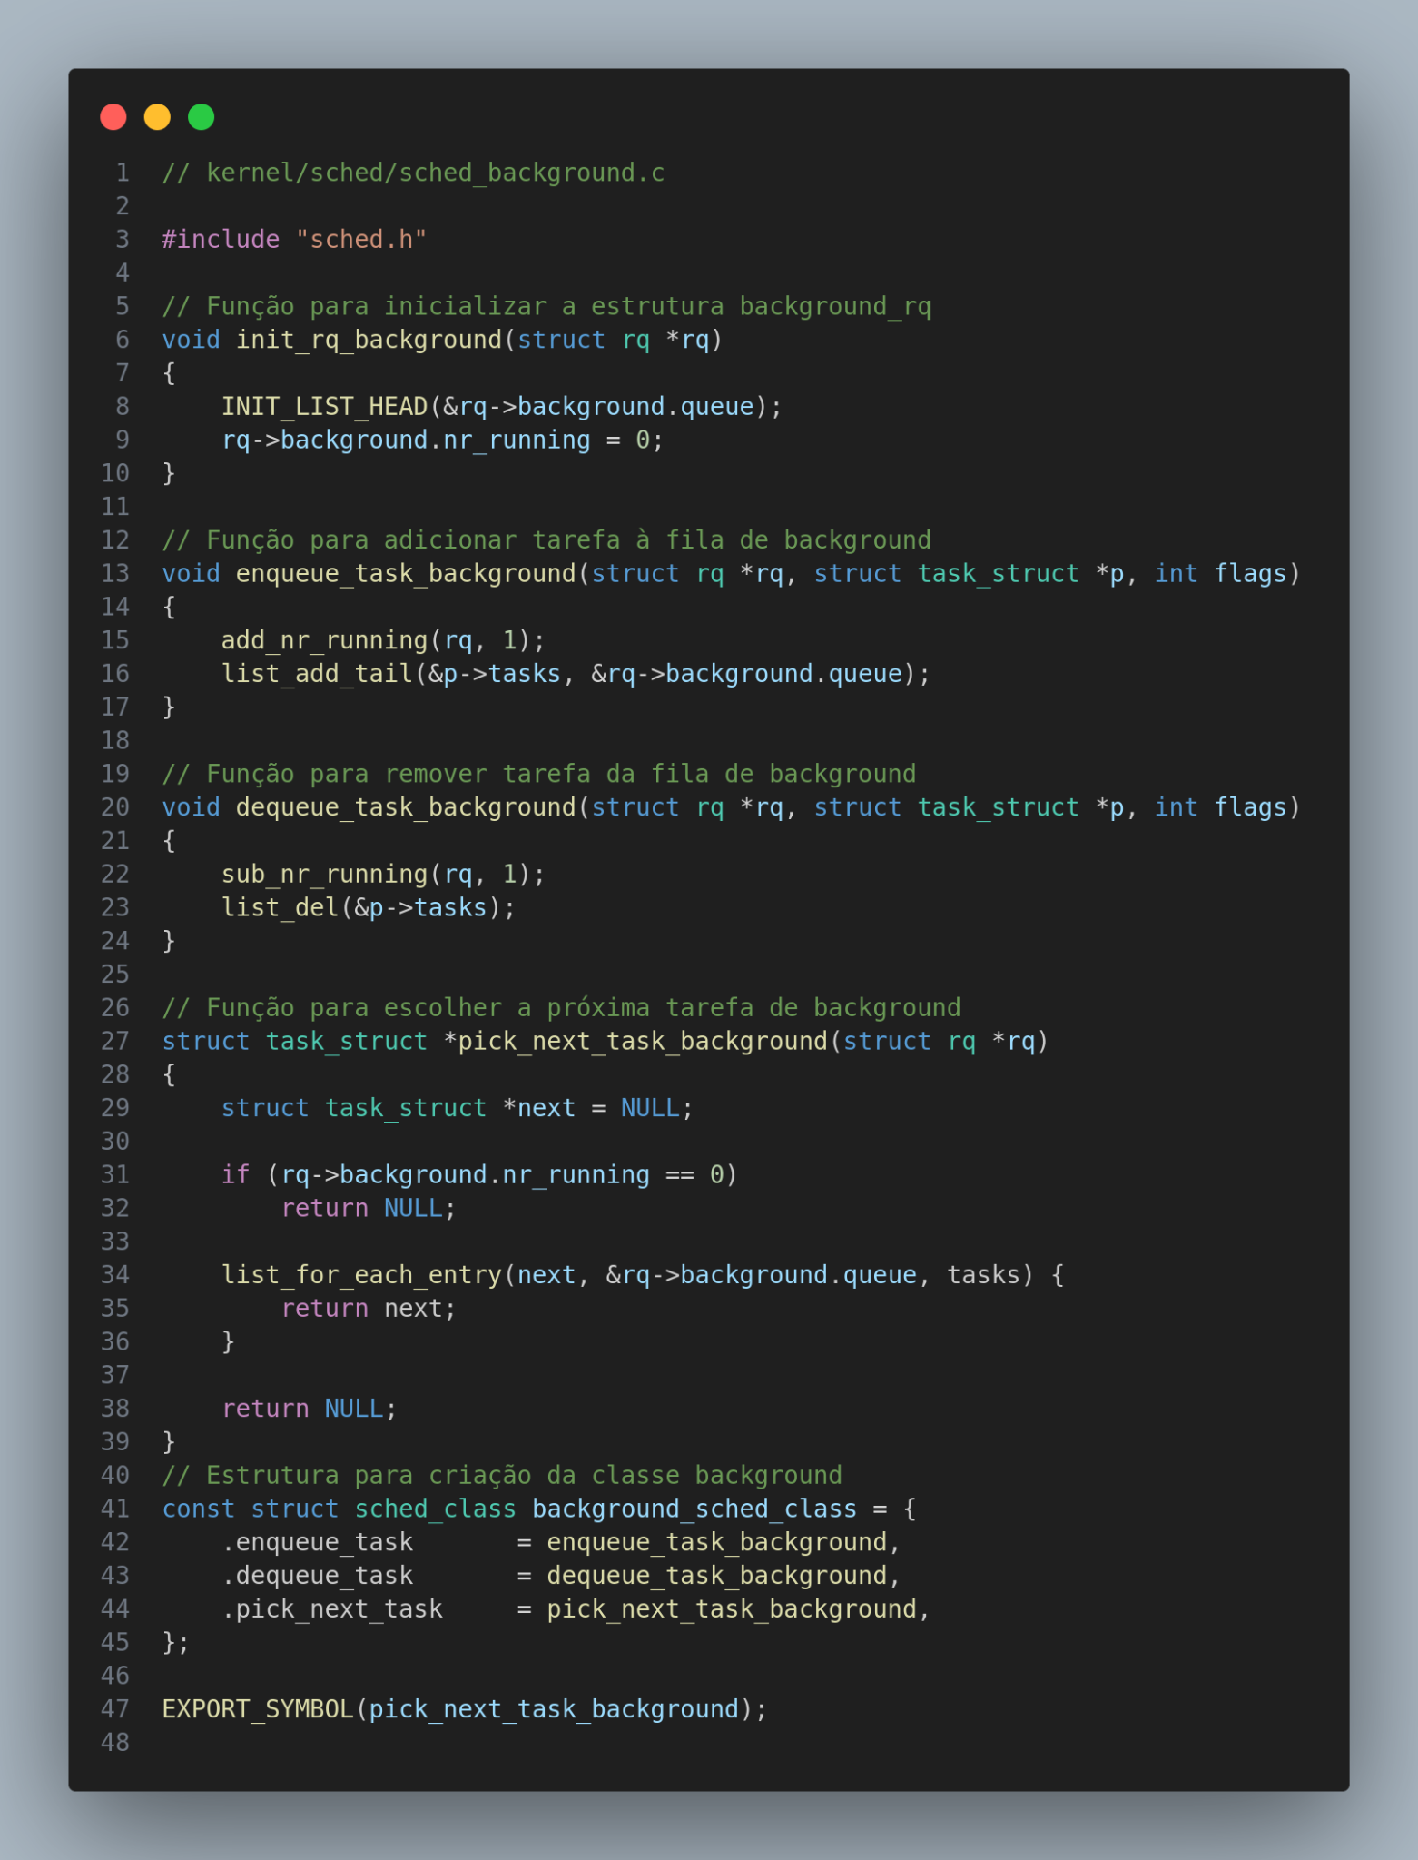

**/KERNEL/SCHED/SCHED_BACKGROUND.H:**

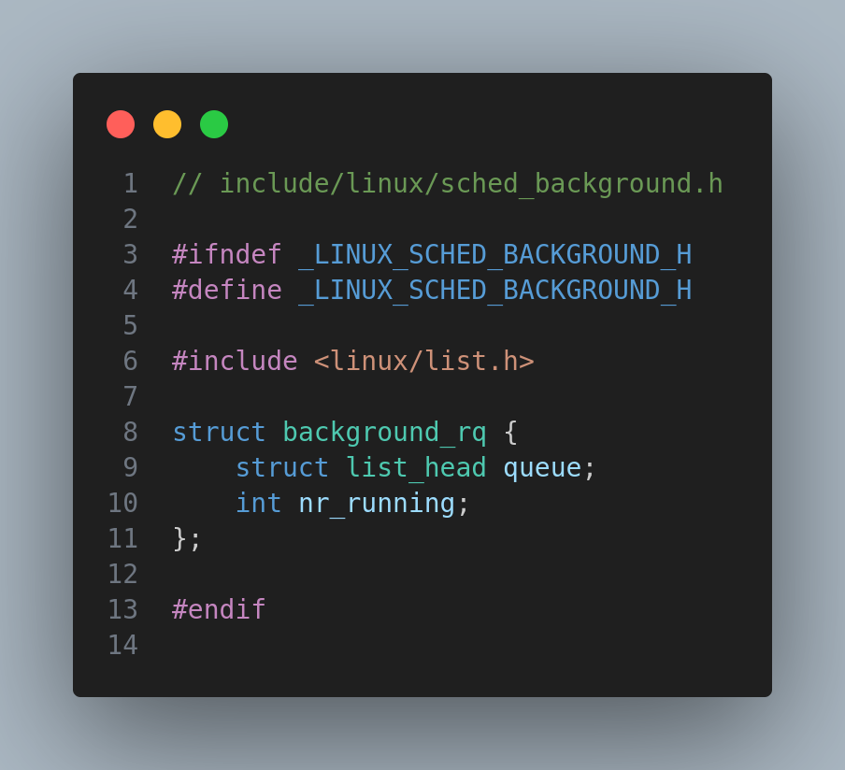

**/KERNEL/SCHED/SCHED.H:** adicionar o include #include "sched_background.h" e adicionar novas funções.

1. **Criar uma função *background_policy* (preferencialmente próximo da função *valid policy*):**

static inline int background_policy(int policy){

return policy == SCHED_BACKGROUND;}

1. **Adicionar na função *valid_policy* a nova política:**

static inline bool valid_policy(int policy){

return idle_policy(policy) || fair_policy(policy) ||

rt_policy(policy) || dl_policy(policy) || background_policy(policy);}

1. **Criar uma função *task_has_background_policy*:**

static inline int task_has_background_policy(struct task_struct *p){

return (p->policy == SCHED_BACKGROUND);}

1. **Na estrutura *struct rq* adicionar junto das outras estruturas a background:**

struct cfs_rq cfs;

struct rt_rq rt;

struct dl_rq dl;

struct background_rq background;

1. **Junto das outras classes *sched_class* adicionar a background:**

…

extern const struct sched_class idle_sched_class;

extern const struct sched_class background_sched_class;

1. **Criar *task_struct* da background:**

…

extern struct task_struct *pick_next_task_idle(struct rq *rq);

extern struct task_struct *pick_next_task_background(struct rq *rq);

**/KERNEL/SCHED/CORE.C:** Modificar algumas funções.

1. **Modificar a função *task_struct * __pick_next_task***

static inline struct task_struct *

__pick_next_task(struct rq *rq, struct task_struct *prev, struct rq_flags *rf){

const struct sched_class *class;

struct task_struct *p;

if (likely(prev->sched_class <= &fair_sched_class &&

rq->nr_running == rq->cfs.h_nr_running)) {

p = pick_next_task_fair(rq, prev, rf);

if (unlikely(p == RETRY_TASK))

goto restart;

if (!p) {

put_prev_task(rq, prev);

p = pick_next_task_idle(rq);}

return p;}

restart:

put_prev_task_balance(rq, prev, rf);

for_each_class(class) {

p = class->pick_next_task(rq);

if (p)

return p;}

/* Novo caso para SCHED_BACKGROUND */

if (likely(rq->background.nr_running > 0)) {

p = pick_next_task_background(rq);

if (p)

return p;}

BUG();}

1. **Modificar a função *__sched_setscheduler.***

static int __sched_setscheduler(struct task_struct *p,

const struct sched_attr *attr,

bool user, bool pi){

int oldpolicy = -1, policy = attr->sched_policy;

int retval, oldprio, newprio, queued, running;

const struct sched_class *prev_class;

struct callback_head *head;

struct rq_flags rf;

int reset_on_fork;

int queue_flags = DEQUEUE_SAVE | DEQUEUE_MOVE | DEQUEUE_NOCLOCK;

struct rq *rq;

/* The pi code expects interrupts enabled */

BUG_ON(pi && in_interrupt());

recheck:

/* Double check policy once rq lock held: */

if (policy < 0) {

reset_on_fork = p->sched_reset_on_fork;

policy = oldpolicy = p->policy; }

else {

reset_on_fork = !!(attr->sched_flags & SCHED_FLAG_RESET_ON_FORK);

if (!valid_policy(policy))

return -EINVAL;}

if (attr->sched_flags & ~(SCHED_FLAG_ALL | SCHED_FLAG_SUGOV))

return -EINVAL;

/*

* Valid priorities for SCHED_FIFO and SCHED_RR are

* 1..MAX_RT_PRIO-1, valid priority for SCHED_NORMAL,

* SCHED_BATCH, SCHED_IDLE, and SCHED_BACKGROUND is 0.

*/

if (attr->sched_priority > MAX_RT_PRIO-1)

return -EINVAL;

if ((dl_policy(policy) && !__checkparam_dl(attr)) ||

(rt_policy(policy) != (attr->sched_priority != 0)))

return -EINVAL;

/*

* Allow unprivileged RT tasks to decrease priority:

*/

if (user && !capable(CAP_SYS_NICE)) {

if (fair_policy(policy)) {

if (attr->sched_nice < task_nice(p) &&

!can_nice(p, attr->sched_nice))

return -EPERM;}

if (rt_policy(policy)) {

unsigned long rlim_rtprio =

task_rlimit(p, RLIMIT_RTPRIO);

/* Can't set/change the rt policy: */

if (policy != p->policy && !rlim_rtprio)

return -EPERM;

/* Can't increase priority: */

if (attr->sched_priority > p->rt_priority && attr->sched_priority > rlim_rtprio)

return -EPERM;}

/*

* Can't set/change SCHED_DEADLINE policy at all for now

* (safest behavior); in the future we would like to allow

* unprivileged DL tasks to increase their relative deadline

* or reduce their runtime (both ways reducing utilization)

*/

if (dl_policy(policy))

return -EPERM;

/*

* Treat SCHED_IDLE as nice 20. Only allow a switch to

* SCHED_NORMAL if the RLIMIT_NICE would normally permit it.

*/

if (task_has_idle_policy(p) && !idle_policy(policy)) {

if (!can_nice(p, task_nice(p)))

return -EPERM;}

/*

Trate SCHED_BACKGROUND de forma semelhante a SCHED_IDLE:

*/

if (task_has_background_policy(p) && !background_policy(policy)) {

if (!can_nice(p, task_nice(p)))

return -EPERM;}

/* Can't change other user's priorities: */

if (!check_same_owner(p))

return -EPERM;

/* Normal users shall not reset the sched_reset_on_fork flag: */

if (p->sched_reset_on_fork && !reset_on_fork)

return -EPERM;}

if (user){

if (attr->sched_flags & SCHED_FLAG_SUGOV)

return -EINVAL;

retval = security_task_setscheduler(p);

if (retval)

return retval;}

/* Update task specific "requested" clamps */

if (attr->sched_flags & SCHED_FLAG_UTIL_CLAMP) {

retval = uclamp_validate(p, attr);

if (retval)

return retval;}

if (pi)

cpuset_read_lock();

/*

* Make sure no PI-waiters arrive (or leave) while we are

* changing the priority of the task:

*

* To be able to change p->policy safely, the appropriate

* runqueue lock must be held.

*/

rq = task_rq_lock(p, &rf);

update_rq_clock(rq);

/*

* Changing the policy of the stop threads is a very bad idea:

*/

if (p == rq->stop) {

retval = -EINVAL;

goto unlock;}

/*

* If not changing anything there's no need to proceed further,

* but store a possible modification of reset_on_fork.

*/

if (unlikely(policy == p->policy)) {

if (fair_policy(policy) && attr->sched_nice != task_nice(p))

goto change;

if (rt_policy(policy) && attr->sched_priority != p->rt_priority)

goto change;

if (dl_policy(policy) && dl_param_changed(p, attr))

goto change;

if (attr->sched_flags & SCHED_FLAG_UTIL_CLAMP)

goto change;

p->sched_reset_on_fork = reset_on_fork;

retval = 0;

goto unlock;}

change:

if (user) {

#ifdef CONFIG_RT_GROUP_SCHED

/*

* Do not allow realtime tasks into groups that have no runtime

* assigned.

*/

if (rt_bandwidth_enabled() && rt_policy(policy) &&

task_group(p)->rt_bandwidth.rt_runtime == 0 &&

!task_group_is_autogroup(task_group(p))) {

retval = -EPERM;

goto unlock;}

#endif

#ifdef CONFIG_SMP

if (dl_bandwidth_enabled() && dl_policy(policy) &&

!(attr->sched_flags & SCHED_FLAG_SUGOV)) {

cpumask_t *span = rq->rd->span;

/*

* Don't allow tasks with an affinity mask smaller than

* the entire root_domain to become SCHED_DEADLINE. We

* will also fail if there's no bandwidth available.

*/

if (!cpumask_subset(span, p->cpus_ptr) ||

rq->rd->dl_bw.bw == 0) {

retval = -EPERM;

goto unlock;

}

}

#endif

}

/* Re-check policy now with rq lock held: */

if (unlikely(oldpolicy != -1 && oldpolicy != p->policy)) {

policy = oldpolicy = -1;

task_rq_unlock(rq, p, &rf);

if (pi)

cpuset_read_unlock();

goto recheck;}

/*

* If setscheduling to SCHED_DEADLINE (or changing the parameters

* of a SCHED_DEADLINE task) we need to check if enough bandwidth

* is available.

*/

if ((dl_policy(policy) || dl_task(p)) && sched_dl_overflow(p, policy, attr)) {

retval = -EBUSY;

goto unlock;}

p->sched_reset_on_fork = reset_on_fork;

oldprio = p->prio;

newprio = __normal_prio(policy, attr->sched_priority, attr->sched_nice);

if (pi) {

/*

* Take priority boosted tasks into account. If the new

* effective priority is unchanged, we just store the new

* normal parameters and do not touch the scheduler class and

* the runqueue. This will be done when the task deboost

* itself.

*/

newprio = rt_effective_prio(p, newprio);

if (newprio == oldprio)

queue_flags &= ~DEQUEUE_MOVE;}

queued = task_on_rq_queued(p);

running = task_current(rq, p);

if (queued)

dequeue_task(rq, p, queue_flags);

if (running)

put_prev_task(rq, p);

prev_class = p->sched_class;

if (!(attr->sched_flags & SCHED_FLAG_KEEP_PARAMS)) {

__setscheduler_params(p, attr);

__setscheduler_prio(p, newprio);}

__setscheduler_uclamp(p, attr);

if (queued) {

/*

* We enqueue to tail when the priority of a task is

* increased (user space view).

*/

if (oldprio < p->prio)

queue_flags |= ENQUEUE_HEAD;

enqueue_task(rq, p, queue_flags);}

if (running)

set_next_task(rq, p);

check_class_changed(rq, p, prev_class, oldprio);

/* Avoid rq from going away on us: */

preempt_disable();

head = splice_balance_callbacks(rq);

task_rq_unlock(rq, p, &rf);

if (pi) {

cpuset_read_unlock();

rt_mutex_adjust_pi(p);}

/* Run balance callbacks after we've adjusted the PI chain: */

balance_callbacks(rq, head);

preempt_enable();

return 0;

unlock:

task_rq_unlock(rq, p, &rf);

if (pi)

cpuset_read_unlock();

return retval;}

1. **Modificar também SYSCALL_DEFINE1(sched_get_priority_max, int, policy) e SYSCALL_DEFINE1(sched_get_priority_min, int, policy)**

SYSCALL_DEFINE1(sched_get_priority_max, int, policy){

int ret = -EINVAL;

switch (policy) {

case SCHED_FIFO:

case SCHED_RR:

ret = MAX_RT_PRIO-1;

break;

case SCHED_DEADLINE:

case SCHED_NORMAL:

case SCHED_BATCH:

case SCHED_IDLE:

case SCHED_BACKGROUND:

ret = 0;

break;

}

return ret;

}

/**

* sys_sched_get_priority_min - return minimum RT priority.

* @policy: scheduling class.

*

* Return: On success, this syscall returns the minimum

* rt_priority that can be used by a given scheduling class.

* On failure, a negative error code is returned.

*/

SYSCALL_DEFINE1(sched_get_priority_min, int, policy)

{

int ret = -EINVAL;

switch (policy) {

case SCHED_FIFO:

case SCHED_RR:

ret = 1;

break;

case SCHED_DEADLINE:

case SCHED_NORMAL:

case SCHED_BATCH:

case SCHED_IDLE:

case SCHED_BACKGROUND:

ret = 0;

}

return ret;

}

1. **Configure o kernel:**

Existem duas opções de configuração do kernel:

1. Utilizando o comando `cp /boot/config-$(uname -r) .config`, que copia as configurações do kernel atual. No entanto, se o kernel não for o mesmo ou se houver a necessidade de um kernel específico, será necessário realizar modificações.

2. Usando o comando `make defconfig`, que carrega configurações padrão, onde diversos drivers e outros componentes estão desativados.

Para personalizar as configurações, pode-se utilizar o comando `make menuconfig`. Caso essa ferramenta não esteja disponível, pode-se prosseguir sem ela.

1. **Compile o kernel**

make -j$(nproc)

1. **Instale o kernel**

sudo make modules_install

sudo make install

1. **Atualize o grub e reinicie**

sudo update-grub

sudo reboot

1. **Verifique a nova versão do kernel**

uname -r

1. **Teste a nova política**

Para fins de teste, foram criados dois arquivos .c: *teste_background.c* e *teste_performance.c*.

teste_background.c: Destinado a verificar se a nova política foi criada com sucesso.

#include <stdio.h>

#include <sched.h>

#include <unistd.h>

#define SCHED_BACKGROUND 7

int main() {

    struct sched_param param;

    param.sched_priority = 0;

    if (sched_setscheduler(0, SCHED_BACKGROUND, &param) == -1) {

        perror("sched_setscheduler");

        return 1;}

    printf("SCHED_BACKGROUND aplicada com sucesso!\n");

    return 0;}

**TESTE_PERFORMANCE.C:** Para saber a performance da nova política nova

#include <sys/time.h>

#include <sys/resource.h>

#include <stdio.h>

int main() {

struct timeval start, end;

struct rusage usage;

gettimeofday(&start, NULL);

for (long i = 0; i < 1000000000; i++);

gettimeofday(&end, NULL);

getrusage(RUSAGE_SELF, &usage);

long seconds = end.tv_sec - start.tv_sec;

long micros = ((seconds * 1000000) + end.tv_usec) - start.tv_usec;

printf("Tempo de wallclock: %ld microssegundos\n", micros);

printf("Tempo de usuário: %ld microssegundos\n", usage.ru_utime.tv_sec * 1000000 + usage.ru_utime.tv_usec);

printf("Tempo de sistema: %ld microssegundos\n", usage.ru_stime.tv_sec * 1000000 + usage.ru_stime.tv_usec);

return 0;

}

**Após a criação basta usar os comandos:**

gcc -o teste_background teste_background.c

sudo ./teste_background

gcc -o teste_performance teste_performance.c

sudo ./teste_performance